While ARC has adopted a few standard templates such as the project initiation form and project charter template, there are a variety of optional tools offered for the convenience of those involved with project management. The list below summarizes the available tools and their intended use. Most templates are available via IGOR (Institutional Governance Online Repository) at https://apps.arc.losrios.edu/IGOR.

Template or Tool | Type/Format | Intended Purpose | Access
Project Charter Template | Required – Word format  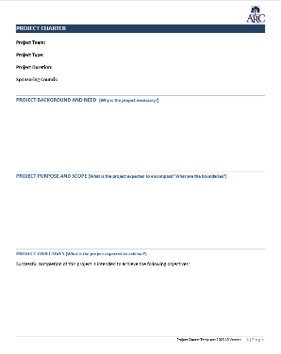 | The charter template was adopted by the Executive Leadership Team (ELT) and is used for all projects. The template is used to define the project purpose, scope, deliverables, basic timeline, and other details. Once drafted, the charter is submitted to ELT for approval.  Additional Resource: There is also a how-to video available that gives a walkthrough of each section of the charter template. | Download from Templates in IGOR
Meeting Agenda Editor | Required – Electronic Form  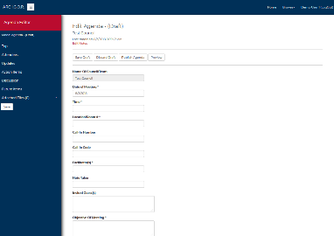 | The standardized format of this template is designed for consistency across all councils/project teams. Agendas can be reviewed in draft form by the leads/notetakers or published for viewing by the council, team, and college community via IGOR, the Institutional Online Governance Repository. Published agendas can also be exported as PDFs for use outside of IGOR.  An email notification is also sent to the council or project team as soon as an agenda is published to prompt quick access to the agenda and attached files.  Additional Resource: How to Create an Agenda - instructions for using IGOR | Use electronic form in IGOR
Meeting Notes Editor | Required – Electronic Form  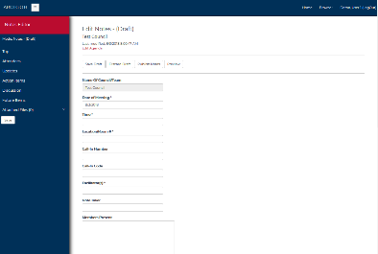 | The standardized format of this template is designed for consistency across all councils/project teams. Notes can be reviewed in draft form by the leads/notetakers or published for viewing by the council, team, and college community via IGOR.  Information contained in notes may be automatically pulled into other documents to highlight governance work for the college.  Additional Resource: How to Record Notes - instructions for using IGOR | Use electronic form IGOR
Membership Roster | Required – Electronic Form  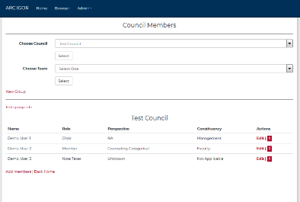 | COUNCIL CHAIR USE ONLY – Council chairs (or their designated note taker) maintain the rosters for sponsored projects. Please refer all requests for changes to the council chair. Changes to the project team roster may require appointment by constituent groups.  Once a change is made, the project leads should be notified so that new individuals can be added to Basecamp and past individuals can be removed. | Use electronic form in IGOR  (chairs only)
Status Update Form | Required – Electronic Form  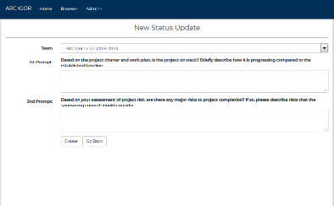 | This form is used to regularly update the sponsoring council on project status. It answers two key project management questions:  - Is the project on track based on the project charter/work plan?  - Are there any major risks to project completion that the council should consider?  Updates are expected monthly, but the exact timing should be coordinated with the meeting schedule of the sponsoring council. | Use electronic form in IGOR
Agenda Planner Template | Optional – Word format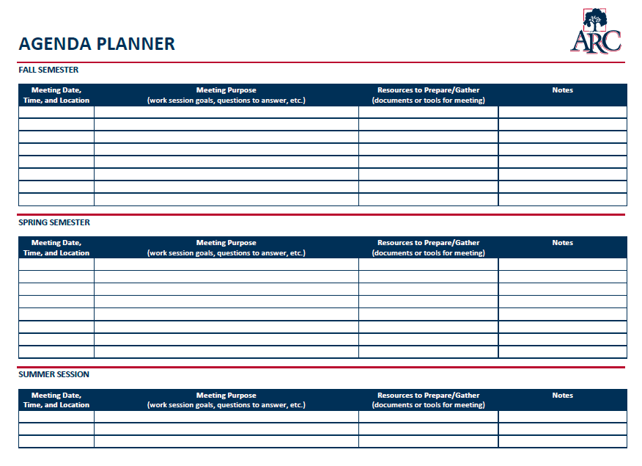 | The work that the project team needs to accomplish during its meetings should be planned in advance to ensure that it can be accomplished in the number of meetings available. The agenda planner is a tool that can be used to map the work and resources needed for each meeting along with meeting preparation (homework) to be completed by the team in advance. | Download from Templates in IGOR
Sample Kickoff Event Schedule | Optional – PDF format  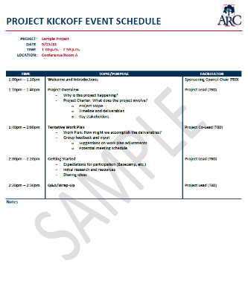 | The project kickoff often has the flavor of an event rather than a meeting or work session. This sample event schedule shows how it might be structured. It includes the key components to cover during a kickoff to create shared understanding of the project and set the stage for the project team to begin project work. | Download from Templates in IGOR
Sample Kickoff Meeting Agenda | Optional – PDF format  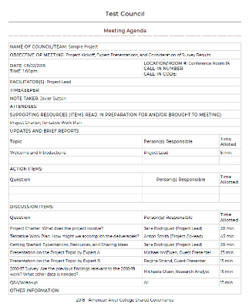 | If the project kickoff is embedded within the project’s first meeting instead of being held as a separate event, the IGOR electronic meeting agenda editor should be used to create the agenda. This sample shows how the agenda might be structured. | Download from Templates in IGOR; then use IGOR agenda editor
Gantt Chart Template  (work plan option 2) | Optional – Excel format  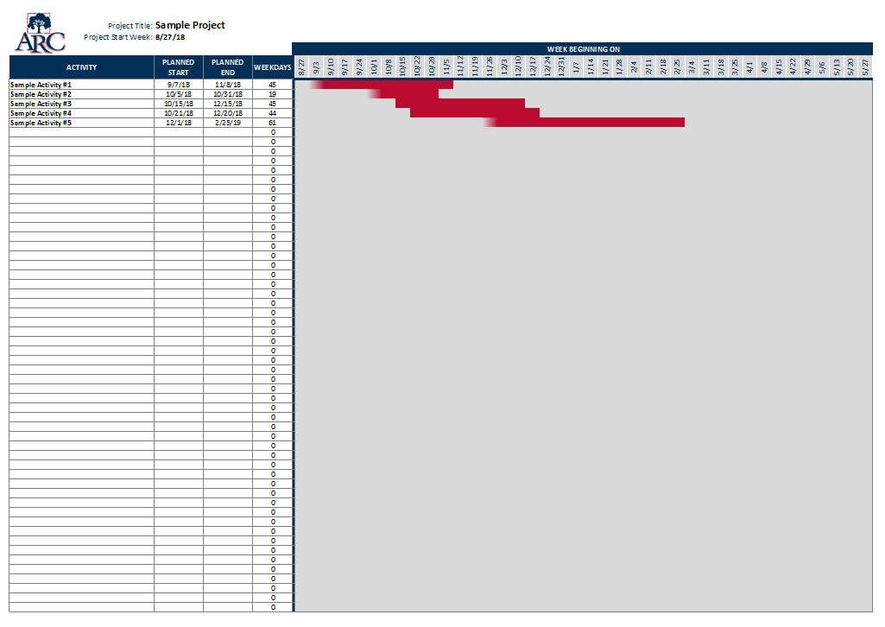 | Work Plan Option 2  Build the tasks into a Gantt chart that can be uploaded to Basecamp and distributed to the sponsoring council or others as needed. The template automates some of the work involved with manually creating a Gantt chart. Once the user enters a project start week, the template calculates 7-day intervals. As tasks are added with start/end dates, the template will automatically display colored bars to indicate the expected time frame of the work. The template is designed with enough weeks to cover the primary terms of an academic year (e.g., mid-August to mid-May). | Download from Templates in IGOR
Month-by-month Work Plan Template  (work plan option 3) | Optional – Word form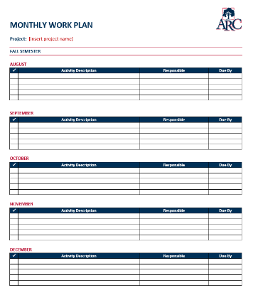 | Work Plan Option 3  Build the tasks into a simple month-by-month chart that can be uploaded to Basecamp and shared with the sponsoring council or others as needed.  Each month includes a table with multiple rows. Each row starts with a check-off box and has space to indicate an activity description, who is responsible, and the due date per item. Additional rows can be added as needed. | Download from Templates in IGOR
Deliverable Cover Sheet | Optional – Fillable PDF  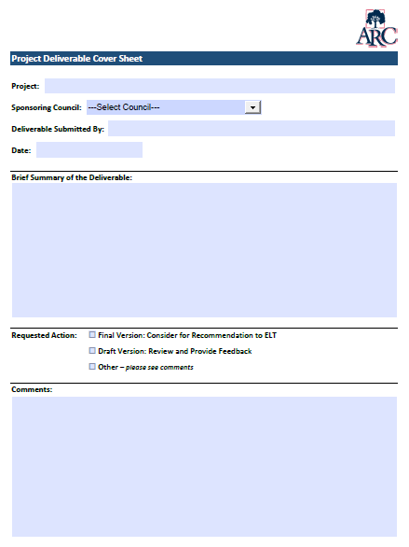 | This cover sheet can be used to give a brief overview of a deliverable that is being submitted to a sponsoring council. | Download from Templates in IGOR
Deliverable Recommendation Form | Optional – Fillable PDF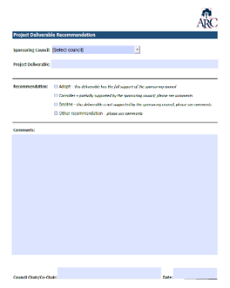 | COUNCIL CHAIR USE ONLY – This cover sheet is an option for council chairs to use when submitting a recommendation on a particular deliverable to the Executive Leadership Team (ELT). | Download from Templates in IGOR
Consolidated Task Checklist | PDF  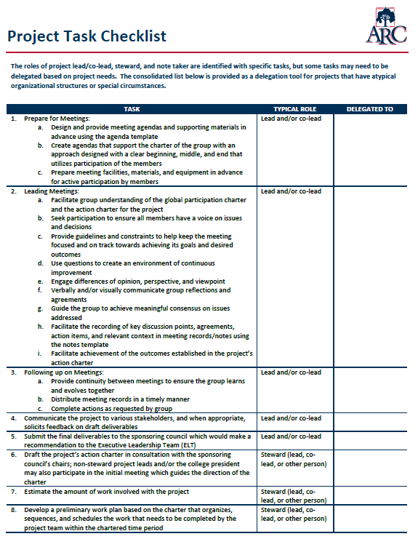 | The task checklist provides a general list of tasks that typically apply to all projects and would normally be done by a project lead, steward, or note taker. It is intended both as a reference for new projects and a mechanism for delegating tasks. It may be particularly useful as a checklist for those who have not previously served as leads.  Please note that tasks may vary if the project is involved with a districtwide process. | Download from Templates in IGOR
Steward Task Checklist | PDF  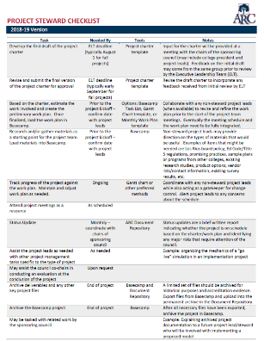 | This checklist can be used if a separate steward is assigned to the project (in lieu of all tasks being handled by the leads). It includes the expected tasks for the steward role with suggested timing, tools, and notes for each item. | Download from Templates in IGOR

Additional Resources

Resource | Format | Intended Purpose | Access
Decision Tree for Project Deliverables (Draft Version) | PDF  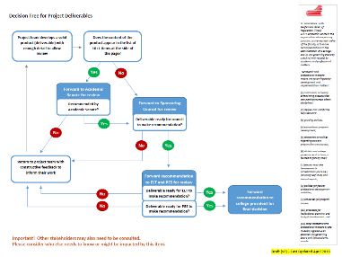 | This decision tree can be used as a guide to the expected flow of deliverables through the Academic Senate, sponsoring council, and the Executive Leadership Team.  The draft was reviewed with the Academic Senate in Spring 2018 but has not yet been formally adopted by the councils. | Download from Files in IGOR
Lifecycle of a Project Team | PDF  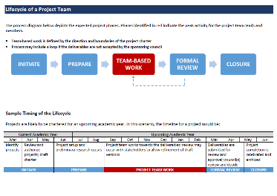 | This resource gives an overview of the basic phases of a project along with sample timing. The phase shown in red is the team-based work that is bound by the project charter. The blue phases are more likely to involve only the project leads (and stewards) in order to plan, prepare, and close the project. | Download from Files in IGOR
Participation Charter  (Draft Version) | PDF  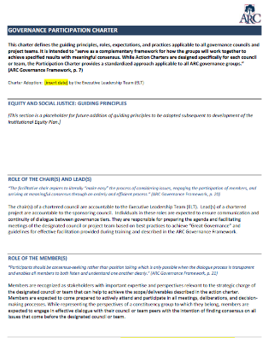 | The participation charter defines the guiding principles, roles, expectations, and practices applicable to all governance councils and project teams. It can be thought of as the “rules of the game” for effective participation.  The draft version of the participation charter is currently available. It is based on the ARC Governance Framework and is expected to be considered by the Executive Leadership Team (ELT) in August 2018. The final version will be uploaded as soon as it adopted by ELT. | Download from Files in IGOR
Project Communication | PDF  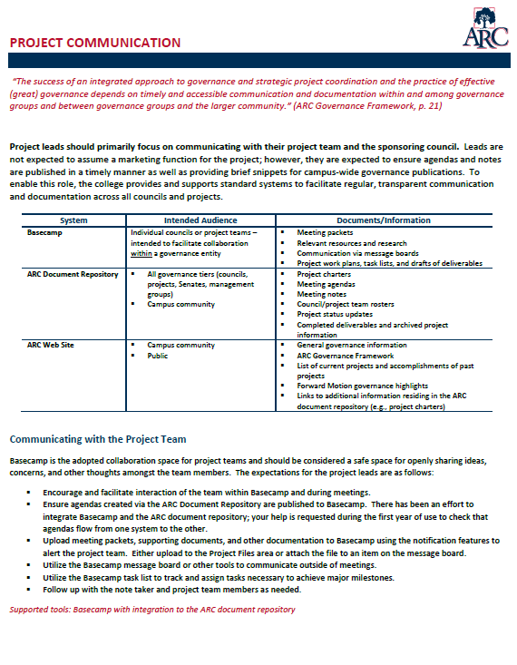 | This resource describes the available technologies, expectations, and avenues for project communication. It covers communication within the project team as well as with the sponsoring council, the entire college, and key stakeholders offering a variety of methods and guidance.  Note: This document also contains suggested prompts for mid-project progress reports. If a progress report is requested by the sponsoring council, please contact the council chair for further details on preferred format, length, and content. | Download from Files in IGOR
Sample Deliverables | PDFs | The deliverables submitted by previous project teams are listed under Accomplishments on the Forward Motion page of the Governance web pages.  http://www.arc.losrios.edu/About_ARC/ARC_Governance/Forward_Motion.htm | Access via the ARC Web Site

