10/12/23
3:00 PM
ARC Student Center Boardroom
Zoom Meeting ID: 814 3639 5801
https://lrccd.zoom.us/j/81436395801

American River College Academic Senate Regular Meeting Approved Minutes
Preliminaries
- Call to Order
- Approval of the Agenda - Approved by consent
- Approval of the Minutes Sept 14 - Approved by consent
- Approval of Minutes Sept 28 - Approved by consent
- Introduction of Guests - LaQuisha Beckum, Adam Karp, Margaret Travis, Dylan Popowicz, Amy Gaudard, Araceli Badilla, Bill Zangeneh-Lester
- Public Comment Period (3 minutes per speaker)
The college is hiring a permanent dean of English and the English area just found out on Tuesday who would serve on the committee. It appears that the faculty were selected by the AVP, and approved by the Senate President, but there was no ability for faculty to give input on who should serve. Is there a way to make this more transparent and collegial? Senate President apologized. He was under the impression that there had been faculty input.
Comment shared at Indigenous People’s Day March shared in Senate. On behalf of the Native American Resource Center, can the public information policy be changed to allow the Native American Resource Center to email all at ARC? Current policy stifles the ability for the Native American Resource Center or other equity groups to send messages to all.
- President’s Report
Requests for New Faculty Hiring are Due Tomorrow Link. Job description does not need to be included. Reported by a senator that the process was unclear and stressful. Indicated that a job description was required, but that is not accurate.
Presenters will have 2 minutes to present and then 3 minutes for questions.
If you have an alternate senator, please make sure you know who’s voting, so that we don’t get extra votes.
Please read the requests for new faculty prior to the meeting.
Inquiry if it is possible for a separate process/funding for nursing faculty? Response: Conversations on this topic are taking place.
Inquiry if it is possible to have an endowed chair for nursing, that could be paid more to help make up for the gap in what nurses could make in the industry?
Programs requesting multiple positions do not get more time, unless they are different job descriptions.
Follow Up on Town Hall
Davies Hall Updates: Deans should be working with faculty on office space. Hopefully that will be a collegial consultation. Exploring possible additional faculty workspaces, possibly including the faculty dining space. Concern raised that LRCFT contract indicates there should be a faculty dining space. Dining space currently being used as a storeroom.
Los Rios Prison Education Program - Fall 2023 professional learning experience, Oct 27 or 28.
District NAGPRA Moratorium
HomeBase (Embedded Counselors) Update: For now, counseling will be staying in current location.
Still opportunity for Faculty Home Base Liaison for Manufacturing, Construction, & Transportation - .2 reassign time
AB828 - Associate Degree for Transfer, Intersegmental Implementation Committee Report - potential legislation open for public comment until 11/15. Report.
Consent Items
8. Approval of Remote Attendees - approved by consent
9. Program Review Questions
Introduction
1. In 3-5 sentences, describe your unit to an audience of potential students. Many units take this information from their website. If it has been awhile since your unit has updated its website, take this opportunity to design a brief description of your unit for today’s students.
Strategic Analysis and Reflection
2. Who is disproportionately impacted in your unit?
3. What equity advancing actions have your programs already taken?
4. What will be your unit’s objectives for eliminating disproportionate impact (DI)?
5. What support do you need to eliminate disproportionate impact (DI)?

Additional Issues (Optional)
6. What other issues or concerns have affected your unit and are important for you to bring up?
Inquiry if we can make clear the definition of DI.
Concern that onus is on program, not on the institution - What is the district doing?
Concern expressed about use of word objectives in question 4. Are we asking for strategies or objectives?
Inquiry about whether question 3 is really about the program or about individuals within the department.
Inquiry if question 6 should be optional.
Item pulled from consent.
Action Items
10. Military Credit Draft regulation (2nd reading) - concern expressed about use of red text. Suggested that we investigate accessibility and how to indicate revisions. – Approved unanimously.
Yes: Dyanne Marte, Diane Lui, Tak Auyeung, Kahkashan Shaukat, Christian Speck, Vivian Dillon, Mayra Mireles, Michaela Cooper, Caroline Prieto, Gina Barnard, Susan Chou, Jill Birchall, Andrew Fix, Sarah Lehmann, Chris Moore, Gary George, Lauren Chavez, Robin Akawi, Ricardo Caton, Ellen Bowden, Deborah Gale, Sonya Reichel, Lana Anischenko, Glenn Jaecks, Veronica Lopez, David McCusker, Alisa Shubb.

11. Academic Renewal Draft regulation (2nd reading)

Concern expressed about 1.3.4.3. Proposed change seems inequitable. Why take out the part about extenuating circumstances? Response that 1.3.6.1 makes it so students can get an EW.

8.3 district suggesting a 3 year limit on request for a grade change. Why does an instructor need to verify? ARC senate not in favor of supporting changes to section 8.

Motion to approve changes, exempting any changes to section 8. Seconded. Motion approved unanimously.
Yes: Dyanne Marte, Diane Lui, Tak Auyeung, Kahkashan Shaukat, Christian Speck, Vivian Dillon, Mayra Mireles, Michaela Cooper, Caroline Prieto, Gina Barnard, Susan Chou, Jill Birchall, Andrew Fix, Sarah Lehmann, Chris Moore, Gary George, Lauren Chavez, Robin Akawi, Ricardo Caton, Ellen Bowden, Deborah Gale, Sonya Reichel, Lana Anischenko, Glenn Jaecks, Veronica Lopez, David McCusker, Alisa Shubb.

.
12. Davies Hall Resolution (1st reading)

Suggested to have a brief resolution with an accompanying white paper.

Suggested that audience might not be the board, it might be the media.

Suggested that we be mindful of how white supremacy culture may be working in this process.

Suggested that we might ask that who reviews the chancellor’s performance be broadened.

Senators asked to bring the resolutions to their areas and ask who would want to be involved in the writing process. If interested, please contact President Knirk asap.

13. Vote of No Confidence Resolution – Chancellor (1st reading)

Suggested to have a brief resolution with an accompanying white paper.

Suggested that audience might not be the board, it might be the media.

Suggested that we be mindful of how white supremacy culture may be working in this process.

Suggested that we might ask that who reviews the chancellor’s performance be broadened.

Senators asked to bring the resolutions to their areas and ask who would want to be involved in the writing process. If interested, please contact President Knirk asap.

14. Curriculum Committee Charter Update (1st reading) – Not discussed at this time
Reports (5-10 minutes per item)
15. AS Committee Brown Act Requirements – Not discussed at this time.
Discussion (10-15 minutes per item)
16.Senate Bylaws and Voting Caucuses – Not discussed at this time.
17.Discussion of Dr. Cardoza’s Monday Email – Not discussed at this time.
18.Report Back (Feedback from College Areas) - Not discussed at this time.
19.Report Out (Information from District Meetings and Other Areas) - Not discussed at this time.
20.Items from College Areas for Academic Senate Consideration - Not discussed at this time.

Upcoming Meetings:
- District Academic Senate: Tuesday, 10/17 3:00 PM (District Conference Room)
- Academic Senate: Thursday, 10/26 3:00 PM – Faculty Prioritization (ARC Board Room)

Supplemental Materials

Los Rios’ Prison Education Program
Hi faculty Colleague,
Are you interested in potentially teaching, counseling, or in other ways being involved in Los Rios' prison education program? Would you like to understand how to support Los Rios' currently or formerly incarcerated students? If so, please attend the fall 2023 in-prison professional learning experience on either October 27th or 28th. You can register here: Fall 2023 College While Incarcerated Registration Link

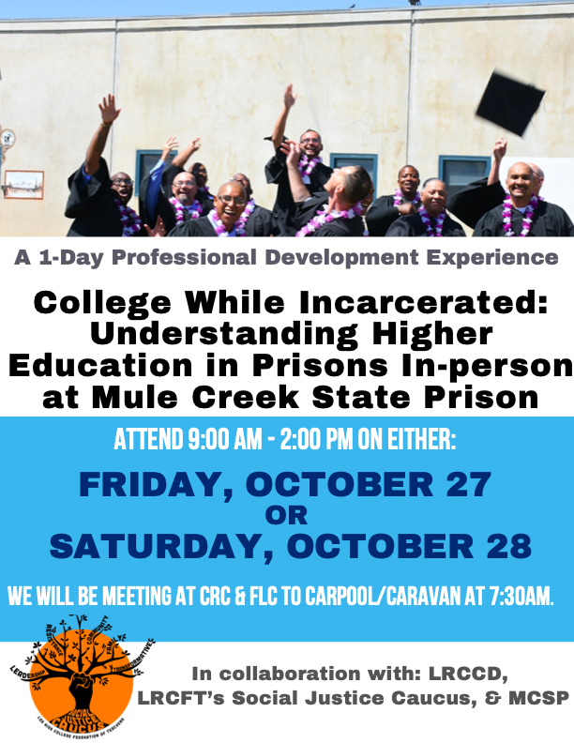

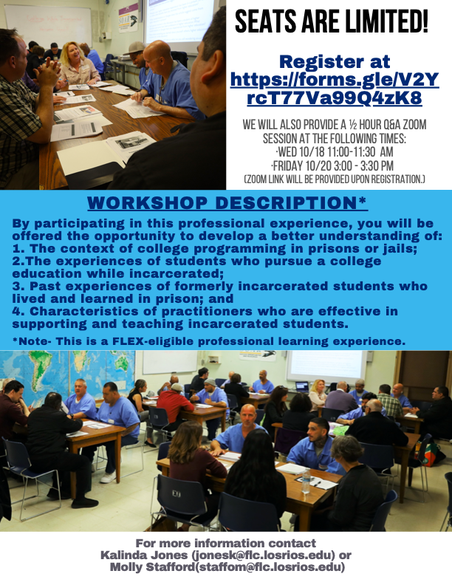
Here are a few important details about the event:
- Overview
  - 20+ students will be involved.
  - Hear students' stories about their college in prison experiences.
  - Participate in co-learning discussions led by students.
  - Learn from our education partners who work for CDCR (California Dept of Corrections).
  - Co-learn with other Los Rios faculty, staff, and administrators.
- Date:
  - Choose EITHER Friday 10/27 OR Saturday 10/28.
- Time:
  - 9:00 - 2:00
  - 7:30 - 3:30 (with travel time)
- Location:
  - Mule Creek State Prison, 001 CA-104, Ione, CA 95640
  - Option to carpool from either FLC or CRC
- How to prepare:
  - Q & A on zoom (10/18 11-11:30 or 10/20 at 3-3:30 or other times if needed)
  - Zoom link will be sent after you register
- How to register: Fall 2023 College While Incarcerated Registration Link
Hope to see you on October 27th or 28th,

Lynn Baker-Nauman, Kalinda Jones, Mari Peshon, & Molly Stafford (College While Incarcerated Organizing Team)

Kalinda R. Jones, Ph.D.
Professor of Social Work/Human Services
Faculty Coordinator for Los Rios' In-Prison Program
LRCFT Campus Representative and Executive Board Member

Folsom Lake College |10 College Pkwy, Folsom CA 95630
Work Phone: 916-608-6844 | Cell Phone: 734-323-3995 (preferred phone contact)
JonesK@flc.losrios.edu​

Email Sent By Brian King, Wednesday, October 4, 2023

NAGPRA Update/Moratorium

Colleagues,

We talk a lot, and for good reason, about our values in Los Rios and our commitment to the equity work that led so many of us to pursue a career in higher education, and community colleges in particular. Those values are critical to our work, and serve as our true north. There are also moments where we are called to translate those values into action.

For years, there has been a national conversation about the repatriation of Native American and other indigenous ancestral remains. Countless higher education and other academic institutions like the CSU system and the Smithsonian Institute are currently in the midst of an overdue reckoning on these issues, the breadth and seriousness of which extend beyond operational issues and into the heart of the core values we collectively embrace. This issue is in part about compliance with the federal Native American Graves Protection and Repatriation Act (NAGPRA) enacted in 1990, but framing this as simply a compliance issue obscures the larger point about doing what is right by a historically marginalized community.

Los Rios has been working with local Native American tribes for a number of months regarding the repatriation of ancestral remains and cultural items in our possession for generations. The process for returning remains to their rightful resting place(s) with their ancestors, as well as the process to begin atoning for this historical wrong, is understandably painful for our tribal partners. These discussions began in our district (and remain underway) at American River College, where the NAGPRA repatriation process was first initiated, but our other colleges have human remains and Native American cultural items in their possession and are preparing for a similar process.

Through our commitment to making this right, and through painstaking work by many involved at ARC and the district, we have slowly begun to rebuild trust with our tribal partners. In the coming year, we expect to develop a new Los Rios policy through our established consultative process that clearly lays out rules for the ethical procurement of human remains for instructional purposes. This process will take some time, and will go through all of our normal policy governance processes and protocols.

However, based on our commitment to doing what is right and at the direct request of our tribal partners, we are implementing an immediate moratorium on the use of any human remains and Native American cultural items at our colleges, until it can be determined that they were obtained ethically and/or we have a formal policy in place. The specific language in the moratorium, as well as some frequently asked questions, can be found on our NAGRPA website. It is worth noting that obtaining remains legally is very different than obtaining remains ethically. We have no reason to believe that the human remains in our possession were obtained illegally, but rather many of the legal sources used to procure these remains used practices for generations that we now know to be inconsistent with our shared values.

For the past several weeks, we have been working with our Academic Senate partners on this topic, and we have great appreciation for the Senate’s leadership and commitment to an authentic partnership with our tribal communities. At its meeting this week, the Academic Senate voted to support the moratorium while highlighting some legitimate questions and concerns about its implementation. The FAQ page addresses some of these issues, but we will continue to work with our district and college Academic Senates to work collaboratively through these and other issues that might arise. To be clear, we are committed to working with our Senates to create a central role for faculty in this process that doesn’t supersede or infringe upon the spiritual and cultural dominion of our tribal partners. Local tribes are leading and facilitating this process, and we are grateful for leadership and patience during these complicated and painful discussions.

In preparation for the possibility of a moratorium, many faculty and instructional leaders have already begun the process of identifying possible digital or synthetic alternatives to real human remains that could be used in classrooms to ensure that we continue to meet the curricular requirements in all of our academic programs. Additionally, we have begun reviewing a list of potential vendors for ethically obtaining human remains with documentation that the individual consented to the use of their remains for teaching, research, or similar purposes (a link to one approved vendor is already included in the FAQ). The district has committed whatever resources are necessary to secure the necessary alternatives.

We are tremendously grateful and appreciative for the thoughtfulness and leadership of everyone involved in this discussion, starting with our tribal partners and including all faculty, staff, and administrators who have been involved in the ongoing work to right these historical wrongs. Los Rios has long held ourselves up as leaders in the work of equitably elevating the voices of historically underserved communities, and we are proud of how we embraced that mantle with regards to this project.

Sincerely,

Brian King
Chancellor
Los Rios Community College District

Lisa Cardoza
President
American River College

Ed Bush
President
Cosumnes River College

Art Pimentel
President
Folsom Lake College

Albert Garcia
President
Sacramento City College

Attendance
Formally known as | Area (as of Fall 2023) | Senator | Adjunct/FT | Term End | Clicker Number
 | Arts | Dyanne Marte (Fashion) | Full-time | 2026 | 21 | Present
 | Arts | Linda Gelfman (Art) | Full-time | 2024 | 22 | Absent
 | Arts | Diane Lui | Adjunct | 2023 | 23 | Present
 | Arts | Unfilled | Full-time | 2025 | 24
 | Arts |  | Alternate Full-Time |  | 25
 | Arts |  | Alternate Adjunct
Business & Computer Sciences | Business | Marc Condos (BUS) | Full-time | 2026 | 6 | Absent
 | Business | Tak Auyeung (CSIT) | Full-time | 2025 | 7 | Approved Remote
 | Business | Kahkashan Shaukat (CSIT) | Full-time | 2024 | 8 | Approved Remote
 | Business | Christian Speck | Adjunct | 2023 | 25 | Present
 | Business | Damon Antos | Alternate Full-Time |  | 10
 | Business |  | Alternate Adjunct
Workforce/ Work Experience/Apprenticeship/ SRPSTC (Sacramento Regional Public Safety Training Center) | Career Education, Workforce, Public Service, & Apprenticeship | Vivian Dillon | Full-time | 2024 | 49 | Present
 | Career Education, Workforce, Public Service, & Apprenticeship | Carlos Ponce | Adjunct | 2024 |  | Absent
 | Career Education, Workforce, Public Service, & Apprenticeship | Jody Johnson | Adjunct | 2026 |  | Approved Remote
 | Career Education, Workforce, Public Service, & Apprenticeship | Unfilled | Adjunct
 | Career Education, Workforce, Public Service, & Apprenticeship | Lonetta Riley | Alternate Full-Time |  | 50
 | Career Education, Workforce, Public Service, & Apprenticeship |  | Alternate Adjunct
Counseling | Counseling | Vacant | Full-time | 2023 | 11 | Absent
 | Counseling | Joyce Fernandez | Adjunct | 2024 | 12 | Absent
 | Counseling | Mayra Mireles | Full-time | 2026 | 13 | Present
 | Counseling | Carmelita Palomares | Full-time | 2025 | 14 | Present
 | Counseling | Kim Herrell | Alternate Full-Time |  | 29
 | Counseling |  | Alternate Adjunct |  | 12
English | English | Valerie Bronstein | Adjunct | 2023 | 16 | Absent
 | English | Michaela Cooper | Full-time | 2026 | 30 | Present
 | English | Caroline Prieto | Full-time | 2024 | 18 | Present
 | English | Gina Barnard | Full-time | 2025 | 19 | Present
 | English | Melissa Diaz | Alternate Full-Time |  | 20
 | English |  | Alternate Adjunct |  | 16
Health & Education | Health & Education | Unfilled | Full-time |  | 26
 | Health & Education | Unfilled | Full-time |  | 27
 | Health & Education | Susan Chou (NUT) | Full-time | 2024 | 28 | Present
 | Health & Education | Unfilled | Adjunct
 | Health & Education |  | Alternate Adjunct
 | Health & Education | John Coldiron | Alternate Full-Time
Kinesiology & Athletics | Kinesiology & Athletics | Eric Black | Full-time | 2024 | 37 | Absent
 | Kinesiology & Athletics | Unfilled | Full-time
 | Kinesiology & Athletics | Unfilled | Full-time |  | 38
 | Kinesiology & Athletics | Unfilled | Adjunct |  | 39
 | Kinesiology & Athletics |  | Alternate Full-Time
 | Kinesiology & Athletics |  | Alternate Adjunct
Humanities | Language & Communication | Unfilled | Full-time | 2025 | 31
 | Language & Communication | Jill Birchall (sign lang) | Full-time | 2024 | 32 | Approved Remote
 | Language & Communication | Jeff Moran | Full-time | 2026 | 36 | Absent
 | Language & Communication | Andrew Fix | Adjunct | 2025 | 34 | Present
 | Language & Communication | Erik Haarala (ESL) | Alternate Full-Time |  | 35
 | Language & Communication |  | Alternate Adjunct
Library/Learning Resources/Instructional Tech. Center | Library/Learning Resources/Instructional Tech. Center | Kate Williamson | Full-time | 2024 | 41 | Absent
 | Library/Learning Resources/Instructional Tech. Center | Sarah Lehmann | Full-time | 2026 | 40 | Present
 | Library/Learning Resources/Instructional Tech. Center | Marianne Harris | Alternate Full-Time |  | 42
Technical Education | Manufacturing, Construction & Trasnportation | Chris Moore | Full-time | 2024 | 60 | Present
 | Manufacturing, Construction & Trasnportation | Mikhail Drobot | Adjunct | 2023 | 61 | Absent
 | Manufacturing, Construction & Trasnportation | Gary George | Full-time | 2023 | 62 | Approved Remote
 | Manufacturing, Construction & Trasnportation | Unfilled | Full-time |  | 63
 | Manufacturing, Construction & Trasnportation |  | Alternate Full-Time |  | 64
 | Manufacturing, Construction & Trasnportation |  | Alternate Adjunct
Behavioral & Social Sciences | People, Culture & Society | Lauren Chavez (Anthro) | Adjunct | 2024 | 1 | Present
 | People, Culture & Society | Robin Akawi (Psy) | Full-time | 2026 | 2 | Present
 | People, Culture & Society | Unfilled | Full-time | 2024 | 3
 | People, Culture & Society | Ricardo Caton (History) | Full-time | 2025 | 4 | Present
 | People, Culture & Society | Unfilled | Alternate Full-Time |  | 5
 | People, Culture & Society | Ellen Bowden (Anthro) | Alternate Adjunct |  |  | Absent
Mathematics | STEM - Math | Deborah Gale | Adjunct | 2024 | 44 | Present
 | STEM - Math | Rocio Owens | Full-time | 2026 | 45 | Absent
 | STEM - Math | Adrianne Avila | Full-time | 2024 | 46 | Absent
 | STEM - Math | Sonya Reichel | Full-time | 2025 | 47 | Present
 | STEM - Math | Lana Anishchenko | Alternate Full-Time |  | 48 | Approved Remote
 | STEM - Math |  | Alternate Adjunct
Science & Engineering | STEM - Science | Mihaela Badea-Mic | Adjunct | 2025 | 52 | Absent
 | STEM - Science | Glenn Jaecks (Earth Science) | Full-time | 2025 | 53 | Present
 | STEM - Science | Charles Thomsen (Science) | Full-time | 2024 | 54 | Absent
 | STEM - Science | Mike Holmes (Bio) | Full-time | 2025 | 55
 | STEM - Science |  | Alternate Full-Time
 | STEM - Science |  | Alternate Adjunct
Student Support Services | Student Support Services | Judith Valdez | Full-time | 2024 | 57 | Absent
 | Student Support Services | Unfilled | Adjunct |  | 51
 | Student Support Services | Arthur Jenkins | Alternate Full-Time |  | 56
 | Student Support Services |  | Alternate Adjunct
 | Officers | Brian Knirk |  | President | -- | Present
 | Officers | Veronica Lopez |  | Vice President | 66 | Present
 | Officers | David McCusker |  | Secretary | 67 | Present
 | Officers | Alisa Shubb |  | Past President | 68 | Present
 | Liaison |  |  | Program Review & ASCCC Liaison
 | Liaison | Kate Williamson |  | Open Educational Resources Liaison
 | Liaison |  |  | Classified Senate
 |  | Aaron Bradford |  | Curriculum |  | Present
 |  | Jeff Sacha |  | Program Pathways
 | Total Senate Seats Available (without Officers) |  | 52
 | Unfilled Seats |  | 0
 | Total Filled Seats |  | 52
 | Quorum (25% of filled seats) |  | 13 | (round 0.5 up)
 | A = 2023 | 6
 | B = 2024 | 16
 | C = 2025 | 10

