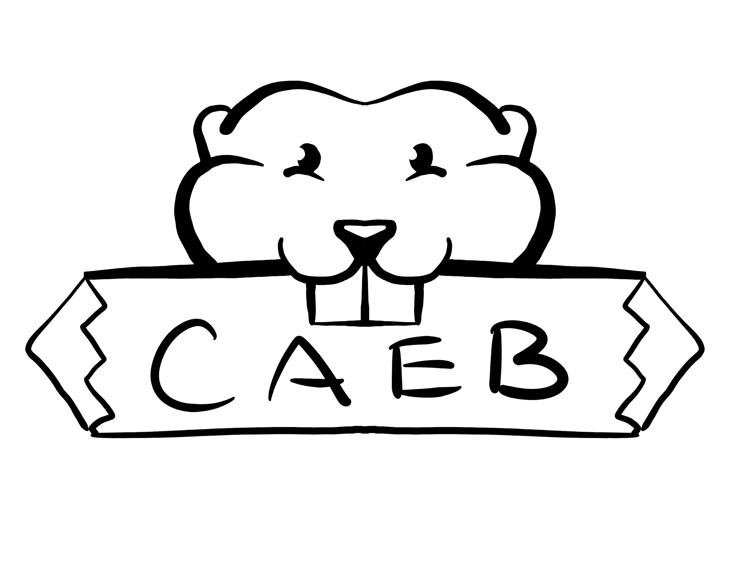
Club and Events Board
Meeting Agenda
September 26, 2023
ARC Student Center
10:30 am -12:00 pm

Posted by: Kimberly Bossman
ASB Club and Events Board President

“The purpose of the Clubs and Events Board is to coordinate events, serve, unify and represent all student organizations at American River College.”

NOTICE IS HEREBY GIVEN that the Associated Student Body Clubs and Events Board will hold a meeting on September 26, 2023. The location and meeting time is noted above. All Associated Student Body Clubs and Events Board meetings are held in locations that are wheelchair accessible. Other disability-related accommodations will be provided to persons with disabilities upon request. Persons requesting such accommodations should notify Clubs and Events Board facilitator Kimberly Bossman at kimberly.bossman.asbarc@gmail.com , no less than two days prior to the meeting. Efforts will be made to meet requests made after such date, if possible.

Indigenous Land Use Statement
We acknowledge the land which we occupy today as the traditional home of the
Nisenan, Maidu, and Miwok tribal nations. These sovereign people have been the
caretakers of this land since time immemorial. Despite centuries of genocide and
occupation the Nisenan, Maidu, and Miwok continue as vibrant and resilient tribes and
bands, both Federally recognized and unrecognized. We take this opportunity to
acknowledge the generations that have gone before as well as the present-day
Nisenan, Maidu, and Miwok people.

- Call to Order 1 minute

- Request for Remote Participation: 1 minute
The Student Senate will consider member requests for remote participation under the provisions of California Assembly Bill 2449.

- Roll Call 1 minute

- Adoption of the Agenda 5 minutes

- Approval of the Minutes 2 minutes

- Chair’s Message 5 minutes

- Advisor’s Message 5 minutes

- Public Comment 5 minutes
This time is reserved for members of the public to address the Clubs and Events Board on issues not already appearing on the agenda. A limit of two (2) minutes per speaker shall be observed, with a maximum of four (4) minutes per topic. No discussion is allotted on public comment. The law does not permit any action to be taken, nor extended discussion of any items not on the agenda. The ASB Clubs and Events Board may briefly respond to statements made for questions posed, however, for further information, please contact the ASB Clubs and Events Board President for the item of discussion to be placed on a future agenda (Brown Act §54954.3(b))

- Appointments/Swearing-In 5 Minutes
This time is reserved to discuss and vote on potentially filling the Vice President and the Historian positions.

- Approval of Club Charters
This time is reserved to discuss and potentially take action the approval of club charters submitted to the Center for Leadership and Development. Formal charters must follow the requirements set forth by the ASB Constitution and CAEB bylaws.
- International life
- Sociology
- Phi Theta Kappa-Beta Zeta Pi Chapter
- Muslim Student Association
- Psi Beta Honor Society/Psychology Club

- Unfinished Business 10 Minutes
11.1 Club Day
This time is reserved to discuss and potentially take action on any progress made on Club Day.

- New Business
12.1 Silent Disco Discussion 20 Minutes
This time is reserved to discuss potentially funding sage silent disco event.
12.2 Silent Disco F23-XX Bill
This time is reserved to discuss and potentially allocate up to $ () dollars to be used for planning an upcoming silent disco event
12.3 Committees for Upcoming Events
This time is reserved to discuss and potentially take action on forming committees for future events.

- Board Member Reports 10 Minutes
This time is reserved for board members to inform the board about relevant campus-wide events, and to report any pertinent committee activities. A time of three (3) minutes per report shall be observed.

- Student Club and Organization Reports 10 minutes
This time is reserved for recognized student clubs and organizations of the ASB Club and Events Board to inform board members about club activities, initiatives, or campus events. A time of (3) minutes per report shall be observed.

- Public Comment
This time is reserved for members of the public to address the Clubs and Events Board on issues not already appearing on the agenda. A limit of two (2) minutes per speaker shall be observed, with a maximum of four (4) minutes per topic. No discussion is allotted on public comment. The law does not permit any action to be taken, nor extended discussion of any items not on the agenda. The ASB Clubs and Events Board may briefly respond to statements made for questions posed, however, for further information, please contact the ASB Clubs and Events Board President for the item of discussion to be placed on a future agenda (Brown Act §54954.3(b))

- Adjournment

_____________________________________________ ________________________________________
Kimberly Bossman, Club and Events Board President Brett Sawyer, Advisor

