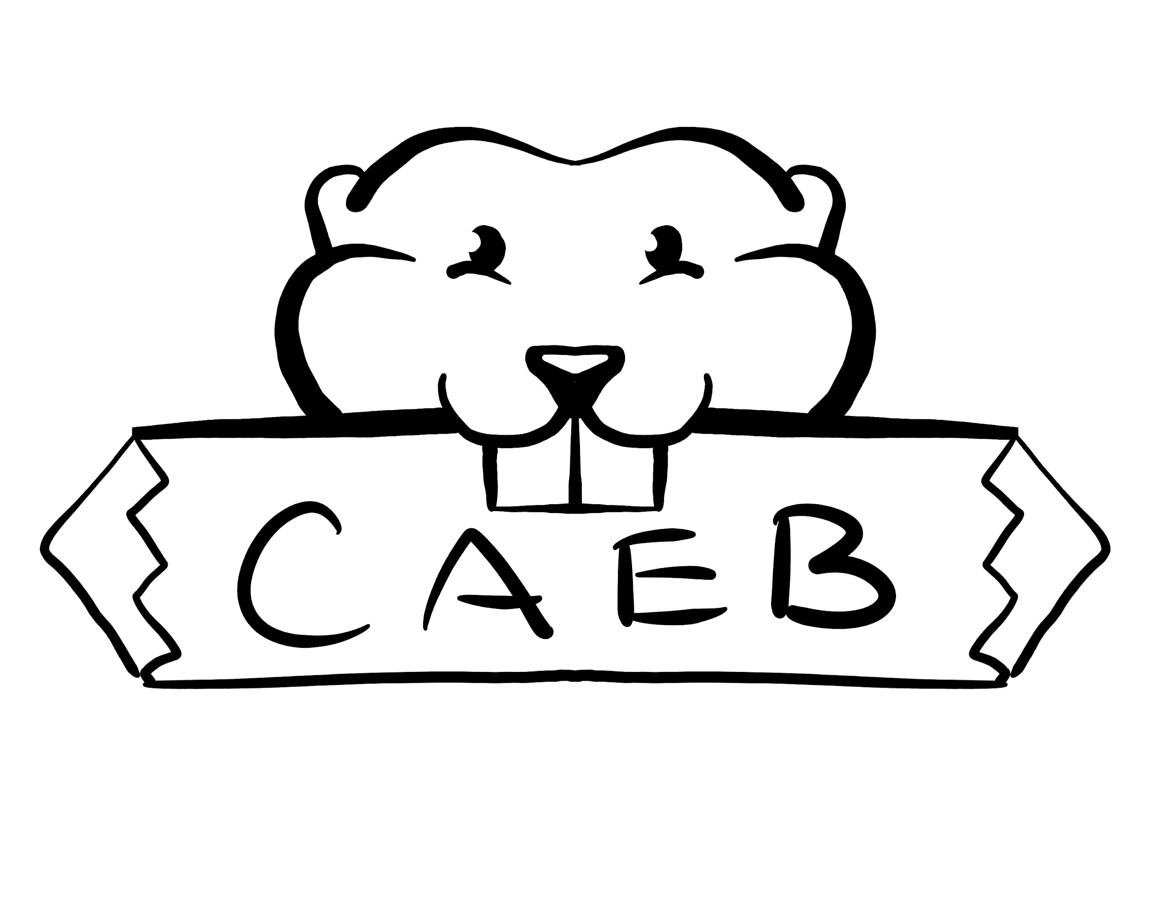
Meeting Minutes
Tuesday, February 7th, 2023
Student Center – Boardroom
10:30 am -12:00 pm

Zoom Meeting ID #392 800 2019
Password: ASBARC

Posted by: Kevin Hill
ASB Club and Events Board President

“The purpose of the Clubs and Events Board is to coordinate events, serve, unify and represent all student organizations at American River College.”

NOTICE IS HEREBY GIVEN that the Associated Student Body Clubs and Events Board will hold a meeting on Tuesday, February 7th, 2023. The location and meeting time is noted above. All Associated Student Body Clubs and Events Board meetings are held in locations that are wheelchair accessible. Other disability-related accommodations will be provided to persons with disabilities upon request. Persons requesting such accommodations should notify Clubs and Events Board facilitator Kevin Hill at k.hilljr.asbarc@gmail.com, no less than two days prior to the meeting. Efforts will be made to meet requests made after such date, if possible.

Indigenous Land Use Statement
We acknowledge the land which we occupy today as the traditional home of the
Nisenan, Maidu, and Miwok tribal nations. These sovereign people have been the
caretakers of this land since time immemorial. Despite centuries of genocide and
occupation the Nisenan, Maidu, and Miwok continue as vibrant and resilient tribes and
bands, both Federally recognized and unrecognized. We take this opportunity to
acknowledge the generations that have gone before as well as the present-day
Nisenan, Maidu, and Miwok people.

- Call to Order 10:31 AM

- Roll Call
- President Kevin Hill- Present
- VP Kimberly Bossman-Present
- Director of Activities Stephanie Zaragoza- Present
- Director of Public Relations Jay Doherty- Present
- Historian Venecia Zamora- Present
- Director of Finance Nika Radgoudarzi- Present
- Computer Science Club- Present
- GSA- Present
- Model UN- Present
- Director of Communications Joey Ayague-Fox- absent
- 6 of 7 executive members present, quorum has been met.

- Adoption of the Agenda Approved

- Approval of the Minutes- Jan 31, 2023 Approved

- Chair’s Message

- Welcome to Week 4!
- Oak Café is now open 10-2 PM
- Feb 28 is Club Day- looking for more clubs participation
- JBC approved CAEB and Senate 71 funds- more money for clubs
- Running for office Elections materials available March 6-30

- Advisor’s Message
- Aloha
- Lobby Day Feb 23rd
- Meeting Feb 14th will be Club Day ad hoc committee meeting instead of CAEB
- Strategic Planning at Senate Friday Feb 3rd meeting
- ARC President search extended into March- will impact impression panel dates.

- Public Comment
N/A

- Appointments/Swearing-In
  - Elections committee- Stephanie Zaragoza
  - Finance Committee
  - Public Relations Committee
  - Activities committee

- Approval of Club Charters
N/A

- Unfinished Business
  - Club Day February
    - This time is reserved to discuss and potentially take action on the planning of a Club Day in February.
- Colors will be Pink, Red, Brown, White
- Created Google Form for clubs
- 1-4 PM
- In conjunction with Senate sponsored event.
- New Business N/A
- Board Member Reports

- Director of Activities Zaragoza- AES Mentor relationship program w/Dual Enrollment Students at Highlands HS.
- Computer Science Club- Prof Hartley working with club on Robotics in Design Hub. Had meeting last week to get access to the club.
- Take a Hike- Meeting last week, hike this week.

- Public Comment
N/A

- Adjournment- 11:08 AM

_____________________________________________ ________________________________________
Kevin Hill, Club and Events Board President Brett Sawyer, Advisor

