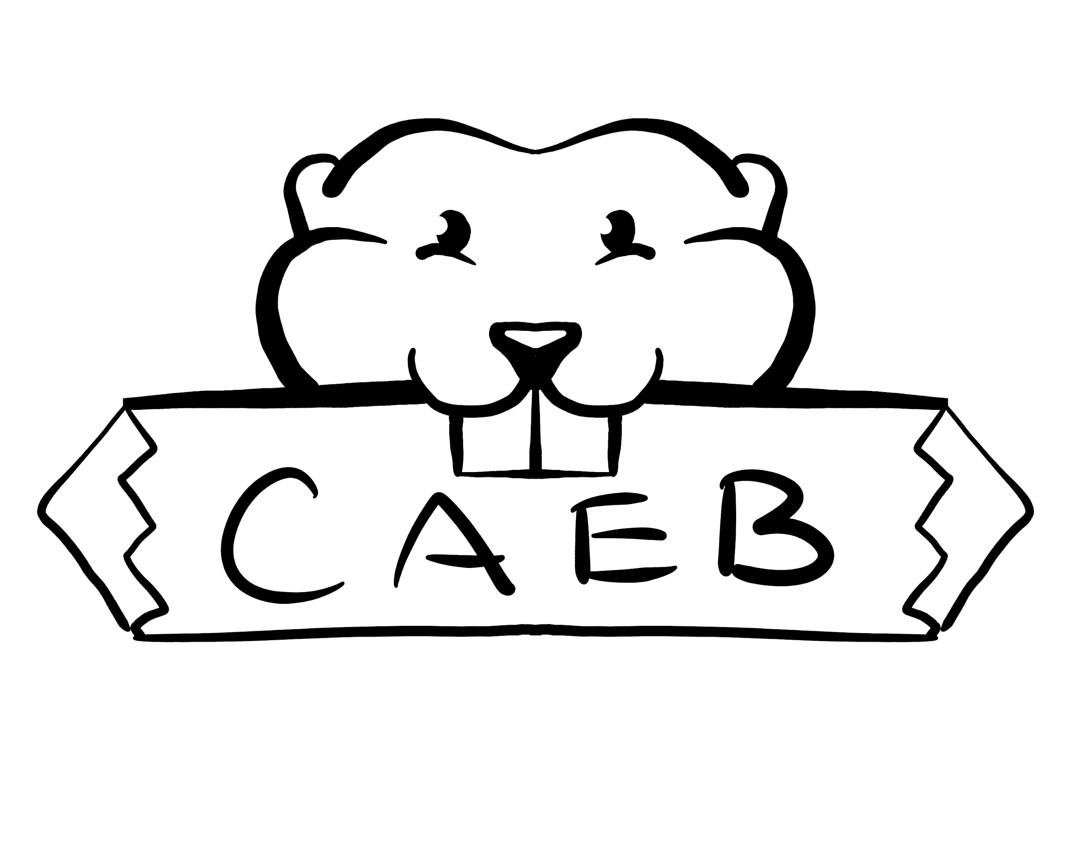
Club Day Committee Meeting Agenda
Tuesday, February 14th, 2023
CLD- Club Room
10:30am-12pm

Posted by: Kevin Hill, Club and Events Board President

“The purpose of the Clubs and Events Board is to coordinate events, serve, unify and represent all student organizations at American River College.”

NOTICE IS HEREBY GIVEN that the Associated Student Body Clubs and Events Board will hold a meeting on Tuesday, February 14th, 2023. The location and meeting time is noted above. All Associated Student Body Clubs and Events Board meetings are held in locations that are wheelchair accessible. Other disability-related accommodations will be provided to persons with disabilities upon request. People requesting such accommodations should notify Clubs and Events Board facilitator Kevin Hill at k.hilljr.asbarc@gmail.com, no less than two days prior to the meeting. Efforts will be made to meet requests made after such date, if possible.

- Call to Order 1 minute

- Roll Call 1 minute

- Adoption of the Agenda 2 minutes

- Approval of the Minutes 2 minutes

- Public Comment 5 minutes
This time is reserved for members of the public to address the Clubs and Events Board on issues not already appearing on the agenda. A limit of thtwo (2) minutes per speaker shall be observed, with a maximum of four (4) minutes per topic. No discussion is allotted on public comment. The law does not permit any action to be taken, nor extended discussion of any items not on the agenda. The ASB Clubs and Events Board may briefly respond to statements made for questions posed, however, for further information, please contact the ASB Clubs and Events Board President for the item of discussion to be placed on a future agenda (Brown Act §54954.3(b))

- Unfinished Business 80 Minutes
  - Club Day Theme Decorations
  - Club Day Layout
  - Set-Up Web and Physical Table Sign-Up Sheet
  - Expenditures

- New Business

- Adjournment

_____________________________________________ ________________________________________
Kevin Hill, Club and Events Board President Brett Sawyer, Advisor

