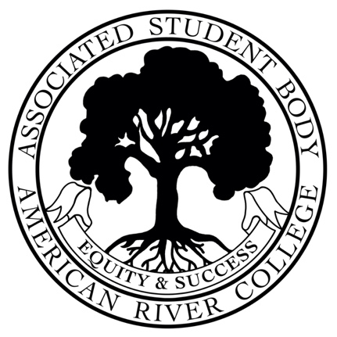
ASSOCIATED STUDENT BODY
Student Senate
Meeting Minutes
Friday, September 23, 2022
https://us02web.zoom.us/j/83626445463?pwd=ASBARC
Zoom ID: 836-2644-5463 Password: ASBARC
10:30am-12:00pm PDT
Posted by: ,ASB Senate Board

NOTICE IS HEREBY GIVEN that the Associated Student Body Senate will hold a meeting on Friday September 23, 2022. The location and meeting time is noted above. All Associated Student Body Senate meetings are held in locations that are wheelchair accessible. Other disability-related accommodations will be provided to persons with disabilities upon request. Persons requesting such accommodations should notify ASB Advisor Brett Sawyer at Sawyerb@arc.losrios.edu no less than two days prior to the meeting. Efforts will be made to meet requests made after such date, if possible.
Indigenous Land Use Statement
We acknowledge the land which we occupy today as the traditional home of the Nisenan, Maidu, and Miwok tribal nations. These sovereign people have been the caretakers of this land since time immemorial. Despite centuries of genocide and occupation the Nisenan, Maidu, and Miwok continue as vibrant and resilient tribes and bands, both Federally recognized and unrecognized. We take this opportunity to acknowledge the generations that have gone before as well as the present-day Nisenan, Maidu, and Miwok people.

I. Call to Order 10:30 AM
II. Roll Call
- Acting chair, CAEB Representative Kevin Hill- present
- VP Warda Ali- present
- Senator Sarah Reade- present
- Senator Molly Nealon- present
III. Adoption of the Agenda adopted
IV. Approval of the Minutes – September 9, 2022 adopted

V. Chair’s Message
- Good morning
- Hoping to see a larger presence on ground for both CAEB and Senate members
- Please help promote campus events, activities
- Hope to see you in the ASB office soon
VI. Advisor’s Message
- Aloha
- Senate President Nugent resignation- wish her well and thank you for all her hard work.
- Club Rush event on 9/20 was a great event, great turnout
- New Club Room is open and available for club use
- Transfer Day on Wednesday 9/28
- Thank you Rod Agbunag, ARC counselor who is leaving for a new position at SCC.
VII. Public Comment
- Eva Blankenship- still interested in joining Senate as Director of Finance. ASB will contact her shortly.
VIII. Appointments/Swearing-In

Operations Council- CAEB VP Kimberly Bossman- appointed
Discipline Committee- Ethan Kruithof, Kevin Hill and John Doherty- appointed
Student Success Council- N/A
Textbook Affordability Committee -N/A

IX. Unfinished Business
N/A
X. New Business

10.1 SSCCC Presentation 15 minutes
Student Senate of California Community Colleges (SSCCC) Representative Stephen Kodur will discuss the advocacy efforts of SSCCC at the regional and state level.

- Ballot Bowl update
- Interest in joining SSCCC
- Student Rep Fee and where it goes at SSCCC
- General Assembly March 31- April 2 in Long Beach, CA.

10.2 Bill F22-05 ASB and ARC Athletics Advocacy Collaboration 15 minutes
Student Senate will discuss and potentially take action on Bill F22-05 to allocate up to ten thousand dollars ($10,000) on a collaboration of ASB and ARC Athletics.

VP Ali- Yes
Sen Reade- Yes
Sen Nealon- Yes

Bill F22-05 passes unanimously, 3-0.

10.3 Adoption of Findings Related to Public Meetings Pursuant to AB 361 3 minutes
Student Senate will discuss and take action upon AB 361 compliance along with the Brown Act.

AB 361 allows local legislative bodies to conduct virtual meetings during a state of emergency proclaimed by the Governor under certain conditions, including when “state or local officials have imposed or recommended measures to promote social distancing," or...a determination has been made "that meeting in person would present imminent risks to the health or safety of attendees as a result of the state of emergency."

Board approves- will revisit in October per AB 361.
XI. Committee Reports
- Executive Leadership Team (ELT)
  - Accreditation report coming up, visit will be October 10-12 at ARC main campus.
- Student Advisory Council (SAC)
  - Dual Enrollment presentation with Sean O’Neill and Jason Ralphs
  - Mental Health presentation with Dr. Chase Moore
  - Lobby Day topics at October meeting
  - ARC will present to Board of Trustees at Oct 19th meeting
- Homebase Resource Panel
  - Sen Nealon would like to recognize hard work of the panel- they have students’ best interests at heart.
XII. Board Member Reports/Announcements
- Senator Reade- will help in publicizing Club Rush and other ASB events
- CAEB Representative Hill- Joint Budget Committee coming up soon

XIII. Public Comment
N/A
XIV. Adjournment -11:47 AM
ASB Senate Brett Sawyer Advisor

