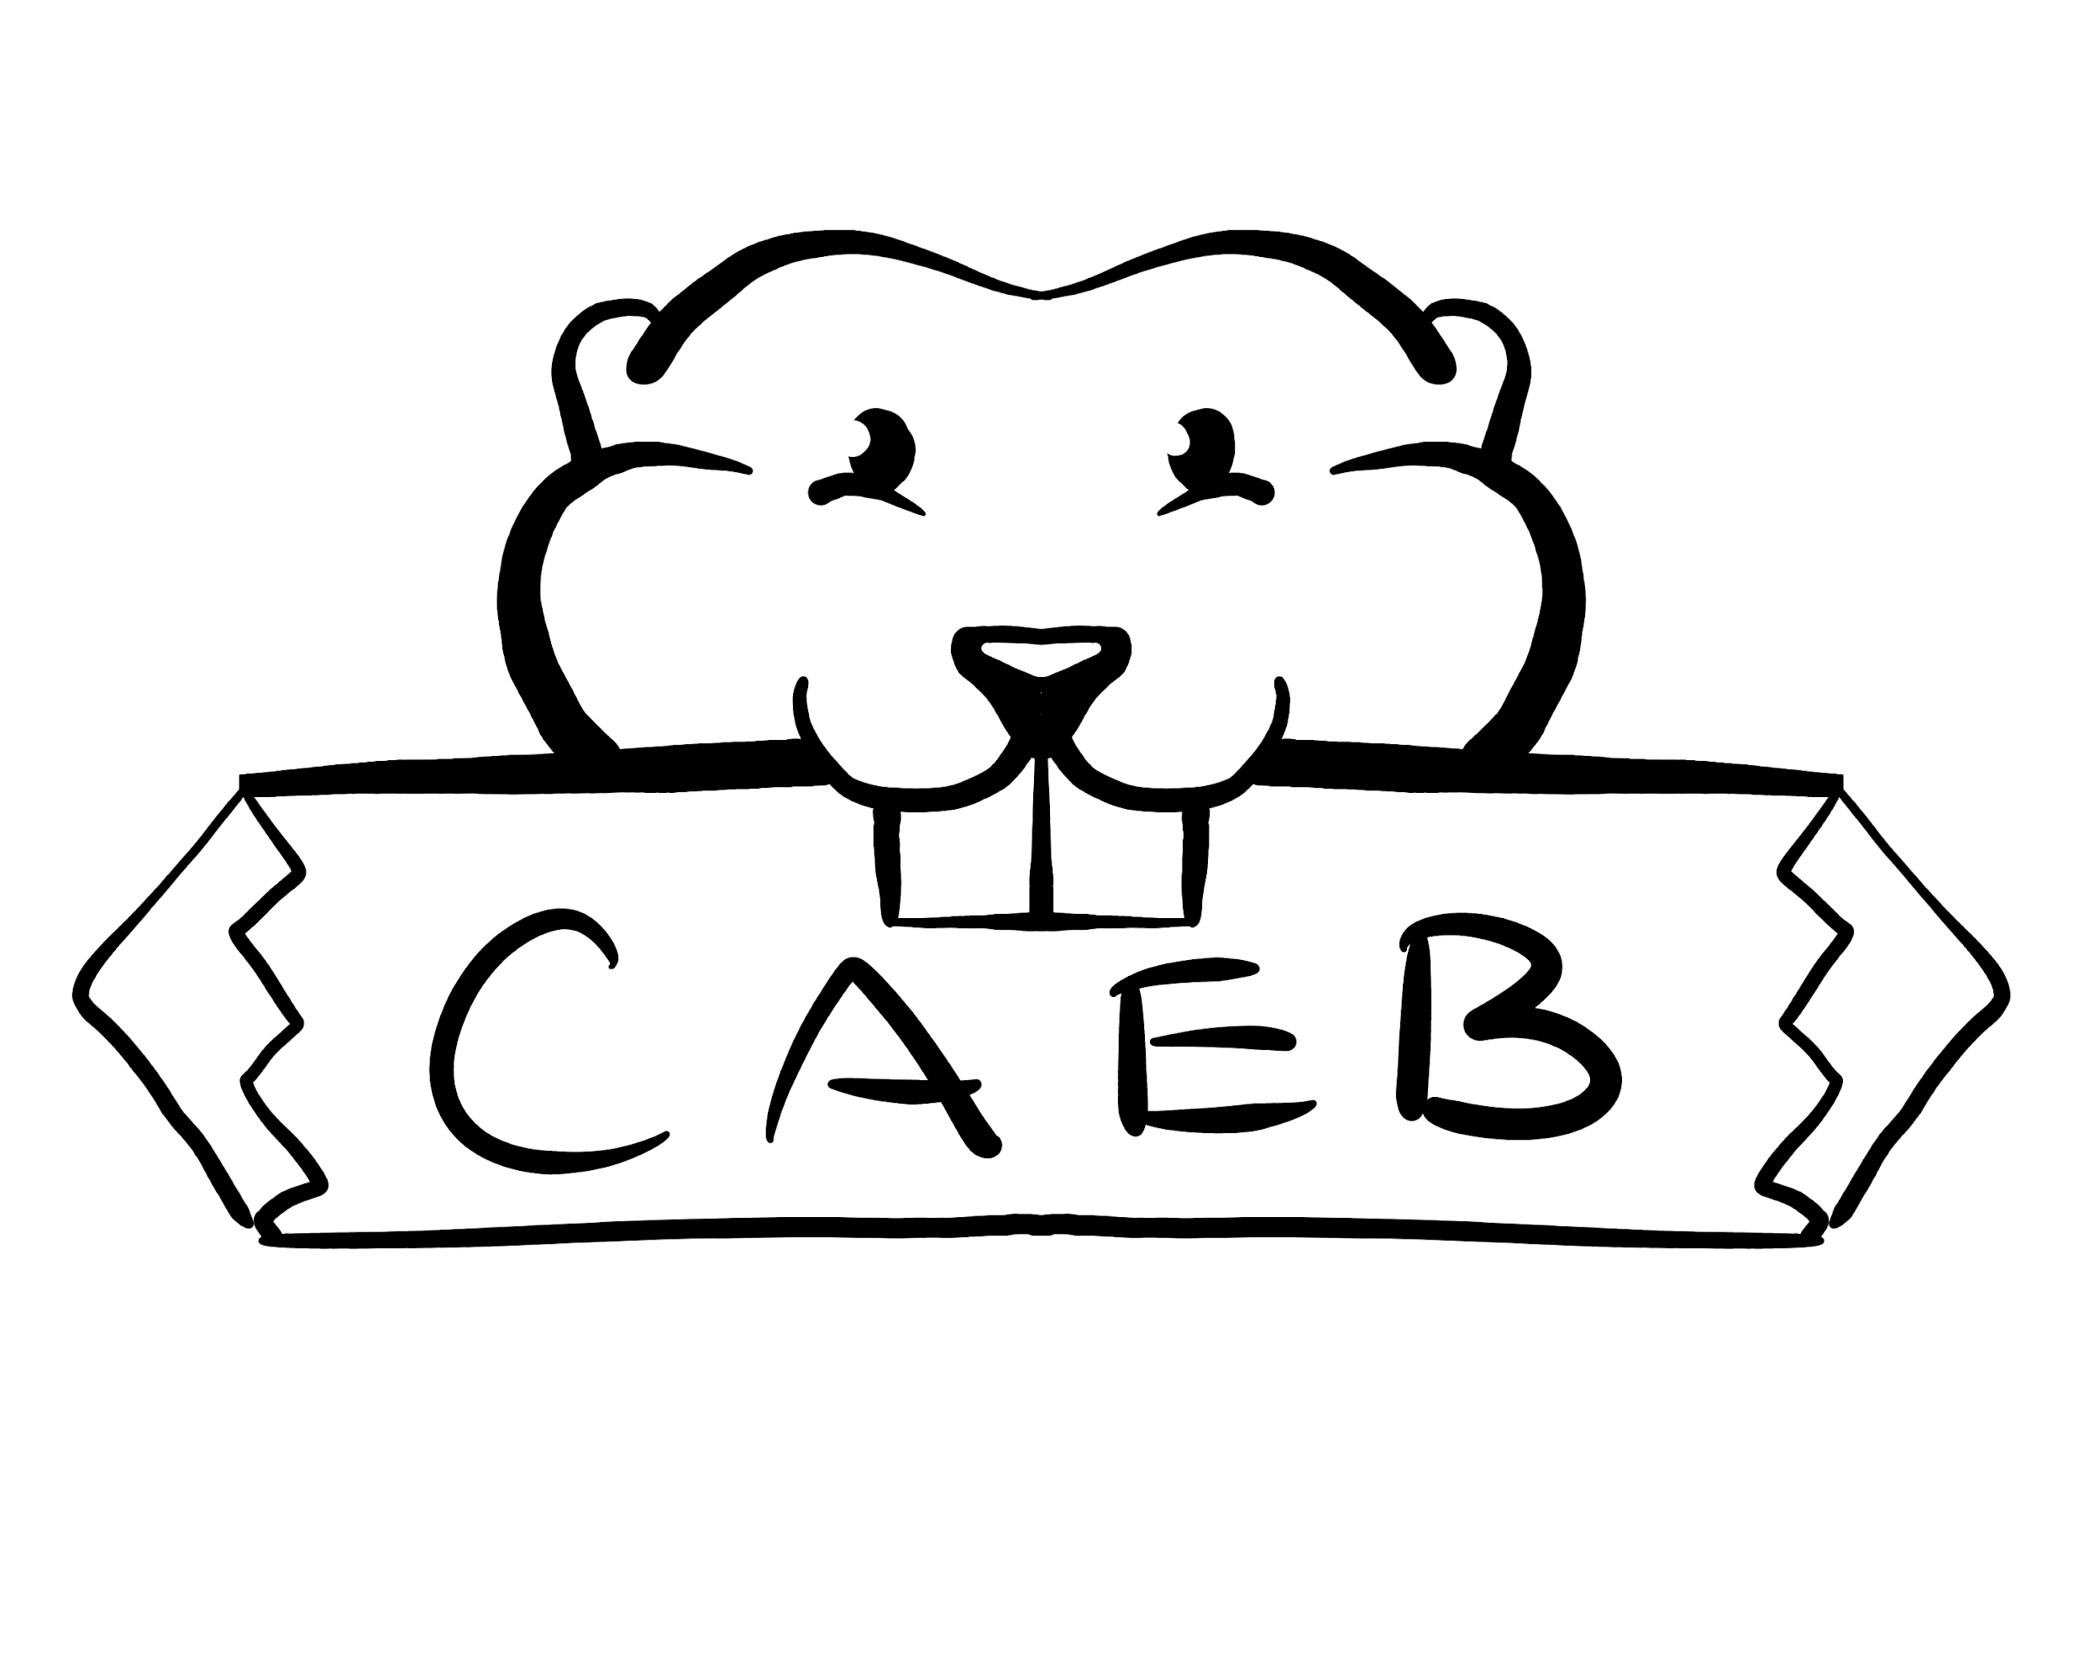
Meeting Minutes
Tuesday, September 13th, 2022
Student Center – Boardroom
10:30 am -12:00 pm

Posted by: Kevin Hill
ASB Club and Events Board President

“The purpose of the Clubs and Events Board is to coordinate events, serve, unify and represent all student organizations at American River College.”

NOTICE IS HEREBY GIVEN that the Associated Student Body Clubs and Events Board will hold a meeting on Tuesday, September 13th, 2022. The location and meeting time is noted above. All Associated Student Body Clubs and Events Board meetings are held in locations that are wheelchair accessible. Other disability-related accommodations will be provided to persons with disabilities upon request. Persons requesting such accommodations should notify Clubs and Events Board facilitator Kevin Hill at k.hilljr.asbarc@gmail.com, no less than two days prior to the meeting. Efforts will be made to meet requests made after such date, if possible.

Indigenous Land Use Statement
We acknowledge the land which we occupy today as the traditional home of the
Nisenan, Maidu, and Miwok tribal nations. These sovereign people have been the
caretakers of this land since time immemorial. Despite centuries of genocide and
occupation the Nisenan, Maidu, and Miwok continue as vibrant and resilient tribes and
bands, both Federally recognized and unrecognized. We take this opportunity to
acknowledge the generations that have gone before as well as the present-day
Nisenan, Maidu, and Miwok people.

- Call to Order 10:30 AM, recess until 10:35 AM, call to order 10:35 AM

- Roll Call

CAEB President Kevin Hill- present
CAEB Vice President Kimberly Bossman- present
CAEB Director of Activities Stephanie Zaragoza- present
Director of Media Relations Ethan Crowell- present
Director of Finance Nika Radgoudarzi- present
CAEB Historian Venecia Zamora- present

6 of 6, quorum was met.

Student Clubs present:

American Medical Student Association- present
Take a Hike- present
ARC Honors club- absent
American River Student Nurses Association- absent

- Adoption of the Agenda Adopted

- Approval of the Minutes- September 6, 2022 Adopted

- Chair’s Message

- CAEB meetings will move to every Tuesday at 10:30 AM
- Constitution Day on Thursday Sept 15 from 11-1 PM
- VP Kimberly Bossman will be appointed to ARC Operations Council (pending Senate approval)
- Jay Doherty appointed to Director of Public Relations!

- Advisor’s Message
- Constitution Day
- Club Rush on Tuesday Sept 20, 12-2 PM
- Food options coming soon to Cafeteria
- Welcome to new clubs!

- Public Comment
N/A

- Appointments/Swearing-In
VP Bossman- Operations Council
Director of Public Relations- Jay Doherty
- Approval of Club Charters
Clubs officially approved:
ARC Sociology Club
ARC Progressive Democrats Club
ARC International Life
Phi Theta Kappa Honor Society (Beta Zeta Pi Chapter)
Future Educators Club

- Unfinished Business
  - September Club Rush
Update from Chair Zaragoza:
- Flyer created, sent to clubs and faculty advisors
- Only 3 clubs have responded so far
- Flyers have the QR codes to register for event
- New Business 35 Minutes
  - Constitution Day
Plans for Constitution Day discussed
Cake purchased, balloons ordered

  - Club Day: October
Ideas for October Club Rush were discussed. Themes, potential dates.
VP Bossman will chair October Club Rush committee, and report back at September 27th meeting.
- Board Member Reports 10 Minutes
AMSA
  - meet every Friday at 11 AM in STEM Center.
  - Looking to have more guest speakers, and educate on better study habits.
  - Currently selling googles for Lab courses.

Take a Hike
- Have a discord channel
- Great American River Cleanup Saturday Sept 17th. Riverbend Park

ELLIS Club (unchartered)
- Works and supports Immigrant students
- Working on outreach at adult schools in the community

CAEB Director of Media Relations Crowell
- Working with advisor on Social Media Access
- Reach out for help if clubs want to promote on Social Media

CAEB VP Bossman
- Working on a Spirit Week in October
- Need help with Food for all events, will be inviting VPA Vang to future meeting

CAEB President Hill
- Executive Leadership Team updates:
  - Plans to get students back on campus
  - Working on food for Cafeteria (coffee, pizza, sandwiches etc)
  - Push for more students to at least take hybrid classes so they are back on campus

- Public Comment
N/A

- Adjournment- 11:12 AM

_____________________________________________ ________________________________________
Kevin Hill, Club and Events Board President Pro-Tem Brett Sawyer, Advisor

