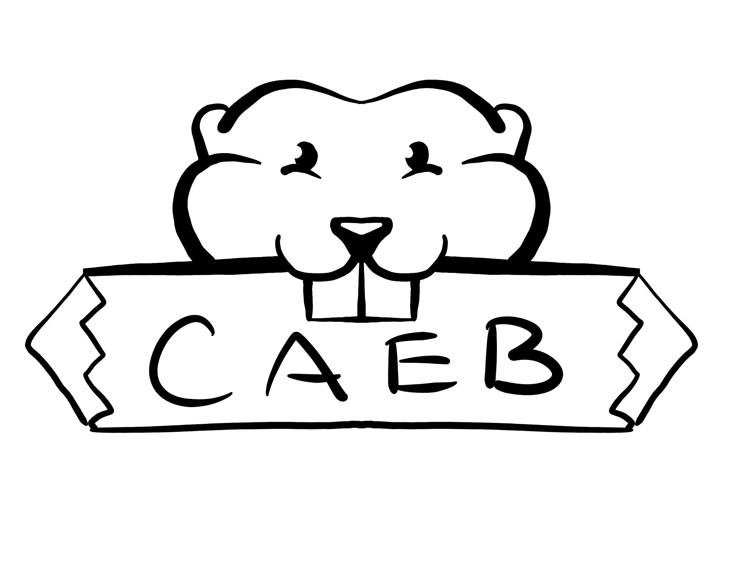
Meeting Agenda
Tuesday, September 20th, 2022
Student Center – Boardroom
10:30 am -12:00 pm

Zoom Meeting ID #392 800 2019
Password: ASBARC

Posted by: Kevin Hill
ASB Club and Events Board President

“The purpose of the Clubs and Events Board is to coordinate events, serve, unify and represent all student organizations at American River College.”

NOTICE IS HEREBY GIVEN that the Associated Student Body Clubs and Events Board will hold a meeting on Tuesday, September 20th, 2022. The location and meeting time is noted above. All Associated Student Body Clubs and Events Board meetings are held in locations that are wheelchair accessible. Other disability-related accommodations will be provided to persons with disabilities upon request. Persons requesting such accommodations should notify Clubs and Events Board facilitator Kevin Hill at k.hilljr.asbarc@gmail.com, no less than two days prior to the meeting. Efforts will be made to meet requests made after such date, if possible.

Indigenous Land Use Statement
We acknowledge the land which we occupy today as the traditional home of the
Nisenan, Maidu, and Miwok tribal nations. These sovereign people have been the
caretakers of this land since time immemorial. Despite centuries of genocide and
occupation the Nisenan, Maidu, and Miwok continue as vibrant and resilient tribes and
bands, both Federally recognized and unrecognized. We take this opportunity to
acknowledge the generations that have gone before as well as the present-day
Nisenan, Maidu, and Miwok people.

- Call to Order 1 minute

- Roll Call 1 minute

- Adoption of the Agenda 5 minutes

- Approval of the Minutes 2 minutes

- Chair’s Message 5 minutes

- Advisor’s Message 5 minutes

- Public Comment 5 minutes
This time is reserved for members of the public to address the Clubs and Events Board on issues not already appearing on the agenda. A limit of two (2) minutes per speaker shall be observed, with a maximum of four (4) minutes per topic. No discussion is allotted on public comment. The law does not permit any action to be taken, nor extended discussion of any items not on the agenda. The ASB Clubs and Events Board may briefly respond to statements made for questions posed, however, for further information, please contact the ASB Clubs and Events Board President for the item of discussion to be placed on a future agenda (Brown Act §54954.3(b))

- Appointments/Swearing-In 5 Minutes
-PG Committees

- Approval of Club Charters
This time is reserved to discuss and potentially take action the approval of club charters submitted to the Center for Leadership and Development.

- Unfinished Business 15 Minutes
  - September Club Rush
This time is reserved to discuss and potentially take action on the progress report provided by DoA Stephanie Zaragoza.
- New Business 35 Minutes
  - CAEB Bill F22-01: Fall Club Days Supplies Bill
This time is reserved to discuss and potentially take action on CAEB Bill F22-01.
  - Athletics Spirit Week
This time is reserved to discuss and potentially take action on a spirit week event for the week of 10/17-10/21, leading up to last home games of the year for our fall sports
  - Club Point Allocation System
This time is reserved to discuss and potentially take action on the adoption of a club point allocation system.
- Board Member Reports 10 Minutes
This time is reserved for board members to inform the board about relevant campus-wide events, and to report any pertinent committee activities. A time of three (3) minutes per report shall be observed.

- Public Comment
This time is reserved for members of the public to address the Clubs and Events Board on issues not already appearing on the agenda. A limit of two (2) minutes per speaker shall be observed, with a maximum of four (4) minutes per topic. No discussion is allotted on public comment. The law does not permit any action to be taken, nor extended discussion of any items not on the agenda. The ASB Clubs and Events Board may briefly respond to statements made for questions posed, however, for further information, please contact the ASB Clubs and Events Board President for the item of discussion to be placed on a future agenda (Brown Act §54954.3(b))

- Adjournment

_____________________________________________ ________________________________________
Kevin Hill, Club and Events Board President Pro-Tem Brett Sawyer, Advisor

