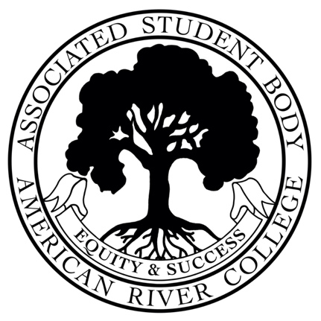
ASSOCIATED STUDENT BODY
Student Senate
Meeting Minutes
Friday, August 26, 2022
https://us02web.zoom.us/j/83626445463?pwd=ASBARC
Zoom ID: 836-2644-5463 Password: ASBARC
10:30am-12:00pm PDT
Posted by: Nicole Nugent, ASB Senate President

NOTICE IS HEREBY GIVEN that the Associated Student Body Senate will hold a meeting on Friday, August 26, 2022. The location and meeting time are noted above. All Associated Student Body Senate meetings are held in locations that are wheelchair accessible. Other disability-related accommodations will be provided to persons with disabilities upon request. Persons requesting such accommodations should notify ASB Senate President Nicole Nugent at Nicole.Nugent.asbarc@gmail.com no less than two days prior to the meeting. Efforts will be made to meet requests made after such date, if possible.
Indigenous Land Use Statement
We acknowledge the land which we occupy today as the traditional home of the Nisenan, Maidu, and Miwok tribal nations. These sovereign people have been the caretakers of this land since time immemorial. Despite centuries of genocide and occupation the Nisenan, Maidu, and Miwok continue as vibrant and resilient tribes and bands, both Federally recognized and unrecognized. We take this opportunity to acknowledge the generations that have gone before as well as the present-day Nisenan, Maidu, and Miwok people.

I. Call to Order 10:31 AM
II. Roll Call
President Nicole Nugent- Present
Vice President Warda Ali- Present
Senator Sarah Reade- Present
Senator Molly Nealon- Present
CAEB Representative Kevin Hill- Present
Senator Trevor Middleton- absent, dismissed (did not attend Orientation)
Senator Esa Safi- absent, dismissed (did not attend Orientation)
Senator Jasmine Gonzales- resigned

5 of 5 members present, quorum has been met.
III. Adoption of the Agenda Adopted with no objections
IV. Approval of the Minutes August 9, 2022 Adopted with no objections

V. Chair’s Message
- Welcome to ASB!
- Great to see students on ground during Week of Welcome
- Help with committees, need members or appointees to serve
VI. Advisor’s Message
- Aloha!
- Student Advisory Council meeting Sept 7th, Los Rios Board of Trustees meeting September 14th
- WOW updates and thank you for those able to attend and participate
- New Dean of Student Services Hannah Blodgett, will begin full time on Tuesday Sept 6
- Food updates, 5 drips coffee is now hiring, hope to open in September
- Make sure to set up your office hour

VII. Public Comment
N/A
VIII. Appointments/Swearing-In
Discipline Appeals Panel Student Appointment-Molly Nealon

IX. Unfinished Business
X. New Business 30 minutes

10.1 CCCSAA Student Leadership Conference Funding

Bill F22-02 will provide funding of up to twenty thousand dollars ($20,000) to fund the 2022 CCCSAA Student Leadership Conference in San Diego, CA (Oct 21-23).

Vice President Warda Ali- Yes
Senator Sarah Reade- Yes
Senator Molly Nealon- Yes
CAEB Representative Kevin Hill- Yes

Bill F22-02 passes 4-0
10.2 Associated Student Body Senate & CAEB Members Funding

Bill F22-03 will provide funding of up to ten thousand dollars ($10,000) to provide office supplies, board uniforms, and laptops for hybrid/virtual duties of the Associated Student Body.

Vice President Warda Ali- Yes
Senator Sarah Reade- Yes
Senator Molly Nealon- Yes
CAEB Representative Kevin Hill- Yes
Bill F22-03 passes 4-0

XI. Committee Reports
Senator Nealon, Homebase Committee- Homebases much more visible this year on ground. Meetings resume in September.
XII. Board Member Reports/Announcements
CAEB Rep Kevin Hill
- CAEB 1st meeting on Tuesday August 30 on ground in ARC Board Room
- Nachos during WOW week were great
- CAEB working on hybrid options

Senator Molly Nealon
- Reactivating ARC Honors Club, Professor Michael Crowder is Faculty Advisor, promoting on Instagram. Club hopes to increase students participation in Honors classes and receiving honors certificates

Senator Sarah Reade
- Ice Cream Event was good, nice to see folks
- Many students were hesitant to approach the table
- Will participate in more ASB training, work on ASB elevator pitch

XIII. Public Comment
ARC Current Reporter- Where to find agendas?
- On IGOR https://igor.arc.losrios.edu/Document
- On Instagram- @asb_arc
XIV. Adjournment – 11:19 AM
Nicole Nugent ASB Senate President Brett Sawyer Advisor

