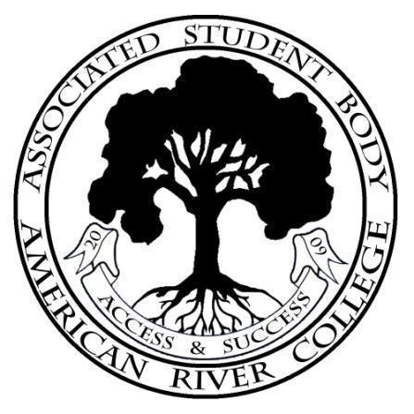
ASSOCIATED STUDENT BODY
Student Senate
Meeting Agenda
Friday, February 11, 2022
https://us02web.zoom.us/j/83626445463?pwd=ASBARC
Zoom ID: 836-2644-5463 Password: ASBARC
10:30am-12:00pm PDT
Posted by : Stacey Burrows, ASB Senate President
NOTICE IS HEREBY GIVEN that the Associated Student Body Senate will hold a meeting on Friday, February 11 2022. The location and meeting time is noted above. All Associated Student Body Senate meetings are held in locations that are wheelchair accessible. Other disability-related accommodations will be provided to persons with disabilities upon request. Persons requesting such accommodations should notify ASB Senate President Stacey Burrows at sburrows.asbarc@gmail.com, no less than two days prior to the meeting. Efforts will be made to meet requests made after such date, if possible.
Indigenous Land Use Statement
We acknowledge the land which we occupy today as the traditional home of the Nisenan, Maidu, and Miwok tribal nations. These sovereign people have been the caretakers of this land since time immemorial. Despite centuries of genocide and occupation the Nisenan, Maidu, and Miwok continue as vibrant and resilient tribes and bands, both Federally recognized and unrecognized. We take this opportunity to acknowledge the generations that have gone before as well as the present-day Nisenan, Maidu, and Miwok people.
I. Call to Order 1 minute
II. Roll Call 1 minute
III. Adoption of the Agenda 1 minute
IV. Approval of the Minutes 1 minute

V. Chair’s Message 5 minutes
VI. Advisor’s Message 5 minutes
VII. Public Comment 5 minutes
This time is reserved for members of the public to address ASB Senate on issues not already appearing on the agenda. A limit of two (2) minutes per speaker shall be observed, with a maximum of four (4) minutes per topic. No discussion is allotted on public comment. The law does not permit any action to be taken, nor extended discussion of any items not on the agenda. The ASB Senate may briefly respond to statements made for questions posed, however, for further information, please contact the ASB Senate President for the item of discussion to be placed on a future agenda. (Brown Act §54954.3(b))
VIII. Appointments/Swearing-In 5 minutes
This time will be reserved for the appointment and swearing-in of current members to ASB Senate and/or committees.
IX. Unfinished Business 0 minutes

X. New Business
10.1 HomeBase Student Feedback 15 minutes
ASB Senate Legislative Analyst Angela Velarde-Burch will lead a discussion pertaining to a recent agenda item from the Student Success Council.

10.2 SSCCC DSPS Community Resolution Sponsorship 15 minutes
Sacramento City College student Olivia Garcia-Godos Martinez and Sierra College student Ruby Chavez are seeking sponsorship from student body associations within the LRCCD for a SSCCC General Assembly resolution in support of community college students with disabilities.
XI. Committee Reports 0 minutes
This time is reserved for committee chairs to provide the board with a brief report on the current standing of active committees.
XII. Board Member Reports/Announcements 5 minutes
This time is reserved for board members to inform the board about relevant campus-wide events, and to report any pertinent committee progress/activities. A time of three (3) minutes per report shall be observed.
XIII. Public Comment
This time is reserved for members of the public to address the ASB Senate on issues not already appearing on the agenda. A limit of two (2) minutes per speaker shall be observed, with a maximum of four (4) minutes per topic. No discussion is allotted on public comment. The law does not permit any action to be taken, nor extended discussion of any items not on the agenda. The ASB Senate may briefly respond to statements made for questions posed, however, for further information, please contact the ASB Senate President for the item of discussion to be placed on a future agenda. (Brown Act §54954.3(b))
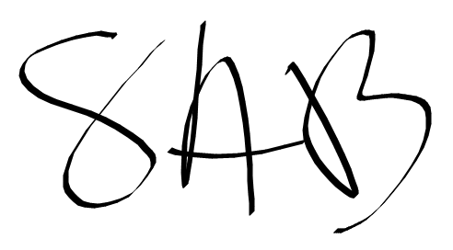
XIV. Adjournment
ASB Senate President Brett Sawyer Advisor

