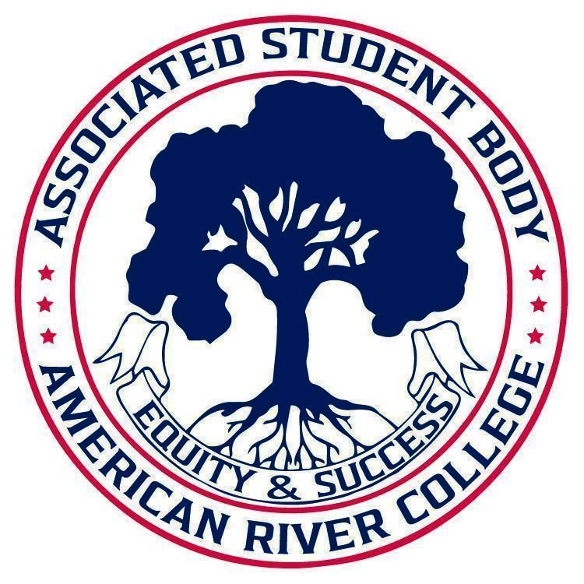
ASSOCIATED STUDENT BODY
Student Senate
Meeting Minutes
Aug 29, 2025
Location: Board Room
10:30 AM-12:00 PM PDT
Posted by : Soraya Amin, Student Senate President

NOTICE IS HEREBY GIVEN that the Associated Student Body Senate will hold a meeting on August 29, 2025 The location and meeting time is noted above. All Associated Student Body Senate meetings are held in locations that are wheelchair accessible. Other disability-related accommodations will be provided to persons with disabilities upon request. Persons requesting such accommodations should notify ASB Senate President Soraya Amin at sorayaamin.asbarc@gmail.com no less than two days prior to the meeting. Efforts will be made to meet requests made after such date, if possible.
Indigenous Land Use Statement
We acknowledge the land which we occupy today as the traditional home of the Nisenan, Maidu, and Miwok tribal nations. These sovereign people have been the caretakers of this land since time immemorial. Despite centuries of genocide and occupation the Nisenan, Maidu, and Miwok continue as vibrant and resilient tribes and bands, both Federally recognized and unrecognized. We take this opportunity to acknowledge the generations that have gone before as well as the present-day Nisenan, Maidu, and Miwok people.

I. Call to Order 10:31 AM

II. Request for Remote Participation:
The Student Senate will consider member requests for remote participation under the provisions of California Assembly Bill 2449.

N/A
III. Roll Call
President Amin | Present
Vice-President Garcia | Present
Director of Legislative Affairs Kim | Present
Director of Public Relations Amini | Present
Legislative Analyst Karachev | Present
Senator Galvez | Present
Senator Limon | Present
Senator Smith | Absent
Senator Ratz | Present
Senator Kralya | Present
Senator Kamara | Absent
Senator Chen | Present
Director of Finance Bourez | Present
CAEB Representative | Present

12 of 14 members present, quorum has been met.

IV. Adoption of the Agenda Approved
V. Approval of the Minutes Approved

VI. Chair’s Message
- Good morning! Happy first week of the fall semester
- Gave a speech at Fall Convocation and was a part of AI Faculty Panel
- Looking forward to more members joining the board
VII. Advisor’s Message
- Aloha! Hope the first week went well for everyone!
- Saw President Amin give speech at Fall Convocation via Zoom
- Thanked the members of the board for their help in participating in the Week of Welcome event
- Chancellor hiring committee is looking for 1 to 2 students to participate in the hiring process
- Student Trustee Brianna Pham has asked for 1 to 2 students to take a form of student hiring training prior to joining committee
- Enrollment is up and there is a possibility of student representation fees increasing in the near future.
- CCCSSAA registration is complete
- Student Conduct Office has been renamed to the Student Advocacy and Accountability Office
VIII. Public Comment
This time is reserved for members of the public to address ASB Senate on issues not already appearing on the agenda. A limit of two (2) minutes per speaker shall be observed, with a maximum of four (4) minutes per topic. No discussion is allotted on public comment. The law does not permit any action to be taken, nor extended discussion of any items not on the agenda. The ASB Senate may briefly respond to statements made for questions posed, however, for further information, please contact the ASB Senate President for the item of discussion to be placed on a future agenda. (Brown Act §54954.3(b))

● Audience Member #1: What trips does ASB offer to students? I’m curious because I might be interested in joining.
IX. Appointments/Swearing-In
This time will be reserved for the appointment and swearing-in of current members to ASB Senate and/or committees.
April Starr - Institutional Effectiveness Council
Sapeidah Saeedi - SSCCC Delegate
Alina Kralya - Director of Communications
Ramses Galvez - Undocuscholar Advisory Group

X. Unfinished Business

N/A
XI. New Business 20 minutes

- 11.1 Student Equity Plan Discussion
This time is reserved for the Student Equity Plan (SEP) presentation by Angela Milano and Dr. David Miramontes-Quiñones, a statewide effort focused on closing equity gaps, advancing racial equity, and improving student outcomes.
- Moved by DoA Saeedi, 2nd by CAEB Rep Hafiz

- Dr. David Miramontes-Quiñonescame in and did a presentation.

- 11.2 Food Accessibility On Campus
This time is reserved to discuss forming a Food Accessibility Committee focused on addressing student needs for halal, vegan, and other inclusive options, while preventing cross-contamination and promoting equitable food access.

- Moved by DoA Saeedi, 2nd by DoPR Amini

DoA Saeedi - Differed
DoPR Amini cross contamination of food grill
Soraya- PD try to be more careful for cross contamination grill situation is still happening. Halal food committee. Vegan and allergy friendly.

Soraya formed a committee - Food Accessibility Committee goal: ARC has accessible food for all students with dietary restrictions. Chair for food accessibility Sapeidah and Hadia will be chairs of the committee
Sapeidah wrote down members
Report back date: September 19th next meeting

- 11.3 Exploring ASB Stipends
This time is reserved to discuss creating a Stipend Committee that will focus on identifying options, processes, and funding sources to ensure ASB members are compensated for their work.

- Moved by DoA Saeedi, 2nd by DoF Bourez

Differed by DoA Saeedi
DoF Bourez - Is it possible we might face opposition from the other colleges within the Los Rios District if we move forward with this?

President Amin: Last year we were working on getting ASB members paid and compensated for dedicating a lot of their time into committees and council meetings. We passed a bill here at the Student Senate last spring. We initiated a conversation with the Student Advisory Committee. It was not presented as a proposal to them. It was more of an informational presentation.

President Amin: Formed ASB Stipend Committee - appointed DoA Saeedi as chair and President Amin as Co-chair
Report back date: September 19th

- DoPR Amini: Did we pass a bill about this in the Student Senate last year?

- President Amin: Passing the bill here does not guarantee stipends for ARC’s ASB members.This needs to be presented to SAC in order to go somewhere

- Advisor Sawyer: Allowable expense. Some schools in our district do not have the revenue streams that ARC has, so if we pass this, we need to find an equitable plan. Go to CCCSSA to ask folks that are currently getting paid for

- Senator Ratz: How do committees meet?

- President Amin: We send out emails and doodle polls to agree on availability.

- 11.4 ASB Office Hours
This time is to discuss what office hours will entail, what projects can be worked on, and establishing times for all members of the Student Senate to hold for ARC students.
- Moved by VP Garcia, 2nd by DoA Saeedi

VP Garcia: Explained what office hours were to the board adn whya they are important and essential in fostering communication with both the students and faculty at American River College

DoA Saeedi: Reminded the board to keep in mind the existing office hours and not overlap with your own members and the members of the Clubs and Events Board

Advisor Sawyer: Can be held in other places, hold one office/ week
Soraya Report date: September 19th. Office Hours document in the google drive

XII. Committee Reports
This time is reserved for committee chairs to provide the board with a brief report on the current standing of active committees.
N/A
XIII. Board Member Reports/Announcements
This time is reserved for board members to inform the board about relevant campus-wide events, and to report any pertinent committee progress/activities. A time of three (3) minutes per report shall be observed.

- VP Garcia: Excited to be back and for what is to come this semester as student enrollment is up.
- Nice to see the campus spaces being utilized and full of life again.
- Attended both Fall kickoff and Fall Convocation and saw President Amin present her speech

- DoC Kralya: Excited to be joining the Student Senate Board this year
- Former Women In Stem President and now Vice President
- FLC is hosting an event working with NASA to create an app. This is an amazing opportunity for STEM students.
- Stop by MESA space. Speak with transfer center connections to their admissions. Women In stem club: Sept. 4th Welcome Day.

- Senator Naomi: No report

- DoLA Kim: Newly appointed president of Model UN Club

- LA Karavchev: No report

- DoF Bourez: Will present the numbers spent last year and will present the budget for this 2025-2026 academic year

- Senator Ratz: No report

- Senator Limon: No report

- Senator Galvez: Undocuscholar Center Hope everyone had a s

- DoA Saeedi: Excited to work with everyone
- Nice to see a full board this year and looks forward to working with everyone

- Senator Chen: Former officer of AMSA and CAEB representative for AMSA.
- Office hours will be on Fridays at 10:00 AM on Zoom

- Senator Unknown:
- First year and first time on board

- DoPR Amini: Good morning! Seeing a mix of new and returning students on the board.
- Works as a tutor at the Learning Resource Center
- Attended the LRC Peer Mentor Workshop
- Would like to start a newsletter for ASB. It would highlight the projects and initiatives ASB members are taking on and keep students informed and up to date with ASB events.
- A reminder that the listening session for HomeBases is at 12:00 PM today!

- CAEB Rep: Hello everyone!
- Is in attendance representing CAEB.
- Club Day is on Tuesday September 16th. The theme is ‘Gold and white.
- Reminder to RSVP for MSA Club’s Fall Into Faith event on Wednesday September 3rd.
- First CAEB meeting will be next Tuesday on September 2nd at 10:30 AM in the Board Room

- President Amin - AI faculty panel. Has been a large topic plan to speak about this at a future meeting. Discussed ideas for student senate board to collaborate Committees from last year: bring back scholarship committees, start these committees earlier

XIV. SSCCC & Region 2 Updates 3 minutes
This time is reserved for appointed board members, members of the Student Senate of California Community Colleges (SSCCC) to provide updates about state and regional initiatives.

- Advisor Sawyer - $2 Student representation fees are divided between ASB and SSCCC. SSCCC is a statewide organization and has regional meetings once a month. Los Rios is part of Region II and includes the surrounding community colleges such as Sierra, Woodland, Solano, Santa Rosa, Yuba, etc.
- Your regional officers represent your voice at the regional meetings
- Many of these regional officers are already admitted and attending 4-year universities. These regional officers will be in attendance at the CCCSSAA Conference in October
- In some near future, student rep fees might go up to $6 instead of $2
XV. Public Comment
This time is reserved for members of the public to address the ASB Senate on issues not already appearing on the agenda. A limit of two (2) minutes per speaker shall be observed, with a maximum of four (4) minutes per topic. No discussion is allotted on public comment. The law does not permit any action to be taken, nor extended discussion of any items not on the agenda. The ASB Senate may briefly respond to statements made for questions posed, however, for further information, please contact the ASB Senate President for the item of discussion to be placed on a future agenda. (Brown Act §54954.3(b))

- Audience member #2: How do I become appointed? I want to join Student Senate
- Advisor Sawyer: After this meeting, you can write down your contact information and give it to President Amin and then I will verify that you meet the ASB requirements. Thank you!

XVI. Adjournment
Soraya Amin ASB Senate President Brett Sawyer Advisor

