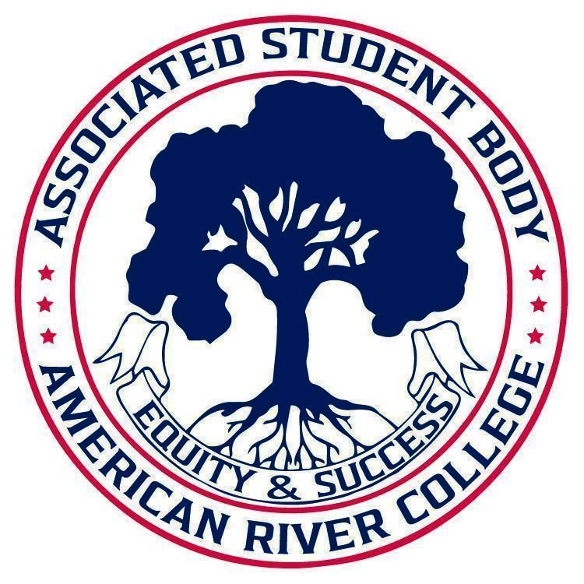
ASSOCIATED STUDENT BODY
Student Senate
Meeting Minutes
Jul 31, 2025
Location: Board Room
2:30 PM-4:00 PM PDT
Posted by : Soraya Amin, Student Senate President

NOTICE IS HEREBY GIVEN that the Associated Student Body Senate will hold a meeting on July 31, 2025. The location and meeting time is noted above. All Associated Student Body Senate meetings are held in locations that are wheelchair accessible. Other disability-related accommodations will be provided to persons with disabilities upon request. Persons requesting such accommodations should notify ASB Senate President Soraya Amin at sorayaamin.asbarc@gmail.com no less than two days prior to the meeting. Efforts will be made to meet requests made after such date, if possible.
Indigenous Land Use Statement
We acknowledge the land which we occupy today as the traditional home of the Nisenan, Maidu, and Miwok tribal nations. These sovereign people have been the caretakers of this land since time immemorial. Despite centuries of genocide and occupation the Nisenan, Maidu, and Miwok continue as vibrant and resilient tribes and bands, both Federally recognized and unrecognized. We take this opportunity to acknowledge the generations that have gone before as well as the present-day Nisenan, Maidu, and Miwok people.

I. Call to Order 2:35 PM

II. Request for Remote Participation: 1 minute
The Student Senate will consider member requests for remote participation under the provisions of California Assembly Bill 2449.

N/A
III. Roll Call

President Amin | Present
Vice-President Garcia | Present
Legislative Analyst Karachev | Present
Senator Galvez | Present
Senator Limon | Absent
Senator Smith | Present
Senator Ratz | Excused Absence
Director of Finance Bourez | Present
CAEB Representative | Excused Absence
6 of 9 members present, quorum has been met.
IV. Adoption of the Agenda Approved
V. Approval of the Minutes N/A

VI. Chair’s Message
- Excited to be here, and work with all of you
- Ask for your support in various committees, tasks.
- Looking forward to a great year!
VII. Advisor’s Message
- Aloha
- August 19th, New Faculty Hiring Orientation; student panel 1:05-2:20 PM
- Student Senate x Academic Senate meeting: Tuesday August 19th from 3:00-5:00 PM
- Convocation will take place Friday Aug 22 8-11:30 AM
- Friday Aug 29th, 12-1:30 PM, Homebase Listening Session- Students of ARC.
VIII. Public Comment 5 minutes
This time is reserved for members of the public to address ASB Senate on issues not already appearing on the agenda. A limit of two (2) minutes per speaker shall be observed, with a maximum of four (4) minutes per topic. No discussion is allotted on public comment. The law does not permit any action to be taken, nor extended discussion of any items not on the agenda. The ASB Senate may briefly respond to statements made for questions posed, however, for further information, please contact the ASB Senate President for the item of discussion to be placed on a future agenda. (Brown Act §54954.3(b))
- Shazil: Please continue work of Halal Food Committee work from previous board
- Alicia: Former Senate President, continue to do the work, excited for everything you all will do.
- Kevin: This is often thankless work, but it is seen. Continue to use your voice at meetings and committees.
IX. Appointments/Swearing-In 5 minutes
This time will be reserved for the appointment and swearing-in of current members to ASB Senate and/or committees.

Student Senate has appointed the following to open positions:
- Director of Legislative Affairs: Lucienne Kim
- Director of Public Relations: Hadia Amini
- Senator: Mae Kamara
- Senator: Annie Chen
- Senator: Alina Krayla

- 10.1 Senate Governance Committee
This time is reserved to inform and potentially create the Senate Governance Committee.
Vice-President Garcia will chair this committee. More information to follow at Friday Aug 29th meeting.
- 10.2 Shared Governance Appointments
This time is reserved to inform and potentially appoint student representatives to the following committees:
- Executive Leadership Team: Soraya Amin & Sahar Hafiz
- Student Success Council: Marilyn Garcia & Ramses Galvez
- Operations Council: Marilyn Garcia
- Institutional Effectiveness Council: Vacant

X. Unfinished Business
XI. New Business
- 11.1 F25-01 Week of Welcome Activities
This time is reserved to inform and take action on the passage of ten thousand dollars ($10,000.00) for the Fall 2025 Week of Welcome Activities. Funds can be spent but not limited to food, supplies, campus activities, balloons, printing materials, and any potential reimbursements.

- Moved by VP Garcia, 2nd by DoF Bourez
- Approved 9-0: Garcia, Bourez, Karachev, Galvez, Smith, Amini, Kamara, Chen & Krayla

- 11.2 F25-02 National Voter Registration Day and Constitution Day
This time is reserved to inform and take action on the passage of up to five thousand dollars ($5,000.00) for American River College Associated Student Body efforts around National Voter Registration Day and US Constitution Day. Funds can be spent but not limited to food, supplies, balloons, printing materials, and any potential reimbursements.

- Moved by VP Garcia, 2nd by DoF Bourez
- Approved 9-0: Garcia, Bourez, Karachev, Galvez, Smith, Amini, Kamara, Chen & Krayla

- 11.3 F25-03 CCCSAA Student Leadership Conference
This time is reserved to inform and take action on the passage of up to twenty-five thousand dollars ($25,000.00) for American River College Associated Student Body delegation to attend the 2025 California Community College Student Affairs Association (CCCSAA) Student Leadership Conference on October 17-19 in Santa Clara, CA. This also includes an institutional membership to CCCSAA for the 2025-26 academic year.

- Moved by VP Garcia, 2nd by DoF Bourez
- Approved 9-0: Garcia, Bourez, Karachev, Galvez, Smith, Amini, Kamara, Chen & Krayla

- 11.4 F25-04 ASB Swag and Merchandise
This time is reserved to inform and take action on the passage of up to fifteen thousand dollars ($15,000.00) for American River College Associated Student Body merchandise. Funds can be spent but not limited to business cards, stickers, shirts, jackets etc.

- Moved by DoA Amini, 2nd by VP Garcia
- Approved 9-0: Garcia, Bourez, Karachev, Galvez, Smith, Amini, Kamara, Chen & Krayla

- 11.5 ASB Office Supplies
This time is reserved to inform and take action on the passage of up to one thousand dollars ($1,000.00) for American River College Associated Student Body Elections. Funds can be spent but not limited to general office supplies, hardware, software, furniture etc.

- Moved by by DoF Bourez, 2nd by VP Garcia
- Approved 9-0: Garcia, Bourez, Karachev, Galvez, Smith, Amini, Kamara, Chen & Krayla

- 11.6 ASB Headshots: Photographer
This time is reserved to inform and take action on the passage of up to one thousand dollars ($2,000.00) for American River College Associated Student Body Professional Headshots for ASB members. These photos will be used for all official ASB marketing, and outreach opportunities.

- Moved by VP Garcia, 2nd by DoF Bourez
- Approved 9-0: Garcia, Bourez, Karachev, Galvez, Smith, Amini, Kamara, Chen & Krayla

- 11.7 ASB Orientation Reimbursement
This time is reserved to inform and take action on the passage of up to six hundred dollars ($600.00) for American River College Associated Student Body Orientation.

- Moved by VP Garcia, 2nd by DoF Bourez
- Approved 9-0: Garcia, Bourez, Karachev, Galvez, Smith, Amini, Kamara, Chen & Krayla

- 11.8 ASB End of Year Expenditures
This time is reserved to inform and take action on the passage of up to one thousand dollars ($2,000.00) for American River College Associated Student Body End of Year Celebration that took place June 3-4, 2025. 2 outstanding invoices remain for the Marriott Courtyard and The Habbibis Grill.

- Moved by VP Garcia, 2nd by DoF Bourez
- Approved 9-0: Garcia, Bourez, Karachev, Galvez, Smith, Amini, Kamara, Chen & Krayla

XII. Committee Reports
This time is reserved for committee chairs to provide the board with a brief report on the current standing of active committees.
N/A
XIII. Board Member Reports/Announcements
This time is reserved for board members to inform the board about relevant campus-wide events, and to report any pertinent committee progress/activities. A time of three (3) minutes per report shall be observed.

VP Garcia:
- Current Student Ambassador
- Promote Events & Activities
- Increase Social Media
- Improve Communication on Campus

Senator Krayla
- Temp SSA for MESA Program
- Connect for info on Women in STEM & MESA questions
- MESA hosting Welcome back event Sept 3, 12-2 PM

Senator Kamara
- Been working with a vendor for Week of Welcome Arcade Day, may need to contact the vendor to reduce some of the items.

Legislative Analyst Karachev
- New to ASB, looking forward to learning more.

Director of Finance Bourez
- Hi
- Excited to update boards on budgets and purchasing updates

Senator Smith
- Currently serve as a Clerk for the Business Homebase

Senator Galvez
- Hoping to utilize funds and ASB to long-term planning, rather than one day events.

Senator Chen
- Former AMSA Representative for 2024-25 CAEB Board
- Will be hosting CPR Events in Fall 2025 and Spring 2026

Director of Public Relations Amini
- Just finished Final!
- Good luck to those still working on Summer Classes
- Excited for the upcoming year and to work with all of you
- How can we promote Student Senate
  - Fall Kickoff
  - Week of Welcome
  - Throughout the year

XIV. SSCCC & Region 2 Updates
This time is reserved for appointed board members, members of the Student Senate of California Community Colleges (SSCCC) to provide updates about state and regional initiatives.
SSCCC Region 2 Regional Affairs Director Kevin Hill:
- August 10, SSCCC will host delegate training
- SSCCC hosting Advocacy Conference in November, and a DC Conference in March 2026
- March in March for 2026 planning already taking place
- SSCCC is happy to conduct trainings around Parliamentary Procedure, Brown Act and Robert’s Rule of Orders
XV. Public Comment
This time is reserved for members of the public to address the ASB Senate on issues not already appearing on the agenda. A limit of two (2) minutes per speaker shall be observed, with a maximum of four (4) minutes per topic. No discussion is allotted on public comment. The law does not permit any action to be taken, nor extended discussion of any items not on the agenda. The ASB Senate may briefly respond to statements made for questions posed, however, for further information, please contact the ASB Senate President for the item of discussion to be placed on a future agenda. (Brown Act §54954.3(b))
XVI. Adjournment 3:34 PM
Soraya Amin ASB Senate President Brett Sawyer Advisor

