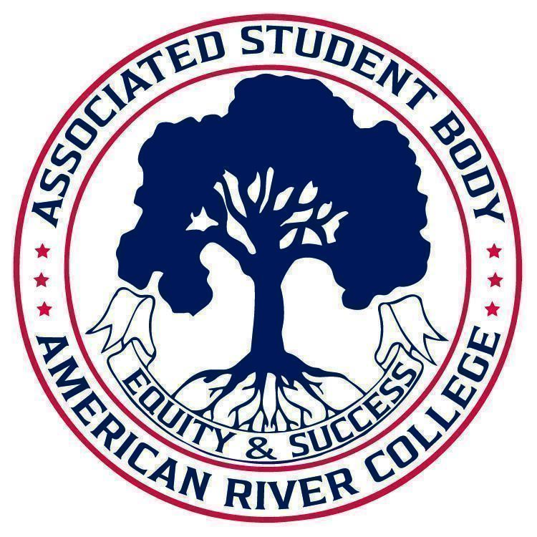
ASSOCIATED STUDENT BODY
Halal Food Committee
Meeting Agenda
December 12th, 2024
Location: Club Room, Center for Leadership and Development, Student Center
3:00 PM-4:00 PM PDT
Posted by : Shazil Mahmood, Student Senate Director of Public Relations

NOTICE IS HEREBY GIVEN that the Associated Student Body Halal Food Committee will hold a meeting on December 12th, 2024. The location and meeting time is noted above. All Associated Student Body Halal Food Committee meetings are held in locations that are wheelchair accessible. Other disability-related accommodations will be provided to persons with disabilities upon request. Persons requesting such accommodations should notify ASB Senate Director of Public Relations, Shazil Mahmood, at shazil.mahmood.asbarc@gmail.com no less than two days prior to the meeting. Efforts will be made to meet requests made after such date, if possible.
Indigenous Land Use Statement
We acknowledge the land which we occupy today as the traditional home of the Nisenan, Maidu, and Miwok tribal nations. These sovereign people have been the caretakers of this land since time immemorial. Despite centuries of genocide and occupation the Nisenan, Maidu, and Miwok continue as vibrant and resilient tribes and bands, both Federally recognized and unrecognized. We take this opportunity to acknowledge the generations that have gone before as well as the present-day Nisenan, Maidu, and Miwok people.

I. Call to Order 1 minute

II. Request for Remote Participation: 1 minute
The Halal Food Committee will consider member requests for remote participation under the provisions of California Assembly Bill 2449.
III. Roll Call 1 minute
IV. Adoption of the Agenda 1 minute
V. Approval of the Minutes 1 minute
VI. Chair’s Message 5 minutes
VII. Public Comment 5 minutes
This time is reserved for members of the public to address ASB Halal Food Committee on issues not already appearing on the agenda. A limit of two (2) minutes per speaker shall be observed, with a maximum of four (4) minutes per topic. No discussion is allotted on public comment. The law does not permit any action to be taken, nor extended discussion of any items not on the agenda. The ASB Halal Food Committee may briefly respond to statements made for questions posed, however, for further information, please contact the ASB Senate Director of Public Relations for the item of discussion to be placed on a future agenda. (Brown Act §54954.3(b))
VIII. Appointments/Swearing-In 0 minutes
This time will be reserved for the appointment and swearing-in of members to the ASB Halal Food Committee.
IX. Unfinished Business
9.1 Survey Updates 30 minutes
This time is reserved to review and update the Halal Food Survey. The data gathered from this survey will be used to present the need of Halal Food to the college community.

X. New Business

10.1 Spring Meeting Times 5 minutes
This time is reserved to discuss potential meeting times for the Spring 2025 Semester.

10.2 Next Steps 10 minutes
This time is reserved to discuss and potentially plan next steps for the Halal Food Committee.

XVI. Adjournment
Shazil Mahmood ASB Senate Director of Public Relations Brett Sawyer Advisor

