Project Final Report
DRAFT 1.0
Project Name: Strategic Enrollment Management
Description: The Strategic Enrollment Management team is responsible for developing a plan to assess existing enrollment management practices and is intended to cultivate optimum enrollment levels in alignment with the college’s mission and strategic plan. The planning process should utilize strategic enrollment management methodology to align holistically efforts across all stages of the student life cycle to simultaneously foster student success.
Project Sponsor: Student Success Council
Team Leads: Dyne Eifertsen, Instructional Faculty, Music [Co-Lead]
Kale Braden, AVP Instruction (Learning Resources) [Co-Lead]
Team Members: Kevyn Montano Classified, Lead ISA
Kirsten Corbin Dean, Business and Computer Science
Marsha Reske Dean, Distance Education and VEC
Kathryn Sorensen Dean, Student Services, Counseling & Transfer Services
Jason Ralphs Supervisor, Enrollment Services
Roger Davidson Dean, Natomas Education Center
Douglas Herndon Dean, English Department
Tyler Rollins Classified, Research
Jessica Nelson Counseling Faculty
Michelle Brock Instructional Faculty, Mathematics
Dianne Meador Instructional Faculty, Chemistry
Kevin Porter Classified, Note Taker
Date: February 2020

Table of Contents
Executive Summary: Strategic Enrollment Management Report 1
Assessing Metrics for Scheduling vision. 1
American River College’s Scheduling Vision: 4
ARC’s schedule development process requires: 4
Guiding principle for scheduling: 4
Guiding principle for scheduling courses: 4
Courses should be prioritized and scheduled based on the following considerations: 4
Other Considerations affecting how to prioritize sections to schedule: 5
Assessment of Current State 6
A few observations about the allocations coming from district: 6
Applying Metrics to ARC’s Scheduling Vision 7
Schedule to allow student to navigate program pathways efficiently based on data. 7
Schedule sections into blocks of time that allow for efficient use of classrooms. 8
Scheduling Vision that Still Need Metrics Developed or Identified: 8
Schedule Development 9
Rolling over the Schedule 9
The Core Schedule 10
The Planning Calendar 11
Phased in approach to modifying roll-over procedures 12
Spring 2020 12
Fall 2020 12
Spring 2021 12
Full Time Equivalent Faculty (FTEF) Allocation: 13
Interests for the semester FTEF allocations: 13
District Allocation: 13
ARC Allocation Process: 14
The Fall FTEF Allocation: 15
Identifying FTEF scheduled in the Previous Like-Fall Term 15
The Division Baseline FTEF 17
Baseline FTEF Delta 17
Legislative, Policy, or other mandated changes requiring FTEF Allocation adjustment 18
Opt-Out Schedules requiring FTEF Allocation adjustment 18
Analytics requiring FTEF Allocation adjustment 18
Pathways requiring FTEF Allocation adjustment 18
SEM and the FTEF Allocation 18
The Spring FTEF Allocation 19
The Summer FTEF Allocation 19
Student Contact Hours Goals 20
What are Student Contact Hours and why do they matter? 20
Challenges of Measuring/Predicting WSCH 20
District WSCH Goals 21
Division/Department Level WSCH Goals 22
Phased in approach to WSCH goals 22
Fall 2020 22
Spring 2021 23
Block Scheduling 24
Guiding Principals 24
Block Scheduling/Uniform Meeting Patterns 24
Overarching Guidelines 24
Proposed Start Times (by class units and days per week): 25
Phased in Approach to Block Scheduling 27
Fall 2020: 27
Spring 2021: 27
SEM Recommendations 28
SEM Next Steps/Aspirational Goals 28
Glossary: 30
Appendix 1: Scheduling Timeline 36
Appendix 2: Fall 2019 Summary FTE & WSCH by Location 38
Appendix 3: FTEF Worksheet 39

Executive Summary: Strategic Enrollment Management Report
Parts of This Document
American River College’s Scheduling Vision
This section is designed to explicitly connect scheduling back to American River College’s Mission, Vision, and Values. Scheduling for student success means creating paths to transfer or employment while maintaining maximum effectiveness and efficiency in the use of faculty, finances, and facilities. A program map or a pathway is a promise that we are making to students that they will be able to complete a program in a set amount of time. American River College’s goal is to provide a schedule that allows students to meet successfully their educational goals.
Assessment of Current State
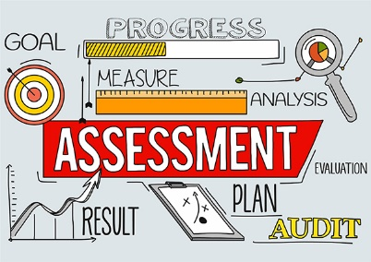
This section provides a brief overview and assessment of the FTEF ARC has received from district and the WSCH which has been generated. Over the past five years American River College and the Los Rios Community College district has experienced softening enrollment, productivity, and WSCH generation. Since the 2014-2015 term, American River College has experienced repeated term-over-term reductions in WSCH generation (down 12.54% over the past five years) and productivity (down 9.31% over the past five years) with a slight uptick in the 2018-2019 term. At the same time, ARC’s FTEF allocation from the district has been reduced by 3.28% over the past five years and the actual amount of FTEF scheduled by ARC has been reduced by 3.49%. District will continue to transfer FTEF between campuses that show more ability to schedule classes that generate WSCH productively. Between the ’14-’15 and ’19-’20 terms, the FTEF allocation from district to ARC was reduced from 1,086 FTEF to 1052 FTEF (down by 34 FTEF, a 3% reduction) while CRC’s allocation increased from 504 FTEF in ’14-’15 to 538 FTEF in ’19-’20 (a 34 FTEF increase, or a 6% increase for CRC). If ARC does not stabilize their schedule and find a way to increase WSCH generation, other schools in the district will continue to receive the FTEF that ARC cannot effectively schedule.

Assessing Metrics for Scheduling vision.
This section provides specific data points and metrics that may be used to measure how successful ARC has been in meeting the goals set forth in the ARC Scheduling vision.
Schedule Development
This section evaluates the current process by which schedules are “rolled-over” from one term to the next. This section makes a recommendation to evaluate what the “core” schedule (i.e. those sections that are unchanged time and day pattern), better planning for sections that rotate (i.e. offered every other term, every odd term, et cetera.), and to create six developmental schedules in PeopleSoft: Fall-odd, Fall-even, Spring-odd, Spring-even, Summer-odd, and Summer-even. The goal of these recommendations are to provide more capacity for planning and to provide a two-year planning cycle that works within the district’s current technological infrastructure.
Full Time Equivalent Faculty (FTEF) Allocation
This section is an appraisal and discussion of how FTEF is allocated by the state to the district, from the district to the college, from the college to divisions, and then from divisions to the departments. The intention of this section is to both “peel back the curtain” as well as to define out specific processes and procedures to adjust FTEF allocations taking into account many different factors including, legislative changes, opt-out scheduling, pathway scheduling, and staffing changes.
Student Contact Hours Goals
Fundamental to understanding Student Contact Hours is an understanding of how California Community Colleges are funded. The State provides most of the funding for California Community Colleges based on the number of students attending the college. The number of students attending a college are packaged up into the Full Time Enrollment Student (FTES). FTES represents neither student headcount nor student enrollment, but it is a conceptual measure of student enrollment. One Full-time Equivalent Student (FTES) is equal to one student enrolled in 15 semester hours for 2 semesters. One FTES is equal to 525 contact hours. This “conceptual” measurement is the basis of how California Community Colleges receive 60% of their funding from the state.
Block Scheduling
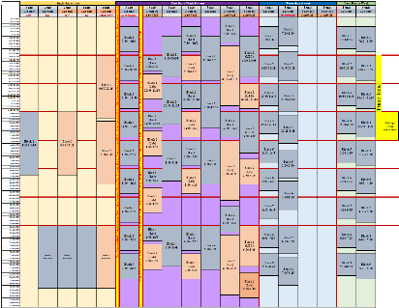
Classroom spaces are a limited resource and it is the role of the administration and department faculty to ensure that they are scheduled efficiently to promote student success and the mission of the college. Classrooms are owned by the college and ultimately by the citizens of the State of California and not by any department or individual. While classrooms may typically be scheduled by individual departments, the assignments are not considered permanent. Classroom scheduling is a dynamic process requiring reevaluation of class size, equipment specifications, and pedagogical changes each semester. The assignment of a specific room at a specific time in a given semester will not automatically guarantee a continuing assignment of that space, even if the room was used efficiently. Faculty members should not expect to use the same space on a continuing basis. To carry out the mission of American River College, the classroom facilities are primarily for use by students, faculty and staff for activities and programs that are directly related to supporting students in strengthening basic skills, earning associate degrees and certificates, transferring to other colleges and universities, and achieving career as well as other academic and personal goals. Every effort is made to ensure that classrooms are assigned fairly, used appropriately, and accommodate the College’s academic and instructional needs.
SEM Recommendations, Next Steps, and Aspirational Goals
Recommendations:
- Develop standing Strategic Enrollment Management team to monitor enrollment data, rubrics, and procedures.
- Hire support staff to facilitate maintenance of Ad Astra Platinum system, interface between data on demand system (research office), and coordination with other technical solutions (Highpoint, Starfish, et cetera.)
- Work with District IT to build out six development schedules in PeopleSoft. These six development schedules would then be evaluated using Ad Astra and other data to create the stock offerings that will be used to rollover into the development terms for the appropriate upcoming semester.
- American River College needs a centralized system to track external FTEF (grants) that fund sections, instructional FTEF used to support coordinators and other work of the college, and other programs that are scheduling sections in addition to division offices (e.g. the Advanced Education program).
SEM Next Steps/Aspirational Goals
- Fall 2021: SEM will develop and submit to Student Success Council a Refined Block Scheduling proposal that will include exemptions, thresholds, goals, and other specific procedures.
- Fall 2021: SEM will investigate using the Ad Astra Optimizer and build priority lists of when sections should be scheduled in classrooms.
- Develop metrics and analytics to support measuring and planning for expanded use of short-term sections.
- Develop metrics and analytics to measure demand for different instructional modalities (fully online, partially online, face-to-face, et cetera.).
- Refine predictive modeling for capstone classes to help identify ideal rotational patterns for traditionally low-enrolled sections.
- Refine rubrics for different types of sections to identify when sections need to be cancelled and when additional sections may need to be added into the schedule.
- Work towards building a schedule that we can consider a promise to American River College’s students and faculty where we do not cut sections right before the start of the semester.
- Work with ARC research and District Fiscal to build reports and tools to better predict and monitor the FTES and WSCH production of sections from the planning stage, through registration, and to the various census dates for different Attendance types.
- Refine techniques of creating realistic and data based WSCH goals to assist in meeting the division/college level WSCH goals.
- Tools to provide “sandboxes” in schedule development to help predict how changes to a draft schedule may affect a department or division hitting their WSCH goals.
- Tools to measure WSCH (and project trends) during enrollment.
- Procedures for post-mortem evaluation of how divisions and departments did in meeting WSCH targets.

American River College’s Scheduling Vision:
Students are the reason we are here, and their education is our primary responsibility. The primary purpose driving the development of American River College’s Academic Schedule is to provide students access and opportunities to:
- develop their abilities;
- engage in critical and creative thinking;
- succeed in a competitive global work environment;
- exhibit responsible citizenship benefit society as well as themselves;
- participate in lifelong learning;

ARC’s schedule development process requires:
- fiscally sound, efficient, transparent, and accountable practices;
- effective communication within the college and with the communities served by the college;
- civil and honest communication that promote mutual respect and trust;

Guiding principle for scheduling:
Scheduling for student success means creating paths to transfer or employment while maintaining maximum effectiveness and efficiency in the use of faculty, finances, and facilities. A program map or a pathway is a promise that we are making to students that they will be able to complete a program in a set amount of time. American River College’s goal is to provide a schedule that allows students to meet successfully their educational goals.
Aspirational Goal 1 | American River College has an interest to move towards a model where divisions build term schedules that are as closely aligned as possible with student needs. The ultimate goal is to create a process that emphasizes schedule integrity and where divisions rarely need to cut sections at the beginning of the semester, rather divisions are adding in additional sections throughout registration to relieve bottlenecks.

Guiding principle for scheduling courses:
Courses should be selected to maximize the potential for student success. Courses scheduled should lead to the following:
- College readiness;
- Two-year transfer preparation;
- Associate degrees, particularly TMCs;
- Degrees and certificates that prepare students for professional licensure and certification;
- Certificates that have a demonstrated record of employment;
- Addressing equity gaps in retention, persistence, and completion;
- Support for visual and performing arts, cultural awareness, wellness, and intercollegiate sports;

Courses should be prioritized and scheduled based on the following considerations:
- Schedule course sections to meet demand/required number of sections in order for students to navigate efficiently program pathways based on data.
- Schedule course sections to meet student demand for opt-out-schedules based on data.
- Schedule course sections to meet the target WSCH/Productivity that has been determined for each program or discipline. FTEF will be apportioned based on historical data and student needs.
- Schedule sections into blocks of time that allow for efficient use of classrooms. Students should be allowed at least ten minutes to get from one class to another. They should not be precluded from taking a class because it overlaps the timeframe of another.
- Schedule sequential courses that lead to college readiness, degrees, certificates, or licensure such that students will make successful progress from one course to another. Strategies include offering sections at a time that has proven successful and offering enough sections to accommodate the numbers of students completing the prerequisite course or move to college level writing and math skills.
- Schedule courses that are designed or proven to help close equity gaps.
- Offer low-enrollment sections needed for transfer, certification, or licensure at adequate intervals to allow students to move ahead with their goals.
  - Fill-rate alone should not be used as the basis for offering a course. While fill-rate is important for determining if there are enough or too many seats available for students, a low fill-rate in a capstone course would not necessarily necessitate that section being removed from the schedule. American River College students’ ability to move toward transfer and employment must be actively ensured. In addition, low class size may be mandated by external regulations, program accreditation standards, or facility/safety issues.
- Balance choices of times, locations, and delivery methods based on data. Online and partially online courses offer students important options. Offer sufficient sections to meet student demand in all modalities.
- Other factors being equal, course sections with evidence of higher success rates and lower withdrawal rates are preferable. Departments need to address reasons for lower success and higher withdrawal rates paying particular attention to disproportionately impacted students.
- Consider courses that provide student support and pathways to success, including learning communities, and supplemental instruction.

Other Considerations affecting how to prioritize sections to schedule:
- Sections should be prioritized when added into the schedule
  - Priority should be given to courses that are a required part of degrees and certificates.
  - Courses that assist students to meet their math and English requirements.
  - Courses that are a part of a narrow and restricted list of electives within a degree or certificate should be scheduled based upon historical and predictive data that provides evidence of demand for these sections.
  - Scheduling decisions regarding courses that meet GE or program electives that are specifically delineated in program pathways or maps should be scheduled based upon historical and predictive data demonstrating demand for these sections.
  - All efforts should be made to schedule courses where departments have identified a rotation of the offerings (every fall term, every other spring term, et cetera.)
  - Courses that are required to support publications, performances, athletics, and equity and inclusion college efforts should be supported in the schedule. There should be a recursive conversation regarding enrollment and these programs.
  - Courses that have a demonstrated demand—in spite of a lack of predictive demand
  - Sections that promote lifelong learning, that are not part of restrictive course requirements for degrees or certificates, are parts of long lists of unrestricted electives or General Education options, or do not meet any specific requirements are still valuable parts of a comprehensive community college schedule, however they should be added last into the schedule.
- Courses intended to be scheduled into non-specialty classrooms that are scheduled within the Block Schedule Guidelines should be scheduled into rooms before courses that are scheduled “off-block.”

Assessment of Current State
Over the past five years American River College and the Los Rios Community College district has experienced softening enrollment, productivity, and WSCH generation. Since the 2014-2015 term, American River College has experienced repeated term-over-term reductions in WSCH generation (down 12.54% over the past five years) and productivity (down 9.31% over the past five years) with a slight uptick in the 2018-2019 term. At the same time, ARC’s FTEF allocation from the district has been reduced by 3.28% over the past five years and the actual amount of FTEF scheduled by ARC has been reduced by 3.49%.

Figure 1: Five-Year Term-over-Term Assessment of Enrollment Trends
 | Actual |  |  |  | Goal |  |  |  | % ∆ between Goal and Actual
Year | WSCH | FTEF | Prod | District Prod | WSCH | FTEF Allocation | Prod | District Prod | % WSCH ∆ | % FTEF ∆ | % PROD ∆ | % Dist Prod ∆
2014-2015 | 275,554 | 545 | 505 | 507 | 288,005 | 549 | 525 | 528 | -4% | -1% | -4% | -4%
2015-2016 | 269,400 | 541 | 498 | 500 | 283,432 | 549 | 516 | 518 | -5% | -1% | -3% | -3%
2016-2017 | 254,250 | 536 | 475 | 481 | 278,356 | 539 | 516 | 518 | -9% | -1% | -8% | -7%
2017-2018 | 237,660 | 531 | 448 | 462 | 275,834 | 536 | 515 | 518 | -14% | -1% | -13% | -11%
2018-2019 | 241,000 | 526 | 458 | 470 | 273,311 | 531 | 515 | 518 | -12% | -1% | -11% | -9%
Source: LRCCD Approved Budgets 2013-2014 through 2019-20

A few observations about the allocations coming from district:
- Schedule preparation for a fall term begins in October prior to the term, is finalized in March, and enrollment begins in April. The FTEF allocations and WSCH/Productivity goals are first released to the college as a part of the tentative budget presented to the board in June, a month and a half after students have begun enrolling in the term. The allocation is not finalized until almost a month into the fall semester when the final budget is presented.
- ARC begins the fall scheduling process by setting a tentative allocation based upon the prior-year allocation and then adjusting the schedule as the tentative budget is released in June.
- Los Rios has maintained a consistent productivity goal of 518 since 2015-2016, however the district and colleges have moved further and further from this goal:
Figure 2: Percentage of Delta between District Goal and Actual
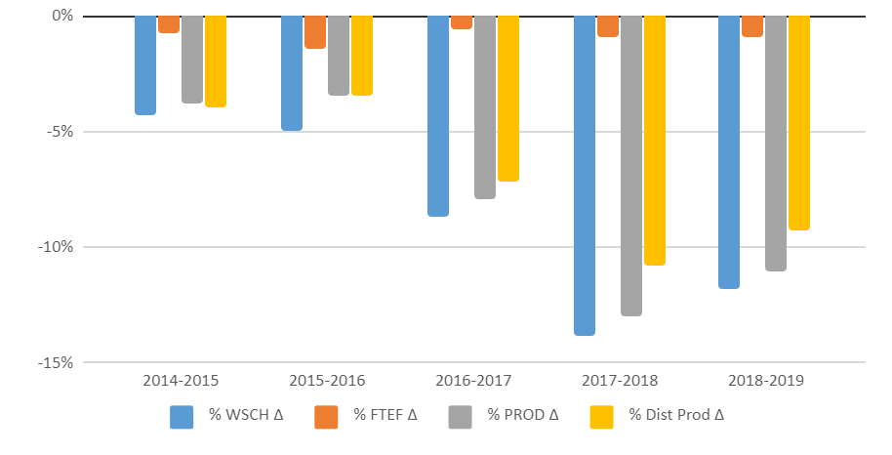
- In ‘19-’20 ARC received a total allocation of 522.900 annual FTEF (1045.800 FTEF actual which represents a 1% reduction in FTEF). At the same time
- Los Rios projected an increase of 12% in WSCH and instructional productivity.
With a goal of increasing productivity year-over-year by 12%, the Los Rios District continues to project an incredibly aggressive growth agenda for ARC.
District will continue to transfer FTEF between campuses that show more ability to schedule classes that generate WSCH productively. Between the ’14-’15 and ’19-’20 terms, the FTEF allocation from district to ARC was reduced from 1,086 FTEF to 1052 FTEF (down by 34 FTEF, a 3% reduction) while CRC’s allocation increased from 504 FTEF in ’14-’15 to 538 FTEF in ’19-’20 (a 34 FTEF increase, or a 6% increase for CRC). If ARC does not stabilize their schedule and find a way to increase WSCH generation, other schools in the district will continue to receive the FTEF that ARC cannot effectively schedule.

Applying Metrics to ARC’s Scheduling Vision

Schedule to allow student to navigate program pathways efficiently based on data.
Ad Astra Platinum Analytics provides insight into this goal by providing a Key Velocity Metric (2-year) dashboard that provides the following metrics:
- Degree velocity: The average ‘productive’ hours completed by the goals annually. Measured as a percentage. Example: Student completes 24 units in the year, with 21 of those units applying to the program pathway. If the goal is for students to be full-time (with 30 units completed in a year) the degree velocity would be 21/30 or 70%
- Time to Degree (Years): For active students, this is the estimated time to completion of the degree based on remaining hours and assuming the student(s) stay on the same pace and in the same pathway.
- Total Velocity: This is the hours completed divided by the goal annually and measured as a percentage. From the example above, the Total Velocity would be 24/31 or 80%.
- Credits per year: the average number of credits students have taken per year.
- Productive Credits per year.
- Productive Ratio: This is the productive hours divided by the overall hours completed. From the example above, the productive ratio would be 21/24 or 87.5%.
- Credits to complete: This is the average total completed credits per student for their degree program.
ARC Key Velocity Metrics, 2/21/2020
Degree Velocity | Time to Degree (Years)
28.5% | 7.02
Total Velocity | Credits Per Year | Productive Credits per year
53.96% | 16.9 | 8.55
Productive Ratio | Credits to Complete
52.81% | 113.61
Figure 3: Key Velocity Metrics from Ad Astra Platinum Analytics Dynamic Visualizations
Aspirational Goal 2 | SEM to set goals (by college and programs) to:  - Increase degree velocity  - Reduce time to degree  - Increase Productive Ratio  - Increase both Credits per year and productive credits per year.

Schedule sections into blocks of time that allow for efficient use of classrooms.
The following SQL query:
SELECT DISTINCT LR_MSF.Start_Time1, LR_MSF.End_Time1, LR_MSF.MTG_Pat1, Count(LR_MSF.CLASS_KEY) AS CountOfCLASS
FROM LROC.LR_MSF
WHERE ((STRM_DESCR = "Spring 2020") AND (SESSION_CD="FT") AND (START_TIME1!= ""))
GROUP BY Start_Time1, End_Time1, MTG_Pat1;
When this SQL code is run against the Research database PeopleSoft data mirror it provides a list of all time blocks that courses have been scheduled into for a term and the number of sections for which they were scheduled. For example, in the spring 2020 semester for full term sections, there were 1201 distinct time blocks scheduled for 5503 full-term sections.

Scheduling Vision that Still Need Metrics Developed or Identified:
- Schedule to promote college readiness, degrees, certificates, or licensure allowing students to successfully progress from one course to another.
- Schedule courses that are designed or proven to help close equity gaps.
- Offer low-enrollment sections needed for transfer, certification, or licensure at adequate intervals to allow students to move ahead with their goals.
- Build a schedule that we can consider a promise to American River College’s students and faculty where we do not cut sections right before the start of the semester. Potentially: Could use “Sections Cancelled During Registration” (in Platinum Visualizations”) as a metric
- Balance schedule for section times, locations, and delivery methods based on data
- Schedule course sections with evidence of higher success rates and lower withdrawal rates.
- Consider courses that provide student support and pathways to success, including learning communities, and supplemental instruction.
- Prioritize courses that are a required part of degrees and certificates.
- Prioritize courses that assist students to meet their math and English requirements.
- Historical and predictive data should be used to inform the priority of scheduling courses that are a part of a narrow and restricted list of electives within a degree or certificate.
- Scheduling decisions regarding courses that meet GE or program electives that are specifically delineated in program pathways or maps should be scheduled based upon historical and predictive data demonstrating demand for these sections.
- All efforts should be made to schedule courses where departments have identified a rotation of the offerings (every fall term, every other spring term, et cetera.)
- Courses that are required to support publications, performances, athletics, and equity and inclusion college efforts should be supported in the schedule. There should be a recursive conversation regarding enrollment and these programs.
- Courses that have a demonstrated demand—in spite of a lack of predictive demand
- Sections that promote lifelong learning, that are not part of restrictive course requirements for degrees or certificates, are parts of long lists of unrestricted electives or General Education options, or do not meet any specific requirements are still valuable parts of a comprehensive community college schedule, however they should be added last into the schedule.

Schedule Development

Rolling over the Schedule
Currently, after the census date (third week of a full-term semester) the scheduled is “rolled over” into a development schedule where the rooms, buildings, and instructors are stripped out. This schedule becomes the “Round One” draft that is distributed to divisions to be used for schedule development on the next like term.
Aspirational Goal 2 | Working with District IT, ARC hopes to create six developmental schedules in addition to the production development schedules that become the term schedules we now have:  - Fall (odd year) & Fall (even year)  - Spring (odd year) & Spring (even year)  - Summer (odd year) & Summer (even year)
These development schedules would then have development sandboxes in Ad Astra Platinum Analytics where divisions and departments will refine the schedules that would be rolled over into the draft schedules for departments and divisions to work on.
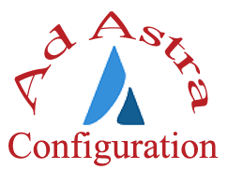  Ad Astra Config 1 | Ad Astra is currently developing a new infrastructure for schedule development. These web-based modules, Align and Schedule, will be configured to allow for sandboxing and development with these development schedules. Rather than rolling over the prior term, ARC will rollover the appropriate development schedule. It would look something like:
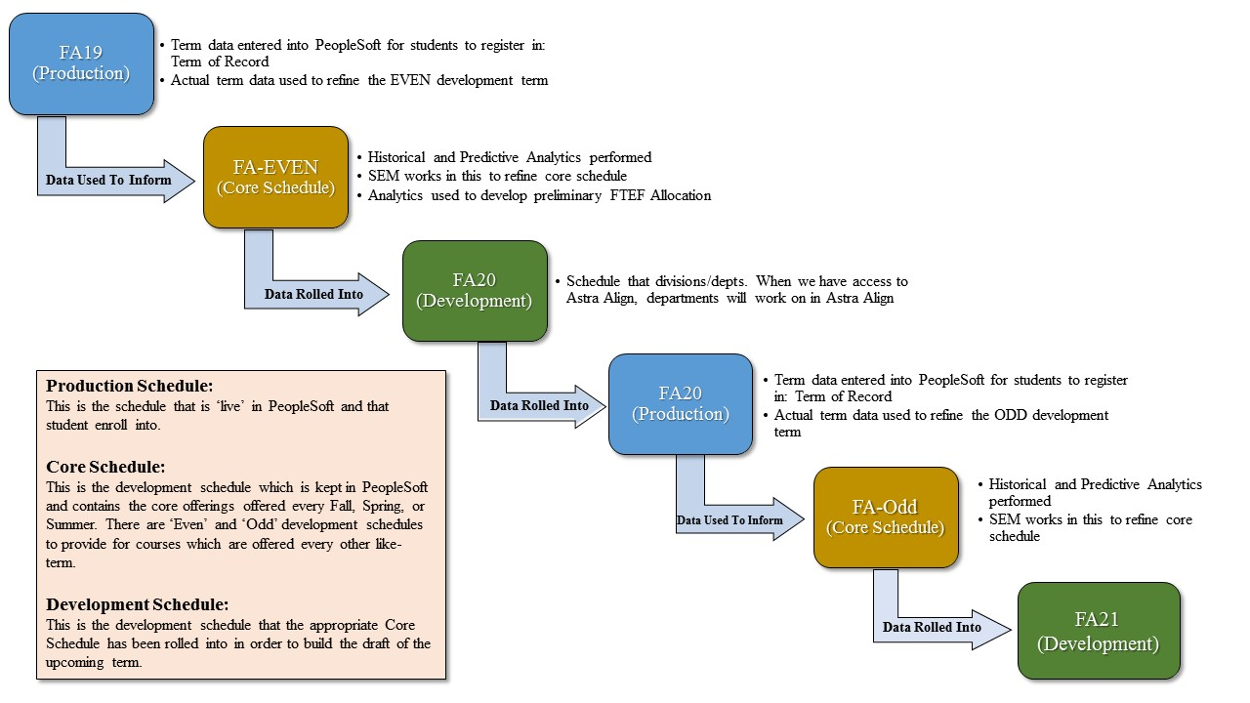
Figure 4: Interaction of 'Development' schedules, 'Core' schedules, and 'Production' schedules.
This process will allow ARC to:
- Develop a two-year pattern of course offerings representing both student needs and minimum scheduling levels to assure that we are meeting full-time contractual obligations
- Provide capacity and space for vetting schedules before they are rolled over and presented to department for review/scheduling work.
- Provide the capacity to hold post-mortem scheduling meetings in the summer to review what worked or did not work with the previous terms and any changes that should be applied to the core schedules.
- Capture course rotations beyond the whole-terms recorded by PeopleSoft: PeopleSoft only tracks course rotation for whole terms: every fall, every spring, et cetera. We have many courses which may need to be on an every-other fall, every-other spring, et cetera. type of rotation.
- Moving towards a model where departments and divisions have time to discuss the core schedules and then departments propose additions to that schedule based upon data or programmatic changes.
- Develop schedules in a two-year rotation of sections where individual term schedules becomes more refined as the college gets closer to registration and the core schedule is continually being refined with multiple points of data.

The Core Schedule
Within our current process of rolling prior term schedules into development schedules, there are often only incremental changes made to the schedules. The table below shows the percentage of courses which have been scheduled over the past four, three, and two like terms where the course, beginning time, ending time, and day pattern remained the same. (Note this is a comparison of Crystal Class Size No Grouping by LOC (RCINS0019) reports for sections that had FTEF attached and were scheduled for a unit value. This methodology eliminated cross-listed sections and the lab portions of Lecture/Lab courses that would have skewed the number of sections).
 |  | Main Campus, Fall Term
 |  | Past 4 Terms |  |  |  | Past 3 Terms |  |  | Past 2 Terms |  |  | Total Sections 2019
 |  | Count |  | % |  | Count |  | % | Count |  | % | Count
Fall |  | 807 |  | 36.3% |  | 1114 |  | 50.1% | 1471 |  | 66.2% | 2223
Spring |  | 786 |  | 35.9% |  | 1094 |  | 49.9% | 1454 |  | 66.4% | 2191
Summer* |  | - |  | - |  | 241 |  | 36.0% | 293 |  | 43.8% | 669
*Data missing for Summer 2016 comparison
 | Natomas
 | Past 4 Terms |  |  |  | Past 3 Terms |  |  |  | Past 2 Terms |  |  | Total Sections 2019
 | Count |  | % |  | Count |  | % |  | Count | % |  | Count
Fall | 58 |  | 30.5% |  | 90 |  | 47.4% |  | 131 | 68.9% |  | 190
Spring | 37 |  | 19.4% |  | 73 |  | 38.2% |  | 103 | 53.9% |  | 191
Summer* | - |  | - |  | 17 |  | 45.9% |  | 20 | 54.1% |  | 37
*Data missing for Summer 2016 comparison
Figure 5: Percentage of course that were scheduled with the same time and day pattern term-over-term.
Moving forward, allocations will begin with the approximately 66% of sections which are core to the schedule (i.e. they do not typically change like term to like term). This “core schedule” will provide the foundation for division allocations. Added to this will be the FTEF that has been identified by departments as being necessary for the rotational offerings, those courses that may be offered every other term or on some other pattern to allow for students to complete pathways, degrees, and or certificates. Additional FTEF will be allocated to divisions (beyond the amount needed to support core and rotational offerings). See ARC Allocation Process, page 1 of this document) for information on FTEF allocation.

The Planning Calendar
Planning for the academic calendar is a continual process of resource allocation, data analysis, scheduling drafts, schedule publishing, student enrollment, and enrollment monitoring. Unfortunately, many of the important dates within the scheduling timeline fall right in the middle of other busy times throughout the semester. This draft attempts to lay out a continual, two-year cycle of schedule monitoring, adjustment, planning, and implementation that spreads the analytic load into less busy times and will (hopefully) provide a more logical structure of “Just-in-time” data to inform schedule decisions.
Two-Year Scheduling Rotation

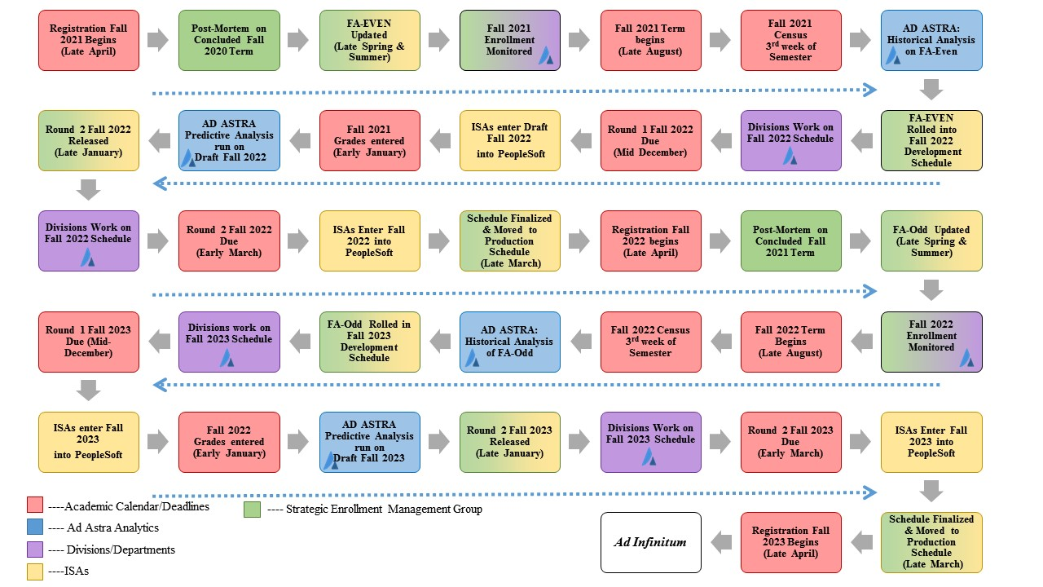Figure 6: The graphic above represents the two-year cycle of scheduling and how the Core Schedules are informed with analytics, rolled into draft schedules, and moved into being a production schedule for student registration.
See Appendix 1: Scheduling Timeline (page 1) for a draft of the scheduling activities broken out over a two-year cycle.

Phased in approach to modifying roll-over procedures

Spring 2020
- Work with district office to investigate feasibility of multi-development schedules to live in PeopleSoft.
- Identify ‘core’ sections offered in fall, spring, and summer terms. Engage in discussions with divisions and departments to investigate what these core schedules should be to support pathways, degree/certificate completion, and student success and retention.

Fall 2020
- Continue working with District and Ad Astra to implement Ad Astra Align and Schedule. These two products are designed to manage schedule development workflow and allow users to build term schedules within Ad Astra.
- Train faculty, staff, and administrators to use Align and Schedule.

Spring 2021
- Begin using Ad Astra Align and Schedule to build spring 2022 schedule, based upon the Even-Spring roll-over development schedule.

Full Time Equivalent Faculty (FTEF) Allocation:
The Los Rios District is annually approved to offer a set amount of FTEF by the State Chancellor’s Office. This district allocation is tied to the State Budget process. In turn, the district allocates an approved amount of FTEF to each campus in the district. The ARC Instruction Office (through the Strategic Enrollment Management team) then allocates FTEF to college divisions and centers. ARC Division deans then allocated FTEF to individual departments.

Interests for the semester FTEF allocations:
Schedules for each semester shall be planned to accommodate the needs of students, to ensure the quality of education, and to utilize facilities efficiently. The Strategic Enrollment Management Team will utilize the following criteria to determine FTEF allocations for divisions.
- Provide enough FTEF to meet the contractual obligation to provide load for all full-time faculty.
- Afford the Natomas center the ability to enroll at least 1,000 FTES and maintain its Center Status per title 5, § 58771(i) (5).
- Take into account legislative, regulation, or other policy changes that may require resources to be adjusted.
- Be based upon data that indicates a historical five-year, like term-over-term student demand for courses. (Note that the historical demand must be tempered with an analysis of the status of a program. For example, in 2019 a 5-year like term analysis of English and Math department enrollments would not provide much insight due to the changes wrought by AB 705.)
- Be based on predictive data that provides an analysis of what students will need to take in order to complete work on degrees, certificates, and college pathways. In particular, FTEF Allocation should be based upon meeting the following institutional interests:
  - College readiness;
  - Two-year transfer preparation;
  - Associate degrees, particularly TMCs;
  - Degrees and certificates that prepare students for professional licensure and certification;
  - Certificates which have a demonstrated record of employment;
  - Support for visual and performing arts, cultural awareness, wellness, and intercollegiate sports.

District Allocation:
The Los Rios District produces a draft budget each year. The budget is crafted after the California Governor submits their “May Budget Revise” to the legislature. This draft is generally presented to the Board of Trustees at their June board meeting. After the State Budget is finalized, the final budget is brought to the board for approval (generally in the September Board meeting). Within the tentative and approved budgets, the District Office provides both the FTEF allocations for the year as well as the projected WSCH goals and Productivity goals for the district:
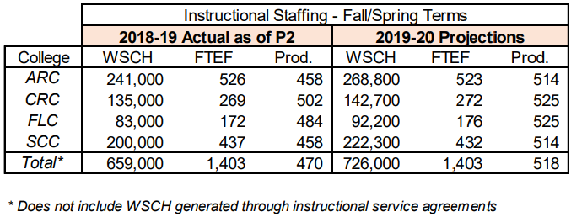
Figure 7: From 2019-20 Adopted Budget presented to the Board of Trustees September 11, 2019, Pg. 124
The Instructional Staffing charts in the Adopted Budget documents provides the FTEF allocated by the district (annualized: multiply by 2 for the total authorized amount for fall and spring) and the District’s projected WSCH and productivity goals.
A few observations about the allocations coming from district:
- Schedule preparation for a fall term begins in October prior to the term, is finalized in March, and enrollment begins in April. The FTEF allocations and WSCH/Productivity goals are first released to the college as a part of the tentative budget presented to the board in June, a month and a half after students have begun enrolling in the term. The allocation is not finalized until almost a month into the fall semester when the final budget is presented.
- ARC begins the fall scheduling process by basing it upon the prior-year allocation and then adjusting the schedule as the tentative budget is released in June.
Tentative allocations are prepared at the campus level based upon the prior year’s allocation as the process for creating the fall schedule begins in October, seven to nine months before the district provides the actual allocation. The offset nature of our planning calendar with the allocation calendar can lead to volatile swings in FTEF.

ARC Allocation Process:
FTEF is allocated from the Office of Instruction at the division level and the Area Deans then allocate FTEF down to the department level. The allocation process starts with an evaluation of what was scheduled in the prior Fall Term. Historically this began with a “Roll-over” of the previous production term into a development term for departments to adjust the schedule. Historically, the Instruction Office has worked with the District Office create a copy of the previous like term’s schedule with the room assignments and staffing removed. This copy would become the development schedule for the new term. For example, the development schedule for fall 2020 is a copy of the fall 2019 schedule taken on or around the census date and stripped of instructor names and the rooms that classes had been scheduled into. The development schedule was then distributed to divisions as the first round of schedule development.
A few observations regarding the “Roll-Over” process of schedule development:
- Basing the development schedule for the next term off of the schedule which was in place at census the previous like term does capture what was scheduled, but is not nuanced enough of a process to account for:
  - Last minute sections that were added into the schedule to accommodate FTEF added just before the semester.
  - Under-enrolled sections that were for various reasons not cut from the schedule, but are now rolled forward.
  - Accounting for course rotations for electives, capstones, or options within programs that call for courses to be rotated every other term.
- The timing of the rollover and the release of the first round to divisions to work on the next term’s schedule does not leave a lot of time for analysis of student needs or FTEF allocations.

The Fall FTEF Allocation:
The state and district provide annual FTEF allocations to cover the fall and spring Terms, with summer being “rolled over” with a less formal allocation process from district. The ARC allocation process of providing FTEF to divisions to build their schedule begins in the fall schedule. The Tentative Allocation that is provided to allow divisions to work on the first round of an upcoming schedule is provided well before the state or district has provided an official allocation for American River College:
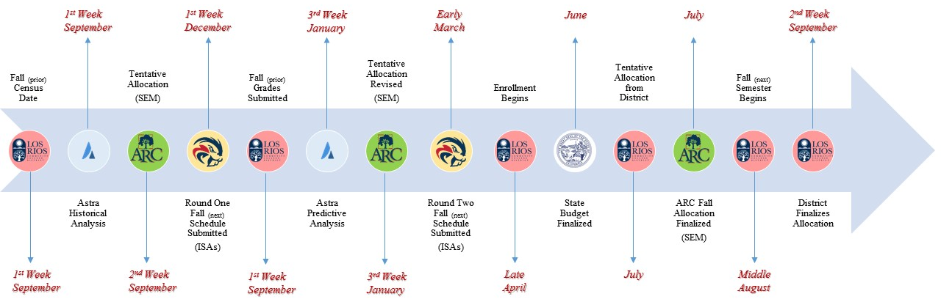
Figure 8: Diagram of FTEF Allocation process
The Allocation is refined as additional information comes in from the state and district. Ultimately, when the final allocation is approved by the state in September, the Spring Allocation will often bear the burden of having to be adjusted to compensate for any over or under scheduling in the fall semester. This timeline has led to radical scheduling swings in Late August and mid-January as the college and divisions attempted to adjust to FTEF swings coming in from the district. A primary interest in moving towards a more Strategic Enrollment Management process will be to mitigate and minimize these schedule swings. This will be accomplished by:
- Focusing upon the core schedule and identifying where there may be bottlenecks preventing students from moving efficiently through programs.
- Identifying opportunities to pre-schedule potential sections and hold them as inactive until bottlenecks and additional resources may be identified.

Identifying FTEF scheduled in the Previous Like-Fall Term
FTEF totals for Los Rios academic schedules are dynamically calculated by district in order to populate the quarterly CCFS-320 reports to the California Community College Chancellor’s Office (CCCCO) and Crystal reports. The CCFS-320 reports are what the CCCCO uses to determine the enrollment funding for the district. The baseline report used to begin the allocation process is the District Crystal report Summary FTE & WSCH by Location (RCSM 0294). When run after census, this report provides an accounting of the baseline of what was scheduled in each division (See Appendix 2: Fall 2019 Summary FTE & WSCH by Location, page 1).
This report provides the total numbers of sections and FTEF scheduled by location. At ARC, division allocations are all of the sections which are taught on (or in the case of online sections: scheduled through) the Main campus. The exception to this are the TVC sections taught at Mather that are a part of TVC’s Main Campus allocation. The allocations for McClellan and Natomas are based upon the total amounts of FTEF to be scheduled at the center and are not split up into division allocations (the center deans allocate to the different departments/divisions within the center’s offerings).
From the totals of FTEF scheduled provided by the Summary FTE & WSCH by Location report, the following types of FTEF needs to be removed from the totals in order to get an accurate accounting of what was scheduled by divisions with their prior allocations:
- Any grant funded FTEF (sections that are paid for through external funding sources). Grant funded FTEF is scheduled on top of the FTEF allocation provided by district. District tracks grant funded sections through how they are tagged in PeopleSoft. The sections (and FTEF) charged to grants can be found in the Grant Funded Classes (RC SCH 0358) Crystal report.
For the FA19, the following grant funded FTEF was scheduled:
Div | FTEF |  | Div | FTEF
BSS | .200 |  | HEDU | .400
ENG | .267 |  | TVC | 1.374
The grant amounts should be removed from the division totals provided by the FTE & WSCH by Location (RCSM 0294) report.
- Apprenticeship, public safety, and other categorically funded FTEF that is scheduled as Positive Attendance uses a different method to calculate their allocation (based on actual use and WSCH generation from the prior like term). For the sake of calculating allocations for the upcoming semester, work with DO for the amounts that they will be projecting for the upcoming term.
- Dual Enrollment FTEF used to schedule online courses taught for local high School Students. This FTEF comes out of ARC’s District FTEF allocation, but is not a part of the division’s allocation (rather the Advanced Ed program receives its own allocation). The list of these sections is maintained by the Associate Vice President of Instruction’s office.
For the FA19, the following Advance Education funded FTEF was scheduled:
Div | # of Sections | FTEF
ART | 1 | 0.200
BSS | 5 | 1.000
ENG | 6 | 1.200
Note that this FTEF is removed from the totals of the divisions (i.e. not counted as a part of the division’s allocation), but is still a part of the overall FTEF charged to the college. This total becomes the baseline for the Advanced Education allocation. While the FTEF is removed from the allocation, the WSCH generated is still counted towards division and department goals.
- The Study Abroad FTEF (this refers to the semester long, district program that is currently housed at American River College) needs to be removed from the semester’s schedule as the 0.800 FTEF is provided as a separate allocation from district. This allocation is maintained by the Study Abroad director’s office.
For the FA19 schedule being used as an example for this document, the BSS division scheduled an additional 0.800 FTEF to support the Study Abroad program.
Note that the FTEF for the study abroad sections are removed from the totals of the division (i.e. not counted as a part of the division’s allocation). At this point, the Study Abroad FTEF is still a part of the overall FTEF charged to the college, though it is a district program. While the FTEF is removed from the allocation, the WSCH generated is still counted towards division and department goals.
- The Honors sections FTEF potentially would need to be removed from division totals, if the Honors program was moved to a model of receiving an allocation for offerings, rather than Honors courses being offered though division decisions. Honors sections are designated by numbers between 480 and 489 and the FTEF for these courses should be removed for each division this can be calculated from the Class Size No Grouping by Loc (RC IN S0019) Crystal report. | Aspirational Goal 3
For the FA19, the following Honors funded FTEF was scheduled:
Div | # of Sections | FTEF
BSS | 3 | 0.600
ENG | 5 | 1.000
HEDU | 1 | 0.200
SCI | 1 | 0.350
Note that this FTEF is removed from the totals of the divisions (i.e. not counted as a part of the division’s allocation), but is still a part of the overall FTEF charged to the college. This total becomes the baseline for the Honors program allocation. While the FTEF is removed from the allocation, the WSCH generated is still counted towards division and department goals.

The Division Baseline FTEF
The baseline FTEF is the minimum amount of FTEF a division needs to meet the obligation to schedule to meet the full-time faculty obligation. The amount is exclusive of any reassigned time or coordinator time assigned to fulltime faculty (this means that it may not be a 1:1 relationship between the number of fulltime faculty and the amount of FTEF needed to meet scheduling obligations). This number is provided by the Instruction office and is generated through the Regular Position Control FTE requests sent out to divisions.

Baseline FTEF Delta
Fall marks the beginning of the hiring process for American River College. As a part of this process, divisions must identify how resignations, retirements, or potential new hires may affect the FTEF needs in the following fall schedule. For example, a division may be intending to hire a new faculty and convert currently taught courses (taught by adjuncts or a retiring/resigning faculty member) into the load of the new faculty member, this would represent a 0.000 change in the allocation need. Alternately, a division may be adding in a growth position to expand offerings within a program that would represent a need for additional FTEF to be added into the division FTEF Allocation.

Legislative, Policy, or other mandated changes requiring FTEF Allocation adjustment
- What is ARC’s process to evaluate potential FTEF shifts caused by external factors? How do we plan for how these external factors will result in FTEF being shifted within the college or the district?

Opt-Out Schedules requiring FTEF Allocation adjustment
- How do we ensure that the sections promised in the opt-out scheduling process (which will begin months after the schedule is initially discussed) are available for students?
Analytics requiring FTEF Allocation adjustment  - What are the criteria by which allocations should be adjusted due to analytics?  - What do those analytics need to evaluate?  - What is the human factor in the analytics that provides context? | Aspirational Goal 4

Pathways requiring FTEF Allocation adjustment
- How do we ensure that the sections promised in American River College’s pathways are available for students?  - How do we balance the developed pathways with the number of students in a pathway (i.e. how do we account for pathways where there are very low number of students identified as being in the pathway?) | Ad Astra Config 2

SEM and the FTEF Allocation
The Strategic Enrollment Management will use the prior term data along with the following points to develop ARC’s divisions and centers’ Tentative FTEF Allocation and WSCH goal for the upcoming term:
- Did the division meet their WSCH goal for the previous term?
- Did the division over-schedule, under-schedule, or match their FTEF allocation for the previous term?
- What significant programmatic changes have occurred in the division between the upcoming semester and the previous term? For example:
  - Curriculum changes
  - Associate Degrees for Transfer or other Articulation changes
  - Proposed staffing changes (faculty hires, resignations, or retirements)
  - Legislative changes requiring FTEF adjustment
  - Identified bottlenecks that prevent students from getting the classes that they need to be successful.
The Fall FTEF Allocation process begins with the FTEF scheduled at census for the prior like-fall-term’s allocation. The overall allocation must be built off an assumption that the allocation will remain relatively consistent term to term. The information from the criteria and data points listed above are entered into the Fall FTEF Allocation Worksheet (see Appendix 3: FTEF Worksheet, page 1) and the committee works to adjust allocations as necessary. The preliminary allocations are distributed with the first round of the fall schedule, in September. These allocations need to be updated or adjusted at a series of points throughout the semester:
- First Revision: Before the second planning round for fall is distributed at census for the spring term directly before the fall term. This allows adjustment to account for changes in the prior-Fall term since census, enrollment trends, and to account for potential spring changes. ).
- Second Revision: Mid-summer as the actual FTEF allocation is provided by the district.
- Third Revision: Three weeks out from the semester starting to account for enrollment trends.
If the fall schedule is over-scheduled, (i.e. more FTEF is scheduled than allocated) the overage will be taken from the Spring FTEF allocation. The District Office manually produces an Instructional FTE Report on the full term Census date (3rd week of the semester). The report is produced in November (the FA19 report was produced on 11/19/20 and was distributed to the VPIs at their meeting on 11/26/19). The numbers provided by this report offer District Office’s official accounting of the FTEF scheduled by the college in the fall and therefore must be used to verify the allocations for the upcoming spring semester.

The Spring FTEF Allocation
The total allocation of FTEF available to be scheduled for the spring semester is the estimated Annual FTEF allocation from the LRCFT Annual Budget minus what was allocated in the fall semester. In the case of the fall 2020 worksheet, the annual allocation for FA19 was 522.90; therefore, ARC had a total of 1045.800 FTEF for the year. FA20 total allocation is 525.211 that leaves 520.589 for the amount that can be scheduled for spring 2021. Enrollment is generally larger in fall semesters and therefore FTEF is weighted to provide more sections in the fall than in the summer.

The Summer FTEF Allocation
The summer allocation process in not clearly defined at district. ARC will need to work with DO to fully define how this allocation is set and how the WSCH and FTES generated from the Summer term is accounted for (i.e. the mechanisms by which it may be rolled forward into the next fiscal year and when we roll it back into the current fiscal year).
Aspirational Goal 5 | The SEM will continue to work with available Crystal reports and datasets to align our decision making with the data that District is using to make decisions. Ultimately, ARC’s homegrown numbers must be reconciled with the official enrollment, WSCH, and FTEF values that District is using. District’s numbers trumps local numbers.

Student Contact Hours Goals

What are Student Contact Hours and why do they matter?
Fundamental to understanding Student Contact Hours is an understanding of how California Community Colleges are funded. The State provides most of the funding for California Community Colleges based on the number of students attending the college. The number of students attending a college are packaged up into the Full Time Enrollment Student (FTES). FTES represents neither student headcount nor student enrollment, but it is a conceptual measure of student enrollment. One Full-time Equivalent Student (FTES) is equal to one student enrolled in 15 semester hours for 2 semesters. One FTES is equal to 525 contact hours. This “conceptual” measurement is the basis of how California Community Colleges receive 60% of their funding from the state. FTES is calculated differently depending upon the designation of the section’s Attendance Type.
 |  | Attendance Type
 | TERM | W | D | P | O
 | OT | 0 | 358 | 297 | 8
 | FT | 2061 | 11 | 61 | 2
 | 8W1 | 0 | 104 | 5 | 0
 | 8W2 | 1 | 147 | 0 | 1
 | 8WB | 0 | 5 | 1 | 0
 | 5W1 | 0 | 15 | 0 | 0
 | 5W2 | 0 | 18 | 0 | 0
 | 5W3 | 0 | 20 | 0 | 0
Total # of sections |  | 2062 | 678 | 364 | 11
% of Schedule |  | 66% | 22% | 12% | 0%
Figure 9: Count of sections by Attendance Type and Term for sections scheduled with FTEF in SP20. From Crystal Report Class Size No Grouping by Loc (RC IN S0019) generated 2/13/2020.
The most common Attendance type in the American River College schedule is full-term, weekly attendance (W) sections. Sections scheduled in for the full term with an attendance type of ‘W’ are also the easiest types of sections to calculate Student Contact Hours for and are reported as Weekly Student Contact hours (WSCH). These courses have their WSCH set at census (the Monday of the third week of the semester).
The next most common type of sections scheduled are sections scheduled with daily attendance (D). These are most often sections scheduled outside of the full-term. Sections scheduled with daily attendance have a slightly more complicated calculation for their Student contact hours that are reported as Daily Student Contact Hours. These courses have their DSCH set at the census date for the term that they are scheduled in, which is at the 20% mark of the term.
Positive Attendance courses WSCH is calculated at the end of the semester and is based on the actual number of hours spent in instruction by each student enrolled in a section. This makes Positive Attendance courses extremely difficult to predict or monitor through the semester (attendance reports are not tabulated until the end of the semester not on an ongoing basis throughout the semester.

Challenges of Measuring/Predicting WSCH
There are some challenges to contemporaneously predicting and measuring WSCH when planning a term or monitoring enrollments:
- WSCH is calculated differently for different types of attendance types. While Weekly attendance is easy to calculate, Daily Attendance is more complicated, and Positive Attendance is impossible to calculate until the end of the term.
- WSCH and DSCH are used to calculate FTES and becomes the basis of 60% of the funding that Los Rios receives from the state. The LRCCD fiscal office is very concerned about making sure these numbers are accurately reported to the state each quarter on the CCCCO 320 Apportionment report. The calculations for these reports are very complex and the expectation from the state is that the district will continue to submit revisions to the FTES values through the reports that are submitted after the close of a term. The Los Rios District’s models are built for accurate reporting of FTES (with room for revisions) not accurate predicting or monitoring of FTES or WSCH.
- It is unclear how WSCH is calculated/tabulated in district crystal reports. For example, in the Class Size No Grouping by Loc (RC IN S0019) report, which is recommended by this report to be used for monitoring FTEF scheduled and enrollment, not all of the courses have WSCH calculated:
ATT_TP | Count of sections | WSCH Reported | % Reported | No WSCH Reported | % not Reported
D | 678 | 663 | 98% | 15 | 2%
P | 364 | 173 | 48% | 191 | 52%
W | 2062 | 2055 | 100% | 7 | 0%
O | 11 | 6 | 55% | 5 | 45%
Total | 3115 | 2897 | 93% | 218 | 7%
Figure 10: Count of sections with WSCH calculated by Attendance Type and Term for sections scheduled with FTEF in SP20. From Crystal Report Class Size No Grouping by Loc (RC IN S0019) generated 2/13/2020.
Care will need to be taken in working with departments/divisions who have multiple positive attendance sections or daily attendance to build predictive models to assist in monitoring and planning for WSCH generation. In addition, the totals of WSCH reported on this report are tentative and likely to be recalculated as additional attendance information is provided.

District WSCH Goals
The District Office produces an annual budget that includes the FTEF allocation for the college as well as Weekly Student Contact Hours (WSCH) goals and productivity goals. The district provides annualized FTEF, WSCH, and productivity goals, meaning that the totals below represent one-half of the total allocation and WSCH production for the year (i.e. the total FTEF allocated for fall and Spring in 2018-19 was 1,052 FTEF and the college generated 482,000 WSCH).
Figure 11: From 2019-20 Adopted Budget presented to the Board of Trustees September 11, 2019, Pg. 124
For example, in the above figure, District is projecting an 11.54% increase of WSCH generation year over year (with a 6.000 reduction of FTEF). Historically, WSCH goals have been communicated as a general growth target (for example, with the above allocation we might say, “ARC needs to grow by 11%”). There are structural issues with approaching WSCH goals as a singular growth number for the whole college. In particular, there are programs that are impacted by space concerns, limited lab slots, accreditation limitations, et cetera. that simply cannot meet an 11% growth target. While there may be other programs that can absorb that much (and more) growth. Without carefully considering where it is appropriate to direct growth efforts, we may anticipate growth from areas that are too constrained to grow, miss opportunities for appropriate growth, or promote short-term growth that may hurt long-term growth (e.g. adding in additional sections in the fall that decimates enrollment in the spring). Applying a universal growth target is a non-strategic approach to directing resources towards meeting college growth goals.

Division/Department Level WSCH Goals
Similar to the process described to identifying FTEF scheduled in the previous like term (page 1), the process of identifying the WSCH generated begins with the Summary FTE & WSCH by Location (RCSM 0294) Crystal report as a part of the FTEF allocation process. See Appendix 3: FTEF Worksheet, page 1 for the current version of the FTEF allocation worksheet that also contains WSCH goals. At this stage in WSCH monitoring and goal setting, ARC is not setting specific goals for divisions, rather it is responding to the overall percentage which district is projecting out for the college.
The LRCFT contract, §4.5.3.1 and §4.5.3.2 establish potential structures for both College and Division Workload Committees to “…determine the WSCH goals for each of the major subject areas and the workload goals for other service areas in order for the college to obtain the overall assigned workload goals.” The college will need to work to formulate advisory, analytic, and monitoring structures to promote a more robust engagement with individual divisions being responsible for hitting WSCH goals. In particular, the college will need to work on:
- Metrics, tools, and procedures for setting reasonable WSCH targets for departments and divisions.
- Tools to provide “sandboxes” in schedule development to help predict how changes to a draft schedule may affect a department or division hitting their WSCH goals.
- Tools to measure WSCH (and project trends) during enrollment.
- Procedures for post-mortem evaluation of how divisions and departments did in meeting WSCH targets.

Phased in approach to WSCH goals

Fall 2020
Aspirational Goal 6 | An analysis of the past five Fall schedules (2014-2019) will be run to identify trends in FTEF and WSCH generation at the department and division levels. This trend data will be compared with the pathway and program predictive data from Ad Astra’s Platinum Analytics to evaluate opportunities for increasing WSCH. In addition working with department chairs and division deans, the SEM will identify:
- Programs and pathways which may be limited in their ability to increase WSCH generation due to accreditation, physical space, staffing, or other structural limitations of the programs and pathways.
- Opportunities where ameliorating bottlenecks in the schedule may provide opportunities for student persistence, increased enrollments (and WSCH generation), and degree and certificate completions.
- Evaluation and identification of capstone courses and developing appropriate rotational offerings. Collaborating with Ad Astra, the SEM will be working to develop a methodology to measure the Pathway Critical Mass of program that assesses the number of students who have identified that they are in a program or pathway and then helps to predict the number of students available each term to take capstone courses.
- Developing more nuanced rubrics to assess the need to cancel or add in sections. ARC has traditionally relied on a blanket “if a course is enrolled with under 22 students or under 80% of the course cap it should be cancelled,” the reality is often much more nuanced and variable. The SEM will work with departments and divisions to develop specific rubrics and criteria for different types of courses which take into account student completion and persistence, WSCH generation, faculty loads, and assessment tools to predict sections which may be challenged during enrollment so that decisions can be made earlier in the scheduling process.
The work that the SEM does regarding WSCH and the Fall 2020 schedule will provide recommendation late in the schedule building process, so it is more likely that the recommendations, rubrics, and techniques developed while assessing Fall 2020 will be of value as a development phase for building the toolkits. At a minimum, fall 2020 will have flat percentage recommendations for increased WSCH applied to divisions’ term-over-term WSCH generation (see Appendix 3: FTEF Worksheet, page 1 of this document). The SEM will work to provide data and reports to assist departments and chairs monitor WSCH generation throughout enrollment.
Before FTEF allocations and WSCH goals are sent out for fall 2021, there should be a full analysis of WSCH potential before the schedule drafts are sent out to departments.

Spring 2021
By spring 2021, the SEM should have the rubrics for adding in sections/cancelling sections defined for use by divisions. More specific and tactical WSCH goals (taking into account opportunities for growth and programs that have affected enrollments and cannot increase WSCH) should be in place. Round two of the fall 2021 and spring 2022 schedules should be informed by the WSCH goals, tools, and analytics.

Block Scheduling

Guiding Principals
Classroom spaces are a limited resource and it is the role of the administration and department faculty to ensure that they are scheduled efficiently to promote student success and the mission of the college. Classrooms are owned by the college and ultimately by the citizens of the State of California and not by any department or individual. While classrooms may typically be scheduled by individual departments, the assignments are not considered permanent.
Classroom scheduling is a dynamic process requiring reevaluation of class size, equipment specifications, and pedagogical changes each semester. The assignment of a specific room at a specific time in a given semester will not automatically guarantee a continuing assignment of that space, even if the room was used efficiently. Faculty members should not expect to use the same space on a continuing basis.
To carry out the mission of American River College, the classroom facilities are primarily for use by students, faculty and staff for activities and programs that are directly related to supporting students in strengthening basic skills, earning associate degrees and certificates, transferring to other colleges and universities, and achieving career as well as other academic and personal goals. Every effort is made to ensure that classrooms are assigned fairly, used appropriately, and accommodate the College’s academic and instructional needs.
All departments are strongly encouraged to plan and distribute classes across all the days of the week (Mon – Fri) and all hours of the day as much as possible to maximize use of campus classrooms and minimize class conflicts for students. These protocols are designed to ensure that semester course offerings are scheduled in a manner that permits access to available offerings by the greatest number of students and that allows the best match between the specific instructional needs of the faculty and courses being offered and the existing facilities.
Teaching facilities are a finite resource, and the goal of these policies is to maximize room and seat utilization as well as apply scheduling policies in a consistent and equitable manner. These objectives and classroom utilization expectations apply to all academic departments and classroom space.

Block Scheduling/Uniform Meeting Patterns
In the fall of 2016, Dean Roger Davidson produced a draft of a Block Scheduling procedure for ARC. This portion of the paper will utilize that proposal as a basis with commentary injected with suggestions from the other Policy papers.

Overarching Guidelines
- There are more 3-unit lecture classes at ARC than any other format, and since these courses fit contiguously with a 10-minute passing time every 90 minutes, these “blocks” starting at 7:30AM form the basis for scheduling other class formats.
- Try to keep other class formats from crossing more than two “blocks” in general, and try to avoid more than one crossing during peak hours (assumed 9AM-1PM).
- Start evening classes at 6PM (no earlier than 5:30PM) to allow working students to travel from work to campus for class.

Proposed Start Times (by class units and days per week):
3-unit classes
- Meeting twice per week (MW or TR) – 80 minutes per day
  - 7:30AM, 9AM, 10:30AM, Noon, 1:30PM, 3PM, 4:30PM, 6PM, 7:30PM
  - These are the basic “blocks” of the block schedule.
- Meeting once per week – 185 minutes per day
  - Noon, 6PM
- 3-Unit Lecture/Lab sections need to start at a block time or end before a block time (schedule to minimize crossing blocks).
4-unit classes
- Meeting four times per week (MTWR) – 50 minutes per day
  - 8AM, 9AM, 11AM, Noon, 2PM, 3PM, 5PM, 6PM
- Meeting thrice per week (MWF {or TRSa?}) – 70 or 75 minutes per day
  - 7:30AM, 9AM, 10:30AM, Noon, 1:30PM, 3PM, 4:30PM, 6PM, 7:30PM
  - Same as the 3-unit, 2-day blocks
- Meeting twice per week (MW or TR) – 125 minutes per day
  - 8AM, 10:30AM, 12:45PM, 3PM, 6PM
- Meeting once per week (F, Sa or Su) – 245 minutes per day
  - 8AM, 1PM
5-unit classes
- Meeting four times per week (MTWR) – 65 minutes per day
  - 7:45AM, 9AM, 10:45AM, Noon, 1:45PM⁴, 3PM, 4:30PM, 6PM, 7:30PM
- Meeting thrice per week (MWF {or TRSa?}) – 90 minutes per day
  - 7:20AM, 9:15AM, 11AM, 12:45PM, 2:25PM, 6PM
  - Same as the 3-unit, 2-day blocks
- Meeting twice per week (MW or TR) – 140 minutes per day
  - 8AM, 10:30AM, 1:30PM, 6PM

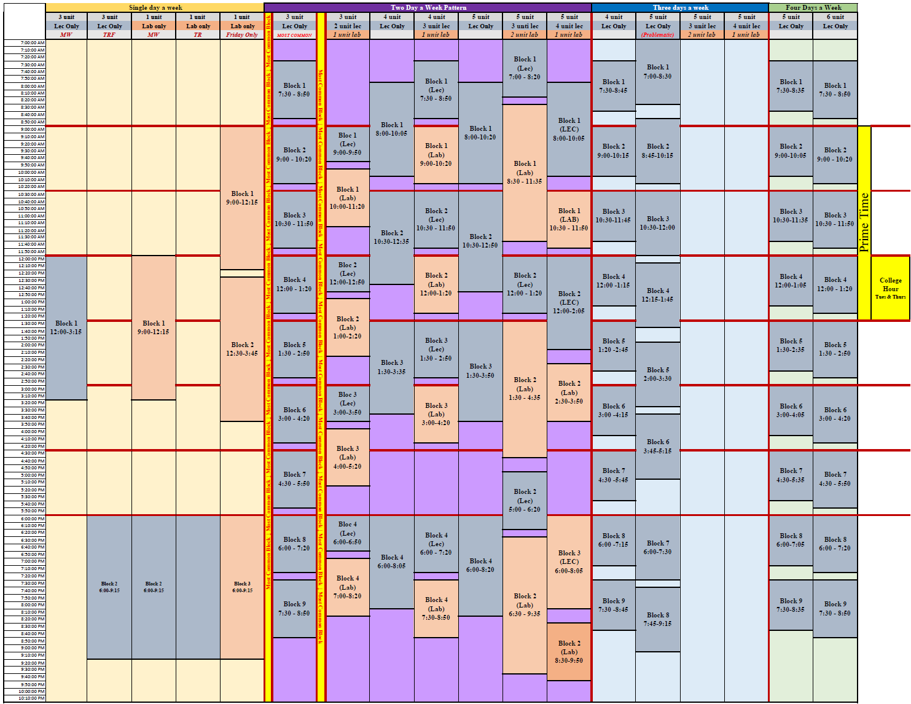

Phased in Approach to Block Scheduling

Fall 2020:
Aspirational Goal 7 | An analysis of the Fall 2020 schedule will be run to identify sections that have been scheduled off-block. Department Chairs and Deans will be asked to discuss their reasoning for why sections were scheduled off block. Through this analysis and discussion with divisions/departments, the Strategic Enrollment Management team will identify:
- Any rooms that are only used by particular programs and therefore sections scheduled off-block will not affect the room use efficiency (e.g. welding labs, science labs, or other specialty facilities). Research will then be performed to see if the scheduling of these sections off block produce programmatic bottlenecks for students to take additional courses in a semester.
- Potential efficiencies where inefficient off-block sections could be paired with another like section to increase efficiency (e.g. a partially online section which meets only on Tuesdays from 10:00-11:50 might be paired with a Thursday partially online section which also meets 10:00-11:50).
- Goals and thresholds for department/divisions to meet in scheduling on block. For example, several higher education scheduling procedures throughout the country include a requirement that departments maintain a minimum number of sections scheduled on block.
- Sections or programs that may need an exemption from block scheduling (and potential ramification for students if a program is scheduling off block.)
- Experimental use of the Ad Astra Room optimizer to build out procedures to maximize room efficiency.
- Refined Block Scheduling proposal to be run through Student Success Council, Fall 2020

Spring 2021:
Aspirational Goal 8 | An Off-Block Room report will be run prior to the schedule going live for students to see. Deans and departments will be asked to justify schedules that are off-block.
Ad Astra Config 3 | Through Fall 2020 and Spring 2021, the SEM will also engage in conversations to develop room use priorities and procedures/criteria where we may use the Ad Astra Room optimizer to help with assigning sections to rooms.

SEM Recommendations
RECOMMENDATION 1:
Develop standing Strategic Enrollment Management team to monitor enrollment data, rubrics, and procedures. This team will provide recommendations on:
- FTEF allocations to divisions
- Recommendations on enrollment policies and criteria (for example developing the criteria by which sections may be scheduled outside of the block scheduling blocks).
- Curate enrollment reports and host scheduling post-mortems to discuss trends in enrollment.
- Discuss and develop WSCH goals for divisions.
RECOMMENDATION 2:
Hire support staff to facilitate maintenance of Ad Astra Platinum system, interface between data on demand system (research office), and coordination with other technical solutions (Highpoint, Starfish, et cetera.)
RECOMMENDATION 3:
Work with District IT to build out six development schedules in PeopleSoft:
- Fall Odd-Years
- Fall Even-Years
- Spring Odd-Years
- Spring Even-Years
- Summer Odd-Years
- Summer Even-Years
These six development schedules would then be evaluated using Ad Astra and other data to create the stock offerings that will be used to rollover into the development terms for the appropriate upcoming semester. For example, the Fall Even-Year Development Term would be rolled over into the fall 2022 developmental schedule. See Rollover schedules in this document for more information.
RECOMMENDATION 4:
American River College needs a centralized system to track external FTEF (grants) that fund sections, instructional FTEF used to support coordinators and other work of the college, and other programs that are scheduling sections in addition to division offices (e.g. the Advanced Education program).

SEM Next Steps/Aspirational Goals
- Fall 2021: SEM will develop and submit to Student Success Council a Refined Block Scheduling proposal that will include exemptions, thresholds, goals, and other specific procedures.
- Fall 2021: SEM will investigate using the Ad Astra Optimizer and build priority lists of when sections should be scheduled in classrooms.
- Develop metrics and analytics to support measuring and planning for expanded use of short-term sections.
- Develop metrics and analytics to measure demand for different instructional modalities (fully online, partially online, face-to-face, et cetera.).
- Refine predictive modeling for capstone classes to help identify ideal rotational patterns for traditionally low-enrolled sections.
- Refine rubrics for different types of sections to identify when sections need to be cancelled and when additional sections may need to be added into the schedule.
- Work towards building a schedule that we can consider a promise to American River College’s students and faculty where we do not cut sections right before the start of the semester.
- Work with ARC research and District Fiscal to build reports and tools to better predict and monitor the FTES and WSCH production of sections from the planning stage, through registration, and to the various census dates for different Attendance types.
- Refine techniques of creating realistic and data based WSCH goals to assist in meeting the division/college level WSCH goals.
- Tools to provide “sandboxes” in schedule development to help predict how changes to a draft schedule may affect a department or division hitting their WSCH goals.
- Tools to measure WSCH (and project trends) during enrollment.
- Procedures for post-mortem evaluation of how divisions and departments did in meeting WSCH targets.

Glossary:

1st Round Planning | Campus Definition | The first opportunity to review data and indicate desired changes for the upcoming term(s). Changes are entered into PeopleSoft by an ISA prior to 2nd Round Planning.
2nd Round  Planning | Campus Definition | The last opportunity to review data and indicate desired changes for the upcoming term(s). The 2nd Round uses a snapshot of the rolled data after all 1st round changes have been applied. The data should be checked for accuracy and any additional changes should be indicated. After 2nd Round Planning, an ISA will enter the revisions in PeopleSoft prior to the district-wide deadline for schedule changes. Once the deadline passes, sections can no longer be deleted.
Apportionment: State to District | CCCCO Definition | The state of California provides apportionment funding to colleges that is primarily based on FTES. In general, ARC receives more funding if it generates more resident FTES. Credit classes are funded at a higher rate than non-credit classes.
Allocation, FTEF from District to College | District Definition  &  Campus Definition | The amount of FTEF available to a college, division, or department to schedule its course offerings. The district provides an allocation to the college as a part of the Los Rios Budget process (generally goes to the Board for a final approval around September).  The College allocates FTEF to divisions as a part of the schedule planning process (October for the following Fall and Summer terms and March for the following Spring Term). Note that the FTEF allocation from district is finalized eleven months after the allocation is provided for planning.
Allocation, FTEF to Divisions | Campus Definition | Divisions receive a FTEF allocation from the Instruction Office to assist in planning upcoming terms. The first allocation is provided with the release of the 1st round planning schedule draft. This allocation may be revised by the Instruction Office with the release of the 2nd Round scheduling draft and may be further adjusted through the enrollment period to reflect demand and enrollment trends.
Allocation, FTEF to Departments | Campus Definition | Division deans allocate FTEF to the departments within the division and may shift FTEF between departments to match enrollment trends.
Areas of Interest | Campus Definition | ARC has defined eight broad areas of interest that students can explore before deciding on a specific program. Each area is a group of related programs organized by theme. Once a student selects an area of interest, the related pathway community provides further connection to career- and program-oriented information and services. The pathway communities are:  - Arts  - Business  - Health, Human Services & Well Being  - Language and Communication  - Manufacturing, Construction & Transportation  - People, Culture & Society  - Public Service  - STEM
Attendance Type | CCCCO Definition | The state reimburses ARC using different calculations depending on the Attendance Type that a section is designated.  The common attendance types are (See FTES for specifics on how these types impact calculations for reimbursement):  - Weekly attendance (most common)  - Daily  - Positive Attendance  For specifics see the CCCCO Student Attendance Accounting Manual.
Block Scheduling | Campus Definition | At ARC, block scheduling refers to the use of standardized time blocks to create a schedule with fewer conflicts for students and more efficient room utilization.
Bottleneck Course | Ad Astra Definition | A scheduling deficit where students are unable to proceed through a degree pattern or pathway due to there being an insufficient number of seats scheduled in a term.
Capstone Course  (WORKING DEFINITION) | Campus Definition | A Capstone Course is a course that is a required part of a program (degree or certificate). These sections are often low-enrolled, single sections on a schedule and may be identified as “Elimination” Candidates” by Ad Astra.
Daily Contact Hours | CCCCO Definition | In the California Community colleges, an hour is 50 minutes, there are required breaks, and byzantine rules to calculate out how to calculate the number of hours of contact based upon the number of minutes of instruction. For more specifics, see the CCCCO Student Attendance Accounting Manual.
Fill-Rate  (Fill Ratio) | Campus Definition | The ratio that a particular section has filled. This is measured by:  Enrollment  Max Class Size
FTEF | CCCCO Definition | This stands for Full Time Equivalent Faculty. In a FTEF, a faculty member’s actual workload is standardized against the teaching load. Thus, FTEF does not represent an actual number of faculty members; it is a conceptual measure workload at an academic department, or an institution. In Los Rios FTEF is calculated slightly differently between lecture and lab instruction modes:  - Lecture sections: one unit of lecture is equal to 18 hours of instruction and represents .066FTEF. Thus, a three-unit lecture course is equal to 54 hours of instruction and represents .200 FTEF.  - Lab Sections: one unit of lab is equal to 54 hours of instruction and represents .150 FTEF.  One of the most common types of lecture/lab sections in ARC’s schedule is 36 hours of lecture (2 units of lecture and .133 FTEF) and 54 hours of lab (1 unit of lab and .150 FTEF) for a total of 3 units and .283 FTEF.
FTES | CCCCO Definition | This stands for Full Time Equivalent Students FTES is a standard statewide measure of student enrollment at an academic department, or an institution. FTES is a key performance indicator, productivity measure, and funding rate. FTES represents neither student headcount nor student enrollment, but it is a conceptual measure of student enrollment. One Full-time Equivalent Student (FTES) is equal to one student enrolled in 15 semester hours for 2 semesters. One FTES is equal to 525 contact hours.  FTES is calculated differently depending upon the Attendance Type of the section.
FTES (Weekly) | CCCCO Definition | Weekly Census Procedure  - Offered for Credit and in primary terms only  - Course is coterminous with the primary term  - Meets the same number of days and hours each week of primary term, including TBA hours  - Synchronous Instruction occurs each scheduled class meeting and students and instructor are able to interact during the class session via some sort of communication technology  - Clears the rolls of inactive enrollment as of census date  - WSCH is from regularly scheduled contact hours  FTES for Weekly Census courses is calculated as:  WSCH x TLM  525  For specific information, see the CCCCO Student Attendance Accounting Manual.
FTES (Daily) | CCCCO Definition | Daily Census Procedure  - Offered for Credit and meets five or more days  - Meets the same number of hours on each scheduled day, including TBA hours  - Not coterminous with the primary term  - Synchronous Instruction occurs each scheduled class meeting and students and instructor are able to interact during the class session via some sort of communication technology.  - Clears the rolls of inactive enrollment as of census day  - Daily Student Contact (DSCH) is generated from regularly scheduled contact hours  - Daily Attendance includes classes that meet on a regular basis for at least 5 days, but do not meet the full semester.  - Enrollment is counted on each course’s individual census day (20% of course). Summer, short-term courses, and Intersession are generally coded as Daily Contact.  FTES for Daily Census courses is calculated as:  (DSCH x Enrolled) x Total days met  525  For specific information, see the CCCCO Student Attendance Accounting Manual.
FTES (Positive Attendance) | CCCCO Definition | Positive Attendance Procedure  - Synchronous Instruction occurs each scheduled class meeting and students and instructor are able to interact during the class session via some sort of communication technology.  - Instructor must keep accurate records of every hour each student attends  - Contact hours based upon the count of students present at each course meeting. No census date.  - Positive attendance cannot be accurately calculated until the end of the semester and attendance records are submitted.  - Actual hours of attendance are counted. If a student attends, they count. If not, they do not. Every 525 hours counts as one FTES.  - Positive Attendance is calculated using the Weekly Contact Hours (WCH), which is the number of hours met each day multiplied by the number of days met each week.  - Positive Attendance courses generally are:  - Irregularly scheduled credit courses  - Open entry/open exit  - Non-credit classes  - Apprenticeship classes  - Tutoring courses  For specific information, see the CCCCO Student Attendance Accounting Manual.  FTES for Positive Attendance courses is calculated as:  ( (Enrolled x WCH) x TLM ) x % of attendance  525
FTES (Alternative Attendance) | CCCCO Definition | Alternative Attendance Accounting Procedure  - Most DE courses do not have the attributes necessary to apply one of the basic attendance accounting procedures:  - Weekly Census, Daily Census, and Positive attendance  - For these courses, the only option left is the Alternative Attendance Accounting Procedure  - Unless eligible for an exception provided by Title 5 §58009, this procedure uses the number of units of credit as the basis for determining the number of student contact hours for the course  - Attributes of a Distance Education Credit Course on Alternative Attendance Accounting Procedure  - The Title 5 §58009 exception applies only to Independent Study LABORATORY courses and DE LABORATORY courses that consist partly or exclusively of laboratory work  For specific information, see the CCCCO Student Attendance Accounting Manual.
Pathways | District Definition  &  Campus Definition | A program map or a pathway is a promise that we are making to students that they will be able to complete a program in a set amount of time. The pathway is developed by departments to lay out how courses will be offered to allow students to plan how they will take courses and complete the pathway.
Pathway Critical Mass | Campus Definition  &  Ad Astra Definition | The Pathway Critical Mass (PCM) is a measurement of the expected number of students within a pathway who will enroll in capstone courses. For example if you have a pathway with 120 declared majors, an expectation of completion in four semesters, and a class that is offered every semester, the expectation would be that there would be 30 students potentially available to enroll in a capstone course each term.  Majors = Program Critical Mass  # Terms offered  The PCM value will be used to evaluate capstone course offering patterns (if offering a class every term produces a low PCM, it may be suggested to change the frequency that a course is scheduled.
Productivity  WSCH/FTEF | CCCCO Definition | Measure of instructional resource efficiency. Productivity is calculated by dividing Weekly Student Contact Hours (WSCH) by total instructional full-time equivalent faculty (instructional FTEF).  For specific information, see the CCCCO Student Attendance Accounting Manual.
Opt-Out Scheduling | District Definition  &  Campus Definition | A technique where incoming students are provided with a draft schedule for their first term that they will be attending American River College. In order to change the schedule they would have to “opt-out” and change it themselves. The precise mechanism of how ARC will do this is still in development (SP20).
Rolled Schedule | Campus Definition | A copy of the schedule from the last similar term (e.g., current fall schedule is rolled for the upcoming fall). Section information including days, times, meeting patterns, and schedule notes are rolled. Instructors and rooms are not copied.
Term Length Multiplier | CCCCO Definition | The standard California Community Term length is 17.5 weeks. Colleges may choose (with Chancellor’s office approval) to compress their calendar, teaching more hours per week in fewer weeks. To account for this in calculating FTES, the State Chancellor’s office assign Term Length Multipliers (TLM) to standardize FTES calculations across all 114 on-ground California Community colleges. The TLM are available on the State Chancellor’s website. American River College’s TLM is 17.0.
Time Block | Campus Definition | This represents a meeting pattern of the start time and end time for a course along with the day pattern.
WSCH | CCCCO Definition | Weekly Student Contact Hours. Measure of instructional contact. Generally calculated as number of hours of contact per week multiplied by the number of students enrolled.  For specific information, see the CCCCO Student Attendance Accounting Manual.
WSCH & Productivity Goal: District | District Definition | As a part of the Los Rios budgeting process, the district provides the campus with both an allocation of FTEF along with a goal for WSCH that the college will generate and the desired productivity for the college. Productivity is calculated as WSCH/FTEF.

Appendix 1: Scheduling Timeline
SU _{odd} | FA _{odd} | SP _{even} | SU _{even} | FA _{even} | SP _{odd} | Event | Date | Responsible
 | Registration | Analysis |  |  |  | Development Schedules Post mortems | Mid-Summer | SEM
 |  |  |  |  |  | FTEF Allocations Adjusted upcoming Fall/Spring/Summer | Mid-Summer | SEM
 |  |  |  |  |  | Summer _{odd} Semester ends | Early Aug. | District
 |  |  |  |  |  | Summer _{odd} Grades due | Mid-Aug. | District
 | In session |  |  |  |  | Fall _{odd} Semester Begins | 3rd week of Aug. | District
 |  |  |  |  |  | Fall _{odd} Census | 1st Week Sept. | DO
 |  |  | 1st Round Development | 1st Round Development |  | FA-Even dev scheduled rolled into Fall _{even} draft Schedule | 2nd Week Sept. | ISAs/DO
 |  |  |  |  |  | SU-Even dev schedule rolled into Summer _{even} draft schedule | 2nd Week Sept. | ISAs/DO
 |  |  |  |  |  | Fall Historical Analysis run on Fall _{even} draft Schedule | 2nd Week Sept. | Ad Astra
 |  |  |  |  |  | Summer Historical Analysis run on Summer _{even} draft Schedule | 2nd Week Sept. | Ad Astra
 |  |  |  |  |  | Predictive analysis Run on draft Spring _{even} Schedule | 2nd Week Sept. | Ad Astra
 |  |  |  |  |  | Tentative FTEF Allocation set for Fall _{even} and Summer _{even} | 2nd Week Sept. | SEM
 |  |  |  |  |  | FTEF Allocation finalized for Spring _{even} draft schedule | 2nd Week Sept. | SEM
 |  |  |  |  |  | First round of Fall _{even} and Summer even Draft Schedule released | 2nd Week Sept. | ISAs/SEM
 |  |  |  |  |  | Second round of Spring _{even} draft schedule released | 2nd Week Sept. | ISAs/SEM
 |  | 2nd Round |  |  |  | Divisions work on Schedules
 |  |  |  |  |  | Second Round Spring _{even} Draft due to ISAs | Last week Oct. | Divisions
 |  |  |  |  |  | Spring Semester _{even} Published | Early Nov. | ISAs
 |  | Registration |  |  |  | Enrollment begins for Spring _{even} Semester | 3rd week of Nov. | District
 |  |  |  |  |  | First round of Fall _{even} and Summer _{even} Due | Early Dec. | ISAs
 |  |  | Analysis | Analysis |  | End of Fall _{odd} Semester | Middle of Dec. | District
 |  |  |  |  |  | Fall _{odd} Semester Grades Due | Early Jan. | District
 |  | In Session |  |  |  | Spring _{even} Semester Begins | 3rd week of Jan. | District
 |  |  |  |  |  | Spring _{even} Census | 1st week of Feb. | District
 |  |  |  |  | 1st Round development | SP _{odd} dev schedule rolled into Spring _{odd} draft schedule | 1st week Feb. | ISAs
 |  |  |  |  |  | Spring historical run on Spring _{odd} draft schedule | 1st week of Feb. | Ad Astra
 |  |  |  |  |  | Predictive analysis run on draft Fall _{even} Schedule | 1st week of Feb. | Ad Astra
 |  |  |  |  |  | Predictive analysis run on draft Summer _{even} Schedule | 1st week of Feb. | Ad Astra
 |  |  |  |  |  | Tentative FTEF allocation Fall _{even} and Summer _{even} adjusted | 1st week of Feb. | SEM
 |  |  |  |  |  | 1st Round of Spring _{odd} draft released | 2nd week Feb. | ISAs/SEM
 |  |  | 2nd Round | 2nd Round |  | 2nd round of Fall _{even} and Summer even drafts released | 2nd week Feb. | ISAs/SEM
 |  |  |  |  |  | Divisions work on Schedules
 |  |  |  |  |  | 2nd Round Fall _{even} and Summer _{even} drafts due | Early March | ISAs
 |  |  | Registration | Registration |  | Fall _{even} and Summer _{even} enrollment begins | Late April | District
 |  |  |  |  |  | 1st round of Spring _{odd} due | Early May | ISAs
 |  |  |  |  | Analysis | End of Spring _{even} Semester | Mid-May | District
 |  |  |  |  |  | Spring _{even} grades due | End of May | District
 |  |  |  | In session |  | Summer _{even} Semester begins | Mid-June | District
 |  |  |  |  |  | State finalizes upcoming budget | End of June | State
 |  |  |  |  |  | Development Schedules Post mortems | Mid-Summer | SEM
 |  |  |  |  |  | FTEF Allocations Adjusted upcoming Fall/Spring/Summer | Mid-Summer | SEM
 |  |  |  |  |  | Summer _{even} Semester ends | Mid-Aug. | District
 |  |  |  |  |  | Summer _{even} Grades due | Mid-Aug. | District
 |  |  | In Session |  |  | Fall _{even} Semester Begins | 3rd week of Aug. | District
 |  |  |  |  |  | Fall _{even} Census | 1st Week Sept. | DO
1st Round Development | 1st Round Development |  |  |  |  | FA-Odd dev scheduled rolled into Fall _{odd} draft Schedule | 2nd Week Sept. | ISAs/DO
 |  |  |  |  |  | SU-Odd dev schedule rolled into Summer _{odd} draft schedule | 2nd Week Sept. | ISAs/DO
 |  |  |  |  |  | Fall Historical Analysis run on Fall _{odd} draft Schedule | 1st Week Sept. | Ad Astra
 |  |  |  |  |  | Summer Historical Analysis run on Summer _{odd} draft Schedule | 1st Week Sept. | Ad Astra
 |  |  |  |  |  | Predictive analysis Run on draft Spring _{odd} Schedule | 1st Week Sept. | Ad Astra
 |  |  |  |  |  | Tentative FTEF Allocation set for Fall _{odd} and Summer _{odd} | 2nd Week Sept. | SEM
 |  |  |  |  |  | FTEF Allocation finalized for Spring _{odd} draft schedule | 2nd Week Sept. | SEM
 |  |  |  |  |  | First round of Fall _{odd} and Summer _{Odd} Draft Schedule | 2nd Week Sept. | ISAs/SEM
 |  |  |  |  |  | Second round of Spring _{odd} draft schedule released | 2nd Week Sept. | ISAs/SEM
 |  |  |  |  | 2nd Round | Divisions work on Schedules
 |  |  |  |  |  | Second Round Spring _{odd} Draft due to ISAs | Last week Oct. | Divisions
 |  |  |  |  |  | Spring Semester _{odd} Published | Early Nov. | ISAs
 |  |  |  |  | Registration | Enrollment begins for Spring _{odd} Semester | 3rd week of Nov. | District
 |  |  |  |  |  | First round of Fall _{odd} and Summer _{odd} Due | Beginning of Dec. | ISAs
Analysis | Analysis |  |  |  |  | End of Fall _{even} Semester | Middle of Dec. | District
 |  |  |  |  |  | Fall _{even} Semester Grades Due | Early Jan. | District
 |  |  |  |  | In Session | Spring _{odd} Semester Begins | 3rd week of Jan. | District
 |  |  |  |  |  | Spring _{odd} Census | 1st week of Feb. | District
 |  | 1st Round Development |  |  |  | SP _{even} dev schedule rolled into Spring _{even} draft schedule | 1st week Feb. | ISAs/DO
 |  |  |  |  |  | Spring historical run on Spring _{even} draft schedule | 1st week of Feb. | Ad Astra
 |  |  |  |  |  | Predictive analysis run on draft Fall _{odd} Schedule | 1st week of Feb. | Ad Astra
 |  |  |  |  |  | Predictive analysis run on draft Summer _{odd} Schedule | 1st week of Feb. | Ad Astra
 |  |  |  |  |  | Tentative FTEF allocation Fall _{odd} and Summer _{odd} adjusted | 1st week of Feb. | SEM
 |  |  |  |  |  | 1st Round of Spring _{even} Draft released | 2nd week Feb. | ISAs/SEM
2nd Round | 2nd Round |  |  |  |  | 2nd round of Fall _{odd} and Summer _{odd} drafts released | 2nd week Feb. | ISAs/SEM
 |  |  |  |  |  | Divisions work on Schedules
 |  |  |  |  |  | Fall _{even} and Summer _{even} drafts due | Early March | ISAs
Registration | Registration |  |  |  |  | Fall _{even} and Summer _{even} enrollment begins | Late April | District
 |  |  |  |  |  | 1st round of Spring _{even} due | Early May | ISAs
 |  | Analysis |  |  |  | End of Spring _{odd} Semester | Mid-May | District
 |  |  |  |  |  | Spring _{even} grades due | End of May | District
 |  |  |  |  |  | Summer _{even} Semester begins | Mid-June | District

Appendix 2: Fall 2019 Summary FTE & WSCH by Location
 | Report ID:  RC SM 0294 V8 | Los Rios Community College District
 |  | SUMMARY FTE & WSCH BY LOCATION
 |  |  |  | # of Sections |  | FTE |  | Sem. WSCH |  | Productivity |  | Census Enrollment |  | Avg. Class Size, Census |  |  | Current Enrollments |  |  |  | Avg. Class Size, Current |  |  |  | Wait List Counts |  |  |  | Avg. Wait List Size
 | ARC MAIN
APPR Total |  |  | 328 |  | 82.797 |  | 22,855.94 |  | 276.05 |  | 8,485 |  | 19.89 |  |  | 8483 |  |  |  | 19.88 |  |  |  | 0 |  |  |  | 0.00
ART Total |  |  | 313 |  | 48.562 |  | 22,060.86 |  | 454.28 |  | 5,646 |  | 16.85 |  |  | 4986 |  |  |  | 14.78 |  |  |  | 208 |  |  |  | 0.66
BSS Total |  |  | 312 |  | 56.427 |  | 32,211.31 |  | 570.85 |  | 10,350 |  | 33.17 |  |  | 8741 |  |  |  | 28.02 |  |  |  | 293 |  |  |  | 0.94
COU Total |  |  | 19 |  | 2.934 |  | 1,642.23 |  | 559.82 |  | 648 |  | 34.11 |  |  | 583 |  |  |  | 30.68 |  |  |  | 39 |  |  |  | 2.05
ENG Total |  |  | 601 |  | 52.661 |  | 17,859.41 |  | 339.14 |  | 8,040 |  | 13.32 |  |  | 6777 |  |  |  | 11.24 |  |  |  | 123 |  |  |  | 0.20
HEDU Total |  |  | 107 |  | 38.614 |  | 13,665.34 |  | 353.90 |  | 2,587 |  | 20.55 |  |  | 2224 |  |  |  | 17.71 |  |  |  | 110 |  |  |  | 1.03
HUM Total |  |  | 319 |  | 61.049 |  | 29,440.85 |  | 482.25 |  | 7,535 |  | 22.13 |  |  | 6632 |  |  |  | 19.48 |  |  |  | 320 |  |  |  | 1.00
LRC Total |  |  | 8 |  | 0.667 |  | 288.24 |  | 432.20 |  | 158 |  | 16.20 |  |  | 135 |  |  |  | 13.80 |  |  |  | 0 |  |  |  | 0.00
MATH Total |  |  | 399 |  | 48.267 |  | 24,767.29 |  | 513.13 |  | 6,122 |  | 15.34 |  |  | 4671 |  |  |  | 11.71 |  |  |  | 62 |  |  |  | 0.16
PE Total |  |  | 150 |  | 21.523 |  | 11,040.60 |  | 512.96 |  | 2,673 |  | 17.80 |  |  | 2325 |  |  |  | 15.51 |  |  |  | 33 |  |  |  | 0.22
SCI Total |  |  | 228 |  | 69.499 |  | 36,579.24 |  | 526.33 |  | 6,225 |  | 26.72 |  |  | 5095 |  |  |  | 21.71 |  |  |  | 341 |  |  |  | 1.50
TECH Total |  |  | 258 |  | 40.794 |  | 20,042.10 |  | 491.30 |  | 6,366 |  | 24.07 |  |  | 5250 |  |  |  | 19.82 |  |  |  | 265 |  |  |  | 1.03
TVC Total |  |  | 107 |  | 27.737 |  | 10,999.28 |  | 396.56 |  | 2,097 |  | 20.04 |  |  | 1889 |  |  |  | 18.10 |  |  |  | 60 |  |  |  | 0.56
WEXP Total |  |  | 12 |  | 0.400 |  | 52.00 |  | 130.00 |  | 31 |  | 2.58 |  |  | 21 |  |  |  | 1.75 |  |  |  | 0 |  |  |  | 0.00
ARC MAIN Total |  |  | 3,161 |  | 551.929 |  | 243,504.69 |  | 441.19 |  | 66,963 |  | 20.25 |  |  | 57,812 |  |  |  | 20.34 |  |  |  | 1,854 |  |  |  | 0.59
Mather (TVC Totals Added into Main Campus TVC)
APPR Total |  |  | 3 |  | 0.925 |  | 390.02 |  | 421.69 |  | 74 |  | 24.67 |  |  | 60 |  |  |  | 20.00 |  |  |  | 6 |  |  |  | 2.00
TVC Total |  |  | 18 |  | 5.333 |  | 1,578.97 |  | 296.10 |  | 265 |  | 15.09 |  |  | 253 |  |  |  | 14.39 |  |  |  | 0 |  |  |  | 0.00
Mather Total |  |  | 21 |  | 6.258 |  | 1968.99 |  | 314.66 |  | 339 |  | 16.5641 |  |  | 313 |  |  |  | 16.564 |  |  |  | 6 |  |  |  | 0.285714
McClellan (Allocation based upon Total offered at McClellan, not set by divisions)
BSS Total |  |  | 1 |  | 0.200 |  | 101.91 |  | 509.56 |  | 33 |  | 33.00 |  |  | 30 |  |  |  | 30.00 |  |  |  | 4 |  |  |  | 4.00
CJ Total |  |  | 20 |  | 4.000 |  | 2,099.40 |  | 524.85 |  | 663 |  | 33.15 |  |  | 569 |  |  |  | 28.45 |  |  |  | 32 |  |  |  | 1.60
ENG Total |  |  | 1 |  | 0.200 |  | 69.00 |  | 345.00 |  | 23 |  | 23.00 |  |  | 14 |  |  |  | 14.00 |  |  |  | 0 |  |  |  | 0.00
HUM Total |  |  | 1 |  | 0.200 |  | 129.00 |  | 645.00 |  | 43 |  | 43.00 |  |  | 34 |  |  |  | 34.00 |  |  |  | 1 |  |  |  | 1.00
MATH Total |  |  | 1 |  | 0.333 |  | 187.20 |  | 561.66 |  | 36 |  | 36.00 |  |  | 31 |  |  |  | 31.00 |  |  |  | 0 |  |  |  | 0.00
SCI Total |  |  | 1 |  | 0.200 |  | 96.00 |  | 480.00 |  | 32 |  | 32.00 |  |  | 24 |  |  |  | 24.00 |  |  |  | 2 |  |  |  | 2.00
McClellan Total |  |  | 25 |  | 5.133 |  | 2682.51 |  | 522.57 |  | 830 |  | 33.2 |  |  | 702 |  |  |  | 33.4 |  |  |  | 39 |  |  |  | 1.56
Natomas (Allocation based upon Total offered at Natomas, not set by divisions)
ART Total |  |  | 10 |  | 2.192 |  | 1,052.04 |  | 480.03 |  | 293 |  | 28.00 |  |  | 263 |  |  |  | 25.21 |  |  |  | 5 |  |  |  | 0.50
BSS Total |  |  | 32 |  | 5.800 |  | 3,414.76 |  | 588.75 |  | 1,075 |  | 33.59 |  |  | 926 |  |  |  | 28.94 |  |  |  | 33 |  |  |  | 1.03
COU Total |  |  | 2 |  | 0.400 |  | 226.33 |  | 565.82 |  | 74 |  | 37.00 |  |  | 60 |  |  |  | 30.00 |  |  |  | 0 |  |  |  | 0.00
ENG Total |  |  | 79 |  | 6.199 |  | 2,111.62 |  | 340.67 |  | 1,054 |  | 13.34 |  |  | 916 |  |  |  | 11.59 |  |  |  | 28 |  |  |  | 0.35
HEDU Total |  |  | 3 |  | 0.600 |  | 310.10 |  | 516.83 |  | 96 |  | 32.00 |  |  | 89 |  |  |  | 29.67 |  |  |  | 4 |  |  |  | 1.33
HUM Total |  |  | 36 |  | 8.534 |  | 3,330.55 |  | 390.28 |  | 918 |  | 22.43 |  |  | 798 |  |  |  | 19.50 |  |  |  | 26 |  |  |  | 0.72
MATH Total |  |  | 82 |  | 6.600 |  | 2,850.93 |  | 431.96 |  | 699 |  | 8.52 |  |  | 501 |  |  |  | 6.11 |  |  |  | 6 |  |  |  | 0.07
PE Total |  |  | 4 |  | 0.600 |  | 319.34 |  | 532.23 |  | 100 |  | 25.00 |  |  | 80 |  |  |  | 20.00 |  |  |  | 1 |  |  |  | 0.25
SCI Total |  |  | 7 |  | 2.100 |  | 1,172.80 |  | 558.48 |  | 204 |  | 28.80 |  |  | 171 |  |  |  | 23.80 |  |  |  | 8 |  |  |  | 1.14
TECH Total |  |  | 12 |  | 2.634 |  | 1,039.79 |  | 394.83 |  | 293 |  | 23.00 |  |  | 249 |  |  |  | 19.50 |  |  |  | 9 |  |  |  | 0.75
Natomas Total |  |  | 267 |  | 35.657 |  | 15828.26 |  | 443.90 |  | 4806 |  | 17.92 |  |  | 4053 |  |  |  | 17.93 |  |  |  | 120 |  |  |  | 0.45
Modesto APPR |  |  | 1 |  | 0.834 |  | 63.00 |  | 75.58 |  | 21 |  | 21.00 |  |  | 21 |  |  |  | 21.00 |  |  |  | 0 |  |  |  | 0.00
PST Center Total |  |  | 54 |  | 11.478 |  | 5,212.06 |  | 454.11 |  | 1,156 |  | 21.56 |  |  | 1,158 |  |  |  | 21.70 |  |  |  | 0 |  |  |  | 0.00
SCSD Total |  |  | 1 |  | 2.839 |  | 3,036.71 |  | 1,069.71 |  | 62 |  | 62.00 |  |  | 50 |  |  |  | 54.00 |  |  |  | 0 |  |  |  | 0.00
SFD Total |  |  | 1 |  | 1.683 |  | 854.94 |  | 508.08 |  | 26 |  | 26.00 |  |  | 26 |  |  |  | 26.00 |  |  |  | 0 |  |  |  | 0.00
SPD Total |  |  | 33 |  | 2.014 |  | 4,115.82 |  | 2,043.91 |  | 194 |  | 6.55 |  |  | 191 |  |  |  | 6.43 |  |  |  | 0 |  |  |  | 0.00
UCD - Fire Total |  |  | 2 |  | 0.450 |  | 562.24 |  | 1,249.41 |  | 87 |  | 44.00 |  |  | 86 |  |  |  | 44.00 |  |  |  | 0 |  |  |  | 0.00
ARC Total |  |  | 3566 |  | 618.274 |  | 277829.22 |  | 449.36 |  | 74484 |  | 20.89 |  |  | 64412 |  |  |  | 18.06 |  |  |  | 2019 |  |  |  | 0.57
Figure 12: Exported and reformatted Summary FTE & WSCH by Location (RCSM 0294) Crystal report.

Appendix 3: FTEF Worksheet
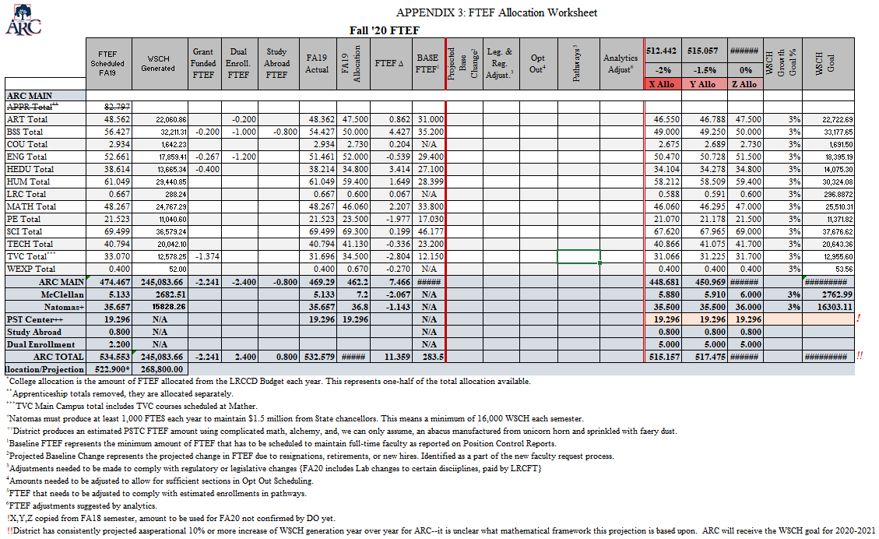
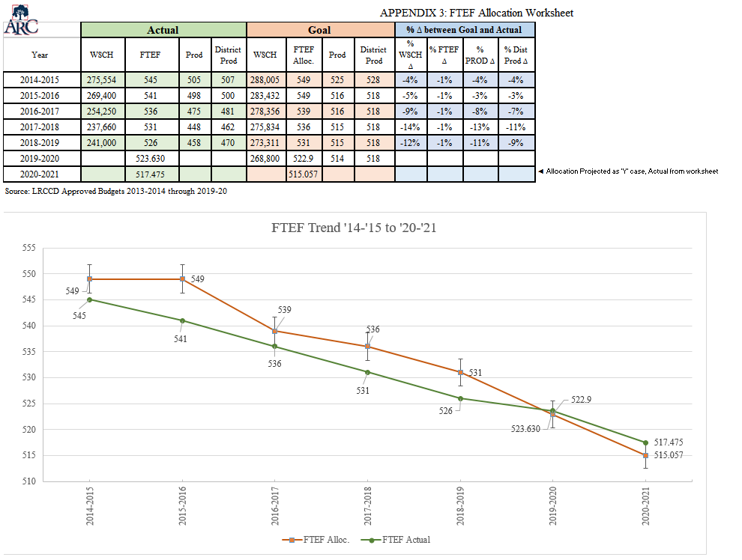

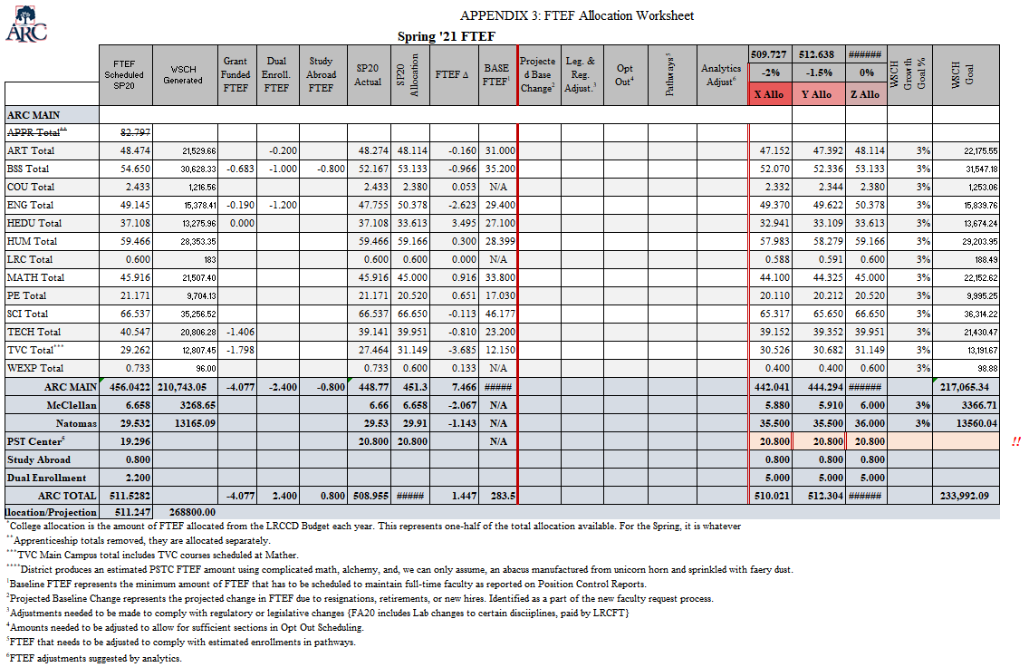

(5) Educational centers: $1,000,000 for each center described in subdivision (b)(1) of section 55180 and reporting 1,000 or more FTES. A district is not eligible for the basic allocation revenue provided by this subdivision associated with an educational center that is approved by the Board of Governors on or after May 1, 2008, unless and until the Chancellor determines that the center reported at least 1,000 FTES on the district's most recent final attendance report.
No predictive model is always accurate. Deference should be paid to the on-the-ground experience of discipline faculty serving their program’s students. However, if a decision is made to ignore predictive data the allocated FTEF should be monitored and evaluated. If the predictive data was correct about demand, it should be followed moving forward. If the intuition of discipline faculty/deans are correct about demand this should be brought to the SEM for an evaluation of the predictive model that was used.
“Dynamically calculated” refers to the fact that FTEF is not stored in PeopleSoft as a set value, rather is calculated from a variety of values store in PeopleSoft when queried.
If sections are not designated in PeopleSoft as being grant funded, even if they are later charged against a budget, they will be seen as not being grant funded by DO and therefore will not be subtracted from allocation calculations. It is therefore very important that these sections be indicated in PeopleSoft correctly.
The difficulty of pulling out this FTEF is one of the reasons that ARC is advocating for a new location code to be created within PeopleSoft to allow for a cleaner scheduling of these types of courses.
The recent implementation of AB705 is a very good example of this. The changes to English, Math, and ESL course patterns caused both the shifting of FTEF to accommodate the changes and vastly disrupted our ability to rely upon historical data to predict how students would navigate through these requirements.

