Institutional Analysis

Standard I: Mission, Academic Quality and Institutional Effectiveness, and Integrity

The institution demonstrates strong commitment to a mission that emphasizes student learning and student achievement. Using analysis of quantitative and qualitative data, the institution continuously and systematically evaluates, plans, implements, and improves the quality of its educational programs and services. The institution demonstrates integrity in all policies, actions, and communication. The administration, faculty, staff, and governing board members act honestly, ethically, and fairly in the performance of their duties.

Mission

- The mission describes the institution’s broad educational purposes, its intended student population, the types of degrees and other credentials it offers, and its commitment to student learning and student achievement. (ER 6)

Evidence of Meeting the Standard

The American River College mission consists of four distinct parts: the College’s vision, mission, commitment to social justice and equity, and strategic goals. The College reviews its mission every 5 years in alignment with the District strategic planning process and to ensure it reflects state laws and regulations, as well as the evolving and diverse needs of students and the community. The current statement of mission was adopted by the Planning Coordination Council and subsequently approved by the LRCCD Board of Trustees on May 10, 2017.
Vision:
Transform the future of all students and community through inclusive, equitable education.
Mission:
American River College places students first in providing an academically rich, inclusive environment that inspires critical thinking, learning and achievement, and responsible participation in the community.
American River College, serving the greater Sacramento region, offers education and support for students to strengthen basic skills, earn associate degrees and certificates, transfer to other colleges and universities, and achieve career as well as other academic and personal goals.

Commitment to Social Justice and Equity:
American River College strives to uphold the dignity and humanity of every student and employee. We are committed to equity and social justice through equity-minded education, transformative leadership, and community engagement. We believe this commitment is essential to achieving our mission and enhancing our community.
ARC Vision, Mission, and Values https://arc.losrios.edu/about-us/our-values
ARC Strategic Goals https://inside.arc.losrios.edu/training/center-for-teaching-and-learning/strategic-goals-2017-21
BOT minutes of May 10, 2017 meeting (page 7) https://losrios.edu/lrccd/main/doc/board/2017/minutes/20170510-bot-minutes.pdf
BOT presentation at May 10, 2017 meeting https://losrios.edu/lrccd/main/doc/board/2017/enc/20170510-arc-mission.pdf

Analysis and Evaluation

The institution’s mission clearly identifies the institution’s educational purpose, stating that “American River College ... offers education and support for students to strengthen basic skills, earn associate degrees and certificates, transfer to other colleges and universities, and achieve career as well as other academic and personal goals.” The mission defines the student population the institution serves, namely the residents of the greater Sacramento region who would benefit from community college instruction.
The institution’s educational purpose is appropriate to an institution of higher learning. ARC is a public community college granting associate degrees and certificates, as well as preparing students for transfer and careers. The mission states the types of degrees and certificates it offers, namely associate degrees and certificates.
The mission demonstrates the institution’s commitment to student learning and student achievement. It says “American River College places students first in providing an academically rich, inclusive environment that inspires critical thinking, learning and achievement, and responsible participation in the community.” Strategic Goals 1 and 2 further clarify the College’s commitment to learning and achievement. Strategic Goal 1 (Students First) says “The College engages and connects students early and often to people, programs, and services as an integrated educational experience. By providing personalized, proactive support, the College fosters relationships that ensure all students, particularly the historically underserved and marginalized, persist, learn, and succeed.” And, Strategic Goal 2 (Clear and Effective Paths) says “The College provides easily recognizable pathways to, through, and beyond ARC. Offering well defined and supported pathways provides a foundation for success as students enter the College, make timely progress toward achieving their informed educational goals, and seamlessly transfer to other colleges and universities or find employment in their chosen career.”

- The institution uses data to determine how effectively it is accomplishing its mission, and whether the mission directs institutional priorities in meeting the educational needs of students.

Evidence of Meeting the Standard

The College publishes on its webpage student achievement data that aligns with its mission. Additionally, reflective of the College’s mission, a data set which includes enrollment, productivity, disproportionately impacted groups, department set standards, and student learning outcomes data prompts planning units to respond as a component of the integrated planning process.

IA2.1 Student achievement data on college webpage: https://arc.losrios.edu/why-arc/facts-and-statistics
IA2.2 Integrated Planning Portal data:
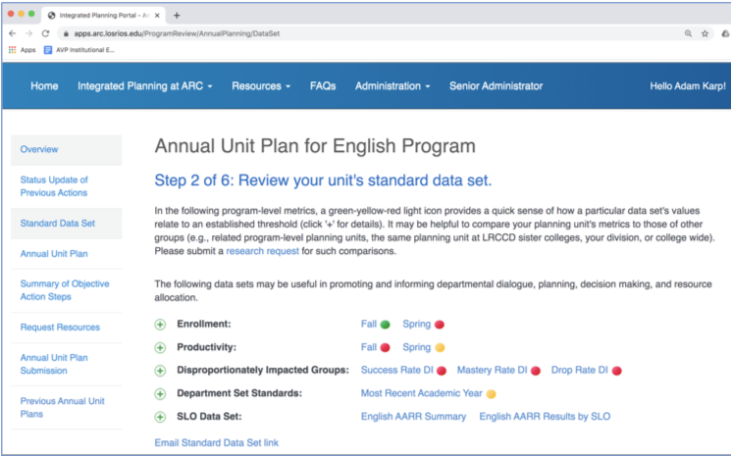

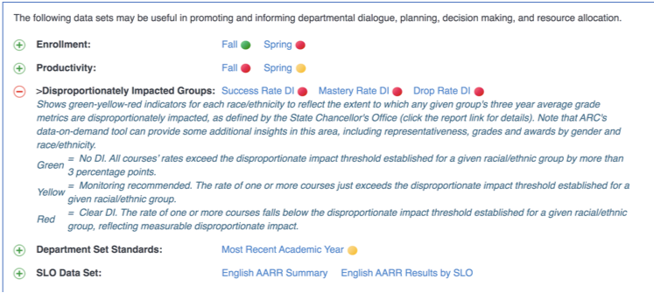

Analysis and Evaluation

The College analyzes student achievement data regularly and discusses the analysis with the Institutional Effectiveness Council [IEC meeting notes]. Also, the College presents planning units with their student achievement data as a component of its planning process. This common data set within the Integrated Planning Portal prompts planning units to provide actions to be taken to address the data. Student achievement data is also published on the Institutional Research webpage, which is publicly available. The College analyzes institutional data to determine the effectiveness of college programs and services in meeting the educational needs of its students and in accomplishing its mission.

- The institution’s programs and services are aligned with its mission. The mission guides institutional decision-making, planning, and resource allocation and informs institutional goals for student learning and achievement.

Evidence of Meeting the Standard

- Curriculum website and Socrates
- College Catalog
- Integrated Planning Portal -- Mission statement?
- Education Master Plan

Analysis and Evaluation

The College has established a robust curriculum program approval process to assure that programs and services are aligned with its mission. The College catalog describes the courses, certificate, and degree programs and college services designed to help students improve their foundational skills, earn certificates and degrees, transfer, and improve their employment opportunities [link catalog pages].
The mission statement informs the creation of strategic goals, which serve as the basis of integrated planning [link]. The Educational Master Plan [link] outlines guiding imperatives considered essential to achieving American River College’s mission and realizing its overarching vision. Moreover, the response to each imperative is grounded in ARC’s commitment to social justice and equity which defines how those involved will approach this work.

- The institution articulates its mission in a widely published statement approved by the governing board. The mission statement is periodically reviewed and updated as necessary. (ER 6)

Evidence of Meeting the Standard

The current statement of mission was adopted by the Planning Coordination Council and subsequently approved by the LRCCD Board of Trustees on May 10, 2017 [link]. The mission is published in the college catalog and on the College’s webpage. Additionally, the vision, mission, and values are printed on large poster boards and displayed in meeting rooms and on the walls of high-traffic campus facilities.

Analysis and Evaluation

American River College’s mission is approved by the Board of Trustees and is widely published. The mission is reviewed and updated as a component of the strategic planning process, which occurs on a cycle that aligns with the District’s review of its mission as a component of its strategic planning process.

Conclusions on Standard I.A. Mission

The College meets the standard.

Evidence List

[insert list]

Assuring Academic Quality and Institutional Effectiveness

Academic Quality

  - The institution demonstrates a sustained, substantive and collegial dialog about student outcomes, student equity, academic quality, institutional effectiveness, and continuous improvement of student learning and achievement.

Evidence of Meeting the Standard

Regular reflective dialog is an organized process at American River College directed through the Integrated Planning Guide and the ARC Participatory Governance And Integrated Strategic Planning Framework and ensured through departmental, planning unit, council and college collaboration [links]. The Integrated Planning and Review assessment, a unifying report compiled upon completion of the integrated planning process, is an annual comprehensive reflection on the work of the College [TBD]. The planning process engages faculty, staff, and administrators to assess and document how their instructional or service units contribute to the Strategic Plan goals for future improvement in student learning and achievement, and request resources for their units.

Collaborations in and between governance councils are additional spaces of regular organized dialog at the College. The governance framework is designed to reduce siloing of information and to increase the flow of information between councils and the executive leadership team.

Governance Group | Evidence of Sustained, Substantive, and Collegial Inter-Group Dialog
Executive Leadership Team | Provides ongoing accountability for councils and strategic project implementation; and ensures transparent communications to/from all governance and constituency groups
Institutional Effectiveness Council | Provides coordination for integrated planning; informs research and decision support; integrates and coordinates institutional professional development; supports governance and accreditation to maximize institutional effectiveness; sponsors project teams;  Members collaborate on evaluation of institutional effectiveness outcomes and improvements in planning processes [link]
Student Success Council | Develops and implements the Student Success Strategic Action Framework; sponsors project teams; identifies and communicates cross-functional Operations Council support needs; provides an effective process for leadership development for constituency participants; a critical focus is on leading change and engaging the college community effectively in support of student success outcomes
Operations Council | Conducts planning, problem solving, and oversight for essential ARC operations and facilities functions including budget, capital improvements, technology, public safety, maintenance and similar; responds to support requests from the Student Success Council; sponsors project teams;  In the spirit of institutional effectiveness and continuous improvement, the council engages the planning process to measure how institutional priorities connect with funding sources

Professional development activities offered during Flex days and at various other points throughout the academic year engage the College in substantive and collegial dialog regarding student equity, outcomes, learning and achievement [links]. Invited speakers from outside the College have been especially inspirational in furthering conversations about student equity and institutional effectiveness [links].

Analysis and Evaluation

As a result of its mission-driven integrated planning model, the College has systematized a process that fosters sustained, substantive, and collegial dialog regarding student learning and achievement [link]. Moreover, the resulting dialog about continuous quality improvement of institutional effectiveness is intentionally viewed through a lens of student equity [link]. As evidenced by the dialog provided through program reviews, council notes, and professional development opportunities, the College demonstrates its commitment to this important dialog regarding the improvement of student learning and achievement [links].

  - The institution defines and assesses student learning outcomes for all instructional programs and student and learning support services. (ER 11)

Evidence of Meeting the Standard

All courses and programs at American River College have student learning outcomes. These learning outcomes are housed in Socrates and are listed in the catalog and college website (under the degrees/certificates tab and student learning outcomes expandable).
The SLO assessment process at ARC was established as a method of documenting the effectiveness of the faculty’s continuous assessment of student learning for its numerous courses and programs. This process is defined on the ARC SLO Website and the purpose and function of the process, and of the SLO Assessment Committee is detailed in the SLOAC Official Handbook. Guidance is sent out through the SLOAC at various times during the assessment process for both SLO and Student Service Outcomes (SSO) assessment.
Student Service units have identified common Student Service Outcomes (SSOs). These SSOs are published on the ARC SLO Website and on the ARC Student Resources webpage. Student Services assessed SSOs in 2014-2015, piloted a new process in 2018 that was not adopted, and completed assessment in 2019-2020 with a new process. The assessment data is reported on the Student Services Outcomes Assessment Report (SSOAR) and then the data is analyzed on the SSOAR Data Analysis form, and the results are reviewed annually as a part of Annual Unit Planning and serve as a basis for actions and resource allocation going forward (fall 2021).
Instructional units document their assessment of Student Learning Outcomes (SLOs) on an annual basis through the Authentic Assessment Review Record (AARR). Faculty record student achievement for a randomly assigned course SLO based on one or more authentic assessments that they regularly perform in their classes. The aggregated results are then reviewed annually as part of Annual Unit Planning and serve as a basis for actions and resource allocation. Assessment of program level SLOs relies on the course-level SLO assessment. This strategy is supported by the requirement that program SLOs are explicitly mapped to (or clearly supported by) one or more of the required courses for a degree or certificate. These program mapping matrices were completed by departments and members of the SLO Assessment and Curriculum committees (prior to Fall 2019). They were updated or completed via the Program SLO Linguistic Analysis Tool when changes were made or a minimum of every six years in conjunction with the program review cycle going forward (piloted spring/fall 2020 and adopted fall 2021).

Analysis and Evaluation

The college defines and assesses student learning outcomes for all instructional programs and student and learning support services.
SSOs are in the process of being incorporated into an integrated annual assessment cycle with data incorporated into the Annual Unit Plan.

  - The institution establishes institution-set standards for student achievement, appropriate to its mission, assesses how well it is achieving them in pursuit of continuous improvement, and publishes this information. (ER 11)

Evidence of Meeting the Standard

American River College has established institution-set standards for student achievement, appropriate to its mission. These include standards for course completion, certificates, degrees, and transfers. These standards are published on the college website. Career Education departments also review standards for licensure examination passage rates and job placement rates. Performance against these standards is assessed institution-wide by the Institutional Effectiveness Council, and at the departmental-level through integration into Annual Unit Planning and Program Review, leading to continuous improvement.
In 2016, American River College adopted a consistent college wide methodology for computing Institution Set Standards. Institution Set Standards are computed by first taking the average of the preceding 3 years (not including the current year). Then a 95% Confidence Interval is constructed around the preceding 3 year average. The lower limit of this 95% Confidence Interval serves as the Institution Set Standard. In 2017, American River College utilized the upper limit of the 95% Confidence Interval to serve as the Stretch Goal. In 2019, the procedure for setting Stretch Goals for certificates, degrees, and transfers was modified to align with the California Community College Chancellor’s Office Vision for Success Goals and American River College’s Strategic Planning Goals. This alignment resulted in a stretch goal of a 20% increase for certificates and degrees, and a 35% increase for transfers by 2021 - 2022 using the 2016 - 17 year as a baseline.
The Institutional Effectiveness Council reviews student achievement data relative to the institution-set standards during the ACCJC annual reporting process [2019 IEC notes, 2020 IEC notes].
Institution-set standards drive continuous improvement, professional development, and resource allocation, through their integration (as Departmental level, or Department-set standards) in Annual Unit Planning and Program Review.
Career Education departments also review Institution-set standards for licensure examination passage rates and job placement rates as applicable [link to description].
NOTE REGARDING REVIEW CRITERIA:
“In addition to the above metrics, institutions must demonstrate they are aware of, and use the key metrics used in the USDE College Scorecard.” The College reports values from this scorecard for the ACCJC annual report, which are discussed with the Institutional Effectiveness Council.

Analysis and Evaluation

American River College has established institution-set standards for student achievement, appropriate to its mission, regularly assesses how well it is achieving them in pursuit of continuous improvement, both at the institution-wide and departmental-level, and publishes this information on the college website.

  - The institution uses assessment data and organizes its institutional processes to support student learning and student achievement.

Evidence of Meeting the Standard

The Integrated Planning Guide provides central direction to the College’s planning processes. The guide organizes the cycle of regular planning, governance and planning responsibility, primary and focused plans, program review and unit planning, integration with resource prioritization, and systemic evaluation. Assessment of data is integral to all institutional planning and processes at American River College; student learning outcomes at the course level, program learning outcomes at the program level, and institutional learning outcomes [link] at the institution level are assessed and used to inform decision making in course and program review, planning, budget funding priorities and resource allocation [links]. The faculty SLO Assessment Coordinator serves on the Program Review Committee as part of their assignment. Additionally, the SLO Assessment Coordinator and faculty Program Review Committee chair serve on the Institutional Effectiveness Council where they participate in discussion which leads to decisions about appropriate next steps for increasing effectiveness. Recommendations from these discussions flow to the Program Review Committee for updating program review prompts [link]. Through analysis of assessment data, both on the institutional level and course level, departments regularly discuss improvement strategies focused on student achievement and learning. Assessment of student progress is regularly monitored through the College’s institution level plans, such as the Institutional Equity Plan, Student Equity and Achievement Plan, and the Strategic Plan, and long-term evaluations of departmental courses and programs through comprehensive program review [links].

Through these organized approaches, the College evaluates the effectiveness of its strategies to close achievement and equity gaps and increase student success and completion. Also, the College uses assessment data in the development of its 10-year Educational Master Plan, which is operationalized by five-year Strategic Plans that are informed by and inform unit plans and program reviews [links]. Based on assessment data, institutional goal and objective attainment, as well as other measures of Institutional Effectiveness, the College then allocates resources and organizes its processes to support student learning and achievement.

- Integrated Planning Guide
- Integrated Planning Portal system specifications document
- AUP training slides describe data integration https://apps.arc.losrios.edu/ProgramReview/Docs/Annual%20Unit%20Planning%202020.pdf
- Instructor Equity Data and Department DI Reports in the Integrated Planning Portal (screen shot)
  - Interpretation Guide (pdf)
- Common Data Set in IPP -- enrollment, productivity, institution “department” set standards, department DI data, SLO data
- https://arc.losrios.edu/why-arc/facts-and-statistics (under Student Achievement Data)
- https://arc.losrios.edu/why-arc/facts-and-statistics/program-level-student-learning-outcomes

Analysis and Evaluation

The College uses assessment data to support student learning and student achievement as a core component embedded within its planning portal. The College organizes its institutional processes to support student learning and student achievement as evidenced by its Integrated Planning process.

Institutional Effectiveness

  - The institution assesses accomplishment of its mission through program review and evaluation of goals and objectives, student learning outcomes, and student achievement. Quantitative and qualitative data are disaggregated for analysis by program type and mode of delivery.

Evidence of Meeting the Standard

The American River College mission is at the core of all college planning processes and evaluation, and as such is central to program review, long-term and short-term planning, and student learning outcome and student service outcome development and assessment [links]. The Integrated Planning Guide serves as the formal direction to the College’s work toward achieving the College mission [link]. The framework details the process of mission driven data analysis, planning development, strategy, action and evaluation [link]. Every College unit completes a comprehensive program review on a regular cycle. The planning process details how a program helps to meet the College mission, achieve the College’s strategic goals, and assists students in achieving learning outcomes. Disaggregated data are analyzed and documented to provide a clear picture of how a program contributes to and can improve on enrollment, productivity, institution-set standards, student learning, and disproportionate impact. Resource requests submitted through unit planning detail which planning actions may be better achieved through implementation of requested funding [link]. The annual unit plans and program reviews are also a place where documentation of changes in strategy for student success through evaluation of curriculum, course development, and student learning outcomes occur [link].

In addition to annual unit planning and program reviews, the College also annually evaluates the degree to which it is meeting its institutional goals and objectives in its three-year Strategic Plans (I.B.5.11, I.B.5.12). The College’s Strategic Plan aligns with both the Chancellor’s Office Vision for Success Goals, and going forward resource allocation process will align with the new Student Centered Funding Formula (SCFF) [links].

https://apps.arc.losrios.edu/ProgramReview/Docs/Inquiry%20Guide-Instructional.pdf
Program Review Inquiry Guide for Instructional Units (part of the training materials)
https://apps.arc.losrios.edu/ProgramReview/Docs/PR%20Training.pptx
Program Review Training Presentation
Data disaggregation by program, modality, and other criteria available for use in Program Review through college data dashboard (Precision Campus)
Sample Program Reviews
Annual report shared with college

Analysis and Evaluation

The Program Review process asks faculty to participate in a seven-year process of data inquiry, reflection, and integrated planning that culminates in a Program Review report and presentation to the college on the progress made over the past six years in achieving the program and the college’s goals.

  - The institution disaggregates and analyzes learning outcomes and achievement for subpopulations of students. When the institution identifies performance gaps, it implements strategies, which may include allocation or reallocation of human, fiscal and other resources, to mitigate those gaps and evaluates the efficacy of those strategies.

Evidence of Meeting the Standard

American River College uses the ARC ISLO Graduate Survey to assess achievement of ISLOs based directly on student input at the end of their educational experience at ARC. The ISLO Graduate Survey is distributed on a bi-annual basis and all students that are petitioning to graduate are invited to participate. An in depth analysis is provided in the ARC ISLO Graduate Survey Results document. The findings include an analysis of disproportionate impact and the key findings are disseminated to appropriate groups on campus to inform professional development efforts focused on closing the opportunity gap for disproportionately impacted groups. In 2019, it was disseminated to the Professional Development & Training project team and the Disproportionate Impact LatinX project team.

- Data on demand data disaggregated
- Reallocation of human (staff), fiscal/facilities (Black student resource center – Student Center)
- program reviews

Analysis and Evaluation

The college disaggregates learning outcome data for student subpopulations through the use of the ARC ISLO Graduate Survey.

  - The institution regularly evaluates its policies and practices across all areas of the institution, including instructional programs, student and learning support services, resource management, and governance processes to assure their effectiveness in supporting academic quality and accomplishment of mission.

Evidence of Meeting the Standard

End of term report/assessment by council…

Analysis and Evaluation

[insert response]

  - The institution broadly communicates the results of all of its assessment and evaluation activities so that the institution has a shared understanding of its strengths and weaknesses and sets appropriate priorities.

Evidence of Meeting the Standard

- Agendas and notes in IGOR
- Occasional stories in Beaver Bites employee newsletter
- Content on website

Analysis and Evaluation

- The college does a good job of promoting IGOR as a go-to home for important institutional information. Employees know IGOR is an excellent resource for this information.

  - The institution engages in continuous, broad based, systematic evaluation and planning. The institution integrates program review, planning, and resource allocation into a comprehensive process that leads to accomplishment of its mission and improvement of institutional effectiveness and academic quality. Institutional planning addresses short- and long-range needs for educational programs and services and for human, physical, technology, and financial resources. (ER 19)

Evidence of Meeting the Standard

- Education Master Plan Guiding Imperatives
- Integrated Planning Guide

Analysis and Evaluation

Integrated planning is an ongoing, systematic process designed to create synergy between various plans and the allocation of resources to ensure that institutional priorities are achieved. A culture of inquiry and data‐informed dialogue is central to a planning framework which continuously supports, assesses, and enhances the institution’s capacity to provide a highly effective learning environment. The ARC Integrated Planning Guide is intended as a reference which defines the essential components of the planning structure in the context of American River College. The guide includes an overview of the planning processes; highlights governance and planning responsibilities; describes various institutional plans, program review, and annual unit planning; discusses evaluation mechanisms; and provides a clear indication of how planning drives resource allocation. Each individual plan is represented by a fact sheet which can be used independently from the remainder of the guide.

Conclusions on Standard I.B. Academic Quality and Institutional Effectiveness

The College meets the standard.

Evidence List

[insert list]

Institutional Integrity

- The institution assures the clarity, accuracy, and integrity of information provided to students and prospective students, personnel, and all persons or organizations related to its mission statement, learning outcomes, educational programs, and student support services. The institution gives accurate information to students and the public about its accreditation status with all of its accreditors. (ER 20)

Evidence of Meeting the Standard

- https://arc.losrios.edu/about-us/our-history/accreditation
- https://arc.losrios.edu/2020-2021-catalog/catalog-introduction/about-american-river-college/accreditation
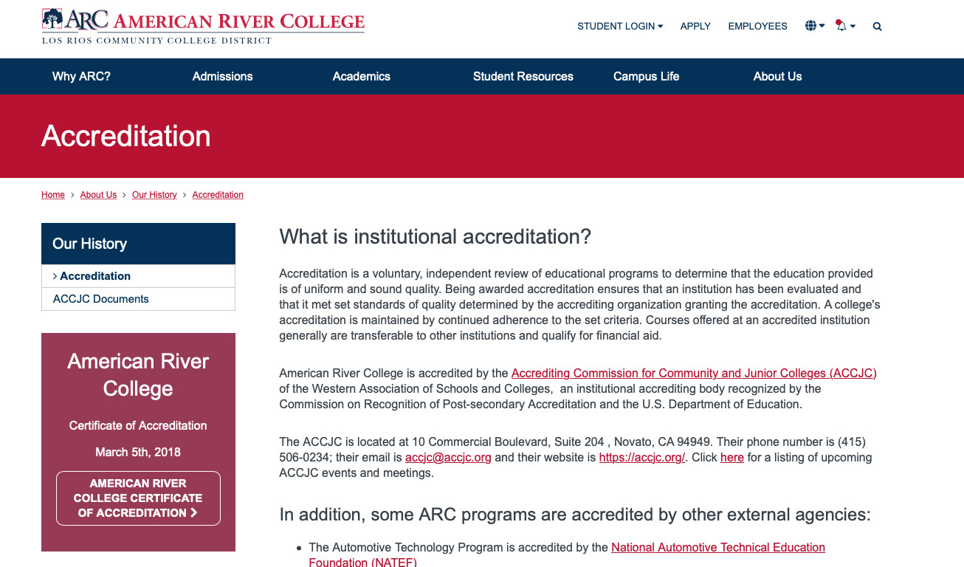

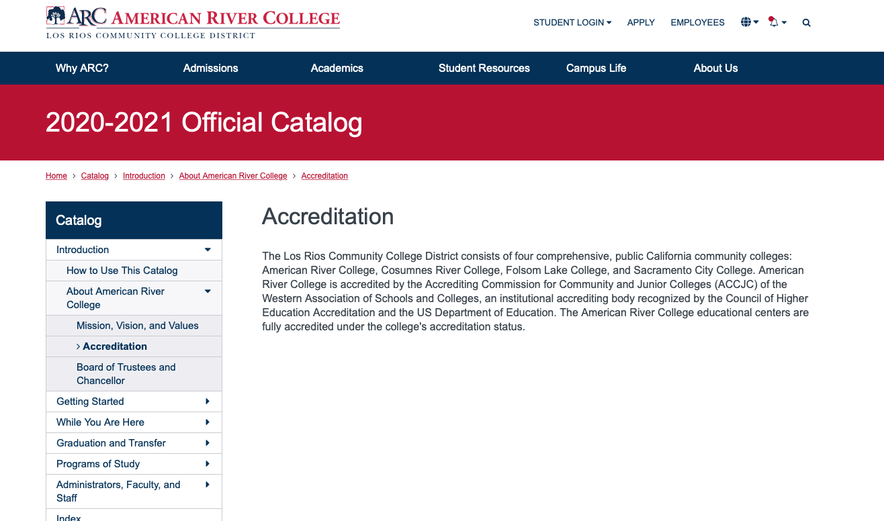

A link to the college’s accreditation webpage is available on every webpage, in the “footer” for the website in the Information category (see screenshot)
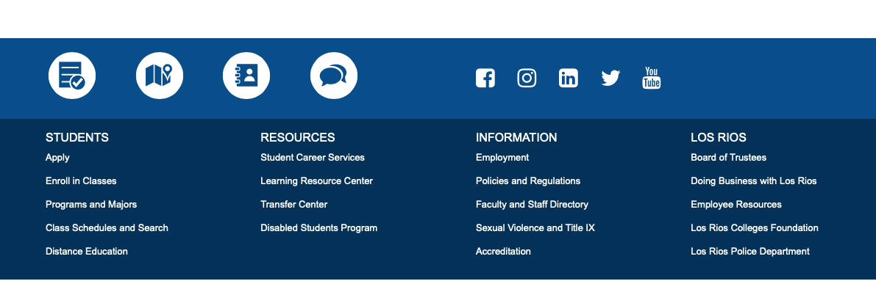

Program Level Student Learning Outcomes are available at https://arc.losrios.edu/why-arc/facts-and-statistics/program-level-student-learning-outcomes
The college’s Consumer Information webpage https://arc.losrios.edu/about-us/our-values/consumer-information provides additional resources and information about student learning outcomes.
The college’s mission, vision, and social justice statement as well as Institutional Learning Outcomes are found at https://arc.losrios.edu/about-us/our-values

Analysis and Evaluation

The College assures the clarity, accuracy, and integrity of information provided to students and prospective students, personnel, and all persons or organizations related to its mission statement, learning outcomes, educational programs, and student support services. The college annually updates its catalog and regularly updates content on its website to ensure the communication of current and consistent information.

- The institution provides a print or online catalog for students and prospective students with precise, accurate, and current information on all facts, requirements, policies, and procedures listed in the “Catalog Requirements”. (ER 20)

Evidence of Meeting the Standard

Links to the Catalog Pages for Each Catalog Requirement Listed Above:
1. General Information
- Official Name, Address(es), Telephone Number(s), and Website Address of the Institution
- Educational Mission
- Representation of accredited status with ACCJC, and with programmatic accreditors if any (need to add this link to the catalog for programmatic accreditors)
- Course, Program, and Degree Offerings
- Student Learning Outcomes for Programs and Degrees – example: Accounting degree
- Academic Calendar and Program Length
- Academic Freedom Statement
- Available Student Financial Aid
- Available Learning Resources (need to add this link to the catalog for learning resources)
- Names and Degrees of Administrators and Faculty
- Names of Governing Board Members
2. Requirements
- Admissions
- Student Tuition, Fees, and Other Financial Obligations
- Degrees, Certificates, Graduation and Transfer
3. Major Policies and Procedures Affecting Students
- Academic Regulations, including Academic Honesty
- Nondiscrimination
- Acceptance and Transfer of Credits
- Transcripts
- Grievance and Complaint Procedures
- Sexual Harassment
- Refund of Fees
4. Locations or Publications Where Other Policies may be Found
- Student Rights and Responsibilities
- Equity and Diversity
- Consumer Information
- Health and Safety

Analysis and Evaluation

The college provides an online catalog for students and prospective students with precise, accurate, and current information on all facts, requirements, policies, and procedures listed in the “Catalog Requirements”. The catalog is published annually, and all catalog pages are reviewed as part of the catalog publication process.
- The institution uses documented assessment of student learning and evaluation of student achievement to communicate matters of academic quality to appropriate constituencies, including current and prospective students and the public. (ER 19)

Evidence of Meeting the Standard

American River College publishes student achievement data including course completion, degree and certificate attainment, and transfer rates and student learning outcomes assessment results on its website.
[Missing: Published job placement data, licensure pass rate data, marketing materials that contain any achievement data, publicly available data dashboards, links to federal scorecard information]

Analysis and Evaluation

The institution uses documented assessment of student learning and evaluation of student achievement to communicate matters of academic quality to appropriate constituencies, including current and prospective students and the public through the college website.

- The institution describes its certificates and degrees in terms of their purpose, content, course requirements, and expected learning outcomes.

Evidence of Meeting the Standard

All available degrees and certificates are published in the online college catalog. These catalog pages for a CTE program [SLPA A.A. page PDF] and a transfer program [Communication Studies AA-T page PDF] are examples of how programs are described in the college catalog. Each listing includes a clear description of the program, including course requirements, prerequisites, total units, and learning outcomes. Programs that have additional enrollment limitations clearly describe those limitations and the process to follow to enroll in the program. [Funeral Service Education A.S. page PDF]
The college recently created a set of program roadmaps, which are published on the college website and shared with students during the onboarding process. Roadmaps contain additional information, including a suggested course sequence, career information (for career programs) and transfer information (for transfer programs). [Communication Studies AA-T map and SLPA AA map PDF]

Analysis and Evaluation

The catalog lists all of the degrees and certificates offered by the college, including description of their purpose, content, course requirements and learning outcomes. Program roadmaps contain additional information to assist students in selecting a program and completing it in a timely manner.

- The institution regularly reviews institutional policies, procedures, and publications to assure integrity in all representations of its mission, programs, and services.

Evidence of Meeting the Standard

- Catalog production
- Website maintenance
- PIO review

Analysis and Evaluation

The institution regularly reviews institutional policies, procedures, and publications to assure integrity in all representations of its mission, programs, and services.
- The institution accurately informs current and prospective students regarding the total cost of education, including tuition, fees, and other required expenses, including textbooks, and other instructional materials.

Evidence of Meeting the Standard

The online catalog has a page that outlines tuition and fees. The college website also has a page discussing the value and affordability of attending ARC, with links to grant and scholarship information. It also has “cost of attendance” page under Admissions, that has a link to a Net Price Calculator students can use to estimate the total cost of attending ARC, including personal expenses, books and supplies, tuition and fees.
The online class schedule provides a link to the college bookstore for each class section, so students can see how expensive the books will be before signing up for a class, and it identifies which classes use zero-cost textbooks. Textbooks are adopted by faculty prior to the publication of the course schedule so that textbook pricing information can be shown to students. If there are additional instructional materials required for a course, such as art supplies for an Art course, the schedule provides a link to a document listing the materials needed.
[PDF copy an example of a class in the schedule.]
[PDF copy of a bookstore page.]
[PDF copy of supply list for an ART 300 class.]
[PDF copy of spring 2021 email describing textbook adoption process]

Analysis and Evaluation

On its website, and the bookstore website, the College accurately informs current and prospective students regarding the total cost of education, including tuition, fees and other required expenses, including textbooks, and other instructional materials. Students can see the cost of attending ARC prior to enrolling in their classes.

- In order to assure institutional and academic integrity, the institution uses and publishes governing board policies on academic freedom and responsibility. These policies make clear the institution’s commitment to the free pursuit and dissemination of knowledge, and its support for an atmosphere in which intellectual freedom exists for all constituencies, including faculty and students. (ER 13)

Evidence of Meeting the Standard

Board Policy P-7142 (Controversial Issues) , which is publicly available on the district website, states “The Board of Trustees adopts the position that in a world of rapid change and recurrent crises, a college best serves its community, not as a stronghold of rigid tradition, but as an open intellectual forum where varying shades of opinion may be freely expressed and fairly debated. Positive values evolve from a free exchange of ideas among informed citizens, and the progressive evolution of American institutions may depend upon their quality of flexibility in meeting changing social and economic needs.” The rest of the policy, along with Board Regulation R-7142 (Controversial Issues) , detail the board’s expectations for faculty and students to present issues openly and fairly.
The Board of Trustees has a systematic and regular process for review of its policies and regulations, which are posted on the district website. This review process assures compliance and responsiveness to the changing needs of the college and the district. (district web page describing review process)
The college catalog, which is publicly available on the college website, has an Academic Freedom Statement and an Academic Honesty statement.
The Academic Senate has an Academic Freedom Statement posted in the Canvas site it set up for all faculty, under the “Orientation to the Academic Senate and Resources” tab. [PDF copy of the statement]. Also, the Academic Senate has a statement on academic integrity.
The LRCFT collective bargaining agreement, which is publicly available on the district website, includes language declaring “The LRCCD and LRCFT agree that academic freedom is essential for the fulfillment of the educational mission of the District and for the ability of faculty members to perform their professional duties.”
The College is also committed to students’ rights to exercise their First Amendment rights of written and oral expression, as well as their right to peaceably assemble. This is published on the ARC website.

Analysis and Evaluation

The District’s governing board has policies on academic freedom and responsibility, which make clear the District’s commitment to the free pursuit and dissemination of knowledge, and its support for an atmosphere in which intellectual freedom exists for all constituencies, including faculty and students. Those policies are reviewed regularly. ARC complies with the LRCCD Board policies, and is committed to the free pursuit and dissemination of knowledge. These policies are published on the District and College websites and are available to the public.

- The institution establishes and publishes clear policies and procedures that promote honesty, responsibility and academic integrity. These policies apply to all constituencies and include specifics relative to each, including student behavior, academic honesty and the consequences for dishonesty.

Evidence of Meeting the Standard

For Students:
- Board Policy P-2411 (Student Rights and Responsibilities)
- Board Policy P-2441 (Standards and Conduct)
- Board Regulation R-2411 (Student Rights and Responsibilities)
- Board Regulation R-2441 (Standards and Conduct)
- Catalog Pages: Academic Rights and Responsibilities, Disciplinary Procedures and Due Process, Plagiarism and Cheating Policy
- other evidence: PDF copies of two course syllabi with academic dishonesty (cheating) policies clearly outlined,
For Faculty & Other Employees:
- Board Policy P-3114 (Board of Trustees Statement of Ethics for all Los Rios Employees)
- PDF of annual rights & responsibilities memo from DO
- “Faculty Statement of Professional Ethics” posted in Academic Senate Canvas site [PDF copy of it]
DE Course Student Identity Verification:
- Documentation that we require students to use their w-id and password to access Canvas

Analysis and Evaluation

The LRCCD Board of Trustees has established and published clear expectations regarding academic honesty and the consequences of dishonesty. The College abides by the California Education Code and all College rules and regulations described in the Board Policy P-2411 (Student Rights and Responsibilities) and P-2441 (Standards of Conduct). Detailed descriptions and consequences related to student honesty can be found in the catalog and on the College website.
Instructors’ syllabi contain statements regarding ARC’s academic honesty policy and their specific classroom policy on academic honesty.
The LRCCD Board of Trustees has established and published clear expectations regarding ethical behavior for all Los Rios Employees. In addition, all Los Rios employees receive a memo every semester reminding them of their rights and responsibilities. That memo, from the Associate Vice Chancellor of Human Resources, provides statements regarding professional and ethical behavior.
The College has an authentication process to ensure students who complete the course are the students who enrolled in the course. Specifically, the College requires students to use their assigned secure log-on and password to access and complete the course.

- Faculty distinguish between personal conviction and professionally accepted views in a discipline. They present data and information fairly and objectively.

Evidence of Meeting the Standard

Board Policy P-7142 and Administrative Regulation R-7142 1.0 and 2.0 clearly outline the expectation that faculty distinguish between personal conviction and professionally-accepted views in a discipline.
In addition, we publish in the college catalog a “Statement of Principles on Academic Freedom” that reinforce that expectation. And, the Academic Senate publishes a “Faculty Statement of Professional Ethics” in the Canvas site it has set up for all faculty. [PDF copy of statement]
The collective bargaining agreement with LRCFT, under Article 11.2 Professional Expectations, states “In order to fulfill their professional expectations, faculty shall clearly differentiate to students the expression of a faculty member’s personal opinions or convictions from the objective presentation of theory, fact, or ideas.” It also outlines a process for performance review for all faculty that provides the opportunity to observe instructors presenting and discussing controversial topics, to ensure they distinguish between personal conviction and professionally-accepted views.

Analysis and Evaluation

Board Policies and Administrative Regulations clearly direct faculty to distinguish between personal conviction and professionally accepted views. The “Faculty Statement on Professional Ethics,” the “Statement of Principles on Academic Freedom” and the LRCFT collective bargaining agreement echo and support this expectation. The college reviews faculty on a regular basis to ensure they are meeting the expectation.

- Institutions that require conformity to specific codes of conduct of staff, faculty, administrators, or students, or that seek to instill specific beliefs or world views, give clear prior notice of such policies, including statements in the catalog and/or appropriate faculty and student handbooks.

Evidence of Meeting the Standard

- mission statement on the college website
- Academic Freedom Statement (college catalog)
- Academic Honesty Statement (college catalog)
- Board Policy P-3114 (Board of Trustees Statement of Ethics for all Los Rios Employees)
- Board Policy P-2411 (Student Rights and Responsibilities)
- Board Policy P-2441 (Student Conduct)
- Board Policy P-2442 (Due Process in Student Conduct Cases)
- Board Policy P-2443 (Drug and Alcohol Use on Campus)
- Expectations of Student Behavior and Conduct on the college website
- [PDF copy of Faculty Statement of Professional Ethics, from Academic Senate Canvas site]

Analysis and Evaluation

ARC does not seek to instill specific beliefs or world views. Instead, “American River College places students first in providing an academically rich, inclusive environment that inspires critical thinking, learning and achievement, and responsible participation in the community.” [from our mission statement] That said, the College does follow established Board policies regarding student and faculty codes of conduct as outlined in the California Education Code and the Policies and Regulations of the District (see standards I.C.7 and I.C.8). The College gives clear prior notice of its student and faculty codes conduct on its website and the District website.

- Institutions operating in foreign locations operate in conformity with the Standards and applicable Commission policies for all students. Institutions must have authorization from the Commission to operate in a foreign location.

Standard I.C.11 is not applicable to American River College. American River College does not operate in foreign locations.

- The institution agrees to comply with Eligibility Requirements, Accreditation Standards, Commission policies, guidelines, and requirements for public disclosure, institutional reporting, team visits, and prior approval of substantive changes. When directed to act by the Commission, the institution responds to meet requirements within a time period set by the Commission. It discloses information required by the Commission to carry out its accrediting responsibilities. (ER 21)

Evidence of Meeting the Standard

- Accreditation webpage
- Annual Reports and Fiscal Reports
- ACCJC directory updates
- Follow up report
- Midterm report

Analysis and Evaluation

[insert response]

- The institution advocates and demonstrates honesty and integrity in its relationships with external agencies, including compliance with regulations and statutes. It describes itself in consistent terms to all of its accrediting agencies and communicates any changes in its accredited status to the Commission, students, and the public. (ER 21)

Evidence of Meeting the Standard

[insert response]

Analysis and Evaluation

The College fully participates in all aspects of the accreditation process.

- The institution ensures that its commitments to high quality education, student achievement and student learning are paramount to other objectives such as generating financial returns for investors, contributing to a related or parent organization, or supporting external interests.

Evidence of Meeting the Standard

Board Policy P-3114 (Statement of Ethics) states that each member of the Board of Trustees (and all District employees) shall
- “keep access and quality education for all students as primary concern”
- “make decisions in the best interest of students and the District”
- “avoid conflicts of interest”
Board Policy P-8631 (Conflict of Interest Rules) defines what a conflict of interest is and states that “a District/College employee shall not participate in a decision or transaction or provide services when they have a conflict of interest.”

Analysis and Evaluation

ARC adheres to Board Policy P-3114, making access to quality education for all students our primary concern, making decisions in the best interest of students, and avoiding conflicts of interest. ARC also adheres to Board Policy P-8631 that bans employees from participating in decisions or transactions that constitute a conflict of interest.
ARC is a publicly funded community college, not responsible for generating financial returns for investors, contributing to a related or parent organization, or supporting external interests.

Conclusions on Standard I.C. Institutional Integrity

The College meets the Standard.

Evidence List

[insert list]

