eXPLORING DISPROPORTIONATE IMPACT:
Full Report
LGBTQIA+

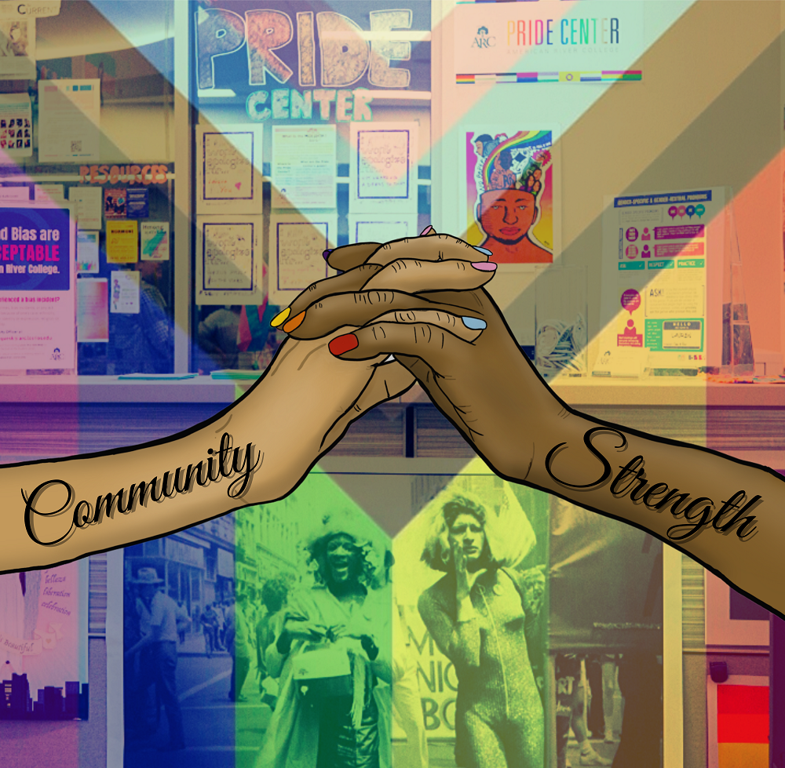

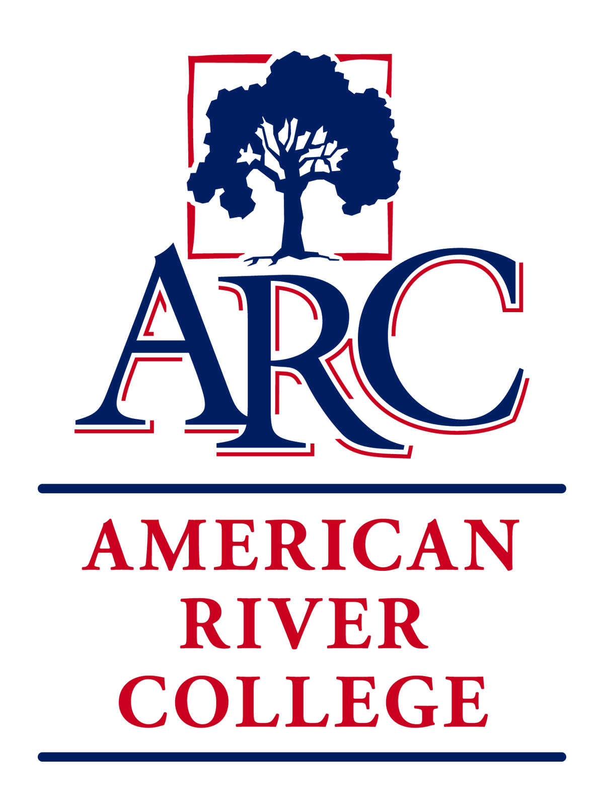

OUR COMMITMENT TO SOCIAL JUSTICE AND EQUITY
American River College strives to uphold the dignity and humanity of every student and employee. We are committed to equity and social justice through equity-minded education, transformative leadership, and community engagement. We believe this commitment is essential to achieving our mission and enhancing our community.
[Placeholder for description of artwork and/or dedication]

Image Credit: Cover art created by Bee Curiel (2020).

Table of Contents
Introduction: Framing the Process 1
Project Team 1
History and Context 2
Definitions and Terms 2
Why QTBIPOC? 5
History of Exclusion and Marginalization of LGBTQIA+ People in the United States 6
Theoretical Framework 17
Critical Race Theory 17
Intersectionality 18
Trickle Up Theory 19
ARC and LGBTQIA+ History 21
ARC’s Role in Prop 8 21
LGBTQ+ Subcommittee of Equity 23
The Importance of Staffing Models 24
Establishment of the ARC Pride Center 24
Pride Centers Across the California Community College System 27
Existing Barriers 28
The Student Experience 31
National and Local Research On LGBTQIA+ Student Experiences in Higher Education 31
Data Invalidation of LGBTQIA+ Students 31
ARC Campus Climate for LGBTQIA+ Students 32
Recommendations for Action 37
References 39

Introduction: Framing the Process
This report is the result of the concerted efforts of a dedicated and diverse team of individuals who came together to create the report under the direction of our college's Institutional Equity Plan. The most important take away that this team wants you to have is the understanding that our LGBTQIA+ students do not identify with nor are defined by a single umbrella term. Our students have intersectional identities based on who they are and how their history has shaped them. For example, you may identify by your gender, your race, your particular religious beliefs and world view, etc.; and all those identities intersect in you. Similarly, our LGBTQIA+ students may identify with any race, any religion in addition to the complex web of genders and sexual attraction. Our team believes that any recommendations made here or actions the college takes will only be as successful as the college is able to support our students as whole persons with intersectional identities.
The report itself is written to familiarize readers outside the LGBTQIA+ community with the terms, history, and sociological theories that underpin this report. In addition, the report highlights that highs and lows of American River College's own history with LGBTQIA+ students and policies. The team took considerable effort to connect with and hear the stories of our students, even while working remotely through the COVID-19 pandemic, and this report shares some of those stories with you to help you better understand the human side of this important work. Ultimately, all these sections of the report inform a set of nine recommendations that the team believes, if implemented, will not only improve the lives of our LGBTQIA+ students, but also allow the college to measure and track that progress.
Thank you for taking the time to better understand and support this community of students at ARC.

Project Team
Special thanks to the project team who offered invaluable contributions that shaped the content of this document and its recommendations.

Emilie Mitchell (Lead)
Roger Davidson (Co-Lead)
Alejandra Fernandez Garcia
Anjelica Maria Lopez
Bee Curiel
Christopher Collins
Christopher Nguyen Pheneger
Corey D. Winfield
David McCusker
Jazzie Muganzo Murphy
Jennifer Laflam
Joshua Moon Johnson
Mario Rodriguez
Mary Goodall
Sara Smith

Sponsoring Council: Student Success Council

History and Context
The LGBTQIA+ student experience at ARC exists within the context of the historical marginalization of this community within the United States as well as how the community is currently defined.
Definitions and Terms
It is essential to recognize that language and terms are continuously evolving and are only a reflection of the current state of understanding. The words used by a community are based on history, a desire to be seen and understood, and sometimes the reclamation of terms formerly used to oppress and marginalize. Acknowledging that not all LGBTQIA+ community members use the same terms or adhere to the same meanings of each term, and acknowledging the importance of using terminology that communities use to name themselves, it can be helpful to give some general definitions to help orientate and familiarize the reader.
Acronyms: LGBTQ+ or LGBTQIA+
Either of these acronyms are commonly used to describe members of the community. The plus sign is a recognition that the acronym falls short of including all the expressions of sex, sexual orientation, gender identity and gender expression.
L = lesbian
G = gay
B = bisexual
T = trans
Q = queer
T = trans
I = intersex
A = ally or asexual

Queer
The term queer has a long and painful history for many gender and sexual minorities. For years, the term queer was used to denigrate and harass individuals as illustrated by the common playground game of the 1970’s and 80’s called “smear the queer.” As with many terms of oppression and marginalization, the term queer has been reclaimed by many in the community to be an omnibus term describing individuals who hold a non-normative identity (i.e., not straight and/or not cisgender). Some people have also reclaimed the term as a celebration of not fitting into social norms; however, it is important to note that not all people who identify as LGBTQIA+ use queer to describe themselves.
Queer and Trans
It has also been increasingly common to see the community referred to as the queer and trans community. In this context these omnibus terms indicate that the community consists of two distinct and separate identities, sexual orientation and gender identity. Within each of these overarching identities there exists much variation. These broad terms encompass the ever-evolving terms associated with sexual orientation and gender identity.
QTBIPOC = Queer and Trans, Black, Indigenous, People of Color “When used within 'BIPOC'— Black, Indigenous, and people of colour— it emphasizes the particular oppression faced by Black and Indigenous peoples when compared to others who may identify as POC but benefit from privilege as the result of their skin colour or physical appearance and/or the particular historical and societal circumstances associated with their race or culture.” -The Canadian Centre for Gender + Sexuality Diversity

Sex versus Gender
Unfortunately, all too often sex and gender are conflated in popular discourse. It is important to understand that ones’ biological sex or sex assigned at birth is a wholly separate concept from ones’ gender and gender identity.
- Sex assigned at birth. The label a person is assigned at birth based on the genitals and chromosomes they have. Individuals are generally assigned either “male” or “female”.
It is vital to understand that even within the realm of biological sex important variations exist.
- Intersex. An umbrella term for individuals whose genitals, gonads, and/or chromosomes do not fit the typical definitions of “male” or “female”.
- Gender. Socially constructed ideas about behavior, actions, and roles a particular sex performs.
Gender Identity
Gender identity is ones’ personal sense of their own gender. This is a spectrum not defined by discrete boxes and for many individuals may change over the course of their life as ones’ understanding of themselves evolves. Below are some common terms used to describe gender identity.
- Transgender. An adjective used to describe an individual whose gender identity and/or gender expression differs from their sex assigned at birth. This is an umbrella term that encompasses any number of ways in which an individual’s personal sense of their gender may differ from their assignment at birth.
- Non-binary. Someone whose gender identity is not exclusively male or female. In recent years, some states have moved to recognize non-binary as an additional gender option on legal documents (e.g., driver’s licenses).
- Two-Spirit. An umbrella term encompassing sexuality and gender in Indigenous Native American communities. Two Spirit people often serve integral and important roles in their communities, such as leaders and healers. It may refer to an embodiment of masculinity and femininity but this is not the only significance of the term. There are a variety of definitions and feelings about the term Two Spirit – and this term does not resonate for everyone. Two Spirit is a cultural term reserved for those who identify as Indigenous Native American. Although the term itself became more commonly used around 1990, Two-Spirit people have existed for centuries.
- Cisgender. An adjective describing someone whose gender identity is in accordance with their sex assigned at birth. This term is often used to highlight the privilege of people who are not transgender.
Gender Expression
This term is used to describe how one expresses their gender identity through outwardly observable characteristics such as behavior, dress, and mannerisms. Gender expression is a spectrum with feminine and masculine at the polar ends and androgynous as the center point.
- Gender conforming. Someone whose gender expression conforms to the norms of those who identify with a particular gender (e.g., an individual who identifies as a cisgender man and wears a suit).
- Gender non-conforming (GNC). Someone whose behavior or appearance does not conform to gender expectations (e.g., an individual identifies as a cisgender woman and wears a suit). It should be noted that what is characterized as non-conforming varies considerably across cultures and historically. For example, within the contemporary “American culture”, gender conforming expectations are stronger and options for expression more limited, for those who identify as “male” than those who identify as “female.” It is also important to remember that GNC (gender non-conforming) is also a variation of gender identity.
Sexual Attraction
This term is also sometimes referred to as physical attraction. In the broadest sense, sexual attraction is attraction that is based on sexual arousal or sexual desire.
- Allosexual. An adjective that describes individuals who experience sexual desire for other individuals
- Demisexual. Individuals who experience sexual attraction only after an emotional connection occurs. Individuals who identify as demisexual may not experience arousal based solely on sexual desire

- Asexual. This term describes an individual who does not experience sexual or physical attractions. It should be noted that asexual individuals often desire and experience fulfilling romantic relationships that are absent the sexual desire or attraction.
Sexual Orientation
Sexual orientation is a term that broadly describes to whom an individual is sexually and/or romantically attracted. It is important to state that sexual and romantic attraction are distinctive types of attraction and individuals may possess the desire for romantic relationships without sexual desire. The definitions below attempt to encompass this complexity of sexual orientation, but recognize that there exists far more variation in sexual and romantic attraction than are captured within these definitions.
- Bisexual. A person who is sexually and romantically attracted to two genders
- Pansexual. An individual who is sexually and romantically attracted to all genders, sexes, and gender identities; said another way, pansexual individuals are attracted to the person irrespective of all aspects of sex and gender
- Lesbian. A woman who is attracted (sexually and romantically) to women
- Gay. Although this term is used by both those who identify as male and female, it generally is understood to mean men who are attracted (sexually and romantically) to men.
- Straight. An individual who is attracted to the opposite sexed individuals
Phobias and Prejudices
Although the term phobia is generally understood to mean an extreme and irrational fear of something, in terms of phobias related to the LGBTQIA+ community the meaning is a bit different. As directed toward the LGBTQIA+ community, phobias indicate fear but also relates to prejudice and a propensity to discriminate and mistreat members of the community.
- Homophobia. A dislike or prejudice against people who are not heterosexual
- Transphobia. A dislike or prejudice against people who are not cisgender
- Heterosexism. The assumption that all people are or should be heterosexual. Heterosexism excludes the needs, concerns, and life experiences of lesbian, gay, bisexual, and queer people while it gives advantages to heterosexual people. It is often a subtle form of oppression which reinforces realities of silence and erasure. (LGBTQIA Resource Center Glossary, UC Davis)
- Heteronormativity. Attitudes and behaviors that privilege heterosexuality and cisgenderism as “normal” and LGBTQIA+ as “other”. It also incorrectly assumes gender is binary, and that people should and will align with conventional ideas around gender identity, gender expression, and sexual or romantic attraction.
- Cissexism. The belief that there are, and should be, only two genders and that one’s gender or most aspects of it, are inevitably tied to assigned sex. This is the systematic marginalization of transgender and gender non-conforming/non-binary people. (LGBTQIA Resource Center Glossary, UC Davis)
- Transmisogyny. A dislike or prejudice towards transwomen or transfeminine people that may not be experienced by cisgender women or transmasculine people. This form of prejudice is at the intersection of transphobia and misogyny (prejudice or discrimination against women). Transmisogyny has shown to have deadly consequences by the disproportionate rates of violence that trans women experience (https://www.hrc.org/resources/violence-against-the-trans-and-gender-non-conforming-community-in-2020).
Misgendering. Attributing a gender to someone that is incorrect/does not align with their gender identity; can occur when using pronouns, gendered language (e.g., “Hey guys” or “Hey ladies”), or assigning genders to people without knowing how they identify

History of Exclusion and Marginalization of LGBTQIA+ People in the United States
Only recently has the United States started to become more inclusive of the rights of LGBTQ people, even while there is much work left to be done. Additionally, progress made in the past several years has been directly threatened, particularly with regard to the rights of transgender Americans. Most recently, the Trump administration imposed a ban on transgender people in the military, and transgender and queer immigrants fleeing violence in their home countries have experienced horrific conditions in Immigration and Customs Enforcement (ICE) detention centers and the denial of very legitimate asylum claims (Chung & Stemple, 2019; LGBTQ Immigrants, n.d).
In this report we outline the long history of the marginalization of LGBTQ people in the United States, with emphasis on the treatment of LGBTQ students and educators. We also highlight the ways in which resistance has always been a central part of this history – from individuals being true to themselves when to do so was violating the law, to more collective forms of resistance to promote social change. We approach this history through an intersectional lens, in recognition that there is no universal experience of what it means to be a member of the LGBTQ community, and that to truly understand this history we must consider the ways in which race and class intersect with gender and sexuality to shape queer history.
Early Queer History
The queer history of the United States began before the inception of the nation. Indigenous populations for centuries accepted same sex marriages and normalized non-binary gender categorizations (Gutiérrez, 1991; Hurtado, 1999). When the Spanish arrived to colonize the Americas, they immediately denounced the indigenous population’s sexual and gender norms and offensively labeled biological males who expressed their gender in feminine ways and took on women’s roles in their tribes berdache, translated as a sodomized boy prostitute. Historian Deborah Miranda describes Spanish colonizers genocidal policies against third-gender indigenous peoples as gendercide. European colonizers like the Spanish and the English understood gender transgression to be reducible to homosexuality, and arrived to the Americas with the belief that same-sex relationships were a disruption to God’s will of procreation and a desecration of human anatomy. As they established their economic and political power in the Americas, European colonizers murdered indigenous communities, stealing land, and indoctrinating the indigenous populations to believe that same-sex relationships and gender transgression were unacceptable forms of behavior (Bronski, 2011; Gutiérrez, 1991; Hurtado, 1996; Miranda, 2010).
Sodomy laws, often called buggery in colonial America, were laws incorporated into colonial society that prohibited anal sex and bestiality (Bronski, 2011; Eskridge, 2008). Intertwining bestiality and same sex relations together was intentional in order to dehumanize the sexual relationship between two consenting males. In this era, the concept of homosexuality was an action rather than an identity and therefore was viewed as something that could be altered through public humiliation and punishment. In 1683, Pennsylvania’s sodomy law called the action of same sex copulation an “unnatural sin” and in East New Jersey the sodomy laws called “offenses against God” (Foster, 2007). More often than not, men of color and immigrants were prosecuted for sodomy, while unsurprisingly sodomy laws were rarely enforced on the politically well-connected wealthy White males who notoriously engaged in same sex relationships according to colonial records. This demonstrates how sodomy laws were created inherently to not only criminalize same sex relationships, but also to make it a crime where only the minoritized and marginalized would be the ones unable to escape punishment.
The institution of slavery was central to the economic, political, and social life of the early nineteenth century America, continuing the more than four century span of a slave system that embodied exploitation, dehumanization, and commodification of Africans and their African American progeny (Smallwood, 2007). Queer history is interconnected to the history of slavery. Evidence of consensual same-sex relationships on US plantations is fragmentary, though it does exist here and there. Because White slave-owners prevented enslaved people from being able to read or write, they could not easily keep a record of their lives or correspond with other enslaved people for fear of punishment. One of the ways that slavery was extraordinarily violent was this theft of written sources that would fill in this history of same-sex relationships and gender transgression among enslaved people. Although sources are limited, there is evidence that demonstrates the understanding of African Americans of their inherent sexual orientation. Linguistically, terms such as mati were used by Creole women to identify their female lovers that bonded them to surviving the saltwater slavery of the Middle Passage. A same-sex relationship was also identified in a court case about an enslaved woman who ran away during the War of 1812. In the court record they identified her enslaved husband and how her name had changed when she entered “an intimacy with” another Black woman. Furthermore, Esteban Montejo’s memoir a Biography of a Runaway Slave, candidly discusses that men outnumbered women on the plantation and he observed that some men opted for celibacy and others had sexual relationships with men (Sears, 2019).
Sex, sexuality, and gendered regulations permeated the lives of enslaved people from birth until death (Parent & Wallace, 1993). The objectification of enslaved female bodies from rape and coercive sexual force was a common occurrence that produced future generations of enslaved people (White, 1985). On the auction block and in the slave pens, masters would touch, fondle, and penetrate the women in order to determine if they could have children demonstrating that sexual assault and rape was a likely occurrence for all enslaved women as multiple points in their lives (Johnson, 1990). What often goes untold is how Black male bodies were also eroticized and similarly were groped, assaulted, and raped (Foster, 2011). Because of the power structure it is crucial to identify the same-sex torment that occurred because of the exploitative nature of slavery, but also perhaps because due to repressed sexual orientation that manifested in sexual abuse towards the enslaved people. In her memoir Incidents in the Life of a Slave Girl, Harriet Jacobs discusses how an enslaved man named Luke was stripped naked and sexually assaulted by a White master. Harriet Jacobs reveals in her autobiography how the plantation’s wife Mrs. Flint encouraged Harriet to sleep in the same bed with her to make sure that Harriet was not raped by the master. Harriet complied, but woke in the middle of the night with fright when she heard Mrs. Flint whispering sexual obscenities while pretending to be her husband. In her writing Harriet Jacob’s describes this happening because Mrs. Flint is jealous about her husband’s constant sexual harassment of Harriet (Sears, 2019). From the limited amount of evidence of same-sex relationships, historians can surmise that the dynamics of slavery and the interconnectedness to queer history was predicated on the structural power of patriarchy and paternalism. The power structure of coercive sexual assaults and attacks from their master that came from a societal sexual orientation repression, denial, and fear their true identity being exposed to the public overshadowed and obfuscated the experiences of enslaved people and caused their consensual same sex relationships to be hidden.
In the late 19th and early 20th centuries, American society viewed queerness through a triad of sin, illness, and crime. Most Christian denominations continued to describe homosexuality and gender-transgression as contrary to God’s plan. And by the late nineteenth century, modern medical science in the West further pathologized queer people as mental illness, and as a result increasing numbers of LGBTQ people were institutionalized and forced to undergo “cures” such a forced abstinence, cold baths, psychoanalysis, surgeries, and castration (Bronski, 2011).
We see the influence of anti-queer cultural norms in the law as well. In the late nineteenth century local municipalities began passing laws against cross-dressing in larger numbers than previously, which, combined with anti-sodomy laws and other laws against “lewdness,” made LGBT identities as well as queer forms of gender expression and intimacy illegal. In order to just be themselves, queer people faced police harassment and imprisonment. In San Francisco, if somebody violated that city’s anti-cross-dressing law, they could face up to six months in jail, deportation for non-citizens, and perhaps even psychiatric institutionalization. These anti-cross dressing and anti-sodomy laws, in combination with laws against “lewdness” and “indecency” were intended, according to historian Clare Sears, to impose “moral order in municipalities in order to make them safe for ‘good’ White middle- and upper-class citizens by excluding gender [and sexual] ‘outlaws’ from public spaces. Predictably the police targeted in particular queer people of color, immigrants, and low-income people for discipline and punishment (Sears, 2015; Ritchie & Whitlock, 2018).

Historically, race- and class-based biases in immigration have intersected with gender and sexuality to target queer immigrants of color, in particular. In 1917, LGBT people and others considered “constitutional psychopathic inferiors” were explicitly barred from entering the United States or were deported, even when legally in the U.S. otherwise. For instance, Sarah Harb Quiroz, was deported to Mexico after her employer testified that she wore “trousers and a shirt when she came to work, and that her hair was cut shorter than some other women’s” (Ritchie and Whitlock, 2018, p.304). In 1952, in the midst of the Cold War, the McCarren Walter Act “recodified the ban on those perceived as lesbian, gay, or gender non-normative, this time on the grounds of ‘psychopathic personality’.” The explicit ban on gays and lesbian immigrants was not repealed until 1990, but even then those who had tested positive for HIV continued to be banned until 2010, a policy that disproportionately harmed cisgender women, gay men, men who have sex with men, and transgender women. It should be noted, moreover, that other racist, sexist, homophobic and transphobic aspects of U.S. law have had, and continue to have, negative impacts on queer immigrants in particular. For instance, before the Supreme Court decision in Obergefell v. Hodges in 2015 legalizing gay marriage, same-gender couples were not able to bring their partner and their partner’s family members to the U.S. through the family reunification provisions of the 1965 Immigrant Act, nor were they able to confer their own citizenship on their partner through marriage. As historian Eithne Luibheid argues, “migration controls have provided a literal means to try to produce a White heteronormative nation-state and citizenry” (Luibheid, 2018, pp.194-195).
World War II as a Turning Point
World War II marked a turning point in gay and lesbian history, as “the mass war mobilization forced many American men and women to discover their homosexuality for the first time, to end their isolation in small towns and find other people like themselves, and strengthen their identity as a minority in American society” (Berube, 1990, pg. #). Even as gay men and lesbians found each other and formed queer subcultures in the military, they also experienced intensified repression. It was during World War II that the federal government, for the very first time, sought to identify and reject all gay recruits from the military. Previously, the military disciplined people for homosexual acts. Now the military persecuted people for their attraction to the same gender; in other words, they were newly persecuted because of their identity as gay or lesbian. If they passed through the screening process without trouble and served in the military but were subsequently discovered to be gay, they could be forced into military prisons and psychiatric wards, and were routinely harassed and beaten up by their fellow soldiers and military commanders. Ultimately, if discovered, they were thrown out of the military as “undesirable” discharges – a new classification meant for them specifically, which in civilian life might out them to their families, friends, and employers (Berube, 1990).
An undesirable discharge disqualified these military veterans from gaining access to the GI Bill, which granted a range of benefits that helped many working-class people – particularly White, cisgender, and straight working-class veterans – lift themselves into the middle-class. The GI Bill provided veterans with generous home and business loans; grants to attend college; and unemployment compensation. The effects of this exclusion were not trivial or incidental. The GI Bill, alongside the Social Security system, comprised the largest portion of welfare state expenditures. This exclusion further institutionalized homophobia in the United States (Canaday, 2011). This practice continued until the repeal of the Don’t Ask Don’t Tell policy in September 2011 (citation)

Queer Communities, Early Homophile Activism, and American Culture, 1920-1960s
In the face of pervasive discrimination, queer people were able to form distinct and often visible subcultures in the decades preceding and the years following World War II, even though they did so at great risk themselves. There was a particularly vibrant gay nightlife in the Black neighborhood of Harlem, New York in the 1920s and 1930s. There were clubs, bars, and speakeasies where Black lesbians, gay men, and gender non-conformists, including many drag queens, socialized with one another and could simply be themselves. This was during the Harlem Renaissance, an unprecedented artistic movement representing and affirming Black life nationally at the same time that the system of Jim Crow segregation was hardening in the South. Many of the most famous artists, writers, and musicians of the Harlem Renaissance were gay or bisexual (Chauncey, 1994). There were gay and lesbian bars in cities and towns across the country even in the 1940s and 1950s, a time period known for its hostility, which promoted the model White, straight nuclear suburban family. From the 1930s through the 1970s, due to outside pressure, most significantly from the Catholic Church, there could be no positive mention of homosexuality in Hollywood films (Epstein and Freedman, 1996). The bars helped to facilitate identity and community formation, both necessary ingredients for future queer political activism. Although these bars provided some respite from the discrimination experienced in the broader society, it is important to note that they had to do so in the shadows and always at great risk of legal and social repercussions.
Police routinely harassed, beat, humiliated, and arrested people they picked up at gay and lesbian bars as local politicians and elites oversaw efforts to stamp out vice and in doing so, sought out gay and transgender street “hustlers” (aka sex workers) to harass and arrest. There was a practice of publishing the names of people arrested for gender and sexual transgressions in the newspapers. So, in addition to experiencing police brutality and possibly imprisonment, queer people also experienced loss of employment, divorce, loss of child custody, vigilante violence, humiliation, and isolation (Ritchie and Whitlock, 2018). Transgender people, particularly trans people of color and poor trans people, often led resistance to this police harassment, even in the 1950s and early to mid-1960s, years before the Stonewall Riot. For example, in May of 1959 at Cooper’s Donuts in Los Angeles, a racially mixed crowd of trans and gay customers resisted the police when they arrived to arrest them. And in San Francisco in 1966, when police arrived at Compton’s Cafeteria in the Tenderloin District to arbitrarily arrest the late-night crowd of drag queens, hustlers, and others, a riot broke out. Ultimately, the riot combined with other forms of activism and resulted in long-lasting institutional change in San Francisco (Stryker, 2017).
The repressive atmosphere created by McCarthyism in the 1940s through the 1960s extended into the schools which had devastating effects on teachers and students. There is a long history of psychologists associating homosexuality with sexual deviance. As historian Estelle Freedman has emphasized, by the 1940s psychologists promoted the idea that environmental factors caused children to become gay, particularly through direct recruitment by gay men sexually interested in minors (Freedman, 1987). Because it was thought that gay adults served as role models for youth, teachers’ sexuality was especially scrutinized. As part of the broader “lavender care” which sought to root out gay and lesbian employees in the federal government, the Johns Committee, a legislative committee in Florida in the 1950s and 1960s, systematically identified and fired gay and lesbian public school teachers claiming that “homosexuals are made by training rather than born” (Frank, 2013, p. 127). This practice made it incredibly difficult for teachers to be open about their sexual or gender identity at work and as a result, students who were trying to make sense of their own identities in a society that said there was something sinful or deviant about them had little open support from teachers.
In the repressive atmosphere of the 1950s small numbers of LGBTQ people, who were mostly though not exclusively White and usually middle-class, became involved in the homophile movement, or early gay rights activism. Harry Hay, a gay White man who had previously been involved in leftist activism, helped to form the Mattachine Society in 1950, a political and social group for gay men. It stated that “homosexuals” were an oppressed minority, a fairly radical proposition, but it also promoted assimilation into the majority culture, a more conservative argument – in essence it tended to promote a politics of respectability. Phyllis Lyon and Del Martin, both White middle-class lesbians, established the Daughters of Bilitis in 1955 for lesbians, and modeled the group’s politics in many ways after the Mattachine society. In the groups’ early years members maintained their anonymity for fear of the social and legal repercussions of being publicly gay (Bronski, 2011).
During the 1950s homophile groups were especially known for their educational work and providing a social space for gays and lesbians, though by the 1960s some homophile activists participated more openly in protests advocating for gay rights. In the 1950s and 1960s, homophile groups efforts to appear respectable to straight people involved mandating a dress code to send a message to straight society that gay people were just like them: men should dress in masculine attire and women should dress femininely, a policy that further marginalized transgender people and gender non-conformists. This lack of solidarity around the rights of transgender people would continue to plague gay and lesbian rights activism over the next several decades, which ultimately would lead transgender activists to strike out on their own to advocate for their rights. (Bronski, 2011; Peacock, 2016).
Participants in these homophile groups tended to be overwhelmingly White. Why they were White is illustrative of some of the issues majority-White gay rights organizations would have for the next several decades. Historian Kent W. Peacock examined the racial politics of the Mattachine Society in Washington, D.C., founded in 1961 in the midst of the Civil Rights Movement and in a city, D.C., that was majority Black. Though the chapter supported civil rights struggles, and wanted to attract Black members to the group, it was unable to do so. Why not? First, leaders of the group like Frank Kameny, who was White, offered explicit comparisons between the discrimination experienced by gay people and African Americans in such a way that implied gay people were White and Black people were straight, a use of language that could feel alienating to people who were both Black and gay. Second, the Mattachine Society lacked an intersectional politics; Kameny, for example, insisted that gay people had a singular experience of homophobia regardless of their gender or race. This ignored the complex ways gay people experienced their social identities. Third, and perhaps most importantly, U.S. society was very segregated politically and socially, which made it difficult (if not impossible) to organize interracially. This segregation was compounded by the fact that the Mattachine Society was a secretive organization. Current members recruited people they knew to join the group, which usually meant recruiting other gay White people. They also often spread the word in gay bars, which were largely segregated by race. White gay bars in Washington, D.C. and elsewhere were also notorious for the ways they discriminated against queer people of color (Peacock, 2016).
Due to the tendency of early gay rights activism to be too White, it is important to consider the ways that queer people of color became involved in other kinds of activism. For instance, the influential though under-appreciated activist Pauli Murray, who was Black, biracial and queer, and focused their activism on the labor movement, Black civil rights, and women’s rights. Murray even helped to found the National Organization for Women in 1966 with Betty Friedan. As a young adult, Murray might have identified as transgender had the language or support existed, though it is important to recognize how people defined themselves at the time, and not unilaterally apply contemporary identity terms to their lives. In any event, Murray certainly was gender transgressive; as a young person, Murray asked a doctor for male hormones, but was denied. Murray also chose to go by the more androgynous or even masculine Pauli in place of Murray’s birth name (Rosenberg, 2017). Additionally, Bayard Rustin, who has become somewhat more well known in recent years, was a gay Black man and an important leader in the Civil Rights Movement. In fact, he was the leading architect and organizer of the 1963 March on Washington. Despite decades of involvement in civil rights activism, Rustin is not as well known as he might be because of the discrimination he experienced for being gay. In fact, Martin Luther King, Jr. distanced himself from Rustin, pressuring him to resign his position in the Christian Leadership Conference, one of the most influential civil rights groups of the 1950s and 1960s. In the 1980s, Rustin was more public about his sexuality and became involved in activism around HIV/AIDS (D’Emilio, 2004).
On college campuses prior to the late 1960s, many LGBT students found ways to be themselves despite legal and social barriers, but usually did so in secret. They developed “semiprivate meeting spaces and informal social networks on many college campuses” before the rise of the homophile movement in the 1950s and 1960s. College students rarely were open about their sexual or gender identities for fear of the legal consequences of violating the law, as well as fear that they would be disciplined or even expelled by their school’s administration for being gay. In 1965, school officials forced openly bisexual student Stephen Donaldson out of his residential hall at Columbia University due to complaints by his roommates (Beemyn, 2003).
Students also formed organizations on college campuses starting in the 1960s, though before the rise of the politics of gay liberation, the groups tended to function in secret for fear of the repercussions. Likely the very first officially chartered gay rights college student group was the Student Homophile League formed at Columbia University in April, 1967 which was founded by a bisexual man. The formation of the group triggered a backlash after the New York Times ran a front-page article about it being granted a charter by the University, with the dean of the college saying it was “quite unnecessary” and the director of the counseling service claiming it would promote “deviant behavior” among students. The university’s administration allowed the group to keep its charter, despite this push back, but only under the condition that it not serve a social function for fear that it would violate New York state’s anti-sodomy laws. The second-ever Student Homophile League was formed at Cornell University soon after. It faced similar challenges as the Columbia chapter – students who decided to become involved insisted on anonymity or using pseudonyms, fearing the consequences of visibility. Because so many gay, lesbian, and bisexual students tended to keep their identities secret it was quite difficult to recruit members; also, at first the meetings were not publicly advertised in order to safeguard the identities of current members (Beemyn, 2003). In its early years, the Cornell Student Homophile League attracted only a few women and many of them were heterosexual allies. Also, the group was not inclusive of transgender students. Pauline Layton, a student who says they “felt stuck in a female body” was disappointed in the lack of awareness around trans issues by the gay students in the group, commenting, “transgender and cross-dressing weren’t much talked about circa 1968-1970” (Beemyn, 2003, p. 211).
Initially the mission of the Cornell Student Homophile Leagues was focused on promoting civil liberties of gays and lesbians and cultivating a gay subculture. Inspired by the militant politics of activism against the war in Vietnam as well as the Black Power movement on campus, the Student Homophile League at Cornell University became increasingly more radical. It changed its name to the Gay Liberation Front in 1970 and began to more openly and directly confront homophobia on campus and in the community. Rather than only holding private house parties, now the group organized very public dances. Rather than just showing up to a local bar to hang out with each other, despite the homophobia of the bar owner, the group organized a sit-in at the bar to demand full inclusion with fifty protestors sitting in and hundreds more demonstrating in front of the bar. This was likely the first ever gay student sit-in. The developments at Columbia and then at Cornell were a harbinger for things to come. By 1971, there were more than 175 gay student organizations at colleges and universities across the U.S. and college students were central in building a political movement for the rights of LGBT people in the years to come (Beemyn, 2003).
The Social Movements of the 1970s and 1980s and the Politics of Backlash
The social movements of the 1960s produced a country in a revolt, helping to inspire and mobilize LGBTQ people to fight for their own rights in ways never quite seen before. The Black Freedom Movement, the movement against the U.S. war in Vietnam, the Women’s Liberation Movement, and the Asian American, Native American, and Chicano movements served as inspiration, proving that marginalized groups could successfully protest against oppression and win. Additionally, many LGBTQ people who started their own groups to challenge homophobia and transphobia had been directly involved in these other movements, gaining the political experience, skills and political analyses that informed their activism for queer rights.
Then on June 28, 1969 anger over police harassment of queer bar patrons at the Stonewall Inn, a gay bar in New York City, exploded into a riot that lasted for days. Transgender women of color, gay street hustlers, and butch lesbians, in particular, played a leading role in sparking the riot. This marked the beginning of the gay liberation movement in the United States. A month after the riot at the Stonewall Inn, Martha Shelley, a lesbian feminist, and Marty Robinson, a gay rights activist, organized a rally of more than 500 gay and lesbian rights activists in Washington Square Park, three blocks from the Stonewall Inn. And then on July 31, activists formed the Gay Liberation Front (GLF)(Eskridge, 2008). Pride Month is celebrated in June, and Pride parades, as well as marches for lesbian and transgender rights, occur each year in June because of the Stonewall Riot.
The rise of gay liberation in the late 1960s and 1970s marked a departure from homophile politics of the previous couple of decades as gay liberationists put forward a more radical critique of American society, particularly repressive gender roles and sexual norms. Gay liberationists also tended to critique broader systems of oppression – like racism, sexism, imperialism, and capitalism – and emphasize the importance of working in solidarity with others on the political Left. Martha Shelley said, “we didn’t want to be accepted into America the way it was....We wanted American to change.”^{[9]} Gay liberationists were informed by the feminist and progressive politics of the day which called for bodily autonomy and sexual freedom. The feminist argument for reproductive rights insisted that women should be able to freely choose whether or not to have children. This argument, rooted as it was in the idea sex should be separated from reproduction, provided a political space for gay liberationists to say loudly and proudly that there was absolutely nothing wrong or “unnatural” about same-gender sexuality. People came out of the closet in unprecedented numbers and joined GLF chapters across the country, particular in big cities in the North and western United States, and on college campuses (Bronski, 2011).
Activism for queer rights in the 1960s and 1970s was not limited to the Gay Liberation Front, as activists found themselves at political odds with one another and formed separate organizations, which was not unusual for a movement consisting of activists of different identities and political inclinations. For instance, gay rights activists – who were disproportionately though not exclusively cisgender White men – became involved in groups like the Gay Activists Alliance, a tactically militant group that was less politically revolutionary than the GLFs – GAA called for political reform rather than radical transformation. Due to experiences with transphobia among gay activists, in New York City transgender people under the leadership of trans women of color Sylvia Rivera and Marsha Johnson left the GAA and formed the Street Transvestite Action Revolutionaries (STAR). Due to homophobia, lesbian and bisexual feminists formed their own groups highlighting women’s oppression and the distinctive experiences of lesbians, while LGBTQ people of color formed groups that offered a more integrated analysis of the ways that various systems of oppression, including racism, shape their lives. For example, in the 1970s in San Francisco queer Latinx activists formed the Gay Latino Alliance which, according to historian Horacio Roque Ramirez, “proved to the foundation for a local social movement that integrated racial, gender, and sexual politics” (Roque Ramirez 2003, p. 225).
Activists had many successes in the 1970s, even while there was much left to be done to protect queer rights. In big cities in the North and West, in particular, activists pressured their local governments to reduce police harassment of gays and lesbians. In San Francisco, for example, in the early 1970s arrests for consensual sodomy and solicitation stopped altogether, though the police continued to make arrests for anybody engaged in public or commercial sex.^{[10]} The mainstream press and Hollywood began to cover the topic of homosexuality in a somewhat more sympathetic manner. By 1976 LGBTQ activists successfully passed twenty laws barring discrimination on the basis of sexual orientation in towns, cities, and counties around the country and by 1979 anti-sodomy laws were repealed in twenty states (Bronski 2012, p. 219). In a particularly big victory, as a result of lobbying by lesbian and gay activists, in December 1973 the American Psychiatric Association decided to drop homosexuality from the Diagnostic and Statistical Manual of Mental Disorders (DSM).^{[11]}
This activism was also felt in education. In a precedent setting victory in San Francisco, for example, the Gay Teachers Coalition successfully pressured the San Francisco Board of Education to include sexual orientation in their nondiscrimination clause (include year).^{[12]} In California teachers worked through their unions to promote the rights of their gay and lesbian students, as well as protect their own rights on the job. At the California Federation of Teachers (CFT) Convention in 1969, for instance, delegates passed a landmark gay rights resolution calling for the establishment of a “vigorous life and sex education program at all school levels which explains the various American life-styles.” And at the 1970s CFT convention delegates approved a resolution, “Counseling the Homosexual Student,” which included plans to draft a pamphlet to be sent to 15,000 CFT members.^{[13]} Though there’s much to celebrate about the activism of the 1960s and 1970s, for the most part American society was still thoroughly homophobic and transphobic.
And then in the 1970s, American society took an even more conservative political turn, with the anti-gay Christian Right embarked on its crusade to undo any progress made on gay rights. The reaction against queer rights by the political Right is perhaps best epitomized by Anita Bryant, who led a backlash against a gay rights ordinance in Dade County, Florida (where Miami is located). Bryant was previously known for being a country singer, former Miss Oklahoma, runner-up for Miss America, and a spokesperson for the Florida Orange Juice Commission. But she was also a Christian fundamentalist who repeatedly expressed concern about the harmful impact that a sexually permissive society would have on children. In fact, central to her message was the impact gay rights would have on the schools. If discrimination against gay people was outlawed, then gay, lesbian, and bisexual people would be hired as teachers and they would be free to be themselves; to Bryant and others, this meant school children would be harmed. Not only would gay, bisexual, and lesbian teachers serve as potential role models to their young students, but as supposed sexual deviants they might even molest the children. Bryant pronounced, “I don’t hate homosexuals! But as a mother, I must protect them from their evil influence” (Smith, 2020).
After the Dade County Board of Supervisors passed an ordinance providing protections against discrimination in housing, employment, and public accommodations based on “sexual preference,” Bryant formed the group Save Our Children with the objective of gathering enough signatures to put repeal of the ordinance up for a popular vote. Her efforts proved successful: on June 7, 1977, voters repealed the ordinance by a vote of 69 to 31 percent (Smith, 2020). Bryant’s campaign inspired conservative activists to take up the cause of defeating gay rights in state after state. In California, John Briggs, a Republican senator from Orange County with dreams of becoming governor on the backs of LGBTQIA+ people, put Proposition 6 (aka the “Briggs Initiative”) on the November 1978 ballot. If passed, the proposition would have fired gay and lesbian teachers, as well as their straight supporters, en masse. Though initially polls showed the Briggs Initiative passing by a big margin, queer activists mobilized up and down the state of California, in not only big cities but also in suburbs and small towns where they went door-to-door to convince voters to do otherwise. Their activism paid off when 59 percent of voters rejected the Briggs Initiative on November 8, 1978 (Smith, 2020).
However, despite this victory in California, the New Right, of which the religious Right was a part, ultimately thrived at the national level from the 1970s through the 1990s promoting a range of conservative social causes including rolling back progress on reproductive rights and gay rights. From the 1970s onward states began passing a range of anti-gay laws, including barring gays and lesbians from fostering or adopting children. The culture wars of the 1970s, moreover, made some people turn violent: in 1978 not long after the defeat of the Briggs Initiative, Harvey Milk, the first openly gay city supervisor in San Francisco, was assassinated along with progressive mayor George Moscone (Bronski 223). And the New Right led a backlash against progress made on racial justice by supporting policies that led to the mass incarceration of people of color, the defeat of affirmative action and school desegregation policies, and the militarization of the United States-Mexico border. The New Right, alongside centrist allies in the Democratic Party, also promoted neoliberal economic policies resulting in de-unionization, capital flight, the gutting of the welfare state, the defeat of environmental and labor regulations, and lowered taxes on the wealthy while the federal minimum wage remained stagnant, all of which contributed to an extreme rise in economic inequality in the U.S. The results were devastating for LGBTQ people, particularly poor queer people and queer people of color, whose experiences at the intersection of various systems of oppression meant they were that much more vulnerable to rising social and economic inequality (Mogul et al., 2012; Duggan, 2004; Ferguson & Kyungwon Hong, 2012).
The HIV/AIDS Epidemic & Cultural and Political Changes in the 1980s and 1990s
Just as the New Right rose in power and influence, helping to elect Republican Ronald Reagan to the presidency in 1980, the U.S. and the rest of the world was about to experience a new and very deadly disease: HIV/AIDS. And though HIV/AIDS was not linked with same-sex sexual behavior, because it initially spread among gay men it became associated with gay male sexuality. Jerry Falwell, a leader of the Religious Right, even said “AIDS is the wrath of a just God against homosexuals.” Rather than the federal government rushing to the aid of people falling victim to this new virus, gay men, as well as bisexual men were reduced to their attraction to men; faced additional stigmatization as disease carriers; and were routinely discriminated against in housing, education, and employment. President Reagan refused to even publicly mention AIDS until 1985, four years after the start of the epidemic (Bronski, 2011).
Governmental neglect was magnified for queer people of color who experienced rates of infection in larger numbers than the queer White population. By 1986 Black people comprised 25% of people with HIV/AIDS, though they made up only 12 percent of the population, while Latinx people comprised 14% of HIV/AIDS cases, though they made up six percent of the U.S. population. Not only that, life expectancy was much lower for people of color with the virus: on average, a White person lived for two years after diagnosis while a person of color only lived for 19 weeks (Esparza, 2019). And, as mentioned previously, immigrants with HIV/AIDS were explicitly prohibited from coming to the United States, a policy only repealed in 2010.
In the face of government neglect, LGBTQ people turned inward. Because gay and bisexual men and transgender women were often rejected by their families, they had to rely on a network of friends and lovers, including many lesbians who offered their help, for care. During the early years of the epidemic, members of the LGBTQ community focused their activism on community caretaking, as they formed organizations like the Gay Men’s Health Crisis in New York City and the National Latino/a Lesbian & Gay Organization to provide support such as meal deliveries, legal assistance, and help with medical paperwork (Esparza, 2020). By the late 1980s, LGBTQ activists marshaled their grief, transformed it into anger, and they formed the AIDS Coalition to Unleash Power (ACT UP) to take direct action to put an end to governmental neglect and medical profiteering while people with HIV/AIDS died in droves. Many ACT-UP activists put forward an intersectional politics, one that emphasized how “problems of housing discrimination, incarceration, immigration, sex work, and racism, sexism, and poverty affected both the spread of the virus and access to and efficacy of medical care” (Hobson, 2016, p.159).
We can see the influence of conservative politics on queer rights in other areas of American political life. In 1986, the U.S. Supreme Court decision Bowers v. Hardwick upholding anti-sodomy laws is an example of how entrenched homophobia was in the law. Additionally, both the Republican and Democratic parties supported anti-queer policies, though there certainly was more active endorsement of anti-queer policies by the Republican Party. Democratic President Bill Clinton signed into law Don’t Ask, Don’t Tell in 1993, which said the military could not ask whether or not a military recruit was gay, but if their gayness was revealed in some way, they could be kicked out of the military and denied all military benefits. Clinton also signed into law the Defense of Marriage Act (DOMA) in 1996, first introduced by Republicans in Congress. DOMA defined marriage as the union of one man and one woman at the federal level, which meant all benefits and rights bestowed upon married couples by the federal government would not be extended to same-gender couples. When Massachusetts became the first state to legalize same-gender marriage in 2004, newly married gay couples were denied, for instance, tax and immigration benefits (Bronski, 2011).
However, in response to these attacks, there was a resurgence of activism for gay, lesbian, bisexual, and transgender rights. In 1987, the Second National March on Washington for Gay and Lesbian Rights drew 650,000 protesters, no small feat. And then in 1993, the efforts of bisexual activists pay off with the inclusion of the word “Bi” in the 1993 March on Washington for Lesbian, Gay, and Bi Equal Rights and Liberation. Though bisexuals had been active in previous social movements for queer rights, their bisexuality was usually erased. This includes activist leaders like Alan Rockway, who, among other things, helped to lead the opposition to Anita Bryant’s anti-gay campaign in Florida. He was publicly open about his bisexuality but usually gets identified as gay by default. The erasure of bisexuality means, as a society, we do not have an adequate understanding of the specific and complex ways bisexual people experience discrimination – for instance, research shows that bisexuals are more likely than lesbians and gays to be closeted and un-accepted, and more likely to experience stereotypes (Hutchins, 2018).
In the 1990s and 2000s there was a surge in activism for the rights of transgender and intersex people in the face of persistent discrimination. In fact, it was around 1990 that the word “transgender” came into usage in the way it is used today as a “catchall term for all nonnormative forms of gender expression and identity” (Stryker, 2017, p. 154). Trans people and their allies had an uphill battle: by the end of the 1980s, only three municipalities in the country had enacted civil rights protections for trans people. New thinking about gender and sexuality in the disciplines of Queer Studies and Trans Studies helped to get trans activism off the ground. Judith Butler’s insight in Gender Trouble, for instance, said gender is not reducible to biological sex, but rather is a performance defined by how we dress, act, move, speak, touch, look, and so on. Stryker writes, “the implication of this argument is that transgender genders are as real as any others, and they are achieved in the same fundamental way” (Stryker, 2017, p. 163). Trans activists embarked on numerous campaigns: they organized for inclusion in gay and lesbian political activism and social spaces; and they fought for HIV/AID treatment and services; an end to legal discrimination in employment; trans inclusive-health coverage; access to all-gender bathrooms, and called attention to violence against trans people, particularly trans people of color (Stryker, 2017).
The early 1990s also witnessed the emergence of an intersex political movement which overlapped with trans activism in some ways. Groups like the Intersex Society of North America demanded an end to the practice of performing genital surgeries on babies born with ambiguous genitalia. After the reconstruction surgery, the doctor would then assign a gender to the baby based on whether or not they constructed male or female genitalia – more often than not, because it was an easier surgery, they decided to construct female genitalia. Often when the babies grew up, they suffered immensely due to this decision made for them when they could not possibly consent. This activism produced results when, in 2006, a “Consensus Statement on the Management of Intersex Disorders” was published in the Journal of Pediatrics affirming much of what intersex activists had been saying all along, though doctors at hospitals across the U.S. continue to perform these surgeries, and intersex activists continue to demand change (Stryker, 2017; Intersex Justice Project).
Queer Rights and Queer Resistance, 1990-2020
The 1990s saw changes in institutions like schools and health organizations that signaled tolerance – if not acceptance and inclusion – of the LGBTQIA+ community. In 1990, a group of teachers formed the Gay, Lesbian, & Straight Education Network (GLSEN) to create supportive education environments for LGBTQIA+ students (GLSEN, n.d.). At the time, only two Gay-Straight Alliance (GSA) clubs were known in the United States (GSAFE, n.d.). In 1998, the GSA Network was founded to connect and support GSA youth and school-based clubs with peer support, leadership development, and community advocacy (GSA Network, n.d.). In 2016, the GSA network formally changed its name to Genders & Sexualities Alliance Network in response to youth leaders who pushed the organization to move beyond the labels of gay and straight (GSA Network, n.d.). The work of these grassroots organizations was supported by the 1996 landmark federal appeals court case Nabozny v. Podlesny, which ruled that schools are responsible and accountable for protecting students from anti-gay violence and abuse (Lambda Legal, n.d.). In 1999, the American Counseling Association Governing Council adopted a resolution officially affirming the rights of LGBTQIA+ clients and opposing the use of “reparative therapy” to “cure” members of the LGBTQIA+ community (GSAFE., n.d.). That same year, numerous health organizations representing 480,000 health professionals took official positions affirming that homosexuality was not a mental disorder (GSAFE., n.d.).
Yet as institutions signaled change, high-profile hate crimes against members of the LGBTQIA+ community marked the decade as reminders that the community continued to experience life-threatening violence. These high-profile crimes that became part of the American narrative in the 1990s were against White victims. In 1993, Brandon Teena, a young transman in Nebraska was brutally beaten, raped, and murdered. In 1998, Matthew Shepard, a gay man, was brutally murdered in Laramie, Wyoming. The hate crime against Teena was dramatized in the 1999 film Boys Don’t Cry, and Shepard’s story became the subject The Laramie Project, a play supported by The Matthew Shepard Foundation designed to stimulate discussion about hate and hate crimes in communities across the country (Fairyington, 2013; Matthew Shepard Foundation, 2020).
Beginning in the 1990s, community activism on college campuses shifted from a focus on social support for LGBTQIA+ students to advocating for and enacting change to make college campuses more inclusive (Marine, 2011). In the last several decades, LGBTQIA+ activism on college campuses has focused on three themes: increasing tolerance at religious institutions, expanding gender-neutral housing, and questioning the legitimacy of the military’s Reserve Officer Training Corps (ROTC) on college campuses (Marine, 2011). Marine (2011) notes that students have contributed the most to movements toward equality on college campuses and the burden of change should move from students’ shoulders to the institutions themselves.
LGBTQIA+ campus resource centers and clubs have grown on U.S. college campuses (Marine, 2011). The founding of each campus resource center has been different, depending on the unique contexts of the colleges; however, resistance and persistence are consistent themes that have led to the founding of centers across colleges (Marine, 2011). Student activists have often pushed for resource centers in response to homophobic incidents, and objections over tax dollars being spent on LGBTQIA+ resource centers at public institutions has also been common (Marine, 2011). By 2011, approximately 190 colleges and universities had centers, and, at that time, only one community college had a center, which was founded in Denver in 1993 (Marine, 2011).
In these four decades, federal court cases have expanded rights and protections for the LGBTQIA+ community, and the regular occurrences of these cases illustrates the continued backlash to the LGBTQIA+ community gaining rights.
[Placeholder for additional narrative if needed]

Theoretical Framework
The theoretical foundation that was considered by the project team, and which subsequently influenced our recommendations, involved the concepts of Critical Race Theory, Intersectionality, and Trickle Up Theory. While each of these theories is distinct, the combined perspective highlights how interlocking systems of oppression prevent LGBTQIA+ students from being successful in higher education.
Critical Race Theory
Critical Race Theory (CRT) provides both a framework for identifying and describing the structures, policies, and practices that advantage dominant populations and marginalize and disadvantage subordinate populations, and a call to action to transform those structures, policies, and practices to promote social justice. While CRT addresses racism, the framework can be, and has been, used to address other forms of oppression. Below are some of the basic tenets of CRT. It is important to note that CRT has been adopted by scholars who apply the theory as a lens to examine the ways dominant oppressive systems operate across other fields, including higher education (Museus, 2014). The tenets of CRT have changed slightly over time, depending on the context in which it is used. Even so, CRT remains a useful analytical lens for exploring, understanding, and analyzing the racialized experiences and conditions of people of color in the United States.
- Basic tenets of CRT: Centrality and intersectionality of race and racism - - race and racism are endemic to, and central factors in, all aspects of U.S. society. Racism intersects with other forms of oppression (heterosexism, gender discrimination, etc.).
- Interest convergence - - a tenet that suggests that policies benefiting people of color are implemented when the policy also benefits White people.
- Social construction - - race is a product of social relations and therefore is socially constructed.
- Differential racialization - - suggests that different racial groups are racialized in different and disparate ways at different times, depending on the shifting needs of the dominant society.
- Anti-essentialism - - the idea that there is no singular experience for any racial group and that there is no essential experience or attribute that defines any racial group.
- Voice-of-color, otherwise known as storytelling - - experiences of people of color are valuable and valid pieces of knowledge that can be used to counter or subvert dominant narratives and to highlight the ways oppression manifests in the everyday lives of people of color.
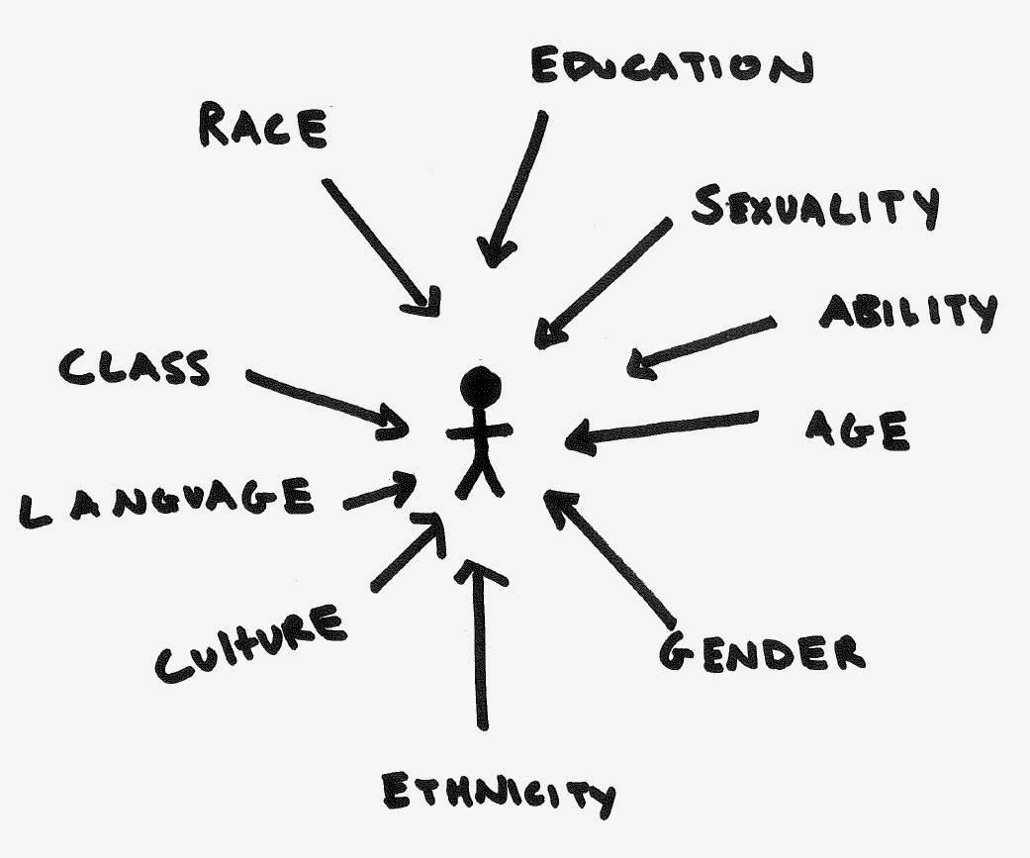
Intersectionality
Intersectionality was first introduced as a legal theory by Dr. Kimberle Crenshaw to signify the way race and gender, specifically racism and gender violence, interact to shape the realities of Black women (Crenshaw, 1989). Like CRT, intersectionality has traveled and been used widely across a number of different fields, including education. Intersectionality is not a fixed body of knowledge, but rather a constant work-in-progress and has been rearticulated within and across multiple fields. It is therefore more important to understand what intersectionality does than what it is (Crenshaw, et. al, 2013).
Collins and Bilge (2020) offer a working definition:
“. . . in a given society at a given time, power relations of race, class, and gender, for example, are not discrete and mutually exclusive entities, but rather build on each other and work together; and that, while often invisible, these intersection power relations affect all aspects of the social world.” (Collins & Bilge, 2020, pg. 1)
Intersectionality provides a tool for critical inquiry of the historical underpinnings of social problems and patterns of social injustice. Through an intersectional lens, we can better understand the complex ways in which social identities are intertwined. Identity cannot be understood by focusing on a single aspect of identity, or multiple identities considered independent of – or added to – each other. Rather, individuals are members of social groups that are constructed and influenced by systems of power and privilege within a specific historical context.
It is important to note that intersectionality does not focus on personal experiences of identity in a vacuum. Instead, intersectionality helps us explore and understand how systems of power and privilege are interconnected and mutually reinforcing and produce environments in which identity is experienced by individuals and social groups. An application of intersectionality can highlight how systems and power relationships affect the nature of knowledge, cultural norms and practices, and institutional structures and policies.
Why is CRT and Intersectionality a useful framework for supporting LGBTQIA+ scholars?
People in the LGBTQIA+ community bring ranging experiences and identities. These experiences and identities are not monolithic. Black and Brown LGBTQIA+ people such as Marsha P. Johnson, Silvia Rivera, and Miss Major, have always been at the forefront of the Queer Liberation Movement and continue to contribute to this social movement through the foundation that they built. Despite this legacy, however, LGBTQIA+ initiatives and representation have also historically benefited White, cisgender middle-class people in their assimilation into mainstream society. In order for us to fully understand and support LGBTQIA+ scholars, we must understand the various other social identities they carry and the systems of oppression that they may navigate simultaneously.
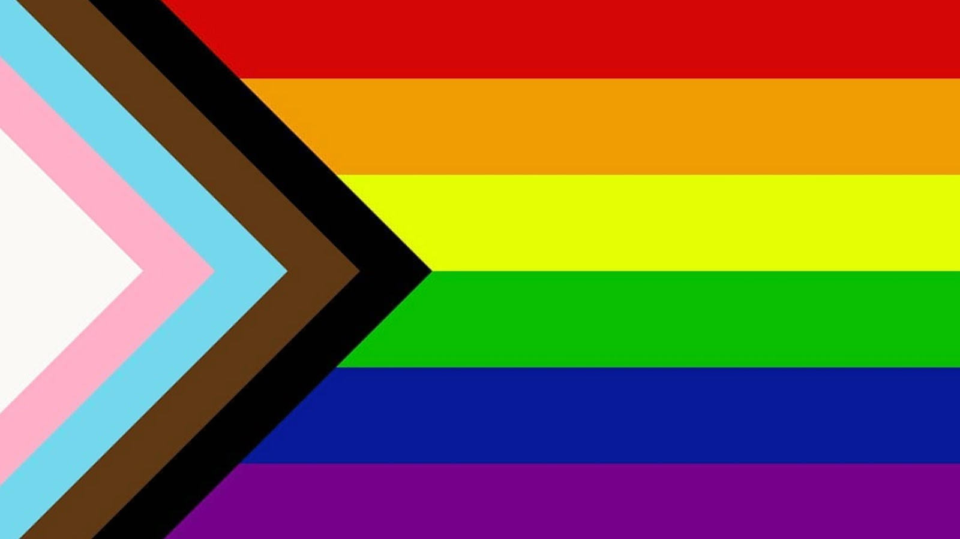
A lens informed by CRT and Intersectionality allows educators to understand the disproportionate impact that might come with navigating multiple target-identities and intersecting systems of oppression. According to Cerezo & Bergfeld (2013), “CRT places a historical and political lens on the treatment of historically marginalized groups, including policies and practices that affect LGBTQ students” and is a useful framework for addressing oppressive campus climates in which students feel the need to conceal their LGBTQIA+ identities. Intersections of Race, Gender, and Sexuality
The LGBTQIA+ community is not immune to systems of oppression existing within it: racism, classism, sexism, cissexism, ableism, etc. . LGBTQIA+ spaces and movements have historically centered white people.like all communities, white privilege, systemic racism, and white supremacy exist in the LGBTQIA+ community. It is crucial for practitioners to be open to learning the unique history and experiences queer and trans Black, Indigenous, and People of Color face
From POC to BIPOC
Progressive Pride Flag, Daniel Quasar, 2018

POC or people of color is a general umbrella term that collectively refers to all people of color - or anyone who isn't white. Historically, we have seen movement away from terms like “colored people,” “marginalized” or “minority” to “people of color” in order to prioritize our collective humanity. While there is power in a unifying “people of color,” Black and Indigenous issues and experiences kept getting glossed over under the POC umbrella. This shift also grew significantly as the world witnessed the murders of Ahmaud Arbery, George Floyd, Breonna Taylor, Tony McDade, and countless others at the hands of law enforcement or white supremacist vigilantes - which is an example of anti-Black racism, or racism that disproportionately affects Black communities.
Black and Indigenous people have moved away from identifying as “people of color” because they have not seen themselves and their experiences acknowledged. While racism can be experienced by anyone who is not white, there are still complexities and nuances to racial dynamics that allow for a perpetuation of anti-Blackness and anti-Indigeneity within broader communities of color. Some effects of racism overlap, but others such as police brutality or land sovereignty remain largely unique to a specific group.
The BIPOC Project
QTBIPOC (formerly known as QTPOC)
QTPOC has evolved into QTBIPOC for the same reasons stated in the aforementioned paragraphs. QTBIPOC serves as an empowering label that embodies self-determination and autonomy. Black and Indigenous queer and trans people face specific oppressions, the acronym names and acknowledges that their experiences are not monolithic under a generalized QTPOC umbrella. It also demands an intersectional lens when it comes to community building, healing, and advocacy. It is important to acknowledge that the acronym QTBIPOC emerged from grassroots community activism, not academia. It has been widely adapted across various community members, organizations, and academic institutions. Ultimately, QTBIPOC are in the constant process of naming themselves, evolving language for liberation and reminding the world that they have always existed--no permission needed.
QTBIPOC History
Trickle Up Theory
In conjunction with CRT and Intersectionality, Trickle Up Theory offers another relevant approach. Trickle up policymaking has been proposed by the researcher Z. Nicolazzo to provide a framework for understanding how to transform our campuses to better serve trans and gender non-conforming students (Nicolazzo, 2017b). This work is based on theorizing around social activism which focuses on centering the voices of the most marginalized when organizing justice movements (Spade, 2015). In utilizing this model to provide recommendations on how to create a more welcoming and affirming campus for LGBTQIA+ students, we assert that queer individuals still face discrimination, harassment, and violence. These affronts are more likely to be borne by the trans community and particularly by transgender and gender non-conforming individuals of color.
Violence and Harassment
Transgender and gender non-conforming individuals face deplorable levels of violence and harassment for their identity. For example, the U.S. Transgender Survey (2015) sampled roughly 30,000 individuals who identified on the trans spectrum from across the United States. The results clearly showed that trans individuals report high levels of violence and mistreatment in their families and community, within educational settings, and in employment. As a consequence, they are more likely to experience poverty and homelessness. Additionally, trans individuals of color were likely to have more aversive life experiences then their White trans counterparts.
Within Families and Community
One in ten of the USTS (U.S. Transgender Survey) respondents reported that a family member was violent towards them because of their identity and 8% were kicked out of the house because they were transgender. More than half of respondents (54%) experienced some form of intimate partner violence during their lifetime. Outside of their families, trans individuals reported high levels of community harassment and violence. Nearly half (46%) of respondents reported being verbally harassed in the past year and nearly 10% were physically attacked (14% for Black transgender respondents). These statistics are also consistent with hate crime statistics and the epidemic of the murder of transgender women. In California, of the hate crimes that were identified as gender based, 83% were directed at trans or gender non-conforming individuals (California Department of Justice Hate Crime Statistics 2018). The murder of transgender individuals has increased year after year. This year alone (2020) has seen 33 transgender people killed. The total number of homicides last year was 26. The majority of these victims were trans women of color and the majority of those are Black trans women.
Within the Educational System
Within educational institutions, trans students recount similar experiences of mistreatment. More than half of youth respondents in the K-12 system reported being verbally harassed, a quarter reported being physically attacked, and a little over 10% reported being sexually assaulted because they were transgender at school. Almost 20% of students reported such severe maltreatment that they left school as a result. These data are wholly consistent with research regarding trans and gender non-conforming student experiences on college campuses as well (Rankin, Weber, Blumenfeld, & Frazer, 2010; Garvey, Taylor, and Rankin, 2015).
Employment
In terms of employment, 30% of the USTS (U.S. Transgender Survey) respondents who had a job reported being fired, denied a promotion, or experiencing some other form of mistreatment in the workplace due to their gender identity or expression. Although transgender people are more likely than the general population to have a college degree, they have double the rate of unemployment as cisgender folks with rates for trans people of color being four times the unemployment rate.
Poverty and Homelessness
Respondents in the USTS sample overall were more than twice as likely as the U.S. population to be living in poverty, and trans and gender non-conforming people of color were up to three times as likely as the U.S. population to be living in poverty. For example, 34% of Black transgender people live in extreme poverty compared to just 9 percent of non-transgender Black people. In terms of homelessness, 30% of respondents had experienced homelessness at some point in their lives, with 12% having had such an experience within the past year. Transgender women of color experienced even higher rates of homelessness. For example, 51% of Black transgender women reported being homeless at some point in their lifetime. These data are also supported by research in our own California Community College system. Specifically, in the most recent Hope Center college survey (#RealCollegeSuvey, 2019) which assessed basic needs for college students, results showed that non-binary and transgender college students reported substantially higher homelessness rates than their cisgender counterparts (31%, 28%, and 17.5%, averaged for cisgender males and females respectively).
How Does Trickle Up Policy Making Work in Practice
Trickle up theory contends that focusing on the most marginalized students when approaching policy development not only creates a more equitable experience for those students, but also for various marginalized groups and the college community as a whole. Thus, as we think about the focus of our work in making changes on campus we must name and consider our most vulnerable students. For the purpose of this project we center on the experiences of transgender and gender non-conforming students, particularly those who are also students of color as they face the strongest barriers to success.
Consider for a moment how campus policies generally favor majority communities at the expense of marginalized communities. In one particularly salient example for members of the trans community are the myriad of institutional forms that ask about gender. The utility and necessity of such questions is generally dubious at best. The vast majority of these forms ask students to indicate their gender as either “male” or “female”. These types of questions disadvantage and marginalize trans students and do not generally provide necessary and important information for the college. In contrast, forms that allow individuals to self identify their gender, or omit gender questions unless absolutely necessary, provide substantial benefits to trans students while creating no negative consequences to cisgender students.
This same type of analysis can be applied to name policies and facilities. Having a name policy that allows one to indicate a lived name that is other than their legal name or the ability to indicate gender pronouns produces no deleterious effects to cisgender students and substantial benefits to transgender students, with such policies resulting in reduced depression, suicidal thoughts, and suicide attempts for trans students (Russell, Pollitt, Li, & Grossman, 2018). Similarly, having all-gender bathrooms on campus does not produce a hostile and threatening environment for cisgender and gender conforming students. However, having only gendered bathrooms substantially endangers transgender students. Research indicates that the vast majority of trans and gender non-conforming individuals face harassment and mistreatment while using the restroom (Herman, 2013). Additionally, research has also shown that restrictive and discriminatory bathroom policies increase the rates of suicide and attempted suicide for transgender individuals (Seelman, 2016). Again, these policies do nothing to increase the safety of the cisgender community and in fact do great harm and inflict violence on the trans community.

ARC and LGBTQIA+ History
In 1999, California enacted the legal vehicle called domestic partnerships as a way to extend many of the rights and benefits of marriage to same-sex couples. The Los Rios Community College District, inclusive of American River College, extended domestic partner and family benefits to its employees on January 1, 2000. Other companies and institutions, particularly academic institutions had begun extending benefits in the early 1990s, and domestic partnerships were established for some California cities in the 1980s, with Berkeley being the first in 1984.
American River College has had LGBTQIA+ student clubs under various names for decades, but they have struggled until recently. An article about ARC on the website www.gobeyondthebrochure.com, which assists students in choosing a college, states that the LGBT community at ARC “is more fledgling than flourishing” and concludes with “If you’re looking for a school with a well funded and very established LGBT group, then you won’t find it at American River College. What you will find is a tight knit community that’s not afraid to chase their goals.” It is our hope that this report on LBGTQ+ disproportionate impact and its recommendations will change this perception.
ARC’s Role in Prop 8
In the spring of 2008, a small group of five religiously conservative students were elected to the ARC Student Association. Only about 300 students voted in that election, and it was later found that three of those students (Viktor Choban, Alex Malash, and Vladimir Musorichi) had violated the campaign rules that all candidates were required to sign. This resulted in those students being stripped of their office by the Student Board of Justice, but they were later reinstated by an administrator who decided the ruling inappropriate.
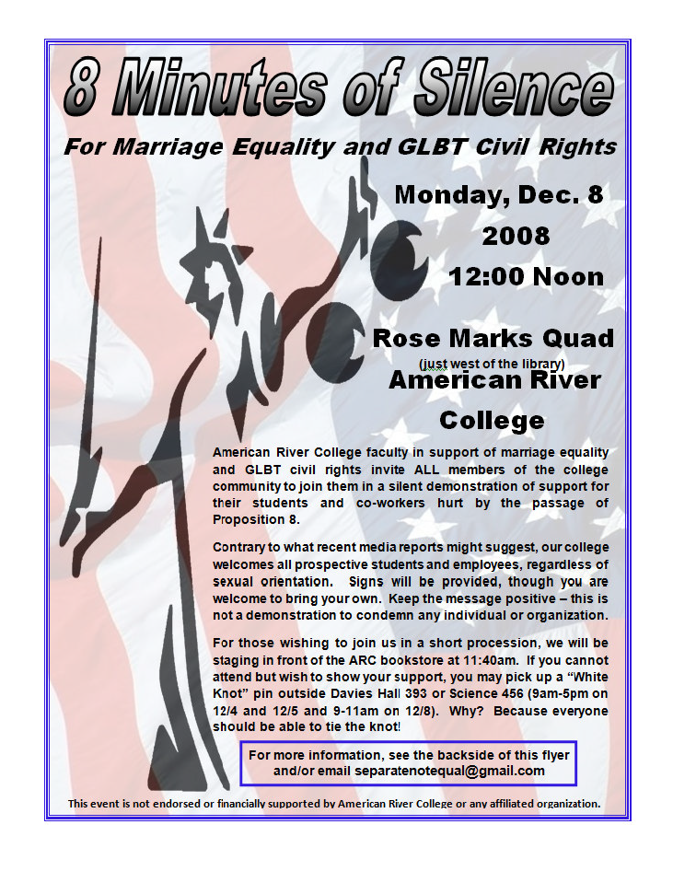
That religiously conservative majority ultimately led to an emotionally charged vote in October of that year on a Student Association resolution in support of Proposition 8 – the voter initiative that banned gay marriage in California. ARC was the only student government association in the state to take such a stance. As a result, ARC became nationally recognized for its anti-marriage-equality stance and was used as an example by Prop 8 supporters (http://digital.library.ucla.edu/websites/2008_993_106/article/arc-student-council-votes-to-back-gay-marriage-ban/index.htm). The main architects of the student council resolution were invited to speak at Prop 8 rallies and often seen at marriage equality protests (https://www.newsreview.com/sacramento/things-to-do-in-sacramento/content?oid=873290). A recall election occurred shortly after, but the all the student association members remained in power.
A silent protest, organized by ARC employees and students, was held in the Rose Marks Quad in opposition to the resolution. During the 8 minutes of silence, Prop 8 supporters stood behind the protestors jeering and trying to engage those observing the silence. As might be expected blog posts from the time are peppered with angry, homophobic comments that, thanks to the internet, live to this day displaying vitriol for everyone to see and damaging our college’s reputation and our students’ psyches (http://www.boxturtlebulletin.com/2008/10/01/3239).
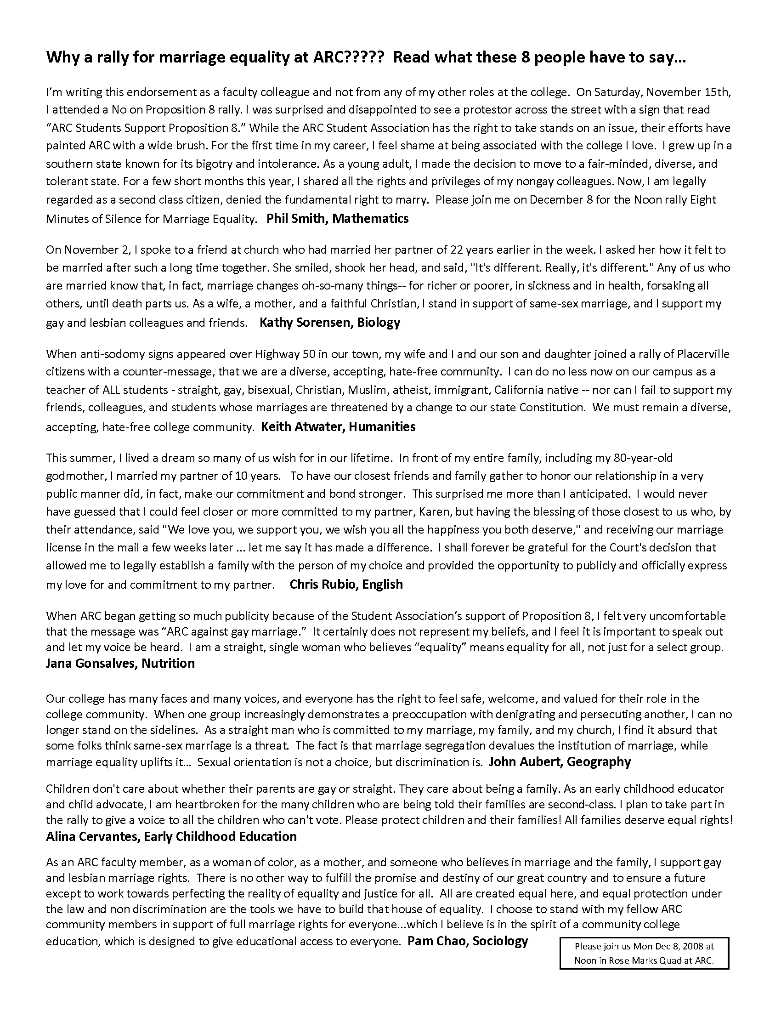
An 2013 editorial in the ARC Current student newspaper (https://www.arcurrent.com/opinion/2013/04/24/arc-should-learn-from-its-prop-8-mistakes/) called on the college to learn from the mistakes made in 2008 surrounding Prop 8. It is the hope of this team that just as ARC was an example of homophobia in 2008 that this report in 2021 will show ARC as an example of how far it has come in shedding its ugly history and will chart a path to better supporting our LGBTQIA+ students as well as those in our district and community colleges in our state.

LGBTQ+ Subcommittee of Equity
Before the establishment of the ARC Pride Center, there were years of groundwork and labor provided by a committed group of faculty, classified professionals, administrators, and students. The Pride Center would not be in existence today without these efforts. Thus, while the Pride Center may have appeared to manifest quickly, it was the result of multi-faceted persistence by the LGBTQ+ Subcommittee of Equity to at once 1) serve our students and campus employees directly concerning LGBTQIA+ equity matters, and 2) to prove the need for a Pride Center over the long haul (2 years to get approval and then another year for the physical space) and commitment to the cause from students, staff, and faculty working on and with the committee.
Initially, two Subcommittee members (Dennis Lee and Natasha Fratello) administered the Campus Climate Index to evaluate the climate for LGBTQIA+ students on campus, and then spearheaded a campus effort to address concerns the Index illuminated. The results of this 2014 evaluation served as the basis for the need on campus for what became the LGBTQ+ Subcommittee of Equity. Once established, the LGBTQ+ Subcommittee of Equity began advocating for the establishment of a Pride Center. At this same time, Brett Spencer, a student and president of our LGBTQ+ student club provided advocacy, support, and many hours of labor advocating for a Pride Center to serve students. The subcommittee members repeatedly and persistently brought up to multiple campus interest groups the need for and the solutions a Pride Center would bring, ensuring the establishment of the Pride Center was part of numerous formal and informal campus conversations. The subcommittee collaborated with each senate – Student, Classified, and Faculty – to approve resolutions stating that they supported a Pride Center at ARC.
They further monitored the Student Equity Plan and made sure LGBTQIA+ students were included, long before the mandate established by AB 1018. Additionally, the committee pushed to ensure that the state mandated AB 620 liaison position was filled. It was through this advocacy and hard work that the ARC Pride Center came into existence.
LGBTQ+ Subcommittee of Equity Members
- Natasha Fratello, Faculty, Psychology, initiating member and initial Chair
- Dennis Lee, Faculty, English, initiating member
- Emilie Mitchell, Faculty, Psychology, second consecutive Chair
- Roderic Agbunag, ARC UNITE Coordinator
- Tori Bovard, Faculty, Psychology
- Kristina Casper- Denman, Faculty, Anthropology
- Alina Cervantes, Faculty, ECE
- Mary Goodall, Clerk III, Operations and Facility Reservations
- Susan Howe, Faculty, English
- Manuel Perez, Dean of Equity Programs and Pathways, Inaugural AB 620 Liaison
- Leslie Reeves, Faculty, CIS and ITC
- Carlos Reyes, Dean, Behavioral and Social Sciences
- Valencia Scott, President, ARC ASB
- Brett Spencer, Student Representative, ASB, President of FIERCE
- Phil Smith, Faculty, Mathematics
- Sara Smith, Faculty, History

The Importance of Staffing Models
During the years and months of negotiations surrounding the establishment of the Pride Center, staffing models were a primary discussion point. Those working on funding the Pride Center were asked by countless administrators along the way to consider having temporary staffing, part time staffing, or no staffing models. The committee was steadfast in advocating for a permanent full-time classified professional position SPA (student personnel assistant) and part-time faculty coordinator position. This stance presciently recognized that in the inevitable lean budgetary times a center staffed with temporary staff would quickly disappear. Those suspicions have been validated by the loss of positions within student equity that had temporary or part-time staff.
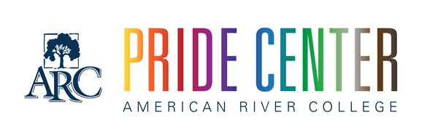
Establishment of the ARC Pride Center
In January of 2018, building on the exemplary work of the LGBTQ+ Subcommittee of Equity and with the support of our college president Thomas Greene, the ARC Pride Center officially opened! The Center’s funding specified a permanent full-time SPA (student personnel assistant) and a part-time faculty coordinator. At the initial opening only the Faculty Coordinator position was filled (Dr. Emilie Mitchell) with oversight provided by the newly hired Dean of Equity, Programs, and Pathways (Dr. Joshua Moon Johnson). This was uncharted territory as few examples of Pride Centers existed in the California Community College system and there was no pre-existing infrastructure on the ARC campus to support the work of the center. Dr. Johnson and Dr. Mitchell set about establishing the mission, goals, and objectives for the center.
During those first few months in collaboration with the GSA (Gender and Sexuality Alliance, formerly known as FIERCE), students helped to develop programs specifically aimed at LGBTQIA+ students including queer D & D meetings, crafting events, and a book club. In addition to programming, the center was able to hire and welcome our permanent full-time classified professional to the team (Alejandra Fernandez Garcia) in July 2018. With a full team in place the center was able to begin to make substantial contributions to improving the campus for the LGBTQIA+ students at ARC as well as undertake some larger district wide accomplishments. Following are just a few of the many accomplishments that the Pride Center has made in its brief two-year existence.
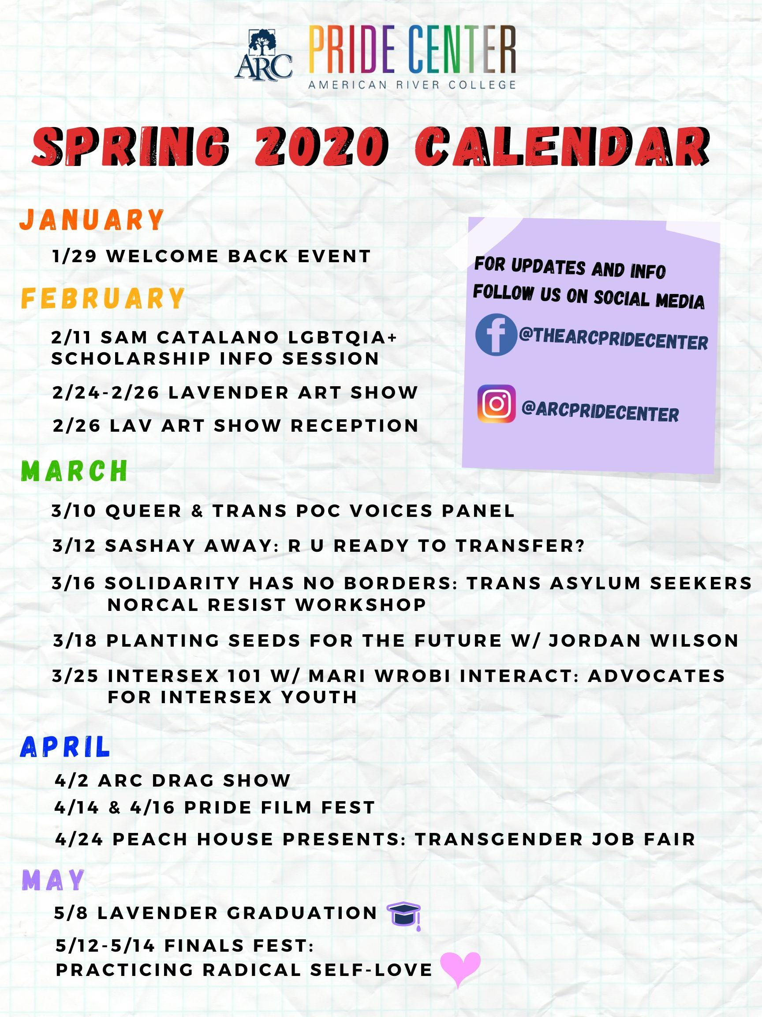
Extensive Programming for Students
Programming and events are intentionally organized through an intersectional lens by the ARC Pride Center Team. The Pride Center’s mission and values clearly state that we seek to uplift and highlight LGBTQIA+ voices that have also been historically ignored.

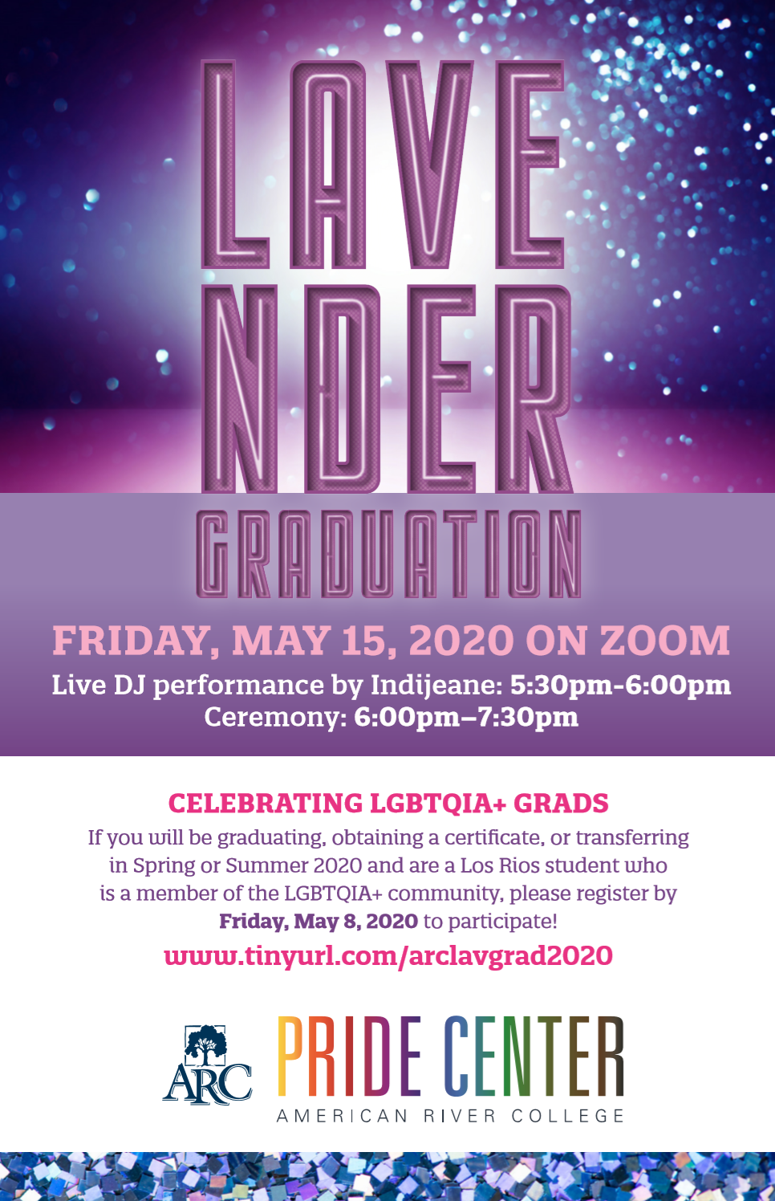
Signature Event - Lavender Graduation
One of the first events that the ARC Pride Center sponsored was the college’s first Lavender Graduation on May 4, 2018. The event had only five graduates that year, but it featured moving speeches by several graduating students as well as a powerful set of closing remarks by Professor Susan Howe. In addition, there were pride award categories for students, faculty/staff, and outstanding alumni. Starting the next year, Lavender graduation expanded to become a district-wide event (although still produced and hosted by ARC’s Pride Center). Lavender Graduation in 2019 was held in the ARC Music Recital Hall with 18 graduates and live performances by the ARC Chamber Singers. The 2020 Lavender Graduation event was held virtually due to the COVID-19 pandemic, but was still well attended and a joyous event.

LGBTQ+ Trainings Across Campus and District
The Pride Center provides general training (LGBTQ+101) as well as more specific training (Bias and Maltreatment Intervention, Intersex Awareness) across the campus and throughout the district. Specifically, trainings are offered every semester during flex events, at least once during college hours, and in response to direct requests for training from departments and individuals or in response to campus events. The Center also provides yearly training for our Los Rios Community College District Police Department to ensure officer awareness of the community; grounding in the history of policing of the LGBTQIA+ community; research on queer and trans experiences with law enforcement; and provide practice opportunities through scenario-based discussions to address real world interactions in the field.

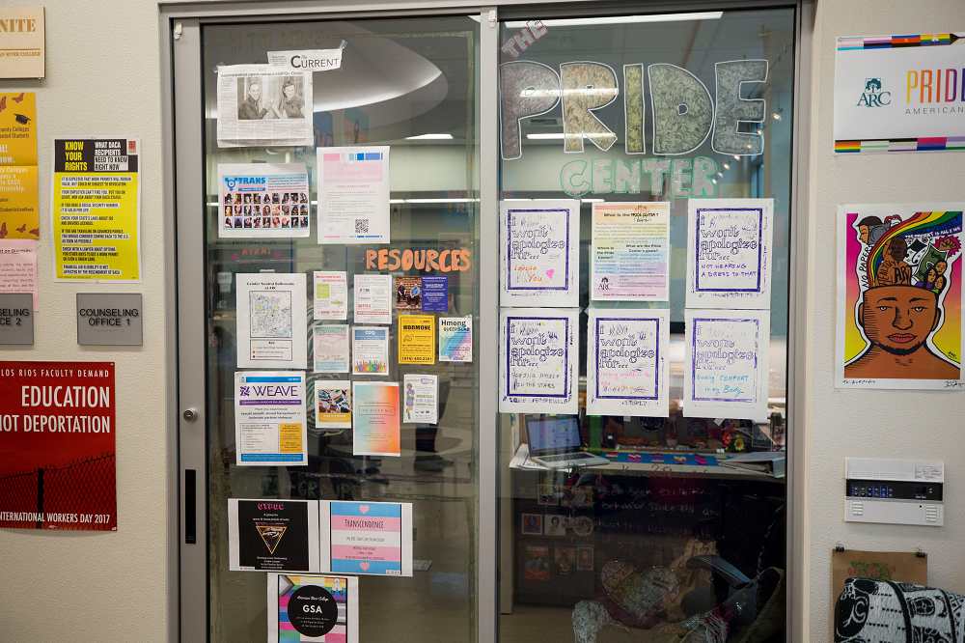
Online/ Social Media Presence
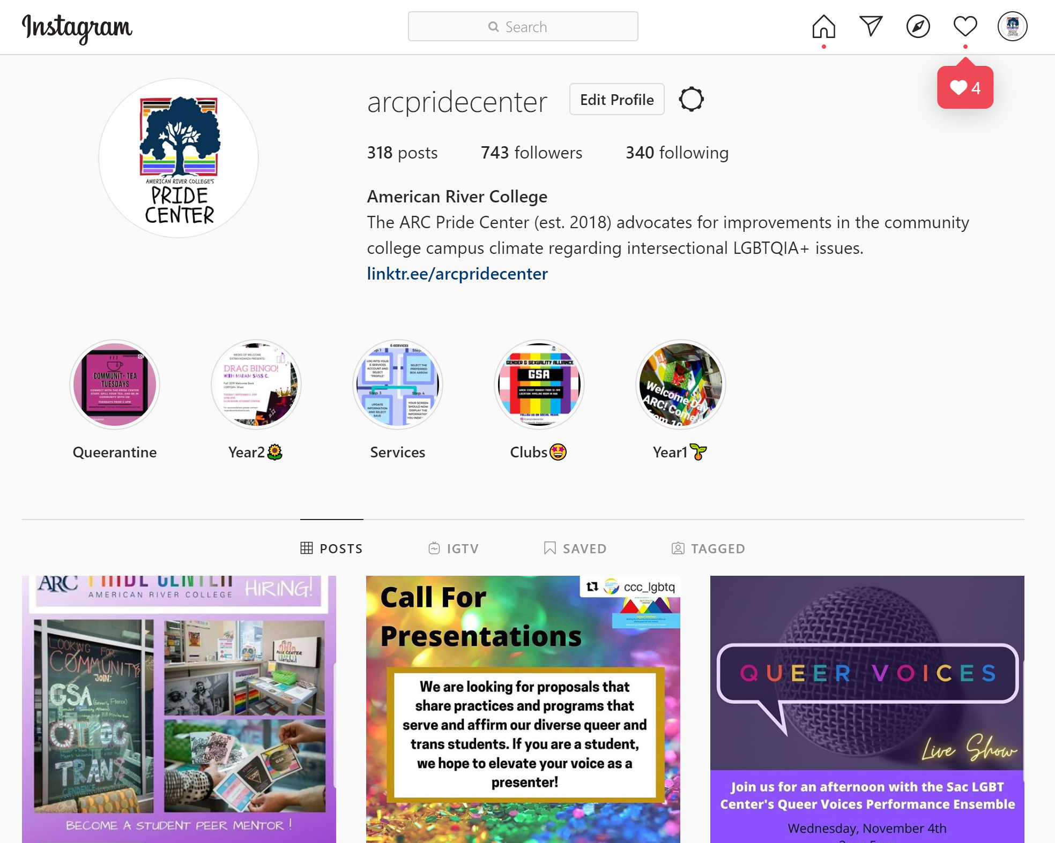
The ARC Pride Center has built an online social media presence, via Instagram & Facebook, in the 2.5 years of its existence. The intention of building these platforms was to meet students where they were at and utilize the tools of communication that most resonated with them.
While the Pride Center still maintains an email list-serv and production of printed materials, the team found that sharing content via social media allowed for a marketing strategy that reached a wider audience, allowing information to be shared easily. These social media platforms facilitated networking and collaborations with other Sacramento based LGBTQIA+ community organizations and sibling Pride Centers across the state. Additionally, these platforms are a documented timeline of all the work that the ARC Pride Center has done since opening in 2018. Visit:
ARC Pride Center Instagram
ARC Pride Center Facebook
Transitioning into remote operations in 2020 with the onset of the COVID-19 pandemic, having a social media presence and launching #TheQueerantineProject has become a critical tool in keeping students connected to community. None of this would have been possible without the immense support and labor of Pride Center student staff.

Establishment of Counseling Services in the Pride Center
In recent years the California Community College State Chancellor’s Office has adopted the Student Centered Funding Formula (SCFF) that ties the funding colleges and districts receive to outcomes that include the number of students earning associate degrees and credit certificates the number of students transferring to four-year colleges and universities, and the number of students who complete transfer-level math and English within their first year. The Pride Center recognized that a direct relationship with a counselor was most likely to result in these outcomes while also being cognizant that many queer and trans students are reluctant to seek services from strangers who may not be culturally competent in serving the community. To ensure that Pride Center students were able to meet these targets, the Pride Center worked in collaboration with the Counseling department administration and with counselor Anita Fortman to begin offering counseling hours in the Pride Center for our students. Anita began offering Counseling services to our students beginning in Spring 2019. The results of this partnership have been quite impressive.
According to the California Community College Chancellor’s Office Student Success Metrics (academic year 2017-2018; the most recent data available), a total of 6,711 students of our roughly 94,855 enrolled in the LRCCD either earned an AA/AS (N = 2,959), an ADT (N = 1,637), or earned a credit certificate (N = 2,115). In aggregate these numbers mean that roughly 7% of our overall student population met these goals. In contrast, 100% of the students served by our Center are working toward the degree of certificate goals. Additionally, according to national statistics just about 30% of students who enrolled in a community college transfer to a four year college or university, the data for our center students indicated that 65% of our students will be transferring. In terms of Math and English completion the Student Success Metrics data indicated that just 5% of our district students completed both transfer-level Math and English in their first academic year (23% for English only and 6% for Math only). Of the students served by our Pride Center those percentages are 9% (both Math and English), 26% (English only), and 9% (Math only).

Relevant Student Success Allocation (SCFF) Data
 | District Wide | Pride Center Students
Aggregated percent of Students earning AA/AS, ADT, or Credit Certificate | 7% | 100% working toward these goals
Percent of students transferring to four-year colleges and universities | 30% (based on national statistics) | 65%
Percent who complete transfer-level Math within their first year | 6% | 9%
Percent who complete English within their first year | 23% | 26%
Percent who complete both transfer-level Math and English within their first year | 5% | 9%

Campus Climate Study
The Campus Climate Study was conducted during the Fall 2018 semester with final data collection ending in mid-December. A total of 1,201 individual student responses were collected focusing on the hiding of one's identity and mistreatment on campus based on their identity.
“Preferred” Name Policy
In 2018, The Pride Center was able to successfully advocate for a change to our systems that allowed all students and employees to indicate a lived or affirmed name on their records that might differ from their legal name. The affirmed name appears on nearly all official college documents and records, including rosters and ID cards. The legal name only appears on any legal document produced by the college or required for state or federal law, such as academic records, transcripts, and financial aid award information. Exceptions continue to creep up, but are quickly rectified once they are reported as was discovered when this committee was established and the system used legal, rather than affirmed, names for our committee members.
Inclusion of Gender Pronouns on Learning Management System and Rosters
As of October 2020, students and employees now also have the ability to indicate their gender pronouns and have those reflected in the Learning Management System (Canvas) and on student rosters.
CCC LGBTQ+ Summit
In 2021, American River College will be hosting the CCC LGBTQ+ Summit. This Summit is an opportunity to collaborate with members of the California Community College campuses at all levels. Allowing students and practitioners to learn from each other’s innovative and successful ideas that will transform campuses to better serve and affirm LGBTQIA+ students. The conference is focused on improving not only individual community college campuses, but encouraging changes at the structural level as well. The Summit will be held on April 28th and 29th and is expected to be an extraordinary conference.
Pride Centers Across the California Community College System
Of the 116 California Community College campuses only 9 currently have at least a half-time paid staff position to serve queer and trans students with three additional campuses currently working to establish such positions. Only a portion of those campuses also include a physical space on campus for queer and trans students to seek services and find support. According to the California Community College Chancellor’s office, the system serves roughly 2.1 million students. It is almost unfathomable that, in an educational system serving millions of students, only a handful of colleges have positions focused on serving queer and trans students. While it is impossible to ascertain an accurate count of the exact number of students on the ARC campus who identify as LGBTQIA+, research from our own Pride Center as well as our Institutional Research Department indicates that between 21-34% of our students identify on the queer spectrum and between 4-13% identify on the trans spectrum. Thus, thousands of our students are members of the LGBTQIA+ community. In addition to the numbers of queer and trans students we serve there also exists structural mandates and changes that make serving students and improving outcomes of utmost important. In 2017 the passage of AB 1018 required the inclusion of LGBTQIA+ individuals in all community college equity plans and requires that colleges articulate the ways in which their campus intends to serve these students.

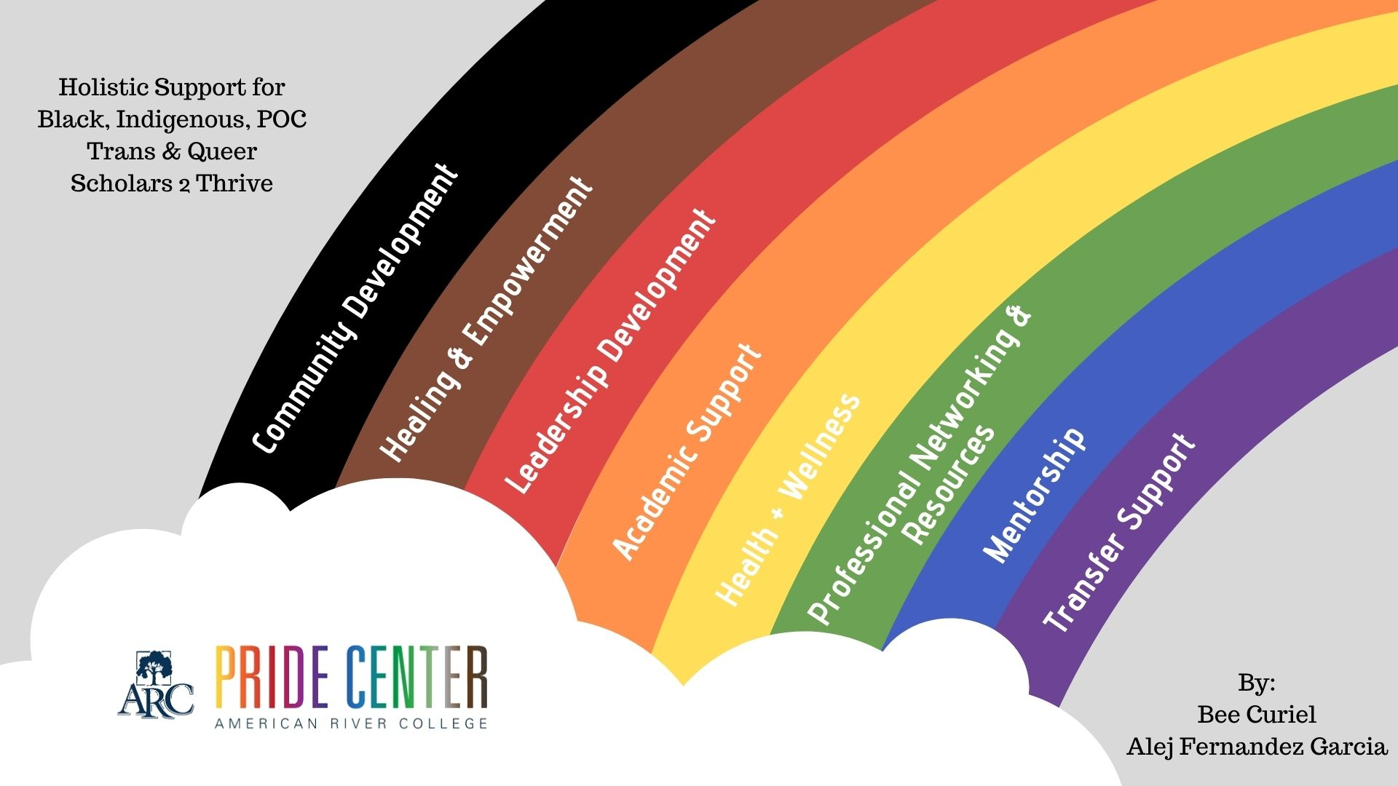
Existing Barriers
Doing More with Less
The CCC system is mandated with serving LGBTQIA+ students; there are large numbers of these community members on campus, and very few resources available to serve them. The most direct consequence of the limited financial resources provided to serve queer and trans students is that progress toward the minimization of disproportionate impacts is hard to obtain. Planning, evaluating, and executing plans to address the needs of LGBTQIA+ students takes considerable time and effort. We are more fortunate than most campuses as we have a full-time classified professional position and a part-time faculty coordinator position. As we think about the accomplishments of our center, both on our local campus and across the district, it must be acknowledged that this is attributable to our increased staffing levels. That being said, we are not able to meet all the needs of our campus, our district, and our students with the current funding.
Organizational Barriers
As administrative shifts have occurred and departments have been dissolved and reconfigured, the administrative structure for the Pride Center has become a barrier to the Center’s continued success. Initially, the Pride Center and other equity programs were housed within the department of Equity Programs and Pathways (EPP). This provided administrative support and oversight by both a Dean (Joshua Moon Johnson) and a supervisor (Satya Chima) focused on equity. In late 2019, a new interim position was hired (Dean of Equity and Inclusion – Nick Daily) in response to the Institutional Equity Plan recommendations. When the decision was made to disband the EPP department, it was assumed that the Pride Center would be housed under the recently created dean position; however, this has not occurred. Currently, the Pride Center belongs to no department or has yet to be informed on where it exists within the organizational structure.

Additional concerns involve classification, compensation, and lack of district level support. As mentioned above, the ARC Pride Center has spearheaded many system level changes and continues to be asked to work on projects that span the four colleges in the district (e.g., district Lavender Celebration, policy initiatives that involve all campuses, programming that spans all colleges, develop and manage an Employee Resource Group). Although the faculty coordinator was given one year of additional release time to work on some of these projects, this funding ended in Spring 2020. Thus, though there is a tacit assumption that the Pride Center would continue to oversee efforts for the district, these additional efforts are done without compensation and in addition to the campus level work. Additionally, there is no singular person at the District Office that is responsible and accountable for programs and services that serve queer and trans students. While programming decisions are best left to the individual colleges, it is incumbent upon our district to ensure that all four colleges are able to provide support to the queer and trans students on their campuses. One need look no further than the wide variation of support provided on each campus to recognize that queer and trans students have vastly different experiences depending on the campus they attend. Specifically, while ARC has a part time faculty coordinator and a full-time classified professional, SCC has a temporary part-time staff position; CRC has one faculty member with a .2 release time and no additional staff; and FLC serves all DI populations with a full-time classified professional and a part-time faculty coordinator. This variation in local campus personnel is directly related to how much support each campus can provide and underpins the importance of a district-level position to help support and bolster the work on each campus.
Another institutional barrier faced by the Pride Center staff is a substantial discrepancy in the classification of the Center’s classified professional job title, the Student Personnel Assistant (SPA). The classified staff SPA position is the only full-time position in the entire LRCCD to date dedicated to serving LGBTQIA+ students. This position is the co-coordinator of the center, though not exemplified by the SPA title, pay scale, or institutional recognition. Specifically, while other equity areas (UNITE and UndocuScholar) are part-time Specialist positions, a higher ranking, the Pride Center position has remained an SPA position. It is important to note that presently the Pride Center SPA position is the only full-time position of all the equity centers (UNITE and UndocuScholar). This pattern of hiring of part-time student affairs professionals to coordinate equity centers, while not providing health benefits, paid time off, or a pension, is not sustainable and does not provide stability for this work to truly thrive. This work is not sustainable or stable if only part-time positions are funded and full-time positions are paid less hourly. Additionally, and not inconsequentially, the Center classified professional has also been asked to take on roles that were well outside their job description and unrelated to their central charge of serving queer and trans student at American River College.
We must be critical and hold our institution accountable for its stated commitment to equity and social justice. We must ask: how is equity work being valued (structure of support, funding, physical space on campus, full time positions)? How are the people working these positions valued and funded? What are their identities? We will often find that the people in these underfunded positions hold multiple intersecting identities with a wealth of lived experiences that resonate with the scholars they serve: Black, Indigenous, People of Color, queer, trans, 1st generation college grads, women, undocumented, working class, living with a disability, current grad students, etc.
Budgets and Business Processes
As mentioned in both the Institutional Equity Plan and the Educational Master Plan, organizational processes are often a barrier to completing tasks and can hinder the ability to serve students effectively. Of particular concern are processes connected to how budgets are established, the limitations of those budgets, and how budgets are accessed. For example, the requisition process is time-consuming, difficult to complete, and frequently unforgiving since there are many possible ways to unintentionally make errors and very few quick remedies. It is neither intuitive, nor well explained for those who lack familiarity with the intricacies of Los Rios business practices, accounting principles, or the siloed budget code categorizations required for California Community Colleges (e.g., supplies vs. equipment). Further, the capacity to navigate processes successfully is sometimes dependent on expertise that is most easily accessible to the well-connected (i.e., who you know) rather than streamlined and clearly communicated procedures. While most processes were designed with good intentions (e.g., accountability), the result can be inherently inequitable.
Additional Barriers
There are many other barriers that exist within the ARC environment that hinder the effort to support LGBTQIA+ students. A few examples that can be highlighted include:
- Club Formation – Clubs create a sense of community, but there are tremendous barriers to forming an officially recognized club. Two particular constraints are the minimum number of members required to form a club and the limitations on who can serve as an advisor. Per Los Rios Board Policy 2312 and its corresponding regulation, each club must have a faculty advisor but many faculty are at capacity.
- Marketing/Communication – It is difficult to promote LGBTQIA+ services and to share information with students about topics such as the presence of a Pride Center, how to change their name in Los Rios systems, and other relevant information.
- Lack of Recognition – Emotional labor involved in supporting marginalized students is not sufficiently recognized and valued. This is difficult for faculty and classified professionals who provide the support. Those with marginalized identities may also feel overburdened when asked to do more (e.g., participate in committees, give presentations).
- Classified Compensation – There is currently no formal structure in place to compensate classified professionals for contributing their talents, energy, and labor to LGBTQIA+ activities that are outside their normal job duties.

The Student Experience
National and Local Research On LGBTQIA+ Student Experiences in Higher Education
Research has consistently found that LGBTQIA+ students experience negative treatment on campus. For example, in the 2010 study by Rankin, Weber, Blumenfeld, & Frazer, researchers found that 21% of LGBT students experienced harassment on their college campus in the last year. The findings further indicated that many students were choosing to conceal their identity in order to avoid this type of harassment. Specifically, 43% of queer spectrum and 63% of trans spectrum concealed their identity. Additionally, trans spectrum and queer spectrum people of color reported more harassment and concealment of their identity to avoid harassment than their White trans and queer spectrum counterparts. Research reveals that these types of experiences directly affect students’ persistence in school. Recent research has indicated that 16% of trans students left school because of their treatment on campus (Herman, Rankin, Keisling, Motter, & Anaf, 2016). Queer-spectrum and trans-spectrum college students are also almost three times as likely to have seriously considered suicide in the last year compared to other college students (Greathouse, BrckaLorenz, et al., 2018).
It should be noted that little research has focused specifically on the experiences of LGBTQIA+ community college students. The few research studies conducted with this student population found that students’ feelings of safety, comfort, and feeling welcomed were the strongest predictors of overall campus climate, and that LGBTQ students rated the community college campus climate as rather low (Garvey, Taylor, & Rankin, 2015). Finally, the recently released California Community College (CCC) Student Success Metrics (https://www.calpassplus.org/LaunchBoard/Student-Success-Metrics) as well as research conducted in the California Chancellor's office (Gobuyan, 2018) suggest that students in the LGBTQIA+ community show an approximately 10% lower rate of transfer, persistence, and course success than non-LGBTQIA+ students.
Data Invalidation of LGBTQIA+ Students
It is very important to understand that getting accurate data on the queer and trans community on our campus faces substantial challenges. First, we understand that being a gender or sexual minority still remains stigmatized. Thus, many students are reluctant to identify themselves as members of the LGBTQIA+ community out of fear or lack of comfort with their identity. Additionally, there are systemic issues that pose difficulties in obtaining accurate counts of LGBTQIA+ community members on our campus. Specifically, almost all students who enroll in California Community Colleges fill out the CCCApply admission application and as of 2011, students were queried regarding their sexual orientation and gender identity. While this was a tremendous step forward, there exist several issues related to this data collection. First, the questions asked regarding sexual orientation and gender identity are not consistent with current terminology and thus likely result in undercounting of the community. Additionally, and most importantly, students under the age of 18 are not shown the SOGI questions (Sexual Orientation and Gender Identity) and students only complete the application at their initial matriculation. Thus, the queer and trans student population live and study in the shadows of our campus and its systems. Consequently, queer and trans students are often not recognized in the demographic profiles of our student population and as a direct result are often overlooked in institutional planning.
At the federal level, the Integrated Postsecondary Education Data System (IPEDS) of the National Center for Educational Statistics is the primary federal data source for information on postsecondary institutions. IPEDS includes only the two dominant gender identifiers, men and women, in its data collection surveys, and it does not collect information on students’ sexual orientation. This lack of data is a glaring problem in the attempts to extend campus equity work to LGBTQIA+ students. While acknowledging the limitations of LGBTQIA+ data, two studies specific to ARC have attempted to ascertain the experiences of queer and trans students on our campus.

ARC Campus Climate for LGBTQIA+ Students
The ARC Pride Center Campus Climate Study surveyed 1201 students in Fall 2018 and the Institutional Campus Climate Survey conducted in Fall 2019 surveyed the campus experiences of 1075 Main Campus students. Below is a summary of findings from each of these two studies.
Clarification of Terms
For the results presented, the term queer spectrum indicates individuals who identified their sexual orientation as other than strictly and exclusively heterosexual or straight. The term trans spectrum indicates individuals who identified their gender identity as other than exclusively cisgender.
ARC Campus Climate for Queer Spectrum Students
When student respondents were asked on the ARC Pride Center Campus Climate study if they hid their sexual orientation, roughly 38% indicated they hid their sexual orientation from fellow students, and just under 31% reported they hid their sexual orientation from their professors. In addition, findings from both the ARC Campus Climate Study as well as Institutional Campus Climate Survey found that in comparison to heterosexual students, queer spectrum students were significantly more likely to report negative experiences on campus and in classrooms. Specifically, queer spectrum students were significantly more likely to report being mistreated by fellow students and instructors; to feel less safe on campus; and reported being more concerned for their psychological and emotional safety. Additionally, queer spectrum students were significantly more likely to report feeling that they were treated less fairly and equitably in the classroom; less heard by their instructors and classmates; and more likely to report that their classes were less accepting of queer individuals. Finally, overall they were significantly more likely to see the campus as homophobic.
ARC Campus Climate for Queer Spectrum Students of Color
Interestingly, the ARC Pride Center Campus Climate study found that student respondents who identified as both queer and person of color (POC) viewed their classes as significantly less accepting of gay, lesbian, bisexual, pansexual, asexual, etc. individuals than queer identified Caucasian/White students. Findings from the Institutional Campus Climate Survey did not find any moderating effects of racial/ethnic identity on findings.
ARC Campus Climate for Trans Spectrum Students
When student respondents were asked if they hid their gender identity, roughly 31% indicated they hid from fellow students and just over 30% reported they hid their gender identity from their professors. In addition, findings from both the ARC Campus Climate Study as well as Institutional Campus Climate Survey found that in comparison to cisgender students, trans spectrum students were significantly more likely to report negative experiences on campus and in classrooms. Specifically, queer spectrum students were significantly more likely to report being mistreated by fellow students and instructors; to feel less safe on campus; reported being more concerned for their psychological and emotional safety; and to believe that students are harassed on campus because of their gender identity. Finally, trans spectrum students were significantly more likely to see the campus as transphobic.

Mistreatment in the Classroom
As mentioned above, both the ARC Campus Climate Study and the Institutional Campus Climate Survey found that both trans and queer spectrum students were more likely than their cisgender heterosexual counterparts to report negative experiences in their classes. This was particularly true for trans spectrum students. Below are several examples of narratives provided by students regarding experiences they have had in their classrooms and with campus departments
“I have been told that my choice of pronoun (they) isn't grammatically correct and that my identity (non-binary, etc.) does not exist.”

Placeholder for quotes or student narratives that may surface from the Student Resource Panel

Reporting and Responding to Hate/Bias Incidences
The aforementioned research and narratives highlight the need for our campus to understand the effect of hate/bias incidences on the experiences of queer and trans students at American River College and develop a strategy for addressing these incidences. One point of confusion for many is the difference between a hate crime and a hate/bias incident and how these incidents affect the collegiate experience.
A hate crime is a legal classification that in the most general terms means a criminal offense that is motivated, in whole or in part, by bias. In California, the definition of a hate crime is a crime against a person, group, or property motivated by the victim’s real or perceived protected social group. In California, you can be a victim of a hate crime if you have been targeted because of your race or ethnicity, nationality, religion, gender, sexual orientation, physical or mental disability, or your association with a person or group with one or more of these “actual” or “perceived” characteristics (https://oag.ca.gov/sites/all/files/agweb/pdfs/civilrights/preventing_hate_crimes_brochure_ENG.pdf). Requirements of the U.S. Department of Education, require that data on hate crimes on college campuses be collected and disseminated (The Clery Act https://www.govinfo.gov/content/pkg/FR-2014-10-20/pdf/2014-24284.pdf#page=3). Thus, the requirements for how to handle a hate crime is quite clear.
What is less clear is how to handle hate or bias incidents and how these types of incidents affect our students. Hate incidents are actions or behaviors motivated by hate or bias but legally protected by the First Amendment right to freedom of expression. Examples of these types of behaviors include: name calling, insults, displaying offensive material on personal property, and distributing biased hateful material on public property. Thus, hate and bias incidents do not meet the level of criminal standards, however they create a hostile campus environment. There is a myriad of these experiences on campus and how our campus chooses to respond or not respond influence the campus climate for queer and trans students. Below are two common examples of hate/bias incidents that occur on our campus.
The Hateful Preachers
Our campus is regularly frequented by proselytizing individuals who vigorously assert their version of religion and morality. Many of these individuals bring incendiary posters (e.g., God Hates Fags) and use inflammatory language (e.g., It is Adam and Eve not Adam and Steve). These individuals often target queer and trans identity and clash with students. ARC is an open campus and these individuals’ right to speak is protected by the Constitution. However, the lack of counter messaging from the campus; the inability for students to have their experiences of victimization and violations acknowledged by the presence of these individuals; and a lack of uniform response to the presences of such people gives the impression that the college at least condones, if not expressly supports, these individuals’ positions which leaves queer and trans students feeling increasing vulnerable on our campus.
The Classroom and Campus Environment
As several of the narratives above clearly illustrate, queer and trans students experience these types of hate and bias incidents in their classrooms and while interacting with various campus departments. These experiences include both direct discrimination as well as microaggressions. Direct discrimination might take the form of name calling or slurs (e.g., being called a faggot or a tranny). Microaggressions are comments or actions that subtly and may unconsciously or unintentionally express a prejudiced attitude toward a member of a marginalized group (The Miriam Webster Dictionary). Research has shown that LGBTQIA+ students who experience microaggressions (e.g., being told to act ‘less lesbian, gay, bisexual, or queer or being told that they talk about discrimination against transgender or gender queer people too much) reported lower self-esteem and higher stress and anxiety. (Seelman, Woodford, & Nicolazzo, 2017) Again, when as a campus we choose not to give students the opportunity to report these incidents and to provide support for students whose identities feel under attack, we leave queer and trans students to experience a campus environment that is hostile and invalidating. We also fail to support our college colleagues in serving our students better.
The Physical Environment
Bathroom Facilities
Our students must interact with the physical campus environment on a daily basis and many of our students find that environment hostile to their identity. Research has been very clear that transgender and gender non-conforming community members experience very high levels of assaultive behavior in the bathroom. For example, in a study by the Williams Institute (UCLA Law School; https://williamsinstitute.law.ucla.edu/press/study-transgender-people-experience-discrimination-trying-to-use-bathrooms/) researchers found that 70 percent of trans and gender non-conforming study participants (N = 93) had expressed harassment while using the restroom. This treatment included being told they were in the wrong facility, told to leave the facility, questioned about their gender, ridiculed or made fun of, verbally threatened, or stared at and given strange looks. In some instances, the police were called and folks were followed after using a facility. Just under 10 percent of respondents reported physical assault. Almost 20% reported being denied access to a restroom. This is also echoed in the comments made by our own students
- “I am routinely ‘informed’ that I'm in the wrong bathroom, sometimes by people looking at the sign on the door and then at me, sometimes by the obvious reaction by people, and sometimes by people asking/telling me I'm in the wrong bathroom. I go out of my way to use a nongendered bathroom, but it's often in use.”

**We could include some additional quotes from the listening sessions
Bathroom restriction is associated with increased rates of physical ailments including dehydration, urinary tract infections, kidney infections, and other kidney problems as folks try to avoid going to the restroom during the day. Additionally, the limited number of single stall all gender bathrooms on campus presents a problem for access to the facilities as well as the time needed to access these restrooms while on campus. American River College currently has six single stall bathrooms on campus which are designated as all gender. These six bathrooms must serve a population of over 30,000 students. The limited access to gender inclusive bathroom facilities results in long wait times and because many of the bathrooms are clustered in the more recently constructed building many folks have no realistic option to utilize these facilities. Additionally, faculty may become irritated by how long it takes a student to leave who needs to use those restrooms. Importantly research has also shown that restrictive and discriminatory bathroom policies negatively affect transgender folks and increase the rates of suicide. Specially, in a study from Georgia State University (https://www.insidehighered.com/quicktakes/2016/04/21/transgender-students-bathroom-access-and-suicide) investigators found the attempted suicide rate of all transgender people in the study was 46.5 percent. This number is consistent with most research on the high rates of suicide in the trans community. The rate for those denied bathrooms or living spaces that reflected their gender identities was 60.5 percent. Gendered bathroom policies do little to increase the safety of the cisgender community and in fact do great harm and inflict violence on the trans community.
Locker Room Facilities
In addition to bathroom facilities, the design of our locker rooms creates substantial barriers for transgender and gender non-conforming students to participate in physical education courses. While less research has focused on the effects of gendered locker room facilities, the Pride Center has fielded numerous complaints from transgender and gender non-conforming students about their inability to utilize the locker room facilities. In all of the cases in which the Pride Center has been involved, the student has dropped this class because we were unable to find an appropriate solution.
It is worth noting that some degrees have a PE requirement, so not only are these facilities issues discriminatory and regressive they also keep us from meeting our basic mission as a college!
It is of utmost importance to note, that our facilities management team (Cheryl Sears and Annaliese Pennell have worked tirelessly to address these issues. They have consistently and vociferously advocated for additional single stall all gender single restrooms as well as multi-stall all gender bathrooms in our new construction projects. They have also stridently worked on retrofitting projects to updated our gendered locker room facilities to allow all students to confident in participating in physical education courses. That being said, our campuses efforts have been unsuccessful at making substantial changes. (I am trying to elude to the resistance we are expressing from district FM)
Identity Invalidation in Curriculum
Curriculum is not neutral. It can either sustain or challenge systems of power and oppression. For queer and trans students, curriculum often promulgates heteronormativity, privileging cisgendered and heterosexual people by positioning them as “normal” and LGBTQIA+ people as “abnormal” or “other”. Curriculum that is not inclusive of LGBTQIA+ voices, experiences, and issues, or that includes anti-LGBTQIA+ bias, sustains heteronormativity. LGBTQIA+ inclusive curriculum challenges heteronormativity and is associated with myriad benefits. LGBTQIA+ students at schools with inclusive curriculum (Kosciw, Clark, Truong & Zongrone, 2019; O’Shaughnessy, Russell, Heck, Calhoun & Laub, 2004):
- Perceive their school as being safer
- Report fewer instances of anti-LGBTQIA+ harassment
- Report that their peers are more accepting of LGBTQIA+ people
- Are less likely to feel unsafe and to report fewer absences due to feeling unsafe
- Report higher levels of school-belonging and lower levels of depression
- Report being more comfortable discussing LGBTQIA+ issues with educators at their school
- Report that other students are more likely to intervene when hearing anti-LGBTQIA+ remarks.

While LGBTQIA+ students at community colleges are understudied in the literature, the existing data suggests that LGBTQIA+ topics are largely absent from community college curriculum (Garvey, Taylor & Rankin, 2014). American River College has made inroads in curricular inclusion with the establishment in Spring 2020 of the Social Justice Degree Program and an Associate of Arts for Transfer degree in Women, Gender, and LGBTQ Studies as well as the development of an Introduction to LGBTQ Studies course that introduces students to Lesbian, Gay, Bisexual, Transgender, and Queer (LGBTQ) studies. It explores how LGBTQ individuals and communities are impacted by various social, cultural, historical, and political factors. Topics include politics of sexuality and sexual identities; forms of oppression including heterosexism, homophobia, and transphobia; resistance to oppression; violence against LGBTQ individuals and communities; and queer activism. This course also includes contemporary issues in families, education, religion, and the law. Although this is a major advance for an inclusive curriculum, it is one class among hundreds offered at American River College. In order to truly affect curricular change all instructors in all courses must ask themselves questions such as these:
- How often do you highlight the contributions of LGBTQIA+ individuals in your field?
- How often is the intersection and difference of sexuality and gender identity addressed in your class?
- How often are the examples given in your class reinforcing only a heteronormative narrative?
- Do the media images you use in your class (e.g., images in presentations or movies) include positive images of LGBTQIA+ individuals?

Training
Campus-wide training is essential for addressing curricular inclusion and improving the campus climate for queer and trans students. Further, comprehensive equity-focused training has the potential to translate across the intersectionality of disproportionately impacted groups by fostering an increasingly equitable educational environment.
Many of the needs, barriers, and potential strategies for improvement were previously discussed in ARC’s Institutional Equity Plan (2019) and Professional Development and Training Report (2020). While these reports did not solely focus on the LGBTQIA+ community, the documents were influenced by members of the community and can offer insight into potential areas of employee growth that would benefit LGBTQIA+ students. The Institutional Equity Plan observes that “ongoing professional development is essential to shifting the institution to an equity-based, student-first focus. Training should equip employees to understand, develop, practice, and become equitable practitioners.” (p. 16)
Among its competency-based model, the Professional Development and Training Report contends that the institution should provide training that helps employees develop a variety of equity-minded qualities such as:
- distinguishes culturally responsive and learner-centered andragogy/pedagogy/heutagogy (p. 13)
- tailors service to the needs of the individual in order to provide intentionally human-centered support that
goes beyond a transactional experience (p. 13)
- fosters inclusivity and a positive (equitable) atmosphere through communication (p. 14)
- uses equity principles to streamline, improve, and/or automate processes (p. 16)
- seeks representative voices from minoritized groups and includes those voices in the decision-making process in a meaningful way (p. 17)
- demonstrates transparency and engages in processes of inclusivity (p. 18).
Although ARC is still in the initial stages of implementation, these recently adopted documents provide hope that the campus climate and curricular inclusion will improve as ARC’s professional development program is cultivated in the years ahead.

Recommendations for Action
Based on the team’s research and dialogue, the following recommendations are offered with the intent to eliminate the equity gap for LGBTQIA+ students.
Recommendations | Comments and Suggested Strategies
Improve data collection regarding LGBTQIA+ status | As discussed in this report, a primary barrier is the lack of accurate data on the queer and trans community at ARC. Specifically, student demographic data collected via the CCCApply admission application has substantial limitations (e.g., sexual orientation questions not presented to minors at time of application) that hinder data-informed decisions and recommendations regarding LGBTQIA+ students. ARC should regularly query students to remedy data gaps and track changes in student demographics over time. Once a method for querying students is implemented, efforts may be needed to create awareness that students can self-identify. The approach could be similar to how ARC communicated that students could select their pronouns and affirmed names.
Adopt a trickle up approach that expects those in positions of power to shift thinking around policy making | Instead of considering what is expedient for faculty, administrators, and students from privileged positions we ask that policy be constructed around the least advantaged. Specifically, we are asking that the campus prioritize the needs of QTBIPOC students. It is our firmly held belief that this is the only way to substantially and systemically create changes that will create a welcoming and affirming campus communities for queer and trans students especially those who hold many additional marginalized identities.
Engage and/or assign a culturally competent mental health professional to assist LGBTQIA+ students | Recognizing the local data that indicates LGBTQIA+ students are significantly more likely to experience mistreatment and hide their identities, as well as national data that indicates a higher likelihood of suicide among queer-spectrum and trans-spectrum college students, there is a substantial need for mental health services to support students as they navigate these issues.
Foster a more inclusive classroom environment for LGBTQIA+ students | The Instruction and Curriculum theme of the Institutional Equity Plan highlights various opportunities and recommendations for better supporting marginalized students. Building upon those recommendations, we contend that the instructional environment could be further adapted to be more inclusive of LGBTQIA+ students. Some suggested strategies include:  - employing more queer faculty, particularly queer BIPOC (Black, Indigenous, and People of Color) faculty in the classroom  - striving for smaller class sizes  - utilizing culturally relevant curriculum
Strengthen the organizational structure to better coordinate efforts | Specific actions that are suggested to strengthen the organizational structure:  - Alter the reporting structure to place the ARC Pride Center under the oversight of the Dean of Equity and Inclusion  - Maintaining equitable staffing levels. Specifically, our campus DI populations are not part time nor are they temporary, therefore, the classified professionals who serve them should not be either! Positions serving DI populations should be full time and permanent.  - Standardize the titles, job classifications, and position descriptions - - recognizing and honoring specialized knowledge and skills - - for centers that support all campus DI populations.  - Advocate for a district-level liaison to help facilitate efforts across all campuses while also recognizing the need for campus-level involvement in decisions about programming and other local efforts  - Offer opportunities for ARC support entities to interact (e.g., regular meetings) to better coordinate efforts that provide support across various facets of students’ lives. For example, the Pride Center might learn how to better assist Veteran students while the Veterans Resource Center might learn how to better assist LGBTQIA+ students.
Increase counseling support through the Pride Center | Expand the number of dedicated hours assigned to the Pride Center for academic counseling. This role is currently filled by Academic Counselor Anita Fortman at .2 FTE.
Increase accountability related to hate and bias incidents | - Institute a bias and reporting system with appropriate infrastructure  - Assign an employee to collect these reports and determine to whom they report  - Market the bias and reporting system so that students are aware of how to report issues  - Adjust the peer review process to hold faculty accountable for their role in identifying and responding appropriately to hate and bias incidents in the classroom and on the ARC campus.
Offer training specific to gender identity and intersectional identities | Provide regular and robust training and professional development for students, faculty, and classified professionals. A component of this training should be increasing understanding of name policy, pronouns, and bias reporting.
Work intentionally to reduce process barriers that inhibit employee efforts | Many Los Rios and ARC processes act as a barrier to equity-minded service and create an inequitable playing field as employees try to navigate the processes. This issue has been previously discussed in both the Institutional Equity Plan and Educational Master Plan (Imperative 8). A few of the processes identified in this report that should be reviewed include processes for how budgets are established and the limitations of those budgets; requisition process; and requirements for club formation (including district policies)  Additionally, the technical complexity of certain existing processes can be both frustrating and error-prone. It would be beneficial to provide:  - quick, solution-oriented responses from those with expertise when errors inadvertently occur rather than merely pointing out the error or returning paperwork to the originator for correction; and  - more frequent training opportunities for employees on specific processes as well as how to navigate the related institutional structures (as described within the Organizational Adeptness competency of the Professional Development and Training Report).

Address Bathroom and Lock Room Issues
Advocate for a district level inclusive building practices policy. This policy should include single and multi-stall all gender bathrooms in new construction projects as well as outline the retrofitting of existing building stack to ensure equitable access to facilities for all students.
References
Beemyn, B. (2003). “The silence is broken: A history of the first lesbian, gay, and bisexual college student groups.” Journal of the History of Sexuality, 12 (2), 205-223.
Bronski, M. (2011). A queer history of the United States. Beacon Press.
Chung, A. (2019). “U.S. court lets Trump transgender military ban stand, orders new review.” Reuters. https://www.reuters.com/article/us-usa-trump-transgender/u-s-court-lets-trump-transgender-military-ban-stand-orders-new-review-idUSKCN1TF1ZM
Chauncey, G. (1994). Gay New York: Gender, culture, and the making of the gay male world, 1890-1940. Basic Books.
Chung, A., Stempel, J. (2019). “U.S. court lets Trump transgender military ban stand, orders new review.” Reuters. https://www.reuters.com/article/us-usa-trump-transgender/u-s-court-lets-trump-transgender-military-ban-stand-orders-new-review-idUSKCN1TF1ZM
D’Emilio, J. (2004). Lost prophet: The life and times of Bayard Rustin (2nd ed.). University of Chicago Press.
Duggan, L. (2004). The twighlight of equality?: Neoliberalism, cultural politics, and the attack on democracy. Beacon Press.
Epstein, R., Friedman, J. (Directors). (1996). Celluloid closet [Film]. Sony Pictures.
Eskridge, W. (2008). Dishonorable passions: Sodomy laws in America, 1861-2003. Viking Adult.
Esparza, R. (2019). “‘Qué bonita mi tierra!’: US Latinx AIDS activism in Mexico and Puerto Rico.” Panel: Beyond biomedicine: Black and Latinx responses to the AIDS Pandemic. Queer History Conference, San Francisco State University.
Esparza, R. (2020). “Latinx ACT-UP: Queer Chicano/a and Puerto Rican transnational AIDS activism.” One Archives Foundation. https://www.onearchives.org/latinx-act-up/, accessed October 28, 2020.
Fairyington, S. (2013). Two decades after Brandon Teena’s murder, a look back at Falls City. The Atlantic. https://www.theatlantic.com/national/archive/2013/12/two-decades-after-brandon-teenas-murder-a-look-back-at-falls-city/282738/
Ferguson, R.A., Kyungwon Hong, G. (2012). “The sexual and racial contradictions of neoliberalism.” The Journal of Homosexuality, 59 (7): 1057-1064.
Foster, T. (2007). Long before Stonewall: Histories of same-sex sexuality in early America. New York University Press.
Frank, F. (2013). “‘‘The civil rights of parents’: Race and conservative politics in Anita Bryant’s campaign against gay rights in 1970s Florida. Journal of the History of Sexuality, 22 (1), 126-160.
Freedman, E. (1987). “‘Uncontrolled desires’: The response to the sexual psychopath, 1920-1960,” Journal of American History, 74 (1), 83-106.
GLSEN. (n.d.). About us. https://www.glsen.org/about-us#snt--1
Greathouse, Maren & BrckaLorenz, Allison & Hoban, Mary & Huesman, Ronald & Rankin, Susan & Stolzenberg, Ellen Bara. (2018). Queer-spectrum and trans-spectrum student experiences in American higher education: the analyses of national survey findings. https://doi.org/doi:10.7282/t3-44fh-3b16
GSA Network. (n.d.). Mission, vision, and history. https://gsanetwork.org/mission-vision-history/
GSAFE. (n.d.). A timeline of lesbian, gay, bisexual, and transgender history in the United States. https://www.gsafewi.org/wp-content/uploads/US-LGBT-Timeline-UPDATED.pdf
Gutiérrez, R. (1991). When Jesus came, the Corn Mothers went away: marriage, sexuality, and power in New Mexico, 1500-1846. Stanford University Press.
Herman, J. L. (2013). Gendered restrooms and minority stress: The public regulation of gender and its impact on transgender people’s lives. Journal of Public Management & Social Policy, 65–80. https://williamsinstitute.law.ucla.edu/wp-content/uploads/Restrooms-Minority-Stress-Jun-2013.pdf
Hobson, E. (2016). Lavender and red: Liberation and solidarity in the gay and lesbian Left. University of California Press.
Hurtado, A. (1999). Intimate frontiers: sex, gender, and culture in old California. University of New Mexico Press.
Hurtado, A. (1996). “When strangers met: Sex and gender on three frontiers.” Frontiers: A journal of Women Studies, 17 (3): 52-75.
Hutchins, L. (2018). “Bisexual history: Let’s not bijack another century.” In Romesburg, D. (ed.), The Routledge history of queer America (pp. 250-261). Routledge.
Intersex Justice Project. (n.d). “The End Intersex Surgery Campaign.” http://www.intersexjusticeproject.org/
Johnson, W. (1990). Soul by soul: Life inside the Antebellum slave market. Harvard University Press.
Lambda Legal. (n.d.). Nabozny v. Podlesny. https://www.lambdalegal.org/in-court/cases/nabozny-v-podlesny
LGBTQ Immigrants (n.d.). National Immigrant Justice System. https://immigrantjustice.org/stop-abuse-detained-lgbt-immigrants.
Luibheid, E. (2018). “Queer and nation.” In Romesburg, D. (ed.), The Routledge history of queer America (pp. 187-199). Routledge.
LGBTQ immigrants. (n.d.). National Immigrant Justice Center. https://immigrantjustice.org/stop-abuse-detained-lgbt-immigrants
Marine, S. (2011). Who are BGLT college students? A historical overview. ASHE Higher Education Report, 37(4), 1-145. http://doi:10.1002/aehe.3704
Matthew Shepard Foundation. (2020). The Laramie Project play. https://www.matthewshepard.org/the-laramie-project/
Miranda, D. (2010). “Extermination of the joyas: Gendercide in Spanish California. GLQ, 16 (1-2), 253-284.
Mogul, J.L, Ritchie, A.J, Whitlock, K. (2012). Queer (in)justice: The criminalization of LGBT people in the United States. Beacon Press.
Ngai, M.M. (2014). Impossible subjects: Illegal aliens and the making of modern America. Princeton University Press.
Peacock, K.W. (2016). “Race, the homosexual, and the Mattachine Society of Washington, 1961-1970.” Journal of the history of sexuality, 25 (3), 267-296.
Roque Ramirez, H.N. (2003). “‘That’s my place!’: Negotiating racial, sexual, and gender politics in San Francisco’s Gay Latino Alliance, 1975-1983.” Journal of the history of sexuality, 12 (2), 224-258.
Rosenberg, R. (2017). Jane Crow: The life of Pauli Murray. Oxford University Press.
Russell, S. T., Pollitt, A. M., Li, G., & Grossman, A. H. (2018). Chosen Name Use Is Linked to Reduced Depressive Symptoms, Suicidal Ideation, and Suicidal Behavior Among Transgender Youth. The Journal of adolescent health: official publication of the Society for Adolescent Medicine, 63(4), 503–505. https://doi.org/10.1016/j.jadohealth.2018.02.003
Sears, C. (2015). Arresting dress: Cross-dressing, law, and fascination in nineteenth-century San Francisco. Duke University Press Books.
Sears, C. (2019). “Centering slavery in nineteenth-century queer history (1800s-1890s).” The Routledge history of queer America (pp. 39-51). Routledge.
Seelman, Kristie L. (2016). “Transgender Adults’ Access to College Bathrooms and Housing and the Relationship to Suicidality,” Journal of Homosexuality, 63:10, 1378-1399, DOI: 10.1080/00918369.2016.1157998
Seelman, Kristie L., Woodford, Michael R. & Nicolazzo, Z. (2017). Victimization and Microaggressions Targeting LGBTQ College Students: Gender Identity As a Moderator of Psychological Distress, Journal of Ethnic & Cultural Diversity in Social Work, 26:1-2, 112-125, DOI: 10.1080/15313204.2016.1263816
Smith, S. (2020). “‘Gay teachers fight back!’: Rank-and-file gay and lesbian teachers’ activism against the Briggs Initiative, 1977-1978.” Journal of the History of Sexuality, 29 (1), 79-107.
Stryker, S. (2017). Transgender history: The root of today’s revolution (2nd ed.). Seal Press.

Though “sexual preference” might have been used in legislation barring discrimination against lesbians, gays, and bisexuals in the 1970s, today we use “sexual orientation” instead, in recognition of, as GLAAD writes, “an individual's enduring physical, romantic and/or emotional attraction to members of the same and/or opposite sex.” “Sexual preference” is often considered offensive because it often used to “suggest that being gay, lesbian, or bisexual is a choice and therefore can and should be ‘cured’” (https://www.glaad.org/reference/offensive).

