Mejorando ARC Para Nuestras Comunidades: Recommendations for Equitable Practices for Latinx Student Success
Full Report
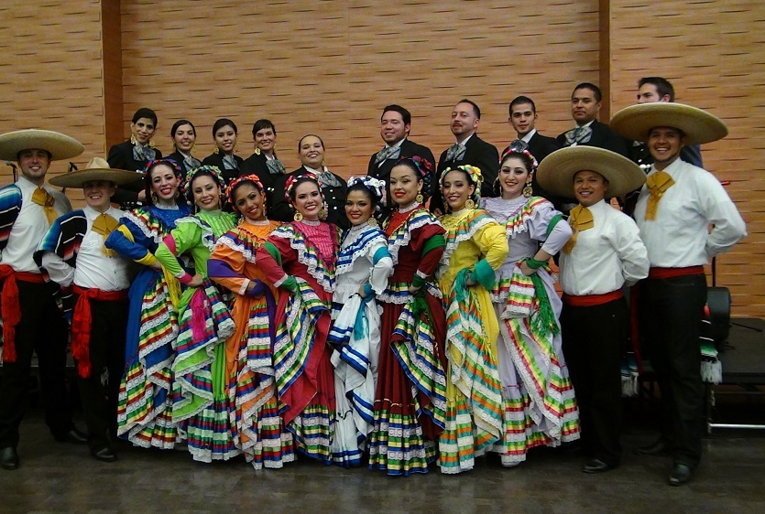
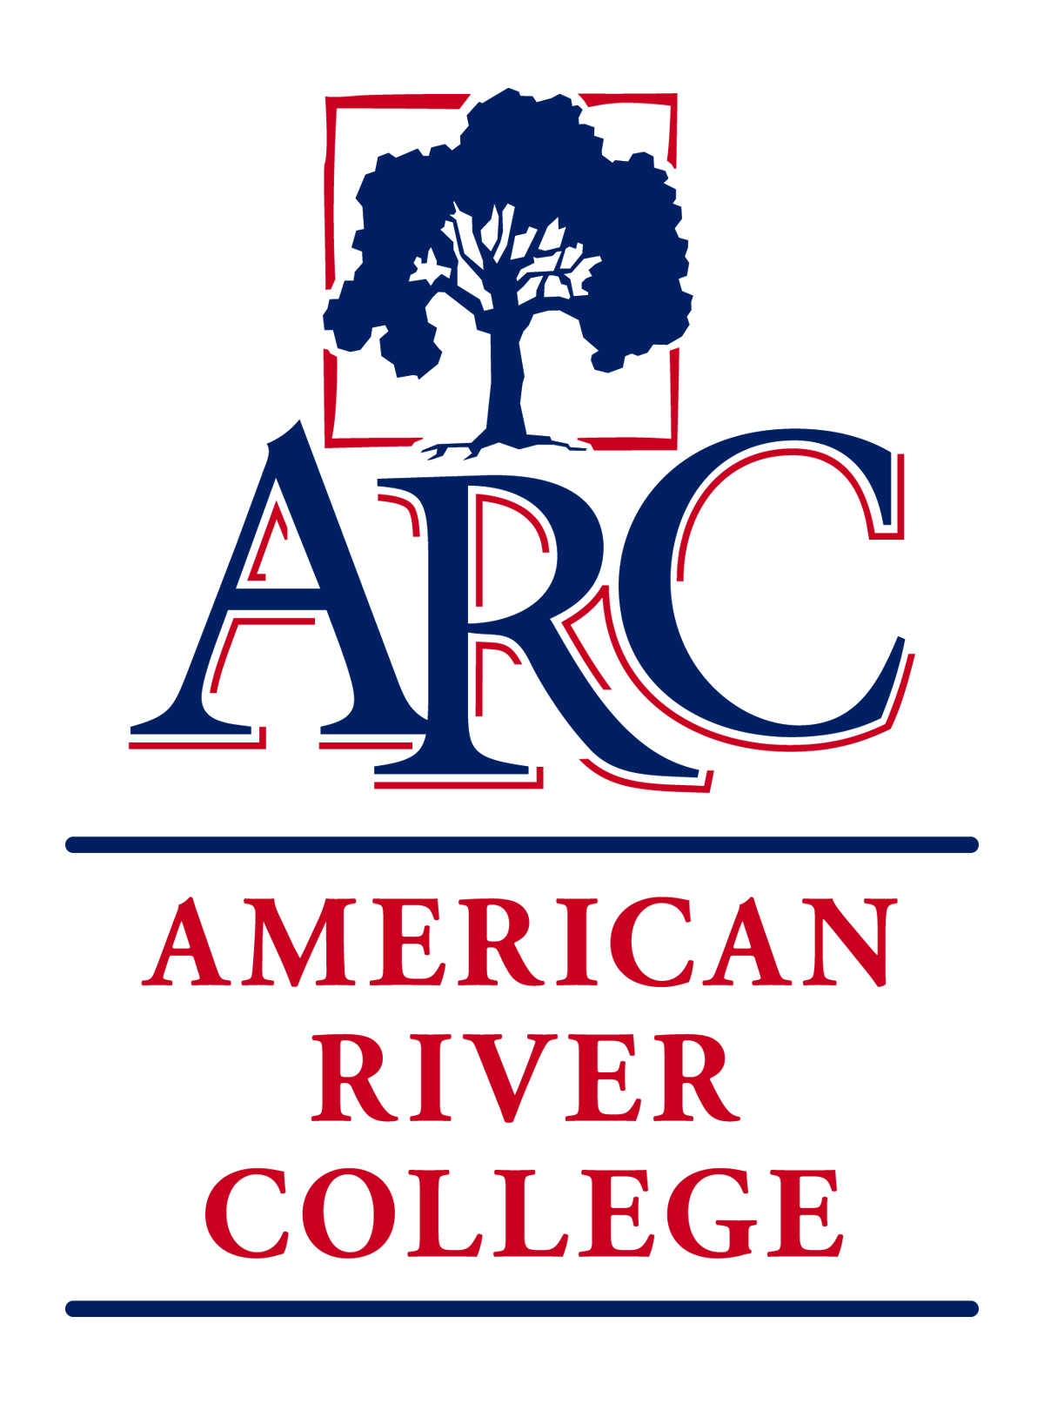
OUR COMMITMENT TO SOCIAL JUSTICE AND EQUITY
American River College strives to uphold the dignity and humanity of every student and employee. We are committed to equity and social justice through equity-minded education, transformative leadership, and community engagement. We believe this commitment is essential to achieving our mission and enhancing our community.
Table of Contents
Project Team and Acknowledgements 1
Latinx Report Team 1
Introduction 2
Terminology: Latinx 2
Terminology: Deficit-minded 2
Scope 3
History 4
Macro-Historical Perspective 4
Micro Historical Perspective: Brief History of Los Rios Latinx Community Advocacy and Activism 15
Proven Culturally-Affirming Success: PUENTE Project 16
Theories 19
Community Action Research (CAR) or Participatory Action Research (PAR) 19
Critical Race Theory: LatCrit 19
Statement of Problems 21
Literature Review 22
DI Population Survey: Findings and Analysis 31
Project Timeline 31
Questionnaire 31
Data Collection 32
Survey Results 33
Discussion 38
Recommendations 42
References 46
Appendices 50
Appendix A: Annual Bilingual Outreach to Immigrant Communities 50
Appendix B: Puente Project Data 52
Appendix C: ARC Latinx/Chicanx Campus Climate Questionnaire and Results (Spring 2019) 57
Appendix D: California Policies Protecting College Opportunity for Undocumented Students 66
Appendix E: Memorandum for the Los Rios General Counsel 67
Appendix F: Miguel Molina Dissertation 68
Appendix G: ARC Student Enrollment (2009-2019) 69
Appendix H: ARC Student Education Status from Data Mart (2018-2019 Primary Terms) 70
Appendix I: Employee Headcount Details March 16, 2020 from ARC Institutional Research 72
Appendix J: Employee Headcount March 16, 2020 from ARC Institutional Research 75
Appendix K: Employee Headcount March 17, 2020 from ARC Institutional Research 77
Appendix L: ARC Faculty/Staff Demographics 2000-2019 78
Appendix M: Employee Headcount (Teaching and Non-Teaching) 2019 79
Appendix N: Publications to Advertise Jobs for Latinx Community in Higher Education 80
Appendix O: Hispanic Serving Institution Organizations 81
Appendix P: Community Organizations 82

Cover Photo: Celebrating Latinx traditions and culture
Project Team and Acknowledgements
“We are not minorities, we are a majority of one.”

– Piri Thomas,
Down These Mean Streets

Latinx Report Team
Appreciation is expressed to the report team for their work in investigating disproportionate impact from the Latinx student perspective and developing recommendations that can benefit future ARC students.

Alej Fernandez Garcia, ARC Pride Center S.P.A.
Carmelita Palomares, Counselor for Achieve and Puente Programs
Cathy Arellano, Professor of English and Puente Co-Coordinator
Cristina Mora, Program Coordinator for California Community College Chancellor’s Office (Retired)
Damaris Vasquez, Student
Deborah Hernandez, UndocuScholar Resource Connection Co-Coordinator
Desiree Rodriguez, Student and UndocuScholar Resource Connection
Luis Santillan, Outreach Officer, Sacramento City College
Manuel Ruedas, Counselor and Puente Coordinator (Retired)
Maria Elena Sepulveda, Student and Academic Senate
Mariana Valdez Jimenez, Student and TRIO
Martin Gomez, Director of EOP&S
Patricia Jimenez de Valdez, Financial Aid Specialist
Ricardo Catón, Professor of History and Faculty Sponsor of Latinos Unidos
Rocio Owens, Professor of Math
Veronica Lopez, Professor of Nutrition and Co-Faculty Advisor for Coalition of Undocumented Students
and Allies

Data Analysis: Kay Lo and Yujiro Shimizu
Acknowledgments: Much thanks to Reid Gómez, Jennifer Laflam, and Dr. Miguel Molina
Sponsoring Council: Student Success Council

Introduction
There was no other motivator for the staff, faculty, and community members on the Latinx DI Team than wanting to make the educational experience at American River College better for current and future Latinx students. We do our best in our respective roles on campus and in the community, but given the opportunity to make a lasting impact we committed to the process. One of the most compelling aspects was the student survey. For better and worse, some of the obstacles ARC Latinx students face in 2020 aren’t new to us. In spite of various historical and structural barriers, we know Latinx students can meet their educational, career, and personal goals. We look forward to the complete analysis of the survey so that we may have another tool to guide our work.
Terminology: Latinx
“In 2017, the [Honrando] planning committee voted to adopt Latinx as part of the ceremony. The X in Latinx is gender inclusive for people who identify as trans, queer, agender, non-binary, gender nonconforming and gender fluid. By changing the name, we hope to foster an environment for students to freely express all identities including: socioeconomic, ethnicity, culture, ability, sex, gender expression, sexual orientation, nationality, citizenship and religion” (Los Rios Honrando).
For the above reasons, this report will refer to people who are designated as or choose to identify their culture/ethnicity/nationality/race as Hispanic, Latina, Latino, etc. unless there is a need to refer to only Latinos or Chicanas. Also, if the report uses a direct quotation, then the original term from the source will be used.
Terminology: Deficit-minded
The title of this report and the title of this group use the term “disproportionately impacted.” “Disproportionately-impacted” refers to Latinx (and other demographic groups) and how well they score or succeed on “standard” criteria like GPA, course completion, etc. compared to Whites (and sometimes Asians). Also, ARC and various sources, such as the PUENTE Project, use “disadvantaged” and “minority” and other deficit-minded terms. (“Deficit-minded” as “dominant cognitive frame [that] leads to a deficit-minded approach—a perspective that places the responsibility for unrealized success solely on students. The deficit frame posits that students who fail in school do so because of alleged internal deficits (such as cognitive and/or motivational limitations) or shortcomings socially linked to the student, such as family dysfunctions or deficits” (Washington 2010, Washington credits University of Southern California’s Center for Urban Education). Yes, our students often don’t do well or do as well as White and/or Asian students. Yes, we need to work on improving…what exactly? Do we need to measure only students or student GPA, course completion? As this report discusses, research shows that academic systems like ARC need to change not students. Maybe we need to measure the “success” or effectiveness of the dominant Euro-centric pedagogical practices adopted by many teachers, staff, and administrators and not students. What can and must change are the terms we use to discuss our students.

“The educator has the duty of not being neutral.”

– Paolo Freire
Brazilian Educator

Scope
“Before you conquer the mountain, you must learn to overcome your fear.”

– Isabel Allende,
The House of the Spirits

The Latinx Disproportionate Impact Team was given the charge to provide a historical summary of practices of exclusion of Latinx students in education, a summary of institutional barriers and motivators to providing equitable education, recommendations for instruction and student services practices based on a literature review, the Institutional Equity Plan, the college’s efforts in Achieve and Pathways (reference charter). The team was also charged with identifying the theories from which it operated and developed recommendations.
Once completed the project was to have the following set of deliverables:

- Summarize the historical context of the education of Latinx students in the United States.
- Provide a literature review (including current scholarship and community college-based praxis, including local quantitative and qualitative data and testimony) which outlines high impact practices that would best serve Latinx student populations.
- Create a comprehensive list of institutional barriers (historical and current) that perpetuate systems of power and privilege that contribute to the achievement gap and impact the experiences of Latinx students at ARC.
- Create a comprehensive list of motivators (Academic, Personal, Spiritual, Cultural, etc.) that inspire and produce positive outcomes for Latinx students as well as self-efficacy.
- Considering the college’s efforts in Achieve and Pathways and the literature review, identify an appropriate methodological framework for Latinx for high impact social justice practices, services, and teaching methods that would best serve the Latinx students at ARC.
- Identify recommended methods for practice based on the literature review and methodological framework that would provide equity minded praxis for Latinx students and eliminate the achievement gap.

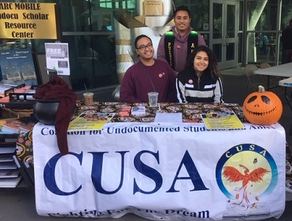
History
Macro-Historical Perspective
Latinx History is American History. Through this brief historical analysis of U.S. discrimination and marginalization policies against Latinx and non-White individuals, it is the Latinx DI Report Team’s desire to provide an understanding of the historical roots responsible for the disproportionate impact that Latinx and other non-White students face in this country’s school system from kindergarten to higher education. Only a serious reading and analysis of the nation’s history will allow ARC to understand the educational emergency and the transformative changes that are required to truly serve its disproportionately impacted student populations.
Historical Roots
People with Spanish ancestry have lived in the lands now known as the U.S. Southwest and Florida since before the establishment in 1607 of the first permanent English settlement at Jamestown, and the official creation of the United States of America in 1783. This significant history, however, rarely appears in history books and classroom lectures, which enables the historical legacy of White Anglo Saxon Protestant colonization and marginalization of people with Spanish and/or Latin American ancestry to continue to negatively affect Latinx communities to the present. From the federal, state, and local government levels, laws and policies dating back to 1790 have directly discriminated against Latinx and other non-White people. The following historical analysis will explain how marginalization of Latinx people is a result of specific U.S. laws and policies, and will clarify the effects these laws and policies have had on Latinx schooling and academic outcomes.
U.S. Naturalization Act of 1790
In order to understand the history of Latinx marginalization in the United States – as with the marginalization of all non-White individuals – it is important to note that the U.S. Naturalization Act of 1790 specified that only “free white” persons could achieve U.S. citizenship. While congressional members debated whether religious (Protestant vs. Catholic) or economic backgrounds could impede full admission to the country, they all agreed with “whiteness” as a prerequisite for citizenship. This was an essential requirement to guarantee that Native Americans and African Americans would have no rights or political voice; assuring the maintenance of white supremacy. From 1790 onward, federal and state governments upheld the “free white” requirement to deny rights and equality to all non-European (especially non-Western European) populations. The roots of Latinx political, economic, and educational marginalization begin in this early notion of “white exceptionalism.”
The 1823 Monroe Doctrine and 1904 Roosevelt Corollary
By the end of the nineteenth century, almost all of Latin America had achieved independence from European rule (specifically Spain, Portugal, and France). Nevertheless, despite achieving political independence, Latin American countries soon became subjected to the economic and military incursions of Britain and the United States. It was President James Monroe who began U.S. meddling in Latin America through his Doctrine of 1823. In the doctrine, President Monroe warned Europe that the United States would “consider any attempt on their [Europe’s] part to extend their system to any portion of this hemisphere as dangerous to our peace and safety.” In other words, any European attempt to retake a former American colony would be a direct threat to the U.S. With this proclamation, President Monroe began the process of proclaiming Latin America as the “backyard” of the United States.
In 1904, President Theodore Roosevelt continued Monroe’s legacy with his Corollary to the Monroe Doctrine. Rather than a warning to Europe, however, President Roosevelt sent a direct warning to the people of Latin America. He proclaimed that, “[c]hronic wrong-doing, or an impotence which results in a general loosening of the ties of civilized society, may in America, as elsewhere, ultimately require intervention by some civilized nation, and in the Western Hemisphere the adherence of the United States to the Monroe Doctrine may force the United States, however reluctantly, in flagrant cases of such wrongdoing or impotence, to the exercise of an international police power.” President Roosevelt proclaimed that the United States was the “civilized nation” that needed to become an “international police power” to assure that Latin Americans “behaved properly.” The United States, of course, would determine when Latin American countries had “loosened” the “ties of civilized society” and needed U.S. military intervention to reestablish order.
U.S.-Mexican War of 1846-1848
As a firm believer in the notion that the United States had a “manifest destiny” to expand westward and implement “civilization” in the “savage wilderness,” President James K. Polk (1845-1849) entered the presidency with an expansionist platform. After a failed attempt to purchase the Mexican territories of Tejas, Nuevo México, and Alta California, Polk decided to instigate a war with Mexico by sending Army General Zachary Taylor and 4,000 troops down to disputed Tejas territory (today’s Brownsville) to begin building a fort and await a Mexican response. The response came after Taylor refused to heed Mexican General Mariano Arista’s warning to cease the building of the fort and march back to the United States. On April 25, 1846, a skirmish between Mexican and U.S. troops led to the death and wounding of sixteen U.S. soldiers which became the justification for war that Polk desired.
On May 11, 1846, Polk addressed a joint session of the United States Congress and proclaimed, “Mexico has passed the boundary of the United States, has invaded our territory and shed American blood upon the American soil. She has proclaimed that hostilities have commenced, and that the two nations are now at war.” He further justified war against Mexico by claiming, “[a]s war exists, and, notwithstanding all our efforts to avoid it, exists by the act of Mexico herself, we are called upon by every consideration of duty and patriotism to vindicate with decision the honor, the rights, and the interests of our country.” From this point on, the United States referred to this war as the “Mexican War” – emphasizing the view that Mexico started the conflict. Precisely because of this distortion of events and the fact that the United States won the war in 1848 and gained close to half of Mexico’s former northern territories, Euro-Americans viewed Mexicans as both enemies and “inferior” people.
As the United States had the upper hand against Mexico in 1847, the “All Mexico Movement” in the U.S. gained popularity. Those in support of this movement desired to incorporate all of Mexico’s lands into the United States after the successful conclusion of the war. Nevertheless, not all in the country agreed with this sentiment. John C. Calhoun, senator from South Carolina, exemplified the opposition to the movement. During an “All Mexico Movement” debate on January 4, 1848, Calhoun proclaimed, “…we have never dreamt of incorporating into our Union any but the Caucasian race – the free white race. To incorporate Mexico, would be the very first instance of the kind of incorporating an Indian race; for more than half of the Mexicans are Indians, and the other is composed chiefly of mixed tribes. I protest against such a union as that! Ours, sir, is the Government of a white race […].” Calhoun decried the “All Mexico Movement,” not on moral or political terms, but on the racist notion that the United States was a country for the “white race.” Even when Euro-Americans proclaimed that this had been an unjust war, they relied on the “superior vs. inferior” dichotomy to make their argument. For example, in his personal memoirs, Ulysses S. Grant wrote, “[f]or myself, I was bitterly opposed to the measure, and to this day regard the war, which resulted, as one of the most unjust ever waged by a stronger against a weaker nation. It was an instance of a republic following the bad example of European monarchies, in not considering justice in their desire to acquire additional territory.”
The U.S. Mexican War officially concluded on February 2, 1848, with the signing of the Treaty of Guadalupe Hidalgo. According to this treaty, the United States government officially recognized all Mexican individuals now residing on U.S. land as citizens of the United States whose property, language, and culture the government would recognize and protect. Despite the assurances made by U.S. officials to their Mexican counterparts as they drafted the treaty, and the fact that these assurances made it to the original treaty signed by both countries, the U.S. government and Euro-Americans in general refused to respect and follow the treaty’s articles; leading to both land loss and marginalization of U.S. citizens with Spanish and Mexican ancestry.
Filibusters
Manifest Destiny, the nineteenth-century belief that “God” gave the United States the “right and duty” to expand across the North American continent, augmented the U.S. desire to expand around the world. Individuals from the United States, both government officials and independent citizens, utilized various methods to proclaim Latin American territories and resources for the country and themselves. Fueling their endeavors was the desire to extend the institution of Southern slavery. In the nineteenth century, U.S. filibusters (from the Spanish filibustero, meaning freebooter) made their presence in Mexico, the Caribbean, and various parts of Central America. One of the most infamous was William Walker.
Originally from Tennessee, Walker had been a medical doctor, lawyer, and journalist. Desiring wealth and power, William Walker set his focus on the developing countries of Latin America. He paid particular attention to the Central American country of Nicaragua, which in 1854 had been an independent republic for only 16 years. Because a civil war between Conservative and Liberal factions had fragmented the country and made it vulnerable, Walker saw an opportunity to implement his presence and authority in the country. In 1854, Walker offered his services to the Liberal faction and they gladly accepted to defeat their Conservative adversaries. Nicaragua’s Liberals came to regret the decision as Walker called on allies from U.S slaveholding states to form an army of fellow filibusters to join him. With these reinforcements, Walker took over the Republic of Nicaragua in 1856 and proclaimed himself president. Although Nicaragua had abolished slavery, Walker reinstated it; he also decided to make English the official language and implemented several policies that encouraged extensive immigration from the United States.
Obtaining word of Walker’s actions in Nicaragua, U.S. President Franklin Pierce wasted no time in recognizing the legitimacy of his government. Despite his U.S. recognition, Walker’s actions triggered a show of Central American unity against him. The governments of Costa Rica, Honduras, and El Salvador sent troops to defeat Walker and his supporters. Although the unified Central American force succeeded in sending Walker back to the United States in April of 1857, he returned to Central America via Honduras in August of 1859 – attempting to repeat his previous success. Unfortunately for Walker, his luck ran out as British forces captured him and handed him over to Honduran authorities who executed him by firing squad on September 12, 1860. William Walker’s filibustering endeavors in Central America and their support from the U.S. Government, exemplify the little regard that White Anglo Saxon Protestants held for Latin America and its peoples. Walker made this clear when he wrote that his actions in Central America, “were intended to place a large portion of the land in the hands of the white race.”
Spanish-American War of 1898
The victory against Mexico in the U.S.-Mexican War and the official territorial acquirement of today’s Texas, New Mexico, Arizona, and parts of Utah and Colorado, did not satiate the U.S. desire for territorial expansion. During the larger part of the nineteenth century, the United States had not achieved much influence in the world and Europeans governments viewed it as a second-rate power. Nevertheless, the technological revolution of the late nineteenth century; the continued settlement and push to industrialize all U.S. territories; and continued belief in Manifest Destiny, served to create and augment a desire for U.S. expansion around the world. Much as in Western Europe, those in the United States who supported U.S. expansionism claimed to desire it in order to “spread civilization.”
From 1868-1898, Cuba fought an intermittent war of independence against 400 years of Spanish colonial rule. The United States was fully aware of Cuba’s war; nonetheless, although many U.S. citizens supported the Cuban desire to become independent from Spain, few desired any direct involvement in the conflict and the country officially took a neutral stance. The decision to remain neutral changed on February 15, 1898, when the USS Maine exploded near Havana while attempting to safeguard U.S. business interests on the island. The United States blamed Spain for the explosion, despite the lack of tangible evidence to support the accusation. In April of 1898, President William McKinley asked Congress for authority to use force against Spain, claiming that the revolutions triggered by its ineffective ruling methods had “caused enormous losses to American trade and commerce, caused irritation, annoyance, and disturbance among our citizens, and, by the exercise of cruel, barbarous, and uncivilized practices of warfare, shocked the sensibilities and offended the humane sympathies of our people.” McKinley relied on a comparison of the “civilization” found in the United States with the “barbarism” of Cuba under Spanish rule to secure congressional approval for war. By this stage in the nineteenth century, Spain was no longer the strong European power it had been in the 16th and 17th centuries, and was unable to counter the wars for independence by its last colonies in the Pacific and the Caribbean – especially after the United States joined the conflict.
With the conclusion of the Spanish-American War, the United States obtained Spain’s former colonies of Puerto Rico, the Philippines, and Guam. The United States recognized Cuba’s independence, but required the independent Cuban government to agree to the Platt Amendment to the new Cuban Constitution. The amendment authorized the United States to intervene militarily in Cuba whenever the U.S. deemed it necessary to “uphold Cuba’s independence” against internal and foreign threat. The Platt Amendment also provided the United States with a permanent settlement in Guantanamo Bay as a naval base. With the U.S. victory in the Spanish American War, English writer Rudyard Kipling wrote and dedicated a poem to the United States titled “The White Man’s Burden” which both congratulated and warned the U.S. that being an imperial power was hard work, but a “necessary burden” for “white men.” Two significant stanzas of the poem read:

Take up the White Man's burden--
Send forth the best ye breed--
Go bind your sons to exile
To serve your captives' need;
To wait in heavy harness,
On fluttered folk and wild--
Your new-caught, sullen peoples,
Half-devil and half-child.
Take up the White Man's burden--
The savage wars of peace--
Fill full the mouth of Famine
And bid the sickness cease;
And when your goal is nearest
The end for others sought,
Watch sloth and heathen Folly
Bring all your hopes to naught.

Banana Republics
In 1904, O. Henry (the pseudonym of fiction writer William Sydney Porter) published the novel Cabbages and Kings set in the fictitious Central American country of “Anchuria” – most likely Honduras where Porter had spent some time. In this work, Porter referred to “Anchuria” as a “banana republic” establishing the term for the first time. In Latin American history, the cynical term “banana republic” came from U.S. business interests in Central America and the Caribbean who viewed the countries of these regions as “small,” “unstable,” and “regularly subject to political upheaval.” United States corporations such as the United Fruit Company (now Chiquita) and Standard Fruit (now Dole) made lucrative business dealings with Central American and Caribbean governments to purchase thousands of acres of land for tropical fruit plantations – especially bananas. These plantations reduced agricultural land for staple foods which in turn negatively hurt the local populations. Again, the U.S. mentality of Manifest Destiny justified these endeavors as “a right” to expand and “civilize” the “savage” lands and people of Latin America.
Political Interventions
Precisely because of U.S. business interests in Central America, the government of the United States was more than willing to safeguard these interests by implementing military interventions. For example, in 1905, U.S. Marines invaded Honduras to “maintain the ties of civilization”; from 1912-1925, U.S. Marines intervened in Nicaragua on behalf of U.S. fruit corporations; in 1918, the U.S. army landed in Panama to protect United Fruit Company plantations; from 1926-1933, U.S. Marines occupied Nicaragua and fought against nationalist forces led by Augusto Sandino; in 1954, the United States supported a coup against democratically elected Guatemalan President Jacobo Árbenz; and from 1936-1979, the United States supported the Somoza family as dictators of Nicaragua. Indeed, despite the rhetoric of supporting freedom, liberty, and democracy in the world, U.S. government and military actions have shown the opposite.

Immigration Act of 1924
In popular memory, the 1920s was a period of prosperity for the United States. Although this is a generalization, the belief has some truth. U.S. industry and consumerism continued to grow during this decade. This prosperity attracted continued migration to the country by Southern and Eastern Europeans, Asians, and Latin Americans. This rise in foreigners, coupled with the perceived decadence and loss of morals in the country, created a backlash among fundamentalist groups in the country. Evangelical Protestantism saw a rise in following from individuals who rejected the notion that religion and science could coexist. Indeed, fundamentalist evangelicals were completely opposed to Charles Darwin’s theory of evolution. Evangelicals also rejected the rise in Judaism and Catholicism due to the continuous arrival of immigrants.
The rising anti-immigrant sentiment in the United States during 1920s gave rise to increased support for the Ku Klux Klan. The Klan received such high support from U.S.-born White Protestants, that the organization spread their influence throughout the United States. The Klan of the early 1920s was willing to step outside and address their anti-Black, Catholic, Jewish, immigrant, feminist, etc. rhetoric – a right, after all, supported by the First Amendment. Although the Klan’s support began to diminish after 1925 due to outright corruption within the organization and public violence against minorities, their larger message of the need to “protect American values” from radicalism and continued immigration remained strong.
While the 1920s saw sustained immigration to the United States, it was also a period of federal implementation of anti-immigrant laws. The U.S. Congress passed the Immigration Act of 1924 that permanently limited European immigration to 150,000 per year. Of this 150,000, quotas restricted the number of Southern and Eastern Europeans from entering the country while promoting the migration of Western and Northern Europeans. Although the Act did not restrict immigration from the Western Hemisphere, it completely terminated it from Asia.
Despite the immigration restrictions, the U.S. government realized that immigrants prohibited from entering the country were still finding means of doing so by crossing through the Canadian and Mexican borders. Because of this continued immigration, the government created a new term to use when referring to these immigrant groups: “illegal aliens.” The federal government also introduced a new enforcement organization tasked with impeding the entrance of “illegal aliens” into the country: the Border Patrol. It is important to note that the term “illegal alien” did not apply to Latin Americans because the 1924 Immigration Act did not exclude immigrants from the Western Hemisphere. The reason for not excluding people from the Western Hemisphere, particularly Mexicans and Puerto Ricans, was the U.S. dependency on inexpensive manual laborers from these parts of Latin America.
The “Repatriation Program” of the 1930s
The exclusion of Latinx people from the 1924 Immigration Act did not mean that Latinx communities were exempt from marginalization and discrimination. In 1928, Congressman John Box from East Texas delivered a speech to the House of Representatives that called for restriction and eventual termination of Mexican immigration to the United States. Box argued, “[a]nother purpose of the immigration laws is the protection of American racial stock from further degradation or change through mongrelization […].” According to Box, Mexicans were a “mixture of Mediterranean-blooded Spanish peasant with low-grade Indians who did not fight to extinction but submitted and multiplied as serfs. Into that was fused Negro slave blood.” Boxer concluded his speech by reminding the members of Congress that Mexicans were illiterate, diseased, poverty-ridden, and criminals: “Few, if any, other immigrants have brought us so large a proportion of criminals and paupers as have Mexican peons.”
The increase of Mexican immigration to the United States during the 1920s, coupled with the Great Depression of the 1930s, created a surge of nativist anti-immigrant sentiment in the country that particularly blamed Mexicans for the economic depression and mass unemployment. It was President Herbert Hoover’s Secretary of Labor, William N. Doak, who proclaimed “[m]y conviction is that by strict limitation and a wise selection of immigration, we can make America stronger in every way, hastening the day when our population shall be more homogenous.” Doak proposed that the federal government scapegoat Mexicans as the reason why there were insufficient jobs in the country. This nativist scapegoating triggered mass deportations of Mexicans and Mexican-Americans through raids in farms and other businesses, officially looking for “illegal aliens.” Nevertheless, it soon became apparent that the citizenship of apprehended individuals did not matter, as over half of the estimated one million deportees were U.S.-born citizens.
The government officially referred to its actions as a “repatriation of Mexicans” which it enacted to return Mexicans to “their homes.” Nevertheless, as aforementioned, the majority of the deportees had resided in the United States all their lives and did not see Mexico as “their home.” The deportees received little time to gather their belongings before having to board trains or other forms of transportation that would take them “back” to Mexico. State governments sold the personal property of the deportees and used the funds to pay for the deportation transportation.
Lemon Grove Indecent, 1930-1931
The anti-Mexican campaign of the 1930s also targeted Mexican and Mexican-American school children by pushing to segregate them from White school children. In 1931, Assemblyman George R. Bliss of Carpinteria, California unsuccessfully pushed a bill to legalize segregation in California of Mexican and Mexican-American school children. Although legal segregation of children with “Indian, Chinese, Japanese, and Mongolian” ancestry existed in California, Mexicans officially fell in the category of “White” because of the 1848 Treaty of Guadalupe Hidalgo. Nevertheless, the ani-immigrant sentiment of the 1920s pushed California to create separate “Mexican Schools” to ensure the “Americanization” of these students.
In January of 1931, Jerome T. Green, principal of the Lemon Grove Grammar School in San Diego County, California, decided to remove the Mexican and Mexican-American students and place them in a newly-constructed school designed to “Americanize” them. The schoolchildren’s parents understood this as the school board’s excuse to segregate their children and provide them with an inferior education. The school board expected the Mexican children and their families to “act docile, follow orders and attend the new school.” Nevertheless, parents challenged the board’s decision by forming the Comité de Vecinos de Lemon Grove (the Lemon Grove Neighbors Committee) to boycott the school and seek legal help to sue the school district over the proposed move. The parents’ efforts led to the Roberto Alvarez v. the Board of Trustees of the Lemon Grove School District case.
During the case’s trial, school board members and school staff attempted to defend the segregation by claiming that it was necessary because, “with one or two exceptions the children assigned to this new school are deficient in their knowledge of the English language, and are older than the other children in corresponding grades and require special attention from the instructors.” They also proclaimed that “the new school was built for the purpose of establishing an Americanization school wherein backward and deficient children could be given better instruction than they could be given in the larger school.” Judge Claude Chambers, who presided over the case, concluded: “I understand that you can separate a few children, to improve their education they need special instruction; but to separate all the Mexicans in one group can only be done by infringing the laws of the State of California […]. I believe that this separation denies the Mexican children the presence of the American children, which is so necessary to learn the English language." Roberto Alvarez v. the Board of Trustees of the Lemon Grove School District became an early victory in the push to end legal segregation and discrimination in U.S. schools.
Mendez v. Westminster, 1947
Unfortunately, despite the significant victory of Roberto Alvarez v. the Board of Trustees of the Lemon Grove School District, marginalization and discrimination of Latinx students continued unabated. In 1945, Gonzalo Méndez – a long-time resident of Westminster, California – asked his sister, who was about to enroll her children in the town’s primary school, to also enroll his daughter and two sons. Mr. Méndez’s sister returned to tell him that school officials were willing to enroll her children because of their light-skin, but his dark-skinned children could not. Gonzalo Méndez spoke with the school’s principal, the Westminster School Board, and even the Orange County School Board, to no avail. The excuse was that Westminster 17th Street School was for “White children,” but his children could attend Hoover School (the “Mexican School” located 10 blocks away in a different district). The Orange County School Board also informed Mr. Méndez that four cities in the county decided to build separate schools to “better serve” Mexican children.
Determined to change these segregationist policies, Gonzalo Méndez spoke with Mexican and Mexican-American parents in the school districts of Westminster, Santa Ana, Garden Grove, and El Modena. He received their support to hire a lawyer to fight their case against the discrimination. Their lawyer, David Marcus, a Los Angeles civil rights attorney, argued that as no California law existed that mandated the segregation of Anglo-Saxon and Mexican children, segregating children of Mexican ancestry violated the Equal Protection Clause of the Constitution’s Fourteenth Amendment. The plaintiffs were five Mexican-American families (Gonzalo Mendez, Thomas Estrada, William Guzman, Frank Palomino, and Lorenzo Ramirez) on behalf of 5,000 Mexican and Mexican-American children.
On March 18, 1946, Judge Paul J. McCormick ruled that the "segregation prevalent in the defendant school districts foster antagonisms in the children and suggest inferiority among them where none exists." He ruled that the school districts had violated the Fourteenth Amendment’s Equal Protection Clause. Thurgood Marshall, who wrote the NAACP's friend of the court brief for Mendez v. Westminster, used the decision as precedent when he argued Brown v. Board of Education in front of the U.S. Supreme Court in the 1950s. Regrettably, as with Roberto Alvarez v. the Board of Trustees of the Lemon Grove School District, Mendez v. Westminster (and arguably Brown v. Board of Education) had relatively little long-lasting effect on the national marginalization and segregation of Latinx, African-American, Native-American, and other non-White students.
Bracero Program of the 1940s
When the United States entered the Second World War after the December 7, 1941 Japanese attack of Pearl Harbor, Hawaii, the country needed all the help it could get on the war and labor fronts. For this help, the United States gladly turned to Mexico. Mexico provided servicemen to help the United States and its allies during the war. On July 10, 1944, Mexico created an elite flight squadron from among its Air Force pilots and sent them to train in the United States. The 201st Squadron, popularly known as the Aztec Eagles, had 59 missions in the Philippines combating the Japanese.
Two years before creating the 201st Squadron, Mexico and the United States also agreed on implementing the Bracero Program (the word bracero comes from the Spanish brazos, meaning arms). Under the Bracero Program, Mexico provided temporary agricultural and industrial workers to reinforce the depleted U.S. labor force. The program recruited an estimated 4.6 million Mexican workers from the program’s inception in 1942 to its termination in 1964. The Mexican and U.S. governments agreed on compassionate transportation practices; humane living and working conditions; and a standard pay for the laborers. Unfortunately, both governments seldom met the conditions. Workers commonly experienced discrimination, substandard housing, unfulfilled contracts, and lower wages than the 30 cents per hour originally agreed upon.
Because many Braceros remained in the United States after the conclusion of their contracts, the U.S. Immigration and Naturalization Service (INS) implemented “Operation Wetback” from 1950-1955. Through this government-led initiative, many U.S.-born children of Mexican Braceros were deported along with their parents. This was a reminder that the United States was swift to accept Mexican help in time of need, but more than willing to deport that help when the need no longer existed. The insulting title of “Operation Wetback” given to this wave of mass deportations also reflected the continued U.S. disdain for people of Mexican ancestry. Further emphasizing the “us versus them” mentality present in the United States during the 1950s, the federal government approved the construction of a barbed-wire fence along the U.S./Mexico border.
The Chicano Movement and Student Walkouts of the 1960s
In 1968, 91 percent of college and university students in the United States were officially White. Latinx students, on the other hand, only composed two percent of enrolled students. Because of these abysmal numbers, members of the two percent who attended college pushed to create student organizations that functioned to support Latinx student success and decry the little or nonexistent effort of colleges and universities to hire and retain Latinx faculty and administrators; offer Latinx history and other courses focusing on Latinx experiences; and to reach out to marginalized and underfunded k-12 schools to promote higher education.
It was the desire for equal educational opportunities that motivated Latinx high school students throughout the U.S. Southwest to boycott the school system in 1968 by walking out of their schools to protest the discrimination and marginalization reflected in substandard quality education, lack of preparation for college prep courses, and little or no effective counseling. These students understood that not being in their seats meant that their schools would not receive funding. Thus, if the schools desired federal, state, and local funds, they needed to provide their Latinx students with the same educational opportunities afforded to White students. The walkouts attracted national attention and forced school administrators to take the students’ demands seriously. The student walkouts of the late 60s helped increase the numbers of Latinx college students, professors, and administrators. Nevertheless, those numbers continue to be low on a national level.
The U.S. and Central America
During the Cold War between the United States and the Soviet Union (1947-1991), the United States saw Latin America as a potential “hotbed of communist agitation.” Under his 1985 Reagan Doctrine, President Ronald Reagan called for aggressive suppression of “left-wing radicalism” in the Americas. Working directly with Latin American governments, the United States trained and funded the militaries of these countries to end the “communist threat.” Because of these actions, violence flared in Guatemala, El Salvador, and Nicaragua. The wars in these countries led to the death and displacement of hundreds of thousands. Destroyed governments, economies, and societies meant few opportunities for education and employment. These conditions contributed to mass Central American migration to the United States. Central American countries, especially Guatemala, Honduras, El Salvador, and Nicaragua continue to deal with the negative legacies of these Cold War era conflicts.
Currently, the nativist and nationalist platform of the Trump Administration continues the derogatory and offensive U.S. perceptions of Latin America and Latin Americans that date back to the late 1700s. Specifically focusing on Central American countries, the Trump administration consistently refers to them as corrupt and “crime infested.” The administration also deliberately focuses on the drug trade, criminal organizations (i.e., MS13), and the “invasion” of Central American immigrants to the United States. Nevertheless, rather than participate in diplomatic talks with these countries to reach potential solutions to the concerns, the executive prefers to disparage these countries and their people. Even worse, the administration has drastically decreased U.S. assistance to Central America for programs aimed at strengthening democracy and human rights. The Trump administration also continues the U.S. precedent of refusing to recognize its role in creating the very conditions these countries and their people face – which the administration is more than happy to mock, criticize, and exacerbate.
Propositions 187 of 1994 and Proposition 209 of 1996
Even with the important legal, political, and educational victories by and for Latinx people in the United States, discrimination and marginalization remained ubiquitous throughout the 1970s, 80s, and 90s. In 1991, Republican Pete Wilson became governor of California (1991-1999) and immediately pushed an anti-immigrant/anti-Latinx agenda. He and his supporters used nativist rhetoric that described immigrants as “drains to the society” and catalysts for crime. In November of 1994, Proposition 187, the “Save our State Initiative,” became part of the California ballot and Governor Pete Wilson, running for reelection, became a staunch supporter of its approval. The proposition sought to terminate public services for undocumented individuals, including the k-12 educational system, and required public schools to verify the citizenship status of students and their parents. The proposition also terminated health services for undocumented people and required all service providers to report potential undocumented persons to local authorities. California voters passed the proposition on November 8, 1994 with a 59 to 41 percent vote.
Pete Wilson and his supporters justified these extreme measures as necessary to end “needless and costly expenses” to California taxpayers. What he and his supporters failed to state was that undocumented individuals pay taxes, pay rent, make purchases, and certainly contribute to the state and national economies every single day. By implementing Proposition 187, the state and its services gladly accepted money from undocumented people but refused to provide those services to all Californians who contributed to pay for them. The classic “they are a burden to our country” argument was again front-and-center. In a March 2017 interview for The Los Angeles Times, Pete Wilson, then 83, maintained the “need” for the measure by stating, “We’d tried everything else for three years…but Washington was deaf, dumb and blind.”
In 1996, during his second term as governor, Wilson also supported Proposition 209 – the California Civil Rights Initiative. This proposition annulled several laws enacted by the California Legislature over the previous twenty years that mandated state agencies and departments to increase representation of women and minorities in state service by “identifying jobs for which their employment numbers were fewer than would reasonably be expected by their availability (absent discrimination),” and to develop affirmative action plans to remedy the discrepancy. Supporters of this measure claimed that “preferential treatment” based on race, sex, ethnicity, or national origin by employers “discriminated against better qualified whites.” Making such claims, supporters of Proposition 209 unknowingly or willingly overlooked the long history of U.S. laws and policies that gave preferential treatment to Whites over non-Whites, which assured that non-White individuals received fewer or unequal educational, economic, and political opportunities in this country. Californians voted to pass Proposition 209 in 1996 and it went into effect in 1997.

The DREAM Act of 2001
“The revolution begins at home.”

– Cherrie Moraga
co-editor This Bridge Called My Back

The DREAM Act (Development, Relief, and Education for Alien Minors Act) is a bi-partisan bill that was first introduced in 2001. The DREAM Act would allow states to offer in-state tuition to undocumented students and provide temporary residency for immigrants enrolled in college or serving in the military. This legislation would provide a pathway for those students who pursued two or four-year degrees to obtain permanent residency. Unfortunately, this legislation has stalled in Congress several times since its introduction in 2001. Most recently, the DREAM Act was reintroduced in May 2019 but the Trump administration plans to terminate it.
Implementation of DACA in 2012
In 2012, President Barack Obama signed the Deferred Action for Childhood Arrivals (DACA). Individuals could apply for DACA if they came to the U.S. before their 16th birthday; were under age 31; had continuously resided in the United States since June 15, 2007; and were in school, graduated or had obtained a certificate of completion from high school, obtained a General Educational Development (GED) certificate, or were an honorably discharged veteran of the Coast Guard or Armed Forces of the United States. Here, as well, the Trump administration is adamantly fighting to terminate this Obama-era decision.
Donald Trump and Continued Latinx Marginalization
On June 16, 2015, while campaigning as a Republican presidential candidate, Donald J. Trump proclaimed, “When Mexico sends its people, they’re not sending their best….They’re bringing crime. They’re rapists. And some, I assume, are good people.” He further stated that, “[t]he country of Mexico is pushing people in. And why not? You know what? If we’re so stupid to take them, why wouldn’t they do that?” The Mexican Migration Project (MMP), a bi-national research effort founded in 1982 to study Mexican migration to the United States – composed of scholars in fields such as statistics, anthropology, sociology, and history – concluded in a 2014 study that undocumented migration from Mexico “was driven largely by U.S. labor demand and by the existence of well-developed migrant networks that provided migrants with access to U.S. labor markets despite a rising enforcement effort. The taking of additional trips is likewise tied to U.S. labor demand and access to migrant networks […].”
Regarding Trump’s claim that the Mexican government is willingly sending criminals into the United States, the MMP demonstrated this to be simply false. The co-director of the project, Professor of Sociology and Public Policy at Princeton University, Douglas Massey, explained that “Mexico has never had a policy of pushing migrants toward the United States, much less ‘forcing many bad people into our country.’ Mexican migration is tied to social and economic circumstances on both sides of the border.”
Conclusion
U.S. discrimination and marginalization policies against Latinx and non-White individuals are as old as the country itself. Precisely because of this long historical legacy, it is vital to understand that there is no rapid and simple solution to end the disproportionate impact on Latinx and other non-White students. Nevertheless, by seriously analyzing our nation’s history and earnestly taking DI faculty/instructor, staff, and student recommendations into consideration, ARC will implement the transformative changes required to justly serve the disproportionately impacted student populations.
Micro Historical Perspective: Brief History of Los Rios Latinx Community Advocacy and Activism
There is a long history in the Los Rios Community College District of Latinx employees who have organized a support system for new and continuing professionals in the district. A sense of familia is critical for Latinx/Chicanx individuals to thrive in the large and complex institution of education, for professionals as much as students (Los Rios Comunidad). We have joined Los Rios to work as professionals for all students. Many of us come from the same or similar neighborhoods as our Latinx students. Many of us come from working class, poor, or “low-income” backgrounds as our Latinx students. We have survived the same or similar educational experiences as our students. We come from families that love us but don’t know how to support our academic pursuits. And we come from families that fear the dominant culture will extinguish all of our academic, career, and personal dreams. We are dedicated professionals who are passionate that today’s Latinx benefit from our educational, professional, and life experiences while maintaining a healthy sense of self, family, community, and culture.
In the early 2000s, the Los Rios Latinx Faculty and Staff Association (LRLFSA) formed at Sacramento City College. In 2009, Sacramento City College started Honrando a Nuestros Estudiantes/Honoring Our Students to celebrate the accomplishments of students that have earned a certificate and/or degree in the current academic year, or are transferring to a four-year university. The following year, Latinx faculty and staff from the three sister colleges joined the celebration (Los Rios Honrando). Latinx faculty and staff of American River College have hosted Honrando twice and will host again in 2021.
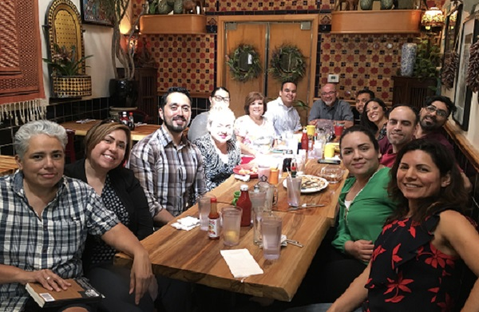
In the Fall of 2014, ARC Dean Manuel Pérez invited Latinx faculty and staff from throughout the district to attend the HSI (Hispanic Serving Institution) Summit at UC Davis. HSIs are “public and private, two- and four-year, not-for-profit, degree-granting. postsecondary institutions that enroll at least 25% full-time equivalent enrollment (FTE) Latinx undergraduate students. The enrollment threshold is used to determine eligibility for federal designation as such” (Garcia 2019). We chose to organize around the problematic term Hispanic given the term’s currency and legitimacy in higher education.
While the speakers and workshops were informative about what HSIs are and what they can do, the immediate outcome was the formation of Comunidad de Los Rios. Coming together at the summit, we shared the need and desire to work on our individual campuses and across the district to advocate for ourselves and Latinx students. Latinx faculty and staff formed Comunidades at each campus. La Comunidad de ARC meets regularly on our own as well as at least once a semester with representatives from the other campuses. At the districtwide Comunidad retreat during the Summer of 2017, members wrote the Mission and Vision statements (Honrando).
“Everyone comes from a family of locas. I find that to be magical and beautiful.”

– Yesika Salgado,
Corazón
We came together around the HSI summit, but Hispanic is a complicated term for many Latinx people. The U.S. Census, Hispanic marketing teams, and some moderate Latinx advocates started using this term in full force for their own purposes (Dowling 2014). Hispanic didn’t originate with Chicanos in the Southwest, Guatemalans in Chicago, or Puerto Ricans on the East Coast, and every other so-called Hispanic community in this colonized country. Families didn’t teach their children to have pride in being Hispanic. Since we have been called this term for decades, some of us now choose to identify with this term, and some of us choose to use this term because there are financial and political consequences if we don’t. Now that ARC has 29% Latinx student body, we will work our hardest to apply for HSI funding to serve our communities within a community. We must be involved with the HSI grant and in all phases.
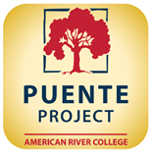
Proven Culturally-Affirming Success: PUENTE Project
The PUENTE Project helps to prepare educationally disadvantaged students for college admission and success through its combination of accelerated instruction, intensive academic counseling, and opportunities for community leadership. PUENTE is open to all students. The PUENTE Project is a national-award winning program that has helped tens of thousands of educationally disadvantaged students enroll in four-year colleges and universities, earn degrees, and return to the community as leaders and mentors to future generations. Begun statewide in 1981, PUENTE combines accelerated instruction, intensive academic counseling, and community leadership opportunities. For over three decades PUENTE has won accolades for its approach to helping underserved students thrive academically—by holding high expectations, valuing cultural and social capital, and ensuing that students and their families have critical college-going information and guidance. PUENTE's staff training programs currently benefit approximately 14,000 students across the state (PUENTE).
Eighteen years ago, Jesus Valle and Manuel Ruedas instituted the PUENTE Program at American River College and served as the English and Counseling coordinators, respectively. Manuel Ruedas retired in December 2018. Rick Ramirez took over as Counseling Coordinator. Jesus Valle stepped away from the program after the Spring 2019 semester. Cathy Arellano applied for and was appointed English Coordinator in Fall 2019.
When ARC PUENTE began, students would take the one level below transfer English and a 1-unit College Success course in the Fall. Then in the Spring, they would take transfer level English and a 3-unit College Success course. Since the passage of AB 705, colleges are figuring out how best to meet the requirements of the law and best serve their students (California Community Colleges Assessment and Placement). In Fall 2018, we implemented a 3-cohort model in order to meet our students where they are. The bill requires that a community college district or college maximize the probability that a student will enter and complete transfer-level coursework in English and math within a one year timeframe and use, in the placement of students into English and math courses, one or more of the following: high school coursework, high school grades, and high school grade point average. Significantly, current ARC PUENTE English and Counseling faculty identify as Latinx and speak a range of Spanish. Speaking with family members, especially parents, in Spanish helps them to feel comfortable about their children spending so many hours at school or doing schoolwork.
“It’s not true people stop pursuing dreams because they grow old.
They grow old because they stop pursuing dreams.”

– Gabriel García Márquez,
One Hundred Years of Solitude

ARC is the first PUENTE program to offer three cohorts. A few programs have two cohorts but almost all have only one. Entering cohorts take ENGWR 300 College Composition Combination which includes the transfer English class plus a computer lab and two supplemental 0.5 unit courses offered through Writing Across the Curriculum and Reading Across the Disciplines for a total of six units. The next cohort takes the traditional college level ENGWR 300. The final cohort takes ENGWR 480 which is the Honors version of the transfer level course. Our allies at UC Los Angeles encouraged PUENTE staff to offer an honors course so that students could take advantage of the UCLA Transfer Alliance Program (TAP) which allows students to “enhance [their] ability to transfer to UCLA at the junior level (UCLA TAP).
Students are matched with a mentor and meet 15-18 hours per semester in both semesters. In the Fall term, students attend a motivational conference with about a 1,000 other Puentistas from northern California. The PUENTE statewide office holds these conferences on a university campus. This helps PUENTE students become a part of those university campuses immediately. University enrollment is transformed from a distant dream to part of the PUENTE experience. They are now part of a university via their PUENTE program. The conference is part college fair with a chance to speak with local, regional, and some national public and private college recruiters. Students also attend workshops focused on applying for university admissions, the transfer process, financial aid, time management, and other topics. Each semester, the English and Counseling instructors attend a 2-day training with workshops focused on their specific area. As early as possible after becoming coordinators, the English and Counseling faculty attend a week-long summer training at the UC Berkeley campus where the statewide PUENTE office is located. PUENTE staff are available to conduct mentor trainings and other matters that arise. All of this professional development ensures that the PUENTE program has the means (and faculty perspective) to achieve the programmatic goals.
PUENTE is a significant point of entry for students who are enrolled in the program. In addition, it’s a point of entry for ARC students not enrolled in the program but seek Latinx-affirming programming and attend Puente-oriented events. Since its inception in 2003, ARC PUENTE has been engaged in bilingual outreach to immigrant and underserved communities utilizing student, faculty and mentor volunteers. This was done to address a need since ARC has never hired a Spanish-speaking general outreach staff. Over the years, many requests for presentations and outreach tabling in Spanish have been fulfilled by the PUENTE Community Outreach volunteer teams and affiliated Latinx student clubs (Appendix A). Contributing to this effort is the fact that ARC PUENTE has hosted/supervised an average of two to four bilingual counseling interns every year. The time is over for volunteers and students to do the work that full-time staff need to do and should have been doing for years. ARC needs to hire for at least one Latinx, Spanish speaking, culturally competent outreach staff person as soon as possible. Ideally, this hire is considered as an exception to the chancellor’s hiring freeze. Outreach staff are key first contacts for many high school students. They can begin the application and orientation processes, start advising and planning, meeting and acculturating parents to higher education.
In addition to the conferences for students and staff, students invite familia (as they choose to define the term) to our Welcome and Orientations at the beginning of the terms and our Noche de Familia events at the end of the terms. English and Spanish are spoken at these events. Students appreciate being able to enjoy the program without translating for family members. They, and their communities, are the center. Between these two events, we hold two mentee-mentor mixers on campus as well as college tours. Many students hear about PUENTE and want to join the program. They are disappointed when they find out they’ve already taken transfer English and won’t get credit if they take it again. However, they are invited to become involved with the program and attend college field trips or on-campus events through the PUENTE Club. The club serves to maintain contact with Puentistas who have graduated from the program but are still attending ARC. In addition, we now provide third-semester Puentistas with a list of PUENTE-recommend equity-minded courses or instructors to take, including Veronica Lopez’s NUTRI 300 Nutrition, Pam Chao’s Sociology 320 Minorites in America, Ricardo Catón’s History of the Chicano/Mexican American (HIST 327), Aisha Lowe’s Introductory Statistics for the Behavioral Sciences (PSYC 330) with Umoja and PRISE students, Jesus Valle’s Native American Literature course (ENGLT 338), and Cathy Arellano’s recently created Latinx Literature (ENGLT 335). This is the type of scaffolding that needs to be in place for all students. PUENTE and the PUENTE Club offer a model academic success program.
PUENTE Project is already established at ARC and has already proven to help students. Below is data from ARC’s PUENTE Program for 2015-2016 (Appendix B):
- 91% were first generation students
- 2003-2016, of 105 students, 51% went to a CSU, 30% went to a UC, and 18% went to a private or out-of-state college
- 2009-2010 students who persisted in first 3 consecutive terms (outcomes 2014-2015): 87% PUENTE, Hispanic non-PUENTE 69%, White and All Students 71%
- 2009-2010 Scorecard: PUENTE 67%, Hispanic 39%, White 41%, All Students 42%
- 2008-2009 students who completed at least 30 units (outcomes 2013-2014): 79% PUENTE, Hispanic non-PUENTE 66%, White 68%, All Students 66%
- 2008-2009 6-year transfer rate PUENTE 53%, Hispanic 24%, White 29%, All Students 29%
- 2013-2014 Credit course/transfer course: PUENTE 79%/75%, Hispanic 67%/65%, White 74%/73%, All 70%/69%
- 2014-2015: 74%/80% PUENTE, 66%/66% Hispanics, 74%/73% Whites, All 70%/68%

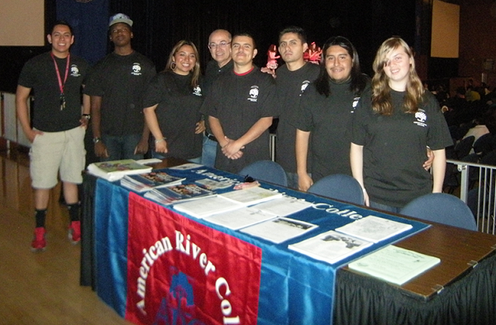
Puente Outreach at UC Davis
Theories
Community Action Research (CAR) or Participatory Action Research (PAR)
The authors of one study describe CAR as “Community action research is an alternative research method that uses the community as the unit of analysis. This approach forges research alliances with relevant stakeholders in the community to explore and develop solutions to local problems” (Ozanne and Anderson 2010). The theory behind this type of research is to involve the people who are invested because they will be impacted by the findings. It is often used with groups working in the health community or with youth who are often studied but not consulted. ARC Latinx faculty and staff are often not consulted in policy or program decisions. CAR/PAR will ensure direct community engagement in shaping the research agenda. This will increase the likelihood that findings and recommendations are in alignment with community needs and result in increased participation and more successful programs. This will allow for substantial growth and change now possible given the college’s recent redesign. The ARC de Comunidad and students already uses CAR/APR and will continue to do so.
In Spring of 2019, ARC’s PUENTE Project requested more funding since we had expanded the program. ARC administrators countered that they probably couldn’t scale up PUENTE. They also made the point that many students couldn’t join the PUENTE program, and we needed to find a way to support those students. We discussed this as Beyond PUENTE. Comunidad de ARC—with valuable input from students, some of whom are current classified staff—created questions, publicized survey, conducted survey (Appendix C). Twenty-nine students took our survey. (Reflective of our commitment to collaborate regionally and nationally, we spoke with UCD Center for Chicanx Latinx Academic Student Success staff. Our relationships with the center have been built through PUENTE programing, including site visits/field trips.) We included personal questions about gender, ethnic/racial, citizenship, and sexual orientation identity. We asked if respondents have children. In addition, we asked if they feel safe and welcome on campus. We asked about treatment by faculty, staff, and other students. Our survey questions indicate our understanding that student success is founded on student health in global terms, such as Maslow’s hierarchy of needs (Maslow). We presented to Vice President of Instruction Lisa Lawrenson and Vice President Student Services Jeff Stephenson. Overall, findings from the students showed they were satisfied with their experiences at ARC, but there is, of course, room for improvement. When Comunidad de ARC collaborated on developing our survey and presenting to ARC administrators, we used community action research (CAR) and believe that it should be used more often with more on campus research.
Critical Race Theory: LatCrit
“[The] basic twin goals [of LatCrit] since 1995 have been: (1) to develop a critical, activist and inter-disciplinary discourse on law and policy towards Latinas/os, and (2) to foster both the development of coalitional theory and practice as well as the accessibility of this knowledge to agents of social and legal transformation. LatCrit theorists aim to center Latinas/os’ multiple internal diversities and to situate Latinas/os in larger inter-group frameworks, both domestically and globally, to promote social justice awareness and activism” (Latina and Latino Critical Legal Theory, Inc.).
Using LatCrit frames certain issues for the Latinx community. With its focus on law and policy and the charge of the Disproportionately Impacted groups to examine how to best serve our individual constituencies, LatCrit is a logical theory to use though the fit is not perfect. Aligning ourselves along cultural/ethnic/racial lines aligns with LatCrit. The law intrudes in our lives, especially when many of us are considered law-less or “illegal” based on our citizenship (undocumented), gender (nonbinary), sexual orientation (queer), among other aspects, without providing us with equal rights or true justice. At this time, we recognize that to function we have to work with and within various structures already in place, even the ones, and there are many, which were not constructed with serving us in mind.
Many of these frameworks were constructed to oppress us, such as the construction of race and ethnicity. When a data request was made for a breakdown for race and ethnicity of ARC employees, the research office labeled the Latinx data as “Hispanic/Latino” for the following categories: administration, faculty, classified staff, and students. When a request was made for the race/ethnicity for all categories of classified staff, the data given was for “Mexican, Mexican-American, Chicano” “Central American,” “South American,” and “Other Hispanic” not “Hispanic/Latino.”
A Latinx person could have been born here in the United States, their ancestor could have arrived 15 generations ago, or an ancestor could have been here since time immemorial, and they are still marked as Latinx. A White student could be a very recent immigrant from north, south, east, or western Europe and they would be counted as White from day one. Nobel Laureate Toni Morrison said the following during a 1992 interview: “In this country American means white. Everybody else has to hyphenate” (Izadi 2019). She is right when it comes to the issue, as it often is, of power. Those who are unhyphenated or whose identity is not split, Whites are seen as basic and whole. They are centered. They come first. They are the default. We, either as Mexican-American or Mexican (no hyphen) American, are seen as not. We are not them. So what does that make us? Second (or further down the number line) place. Left over. Often left out. And need to be included later. Our students are just students who want an education. Yet, they find themselves at this point in history where they are marked. There are tangible consequences to these marks whether one calls oneself Mexican, Mexican American, Mexican-American, Latina/o, Latinx, or Hispanic, such as being tracked in school or stopped by the police. It doesn’t matter what we call ourselves and in what language we name ourselves since we’re not the ones who started calling us other, wrong, deficient. What matters are that steps are taken to bridge the gaps that these marks have left, and the pathways they establish that shape our experiences and success in higher education. It’s not our students who have gaps within them. They are the ones who must traverse each and every large and small gap that has been placed before them.
LANGUAGE
Knowing languages other than English is not bad or wrong. As the U.S. Census makes clear, Latinx students run the spectrum when it comes to ethnicity and race (U.S. Census). Many Latinx students are fluent in both languages, and many are fluent in English only. Even some students who are fluent in English may prefer to speak Spanish. In La Frontera/Borderlands, Gloria Anzaldúa lists eight different languages of English, Spanish, formal, informal, and combinations that she speaks (1987). For some people, speaking in a second or third language causes anxiety, stress, or nervousness. And for some people, they don’t prioritize one language as first or second; they’ve been speaking them the same amount of time. Additionally, forced to speak in a language demanded by others can be fatiguing or feel like an attack. Understandably, classes are taught in English, but ARC can be more welcoming to people speaking other languages on campus.
Language usage can be a tool instead of a weapon. Building on Strength : Language and Literacy in Latino Families and Communities notes the following of K-12 parents, but it is applicable to a degree to community college students and their parents/families, “A school (administrators, staff, teachers, parents, students) that takes its power seriously and commits itself to guard against recruiting Latino children to be complicit subjects in their own devoicing and failure must challenge anti-Latino stereo-types and expose the many disguises of the dominant discourse of English hegemony…” (Zentella 2005). ARC needs to make itself more accessible in other languages. Courses are taught in English. Fine. It’s too expensive to print everything bilingually. Fine. But why can’t information be in languages besides English in signage? Online? Sacramento is the capital of the fifth largest global economy (Forbes 2020). We should embrace the languages and cultures of the world.
“Our language is the reflection of ourselves. A language is an exact reflection of the character and growth of its speakers.”

– Cesar Chavez
United Farm Workers Co-Founder

Statement of Problems
The question isn’t, what’s wrong with Latinx students? The question is, how have Latinx students achieved all that they have with all that they have faced and continue to face? There’s nothing wrong with Latinx students. There is plenty wrong with the system. Therefore, we need systemic changes. Change ARC not the students. It’s not an achievement gap if we start at the same time or with the same resources, but historically that has not been, and today that is not, the case. We are disproportionately impacted because institutional, educational (and other) barriers have been disproportionately directed at us.
- lack of communication between ARC Latinx community and executive leadership team
- lack of ARC Latinx representation on councils, committees, and project teams
- lack of funds and internship opportunities for ARC Latinx students, especially undocumented students, LGBTQ, and low-income
- ARC Latinx staff, faculty, and administration do not reflect ARC Latinx student body; ARC hiring needs to change starting with a Spanish bilingual, bicultural Latinx outreach staff member to serve Latinx immigrant communities as soon as possible
- lack of designated space for ARC Latinx students, especially Latinx undocumented and LGBTQ community members
- lack of anti-bias training for all campus employees regarding Latinx, Latinx LGBTQ, and undocumented community members, especially students
- lack of culturally relevant curriculum or pedagogy
- need to work with community-based programs to better support ARC Latinx students
- ARC must include Comunidad de ARC on the HSI grant from beginning to end

Literature Review
“I am an undocumented person and I’m out here hustling.
I'm not ashamed of it because I have no control over it.”

– Yosimar Reyes,
For Colored Boys Who Speak Softly

Within the Latinx community, we realize that we have more than one identity. While we can’t address all of our individual identities in this report, we must address two specific groups that we are also a part of, the undocumented and LGBTQ communities. Undocumented people contribute in a variety of ways to California, including as artists, entrepreneurs, poets, bakers, teachers, musicians, and more. The U.S. government accepts tax payments from undocumented persons using an Individual Taxpayer Identification Number (ITIN). According to the IRS, “ITIN filers pay over $9 billion in annual payroll taxes” (Internal Revenue Service). Undocumented people also pay taxes when they shop at stores. If an undocumented person were to work using someone else’s social security number, taxes are taken from their paychecks, and they know that there is no chance of them ever getting those tax dollars back. Most of California’s undocumented population comes from Latin America at 82%, with the bulk (68%) coming from Mexico (Undocumented 2019). Approximately 80% of undocumented students attend community college. Financing education is an issue for most students, and it is even more so for undocumented students who can receive in-state tuition but are ineligible to receive federal aid. And “even though undocumented students are eligible for competitive Cal Grants these grants are only disbursed to undocumented students after all other eligible applicants for competitive grants receive awards” (Undocumented 2019). Worse, “compared to undocumented adults across the nation, California’s undocumented adults have educational attainment rates that are lower than that of the rest of the country (Undocumented 2019). As much as undocumented people contribute to the California economy, which is considered to be the fifth largest in the world (Forbes 2020), it is shameful and wrong that they get so little in return. California, and ARC in particular, needs to offer more financial aid to ensure they achieve their academic goals. ARC could work with community-based organizations and have them pay undocumented students for community service. In addition, faculty and staff need more and better training about serving and educating undocumented students.

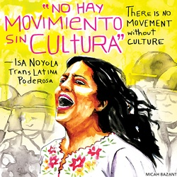
ARC is fortunate to have an UndocuScholar Resource Connection, and the staff is excellent. They do ally trainings; however, they should be doing more for faculty, staff, and administration. They have done trainings for some departments. Administration needs to require departments to undergo training. If all of ARC was trained then undocumented students would feel more welcomed and supported throughout campus and wouldn’t hear that they don’t belong or other ignorant statements. The training is offered during the semester and FLEX. Maybe if an incentive were offered to employees, such as pay increase, more would partake. There are resources such as the document “California Policies for Protecting College Opportunity for Undocumented Students” that should be required reading for all ARC employees (Undocumented 2019). A 1-unit orientation course specific to undocumented students could be offered in HCD. As much good and hard work as the UndocuScholar Resource Connection does, none of them are full-time or permanent. Also, it’s not a full-fledged center. These two aspects make the future of the “connection” nebulous. ARC needs to invest in the staff and solidify positions as well as provide more space and funding.
“Approximately 70% of the LGBTQ+ students enrolled in California community colleges are students of color” (Oakley :30) and of the 115 California community colleges, ARC has one of the only six Pride Centers (Oakley 1:37). In 2017-2018, Latinx students made up 45% of total California community college student enrollment (Key Facts). Not enough research has been done, but last Spring when Comunidad de ARC conducted their survey, 10% of respondents identified as gay or lesbian; bisexual, pansexual, or fluid; or queer (Appendix C). ARC’s Pride Center has one full-time SPA and one other staff member who serves as coordinator and teaching faculty. They do great work, but the need for more cannot be overstated. ARC has some gender neutral bathrooms on campus, but there should be at least one in each building for faculty, and staff a safe place to take care of their basic physical needs. All ARC faculty and staff who teach, process paperwork, take identity cards photos, etc. must receive gender-focused training to avoid negative situations for our LGBTQ campus community members. “Many people are surprised to discover that there is no ‘one stop’ process for getting a name and/or gender marker updated to match their gender identity” (Transgender Law Center). Finally, ARC students need access to a lawyer or an ombuds to help them navigate any legal issues, such as name change. To help ARC community members, ARC should partner with California Rural Legal Assistance, Inc. (CRLA). CRLA “serves a wide array of clients, [including] individuals with disabilities, immigrant populations, school children, lesbian/gay/bisexual and transgender populations, seniors and individuals with limited English proficiency (CRLA). Another possible community partner is Latinas Sin Fronteras (Latinas without Borders) which is “designed to break down the barriers that stand in the way of community member access to culturally responsive services for Spanish-speaking Latinx and immigrant community members, especially transgender Latinx women” (The Sacramento LGBT Community Center).
GLSEN’s (formerly the Gay, Lesbian & Straight Education Network) report is based on their National School Climate Survey (NCSC) 2017 survey taken by 23,001 13-21 year old middle and high school students. The report discusses key issues that relate to Queer Latinx community college students. The GLSEN report addresses “the experiences of Latinx LGBTQ students with regard to indicators of negative school climate and their impact on academic achievement, educational aspirations, and psychological well-being…whether LGBTQ students report experiences of victimization to school officials or their families, and how these adults address the problem…[and] the degree to which LGBTQ students have access to supportive resources in school…” (Zongrone 2020). Safety was a key issue for Latinx LGBTQ students with more than half saying they felt unsafe at school because of their sexual orientation. 44% because of their gender expression, and almost 25% because of their race or ethnicity (Zongrone 2020). The report also found:
- immigrant Latinx LGBTQ students reported feeling unsafe 8% more than U.S.-born;
- 35% reported missing at least one day of school and almost 11% missed four or more days in the last month because they felt unsafe or uncomfortable
- transgender and gender nonconforming (trans/GNC) Latinx students experienced greater levels of victimization than cisgender Latinx LGBQ students;
- Latinx LGBTQ students who had an ethnic/cultural club at their school felt greater belonging to their school community and felt safer due to their ethnicity/race
- Latinx LGBTQ students felt safer if their schools had supportive staff and inclusive LGBTQ curriculum; however, Zongrone couldn’t examine if the curriculum included representations of People of Color.
The 2015 U.S. Transgender Survey (USTS) had 27,715 respondents nationwide. The Report of the 2015 U.S. Transgender Survey states that about one-third of the Latinx trans community identify in one of three ways: transgender men, transgender women, and nonbinary. Some key findings (National Center for Transgender Equality):
- 61% of Latino/a respondents were currently living full time in a gender that was different from the one on their original birth certificates
- 44% had completed some college but had not obtained a degree
- 10% had received an associate’s degree
- 23% of those who were out [as transgender] or perceived as transgender in college or vocational school were verbally, physically, or sexually harassed because of being transgender
- 71% reported that none of their IDs had the name and gender they preferred
- 50+% more Latino/a transgender respondents were living in poverty then the general Latino/a people in the U.S. population.
Undocumented and LGBTQ students both need legal aid. Undocumented students need help dealing with immigration law and LGBTQ students with changing their identification to match their gender. Also, staff, faculty, and administration need to take mandatory anti-bias training so people become aware of what they can and cannot say or do. We need to offer as much information as possible to prevent as much bias and discrimination against Latinx and LGBT Latinx students. The “California Policies Protecting College Opportunity for Undocumented Students” should be given to each ARC employee (Appendix D) The one-page flyer from the Office of the Los Rios General Counsel describes the process for what to do when Immigration and Customs Enforcement is on campus, and that’s not enough (Appendix E). Admittedly, in December 2016, the chancellors of Los Rios, Sacramento State, and UC Davis wrote an op-ed in The Sacramento Bee defending undocumented students. The sad truth is that the rhetorical and physical attacks on undocumented (and immigrant) students did not stop. A statement of unequivocal support from the chancellor and four presidents should accompany this flyer at the very least. The ARC Latinx students need a dedicated space to discuss sensitive topics, such as gender and sexuality identities as well as citizenship status.
In his doctoral dissertation (Appendix F), “Community College PUENTE’s Influence on California’s Mexican-American Students: Countering the Statistics,” Dr. Miguel Molina, the Dean of Financial Aid at Sacramento City College, studied ARC’s PUENTE program and confirms its effectiveness. Molina states, “A number of Latino students find opportunities that help them economically, such as paid internships or student employment, which sometimes lead to professional positions when their degrees are completed…[however] many Latino students often are balancing family and work responsibilities or the hardship of commuting, and subsequently never can take advantage of these campus experiences despite coming to class, doing their studies and completing their degree requirements…” (Molina 2014). Students need more funding. Finances are one key obstacle to Latinx students’ education. One way is to hire more Latinx students for on campus jobs and initiate internships. As stated earlier, Latinx students have already been doing outreach. They can continue to do so as long as they are paid. Currently, Latinx students receive a proportion of financial aid significantly below their proportion of student enrollment.
“The most notable PUENTE influences included a sense of belonging through cultural role models, which included counselors, instructors, and mentors; validation through the cultural pedagogy; writing development with high standards to prepare students for courses throughout their degree program; the element of care; the academic road mapping that helped the students understand degree requirements and processes needed for transfer; the creation of a family setting on-site for peer networks and academic support; and PUENTE having served as the informing entry point for campus resources and student organizations” (Molina 2014). Many of these aspects can be, and in some cases, are already being, developed across campus in non-PUENTE classes. These changes will take a wide array of changes inside and outside the classroom, such as
- Improve Parent Involvement: Molina recognizes the value that family plays in PUENTE students’ lives and ARC PUENTE is already doing that such as inviting them to ARC Latinx Transfer Days before the school closure and plans to involve parents and families more.
- Diversify Faculty and Staff: Staff, faculty, and administration need to represent Latinx student population.
- Improve Professional Development: Professional development across the college is key.
- Earlier Orientation and Collaboration: Molina recommends starting to orient students to the college when they’re still in high school. The much-needed Latinx Outreach Officer will be able to help future ARC students and parents/families begin to get oriented to ARC and higher education in general.
- Improve the Roadmaps: ARC is already working on this, but we must regularly review and make sure students know what courses they need to take to achieve their academic goals. Pathways need to be accessible and attainable or they’re useless.
- Expand PUENTE: PUENTE is a successful program, and as stated earlier we have already expanded to three cohorts, including an Honors component. The program was created with one cohort in mind. We don’t have the personnel or funds to create enough cohorts for 8,000+ Latinx students, but we need to recognize its value as an entry point, retention tool, and develop those in other areas on campus.
As Molina points out, hiring more Latinx faculty is significant but not only for Latinx students. Hiring more Latinx faculty isn’t just significant for Latinx students. More than 50,000 students responded to a survey, and there was an “overall more positive perceptions of Latino and Black teachers compared to their White counterparts (Cherng and Halpin 2016). That is, “on average, all student groups have more positive ratings of minority teachers, including White students and Asian American students, suggests that minority teachers can translate their experiences and identities to form rapports with students that do not share the same race or ethnicity” (Cherng and Halpin 2016). Although the students were in the fourth through ninth grades and the researchers do not address applying their findings to community college, the authors do state it’s important to have diversity among the teaching force (Cherng and Halpin 2016).
In fall 2019, Robert Fairlie presented at Los Rios District Office on his article “A Community College Instructor Like Me: Race and Ethnicity Interactions in the Classroom.” One of his findings was that when Latinx (and African American and Native American students) enter community college they express a higher intention of transferring to a university than White or Asian students; however, White and Asian students actually transfer at higher rates than the other students (Fairlie 2019). His article states, “[M]inority students perform relatively better in [community college] classes when instructors are of the same race or ethnicity” (Fairlie et al 2014). While the percentages are small (1.2% to 3.2%), the authors state that students are more likely to pass and earn a B or higher and less likely to drop out (Fairlie et al 2014). In addition, they found evidence that “an instructor’s race or ethnicity affects the likelihood of taking subsequent courses in the same subject and majoring in the subject” and if they take a class with a “minority” instructor in the first quarter, it “affects a student’s likelihood of retention and degree completion(Fairlie et al 2014). Fairlie and his colleagues state that the results suggest “the academic achievement gap between white and underrepresented minority college students would decrease by hiring more underrepresented minority instructors” (Fairlie et al 2014). Finally, the authors caution that nonminority students do worse with minority instructors and suggest that “a more detailed understanding of heterogenous effects from instructor assignment…is needed before drawing recommendations for improving overall outcomes” (Fairlie et al 2014). Interesting conclusion considering that most “minority” students study under nonminority instructors from kindergarten and throughout their academic careers.
“gringos why do you see us illegal don’t you think[/]
we are the workers around you”

– Javier Zamora,
Unaccompanied
Brazilian educator

“I change myself, I change the world.”
– Gloria Anzaldúa,
co-editor This Bridge Called My Back
“Hispanics are the most underrepresented racial or ethnic group in the faculty ranks, although blacks and Native American/Alaskan Natives also lag far behind whites and Pacific Islanders” (Longtine and Jones 2011). More Latinx, African Americans, and Native American/Alaskan Natives are being hired, but “relative to projected changes in the population of these groups, progress toward equitable representation among faculty is slow” (Longtine and Jones 2011). Unfortunately, it’s nine years later and those in power have not made enough changes. Hiring must change, and these changes are overdue.
In 2014, Latinx became the largest ethnic group in California. Ninety-five percent of Latinx youth are born in California. Of 10 graduating seniors, only three are eligible for public university admissions. Before AB 705, Latinx were more likely than Whites to enroll in remedial coursework. What’s most important for ARC to recognize is that Latinx students graduate at a lower rate from community colleges than they do from the California State University or University of California systems! Broken Mirrors II: Latino Student Representation at Public Colleges and Universities states that Latinx underrepresentation was worse at the community college level than at the university level (Education Trust 2019). Further, the authors state that “Latino students are underrepresented at community and technical colleges in 40 of 44 states” and California is a state with a large Latinx population but does not “enroll equitable shares of Latino residents at public community and technical colleges” (Education Trust-West 2014). The proportion of AA degrees Latinx students attain is smaller than our proportion of the population.
Almost 75% of Latinx Californians are under the age of 45 (Left Out 2018). However, “our college and university campuses remain predominantly White in regard to faculty and leadership. This mismatch can lead students to experience feelings of isolation and inadequacy, and can cause them to question their academic competency. More proportional representation [from Latinx and other under-represented groups is needed]” (Left Out 2018).
“California’s success depends on the success of its Latinx [population]” and it’s “home to the largest Latinx population in the country” (Higher Ed 2018). Further, in 2016-2017, 90% of Latinx students attended a public college or university (Higher Ed 2018). California needs to do more for her Latinx population. We are under-represented across all sectors of higher education in California (Higher Eds 2018). Also, “the gap in degree attainment between Latinx and White students is larger in California than any other state in the nation; and the gap is widening—by almost 2 percentage points since 2000” (Campaign Higher Ed 2018). Further, Latinx transfer within two years at a 2% rate and only 16% within 5-6 years. White students transfer to 4-year colleges in 3-4 years at almost twice the rate, 24% compared to 13%. Latinx completion rates, which include graduation and transfer, is 38% (Campaign Higher Ed 2018).
ARC is working on improving Latinx achieving their educational goals, such as using students’ high school GPA for placement and supporting Puente’s request to offer an honors course. Other things ARC can do are recognize that many students go to school part-time more than full-time and work at least part-time. and work at least as much. ARC must help students who often come from low-income families to keep their debt low.
Education attainment is connected to career earnings operating within the larger economy. When there’s a strong economy, money flows. When there’s a weak economy, money tightens. When it comes to school, this means programs that were supporting students are often cut or completely wiped out. A study looked at student reactions when budget cuts were implemented. From campus community interviews, the following themes emerged: “diminished access, reduced support, and delayed completion” and “devaluation of education and race and class discrimination” [author’s italics] two themes from staff interviews: “reduction of access and services and inequity” (Chacon 2013). The disinvestment in public education disproportionately effects the most vulnerable populations: the undocumented, low-income, first-generation, and Latinx.
Chacón states what is widely accepted: community colleges provide a significant entry point for low-income Latino/a students into higher education (Chacon 2013). He goes onto point out that when budget cuts occur, “’access points’: open enrollment, low registration fees, and subsidy programs such as EOPS, were being transformed into ‘choke points’ as internal support capacity erodes in relation to demand” (Chacon 2013). Chacón makes the case that when equity-based programs and other support services are cut, students may “stop-out or drop-out” because the financial, time, and energy commitment required to attend community college isn’t enough (Chacon 2013). Chacon urges that “Any change in the budget…will require a paradigm shift that reemphasizes the importance of college and programs designed to overcome historical and institutional inequities based on race and class discrimination” (Chacon 2013). He points out that all members from all sectors of the college can mobilize and advocate to slow resource reduction that undermines student equity, preserve or increase funding that prioritizes access points and support services (Chacon 2013).
We are at a time when exceptional leadership is required, as we move to more long-term changes and sustainable responses to the pandemic that support and center the most vulnerable. During the recent crisis, classified staff from The Hub, which houses equity programs and serves many DI students, were reassigned to call centers. They answered phones and directed students to counseling, financial aid, and other college services. In addition, they were required to log their phone calls, email messages, and social media likes. What about the students who needed service from UNITE, UndocuScholar Center, PRIDE Center, or other programs? In our recommendations, retention is addressed. It must be mentioned here because now that students, the college, country, and world are in crisis, those needs were subordinated to the college’s general duties.
The world our students will be returning to, entering, or living in will have a very different economic outlook. Their educational choices and options must reflect these new terms and opportunities. This will be particularly relevant for students interested in humanities and education. Economists generally agree that after an economic depression or recession, the new workers who enter the job market do not earn as much for the first ten years compared to how they would have if the economic downturn had not occurred. And it’s worse for the lower paid workers, “Among graduates, those with the lowest predicted earnings suffer significantly larger and much more persistent earnings losses than those at the top” (National Economic Review Board 2020). Considering that on the average heterosexual White men are paid higher than people of color, women, and queer folks, we can bet that some, if not a majority, of our Latinx students will find themselves looking at a smaller paycheck for the next ten years. Many, if not most, students come to community college to get better jobs and earn higher salaries. Whatever a student’s reason for entering campus, we need to meet them where they are and help them achieve their goals.
Pasadena Community College has faced many of the same challenges as ARC and has made progress by focusing on instructors, “Their core philosophy is that unless professors change what they do in the classroom with a deliberate focus on racial equity, even the most well-meaning and dedicated among them will discourage students of color with subtle messages that they don’t belong, that they aren’t expected to succeed, or that they are on their own to sink or swim…the key for Pasadena has been to create opportunities for professors to recognize where they’ve fallen short, and to make them want to change what they do” (Bombardieri 2019 ). ARC can learn from Pasadena Community College and follow through with like-minded structural change.
Laura Rendón interviewed faculty at two and four-year colleges who were invested in teaching and social justice. One non-Latinx faculty member remarked, “I believe anyone can learn. But not everyone can teach so people can learn. I feel that every student in my class is intelligent. Every student can earn an A. Every student is an A student, and I think it’s up to me to allow them to see that…” (Rendón 2012). Rendón also interviewed a small sampling of students, and they shared what they gained from the instructors: seeing the professor as role model/mentor, feeling the professor’s investment in students, having a validating classroom, and thinking differently about learning (Rendón 2012).
One of the key drivers behind the changes at PCC is Cynthia Olivo, the college’s vice president of student services, who recognizes the difficulty facing faculty, “It's very personal, because when you talk about student success by race and ethnicity, if you're an equity-minded person, what you're saying is, ‘I am not doing something to meet the need of the student,’” she said. “And that can be quite painful, because you're in love with your profession, you want to help, and you intend to do well. But the reality is we have to learn to teach differently, we have to learn to serve differently” (Bombardieri 2019). Community college (and university) professors are not trained to teach and often “The typical professor receives little, if any, training on how to teach well.”
“A cadre of faculty leaders have pushed racial equity alongside Olivo” (Bombardieri 2019). In this time of economic uncertainty, ARC may not have the funds to hire new positions right now; however, ARC has faculty already in place who have expressed in action and word that they are interested in making changes to better serve students, such as Pam Chao (Equity Action Institute Creator and Coordinator), Jennifer Laflam (Center for Teaching and Learning Director), all of the faculty who have voluntarily participated in EAI, Disproportionately Impacted faculty team members, and many others. Also, new faculty hires who attend the New Faculty Academy, which must be sure to always address equity issues each session of the term, are possible recruits to “flatten the curve” on systemic inequality. In addition, the faculty union’s (LRCFT) members of the Social Justice Caucus are perfectly suited for collaboration. Finally, the Professional Development and Training Plan Project Team’s recommendations must seriously be implemented for faculty and staff which will positively impact students.
Latinx Student Inequity
ARC Latinx students earned 18% of the associate’s degrees and have a 22% graduation rate. As of Fall 2019, Latinx students make up 29% of the student body (National Center for Education Statistics 2019).
ARC Student Enrollment from DataMart (Appendix G)
- From Fall 2000 to Fall 2019, there has been a steady change in enrollment for Latinx students reaching +19% in Fall 2019 and a more abrupt change for White students with a net change of -27%. Looking at enrollment in five-year periods, the biggest increase of Latinx enrollment was reached in Fall 2019. The largest decrease of White student enrollment occurred from Fall 2000 to Fall 2005, with a change of -15%.
- As of Fall 2019, Latinx student enrollment is 29% of the total compared to 38% for White students.
ARC Student Education from DataMart (Appendix H)
- BA or higher: More than 50% fewer Latinx student earned associate’s or bachelor’s degrees as White students.
- GED, high school proficiency, diploma: White students have a higher percentage, with lowest difference in diplomas 32% vs 37%.
- In Foreign Secondary School Diploma / Certificate of Graduation Total, Whites earn 50% compared to 7% for Latinx.

2013-2014 to 2017-2018
- Latinx students have gone from earning 18% of the degrees and certificates to 22% while White student change is -4%.
- Regarding the numbers of courses at Mastery level, Latinx students have improved by 4%. White students have changed at -5%. Latinx students hover between 47-49% while White students hover around 58-60%.
- When it comes to Success, Latinx students have improved by 5%. White students have changed at -4%. Latinx students hover between 65-67% while White students hover around 73-76%.
- Both groups of students drop courses within the same range of 2%; Latinx 16-18% and Whites 13-15%. Latinx students’ number of Ws has changed at 7% while White students have changed at -5%.
- One term retention rates for Latinx students ranges 63-67% and 65-68% for Whites. Retention has changed -3% for both groups.
- One year retention rates for Latinx and White students ranges 3%. Retention has changed -3% for both groups.

Latinx Hiring Inequity (Appendices, I, J, K, L, M)
In 2016-2017 when the Left Out report was made, Latinx students made up 22% of ARC’s student enrollment and White students were at 40%. However, Latinx tenured faculty and Latinx non-tenured faculty were at 13% and 9% while White tenured faculty and White non-tenured faculty were at 62% and 73%.
For California, the percentages of students were Latinx 43% and White 28%. Latinx tenured faculty and Latinx non-tenured faculty were at 14% and 13% while White tenured faculty and White non-tenured faculty were at 62% and 61%. (Employee Headcount 2020).
Everyone, including other students, on a college campus impacts individual students’ experiences. While we want students to be positively impacted by everyone they encounter, it is especially important that, as much as possible, every college representative makes a positive impact on every student.
With student enrollment at 29% and 38%, it is clear that Latinx students interact with significantly fewer faculty and staff members who reflect them, and White students see plenty of faculty and staff members who reflect them. Research shows that seeing yourself reflected plays a large role in positive student experience. In three employment categories, Latinx students are under-represented by 15-19% and White students are over-represented by 20-33%. When the counts were made for Fall 2019, Latinx student representation matched administration. Unfortunately, now the chancellor has levied a hiring freeze. ARC administration must advocate as strongly as possible to hire more Latinx faculty once the freeze lifts.
Faculty were broken into tenured/tenure track and non-tenured, but they were not disaggregated according to instructional/teaching faculty and non-instructional/non-teaching faculty, such as counselors and librarians. A request for this breakdown was submitted, and results were given. The data show that 1% of the adjunct non-teaching faculty are Latinx and 4% are White. For adjunct teaching faculty, 9% are Latinx and 67% are White.
For tenured or tenure track non-teaching faculty, 3% are Latinx and 8% are White. For tenured or tenure track teaching faculty, almost 12% are Latinx and 54% are White. The data show that if non-teaching adjunct and non-teaching tenured/tenure track faculty were excluded from the faculty count, the numbers would be even lower. It’s not a big percentage, but counting the 3% Latinx counselors and other helps bulk up the overall faculty count. This is why every effort needs to be made to recruit for Latinx faculty and mentor them so ARC can retain them.
Classified staff data wasn’t separated according to job categories. Aware of the importance of this data, Latinx DI team members urged for those numbers to be found. The more detailed results show the four job categories: Classified Hourly-11 Months, Classified Hourly-10 Months, Classified Hourly-9 Months, Student Employees and Work Study, and Temporary Classified and their staffing by race/ethnicity.
The data show high percentages, 14-21%, of under-representation for Latinx and 12-62% over-representation for Whites. The under- or over-representation is computed using the current student enrollment percentages of Latinx 29% and Whites 38%. The 14% under-representation was in Temporary Classified positions. The 21% under-representation was in Classified Hourly-10 Months. The 12% over-representation was in Classified Hourly-9 Months, and the 62% over-representation was in 11 Classified Hourly – 11 Months category. For this category, there was only one employee, and she is White. The next largest over-representation, 32%, was in Classified Hourly – 10 Months.
We need to value all our workers. We need to use all resources that we already have. For example, if a program asks a faculty member to lead a workshop and this work falls outside the faculty member’s regular duties, the program can pay the faculty member. If this process is available to classified staff, it’s not well-publicized.
Also, some classified staff have much previous professional knowledge that they can share with colleagues to help students. However, some ARC community members neglect or ignore the workshops that classified staff offer and only or mostly attend workshops offered by faculty. To review:
- 29% (and growing) of all student enrollment is Latinx
- 1% of the adjunct non-instructional faculty are Latinx
- 9% of adjunct instructional faculty are Latinx
- 3% of tenured/tenure track non-instructional faculty are Latinx
- Almost 12% tenured/tenure track instructional faculty are Latinx
Our current Latinx representation at the faculty level will never be able to meet our students’ needs. In addition, this supports the fact the same Latinx faculty will continually be asked to do equity work on behalf of Latinx students and colleagues. Worse, these faculty members will probably suffer burnout.
Overall, Latinx students have increased in number and proportion of the student population, while White students have been deserting ARC for decades. Imagine what our numbers would be if we had ever hired a Latinx outreach officer. Latinx students are not performing where White students are, but they are improving. And White students are not performing at the level where they used to. Latinx students are at ARC and keep coming regardless of the many institutional and societal barriers, including not seeing themselves reflected in proportion to their enrollment at the faculty, staff, or administration levels. ARC has the students and some though very committed faculty and staff. During 2014-2020, the administration steered ARC to adopt equity-minded and social justice mission and vision statements. Also, it supported equity reports such as this to prepare path forward. Now, the institution must change course and actively support the students who keep returning to it. Much needs to happen that doesn’t require money; however, serving Latinx students will require funding priorities that support Latinx students. Ideally, the administration will involve the Latinx (and other) communities in making those funding priorities. We’ve already seen what happens when Latinx students are given what everyone else gets: they don’t get what they deserve; and they often don’t get what they do deserve. The HSI grant will help (if we get it), but it’s one temporary piece of a larger structure that must become more solid. The new community college funding formula which focuses on low-income students meeting their educational goals will force ARC to finally prioritize Latinx students (Student Centered Funding Formula). This report’s recommendations should be considered for the HSI application and implementation as well as new and revamped policies to support Latinx students. Latinx students have shown their commitment to ARC. The question is, will ARC fulfill its commitment to Latinx students? Now is a very difficult time, but very difficult times often inspire the best creative, focused, long-term thinking and actions.

DI Population Survey: Findings and Analysis
This section discusses the DI project timeline, key findings from the Student Experience Survey (SES), recommendations, and project limitations.
Project Timeline
Three DI leadership teams representing African American, Latinx, and Native American populations were convened in October 2019. The teams consisted of representatives from each campus constituent group as well as community members. From October 2019 to February 2020, each DI team examined historical data, combed through student development theories, and read academic studies in response to its project objectives. Building on existing literature, the DI teams relied on theoretical frameworks of student belonging, identity development, and inequities in social or academic environments. An extensive literature review laid the foundation for the Student Experience Survey (SES), the DI team’s primary tool for collecting and analyzing local data from American River College (ARC) students. The SES was administered for data collection and analysis from March to early April 2020. Results from the SES were used to inform recommendations made to the Student Success Council and ARC’s Executive Leadership Team by end of spring 2020.
Questionnaire
The SES was informed by works from authors who examined similar phenomena with student experiences in higher education (American River College, 2019; Durham, 2008; Ingram, 2012; Schlossberg, 1990). The student Experience Survey (SES) is largely based on question items from existing questionnaires but was edited to reflect the specific context at American River College (ARC). In February 2020, a paper version of the SES was given to three ARC students soliciting feedback about format, vocabulary, and general question design. Based on their comments, questions were modified to promote greater clarity with comprehension. Students from the pilot study positively commented on the SES, noting that its general inquiry pertained to their experiences.

Data Collection
In mid-March 2020, the SES was converted into an electronic format with 34 five-point Likert scale questions, 18 multiple or single choice options, and three open-ended inquiries. E-mails with survey links were sent to all students who enrolled in spring 2020 and self-identified as having African American, Latinx, and Native American ancestry. Demographic data on students’ racial, ethnic, and/or, cultural identities were drawn from their California Community College (CCC) applications. The initial e-mail soliciting survey participation included a specific link granting access to the SES and was sent to each student’s Los Rios Gmail account. A second e-mail reminding students to complete the SES was sent out about one week after the initial e-mail. Informal e-mail reminders drafted by staff were also sent to certain students to encourage survey participants. A few days before closing data collection, members of the DI team made a short video and sent it via e-mail it to students asking them to complete the SES. Aside from the initial e-mail to all eligible survey participants, subsequent e-mail communications encouraging participation were only sent to students who had not completed the SES at that time. Incentives for completing the SES included ARC bookstore gift cards, food vouchers for the campus pantry, and miscellaneous school or personal items given through prize drawings based on when students completed their surveys.
To prevent possible duplication of survey participation, specific survey links were electronically connected to students’ school identification numbers and became inactive once students submitted survey results. The SES was made available to students for two and a half weeks. A total of 8699 students from African American, Latinx, Native American, and Multi-racial backgrounds were invited to complete the SES. Table 1 shows the demographic composition of survey participants as organized by racial, ethnic, and/or, cultural identities.

Table 1
Survey response rates per racial, ethnic, and/or cultural groups enrolled in spring 2020.
Racial, ethnic, and/or cultural group | Survey invitations  (n= 8699) | Survey  Responses | Response Rates
African American (AA) | 1858 | 229 | 12.3%
Native American (NA) | 119 | 21 | 17.6%
Latinx | 5842 | 558 | 9.6%
Multiracial American * | 880 | 77 | 8.8%
*Students who identify as Multiracial American where at least one racial/ethnic identity consists of AA, NA, or Latinx ancestry.

Survey Results
This section discusses survey results that include perceptions of campus, barriers or challenges, motivators for attending college, motivators for working hard, and contributors to future success in classrooms.
Perceptions of Campus
Using five-point Likert scale questions, the SES inquired about perceptions on campus climate, academic experiences, and personal circumstances. As shown in Figure 1, a majority of students strongly agree (28.9%) or agree (38.7%) that the college is committed to fostering an environment in which students of color can be successful, significantly larger than the combined responses indicating neither agree/disagree (25%), disagree (4.4%) and strongly disagree (3%). Students also report strongly agreeing (29.8%) or agreeing (42.5%) that while being a member of their cultural, ethnic, or racial group they feel socially accepted on campus. Furthermore, there were responses of strongly agree (32.8%), and agree (39.5%) in regards to observing other students with their same cultural, ethnic, or racial background in their classes. A large number of students responded with neither agree/disagree when asked about people of their cultural, ethnic, or racial group being more likely to experience discrimination on campus (37.4%) and seeing teachers who look like them adequately represented in their classrooms (31%). See Figure 1 for Likert scale response represented in percentages.

Figure 1. Student perceptions of campus in spring 2020.

This figure shows a summary of student opinions from all DI groups (African American, Native American, Latinx, and Multiracial American) on five Likert scale questions from the SES.

Barriers
Table 2 illustrates the barriers or challenges for Latinx, African American, and Native American groups in attainment of academic goals this last year. When students were asked to list all challenges in this past year that made it difficult for them to finish their degree, certificate, or transfer to university, there were similarities across all three DI groups. Of the 558 Latinx students who responded to this question, they identified their top challenges as having difficulty balancing work and family (1st), not enough money for general living (2nd), not enough financial aid for school fees (3rd), low self-confidence about academic performance (4th), and taking care of family members (5th). There were 229 total African American students who answered this question, reporting top challenges as not enough money for general living (1st), not enough financial aid for school fees (2nd), difficulty balancing work and family (3rd), taking care of family members (4th), and low self-confidence about academic performance (5th). Unlike the Latinx and African American groups, the 21 Native American students who answered this question indicated similar hardships with not enough financial aid for school fees, taking care of family members, and low self-confidence about academic performance (all equally ranked 1st). They also specified equal challenges with not enough money for general living and difficulty balancing work and family (both equally ranked 2nd).

Table 2
Top challenges or barriers in reaching academic goals in this last year per racial, ethnic, and/or cultural group.
Top challenges or barriers | Latinx | African American (AA) | Native American (NA)
Not enough money to cover general living costs. | 2nd | 1st | 2nd*
Not enough financial aid to cover school fees. | 3rd | 2nd | 1st*
Difficulty balancing work and family demands. | 1st | 3rd | 2nd*
Taking care of family members. | 5th | 4th | 1st*
Low self-confidence about my academic performance | 4th | 5th | 1st*
*Native American student reported equal significance with barriers marked 1st and 2nd.

Motivators for Attending College
Table 3 displays primary motivators influencing students’ decisions to attend college per racial, ethnic, and/or cultural groups. For Latinx students, their top two motivating factors for attending college include obtaining a good paying job (1st) and to help their family, community, and society (2nd). African American students reported expanding career options (1st) and obtaining a good paying job (2nd). The Native American group reported their two most influential motivating factors as expanding career options and helping their family, community and society (both ranked as 1st).
Looking at middle ranked motivators between the DI groups, motivating factors slightly diverge. Latinx students ranked the following: expanding career options (3rd); being a role model and being the first person in their family to accomplish this goal (both as 4th); being able to help people in their culture, ethnic, or racial group (5th); and parent/guardian/family encouragement to attend (6th). African American students ranked mid-level motivators as helping their family, community, and society (3rd), helping people of their culture, ethnic, or racial group (4th), and being a role model (5th). African students reported least influential motivators as being the first person in their family to accomplish this goal (6th) and parent/guardian/family encouragement to attend (7th). In regards to Native American students, they ranked obtaining a good paying job (2nd), being a role model (3rd), and helping people of their culture, ethnic, or racial group (4th). Native American students also identified the two least influential motivators as parent/guardian/family encouragement to attend college and being the first person in their family to accomplish this goal (both ranked 5th).

Table 3
Primary motivators influencing students’ decisions for attending college per racial, ethnic, an/or cultural group.
Primary motivators for attending | Latinx | African American (AA) | Native American (NA)
My parent(s), guardian(s), or family encouraged me to attend college. | 6th | 7th | 5th**
I want to use my education to expand my career options. | 3rd | 1st | 1st**
I want to use my education to obtain a good paying job to help myself and/or family. | 1st | 2nd | 2nd
I want to be a role model. | 4th* | 5th | 3rd
I want to use my education to help people of my cultural, ethnic, or racial group. | 5th | 4th | 4th
I want to use my education to help my family, community, and society. | 2nd | 3rd | 1st**
I want to be the first person in my family to accomplish this goal. | 4th* | 6th | 5th**
*Latinx students reported equal significance with motivators marked 4th.
**Native American students reported equal significance with motivators marked 1st and 5th.

Motivators to Work Hard
In further examination of other success conditions, Table 4 displays the top motivating factors that encouraged students to work harder to be successful at ARC over the last year. All three DI groups (Latinx, African American, and Native American) ranked that positive interaction with a professor (1st) was the most influential motivating factor that encouraged students to do well. Latinx and Native American students reported family support for their education as the second most important motivating factors for success while African Americans ranked financial aid paying for school fees/texts. The greatest difference between groups occurred with mid-level rankings of motivational factors for success. Latinx students indicated financial aid paying for school fees/texts (3rd), culturally relevant instruction in classes (4th), working with a counselor (5th), and positive interaction with a staff person (6th). African American students reported family support for their education (3rd), working with a counselor (4th), positive interaction with a staff person (5th), and job placement to obtain steady income (6th). Native American students ranked positive interaction with a staff person (3rd), financial aid paying for school fees/texts (4th), working with a counselor (5th), and positive interaction with an administrator at ARC (6th).

Table 4
Top motivating factors that encouraged students to work harder towards success at ARC over the last year
Motivating factors that encouraged students to work harder | Latinx | African American (AA) | Native American (NA)
Financial aid to pay for school fees and textbooks. | 3rd | 2nd | 4th
Culturally relevant instruction in the classroom. | 4th
Positive interaction with a staff person at ARC. | 6th | 5th | 3rd
Positive interaction with a professor at ARC. | 1st | 1st | 1st
Family support for my education. | 2nd | 3rd | 2nd
Working with a counselor. | 5th | 4th | 5th
Job placement to obtain steady income. |  | 6th
Positive interaction with an administrator at ARC. |  |  | 6th

High Impact Practices in the Classroom
Table 5 displays the top factors likely to contribute to student success in future classes per racial, ethnic, and/or cultural group. All three groups (Latinx, African American, and Native American) ranked clear explanation of requirements as a top factor for success. Latinx and African American students similarly prioritized regular feedback from professors (2nd), different ways to learn course content (3rd), and safe classroom environment (4th). Native American students identify these factors as important but offer a slightly different ranking order with different ways to learn course content (2nd), safe classroom environment (3rd), and regular feedback from professors (4th). Additionally, Native American students report opportunities to work with classmates (5th) and relevant content that reflects student experiences (6th) as least influential in contributing to their success in the classroom. Latinx students marked opportunities to work with classmates (5th) and relevant content that reflects student experiences (6th). African American students indicated relevant content that reflects student experiences (5th) and opportunities to work with classmates (6th).
Table 5
Top factors likely to contribute to success in future classes per racial, ethnic, and/or cultural group.
Factors contributing to success in the classroom | Latinx | African American (AA) | Native American (NA)
Regular feedback from professor(s) about my academic performance. | 2nd | 2nd | 4th
Opportunities to work with classmates on assignments. | 5th | 6th | 5th*
Clear explanations on what is required to be successful on assignments and/or exams. | 1st | 1st | 1st
Relevant content that reflects my cultural, ethnic, or racial experiences. | 6th | 5th | 6th
Different ways to learn course content | 3rd | 3rd | 2nd
Classroom environments where I feel safe to ask questions without fear of judgement. | 4th | 4th | 3rd
Other** | 7th | 7th | 5th*
*Native American student reported equal significance with factors ranked 5th.
** Short-answer responses in this category yielded no clear themes or conclusions.

Discussion
This section examines the data findings and its implications in understanding the experiences of Latinx, African American, and Native American students at ARC. As defined by the DI project charter, the primary focus of data findings was to inform recommendations for serving African American (AA), Latinx, and Native American (NA) students in alignment with college wide efforts. A summary of student perceptions on campus, challenges or barriers, key motivators, and high impact practices in the classroom are discussed.
Perception on campus
On the five Likert scales examined, over half of students across all racial, ethnic, and/or cultural groups express feeling positive (strongly agree or agree) about seeing other students with their same background represented in their courses, feeling socially accepted on campus, and believing that the college is committed to fostering an environment in which student of color can be successful. At the same time, students across all racial, ethnic, and/or cultural groups also responded that people from their cultural, ethnic, or racial group are more likely to experience discrimination on campus. It is notable that the largest percentage (37.4%) of respondents neither agree/disagree when asked about the probability of their cultural, ethnic, and racial group experiencing discrimination on campus. A similar pattern emerged on the question asking if students saw teachers who looked like them adequately represented in their classrooms (48.3% total for strongly agree and agree, 31% for neither agree/disagree, and 20.7% total for disagree or strongly disagree). On these two measures, the likelihood of student groups experiencing discrimination on campus and observing teachers who look like them adequately represented in the classroom, a substantial amount of student responses indicated neither agree/disagree and the reasons are unknown.
Challenges or Barriers for Students
The top barriers or challenges for DI students provide an intriguing illustration of the how each racial, ethnic, and/or cultural group experiences these obstacles. Latinx and African American students seem to experience the top barriers in varying degrees. However, Native American students identify the same top barriers but ranked them all as equally challenging between first (not enough financial aid for school fees/texts, taking care of family members, and low self-confidence about academic performance) and second (not enough money for general living and difficulty balancing work and family). Group differences in ranking barriers suggests other unique issues may be present and specific to racial, ethnic, and/or cultural contexts. It is intriguing that the top barriers for all three DI groups consists of themes around concerns with finances, family, and low self-confidence about academic performance.
Motivators for Students
The list of student motivators for attending college seems to imply that students are driven to attend ARC for many complex reasons such as personal gain (e.g., expand career options, obtain a good paying job, be a role model, and be the first person to achieve educational goals) and familial or societal contributions (e.g., help their family, community, and society and help people in their cultural, ethnic, or racial group). These findings seem to suggest that students’ reasons for attending ARC are multifaceted with interdependent relationships or outcomes that mutually benefit students’ personal lives and their communities.
High Impact Practices in the Classroom
When students from all three DI groups were asked what they thought would contribute to their success in future classes they all identified the same most significant factor – clear explanations on what is required to be successful on assignments and/or exams. Motivators influencing students to work harder and contributing to success in the classroom suggests that professors have a crucial role in shaping the experience of DI students on campus. It appears positive interactions with professors (Table 4) encourage students to work hard. Professors tend to define course expectations, determine academic content, and facilitate the classroom environment. In addition to the influence from professors, students from DI groups also ranked support from family, counselors, staffs, and administrators as meaningful to their efforts to do well.
Recommendations
The primary charge was to do a literature review, engage in data collection, and form recommendations to help eliminate the equity gap with African American, Latinx, and Native American students at ARC. In this effort, SES results provided a glimpse into the experiences of students from DI groups by asking about their perceptions of campus, challenges or barriers, motivational factors, and contributors to success in the classroom. Data findings appear to reveal intricate issues about student needs and what is important to their success at ARC.
A majority of students from all DI groups indicated positive perceptions about seeing students from their same cultural, ethnic or racial background in their courses, feeling socially accepted on campus, and believing that the college is committed to fostering an environment in which students of color can be successful. At the same time, there are a lot of students who answered with neither agree/disagree when asked about people from their cultural, ethnic, or racial group being more prone to experience discrimination on campus and seeing teachers who look like them adequately presented in classrooms. Since these questions have the potential to inform how students see themselves as belonging to the campus community, it warrants further examination through administering follow up surveys, personal interviews, or focus groups.
Data findings also show that the top challenges and barriers for all three DI groups relates to finances, family responsibilities, and low self-confidence. Potential ways to address challenges or barriers with financial aid and general living costs may include informational workshops on the financial aid process, readily accessible financial aid advisors, free textbooks or school supplies, and greater student employment opportunities (e.g., paid internships or work experiences). As top motivators for students included career options and securing employment, it seems reasonable that comprehensive career services would be crucial in assisting students with career advising, job search, interview techniques, résumé building, and other skills and services required to secure successful employment. One way to support students with family responsibilities may involve greater on-campus assistance for students with children (e.g., easily accessible drop-off/pick-up childcare), vouchers or gift cards for personal needs and groceries, more college success workshops/courses providing academic success skills, and personal mental health support services. In addition to financial assistance and campus resources for students, it may also be necessary for ARC to investigate how systemic practices present barriers by talking to DI populations to learn about their encounters with institutional challenges. The findings from this project offer a snapshot of student perceptions and their experiences offering a preliminary understanding of how to address their needs. It is preferable to do a long-term study to track academic success rates and situational changes within DI groups.
Addressing barriers appears to require an understanding of what motivates students to succeed. Students from all three DI groups report that having positive interactions with their professors was influential in making them want to work harder. Considering that students who are enrolled would have some level of contact with their professors, it is understandable that they would rank the student-professor relationship as an important motivational influence in encouraging them toward hard. To maximize and encourage student-professor relationships, it is important for ARC to support professors in this endeavor. One possible avenue is through long term professional development training to help professors develop best practices for promoting safe classroom environments, incorporating more culturally relevant course materials, implementing diverse learning strategies, and building connections with diverse students in their courses. However, professional development opportunities may not be sufficient. Thus, incorporating mentorships for professors with release time to allow for individual support, engagement in social or campus conversations/activities, opportunity to incorporate new strategies, and receive feedback from others is suggested. Also, as it appears that interpersonal relationships are crucial for student success, it is worth exploring opportunities to involve students’ families in their college experiences at ARC (e.g., multilingual college orientation sessions for families, free campus activities for families throughout the year, and family workshops on financial aid or academic requirements at ARC).
Limitations
The primary focus of this project relates to Latinx, African American, and Native American students at ARC. Thus, students who did not disclose their racial/ethnic/cultural identity on their CCC application where excluded. When selecting students from these three DI groups who were also enrolled in spring 2020, another demographic category emerged – multiracial students with ancestry from at least one the identified DI groups. Multiracial students with Latinx, African American, and/or Native American ancestry were largely excluded from the DI report in efforts to follow the directives of the project charter. It is recommended that future studies include multiracial students as their experiences are important and likely contribute to a more comprehensive understanding of the experience of students of color at ARC.
The DI team had tentative plans to promote the SES and encourage student participation through student groups, campus advertising, and word-of-mouth interactions. These public efforts were canceled due to the emergence of COVID-19 and the unexpected closure of ARC one week after the initiation of data collection. It is likely that survey response rates were negatively impacted with changing student priorities to securing basic needs during a pandemic, adjusting to remote courses, and adapting to the disruption or loss of campus support programs.
The DI project charter set forth by the Student Success Council served as a guiding document informing the timeline, participant selection, data collection, and overall scope of the report. The DI project was expected to start in spring 2019 and end in spring 2020. This short timeline posed many obstacles. DI team leaders and constituent groups were not formalized until mid-fall 2020 semester. The initial stages of this project required 3-4 months of researching previous works before writing a historical literature review, defining a methodical framework, and creating a survey tool that best fits the criteria of the project. In spring 2020, a series of important project steps (e.g., finalization of the SES, conducting a pilot survey, creating the electronic format, participant selection, data collection, and writing the report) all occurred in two to three months.
Conclusion
The primary charge was to do a literature review, engage in data collection, and form recommendations in efforts to eliminate the equity gap with African American, Latinx, and Native American students at ARC. Drawing on previous works, the DI team created the SES to do local data collection on campus. A large majority of students from the three DI groups indicated positive feelings about being socially accepted on campus and the college’s commitment to fostering an environment where students of color can be successful.
Results from the SES also show that top barriers for students from all three DI groups revolve around worries or issues with finances, family responsibilities, and low self-confidence with academic performance. At the same time, these students indicated their motivators for attending college largely as their desire to improve their personal lives and communities. They also identified a top motivator for working hard this last year was due to positive relationships with professors. Students from DI groups also acknowledged that increase success in future classes may likely depend on clear explanations of expectations, regular feedback from professors, different ways to learn course content, opportunities to work with classmates, safe classroom environments, and content relevant to their cultural, ethnic, or racial experiences.
In alignment with key findings, recommendations include increased financial aid services; comprehensive career services; on-campus assistance for students with families; alleviating financial strain with free texts or supplies and employment; offering academic success strategies; and mental health support. As it appears that students highly value extensive support systems, thus, it is important for ARC to provide professors with time and resources in their efforts to redesign classroom environments and build deeper interpersonal relationships with diverse students. Additionally, the campus may want to explore greater opportunities to include students’ families in supporting the academic success of its students. The findings from this project contribute to ongoing conversations about how best to serve students from DI populations in efforts to eliminate equity gaps on campus. However, future studies are needed to further inform institutional practices, support faculty/staff, and meet the diverse needs of students from Native American, African American, and Latinx communities.

References
American River College (2019). Campus Climate Survey [Unpublished]
Durham, L. (2008). Mattering and marginality among African American students at Rowan University.
Ingram, D. C. (2012). College students' sense of belonging: dimensions and correlates (Doctoral dissertation, Stanford University).
Schlossberg, N. K. (1990). The Mattering Scales for Adult Students in Postsecondary Education.

Recommendations
Based on the historical context, theoretical framework, and consideration of the Puente model, the report team offers the following recommendations for American River College.
Recommendations | Comments and Suggested Strategies
Finalize the Analysis of the DI Survey | At this time, the Latinx DI Team does not consider this report complete because the analysis of the data is not yet finished. 558 Latinx students completed the survey and deserve to have their voices heard completely.
Treat This Project as Iterative | The Latinx DI Team believes report is a living document and this project should be conducted every two to three years by members from La Comunidad de ARC. Our students are everchanging and by conducting this work in this cycle, it will allow the institution to respond to the needs of the current students and get feedback on the recommendations that were previously instituted.
Students First | Consider students first AND remember our interaction is because they have come to be students, but that’s not all who they are: they are people who want to learn and get (better) jobs; they are not customers; teach students to be students if they need that help; see more of the person who students are  - Communicate support  - Publicly, regularly, and emphatically communicate vocal, unwavering support and protection for LGBTQ and undocumented students / students from mixed-status families and against hate crimes  - Involve Parent/Family  - implement Family Resource Centers/Liaisons  - translate material into Spanish in print and online  - create space for families  - reduce unfriendly messaging and policies about children and eating on campus  - more transfer, financial aid, etc. workshops geared to parents and family members of students held during different hours  - Allocate dedicated space for Latinx students to study, get counseling and personal/career advice, do extracurricular activities, receive tutoring, relax, be affirmed, inspired, and decrease isolation  - Provide confidential space for students who are undocumented/mixed status family members and LGBTQ students to discuss personal, legal matters  - install gender neutral bathrooms in each building  - Improve funding  - prioritize low-income students  - work with nonprofits and the ARC Office of Philanthropy (ARC Foundation) to pay undocumented students stipends for community service  - provide emergency funds for Latinx students, especially undocumented and mixed status families  - publicize and explicitly state when funds are available for undocumented students too  - Earlier Orientation and Collaboration  - hire bilingual English/Spanish speaking, culturally competent, Latinx Outreach Officer to reach out to high school students and begin acclimation to ARC and processes for admissions, financial aid, dual enrollment, and collaborate with high school counselors and faculty  - support PUENTE’s outreach to high school students to help with application process, filing financial aid, collaborating with high school staff, etc.  - institute Welcome Days for visiting Latinx high school students  - institute Welcome Days for current Latinx high school students  - Clarify the Pathways  - explain processes to students  - make sure students understand  - Tutoring  - hire former PUENTE students to tutor current PUENTE students  - hire more Latinx tutors for Beacon and classrooms  - Expand legal services to undocumented students and students from mixed status families as well as LGBTQ Latinx students  - Institute Latinx welcome activities each semester with a focus on academics.  - Support student-led research (Community Action Research or Community Participatory Research)  - Provide student-led research presentation opportunities  - Expand summer course offerings, (ex. PUENTE-affiliated courses)  - Institute PUENTE or HSI-related (not the same as Achieve) Summer Bridge  - Fund more work study positions  - Launch programs for neglected groups, including formerly incarcerated students
Systems Second | Change the system to fit the student instead of trying to change the student to fit the system  - Continue to build “culture of equity” within New Faculty Academy, Equity Action Institute, and all professional development by asking these groups to volunteer to examine inequities in their departments  - try new ideas as part of inquiry-based research  - use data, make data, review data, repeat  - data must disaggregate by ethnicity/race  - share results  - train others in what works  - Institute FIGs—faculty inquiry groups–whose members volunteer to examine inequities in their departments if unable to happen in other professional development  - Publicize academic success rates by race/ethnicity in every department  - Bring in national experts on race in higher education to train faculty (possibly Estela Mara Bensimon, a University of Southern California professor from the Center for Urban Education)
Mentor and Train Faculty to Teach Better | Improve Professional Development  - implement recommendations from Professional Development and Training Plan Project Team  - work with Center for Teaching and Learning to reimagine and implement more culturally relevant and trauma-informed pedagogical approaches  - provide clear assignments  - provide clear due dates  - grade in a timely manner  - be flexible when possible about due dates  - build community in the classroom  - provide model assignments  - reject the “deficit mindset”  - compensate students to speak on panels to present to faculty about who they are and how they learn  - use accurate culturally-reflective and relevant material  - work on pronouncing names as student prefers  - provide students opportunities both to learn content and to engage in reflection  - use art to engage students  - design a process or ritual to help eliminate fears about learning in general or specific content (ex. English, Math)  - treat students with kindness and compassion  - make class have an academic and interpersonal environment based on relationships  - use study groups or familias  - consistently communicate to students that they can be successful college students  - use writing to connect students their family, meaningful people in their lives, and their culture  - use writing to allow students to find their voice  - when assessing a student’s writing, be encouraging and supportive rather than punitive  - incorporate writings from Latinx authors who are equity-minded  - bring in Latinx professionals to class to speak about their upbringing and how they succeeded in their profession  - mentor students in research
Increase and Support Latinx Employees | Prioritize recruiting, hiring, and retaining bicultural, bilingual Spanish-speaking Latinx and equity-minded staff, faculty, and administrators (including part-time and full-time classified staff, adjunct and tenure track/tenured faculty, interim and permanent administrators) to attain parity with 29% Latinx student body, starting with Latinx Outreach Officer  - Diversify  - review hiring guidelines for all levels to prevent bias against Latinx applicants  - provide guidance on hiring on all levels, making sure applicant pools include Latinx student representation and if not to start process over  - make sure the steps are clear for promotions  - hire at least one full-time, permanent, bicultural, bilingual Spanish-speaking Outreach Officer as soon as possible  - hire and promote Latinx from within ARC or Los Rios as much as possible  - train and support part-time classified Latinx staff for full-time classified positions  - mentor Latinx classified part-time and full-time staff  - work to reduce stigma against Classified staff  - provide Classified staff more professional development opportunities to present and attend  - recruit, hire, and retain Latinx tenure track/tenured faculty  - train part-time/adjunct Latinx faculty for tenure track positions  - facilitate the ability for instructional and counseling faculty to sponsor graduate interns  - recruit, hire, and retain Latinx administrators  - train interim Latinx administrators for permanent administrative positions  - publicize job opportunities in Latinx academic/service publications (Appendix N)  - support campus-led micro-inquiry research projects for Latinx part-time and full-time classified, adjunct and tenure track/tenured faculty, and interim and permanent administration  - support Latinx-focused professional development  - Retain Latinx staff, faculty, and administrators  - Create mandatory anti-bias training for all employees covering following areas:  - recognize diversity within Latinx culture  - recognize value of knowing multiple languages  - affirm that knowledge of English isn’t sign of intelligence  - recognize language is indivisible to person  - recognize students may experience stress speaking English and participating in dominant culture activities even when fluent English speakers and/or dominant culture participants  - recognize not all students have resources, time, or energy for non-curricular activities such as sharing food, attending on or off campus events, etc.  - Incentivize mentoring/training for all new adjunct and tenure track faculty  - Incentivize mentoring/training for all veteran tenured faculty  - Revise evaluations of faculty so they are focused on faculty’s teaching not students’ performance  - Require accurate culturally reflective and relevant curriculum  - Provide students opportunity to submit anonymous evaluations of staff in writing and online  - Provide students opportunity to submit anonymous evaluations of administration in writing and online.  - Clarify rewards for positive evaluations and consequences for negative evaluations for administration, faculty, and staff  - Publicize process for students to report abusive, incompetent, etc. administration, faculty, and staff  - Ensure that students are not retaliated against for reporting abusive, incompetent, etc. administration, faculty, and staff  - Create ombuds office to advocate for students or assist students when they advocate for themselves  - Recognize all workers are teachers, but we teach different things and are not interchangeable  - Recognize that students may confide in non-faculty, non-counselors, non-program specialists, etc. (ex. facilities staff)  - Provide process for non-faculty, non-counselors, non-program specialists, etc. (ex. facilities staff) to communicate concerns shared by students to appropriate college personnel  - Offer free citizenship classes to all Latinx workers and families  - Offer free classes to classified part-time Latinx workers and families  - Do anonymous exit interviews  - study information from exit interviews to prevent more loss of employees  - use data from exit interviews to change policies as needed to retain employees  - share aggregated anonymous exit interviews at least once a semester  - disaggregate by ethnicity/race
Enhance Communication between La Comunidad de ARC and Executive Leadership Team | Regular and consistent communication between La Comunidad de ARC and Executive Leadership Team  Standing regular and mutually agreed upon meeting between ARC president and/or Executive Leadership Team and one or both La Comunidad de ARC co-facilitators and group’s leaders
Increase La Comunidad de ARC Collegewide Representation | ARC president or Executive Leadership Team communicates with La Comunidad de ARC when a new collegewide council, group, team, committee, etc. forms and seeks Latinx representation proportional to Latinx enrollment with full status and voting rights as other members
Achieve Hispanic Serving Institution (HSI) Status | Apply for HSI grant in collaboration with La Comunidad de ARC and hire at least one full-time, permanent equity-minded Latinx employee to usher grant from embryonic stage to implementation to reporting and evaluating. Ex. write grant with regular input and feedback from a grant implementation team of Latinx employees  - Working title: ARC Goes HSÍ or Hentify ARC, Hente-Serving Institute, and Hente SÍ  - Hear what Latinx community says is meaningful support looks like to us  - Students are more invested when they feel welcomed and valued (not when they are told they are welcomed and valued)  - Comunidad will need to work on grant in all phases  - Comunidad (and Concilio which is Comunidad + Latinx students) will be able to help inform grant writers what Latinx students need Ex. Students are more invested when they feel welcomed and valued (not when they are told they are welcomed and valued)

References

Acuña, Rodolfo F. Occupied America: A History of Chicanos, Eighth Edition (Longman Publishing, 2015).
Álvarez, Robert R., Jr. “The Lemon Grove Incident: The Nation’s First Successful Desegregation Court Case,” Journal of San Diego History 32, no. 2 (Spring 1986).
American River College, Institutional Research. Employee Headcount Details in PDF. Fall 2019. 16 Mar. 2020.
American River College, Institutional Research. Employee Headcount in Excel. Fall 2019. 16 Mar. 2020.
American River College, Institutional Research. Employee Headcount in PDF. Fall 2019. 17 Mar. 2020.
Anzaldúa, Gloria. Borderlands/La Frontera: The New Mestiza. Aunt Lute Press. 1987.
“ARC California Dream Act.” American River College. https://arc.losrios.edu/student-resources/financial-aid/california-dream-act
Bombardieri, Marcella. “How to Fix Education’s Inequities One Tweak at a Time.” Politico, September 2019.
“Bracero History Archive,” last modified 2020, http://braceroarchive.org/teaching.
California Community Colleges Assessment and Placement. “What Is AB 705?” https://assessment.cccco.edu/ab-705-implementation
California Community College Chancellor’s Office. Data Mart. 15 Nov 2019, 18 Jan 2020, 31 Mar 2020.
California Community College Chancellor’s Office. “Key Facts.” https://www.cccco.edu/About-Us/Key-Facts
California Rural Legal Assistance. “Mission.” https://www.crla.org/mission
Campaign for College Opportunity. In their Voices: Undocumented in California Public Colleges and Universities, 2019.
Campaign for College Opportunity. Left Out: How Exclusion in California’s Colleges and Universities Hurts Our Values, Our Students, and Our Economy. 2018.
Campaign for College Opportunity. State of Higher Education for Latinx in California. 2018.
Chacón, Justin Akers. “The Experiences of Low-Income Latino/a Students in the California Community College System at a Time of Education Budget Cuts.” Journal of Hispanic Higher Education 12, no. 3 (July 2013): 207–24. doi:10.1177/1538192712468158.
Chávez, Ernesto. The U.S. War with Mexico: A Brief History with Documents (Bedford/St. Martin’s, 2008).
Cherng, Hua-Yu Sebastian, and Peter F. Halpin. “The Importance of Minority Teachers: Student Perceptions of Minority Versus White Teachers.” Educational Researcher 45, no. 7 (October 2016): 407–20. doi:10.3102/0013189X16671718.
Data Mart. California Community College Chancellor’s Office.
“Deferred Action for Childhood Arrivals (DACA),” Department of Homeland Security, accessed March 17, 2020, https://www.dhs.gov/deferred-action-childhood-arrivals-daca.
Dowling, Julie A. Mexican Americans and the Question of Race. Austin, Texas: University of Texas Press, 2014.
Education Trust. Broken Mirrors II: Latino Student Representation at Public Colleges and Universities. 2019.
Education Trust-West. The Majority Report: Supporting the Educational Success of Latino Students in California. 2014.
Foner, Eric Give Me Liberty!: An American History, Volume Two, Sixth Seagull Edition (New York: W.W. Norton, 2017).
Fairlie, Robert. “Improving Outcomes for Community College Students.” Lecture, Districtwide Equity Workshop from Los Rios Community College District, Sacramento, November 15, 2019.
Fairlie, Robert W., Florian Hoffmann, and Philip Oreopoulos. “A Community College Instructor Like Me: Race and Ethnicity Interactions in the classroom. (Author Abstract).” American Economic Review 104, no. 8 (August 1, 2014): 2567–2591.
Forbes. “Best States For Business” https://www.forbes.com/places/ca/
Garcia, Gina Ann. Becoming Hispanic-Serving Institutions : Opportunities for Colleges and Universities Baltimore, Maryland: Johns Hopkins University Press, 2019.
Garrard, Virginia, et al. Latin America in the Modern World (Oxford University Press, 2019)
Grant, Ulysses S. Personal Memoirs of U.S. Grant, 2v. (New York: C.L. Webster & Co., 1885) vol. I.
Holden, Robert H. and Eric Zolov, eds. Latin America and the United States: A Documentary History (Oxford University Press, 2000).
“Immigration and Nationality Act of 1965,” History, Art & Archives: United States House of Representatives,” accessed March 17, 2020, https://history.house.gov/Historical Highlights/1951-2000/Immigration-and-Nationality-Act-of-1965/.
Internal Revenue Service. “Immigration and Taxation.” https://www.irs.gov/pub/irs-utl/20-Immigration%20and%20Taxation.pdf
Izadi, Elahe. “Honoring Toni Morrison through the words she shared with the world,” The Washington Post (Washington, D.C.), Aug. 6, 2019.
Latina and Latino Critical Legal Theory, Inc. “About LatCrit.” http://latcrit.org/content/about/
Longtine, Craig, and Megan Jones. “The Crossroads of U.S. Demographics and Higher Education: a Tale of Disparate futures.(CUR Focus)(Report).” Council on Undergraduate Research Quarterly 31, no. 3 (March 22, 2011).
Los Rios. “Comunidad.”, https://employees.losrios.edu/human-resources-and-benefits/employee-resource-groups/comunidad, Accessed 10 March 2020.
Los Rios. “Honrando a Nuestros Estudiantes.” https://losrios.edu/why-los-rios/graduation-and-transfer/los-rios-cultural-celebrations/honrando-a-nuestros-estudiantes, Accessed 10 March 2020.
“Maslow’s Hierarchy of Needs.” https://go-gale-com.ezproxy.losrios.edu/ps/i.do?p=GVRL&u=sacr22807&id=GALE%7CCX3630900497&v=2.1&it=r&sid=exlibris
Massey, D. S. and Gentsch, K. (2014), “Undocumented Migration to the United States and the Wages of Mexican Immigrants.” Int Migr Rev, 48: 482–499. doi:10.1111/imre.12065.
Mintz, Steven, ed. Mexican American Voices: A Documentary Reader, Second Edition (Wiley Blackwell, 2009).
“Modern History Sourcebook: Rudyard Kipling, The White Man's Burden, 1899,” Fordham University, last modified January 21, 2020, https://sourcebooks.fordham.edu/mod/Kipling.asp.
Molina, Miguel. “Community College Puente’s Influence on California’s Mexican-American Students: Countering the Statistics,” Dissertation, 2014.
Morrison, Toni. https://www.washingtonpost.com/arts-entertainment/2019/08/06/honoring-toni-morrison-through-words-she-shared-with-world/
National Center for Education Statistics. 2019. https://nces.ed.gov/collegenavigator/?q=American+River+College&s=CA&id=109208#general
National Center for Transgender Equality. “2015 U.S. Transgender Survey. Report on the Experiences of Latino/a Respondents.” https://www.transequality.org/sites/default/files/docs/usts/USTSLatinReport-Nov17.pdf
National Economic Review Board. “The Career Effects Of Graduating In A Recession.” https://www.nber.org/digest/nov06/w12159.html
Oakley, Eloy Ortiz. “California Community Colleges Chancellor Welcomes Guests and Attendees of the Second Annual California Community Colleges + Lesbian, Gay, Bisexual, Transgender and Queer + Summit.” December 6, 2019. Video, 2:41. https://www.youtube.com/watch?v=qTzQdmWD_7k&feature=youtu.be
“On Politics: Pete Wilson looks back on Proposition 187 and says, heck yeah, he’d support it all over again,” The Los Angeles Times, March 23, 2017, https://www.latimes.com/politics/la-me-on-politics-column-20170323-story.html.
Ozanne, Julie L., and Laurel Anderson. “Community Action research.(Report).” Journal of Public Policy & Marketing 29, no. 1 (March 22, 2010): 123–137.
Peters, Richard, ed. Public Statues at Large of the United States of America (Boston: Little, Brown, 1853).
“PUENTE Project.” Center for Educational Partnerships. https://cep.berkeley.edu/the-puente-project.
“Prop. 187 Approved in California,” Migration Dialogue-UC Davis, accessed March 18, 2020, https://migration.ucdavis.edu/mn/more.php?id=492.
Rendón, Laura. Sentipensante (Sensing/Thinking) Pedagogy Educating for Wholeness, Social Justice and Liberation. Virginia: Stylus Publishing, 2012.
“Righting a wrong: Mendez v. Westminster brought an end to segregation in O.C. schools - and ultimately throughout the state and nation,” accessed March 16, 2020, http://sylviamendezinthemendezvswestminster.com/aboutus.html.
Sacramento LGBT Community Center. https://saccenter.org/latinas-sin-fronteras/
“The Dream Act, DACA, and Other Policies Designed to Protect Dreamers,” American Immigration Council, accessed March 3, 2020, https://www.americanimmigrationcouncil.org/research/dream-act-daca-and-other-policies- designed-protect-dreamers.
Transgender Law Center. https://transgenderlawcenter.org/about
U.S. Census. https://www.census.gov/topics/population/hispanic-origin/about.html
University of California at Los Angeles. Transfer Alliance Program (TAP). http://www.admission.ucla.edu/Prospect/Adm_tr/ADM_CCO/tap.htm
Washington, Vicki. Understanding Equity Mindedness. University of Wisconsin. 2010.
Zentella, Ana Celia. Building on Strength: Language and Literacy in Latino Families and Communities New York: Teachers College Press, 2005.
Zongrone, A. D., Truong, N. L., & Kosciw, J. G. Erasure and resilience: The experiences of LGBTQ students of color, Latinx LGBTQ youth in U.S. schools. New York: GLSEN. 2020.

Appendices
Appendix A: Annual Bilingual Outreach to Immigrant Communities
Annual Bilingual Outreach to Immigrant Communities List
- Univision College Phone Bank – Univision TV Studio – TBA Jan. 2019
- Steps to College / Pasos a la Universidad – Mexican Consulate – Sat. Feb. 2, 2019
- Future Scholars Conference – SCC – Sat. Feb. 22, 2019
- Cesar Chavez Youth Leadership Conference –UC Davis March 16, 2019
- College Making It Happen – Sac State – April 6, 2019
- Honrando a Nuestros Estudiantes – CRC – Fri. May 17, 2019
- Statewide Chicano/Latino Youth Leadership Conference – Sac State – TBA July 2019
- El Grito/Mexican Independence – State Capitol – Sept. 15, 2019
- Education Fair / Feria de la Education – Sac State – Sat. Oct. 12, 2019
- MECHA Chicano Youth Conference – Sac State – TBA Nov. 2019
- Beyond the Dream Conference – TBA in Los Rios – Dec. 2019

Additional Bilingual Presentations by Request from Schools and Non-profit Orgs
- English Learners Advisory Council (ELAC) meetings – Twin Rivers USD
- Spanish College Presentation - Sagrada Familia Church
- Migrant Education Parent Presentation – Dixon High School
- Migrant Education Parent Presentation – Winters High School
- Feria Universitaria – El Dorado Unified High School District
- Annual Hispanic Chamber Latin Food and Music Festival
- Money Works Financial Aid/College Literacy in Spanish – Opening Doors
- College Night in Spanish –Delta High School
- CalSOAP / AVID Presentation to High School Counselors
- College, Vocational, Military Night – Delta High School
- College and Career Fair – Discovery High School
- EAOP Counselor Summit – UC Davis
- Senior Class Presentations –Rio Linda High School
- Migrant Education Advisor Program (MEAP) presentation
- College and Career Day – San Juan High School
- Spanish Class College Presentation – Natomas High School
- Spanish for Native Speakers Presentation – Natomas High School
- Parent University in Spanish – Burbank High School
- Los Otros Dreamers – ARC-
- Maple School Adult G.E.D. in Spanish
- Highlands Community Adult G.E.D. in Spanish
- College Fair Options for Youth – Rancho Cordova
- Pathways to Higher Ed / Bilingual Parent Night
- Advanced Spanish Class Presentation – Natomas High School
- Junior Parent Night in Spanish – Rosemont High School
- College Workshop/Outreach - St. Rose Church Roseville
- College Workshop/Outreach – Hiram Johnson High School
- College Workshop/Outreach – La Familia Counseling Center
- College Workshop in Spanish – Las Palmas Adult G.E.D.
- Association of Raza Educators Conference – C. K. McClatchy High School
- Community College Application Fair – Dixon High School
- Noche de Padres – Hiram High School
- AVID Class Presentation – Bella Vista High School
- Bilingual College Workshop – Encina High School
- PIQE College Workshop – Grant High School
- CSUS CAMP Migrant Conference – CSUS
- Summer Words Festival – The Hub
- Hosting Rock Creek School at American River College
- Kit Carson School Career Day – Kit Carson School
- Highlands Community School Presentation
- Native American Youth Conference – Jackson Rancheria
- Sacramento CALSOAP Consortium Presentation
- ELAC Parent Meetings – Rio Linda High School
- Senior Info Night – Cristo Rey High School
- College Fair – Woodland High School
Appendix B: Puente Project Data
The following images are from a Puente Student Outcomes document for American River College used at a Puente Statewide Training on March 17, 2017.
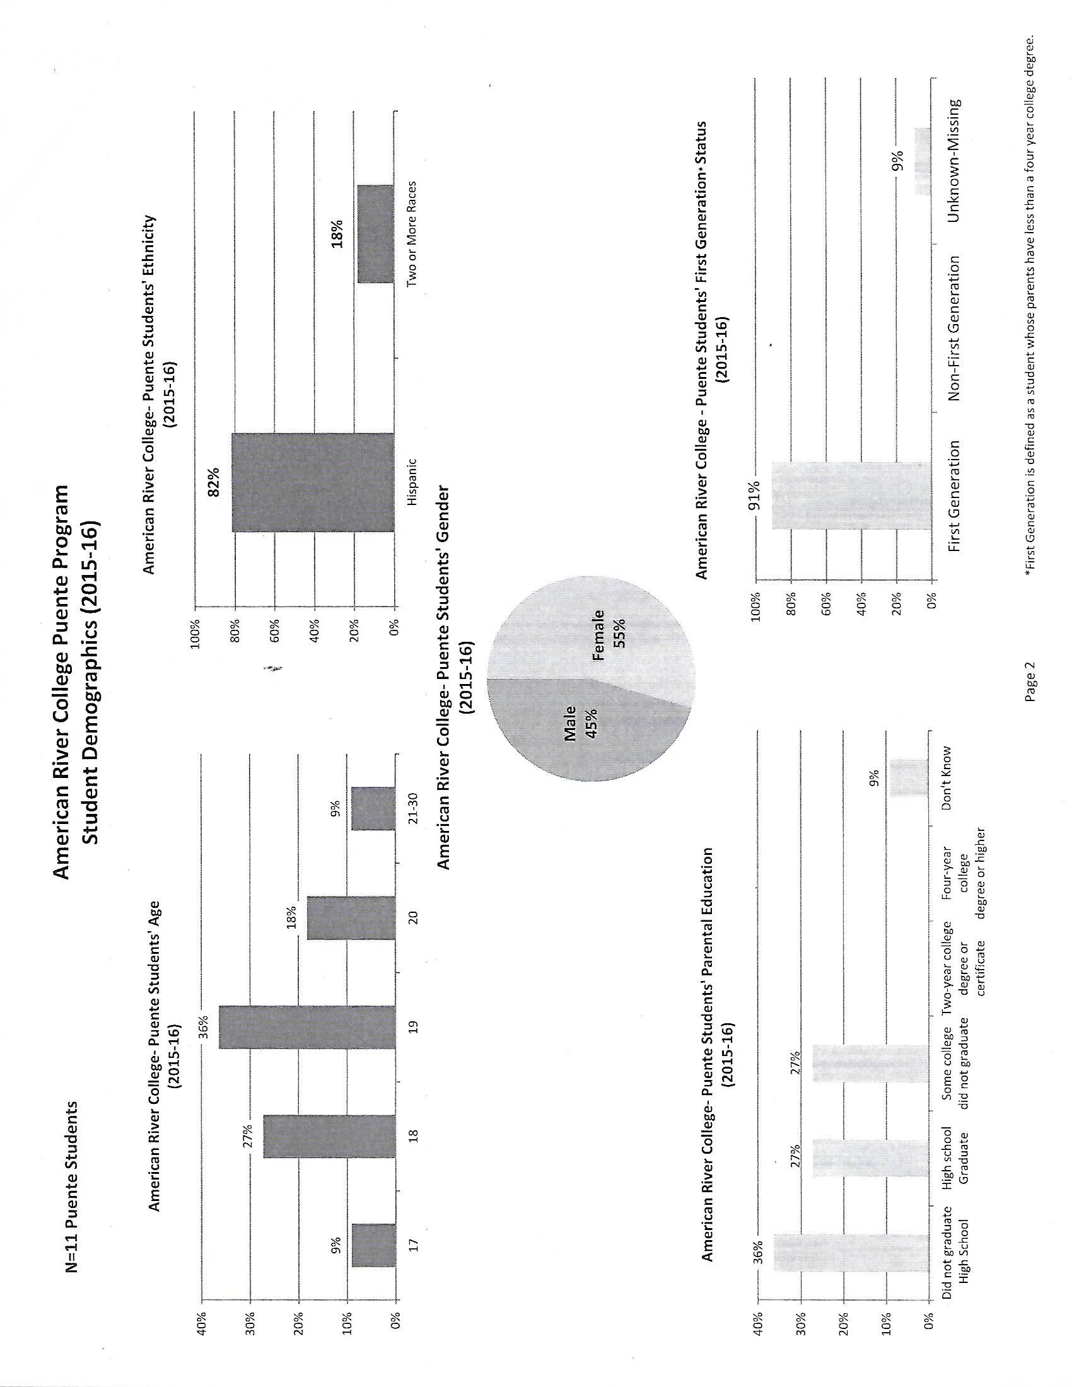
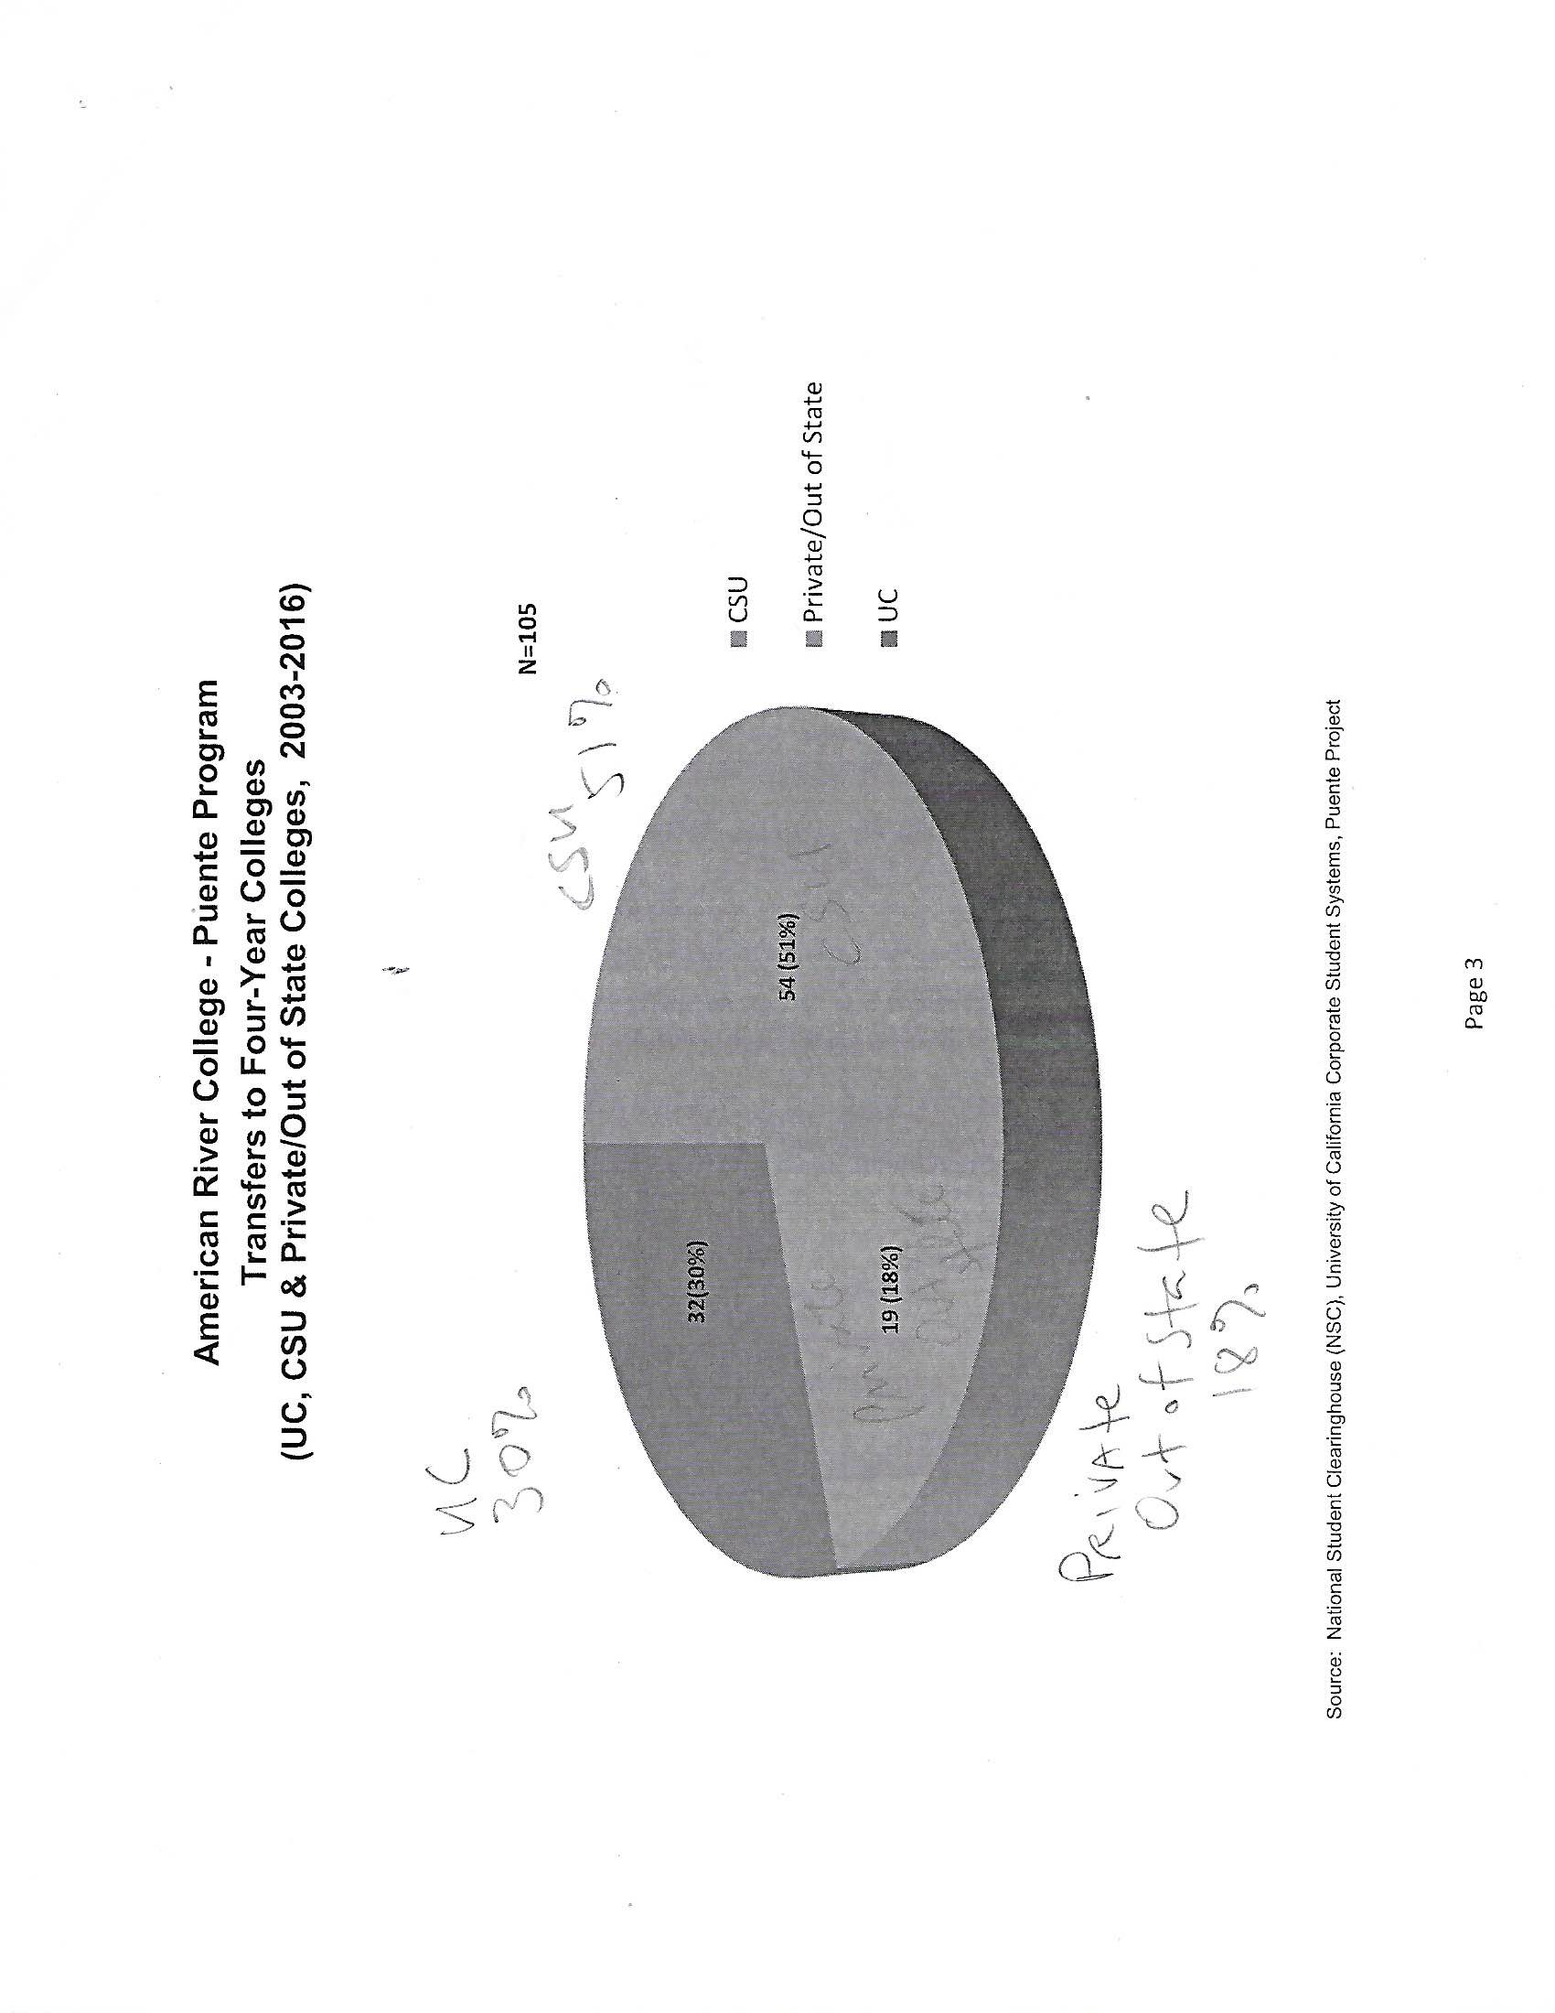
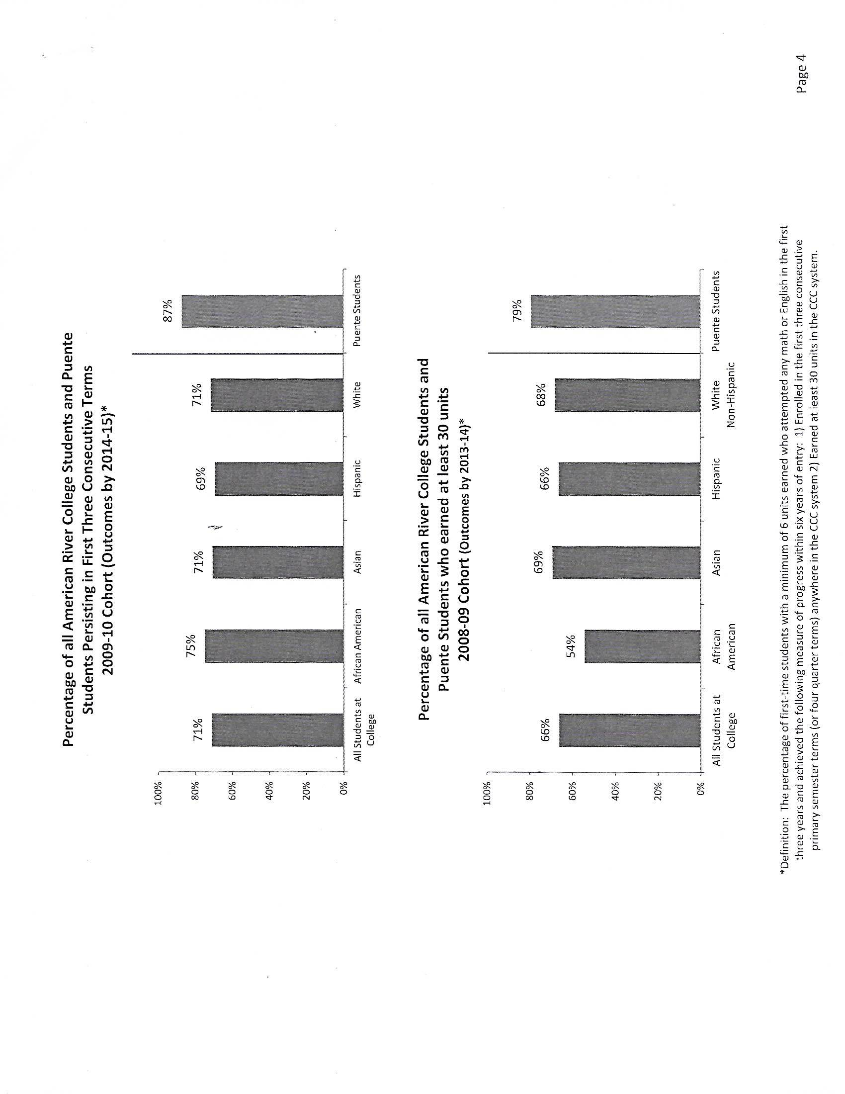
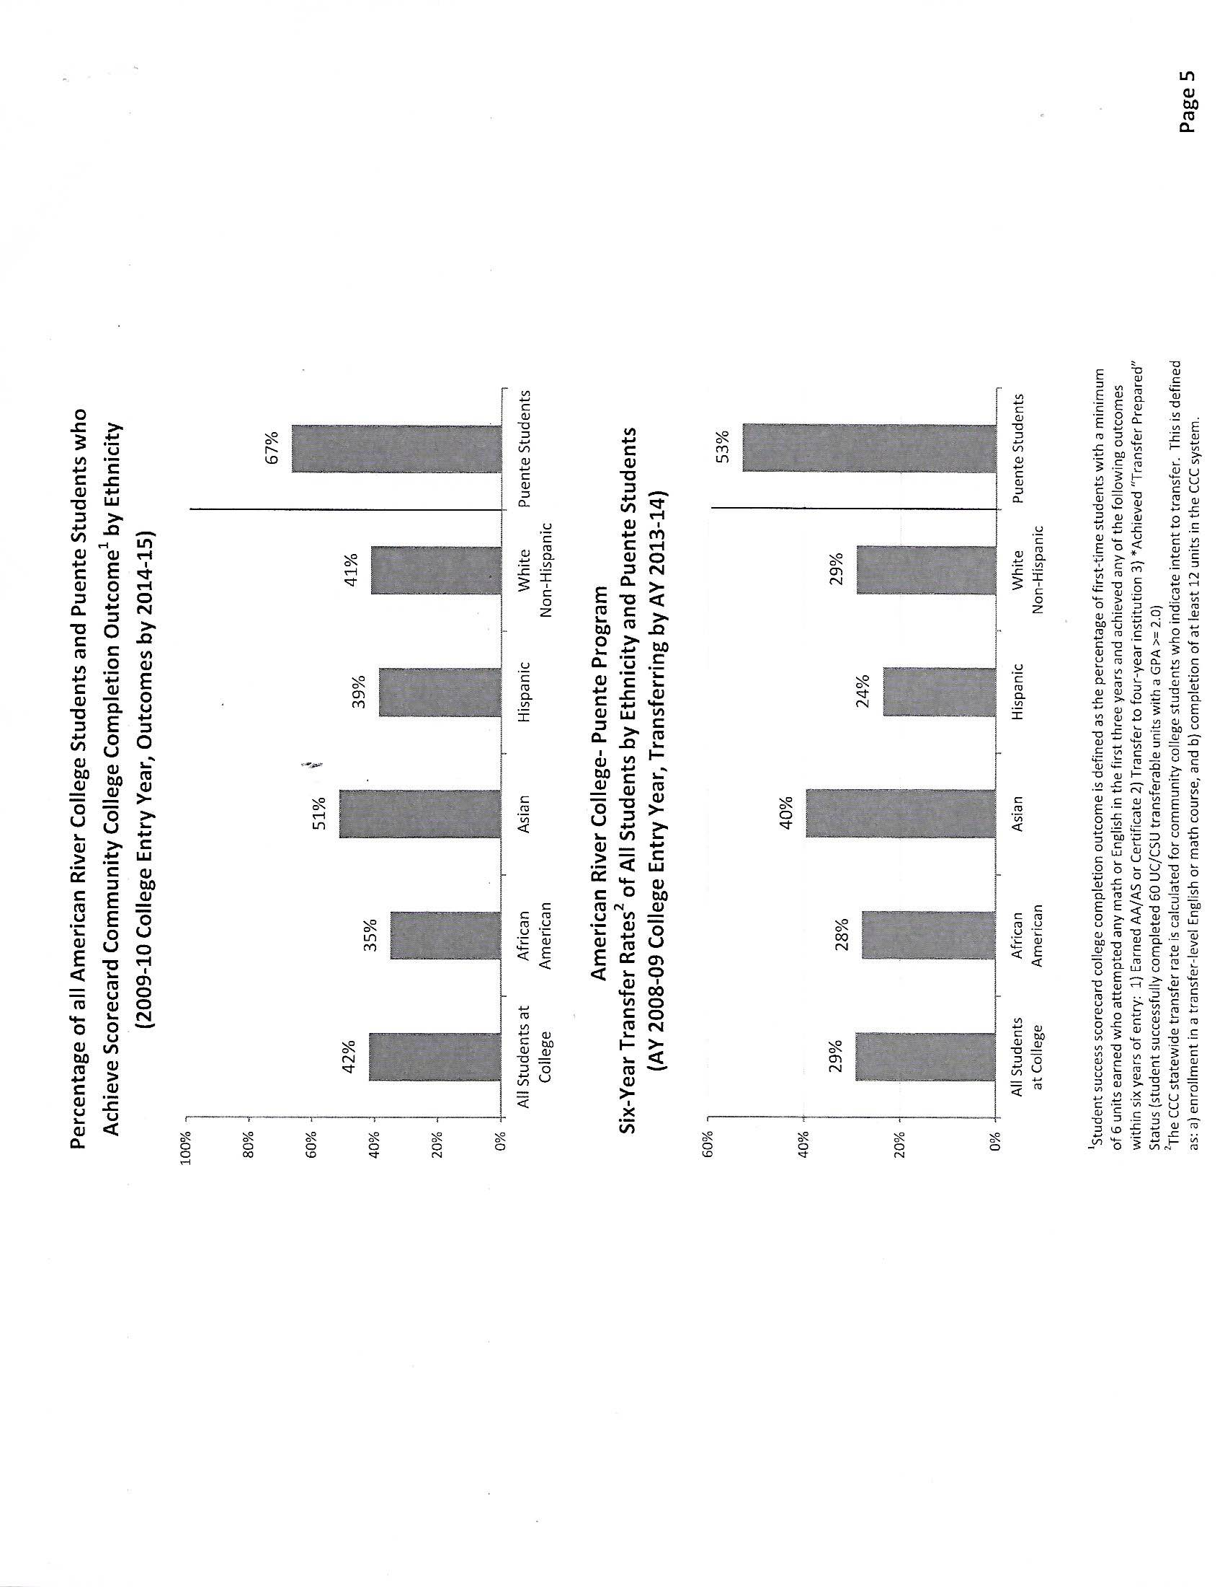
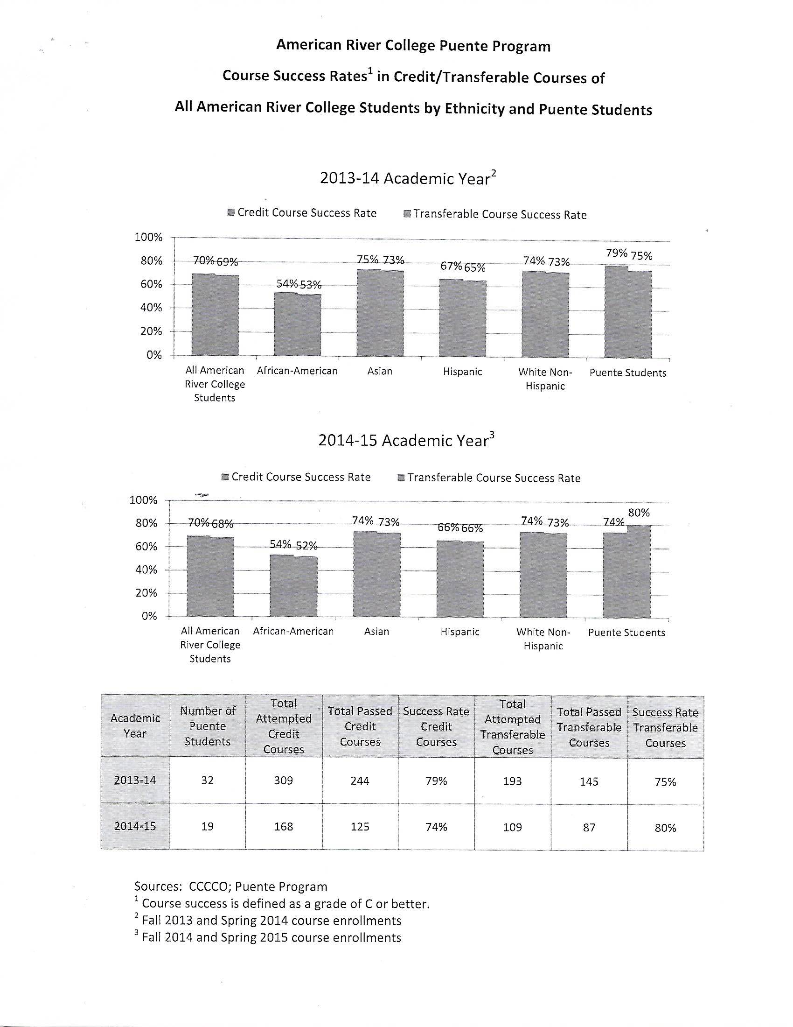

Appendix C: ARC Latinx/Chicanx Campus Climate Questionnaire and Results (Spring 2019)
Thank you, for taking the time to answer a few questions about our campus.
The goal of this questionnaire is to understand where our students feel safe and how we, as an institution, can better serve the students of American River College.
* Required

What is your gender identity? *
- Female
- Male
- Non-binary
- Decline to state

What is your racial/ethnic identity? *
- Latinx
- Chicanx
- Hispanic
- Decline to state
- Afro-Latinx
- Asian-Latinx
- Other:

What is your citizenship status? *
- Citizen
- Undocumented
- Refugee
- Asylee
- Temporary Protected Status
- Student Visa
- Decline to state
- Other:

How do you identify your sexual orientation? *
- heterosexual or straight
- gay or lesbian
- bisexual, pansexual or fluid
- asexual
- queer
- decline to state
- Other:

Do you feel like this campus is child-friendly? *
- Yes
- No
- Other:

If yes, what area do you feel is child-friendly?
Your answer

If no, what suggestions do you have for making ARC more child-friendly?
Your answer

As a member of the Latinx/Chicanx community, do you feel safe on campus? *
- Yes
- No
- Other:

If yes, where? (refer to maps below) *
Your answer

If no, where? (refer to maps below) *
Your answer

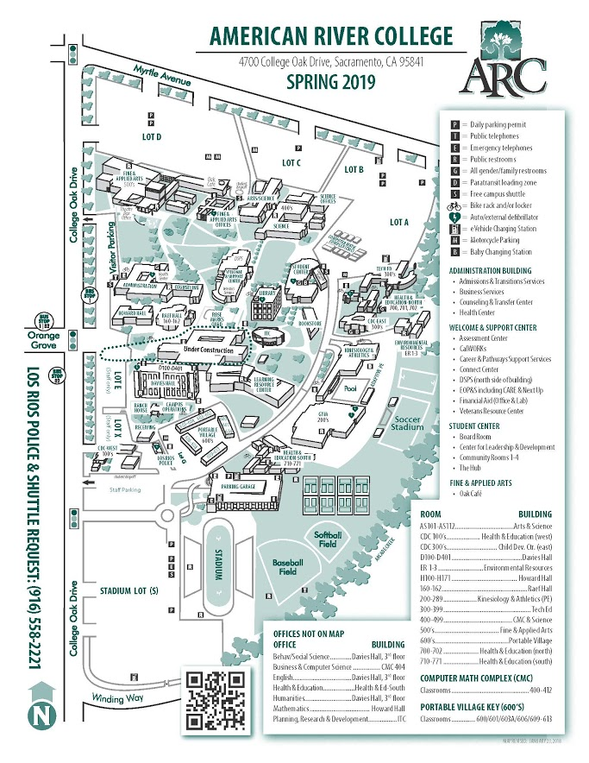
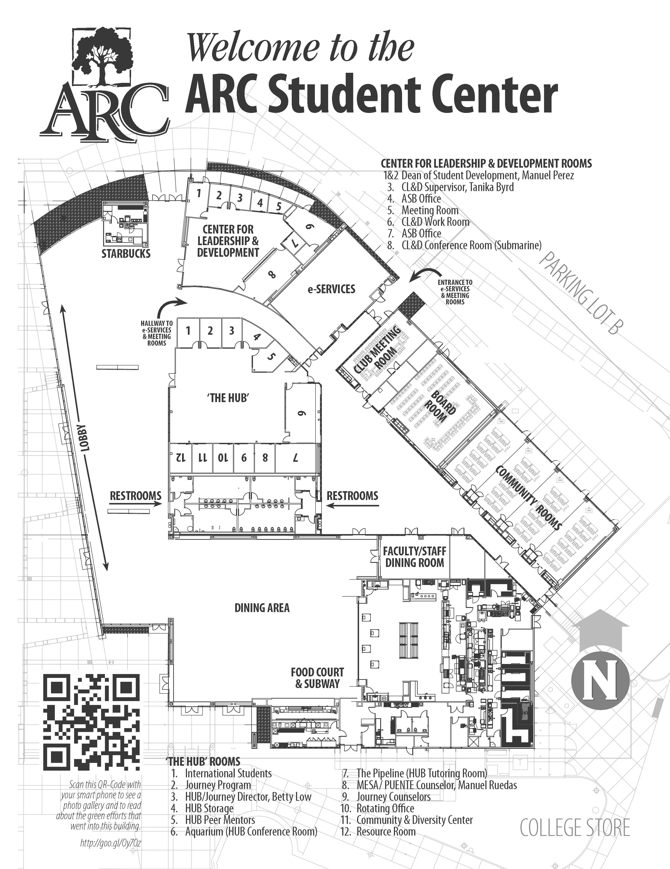

Do you feel welcome on campus? *
- Yes
- No

If yes, where? (refer to maps above)
Your answer

How familiar are you with Latinx/Chicanx staff/faculty/administrators/counselors? *
Not familiar at all 0 1 2 3 4 5 very familiar
Have you ever been mistreated due to your racial/ethnic identity by other students? *
- Yes
- No

Have you ever been mistreated due to your racial/ethnic identity by faculty/staff/counselor? *
- Yes
- No

If yes, by who? (you can select multiple boxes)
- Staff
- Faculty
- Administrators
- Counselors
- Other:

Have you ever been mistreated due to your status by faculty/staff/faculty/counselor? *
- Yes
- No

If yes, by who? (you can select multiple boxes)
- Staff
- Faculty
- Administrators
- Counselors
- Students
- Other:

If someone has mistreated you on campus, who was it (another student, faculty, staff, counselor, or administrator) and what did they do? (If no, write N/A) *
Your answer

How would attending ARC and not being mistreated due to your racial/ethnic identity and/or citizenship status impact your life as a student? *
Your answer

What are your perceived attitudes towards instructors? *
Your answer

What are your perceived attitudes towards counselors? *
Your answer

Are you aware of Latinx/Chicanx centered events? *
- Yes
- No

If yes, what are they?
Your answer

Do you feel like the classes you have taken reflect your racial/ethnic identity? *
- Yes
- No
- Other:

What is the degree of cultural relevancy in courses, events, student activities, competency of faculty/staff/administrators/counselors? *
not relevant at all 0 1 2 3 4 5 completely relevant

How could ARC better reflect your racial/ethnic identity? *
Your answer

Do you have a faculty/staff/administrator/counselor who supports you? *
- Yes
- No

Do you have peers that support you? *
- Yes
- No
ARC Latinx/Chicanx Campus Climate Questionnaire Results Spring 2019
Gender Identity
Female (58.6%)
Male (41.4%)
Non-binary (0%)
Decline to state (0%)

Racial/Ethnic identity (can select more than one)
Latinx (12)
Chicanx (11)
Hispanic (12)
Decline to state (1)
Afro-Latinx (1)
Asian-Latinx (0)
Other
White (1)
Black American (1)
Asian (Thai) (1)
Mexican (1)

Citizenship status
Citizen (82.8%)
Undocumented (13.8%)
Refugee (0%)
Asylee (0%)
Temporary protected status (3.4)
Student visa (0%)
Decline to state (0%)
Other

Sexual orientation
Heterosexual or straight (25)
Gay or lesbian (1)
Bisexual, pansexual or fluid (1)
Asexual (0)
Queer (1)
Decline to state (1)
Other

Have children
Yes (1)
No (28)
Decline to state

Campus Child-friendly
Yes
No
Other

If yes, why?
If no, why

Safe on campus
Yes
No
Other
I only feel comfortable in the HUB because that's where I see my community the most.
I am more of an outcast than safe

If yes, where?
If no, where?

Feel welcome
Yes (93.1%)
No (6.9%)

If yes, where?

How familiar are you with Latinx/Chicanx staff/faculty/administrators/counselors?
0 (2)
1 (4)
2 (3)
3 (7)
4 (8)
5 (3)
Other (2)

Have you ever been mistreated due to your racial/ethnic identity by other students?
Yes (6.9%)
No (93.1%)

Have you ever been mistreated due to your racial/ethnic identity by faculty/staff/counselor?
Yes (3.4%)
No (96.6%)

If yes, by who?
staff (0)
Faculty (1)
Administrators (1)
Counselors (1)
Other

Have you ever been mistreated due to your status by faculty/staff/faculty/counselor?
Yes (3.4%)
No (96.6%)

If yes, by who?
staff (0)
Faculty (1)
Administrators (0)
Counselors. (0)
Other
Students (1)

If someone has mistreated you on campus, who was it (another student, faculty, staff, counselor, or administrator) and what did they do? (If no, write N/A)

How would attending ARC and not being mistreated due to your racial/ethnic identity and/or citizenship status impact your life as a student?

What are your perceived attitudes towards instructors?

What are your perceived attitudes towards counselors?

Are you aware of Latinx/Chicanx centered events?
Yes (69%)
No (31%)

If yes, what are they?

Do you feel like the classes you have taken reflect your racial/ethnic identity?
Yes (48.3%)
No (37.9%)
Other (13.8%)

What is the degree of cultural relevance in courses, events, student activities, competency of faculty/staff/administrators/counselors?
0 (1)
1 (2)
2 (5)
3 (9)
4 (6)
5 (4)

How could ARC better reflect your racial/ethnic identity?

Do you have a faculty/staff/administrator/counselor who supports you?
Yes (96.3%)
No (3.7%)

Do you have peers that support you?
Yes (96.3%)
No (3.7%)

Appendix D: California Policies Protecting College Opportunity for Undocumented Students
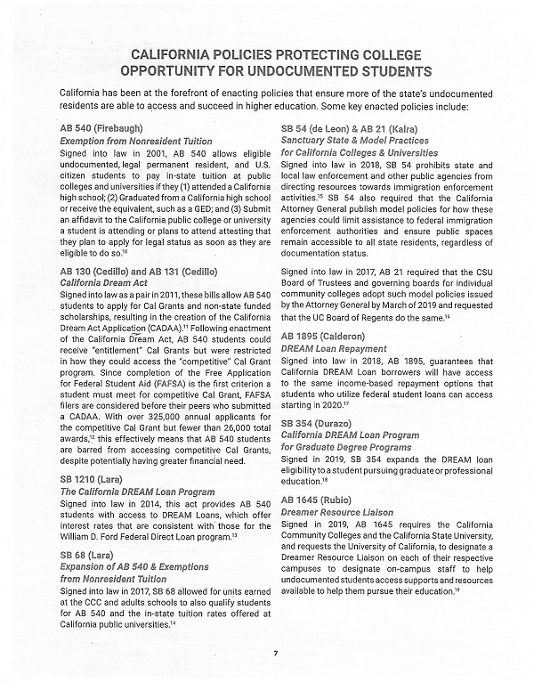
Appendix E: Memorandum for the Los Rios General Counsel



Appendix F: Miguel Molina Dissertation
“Community College’s Puente’s Influence on California’s Mexican-American Students: Countering the Statistics”, 2014
Abstract
Full Text

Appendix G: ARC Student Enrollment (2009-2019)
The following data was compiled from the Student Enrollment Status Summary Report pulled from the Data Mart on March 31, 2020.

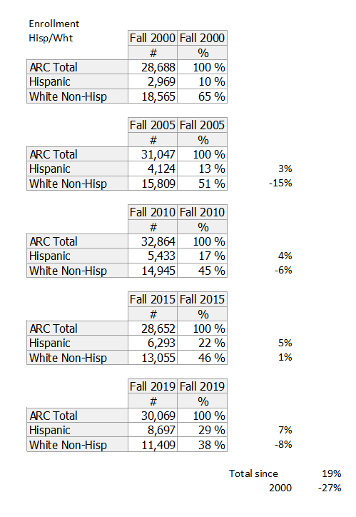

Appendix H: ARC Student Education Status from Data Mart (2018-2019 Primary Terms)
The Student Enrollment Status Summary Report indicating the education status of students at the time of enrollment was pulled from the Data Mart on November 15, 2019.

Appendix I: Employee Headcount Details March 16, 2020 from ARC Institutional Research
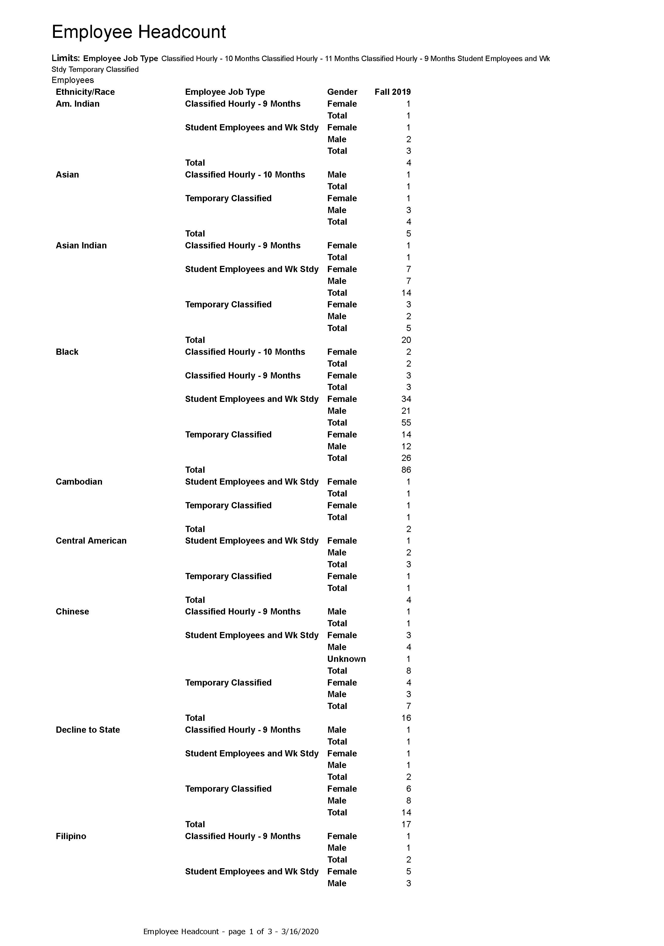
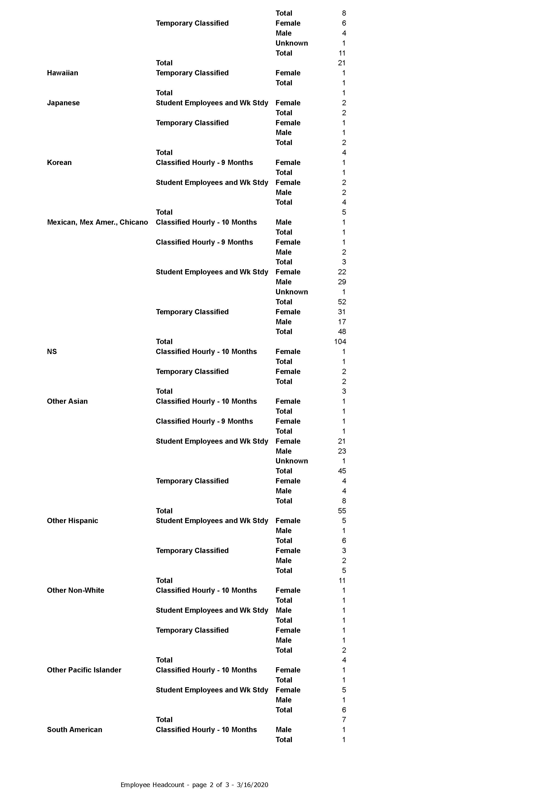



Appendix J: Employee Headcount March 16, 2020 from ARC Institutional Research
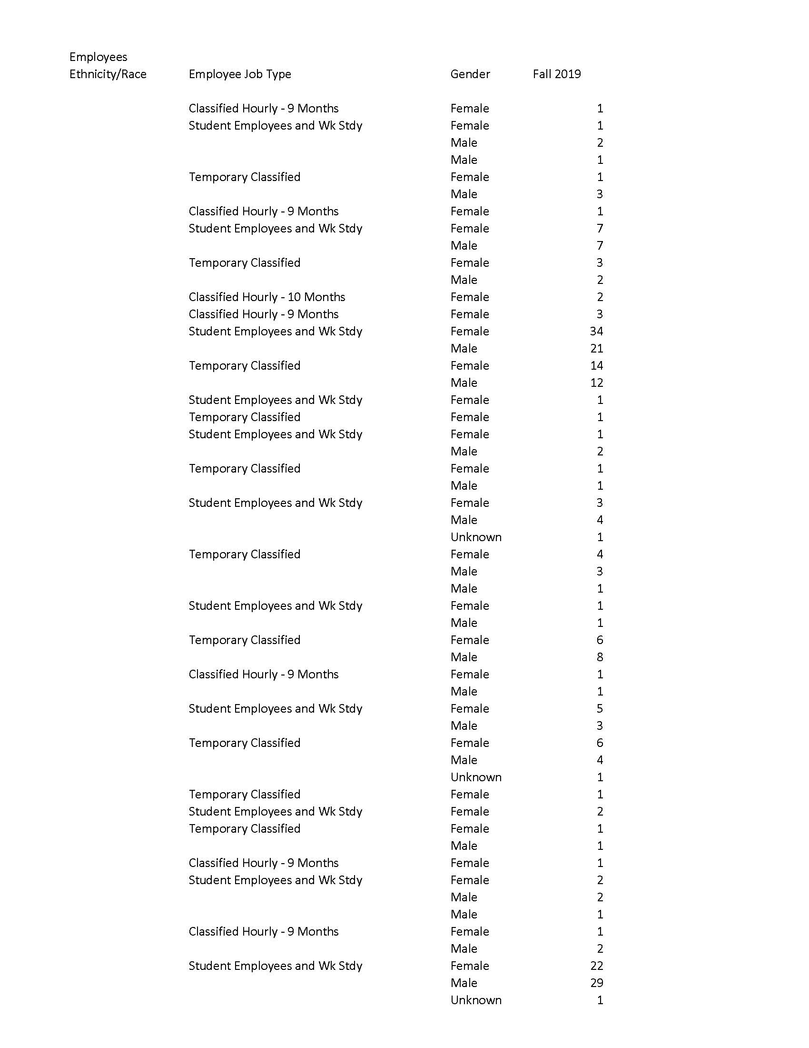
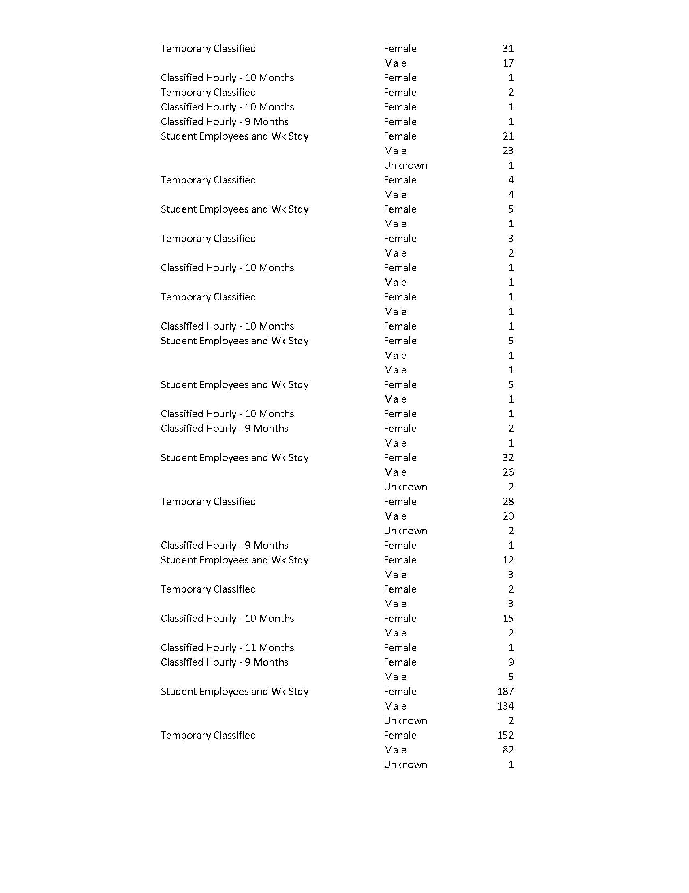

Appendix K: Employee Headcount March 17, 2020 from ARC Institutional Research
Supplied March 17, 2019 by ARC Institutional Research
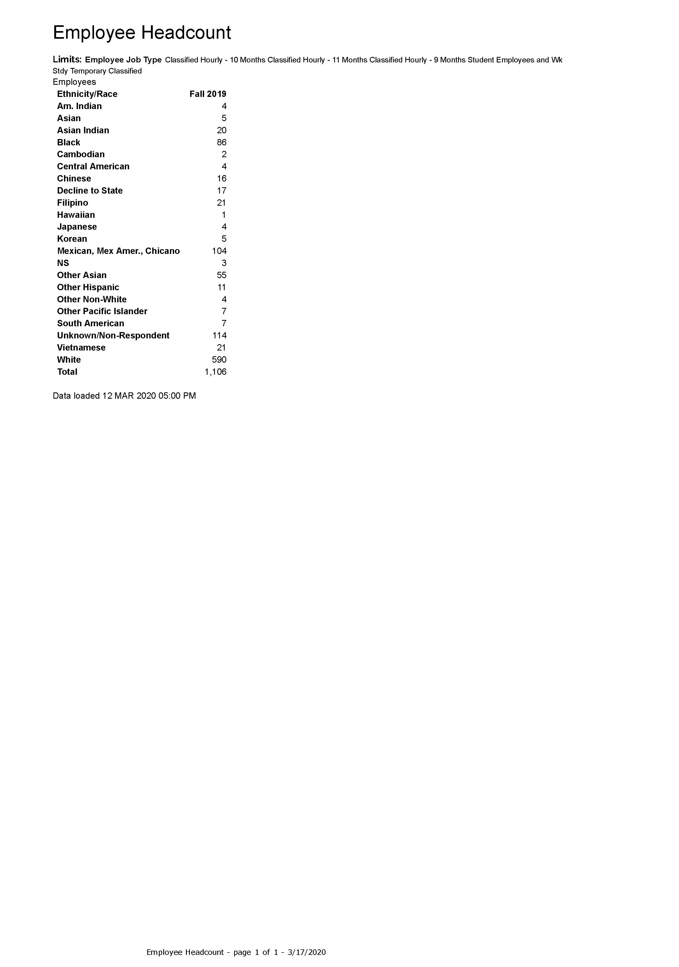
Appendix L: ARC Faculty/Staff Demographics 2000-2019
The data below shows the change in employee demographics between Fall 2000 and Fall 2019. The report was pulled January 18, 2020. For annual counts for each intermediary year, please see https://datamart.cccco.edu/Faculty-Staff/Staff_Demo.aspx.
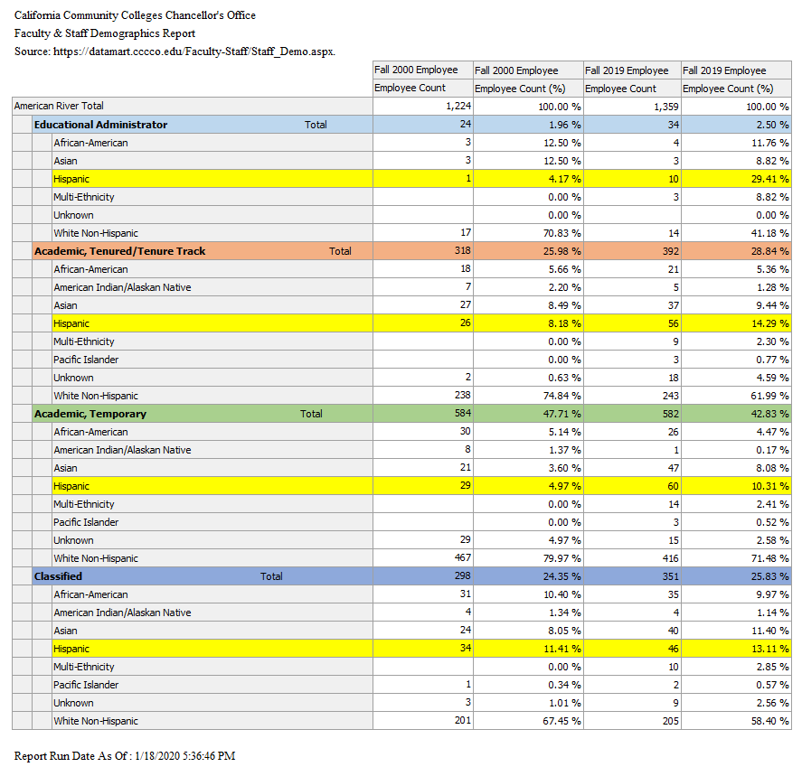

Appendix M: Employee Headcount (Teaching and Non-Teaching) 2019
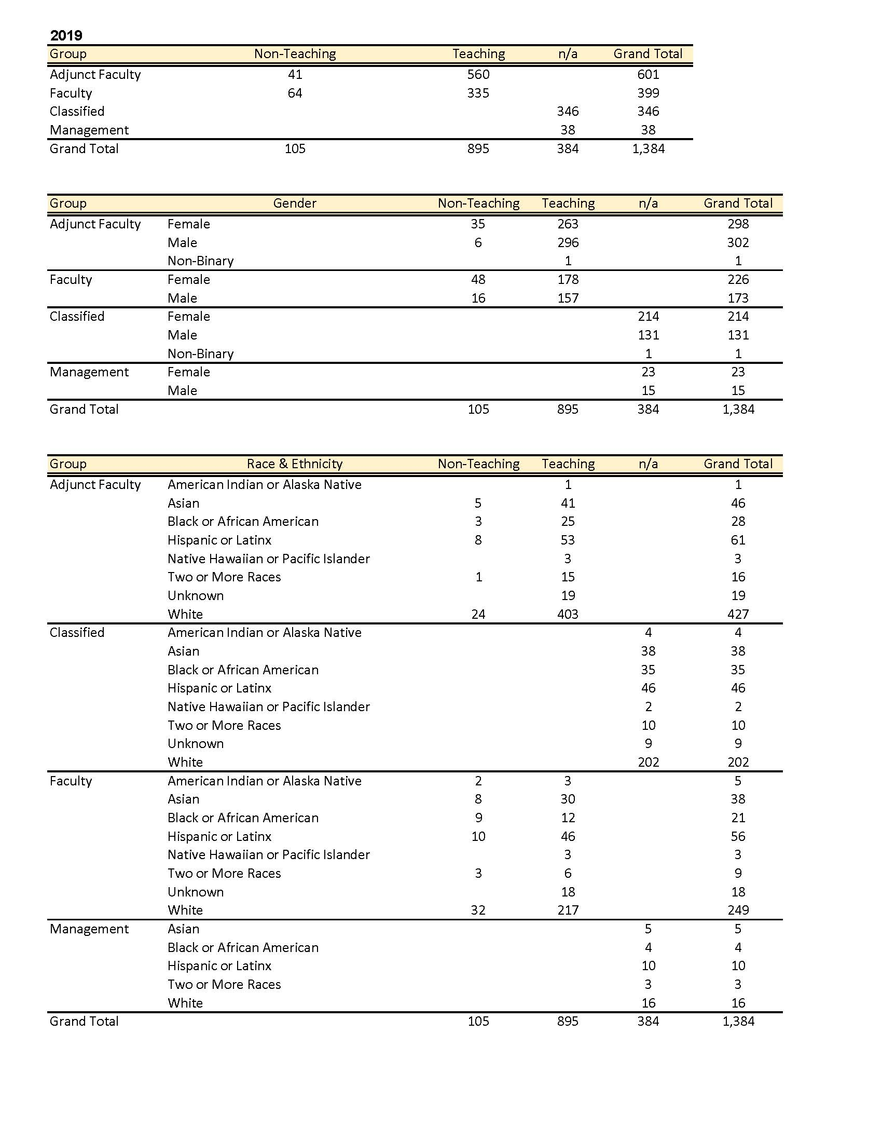

Appendix N: Publications to Advertise Jobs for Latinx Community in Higher Education
American Association of Hispanics in Higher Education (AAHHE)
https://www.aahhe.org/Jobs/jobs.aspx

National Association of Chicana and Chicano Studies Advertising
https://www.naccs.org/naccs/Advertising.asp

Hispanic Association of Colleges and Universities (HACU)
https://www.hacu.net/hacu/See_Job_Postings.asp

Hispanic Outlook on Higher Education
https://www.hispanicoutlookjobs.com/

Hispanics in Higher Education
https://www.hispanicsinhighered.com/

Latinos in Higher Ed
https://www.latinosinhighered.com/

Appendix O: Hispanic Serving Institution Organizations
American Association of Hispanics in Higher Education (AAHHE)
Hispanic Association of Colleges and Universities (HACU)

Appendix P: Community Organizations
California Rural Legal Assistance, Inc. (CRLA)
Cien Amigos
La Familia Counseling Center, Inc.
Latino Center of Arts and Culture (formerly Galería Posada)
Sacramento Food Bank & Family Services
Sacramento LGBT Community Center
Sacramento Poetry Center
Sol Collective
Taller Arte del Nuevo Amanecer (TANA)
United Latinos
Washington Neighborhood Center
WEAVE, Inc.
Wide Open Walls

The Kingdom of Spain officially established the oldest permanent European settlement in what became the continental United States at San Agustín, La Florida in 1565; San Juan de los Caballeros became a Spanish settlement in what today is New Mexico in 1598. Indeed, Spanish was the first permanent European language spoken in the lands that eventually became the United States of America.
I use the term “Latinx” as a gender-neutral and non-binary term to refer to individuals of Latin American ancestry in the United States.
Richard Peters, ed., Public Statues at Large of the United States of America (Boston: Little, Brown, 1853), 1:103-04.
Robert H. Holden and Eric Zolov, eds. Latin America and the United States: A Documentary History (Oxford University Press, 2000), 13.
Ibid., 101.
A lieutenant at the start of the U.S.-Mexican War, Ulysses S. Grant understood the purpose of the army’s deployment to the disputed Tejas territory: “We were sent to provoke a fight, but it was essential that Mexico should commence it […].” Ulysses S. Grant, Personal Memoirs of U.S. Grant, 2v. (New York: C.L. Webster & Co., 1885) vol. I, 67-68.
Ernesto Chávez, The U.S. War with Mexico: A Brief History with Documents (Bedford/St. Martin’s, 2008), vii.
Chávez, The U.S. War with Mexico, 119.
Grant, Personal Memoirs, 53; emphasis added.
Chávez, The U.S. War with Mexico, 122.
Holden and Zolov, eds. Latin America and the United States, 39; Virginia Garrard, et al., Latin America in the Modern World (Oxford University Press, 2019), 129-130.
Holden and Zolov, eds. Latin America and the United States, 40.
Ibid. 7; emphasis added.
Ibid., 70.
Ibid., 81.
“Modern History Sourcebook: Rudyard Kipling, The White Man's Burden, 1899,” Fordham University, last modified January 21, 2020, https://sourcebooks.fordham.edu/mod/Kipling.asp.
Holden and Zolov, eds. Latin America and the United States, 97.
Garrard, et al., Latin America in the Modern World, 214.
Eric Foner, Give Me Liberty!: An American History, Volume Two, Sixth Seagull Edition (New York: W.W. Norton, 2017), 799-801.
Foner, Give Me Liberty!, 802-803.
Foner, Give Me Liberty!, 803-806.
Steven Mintz, ed., Mexican American Voices: A Documentary Reader, Second Edition (Wiley Blackwell, 2009), 138-139.
Rodolfo F. Acuña, Occupied America: A History of Chicanos, Eighth Edition (Longman Publishing, 2015), 217.
Acuña, Occupied America, 213.
Robert R. Álvarez, Jr. “The Lemon Grove Incident: The Nation’s First Successful Desegregation Court Case,” Journal of San Diego History 32, no. 2 (Spring 1986).
Ibid.
“Righting a wrong: Mendez v. Westminster brought an end to segregation in O.C. schools - and ultimately throughout the state and nation,” accessed March 16, 2020, http://sylviamendezinthemendezvswestminster.com/aboutus.html.
Ibid.
Mintz, ed., Mexican American Voices, 149; “Bracero History Archive,” last modified 2020, http://braceroarchive.org/teaching.
Acuña, Occupied America, 309.
Acuña, Occupied America, 382; “Prop. 187 Approved in California,” Migration Dialogue-UC Davis, accessed March 18, 2020, https://migration.ucdavis.edu/mn/more.php?id=492.
“On Politics: Pete Wilson looks back on Proposition 187 and says, heck yeah, he’d support it all over again,” The Los Angeles Times, March 23, 2017, https://www.latimes.com/politics/la-me-on-politics-column-20170323-story.html.
Michael D. Sumner, “Proposition 209 and Public Employment in California: Trends in Workface Diversity,” September 2008, https://www.law.berkeley.edu/wp-content/uploads/2016/07/Proposition-209-and-Public-Employment-Workforce-Diversity.pdf.
Acuña, Occupied America, 383.
“The Dream Act, DACA, and Other Policies Designed to Protect Dreamers,” American Immigration Council, accessed March 3, 2020, https://www.americanimmigrationcouncil.org/research/dream-act-daca-and-other-policies-designed-protect-dreamers.
Ibid; “Deferred Action for Childhood Arrivals (DACA),” Department of Homeland Security, accessed March 17, 2020, https://www.dhs.gov/deferred-action-childhood-arrivals-daca.
Massey, D. S. and Gentsch, K. (2014), Undocumented Migration to the United States and the Wages of Mexican Immigrants. Int Migr Rev, 48: 482–499. doi:10.1111/imre.12065.

