eXPLORING DISPROPORTIONATE IMPACT:
Full Report
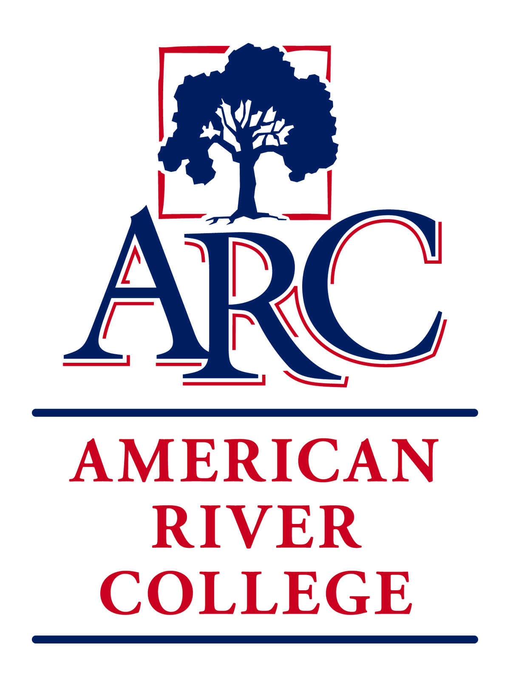
Native american
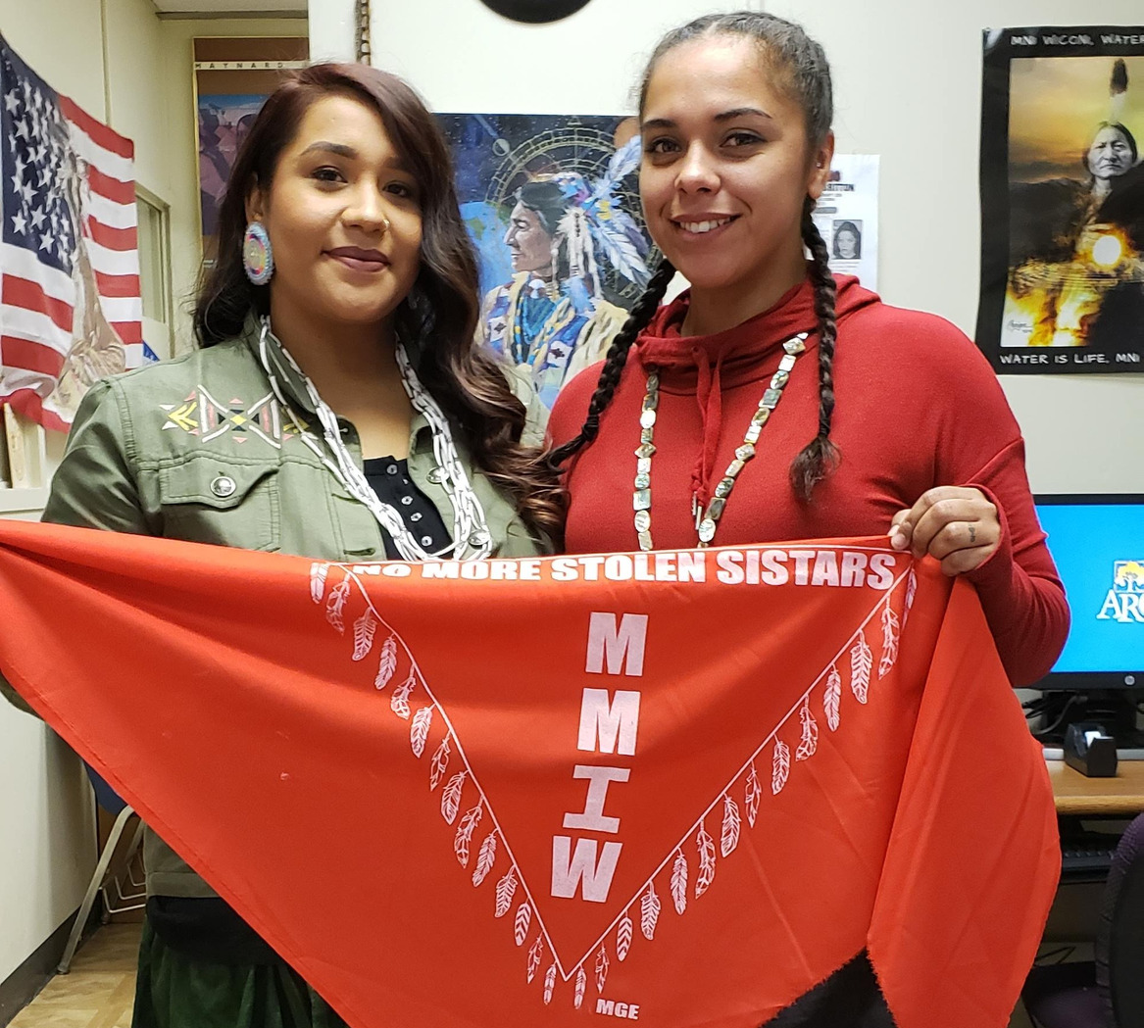
OUR COMMITMENT TO SOCIAL JUSTICE AND EQUITY
American River College strives to uphold the dignity and humanity of every student and employee. We are committed to equity and social justice through equity-minded education, transformative leadership, and community engagement. We believe this commitment is essential to achieving our mission and enhancing our community.
Table of Contents
Introduction: Framing the Process 1
Purpose and Approach 1
Native American Student Report Team 2
The Need for Investigation 3
History and Context: Landscape for American Indian students at ARC 4
Brief Review of the Literature 11
Literature Relevant to Native American Students 11
Barriers and De-motivators at ARC 13
Profile of Native American Students: American River College 15
Student Achievement and Success 15
Disproportionate Impact: 2018-19 Course Completion Comparison 15
Theoretical Framework for Systems Change 16
Tribal Critical Race Theory 16
Declaration of Native Purpose in Higher Education 16
Institutional Office of Indigenization 17
Place-Based Educational Theory 18
Foundations of Cultural Wealth 18
Practical Models: Success in the Literature 20
Culturally Responsive Teaching (Ready for Rigor Framework) 20
Trauma-Informed Approaches 20
Cultural Sanctuary 21
DI Population Survey: Findings and Analysis 22
Project Timeline 22
Questionnaire 22
Data Collection 23
Survey Results 24
Discussion 29
Recommendations: Moving to Action 33
References 36
Resources for Further Reading 38

Introduction: Framing the Process
This report is intended to be actionable by the ARC administration. It is also intended to provide a platform for change in classroom practices. We hope it can be a basis for professional development for all professors, classified staff, and administrators. The report may also be used at the district level to influence policy and system structure. We hope that other Los Rios campuses and beyond will benefit from this report. Finally, it is the Native community itself who can find itself reflected in the report and see that the voice of the community is valued, validated, and acted upon by the educational system that serves it.
Purpose and Approach
In the Fall of 2019, American River College (ARC) launched a project to investigate the experiences of disproportionately impacted groups including Native American students. This endeavor was intended to result in actionable strategies that provide a starting point for eradicating barriers and increasing equitable outcomes. The observations, analysis, and recommendations in this document are reflective of a team comprised of members of the Native American community as well as others who were assigned because of their campus connection and historical support of this population of students. The team was charged with considering the following aspects:
- historical context of the education of Native American students in the United States
- literature for the identified DI population that outlines high impact practices that would best serve Native American students
- institutional barriers (historical and current) that perpetuate systems of power and privilege that contribute to the equity gap and impact the experiences of Native American students at ARC
- motivators (academic, personal, spiritual, cultural, etc.) that inspire and produce positive outcomes for Native American, as well as self-efficacy
From this foundation of knowledge, and considering the college’s existing efforts in Achieve and Pathways, the team was asked to develop an appropriate methodological framework and provide actionable recommendations by which ARC can move forward to affect change.

Native American Student Report Team
Appreciation is expressed to the report team for their efforts to explore and analyze disproportionate impact from the perspective of the Native American experience. It is through these contributions that an actionable framework for system change has been developed that can equitize student success for future Native American students at ARC.

Jesus Valle (Carrizo/Yaqui/Isleta/Apache), Professor of English; Director, ARC Native American Resource Center
Kristina Casper-Denman, Professor of Anthropology and History, ARC
Melinda M. Adams (San Carlos Apache), Student Affairs Officer, Native American Studies, UC Davis
Ricardo Torres (Winnemem Wintu), Counseling Faculty Emeritus, CSU Sacramento
Tonantzin Miranda (Blackfeet/Yaqui/Mexica), ARC Native American Resource Center Assistant Director
Roderic Agbunag, ARC Counselor

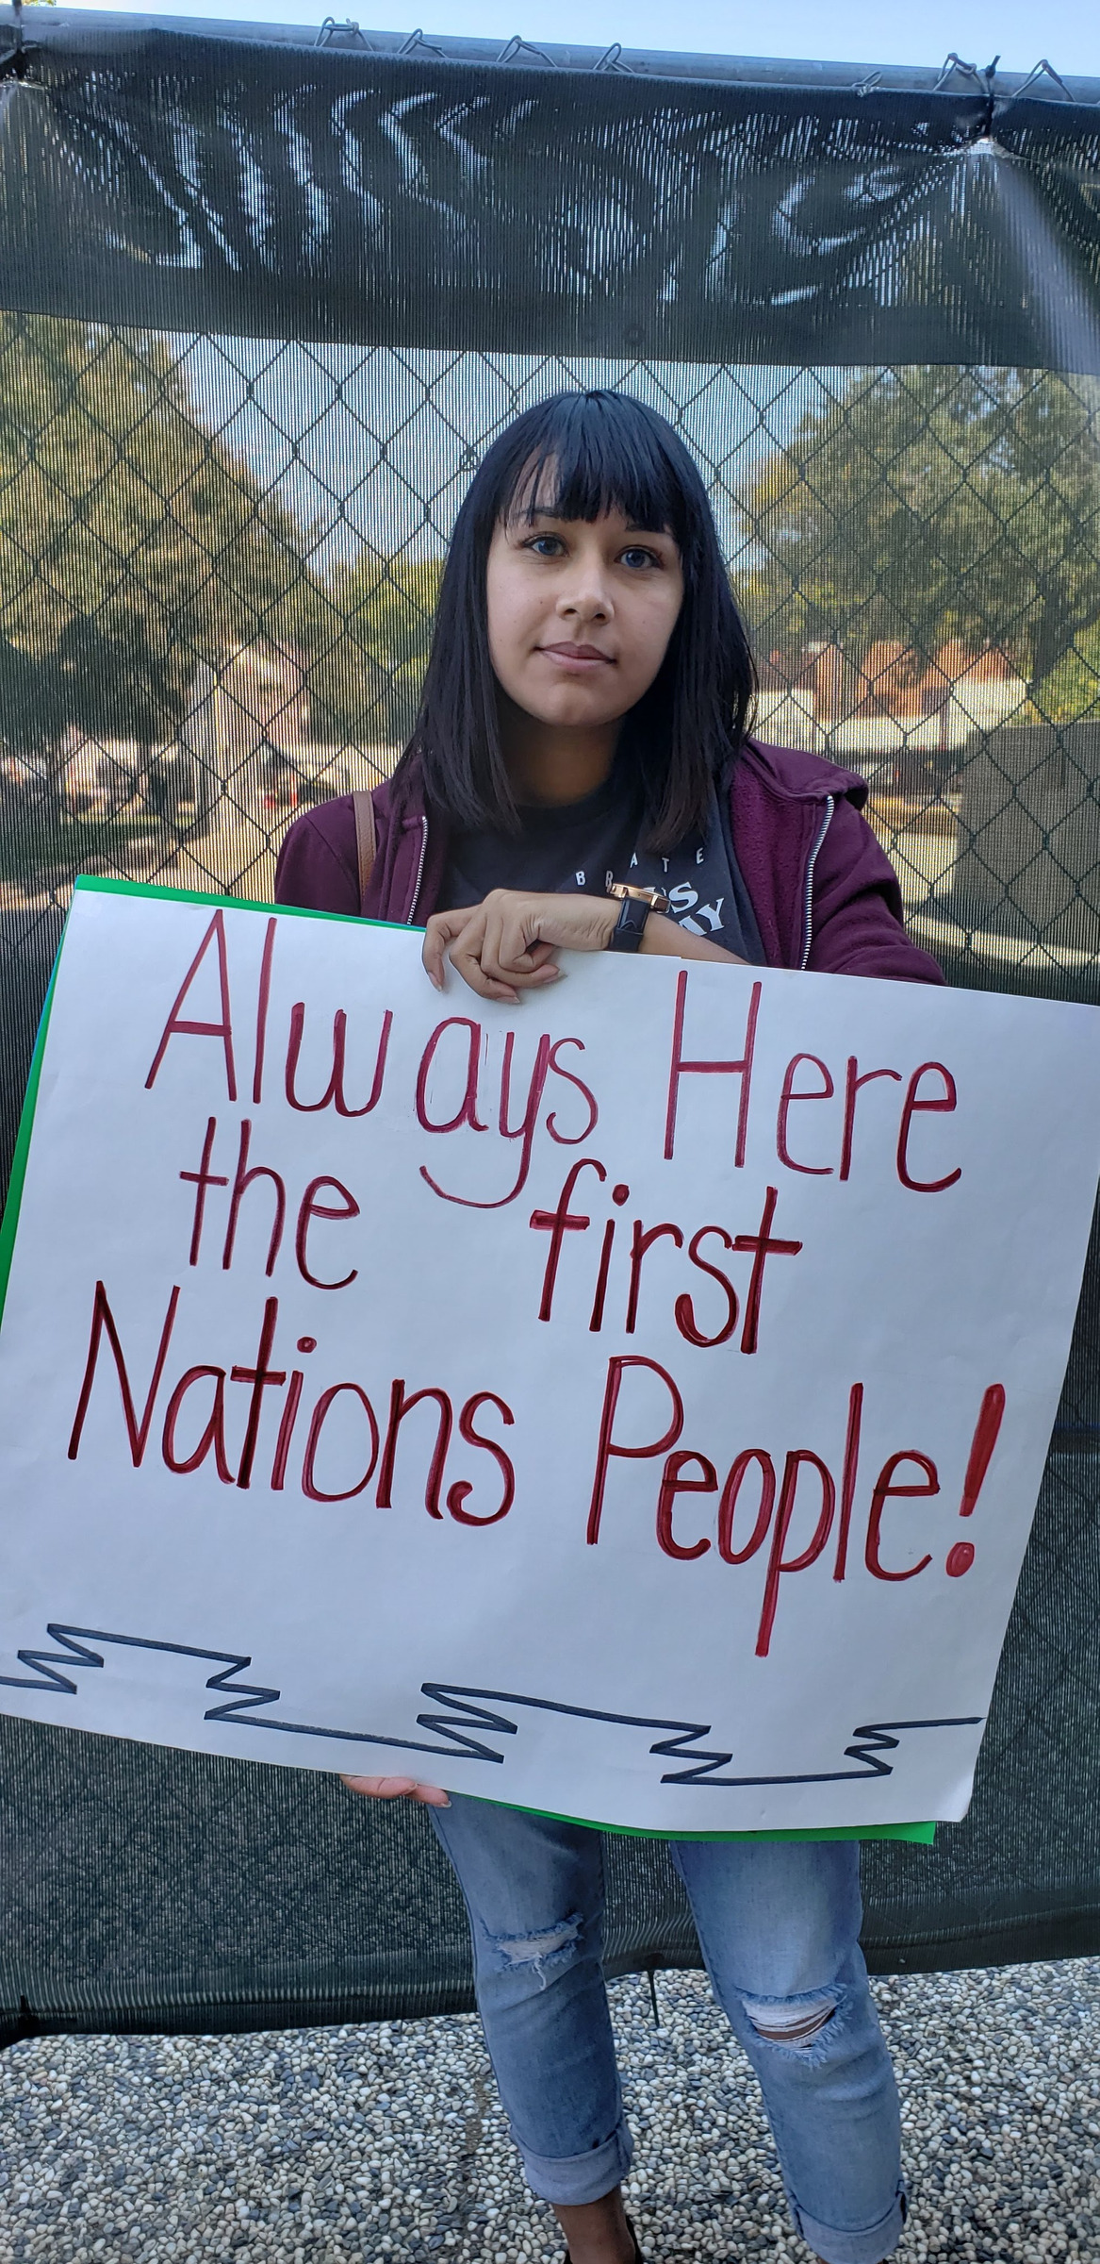

Data Analysis: Kay Lo and Yujiro Shimizu
Sponsoring Council: Student Success Council

The Need for Investigation
American River College is a large, complex system that perpetuates inequities in education as evidenced by student outcomes. ARC’s internal “Data on Demand” service highlights the stark reality:
- Native American students complete courses at 13 percentage points less than the ARC average for completion.
- In English, the equity gap is 14 percentage points.
- In Math the equity gap is 15 points.
It is this gap in system performance that this report seeks to address. Notwithstanding that ARC is a product of both historical and social factors, ARC is responsible for its educational outcomes and must take responsibility to change the student experience.
First, it must be acknowledged that this report will avoid “deficit” approaches that absolve the institution (boards, administration, teachers, structures) of blame for their failure to provide an environment where all students can thrive. The blame for the outcomes is placed squarely on the education system and all of its manifestations to the experience of the student. Individuals as system workers within the system are to blame; however, this is not personalized since individuals as system-inequity actors may not be aware of their role in perpetuating this inequity. It is incumbent, though, of all system individuals to become self-aware practitioners in their roles.
We place the blame for the outcomes squarely on the education system and all of its manifestations to the experience of the student.

There is a clear moral imperative to provide equitable access and support in education. Additionally, ARC is compelled to act by the stated goals of the California Community Colleges Chancellor’s Office (“Looking Ahead”). As a system, community colleges across California have been mandated to “Reduce equity gaps across all of the above measures through faster improvements among traditionally underrepresented student groups, with the goal of cutting achievement gaps by 40 percent within 5 years and fully closing those achievement gaps within 10 years” and “Over five years, reduce regional achievement gaps across all of the above measures through faster improvements among colleges located in regions with the lowest educational attainment of adults, with the ultimate goal of fully closing regional achievement gaps within 10 years.” This change, however, cannot happen spontaneously or in a vacuum. It is only through authentic relationship and engagement with the Native community that outcomes for Native American students can be improved.

History and Context: Landscape for American Indian students at ARC
Human beings have lived in this hemisphere since time immemorial. There has always been, and continues to be, vast linguistic, cultural, social, and material diversity between what are now called “American Indian” or “Native” communities. It is impossible to describe in this report the scale of human suffering that has been brought on by colonization in this hemisphere. It is possible, though, to describe some of the direct actions and policies that have brought about the continued oppression of American Indian individuals in every facet of life. The Native American students at American River College come from a variety of tribes, backgrounds, family histories, and experiences, and these students may find their lives and educations profoundly influenced by a range of systemic and structural barriers to their success.
Colonization by Europeans has occurred, and continues to occur, at various locations in this hemisphere along different timelines. The first invasion of indigenous communities occurred, for instance, in what is now the Bahamas in 1492. A little more than 100 years ago, there were still Native individuals in northern California seeing invading Europeans for the first time. At present, there are tribal communities in Amazonia that remain uncontacted. Colonization is both a moment and a lengthy process; it is direct genocide as well as a genocide of the mind and spirit. The end point is the attempted erasure of indigenous people from the hemisphere, and if not the physical erasure, then the erasure of Native identity and sense of community.
It is impossible to describe in this report the scale of human suffering that has been brought on by colonization in this hemisphere.

Native nations are sovereign. This means that indigenous communities are, and always have been, socially and politically coherent and organized, with inherent rights to self-determination. Despite this fact, Native communities in the United States presently exist in a state of active occupation. Virtually all Native land has been expropriated by federal, state, and local governments, or by individuals who are not of a particular geography. Additionally, Native nations function under a vast burden of laws (federal, state, local) that further affect every aspect of the individual lives of American Indians.
The story of each tribe is unique; however, this report will focus on three general areas of Native community that are relevant to the geography of American River College: 1) northern Native California populations, 2) close neighbors to these tribes, and 3) American Indian citizens of other tribes who reside in the Sacramento region.
Contemporary Native American individuals are the survivors of the American Indian holocaust. They are the grandchildren and great grandchildren of the Indians who could not be caught, killed, sold into slavery, worked to death, force marched, tortured to death, infected with diseases, or interned in concentration camps (missions, ranches, mining claims, reservations). They are also the descendants of those survivors who, through ingenuity and strength of spirit, defied the odds and gave life to the future Native generations. A direct and systematic genocide spanning centuries and continuing in the present has resulted in the dramatic loss of population, numbering in the tens of millions in this hemisphere (Ostler, 2017). The physical extermination of the Native population was codified into all forms of law and took the form of “wars” against populations that were non-violent and not armed (Blakemore, 2017).
The “Mission System” in California was a result of the incursion of Spanish invaders into sovereign Native territory starting in the early 1500’s. The “mission” of the Spaniards was to find gold, increase their wealth, and promote Catholicism through the forced conversion of indigenous populations. The brutality of the Spaniards cannot be overstated. The “missions” were “little more than concentration camps where California's Indians were beaten, whipped, maimed, burned, tortured and virtually exterminated by the friars” (Harrington, 2016).
Colonization is both a moment and a lengthy process; it is direct genocide as well as a genocide of the mind and spirit. The end point is the attempted erasure of indigenous people from the hemisphere, and if not the physical erasure, then the erasure of Native identity and sense of community.

The entire trajectory of vast regions of Native California was forever altered due to the impact of the “missions” and the Spaniards. The missions resulted in cultural loss, population decline, loss of language, generational trauma, displacement, and loss of community structure and stability.
The “Mexican Period” followed the mission period and started in 1821. When the mission period ended, the central Mexican government “divided mission lands and distributed them as land grants. Many former Presidio soldiers and other Mexican citizens established cattle and horse ranches on this property; such citizens generally maintained a high quality of life. Conversely, the distribution of mission lands prevented native people from returning to their former homes and many found work as cowboys and servants on the Mexican ranches or in towns” (“Mexican Period”). This direct expropriation of land through law furthered the disconnect between the people of the land and the land. Natives in California became homeless and landless in their own land. The introduction of cattle and horses and a new economy based on environmental degradation also contributed to the decline of traditional sources of food and material sustenance.
The American Period began in 1848. After a two-year war with Mexico, the “Treaty of Guadalupe Hidalgo, signed on February 2, 1848, ended the Mexican-American War in favor of the United States. The war had begun almost two years earlier, in May 1846, over a territorial dispute involving Texas. The treaty added an additional 525,000 square miles to United States territory, including the land that makes up all or parts of present-day Arizona, California, Colorado, Nevada, New Mexico, Utah and Wyoming. Mexico also gave up all claims to Texas and recognized the Rio Grande as America’s southern boundary.” (History.com Editors, 2009). This resulted in the massive transfer of the application of policy towards Native nations from the approach of the Mexican federal government to the directive of “Manifest Destiny” held by the United States. Tribes in the Southwest and West now fell under the edicts and policies of direct enslavement and extermination promulgated by Washington, DC.
The “Gold Rush” of 1848 and mining in California resulted in the direct enslavement of Native American adults and children. According to Johnston-Dodds (2002), “The 1850 Act for the Government and Protection of Indians facilitated removing California Indians from their traditional lands, separating at least a generation of children and adults from their families, languages, and cultures (1850 to 1865). This California law provided for “apprenticing” or indenturing Indian children and adults to Whites, and also punished “vagrant” Indians by “hiring” them out to the highest bidder at a public auction if the Indian could not provide sufficient bond or bail.” Additionally, “The Legislature passed the bill on April 19, after the Senate amended Section 16 to decrease the whipping punishment for Indians from 100 to 25 lashes. The Governor signed it into law on April 22,8 four months before California became the 31st state in the Union (on September 9, 1850). The Act for the Government and Protection of Indians was not repealed in its entirety until 1937.”

The legislature authorized the enslavement of California Natives. Johnston-Dodds also indicates,
- White persons or proprietors could apply to the Justice of the Peace for the removal of Indians from lands in the white person’s possession.
- Any person could go before a Justice of the Peace to obtain Indian children for indenture. The Justice determined whether or not compulsory means were used to obtain the child. If the Justice was satisfied that no coercion occurred, the person obtained a certificate that authorized him to have the care, custody, control, and earnings of an Indian minor, until their age of majority (for males, eighteen years and for females, fifteen years)
- If a convicted Indian was punished by paying a fine, any white person, with the consent of the Justice, could give bond for the Indian’s fine and costs. In return, the Indian was “compelled to work until his fine was discharged or cancelled.” The person bailing was supposed to “treat the Indian humanely, and clothe and feed him properly.” The Court decided “the allowance given for such labor.”
Further:
- Justices of the Peace had jurisdiction in all cases of complaints related to Indians, without the ability of Indians to appeal at all, including to higher courts of record such as district courts or courts of sessions.
- While Indians or white persons could make complaints before a Justice of the Peace, “in no case [could] a white man be convicted of any offen[s]e upon the testimony of an Indian, or Indians.”
- Justices of the Peace were to “instruct the Indians in their neighborhood in the laws which related to them.” Any tribes or villages refusing or neglecting to obey the laws could be “reasonably chastised.”
- If an Indian committed “an unlawful offen[s]e against a white person,” the person offended was not allowed to mete out the punishment. However, the offended white person could, without process, bring the Indian before the Justice of the Peace, and on conviction the Indian was punished.
There are also direct accounts of the results of this legislation:
[Alta, California – 1862] The Ukiah Herald, published in Mendocino county, has a long article upon the practice of Indian stealing so extensively carried on in that section of the country, and says that one woodman has been caught with sixteen young Indians in his possession, being about to take them out of the county for sale. The Herald says: “Here is well known there are a number of men in this county, who have for years made it their profession to capture and sell Indians, the price ranging from $30 to $150, according to quality. Some hard stories are told of those engaged in the trade, in regard to the manner of the capture of the children. It is even asserted that there are men engaged in it who do not hesitate, when they find a rancheria well stocked with young Indians, to murder in cold blood all the old ones, in order that they may safely possess themselves of all the offspring” (Johnston-Dodds, 2002).
The State of California also funded direct campaigns of extermination against Natives. This came from the highest levels: “That a war of extermination will continue to be waged between the races, until the Indian race becomes extinct, must be expected. While we cannot anticipate this result but with painful regret, the inevitable destiny of the race is beyond the power or wisdom of man to avert. Governor Peter H. Burnett, January 7, 1851” (Johnston-Dodds, 2002).
According to Nazaryan (2016), “Much of the slaughter was carried out by state militias, which enjoyed financial support from both Sacramento and Washington, D.C. In Round Valley, north of San Francisco, the Eel River Rangers were so prolific in their murder of the Yuki that even some white observers became alarmed. ‘The killing of Indians is a daily occurrence,’ reported California's head of Indian affairs. ‘If some means be not speedily devised, by which the unauthorized expeditions that are constantly out in search of them can be restrained, they will soon be exterminated.’ One of the killers sent a bill to California: $11,143. The state paid it nearly in full. Madley notes that of the $1.5 million that California spent on 24 different Indian-killing militia campaigns between 1850 and 1861, Congress paid the state back all but $200,000.”
“The killing of Indians is a daily occurrence,’ reported California's head of Indian affairs. ‘If some means be not speedily devised, by which the unauthorized expeditions that are constantly out in search of them can be restrained, they will soon be exterminated.”
This systematic, sustained, and policy-driven genocide resulted in massive population loss for the California Native communities. It also resulted in family separation, psychological distress, sickness, poverty, and a legacy of generational trauma that persists into the present.
Next came the period during which American Indian survivors were forced onto reservations. This was a wide-scale policy designed to facilitate the expropriation of land and the further extermination of the people because “feuding tribes were often thrown together and Indians who were once hunters struggled to become farmers. Starvation was common, and living in close quarters hastened the spread of diseases brought by white settlers” (History.com Editors, 2017). An “Indian Agent” was assigned to oversee all aspects of the life of the Native individuals. The “Indian Agent” system was rife with corruption and racism. “In both Canada and the United States, Indian agents were responsible for implementing federal Indian policy. They were the government's representatives on reservations and reserves and, as such, they wielded great power over Native peoples, even to the extent of usurping their traditional political authority, suppressing religious practices, and transforming social roles” (Encyclopedia of the Great Plains).
The Dawes Act condoned the further theft of Native American territory. Native people are told, “In 1887, the Dawes Act was signed by President Grover Cleveland allowing the government to divide reservations into small plots of land for individual Indians. The government hoped the legislation would help Indians assimilate into white culture easier and faster and improve their quality of life. But the Dawes Act had a devastating impact on Native American tribes. It decreased the land owned by Indians by more than half and opened even more land to white settlers and railroads. (History.com Editors, 2017).
The creation of the Bureau of Indian Affairs (BIA) resulted in a massive maze of bureaucracy, paperwork, authority layers, and mismanagement of land, resources, and money. The full scope of the impact of the BIA is too large to detail here and is very complex. The BIA itself states that “Since its inception in 1824, the Bureau of Indian Affairs has been both a witness to and a principal player in the relationship between the Federal Government and Indian tribes and Alaska Native villages. The BIA has changed dramatically over the past 185 years, evolving as Federal policies designed to subjugate and assimilate American Indians and Alaska Natives have changed to policies that promote Indian self-determination” (Bureau of Indian Affairs).
Thousands of Native children were systematically stolen from their parents and forced into boarding schools. The effects of the boarding schools were horrendous and long-term. Little (2017) tells us, “As part of this federal push for assimilation, boarding schools forbid Native American children from using their own languages and names, as well as from practicing their religion and culture. They were given new Anglo-American names, clothes, and haircuts, and told they must abandon their way of life because it was inferior to white people’s.” There are many accounts of sickness, death, sexual abuse, emotional abuse, and suffering. Parents were left heartbroken. Native children would eventually return to their communities unable to speak their languages and practice their traditional ways. According to the National Museum of the American Indian: “Indian boarding schools were founded to eliminate traditional American Indian ways of life and replace them with mainstream American culture. The first boarding schools were set up either by the government or Christian missionaries” (Boarding Schools: Struggling). The article also tells us, “In Indian civilization I am a Baptist, because I believe in immersing the Indian in our civilization and when we get them under, holding them there until they are thoroughly soaked. —Richard Henry Pratt, founder of the Carlisle Indian Industrial School”
“As part of this federal push for assimilation, boarding schools forbid Native American children from using their own languages and names, as well as from practicing their religion and culture. They were given new Anglo-American names, clothes, and haircuts, and told they must abandon their way of life because it was inferior to white people’s.”
—B. Little

The Meriam Report called attention to the overall situation of American Indians in 1928. While still assimilationist in purpose and tone, it did point out many of the systematically oppressive factors affecting Natives at that time. In some ways, it was a progressive turn from outright extermination and assimilation. For instance, the report (1928) states: “In recreation and in other community activities the existing activities of the Indians should be utilized as the starting point. That some of their dances and other activities have objectionable features is of course true. The same thing is true of the recreation and the community activities of almost any people. The object should be not to stamp out all the native things because a few of them have undesirable accompaniments but to seek to modify them gradually so that the objectionable features will ultimately disappear. The native activities can be supplemented by those activities borrowed from the whites that make a distinct appeal to the Indians, notably athletics, music, and sewing, and other close work demanding manual skill. The Indians themselves should have a large hand in the preparation of the program.”
The Indian Reorganization Act changed tribal life forever by forcing tribes to adopt Western governmental structures and features. Native people are told that the
Indian Reorganization Act, also called Wheeler–Howard Act, (June 18, 1934), measure enacted by the U.S. Congress, aimed at decreasing federal control of American Indian affairs and increasing Indian self-government and responsibility. In gratitude for the Indians’ services to the country in World War I, Congress in 1924 authorized the Meriam Survey of the state of life on the reservations. The shocking conditions under the regimen established by the Dawes General Allotment Act” (1887), as detailed in the Meriam Report of 1928, spurred demands for reform. Many of the Meriam report’s recommendations for reform were incorporated in the Indian Reorganization Act. The act curtailed the future allotment of tribal communal lands to individuals and provided for the return of surplus lands to the tribes rather than to homesteaders. It also encouraged written constitutions and charters giving Indians the power to manage their internal affairs. Finally, funds were authorized for the establishment of a revolving credit program for tribal land purchases, for educational assistance, and for aiding tribal organization. About 160 tribes or villages adopted written constitutions under the act’s provisions. Through the revolving credit fund, many Indians improved their economic position. With the funds for purchase of land, millions of additional acres were added to the reservations. Greatly improved staffs and services were provided in health and education, with more than half of all Indian children in public school by 1950. The act awakened a wider interest in civic affairs, and Indians began asking for the franchise, which they had been technically granted in 1924 (Britannica Eds. 2016).
In the 1950’s, Congress decided to unilaterally abrogate relationship with select California Native tribes. This process was called “termination” and resulted in the dramatic decrease of resources and stability for certain California tribes. The legacy of “termination” persists to this day. According to the UCLA American Indian Studies Center, “Tribal existence and identity do not depend on federal recognition or acknowledgment of the tribe. Federal recognition does not create tribes, but rather recognizes social/political entities that predate the United States. It creates a trust relationship between the tribe and the federal government, entitles tribes and their members to certain federal benefits, and triggers the operation of a whole body of U.S. law involving respect for tribal sovereignty. In practical terms, it allows tribes to make claims under federal law for the repatriation of their skeletal remains and sacred objects, and to develop gaming and other forms of economic development that take advantage of the tribes' sovereign status. In addition, tribes can receive start–up funds and continuing federal support for their tribal governments, including law enforcement and courts. Federal recognition both introduces federal authority and enables tribes to gain control over their affairs” (Status and Needs of Unrecognized and Terminated California Indian Tribes.) Native people are further told:
In 1954, Congress decided to abandon its trust relationship with a group of tribes that it determined, unilaterally, were ready for full assimilation into non-Indian society. Termination meant an end to federal recognition and the distribution of tribal lands in fee to individual tribal members. By 1958, through the California Rancheria Act, 44 California tribes were identified for termination, with Congress promising them improved roads, water systems, sanitation facilities, and vocational schools before the termination would become effective. While it went about distributing tribal assets and denying federal recognition to these groups, the federal government failed to live up to its promises. Because of inadequate water and sanitation, the lands were rendered uninhabitable and were later sold or passed out of Indian ownership through tax sales or sales born of economic desperation. As a result, the terminated groups brought lawsuits challenging termination on a variety of theories. In 1983, in the case of Hardwick v. United States, 17 northern California tribes were restored through the settlement of a class action. Through other individual cases, all but twelve of the originally terminated groups have been restored. The federal government has not yet, however, fully aided these restored tribes to reestablish their governmental functions. The policy of termination has been repudiated by Congress and the Executive Branch. Yet the harsh lingering effects on twelve California tribal groups remain. They should not be forced to undergo the rigors of litigation in order to achieve restoration to the status of federal recognition. (UCLA American Indian Studies Center)
The American Indian Relocation program of the 1960s resulted in a new lost generation and also sowed the seeds for urban Indian activism in the 1970s. This generation became the grandparents of our current community college students. The National Archives (2016) tell us:
In response to this policy, the BIA began a voluntary urban relocation program. American Indians could move from their rural tribes to metropolitan areas such as Chicago, Denver, Los Angeles, Cleveland, and Seattle. BIA pledged assistance with locating housing and employment. Numerous American Indians made the move to cities. They struggled to adjust to life in a metropolis and faced unemployment, low-end jobs, discrimination, homesickness and the loss the traditional cultural supports. The urban relocation program changed the face of cities as well as American Indian culture. American Indians, who returned to the reservation often, found they did not "fit in" with those who stayed behind. When BIA urban relocation efforts started nearly eight percent of American Indians lived in cities. The 2000 Census noted that American Indian population had risen to approximately sixty-four percent.
“We took charge of our own destinies. We are now capable of meeting our communities’ needs more effectively than any other government. We know our people and are sensitive to their cultural traditions and realities. Our people take comfort in knowing that their governments—not the state or federal government—are making decisions on their behalf.”
—W. Ron Allen, chairman of the Jamestown S’Klallam Tribe in Washington State

The period of American Indian Self-Determination began in 1975. While not perfect, it is a step away from paternalism; tribes are able to chart their own course. The U.S. National Library of Health (“Indian self-determination becomes the law of the land”) tells us: “President Richard Nixon’s administration advances a sweeping federal policy of self-determination, repudiating the earlier policy of terminating tribes. The Indian Self-Determination and Education Assistance Act changes how the U.S. does business in Indian Country, empowering tribes to exercise their sovereignty and control their own affairs. Government agencies must now contract with Indian nations to provide services for their people that previously the federal government provided exclusively. Tribes venture into health care, education, and housing, while beginning to act more like the sovereign governments that had made treaties with the U.S. a century earlier. “We took charge of our own destinies. We are now capable of meeting our communities’ needs more effectively than any other government. We know our people and are sensitive to their cultural traditions and realities. Our people take comfort in knowing that their governments—not the state or federal government—are making decisions on their behalf.” —W. Ron Allen, chairman of the Jamestown S’Klallam Tribe in Washington State”.
The current period of American Indians in education presents a range of experiences:
- Reservation youth who attend reservation schools administered by the tribe.
- Reservation youth who attend off-reservation schools in proximity to reservations.
- Urban and rural Native youth, enrolled in their tribes, who attend K-12 AND participate in Title VI K-12 Indian Education support programs.
- Urban and rural Native youth, enrolled in their tribes, who attend K-12 AND DO NOT participate in Title VI K-12 Indian Education support programs because the programs do not exist at their schools.
- Tribal youth not enrolled in their tribe and in the K-12 system.
- American Indian youth from non-Federally recognized or terminated tribes who are not eligible for Federal support program participation.
- American Indian college students who attend one of 32 tribal colleges in the U.S.
- American Indian college students who attend community colleges. The vast majority do not have support programs.
- American Indian university students (most major universities do have AI support programs).

Brief Review of the Literature
Literature Relevant to Native American Students
The American College Personnel Association in a report entitled “Elevating Native American College Students' Sense of Belonging in Higher Education” declares:
For decades, scholars have documented the persistent challenges encountered by Native American college students, which can include lack of role models, feelings of isolation, racial discrimination, and a cultural mismatch in higher education (Garrod & Larimore, 1997; Larimore & McClellan, 2005). These barriers are coupled by the challenges of being a non-traditional student, with many studies showing that the majority of Native American students are the first in their families to attend higher education, are employed while in college, have dependents, and live in poverty (American Indian College Fund Data, 2011). The confluence of these factors contributes to higher dropout rates among Native American students: only 39% of Native American first-time, full-time students who started college in 2005 graduated within four years, compared to 60% of White students (Knapp, Kelly-Reid, & Ginder, 2012).
The Native American-Serving, Nontribal Institutions (NASNTIS) Survey of American Indian/Alaskan Native Students in Higher Education (2018) indicates:
Financial barriers were identified most often by institutions as having the highest impact on college completion. Some financial barriers mentioned included: 1) students working more hours that lead them to struggle with their commitment to education; 2) supporting a household while attending school; 3) students coming from communities that have poverty rates up to three times the national average; 4) difficulty navigating the scholarship and financial aid process; 5) rural students that have above-average financial needs; and 6) financial stress.
When considering all responses related to barriers to degree completion (including those identified as having the highest impact), financial barriers was the second-most cited barrier with academic preparation being the most frequent factor that prevents or interrupts degree completion. Academic preparation barriers identified included high levels of remediation in reading/ writing and math; lack of study skills for college rigor; challenges related to the need for academic and student support that create extra barriers preventing students from making effective use of available college/university resources; and inadequate math and science preparation. The third-highest barrier to completion identified by responding institutions was family obligations. Institutions responded that American Indian/Alaskan Native (AI/AN) students juggle many family obligations, have higher absentee rates, and struggle to re-engage in coursework when they return to campus. Respondents stated that AI/AN students often support their extended family and when emergency situations arise (such as loss of a loved one, a job loss, and/or health issues) they sometimes must place their education at the bottom of the priority list. Within this scope of barriers, other issues such as childcare/family struggles, work/life balance, living away from home and community, and financial stress were also identified as issues affecting degree completion.
Along similar lines, some institutions noted that a lack of family support for the college going member could impact student completion. Responding institutions also identified transportation issues, such as lack of gas money, unreliable transportation, or a lack of transportation, as being among the highest barriers to completion. In addition, family obligations appear to be particularly high priorities for AI/AN students and present specific conditions for the NASNTIs to address. While many NASNTIs are pursuing various high-impact educational practices to increase academic attainment for AI/AN students, many of the barriers described as most commonly affecting AI/AN students’ progress fall outside of teaching and learning related interventions.

The Native American Youth Mental Wellness Report commissioned by the Sacramento Native American Health Center (2019) details that:
- Native Americans are twice as likely to report being the victim of a violent crime.
- When compared with all youth in the County and all Native youth in the State, Native youth in Sacramento County are experiencing higher rates of child abuse/neglect, higher participation in the foster care system, higher gang membership, more dating violence, higher rates of depression, and poorer overall indicators of health.
The Sacramento Native American Health Center regularly screen patients for depression and suicide, if they present with mental health needs. They report that:
- 30% of all Native patients screened indicated that they were suicidal.
- 60% of youth under 18 were suffering from moderate to severe depression; 2.6% were suicidal.
- 49% of youths 18-25 were suffering from moderate to severe depression; 9.4% were suicidal.
- More than 10% of Native patients screened for depression were under 25.
The 2019 report also indicates that:
- Native youth in Sacramento County also have higher rates of substance abuse than all other races.
- In the 2015-16 school year, Native youth had significantly higher rates of feeling sad or hopeless in the last 12 months than all other races (35.1% compared to 30.5%). Since then, these rates have fallen for all races and there is no longer a significant difference in the rates by race, which may indicate some progress is being made in this area.
The American Indian College Fund created a report entitled “Creating Visibility and Healthy Learning Environments for Native Americans in Higher Education” (2019). This report contends:
However, invisibility is in essence the modern form of racism used against Native Americans. It is this invisibility that leads to a college access and completion crisis among Native American students. When a student is invisible, his or her academic and social needs are not met. This leads to students feeling alienated and alone, derailing their matriculation and the realization of their dreams and potential. Invisibility also prevents many young Native people from even thinking college is a possibility; others entertain the idea but are stopped from enrolling in college because of negative experiences with admissions processes or on college campuses.
It goes on to say:
To solve the problem of equity in higher education, one must look at the underlying causes. Make no mistake, it is invisibility—and its twin opposite—the romanticizing and dehumanization of Native peoples derived from centuries-old practices used to eradicate and fracture the existence of Native lifeways—that together work to feed the Native American college access and completion crises. When Native students’ needs are not met, the result is the unrealized potential of thousands of people, cascading into potentially tragic personal, familial, social, and economic effects. Invisibility is, as stated, the modern form of racism used against Native Americans. In academia, Native peoples continue to be relegated to a mere footnote under an asterisk in reports and scholarship, justifying their exclusion from research studies because of low numbers. In most studies they are simply ignored. This treatment has prompted some Native American scholars to move from using the term underrepresented, when speaking of Native Americans in research, to invisible.
Crosby (2011) indicates that “The literature suggests that five factors affect Native college students’ ability to graduate: 1) previous academic performance; 2) financial aid; 3) familial support; 4) feeling connected; and 5) campus involvement.” Additionally, “This research found that each of the factors predicted by the literature were supported by information collected from the interviews, although at varying levels. Familial support and financial aid were found to be the most important factors in student success while high school GPA and involvement in a first-year group were found to have the least impact.”
“To solve the problem of equity in higher education, one must look at the underlying causes. Make no mistake, it is invisibility—and its twin opposite—the romanticizing and dehumanization of Native peoples derived from centuries-old practices used to eradicate and fracture the existence of Native lifeways—that together work to feed the Native American college access and completion crises.”
—American Indian College Fund

According to “The First Year Experience and Persistence of Native American Students at One Predominantly White Four Year Institution” (2006):
Coming to a college campus for many Native American students is like entering into a different world, especially for those who have had limited experiences away from a reservation. According to Jones (2005) First year minority students are more likely to find themselves in surroundings similar to those reported by new international students where customs, values, and the culture are foreign and it is they, the first-year minority students, who make most of the adjustments (p144). One student who attended Dartmouth College said that ‘On a regular basis, I felt as if I and the other students, as well as the professors, were existing on very different planes of reality’ (Garrod & Larimore, 1997, p34). This student goes on to say ‘How could I tell my grandfather that I was in a place where by many of the values I was raised with, people were not only not decent, but not even sane?’ (Garrod & Larimore, p35). Another student expressed their feelings by saying at Dartmouth, I felt as if my classmates each had their own individual agendas, and cooperation and support were not necessarily priorities’ (Garrod & Larimore, p104). These examples suggest how cultural values are taught to native students and how they view their new environment at college with a certain amount of hesitation and uncertainty.
Barriers and De-motivators at ARC
In addition to the literature, the following is a list of factors, barriers, and de-motivators that profoundly influence the outcomes of Native American students at American River College:
- Being surrounded by colonial culture on all sides
- Direct racism and attitudes towards Native Americans by practically everyone
- The aftermath of “Indian Reorganization” as it relates to tribal politics
- California tribal termination and its influence on the collective well-being of tribes
- The legacy of boarding schools and forced assimilation
- The loss of culture and language
- Sports mascots and Halloween costumes that mock and mimic Native culture
- Racist, colonial tropes in cinema, popular culture, and literature
- Colonial history as the norm; Native historical voices as the elective
- Generational poverty created by colonialism
- Federal mismanagement of funds and resources guaranteed by treaties
- Tribal mismanagement and corruption
- Identity politics and enrollment complexities
- The invisibility of Native Americans on campus
- Lack of formal recognition of certain tribal groups
- High rates of depression and mental health issues; self-medication
- The legacy of forced religious conversion
- The legacy of direct enslavement and sex trafficking of Natives in California
- High rates of Native adoption by non-Natives; loss of identity
- The current possession of Native human remains and cultural items by most major educational systems, colleges, universities, and museum institutions
- The large illegal market in stolen Native goods
- The inability of Native people to access ancestor graves, material artifacts, ceremonial spaces, and raw resources because these are on “private” land
- The continuation of land loss and rights to land (DAPL)
- Massive environmental degradation and direct contamination of the water, land, and air through mercury poisoning, oil spills, pipelines, uranium mining, coal burning, pesticide run-off, and industrial dumping
- The over-representation of colonial history in K-12
- The hyper-sexualization of Native women, as evidenced by the Pocahontas myth, which contributes to the widespread epidemic of violence against Native women
- Family dysfunction as the norm for Native students
- The lack of positive Native role models in education and the professional world
- A lack of self-confidence and self-esteem due to centuries of physical and cultural genocide
- The impacts of high criminalization and incarceration of Native youth
- A caused distrust of everyone and everything as a survival mechanism
- The additional mental and emotional load of maintaining an indigenous identity while managing life in a colonial context
- Transitions from remote and rural life to living in urban areas
- Being surrounded by teachers and peers who have almost no true knowledge about American Indian lived history and experience
- Being the daily target of stereotypes and assumptions about your intelligence
- Being the only Native on a campus or in a classroom
- Not finding American Indian identity reflected in any part of the campus
- Constantly being asked to speak for your people or for all Natives
- Finding historical lies and distorted narratives all around you and having to correct these lies and narratives all the time leads to exhaustion
- Native campus politics and in-fighting
- Generational trauma and its effects; the impact of generational trauma on the individual’s ability to form healthy relationships
- Embedded racism in language

Profile of Native American Students: American River College
In 2018-19, there were 174 Native American students enrolled at ARC. These students represented less than 1% of the total student population (excluding Apprenticeship and Public Safety) in that academic year.
Student Achievement and Success
The following data indicate differences in key metrics based on race/ethnicity. It is apparent that there are significant gaps between the disproportionately impacted group (Native American students) when compared to the overall student population.
Fall 2018 Metrics (excluding Apprenticeship and Public Safety)
Population | Fall-to-Fall Retention | Course Success  (Successful Completion) | Course Mastery  (A and B Grades) | Course Withdrawal
Native American | 35% | 59% | 42% | 21%
All ARC Students | 45% | 71% | 53% | 14%
Source: ARC Data on Demand (April 2020)
Disproportionate Impact: 2018-19 Course Completion Comparison
The following data depict disproportionate impact in course completion among Native American students. In addition to overall course completion, English and mathematics completion rates are highlighted as a gateway to degree completion (competency requirement).
ALL COURSES
Target Population(s) | Percentage of Courses Passed¹ | Point comparison to the all student average²
All Students | 77%
Native American | 67% | -10

ENGLISH
Target Population(s) | Percentage of Courses Passed¹ | Point comparison to the all student average²
All Students | 72%
Native American | 59% | -13
MATHEMATICS
Target Population(s) | Percentage of Courses Passed¹ | Point comparison to the all student average²
All Students | 64%
Native American | 41% | -22
¹ The percentage of courses passed (earned A, B, C, or credit) out of the credit courses students enrolled in & were present in on census day
² Percentage point difference between target population and all student with +/- added
Source: ARC Data on Demand (March 2020)

Theoretical Framework for Systems Change
The following theoretical models are believed to be important to the consideration of Native American student success at American River College.
Tribal Critical Race Theory
The first model utilized is Brian Brayboy’s “tribal critical race theory” (2006). This model is important because it provides understanding of the systemic causes that have created the disproportionate impact to Native students. The model outlines the following:
- Colonization is endemic to society.
- U.S. policies toward Indigenous peoples are rooted in imperialism, White supremacy, and a desire for material gain.
- Indigenous peoples occupy a liminal space that accounts for both the political and racialized natures of our identities.
- Indigenous peoples have a desire to obtain and forge tribal sovereignty, tribal autonomy, self-determination, and self-identification.
- The concepts of culture, knowledge, and power take on new meaning when examined through an Indigenous lens.
- Governmental policies and educational policies toward Indigenous peoples are intimately linked around the problematic goal of assimilation.
- Tribal philosophies, beliefs, customs, traditions, and visions for the future are central to understanding the lived realities of Indigenous peoples, but they also illustrate the differences and adaptability among individuals and groups.
- Stories are not separate from theory; they make up theory and are, therefore, real and legitimate sources of data and ways of being.
- Theory and practice are connected in deep and explicit ways such that scholars must work towards social change.
Declaration of Native Purpose in Higher Education
Another model is provided by Gail, Bruce, & James (2019) on behalf of the American Indian College Fund. The adoption of a “Declaration of Native Purpose in Higher Education” is a significant step for an institution in creating legitimacy, trust, authenticity, and commitment with Native people. The model declaration reads as follows:
The purpose of this declaration is to assist institutions in their efforts to ensure the access, visibility, and success of Native American students in higher education. The intended outcome is for colleges and universities to inspire and build campuses and a United States that value and make visible Native American experiences and stories.
- We believe that Native American students have a right to a higher education and to attend any college or university of their choice.
- We believe that colleges and universities have the duty to recognize and acknowledge that college campuses reside on the original homelands of Indigenous peoples.
- We believe that colleges and universities have the duty to incorporate Indigenous knowledge for Native students to survive and thrive.
- We believe in the inherent right of all Native students to have a place on college campuses that fosters their sense of belonging and importance in their campus Community.
- We believe that colleges and universities have a duty to make visible, to advocate for, and to empower Native students’ degree attainment.
- We believe that colleges and universities have a duty to cultivate an ethic of care in supporting Native peoples by listening, learning, and engaging with Native students, staff, and faculty.
- We believe that senior leadership at higher educational institutions must make a commitment to do system-level work that benefits Native students’ college degree attainment.
- We believe that colleges and universities have the responsibility to uphold tribal sovereignty by generating meaningful government-to-government relationships with tribal nations and tribal colleges and universities.
This model is important because its adoption provides a platform for proactive behavior on the part of the institution.
Institutional Office of Indigenization
A third model is presented in “100 ways to Indigenize and Decolonize Academic Programs and Courses” authored by Dr. Shauneen Pete (Office of Indigenization) at the University of Regina in Canada as well as the various reports put together by that same office (Plans and Policies 2015). The University website notes that “The Office is a leader of Indigenization on campus and is responsive to and seeks direction from various partners and community members…” As a formal office of the institution, it holds the responsibility and oversight to move ahead the relationship between tribes and the college. It also sets an important tone. Consider the following statement, adapted for ARC:
“Indigenization at [ARC] is understood as ‘The transformation of the existing academy by including Indigenous knowledges, voices, critiques, scholars, students and materials as well as the establishment of physical and epistemic spaces that facilitate the ethical stewardship of a plurality of Indigenous knowledges and practices so thoroughly as to constitute an essential element of the university. It is not limited to Indigenous people, but encompasses all students and faculty, for the benefit of our academic integrity and our social viability’” (Indigenous Advisory Circle, University of Regina).
It is also important to note that the Office of Indigenization “works in five main areas: academic Indigenization, Indigenous-centred research, governance and administration, student success, community engagement.” To wit, consider the following responsibilities of the Office:
- “Provide leadership on Indigenization
- Support campus-wide Indigenization activities
- Coordinate the truth and reconciliation strategy
- Provide strategy and policy development related to Indigenization”
The activities of the Office, according to Dr. Shauneen Pete, include:
- Write policy on Indigenous-related matters
- Develop Indigenous-centred strategies
- Hold academic and cultural events related to Indigenous peoples and Indigenous-centred knowledge systems
- Provide lectures and facilitate workshops on Indigenization and Indigenous-centred research
- Build relationships with Indigenous communities throughout Regina, Treaty 4, and the province of Saskatchewan
- Assist faculty, staff, and students to build relationships with Elders/knowledge keepers
- Assist faculty with the development of Indigenized curriculum and teaching practices
- Assist faculty with the implementation of Indigenous-centred research methods, methodologies, and ethics
- Assist university staff members with the Indigenization of their work

Place-Based Educational Theory
An additional approach that holds relevance is place-based educational theory. The American Indian College Fund celebrates place-based learning as a “framework for Native student success.” The Fund details that:
Place-based knowledge also promotes the opportunity for students and faculty to establish relationships between learning outcomes with enacting change in their communities. TCUs utilize cultural bearers and speakers of Native language who are rooted in their history and traditions to help teach and pass on their knowledge to students and community members.
The Fund also observes:
You will see a group of engaged children learning to love their culture and be proud of who they are. These children will be actively learning new things while enjoying the traditions of their ancestors. You will see children connecting with their community, elders, peers, and ancestors through stories, books, and songs. You will see elders and community members coming in to our class to share with us their gifts of knowledge. You will see children bringing their own drumsticks so they can drum with their friends; they feel safe here. You will see boys with long hair; you will hear them talk about why they wear it that way and what it means to them. (2017 Restorative Teachings KBOCC Annual Report, page 20).
In addition, tribal communities’ long-standing relationships with geographical locations allow TCUs to draw on knowledge associated with the surrounding landscapes and to host academic courses and community extension workshops.
“The root of our culture is in the ground. The roots of our cultures as Indigenous people are the roots of the plants. They create our environment and they create our culture. The plants that are growing around us, the soil types, All of that starts in the earth….How you weave your baskets, what foods you eat, what hunting style (you have), what planting style…—Are you an agroecologist? Are you a hunter-gatherer? -all these different things that are put on us in terms of a culture, are based on where we are from…The sustainability of our culture and the sustainability of our environment are wrapped into one.”
-Sage La Pena (Nomtipom Wintu)
Place-based learning is important for our students because ARC resides on Nisenan/Miwuk/Maidu land. Place-based learning benefits all students.
Foundations of Cultural Wealth
Consideration should also be given to Yosso’s idea of foundations of cultural wealth. The following is from Lock’s (“Bringing Theory to Practice”) summary of Yosso’s model (2005):
Tara Yosso’s six-part Cultural Wealth Model includes six types of capital that educational leaders may use to frame their interactions with students. This may be particularly useful to educators committed to increasing the number of students who remain in the p-20 academic pipeline. Yosso argues that all forms of capital can be used to empower individuals. Yosso designed this model to capture the talents, strengths and experiences that students of color bring with them to their college environment.

The six types of capital are:
Aspirational
Aspirational capital is defined by Yosso as the “hopes and dreams” students have. She explains that African American and Latina/o students and their families continue to have high educational aspirations despite persistent education inequities.
Linguistic
Linguistic capital refers to the various language and communication skills students bring with them to their college environment. Yosso further defines this form of capital by discussing the role of storytelling, particularly for students of color. She argues that because storytelling is a part of students’ lives before them arrive on college campuses, they bring with them “skills [that] may include memorization, attention to detail, dramatic pauses, comedic timing, facial affect, vocal tone, volume, rhythm and rhyme.” (p. 79). These are all skills that instructors and student affairs staff can use as a solid foundation for academic success.
Familial
Familial capital refers to the social and personal human resources students have in their pre-college environment, drawn from their extended familial and community networks. Yosso explains that students’ pre-college experiences within a communal environment come with knowledge that campuses can help students leverage into positive experiences in college.
Social
Social capital is a form of capital that Yosso defines as students’ “peers and other social contacts” and emphasizes how students utilize these contacts to gain access to college and navigate other social institutions.
Navigational
Navigational capital refers to students’ skills and abilities to navigate “social institutions,” including educational spaces. Yosso further explains that students’ navigational capital empowers them to maneuver within unsupportive or hostile environments.
Resistance
Resistance capital has its foundations in the experiences of communities of color in securing equal rights and collective freedom. According to Yosso, the sources of this form of capital come from parents, community members, and an historical legacy of engaging in social justice. This historical legacy of resistance leaves students of color particularly well-positioned to leverage their higher education training to enter society prepared to solve challenging problems regarding equitable health, educational, and other social outcomes.

Practical Models: Success in the Literature
The literature suggests three promising models that can be practically applied to promote successful outcomes for Native American Students. These include culturally responsive teaching, trauma-informed approaches, and the role of cultural sanctuary.
Culturally Responsive Teaching (Ready for Rigor Framework)
The second model includes practices outlined by Zaretta Hammond in her book “Culturally Responsive Teaching & the Brain.” Gonzalez summarizes these ideas (2018):
The book is built around the Ready for Rigor Framework, four separate practice areas that, if used together, give us the tools for culturally responsive teaching. The practice areas are:
Awareness. Before teachers can truly meet the needs of diverse learners, we must develop the right mindset. This requires us to understand what “culture” really means, fully explore our own cultural beliefs and biases, and study how the brain learns.
Learning Partnerships. To succeed in school, diverse learners need to feel as if they are in partnership with their teachers. To create these relationships, we need to build trust with students, help them develop positive mindsets, and give them the language to talk about their learning.
Information Processing. Teachers need to understand how to expand students’ intellective capacity so they can engage in deeper, more complex learning. This requires teachers to learn brain-based information processing strategies common to oral cultures like metaphors, rhythmic mnemonics, and “story-ifying” the content.
Community Building. Culturally responsive teachers work to create supportive, welcoming environments, places that feel socially and emotionally safe, so that students are comfortable enough taking the risks required to stretch their brains.
Trauma-Informed Approaches
An additional important frame to consider are trauma-informed approaches. This is very relevant to the Native American student population due to the prevalence of trauma in the community as a result of colonization. Brenda Ingram provides a summary of theory and practice in her presentation “Trauma Informed Approaches to Classroom Management.” She indicates from Bloom (2007): “It’s about changing the helping paradigm from ‘What is wrong with you?’ to ‘What happened to you?’” She also identifies the developmental consequences of trauma:
- Difficulty trusting others
- Social isolation
- Difficulty seeking help
- Hypersensitivity to physical contact
- Increase medical, emotional and mental problems
- Problems with coordination and balance
- Poor affect regulation
- Problems with academic achievement
- Oppositional/antisocial behaviors
- Difficulty planning for the future

Ingram also cites Hummer Crosland and Dollard (2009) as providing the essentials of trauma informed care (TIC):
Connect – Focus on Relationships
Protect – Promote Safety and Trustworthiness
Respect – Engage in Choice and Collaboration
Redirect (Teach and Reinforce) – Encourage Skill Building and Competence
In practice, Ingram uses Brown to provide recommendations:
- Clarify your role with the student.
- Establish yourself as a safe individual.
- Create an environment of respect.
- Give the student opportunities to make choices.
- Talk about safety and what steps you will take to help the student be and feel safe.
- Connect the student to the appropriate resources and people.
- Message to students: “You are not alone.”

She also suggests the following strategies:
- Practice active listening with students and demonstrate empathy.
- Use of specific praise like-- “You did a great job paying attention in class today” vs “Good job today.”
- 10:1 (Ratio of positive to negative statements for traumatized children/adolescents)
- Active ignoring of negative behavior
- Consistent expectations and behavior plans that are based on rewards systems, not punishment.
- Do collaborative problem-solving with students.
Cultural Sanctuary
Finally, the significance of campus physical space is highlighted in the literature as leading to the success and retention of Native American students. These spaces function as a cultural sanctuary away from other campus spaces that may be construed by Native students as oppressive or not culturally congruent. Additionally, these spaces work to allow for proactive contact between Native faculty, advising, and other Native students.
Adam Burke (2019) indicates:
Students who participate in honors programs, intrusive advising, and living-learning communities within residence halls have higher retention rates and higher overall GPAs than their campus peers who do not (Bowman & Culver 2018, Reader 2018, Soria & Taylor 2016).
The premise that these sanctuaries contribute to retention is further reinforced by Leavitt,
Studies indicate that the longer a student remains on campus—and in an academic mindset—the greater their chance for academic growth and success. So, if retention is a key strategy for success, then colleges must consider design solutions that offer a “sense of place” for students outside the classroom.
Wang and Shiveley also point to evidence of the benefit of cultural sanctuaries by stating that “Several ground-breaking studies on this topic (Astin, 1985; Tinto, 1993; Pascarella & Terenzini, 2005) suggest that there is a positive correlation between student engagement and student learning and persistence.” They note that “One recent study on second-year retention showed that “stayers” most likely participated in more extracurricular activities and spent more time on activities such as involvement in student clubs, athletic teams, or other social activities than did “leavers” (Williford & Wadley, 2008).
DI Population Survey: Findings and Analysis
This section discusses the DI project timeline, key findings from the Student Experience Survey (SES), recommendations, and project limitations.
Project Timeline
Three DI leadership teams representing African American, Latinx, and Native American populations were convened in October 2019. The teams consisted of representatives from each campus constituent group as well as community members. From October 2019 to February 2020, each DI team examined historical data, combed through student development theories, and read academic studies in response to its project objectives. Building on existing literature, the DI teams relied on theoretical frameworks of student belonging, identity development, and inequities in social or academic environments. An extensive literature review laid the foundation for the Student Experience Survey (SES), the DI team’s primary tool for collecting and analyzing local data from American River College (ARC) students. The SES was administered for data collection and analysis from March to early April 2020. Results from the SES were used to inform recommendations made to the Student Success Council and ARC’s Executive Leadership Team by end of spring 2020.
Questionnaire
The SES was informed by works from authors who examined similar phenomena with student experiences in higher education (American River College, 2019; Durham, 2008; Ingram, 2012; Schlossberg, 1990). The student Experience Survey (SES) is largely based on question items from existing questionnaires but was edited to reflect the specific context at American River College (ARC). In February 2020, a paper version of the SES was given to three ARC students soliciting feedback about format, vocabulary, and general question design. Based on their comments, questions were modified to promote greater clarity with comprehension. Students from the pilot study positively commented on the SES, noting that its general inquiry pertained to their experiences.

Data Collection
In mid-March 2020, the SES was converted into an electronic format with 34 five-point Likert scale questions, 18 multiple or single choice options, and three open-ended inquiries. E-mails with survey links were sent to all students who enrolled in spring 2020 and self-identified as having African American, Latinx, and Native American ancestry. Demographic data on students’ racial, ethnic, and/or, cultural identities were drawn from their California Community College (CCC) applications. The initial e-mail soliciting survey participation included a specific link granting access to the SES and was sent to each student’s Los Rios Gmail account. A second e-mail reminding students to complete the SES was sent out about one week after the initial e-mail. Informal e-mail reminders drafted by staff were also sent to certain students to encourage survey participants. A few days before closing data collection, members of the DI team made a short video and sent it via e-mail it to students asking them to complete the SES. Aside from the initial e-mail to all eligible survey participants, subsequent e-mail communications encouraging participation were only sent to students who had not completed the SES at that time. Incentives for completing the SES included ARC bookstore gift cards, food vouchers for the campus pantry, and miscellaneous school or personal items given through prize drawings based on when students completed their surveys.
To prevent possible duplication of survey participation, specific survey links were electronically connected to students’ school identification numbers and became inactive once students submitted survey results. The SES was made available to students for two and a half weeks. A total of 8699 students from African American, Latinx, Native American, and Multi-racial backgrounds were invited to complete the SES. Table 1 shows the demographic composition of survey participants as organized by racial, ethnic, and/or, cultural identities.

Table 1
Survey response rates per racial, ethnic, and/or cultural groups enrolled in spring 2020.
Racial, ethnic, and/or cultural group | Survey invitations  (n= 8699) | Survey  Responses | Response Rates
African American (AA) | 1858 | 229 | 12.3%
Native American (NA) | 119 | 21 | 17.6%
Latinx | 5842 | 558 | 9.6%
Multiracial American * | 880 | 77 | 8.8%
*Students who identify as Multiracial American where at least one racial/ethnic identity consists of AA, NA, or Latinx ancestry.

Survey Results
This section discusses survey results that include perceptions of campus, barriers or challenges, motivators for attending college, motivators for working hard, and contributors to future success in classrooms.
Perceptions of Campus
Using five-point Likert scale questions, the SES inquired about perceptions on campus climate, academic experiences, and personal circumstances. As shown in Figure 1, a majority of students strongly agree (28.9%) or agree (38.7%) that the college is committed to fostering an environment in which students of color can be successful, significantly larger than the combined responses indicating neither agree/disagree (25%), disagree (4.4%) and strongly disagree (3%). Students also report strongly agreeing (29.8%) or agreeing (42.5%) that while being a member of their cultural, ethnic, or racial group they feel socially accepted on campus. Furthermore, there were responses of strongly agree (32.8%), and agree (39.5%) in regards to observing other students with their same cultural, ethnic, or racial background in their classes. A large number of students responded with neither agree/disagree when asked about people of their cultural, ethnic, or racial group being more likely to experience discrimination on campus (37.4%) and seeing teachers who look like them adequately represented in their classrooms (31%). See Figure 1 for Likert scale response represented in percentages.

Figure 1. Student perceptions of campus in spring 2020.

This figure shows a summary of student opinions from all DI groups (African American, Native American, Latinx, and Multiracial American) on five Likert scale questions from the SES.

Barriers
Table 2 illustrates the barriers or challenges for Latinx, African American, and Native American groups in attainment of academic goals this last year. When students were asked to list all challenges in this past year that made it difficult for them to finish their degree, certificate, or transfer to university, there were similarities across all three DI groups. Of the 558 Latinx students who responded to this question, they identified their top challenges as having difficulty balancing work and family (1st), not enough money for general living (2nd), not enough financial aid for school fees (3rd), low self-confidence about academic performance (4th), and taking care of family members (5th). There were 229 total African American students who answered this question, reporting top challenges as not enough money for general living (1st), not enough financial aid for school fees (2nd), difficulty balancing work and family (3rd), taking care of family members (4th), and low self-confidence about academic performance (5th). Unlike the Latinx and African American groups, the 21 Native American students who answered this question indicated similar hardships with not enough financial aid for school fees, taking care of family members, and low self-confidence about academic performance (all equally ranked 1st). They also specified equal challenges with not enough money for general living and difficulty balancing work and family (both equally ranked 2nd).

Table 2
Top challenges or barriers in reaching academic goals in this last year per racial, ethnic, and/or cultural group.
Top challenges or barriers | Latinx | African American (AA) | Native American (NA)
Not enough money to cover general living costs. | 2nd | 1st | 2nd*
Not enough financial aid to cover school fees. | 3rd | 2nd | 1st*
Difficulty balancing work and family demands. | 1st | 3rd | 2nd*
Taking care of family members. | 5th | 4th | 1st*
Low self-confidence about my academic performance | 4th | 5th | 1st*
*Native American student reported equal significance with barriers marked 1st and 2nd.

Motivators for Attending College
Table 3 displays primary motivators influencing students’ decisions to attend college per racial, ethnic, and/or cultural groups. For Latinx students, their top two motivating factors for attending college include obtaining a good paying job (1st) and to help their family, community, and society (2nd). African American students reported expanding career options (1st) and obtaining a good paying job (2nd). The Native American group reported their two most influential motivating factors as expanding career options and helping their family, community and society (both ranked as 1st).
Looking at middle ranked motivators between the DI groups, motivating factors slightly diverge. Latinx students ranked the following: expanding career options (3rd); being a role model and being the first person in their family to accomplish this goal (both as 4th); being able to help people in their culture, ethnic, or racial group (5th); and parent/guardian/family encouragement to attend (6th). African American students ranked mid-level motivators as helping their family, community, and society (3rd), helping people of their culture, ethnic, or racial group (4th), and being a role model (5th). African students reported least influential motivators as being the first person in their family to accomplish this goal (6th) and parent/guardian/family encouragement to attend (7th). In regards to Native American students, they ranked obtaining a good paying job (2nd), being a role model (3rd), and helping people of their culture, ethnic, or racial group (4th). Native American students also identified the two least influential motivators as parent/guardian/family encouragement to attend college and being the first person in their family to accomplish this goal (both ranked 5th).

Table 3
Primary motivators influencing students’ decisions for attending college per racial, ethnic, an/or cultural group.
Primary motivators for attending | Latinx | African American (AA) | Native American (NA)
My parent(s), guardian(s), or family encouraged me to attend college. | 6th | 7th | 5th**
I want to use my education to expand my career options. | 3rd | 1st | 1st**
I want to use my education to obtain a good paying job to help myself and/or family. | 1st | 2nd | 2nd
I want to be a role model. | 4th* | 5th | 3rd
I want to use my education to help people of my cultural, ethnic, or racial group. | 5th | 4th | 4th
I want to use my education to help my family, community, and society. | 2nd | 3rd | 1st**
I want to be the first person in my family to accomplish this goal. | 4th* | 6th | 5th**
*Latinx students reported equal significance with motivators marked 4th.
**Native American students reported equal significance with motivators marked 1st and 5th.

Motivators to Work Hard
In further examination of other success conditions, Table 4 displays the top motivating factors that encouraged students to work harder to be successful at ARC over the last year. All three DI groups (Latinx, African American, and Native American) ranked that positive interaction with a professor (1st) was the most influential motivating factor that encouraged students to do well. Latinx and Native American students reported family support for their education as the second most important motivating factors for success while African Americans ranked financial aid paying for school fees/texts. The greatest difference between groups occurred with mid-level rankings of motivational factors for success. Latinx students indicated financial aid paying for school fees/texts (3rd), culturally relevant instruction in classes (4th), working with a counselor (5th), and positive interaction with a staff person (6th). African American students reported family support for their education (3rd), working with a counselor (4th), positive interaction with a staff person (5th), and job placement to obtain steady income (6th). Native American students ranked positive interaction with a staff person (3rd), financial aid paying for school fees/texts (4th), working with a counselor (5th), and positive interaction with an administrator at ARC (6th).

Table 4
Top motivating factors that encouraged students to work harder towards success at ARC over the last year
Motivating factors that encouraged students to work harder | Latinx | African American (AA) | Native American (NA)
Financial aid to pay for school fees and textbooks. | 3rd | 2nd | 4th
Culturally relevant instruction in the classroom. | 4th
Positive interaction with a staff person at ARC. | 6th | 5th | 3rd
Positive interaction with a professor at ARC. | 1st | 1st | 1st
Family support for my education. | 2nd | 3rd | 2nd
Working with a counselor. | 5th | 4th | 5th
Job placement to obtain steady income. |  | 6th
Positive interaction with an administrator at ARC. |  |  | 6th

High Impact Practices in the Classroom
Table 5 displays the top factors likely to contribute to student success in future classes per racial, ethnic, and/or cultural group. All three groups (Latinx, African American, and Native American) ranked clear explanation of requirements as a top factor for success. Latinx and African American students similarly prioritized regular feedback from professors (2nd), different ways to learn course content (3rd), and safe classroom environment (4th). Native American students identify these factors as important but offer a slightly different ranking order with different ways to learn course content (2nd), safe classroom environment (3rd), and regular feedback from professors (4th). Additionally, Native American students report opportunities to work with classmates (5th) and relevant content that reflects student experiences (6th) as least influential in contributing to their success in the classroom. Latinx students marked opportunities to work with classmates (5th) and relevant content that reflects student experiences (6th). African American students indicated relevant content that reflects student experiences (5th) and opportunities to work with classmates (6th).
Table 5
Top factors likely to contribute to success in future classes per racial, ethnic, and/or cultural group.
Factors contributing to success in the classroom | Latinx | African American (AA) | Native American (NA)
Regular feedback from professor(s) about my academic performance. | 2nd | 2nd | 4th
Opportunities to work with classmates on assignments. | 5th | 6th | 5th*
Clear explanations on what is required to be successful on assignments and/or exams. | 1st | 1st | 1st
Relevant content that reflects my cultural, ethnic, or racial experiences. | 6th | 5th | 6th
Different ways to learn course content | 3rd | 3rd | 2nd
Classroom environments where I feel safe to ask questions without fear of judgement. | 4th | 4th | 3rd
Other** | 7th | 7th | 5th*
*Native American student reported equal significance with factors ranked 5th.
** Short-answer responses in this category yielded no clear themes or conclusions.

Discussion
This section examines the data findings and its implications in understanding the experiences of Latinx, African American, and Native American students at ARC. As defined by the DI project charter, the primary focus of data findings was to inform recommendations for serving African American (AA), Latinx, and Native American (NA) students in alignment with college wide efforts. A summary of student perceptions on campus, challenges or barriers, key motivators, and high impact practices in the classroom are discussed.
Perception on campus
On the five Likert scales examined, over half of students across all racial, ethnic, and/or cultural groups express feeling positive (strongly agree or agree) about seeing other students with their same background represented in their courses, feeling socially accepted on campus, and believing that the college is committed to fostering an environment in which student of color can be successful. At the same time, students across all racial, ethnic, and/or cultural groups also responded that people from their cultural, ethnic, or racial group are more likely to experience discrimination on campus. It is notable that the largest percentage (37.4%) of respondents neither agree/disagree when asked about the probability of their cultural, ethnic, and racial group experiencing discrimination on campus. A similar pattern emerged on the question asking if students saw teachers who looked like them adequately represented in their classrooms (48.3% total for strongly agree and agree, 31% for neither agree/disagree, and 20.7% total for disagree or strongly disagree). On these two measures, the likelihood of student groups experiencing discrimination on campus and observing teachers who look like them adequately represented in the classroom, a substantial amount of student responses indicated neither agree/disagree and the reasons are unknown.
Challenges or Barriers for Students
The top barriers or challenges for DI students provide an intriguing illustration of the how each racial, ethnic, and/or cultural group experiences these obstacles. Latinx and African American students seem to experience the top barriers in varying degrees. However, Native American students identify the same top barriers but ranked them all as equally challenging between first (not enough financial aid for school fees/texts, taking care of family members, and low self-confidence about academic performance) and second (not enough money for general living and difficulty balancing work and family). Group differences in ranking barriers suggests other unique issues may be present and specific to racial, ethnic, and/or cultural contexts. It is intriguing that the top barriers for all three DI groups consists of themes around concerns with finances, family, and low self-confidence about academic performance.
Motivators for Students
The list of student motivators for attending college seems to imply that students are driven to attend ARC for many complex reasons such as personal gain (e.g., expand career options, obtain a good paying job, be a role model, and be the first person to achieve educational goals) and familial or societal contributions (e.g., help their family, community, and society and help people in their cultural, ethnic, or racial group). These findings seem to suggest that students’ reasons for attending ARC are multifaceted with interdependent relationships or outcomes that mutually benefit students’ personal lives and their communities.
High Impact Practices in the Classroom
When students from all three DI groups were asked what they thought would contribute to their success in future classes they all identified the same most significant factor – clear explanations on what is required to be successful on assignments and/or exams. Motivators influencing students to work harder and contributing to success in the classroom suggests that professors have a crucial role in shaping the experience of DI students on campus. It appears positive interactions with professors (Table 4) encourage students to work hard. Professors tend to define course expectations, determine academic content, and facilitate the classroom environment. In addition to the influence from professors, students from DI groups also ranked support from family, counselors, staffs, and administrators as meaningful to their efforts to do well.
Recommendations
The primary charge was to do a literature review, engage in data collection, and form recommendations to help eliminate the equity gap with African American, Latinx, and Native American students at ARC. In this effort, SES results provided a glimpse into the experiences of students from DI groups by asking about their perceptions of campus, challenges or barriers, motivational factors, and contributors to success in the classroom. Data findings appear to reveal intricate issues about student needs and what is important to their success at ARC.
A majority of students from all DI groups indicated positive perceptions about seeing students from their same cultural, ethnic or racial background in their courses, feeling socially accepted on campus, and believing that the college is committed to fostering an environment in which students of color can be successful. At the same time, there are a lot of students who answered with neither agree/disagree when asked about people from their cultural, ethnic, or racial group being more prone to experience discrimination on campus and seeing teachers who look like them adequately presented in classrooms. Since these questions have the potential to inform how students see themselves as belonging to the campus community, it warrants further examination through administering follow up surveys, personal interviews, or focus groups.
Data findings also show that the top challenges and barriers for all three DI groups relates to finances, family responsibilities, and low self-confidence. Potential ways to address challenges or barriers with financial aid and general living costs may include informational workshops on the financial aid process, readily accessible financial aid advisors, free textbooks or school supplies, and greater student employment opportunities (e.g., paid internships or work experiences). As top motivators for students included career options and securing employment, it seems reasonable that comprehensive career services would be crucial in assisting students with career advising, job search, interview techniques, résumé building, and other skills and services required to secure successful employment. One way to support students with family responsibilities may involve greater on-campus assistance for students with children (e.g., easily accessible drop-off/pick-up childcare), vouchers or gift cards for personal needs and groceries, more college success workshops/courses providing academic success skills, and personal mental health support services. In addition to financial assistance and campus resources for students, it may also be necessary for ARC to investigate how systemic practices present barriers by talking to DI populations to learn about their encounters with institutional challenges. The findings from this project offer a snapshot of student perceptions and their experiences offering a preliminary understanding of how to address their needs. It is preferable to do a long-term study to track academic success rates and situational changes within DI groups.
Addressing barriers appears to require an understanding of what motivates students to succeed. Students from all three DI groups report that having positive interactions with their professors was influential in making them want to work harder. Considering that students who are enrolled would have some level of contact with their professors, it is understandable that they would rank the student-professor relationship as an important motivational influence in encouraging them toward hard. To maximize and encourage student-professor relationships, it is important for ARC to support professors in this endeavor. One possible avenue is through long term professional development training to help professors develop best practices for promoting safe classroom environments, incorporating more culturally relevant course materials, implementing diverse learning strategies, and building connections with diverse students in their courses. However, professional development opportunities may not be sufficient. Thus, incorporating mentorships for professors with release time to allow for individual support, engagement in social or campus conversations/activities, opportunity to incorporate new strategies, and receive feedback from others is suggested. Also, as it appears that interpersonal relationships are crucial for student success, it is worth exploring opportunities to involve students’ families in their college experiences at ARC (e.g., multilingual college orientation sessions for families, free campus activities for families throughout the year, and family workshops on financial aid or academic requirements at ARC).
Limitations
The primary focus of this project relates to Latinx, African American, and Native American students at ARC. Thus, students who did not disclose their racial/ethnic/cultural identity on their CCC application where excluded. When selecting students from these three DI groups who were also enrolled in spring 2020, another demographic category emerged – multiracial students with ancestry from at least one the identified DI groups. Multiracial students with Latinx, African American, and/or Native American ancestry were largely excluded from the DI report in efforts to follow the directives of the project charter. It is recommended that future studies include multiracial students as their experiences are important and likely contribute to a more comprehensive understanding of the experience of students of color at ARC.
The DI team had tentative plans to promote the SES and encourage student participation through student groups, campus advertising, and word-of-mouth interactions. These public efforts were canceled due to the emergence of COVID-19 and the unexpected closure of ARC one week after the initiation of data collection. It is likely that survey response rates were negatively impacted with changing student priorities to securing basic needs during a pandemic, adjusting to remote courses, and adapting to the disruption or loss of campus support programs.
The DI project charter set forth by the Student Success Council served as a guiding document informing the timeline, participant selection, data collection, and overall scope of the report. The DI project was expected to start in spring 2019 and end in spring 2020. This short timeline posed many obstacles. DI team leaders and constituent groups were not formalized until mid-fall 2020 semester. The initial stages of this project required 3-4 months of researching previous works before writing a historical literature review, defining a methodical framework, and creating a survey tool that best fits the criteria of the project. In spring 2020, a series of important project steps (e.g., finalization of the SES, conducting a pilot survey, creating the electronic format, participant selection, data collection, and writing the report) all occurred in two to three months.
Conclusion
The primary charge was to do a literature review, engage in data collection, and form recommendations in efforts to eliminate the equity gap with African American, Latinx, and Native American students at ARC. Drawing on previous works, the DI team created the SES to do local data collection on campus. A large majority of students from the three DI groups indicated positive feelings about being socially accepted on campus and the college’s commitment to fostering an environment where students of color can be successful.
Results from the SES also show that top barriers for students from all three DI groups revolve around worries or issues with finances, family responsibilities, and low self-confidence with academic performance. At the same time, these students indicated their motivators for attending college largely as their desire to improve their personal lives and communities. They also identified a top motivator for working hard this last year was due to positive relationships with professors. Students from DI groups also acknowledged that increase success in future classes may likely depend on clear explanations of expectations, regular feedback from professors, different ways to learn course content, opportunities to work with classmates, safe classroom environments, and content relevant to their cultural, ethnic, or racial experiences.
In alignment with key findings, recommendations include increased financial aid services; comprehensive career services; on-campus assistance for students with families; alleviating financial strain with free texts or supplies and employment; offering academic success strategies; and mental health support. As it appears that students highly value extensive support systems, thus, it is important for ARC to provide professors with time and resources in their efforts to redesign classroom environments and build deeper interpersonal relationships with diverse students. Additionally, the campus may want to explore greater opportunities to include students’ families in supporting the academic success of its students. The findings from this project contribute to ongoing conversations about how best to serve students from DI populations in efforts to eliminate equity gaps on campus. However, future studies are needed to further inform institutional practices, support faculty/staff, and meet the diverse needs of students from Native American, African American, and Latinx communities.

Recommendations: Moving to Action
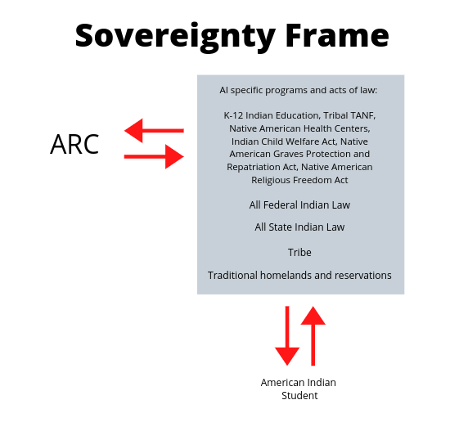
One major recommendation emerged from this study which is that ARC should shift to a sovereignty frame when addressing American Indian (AI) education and pivot away from the consideration of American Indians as part of a racial frame. American Indians are legally unique. The sovereignty frame takes into account first the body of federal and state laws that establish AI students as members of self-governing tribes.
“Indian Nations had always been considered as distinct, independent political communities, retaining their original natural rights, as the undisputed possessors of the soil… The very term “nation” so generally applied to them means ‘a people distinct from others.’”
- Chief Justice Marshall, United States Supreme Court (“Tribal Governance” 2020)
From this, then, the college must also take into account that its relationship is not just with the AI student; it is a reciprocal relationship that extends to the tribe as well. The sovereignty frame also realizes that the relationship between the college and the AI student can only be navigated through the body of Federal and State Indian law. Finally, the sovereignty frame acknowledges the relationship of the AI student to his/her traditional homeland and land base (reserve/reservation/traditional homeland).

Recommendations | Comments and Suggested Strategies
Begin the shift to a Sovereignty Frame by recognizing the implications | The implications include:  - ARC must acknowledge its historical relationship to the land that it occupies.  - ARC should form executive-level MOU’s with local tribes to establish reciprocal relationships and unique services for citizens of those nations.  - ARC should create the administrative capacity to establish and maintain relationships with the tribes represented by its American Indian students.  - ARC should build out support systems for citizens of tribal nations that take into account Federal and State Indian law; historic discrimination against citizens of tribal nations based on tribal status; K-12 Indian Education, Tribal TANF, Native American Health Centers, the Indian Child Welfare Act, the Native American Graves Protection and Repatriation Act, and the Native American Religious Freedom Act.  - ARC should systematically and in broad strokes employ a sovereignty frame that may inform and enrich instruction, operations, construction, planning, and hiring.
Establish an Office of Tribal Relations | - Establish an Office of Tribal Relations to create, maintain, and support the above so as to create an environment where American Indian students can thrive. Models currently exist at Chico State University (https://www.csuchico.edu/tribalrelations/), University of Idaho (https://www.uidaho.edu/president/direct-reports/tribal-relations), University of Arizona (https://universitysecretary.arizona.edu/tribal-relations), University of Oklahoma, (http://www.ou.edu/diversityandinclusion/tribal-liaison), and San Diego State University (https://diversity.sdsu.edu/regional-transborder-affairs/about-tribal-liaison and https://diversity.sdsu.edu/regional-transborder-affairs/strategic-plan).
Continue and expand direct American Indian and Native American student support | The Campus  - A continued dedicated physical space  - Permanent coordination and permanent staffing for the Native student support program  - An operating budget  - Aid navigating through first-in-college informational barriers  - Pathways support  - Tribal scholarship facilitation  - Dedicated counseling  - Direct aid: textbook library, Chromebooks for checkout, food resources, housing partnerships  - Campus and community role models and mentors  - Peer group support through Native Peer Advisors Corps  - Motivational events anchored in American Indian cultural practices  - The continuation of the land statement practice  - Creation of a roster of validated, community-approved consultants to provide individual and small group training to ARC employees in the areas of American Indian cultural awareness  The Classroom  - ARC teachers and counselors trained in cultural awareness regarding Native Americans as well as microaggression avoidance  - ARC teachers and counselors trained in "warm demanding" and "proximal development" (Hammond)  - Practitioner development in trauma awareness and trauma-informed approaches to interactions  The Self  - Mental and physical health services provided in partnership with the Sacramento Native American Health Center  - Healthy families workshops  - Sobriety and addiction support  The Community  - Outreach and collaboration with local Indian Education K-12 programs  - Collaboration with Native student support programs at CSU and UC  - Meaningful, formal partnerships with regional California tribal nations  - Participation in the Sacramento Native American Higher Education Collaborative  - Communication on a case-by-case basis with the specific tribes  - Statewide visibility and articulation with other American Indian associations
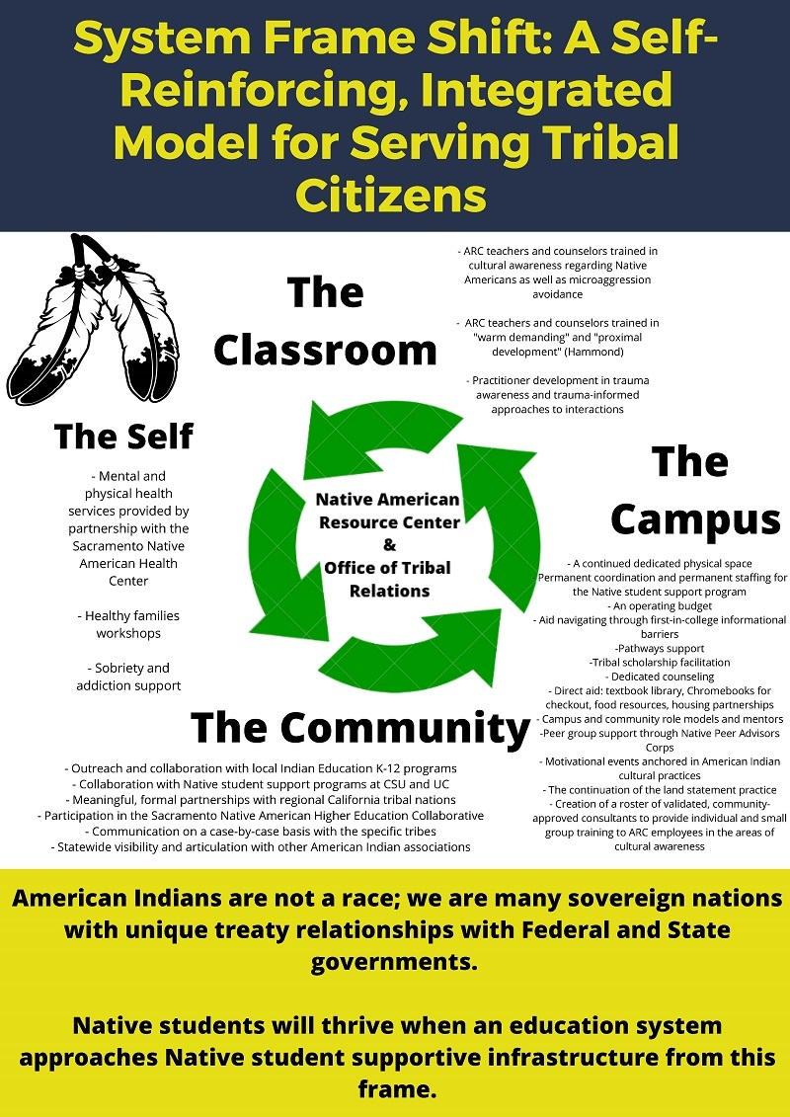

References
American Indian Urban Relocation. (n.d.). Retrieved from https://www.archives.gov/education/lessons/indian-relocation.html.
Blakemore, E. (2017, November 16). California's Little-Known Genocide. Retrieved from https://www.history.com/news/californias-little-known-genocide.
Boarding Schools: Struggling with Cultural Repression. (n.d.). Retrieved from https://americanindian.si.edu/education/codetalkers/html/chapter3.html
Brayboy, B. M. K. J. (2006, March 14). Toward a Tribal Critical Race Theory in Education. Retrieved from https://link.springer.com/article/10.1007/s11256-005-0018-y.
Bringing Theory to Practice: Supporting and encouraging liberal education in linking the learning, well-being, and civic development of students. (n.d.). Retrieved from https://www.bttop.org/.
Bureau of Indian Affairs (BIA). (n.d.). Retrieved from https://www.bia.gov/bia.
Burke, A. (n.d.). Student Retention Models in Higher Education: A Literature Review. Retrieved from https://www.aacrao.org/research-publications/quarterly-journals/college-university-journal/article/c-u-vol.-94-no.-2-spring/student-retention-models-in-higher-education-a-literature-review.
Encyclopedia of the Great Plains. (n.d.). Retrieved from http://plainshumanities.unl.edu/encyclopedia/doc/egp.pg.032.
Falkenstern, C. and Rochat., A. (2018, July). Native American-Serving, Nontribal Institutions (NASNTIs) Survey of American Indian/Alaska Native Students in Higher Education. Retrieved from https://www.wiche.edu/files/files/NASNTI_survey_070518.pdf
Gail, Bruce, & James, M. (2019, July 1). Creating Visibility and Healthy Learning Environments for Native Americans in Higher Education - American Indian College Fund: Native American Scholarships. Retrieved from https://collegefund.org/presidents-blog/creating-visibility-and-health-learning-environments-for-native-americans-in-higher-education/.
Gonzalez, J. (2018, June 6). A Must-Have Guide to Culturally Responsive Teaching. Retrieved from https://www.cultofpedagogy.com/closing-achievement-gap-hammond/.
Harrington, C. (2016, August 13). The Lesser-Told Story Of The California Missions. Retrieved from https://hoodline.com/2016/03/the-lesser-told-story-of-the-california-missions.
History.com Editors. (2017, December 8). Indian Reservations. Retrieved from https://www.history.com/topics/native-american-history/indian-reservations.
History.com Editors. (2009, November 9). Treaty of Guadalupe Hidalgo. Retrieved from https://www.history.com/topics/mexican-american-war/treaty-of-guadalupe-hidalgo.
Indian self-determination becomes the law of the land - Timeline - Native Voices. (n.d.). Retrieved from https://www.nlm.nih.gov/nativevoices/timeline/539.html.
Ingram, B. (n.d.). Trauma Informed Approaches to Classroom Management. Retrieved from https://achieve.lausd.net/domain/4.
Little, B. (2017, August 16). How Boarding Schools Tried to Kill the Indian Through Assimilation. Retrieved from https://www.history.com/news/how-boarding-schools-tried-to-kill-the-indian-through-assimilation.
Lbreiseth. (2015, October 6). Exploring Achievement: Factors Affective Native American College Student Success. Retrieved from https://www.colorincolorado.org/research/exploring-achievement-factors-affective-native-american-college-student-success.
Looking Ahead. (n.d.). Retrieved from https://vision.foundationccc.org/looking-ahead.Mexican Period: 1822-1846. (n.d.). Retrieved from https://www.nps.gov/prsf/learn/historyculture/mexican-period.htm.
Nazaryan, A. (2016, August 22). California's state-sanctioned genocide of Native Americans. Retrieved from https://www.newsweek.com/2016/08/26/california-native-americans-genocide-490824.html.
Ostler, J. (2017, June 8). Genocide and American Indian History. Retrieved from https://oxfordre.com/americanhistory/view/10.1093/acrefore/9780199329175.001.0001/acrefore-9780199329175-e-3
Plans & Policies. (2015). Retrieved from https://www.uregina.ca/indigenization/plans/index.html.
Reeves, & Jean, J. (2006, May 4). The first year experience and persistence of Native American students at one predominantly white four year institution. Retrieved from https://ir.library.oregonstate.edu/concern/graduate_thesis_or_dissertations/b8515q59f.
Status and Needs of Unrecognized and Terminated California Indian Tribes. (n.d.). Retrieved from https://www.aisc.ucla.edu/ca/Tribes14.htm.
System Partners. (n.d.). Retrieved from https://www.snahc.org/system-partners/.
The Editors of Encyclopaedia Britannica. (2016, October 10). Indian Reorganization Act. Retrieved from https://www.britannica.com/topic/Indian-Reorganization-Act.
2002 - Early California Laws and Policies Related to California Indians, Kimberly Johnston-Dodds. (n.d.). Retrieved from https://digitalcommons.csumb.edu/hornbeck_usa_3_d/34/.
Wang, J., & Shiveley, J. (n.d.). The Impact of Extracurricular Activity on Student Academic Performance. Retrieved from https://cair.org/.
Western Interstate Commission for Higher Education. (n.d.). Retrieved from https://www.wiche.edu/pub/Native-American-Serving-Nontribal-Institutions-survey.
Wright, S., Cuevas-Romero, V., et al. (2019). Native American Youth Mental Wellness Report. Sacramento Native American Health Center. Retrieved from https://www.snahc.org/wp-content/uploads/2019/03/Year-1-Reports_Print-Ready.pdf?x43197

Resources for Further Reading
Ambler, M. (2006). School Reform Requires Local Involvement. Tribal College Journal, 17(4), 8. Retrieved from https://ezproxy.losrios.edu/login?url=https://search.ebscohost.com/login.aspx?direct=true&db=a9h&AN=20990824&site=ehost-live&scope=site
Bower, B. (2019). Beliefs on intelligence can affect grades. Science News, 195(5), 12–13. Retrieved from https://ezproxy.losrios.edu/login?url=https://search.ebscohost.com/login.aspx?direct=true&db=a9h&AN=134959929&site=ehost-live&scope=site
Brayboy, B. M. J. (2014). Culture, Place, and Power: Engaging the Histories and Possibilities of American Indian Education. History of Education Quarterly, 54(3), 395–402. DOI: 10.1111/hoeq.12075
Brayboy, B. M. J., & Lomawaima, K. T. (2018). Why Don’t More Indians Do Better in School? The Battle between U.S. Schooling & American Indian/Alaska Native Education. Daedalus, 147(2), 82–94. DOI: 10.1162/DAED_a_00492
Cajete, G. (2006). It is Time for Indian People to Define Indigenous Education on our Own Terms. Tribal College Journal, 18(2), 56–57. Retrieved from https://ezproxy.losrios.edu/login?url=https://search.ebscohost.com/login.aspx?direct=true&db=a9h&AN=23195365&site=ehost-live&scope=site
Carjuzaa, J., Baldwin, A. E., & Munson, M. (2015). Making the Dream Real: Montana’s Indian Education for All Initiative Thrives in a National Climate of Anti-Ethnic Studies. Multicultural Perspectives, 17(4), 198–206. DOI: 10.1080/15210960.2015.1088303
Child, B. J. (2005). American Indian Education: A History. Journal of American History, 92(3), 1008–1009. DOI: 10.2307/3660053
Coleman, M. C. (2005). American Indian Education: A History. Western Historical Quarterly, 36(3), 382–383. DOI: 10.2307/25443213
Conn, D. R. (2013). When Two Worlds Collide: Shared Experiences of Educating Navajos Living off the Reservation. Qualitative Report, 18(25), 1–16. Retrieved from https://ezproxy.losrios.edu/login?url=https://search.ebscohost.com/login.aspx?direct=true&db=a9h&AN=88905612&site=ehost-live&scope=site
DeRosier Jr., A. H., & Cech, V. B. (1991). Western education meets Native Westerners. National Forum, 71(2), 7. Retrieved from https://ezproxy.losrios.edu/login?url=https://search.ebscohost.com/login.aspx?direct=true&db=a9h&AN=9609192167&site=ehost-live&scope=site
Diamond, L. (2014). Sustained Support Needed To Improve Indian Schools. Education Week, 33(15), 22. Retrieved from https://ezproxy.losrios.edu/login?url=https://search.ebscohost.com/login.aspx?direct=true&db=a9h&AN=93618576&site=ehost-live&scope=site
Elevating Native American College Students' Sense of Belonging in Higher Education. (n.d.). Retrieved from https://www.myacpa.org/article/elevating-native-american-college-students-sense-belonging-higher-education.
Factsheets. (2018, September 26). Retrieved September 2, 2019, from https://pnpi.org/native-american-students/
Farkas, G. (2003). Racial Disparities and Discrimination in Education: What Do We know, How Do We Know It, and What Do We Need to Know? Teachers College Record, 105(6), 1119–1146. DOI: 10.1111/1467-9620.00279
Field, K. (2016, August 5). For Native Students, Educations Promise Has Long Been Broken. Chronicle of Higher Education, pp. A20–A24. Retrieved from https://ezproxy.losrios.edu/login?url=https://search.ebscohost.com/login.aspx?direct=true&db=a9h&AN=117290135&site=ehost-live&scope=site
Fischer, S., & Stoddard, C. (2013). The academic achievement of American Indians. Economics of Education Review, 36, 135–152. DOI: 10.1016/j.econedurev.2013.05.005
Fox, M. J. T., & Tippeconnic III, J. W. (2017). American Indian / Native American Studies and the American Indian Education Experience. Wicazo Sa Review, 32(2), 30–45. DOI: 10.5749/wicazosareview.32.2.0030
Gipp, G. E., & Fox, S. J. (1991). Promoting cultural relevance in American Indian education. Education Digest, 57(3), 58. Retrieved from https://ezproxy.losrios.edu/login?url=https://search.ebscohost.com/login.aspx?direct=true&db=a9h&AN=9201272242&site=ehost-live&scope=site
Green, E. L., & Waldman, A. (2018, December 29). ‘I Feel Invisible’: Natives Languishing in Schools. (Cover story). New York Times, pp. A1–A13. Retrieved from https://ezproxy.losrios.edu/login?url=https://search.ebscohost.com/login.aspx?direct=true&db=a9h&AN=133770797&site=ehost-live&scope=site
Growing native education. (2013). Diverse: Issues in Higher Education, 30(13), 7. Retrieved from https://ezproxy.losrios.edu/login?url=https://search.ebscohost.com/login.aspx?direct=true&db=a9h&AN=89573939&site=ehost-live&scope=site
Hermes, M. (2005). Resources for Teachers to Indigenize Education. Tribal College Journal, 16(3), 26–29. Retrieved from https://ezproxy.losrios.edu/login?url=https://search.ebscohost.com/login.aspx?direct=true&db=a9h&AN=16853709&site=ehost-live&scope=site
Kasee, C. R. (2009). American Indian Education: Counternarratives in Racism, Struggle and the Law. American Indian Culture & Research Journal, 33(2), 115–117. Retrieved from https://ezproxy.losrios.edu/login?url=https://search.ebscohost.com/login.aspx?direct=true&db=a9h&AN=43251528&site=ehost-live&scope=site
López, N., Javier Chavez, M., Erwin, C., & Binder, M. (2018). Making the invisible visible: advancing quantitative methods in higher education using critical race theory and intersectionality. Race, Ethnicity & Education, 21(2), 180–207. DOI: 10.1080/13613324.2017.1375185
M. A. Z. (2009). Native American Students. Education Week, 28(36), 5. Retrieved from https://ezproxy.losrios.edu/login?url=https://search.ebscohost.com/login.aspx?direct=true&db=a9h&AN=43406896&site=ehost-live&scope=site
McCombs, B. L. (2000). Reducing the Achievement Gap. Society, 37(5), 29–36. DOI: 10.1007/s12115-000-1034-x
Montgomery, L. M. (2019). Memories that haunt: layered landscapes of historical trauma on the American plains. International Journal of Heritage Studies, 25(7), 736–749. DOI: 10.1080/13527258.2018.1544166
Office of Indigenization. (n.d.). Retrieved from https://www.uregina.ca/indigenization/.

Poitra, C. (2012). Theoretical Perspectives on American Indian Education: Taking a New Look at Academic Success and the Achievement Gap. American Indian Culture & Research Journal, 36(3), 200–202. Retrieved from https://ezproxy.losrios.edu/login?url=https://search.ebscohost.com/login.aspx?direct=true&db=a9h&AN=85163688&site=ehost-live&scope=site
Postsecondary Education for American Indian and Alaska Natives. (2012). ASHE Higher Education Report, 37(5), 1–140. DOI: 10.1002/aehe.3705
Powers, K. (2005). Promoting School Achievement Among American Indian Students Throughout the School Years. Childhood Education, 81(6), 338–342. DOI: 10.1080/00094056.2005.10521323
Riser, Q. H., Rouse, H. L., Dorius, C. J., & Choi, J. Y. (2019). Native American children and school readiness: A nationally representative study of individual and cumulative risks. Children & Youth Services Review, 106, N.PAG. DOI: 10.1016/j.childyouth.2019.104496
Skousen, C. W. (2018). Minding the Gap: Improving Parental Involvement to Bridge Education Gaps between American Indian and Non-Indian Students. Brigham Young University Education & Law Journal, 2018(2), 101–158. Retrieved from https://ezproxy.losrios.edu/login?url=https://search.ebscohost.com/login.aspx?direct=true&db=a9h&AN=133127120&site=ehost-live&scope=site
Szasz, M. C. (2004). American Indian Education, a History. American Indian Culture & Research Journal, 28(4), 131–133. Retrieved from https://ezproxy.losrios.edu/login?url=https://search.ebscohost.com/login.aspx?direct=true&db=a9h&AN=16910695&site=ehost-live&scope=site
Tippeconnic, I. J. W., & Faircloth, S. C. (2006). School Reform, Student Success for Educators Working With Native K-12 Students. Tribal College Journal, 17(4), 26–29. Retrieved from https://ezproxy.losrios.edu/login?url=https://search.ebscohost.com/login.aspx?direct=true&db=a9h&AN=20990829&site=ehost-live&scope=site
Tippeconnic III, J. W., & Tippeconnic Fox, M. J. (2012). American Indian tribal values: a critical consideration in the education of American Indians/Alaska Natives today. International Journal of Qualitative Studies in Education (QSE), 25(7), 841–853. DOI: 10.1080/09518398.2012.720730
Western Interstate Commission for Higher Education. (n.d.). Retrieved from https://www.wiche.edu/pub/Native-American-Serving-Nontribal-Institutions-survey.
Wooocock, D. B., & Alawiye, O. (2001). The Antecedents of Failure and Emerging Hope: American Indians & Public Higher Education. Education, 121(4), 810. Retrieved from https://ezproxy.losrios.edu/login?url=https://search.ebscohost.com/login.aspx?direct=true&db=a9h&AN=5016898&site=ehost-live&scope=site

