eXPLORING DISPROPORTIONATE IMPACT:
Briefing Packet
- AFRICAN AMERICAN
- LATINX
- NATIVE AMERICAN
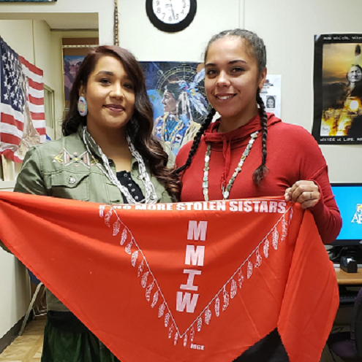
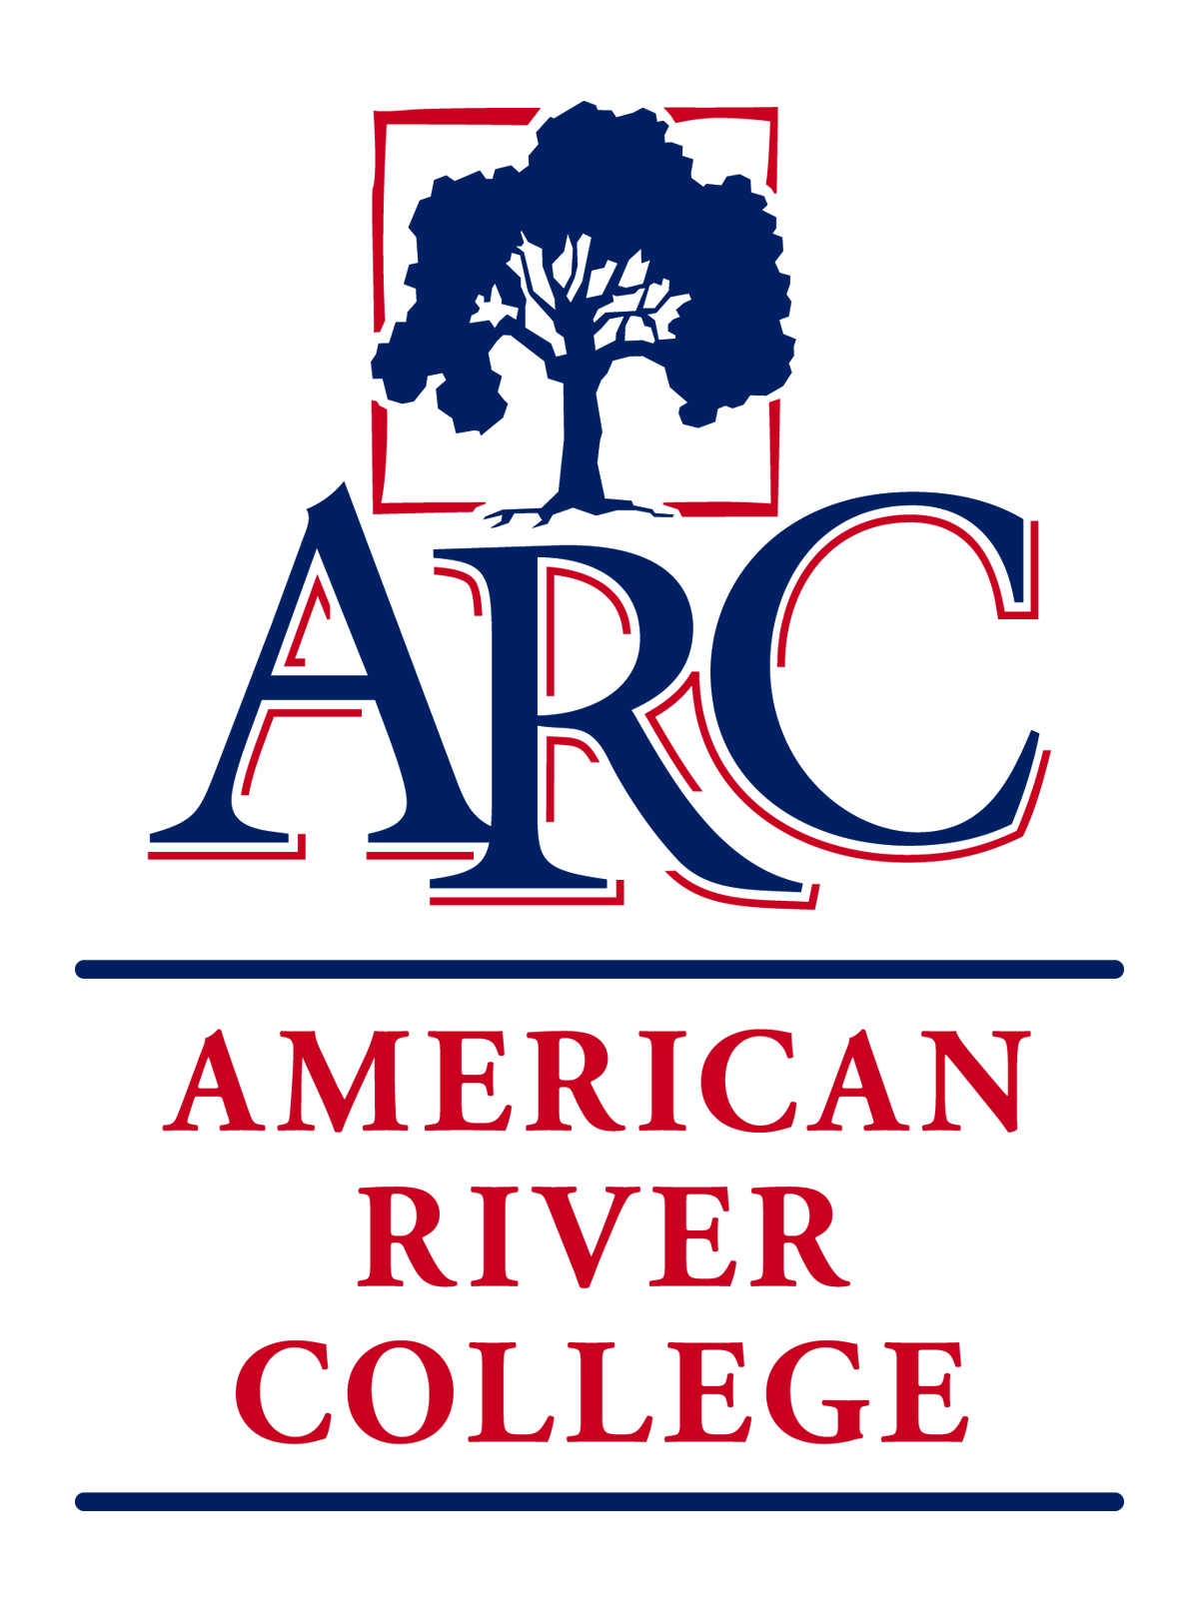



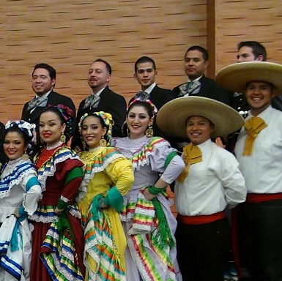

OUR COMMITMENT TO SOCIAL JUSTICE AND EQUITY
American River College strives to uphold the dignity and humanity of every student and employee. We are committed to equity and social justice through equity-minded education, transformative leadership, and community engagement. We believe this commitment is essential to achieving our mission and enhancing our community.

Table of Contents
Introduction: Framing the Process 1
Project Team 1
Purpose and Approach 1
Why this Work Matters 2
History and Context 3
Disproportionate impact: Data Highlights 3
Demographics: Contributing Factors 3
Disproportionate Impact: 2018-19 Subject Area Comparison 4
Disproportionate Impact: 2018-19 Course Completion Comparison 5
African American: Executive Summary 6
Purpose 6
Historical Context 6
Theoretical Framework 6
Connecting the Theoretical Concepts: Emerging Themes 7
Recommendations 8
Latinx: Executive Summary 9
Introduction 9
Overview 9
Recommendations 11
Native American: Executive Summary 12
Recommendation 12
Implications of the Shift to a Sovereignty Frame: 13
Implementation Items 13
Mapping of Recommendations 15

Introduction: Framing the Process
During the 2019-2020 academic year, a project team was formed to gather information and develop recommendations for action that hold potential to eliminate the equity gap among ARC’s most disproportionately impacted (DI) student populations. This briefing packet provides highlights of the team’s work that summarizes the historical exclusion of African American, Native American, and Latinx students in education; considers existing data and literature; and identifies institutional barriers and motivators to providing equitable education. It also includes specific recommendations for actionable change based on a literature review, the Institutional Equity Plan, and the college’s recent redesign efforts. While this briefing packet is provided as a resource for the governance review process, ARC stakeholders are strongly encouraged to use the links below to access the full report for each disproportionately impacted community to gain an in-depth treatment of the topic.
Full Report – African American [insert link to final file to be stored in IGOR]

Full Report – Latinx [insert link to final file to be stored in IGOR]

Full Report – Native American [insert link to final file to be stored in IGOR]

Project Team
Special thanks to the project team of employees, students, and community members who offered invaluable contributions that shaped the content of this briefing packet.
Team Leadership
Derrick Booth (Project Lead)
Cathy Arellano (Project Co-Lead – Latinx Emphasis)
Kim Herrell (Project Co-Lead – African American Emphasis)
Jesus Valle (Project Co-Lead – Native American Emphasis); (Carrizo/Yaqui/Isleta/Apache); Professor of English; Director, ARC Native American Resource Center
Kay Lo (Data Analysis)

Purpose and Approach
Recognizing this issue, ARC began the Disproportionate Impact Project to gather information and develop recommendations that can inform practice to equitize student success for ARC’s most disproportionately impacted student populations. The African American, Latinx, and Native American communities were selected as a focus because they historically have demonstrated the highest levels of disproportionate impact in the ARC data and no previous targeted, college-wide, scalable efforts have been directed at meeting the needs of those DI populations.
To be effective, efforts of this type must be guided by the perspectives and experiences of the impacted communities so that the best path forward can be collaboratively developed. The observations, analysis, and recommendations in this document are reflective of a team composition that was intentionally designed to draw from the collective wisdom of the communities that are currently experiencing disproportionate impact.

Why this Work Matters

It is important to recognize that the educational playing field is not leveled. Over the past 300 years, obtaining an education has been difficult at best and sometimes deadly for disproportionately impacted students. If education across generations (which leads to income stability and a historical expectation of education) were a race, then Whites would have a 250-year head start. Once the DI groups were finally allowed to enter the race, they were challenged by 50 more years of contending with barriers and obstacles. In this playing field, it was as if Whites had a clear lane 1 with a head start while the numerous hurdles and water jumps of a steeple chase were placed in the lanes of the DI groups. While the project team recognizes that some Whites have had significant obstacles to overcome, it must be acknowledged that as a group and comparatively, the access and expectation of education has been substantially easier for those identified as White.
Figure 1: Equality


If we continue with the sports metaphor, the ability to see the game can be viewed as the goal. In Figure 1, the fence serves as a metaphor for a variety of barriers that obstruct the view of the game and keep each of the children from obtaining their goal of seeing the game (education). The difference in difficulty isn’t because of the child’s height (educational capability), but rather because of the uneven ground or context (historical oppression/educational barriers) and the necessity to see over a higher fence (present-day systems of oppression). Each child was then given a box to help see over the fence (reach their goal). Because the fence is taller for some than the others, they still can’t reach their goal despite being provided with boxes of equal size. The box represents the various forms of assistance available to all students. In the top image, the child on the right carved a hole in the fence in order to see through the barrier. This symbolizes “the creative and often subversive ways that people find to work around systems and get some of what they need”. [https://culturalorganizing.org/the-problem-with-that-equity-vs-equality-graphic/]
Figure 2: Equity


The approach that the project team is proposing is a partial reflection of figures two and three. Some of the recommendations advocate for second- and third-level assistance that the DI groups need to see over the higher fence (Figure 2). Other recommendations propose tearing the fence down entirely to create an unobstructed clear view for all to enjoy (Figure 3).

As an institution that has made a commitment to social justice, we must ultimately strive to accomplish Figure 3 by tearing down institutional barriers and obstructions in order to fully eradicate the educational deficit created by 300 years of oppression.
Figure 3: Justice

History and Context
The disturbing history of marginalized groups within the United States, along with the lingering impacts to the present-day minority experience, cannot be ignored. The echoes of past events resonate across the generations to ARC’s current African American, Latinx, and Native American students. While it is not possible to fully understand their lived experience, the historical context is offered as a glimpse into the realities, burdens, and assets that these students carry.
Each team was charged with developing the historical context for the state of education in their community. The work clearly indicates the systems of oppression that continued throughout US history to modern day.
Throughout the history of these marginalized populations, the United States instigated land grabs or blocked persons of color from the ability to have ownership of land and wealth. This contributes mightily to the inability of the groups to take advantage of future educational opportunities. The reality is that when a person must focus on trying to survive, to eat, or to keep a roof over their head, educational opportunities simply either do not exist or are not a priority. Chances are that a person will not succeed in school when there is the real-life intrusion of food and housing insecurity, an inability to concentrate or stay awake.
Disproportionate impact: ARC DEMOGRAPHIC Data
As applied to American River College’s student academic achievement and success metrics, analysis of existing data revealed that African American, Latinx, and Native American students were disproportionately impacted in at least one (if not all) of the following areas: persistence/retention, course completion, and transfer rates.
Demographics: Contributing Factors
One contributing factor is the substantial difference in race/ethnicity of the student population as compared to the employee population. During the Fall 2019 semester, American River College enrolled approximately 30,000 students of which 7.03% self-identified as African American, 28.92% as Latinx, 0.49% as Native American, 37.94% as White, and approximately 26% as other ethnicities. By contrast, the table below depicts the reported ethnicity for ARC employees. For visual effect, color-coded shading has been used to indicate whether various statistics mirror the student population.

Employee Demographics: Fall 2019
Blue = dramatically overrepresented Green = substantially overrepresented Red = substantially underrepresented
Population | Administrator (Management) | Tenured Faculty | Temporary Faculty | Classified  Employees | Students
African-American | 11.80% | 5.40% | 4.50% | 10% | 7.03%
American Indian/Alaskan Native |  | 1.30% | 0.20% | 1.10% | 0.49%
Hispanic | 29.40% | 14.30% | 10.30% | 13.10% | 28.92%
White Non-Hispanic | 41.20% | 62% | 71.40% | 58.40% | 37.94%
Source: California Community Colleges Chancellor’s Office DataMart
Based on these data, ARC has an opportunity to change its practices to seek more equitable hiring of faculty and classified staff of color so that its employee base is more reflective of the student population (see Recommendations).
Balancing limited finances and work responsibilities with the educational and familial needs are another contributing factor to the significant barriers that students navigate. While people of color are accessing various types of financial aid, the percentage of grant and work study awards is often significantly less than one might expect based on the percentage the DI population represents in the overall student population. Across most categories, the White non-Hispanic students receive a higher than expected share of awards.
California College Promise Awards: 2018-2019
Population | Method A  (CalWorks/  TANF/SSI) | Method B  (Income) | Method C  (FASFA/DREAM ACT) | AB 19 Fee Waiver | Students
African-American | 18.29% | 13.38% | 10.05% | 3.56% | 7.03%
American Indian/Alaskan Native | 0% | 0.65% | .54% | .82% | 0.49%
Hispanic | 12.20% | 27.71% | 23.98% | 26.03% | 28.92%
White Non-Hispanic | 42.68% | 31.70% | 40.85% | 47.12% | 37.94%
Note: Method D was not included as there were less than 10 students reported for awards across all ethnicities.
Select Grants: 2018-2019
Population | Cal Grant B | Cal Grant C | PELL Grant | SEOG | Students
African-American | 9.38% | 7.36% | 10.23% | 7.95% | 7.03%
American Indian/Alaskan Native | 0.31% | 0% | .47% | 0.36% | 0.49%
Hispanic | 25.64% | 14.11% | 18.93% | 16.61% | 28.92%
White Non-Hispanic | 44.26% | 60.74% | 46.29% | 52.50% | 37.94%

Work Study: 2018-2019
Population | CA State | CalWORKs | Federal (FWS) |  | Students
African-American | 5.00% | 2.42% | 5.17% |  | 7.03%
American Indian/Alaskan Native | 0.13% | 0% | 0% |  | 0.49%
Hispanic | 5.77% | 7.26% | 10.34% |  | 28.92%
White Non-Hispanic | 56.92% | 77.42% | 72.99% |  | 37.94%
Source: California Community Colleges Chancellor’s Office DataMart
Disproportionate Impact: 2018-19 Subject Area Comparison
The table below indicates the extreme nature of the impact on the Latinx, Native American, and African American communities. The African American community shows a clear disproportionate impact (DI) in 75% of the subject areas in which they have taken courses (81 out of 108 subjects). The Latinx community has a clear DI in 36% of the subject areas with an additional 26% that indicate possible DI. The Native American community presents a challenge as there were often not enough data or no data to compare their success since there is not a large Native American community at ARC. However, where sufficient data exists, Native Americans show a clear DI in 25% and possible DI in another 16%. Compare that to the DI number for White students which showed 0.01% DI or 4.6% potential DI in the same subject areas.
Population | Subjects with Disproportionate Impact | Subjects with Possible Disproportionate Impact | Subjects with No Disproportionate Impact | Insufficient Data to Assess DI
African American | 81 | 16 | 7 | 4
Latinx | 39 | 28 | 40 | 1
Native American | 15 | 9 | 31 | 53
White | 1 | 5 | 102 | 0
Source: [ARC Data on Demand (March 2020)]
The statistics depicted above clearly indicate that if ARC is to reach its goal of equity, then systems and programs must be improved or supplemented to equitably serve these students.

Disproportionate Impact: 2018-19 Course Completion Comparison
The following data depicts disproportionate impact in course completion among African American, Hispanic/Latino, and Native American students. In addition to overall course completion, English and mathematics completion rates are highlighted as a gateway to degree completion (competency requirement).
ALL COURSES
Target Population(s) | Percentage of Courses Passed¹ | Point comparison to the all student average²
All Students | 77%
African American | 64% | -13
Hispanic/Latino | 75% | -2
Native American | 67% | -10

ENGLISH
Target Population(s) | Percentage of Courses Passed¹ | Point comparison to the all student average²
All Students | 72%
African American | 65% | -7
Hispanic/Latino | 68% | -5
Native American | 59% | -13
MATHEMATICS
Target Population(s) | Percentage of Courses Passed¹ | Point comparison to the all student average²
All Students | 64%
African American | 51% | -13
Hispanic/Latino | 56% | -8
Native American | 41% | -22
¹ The percentage of courses passed (earned A, B, C, or credit) out of the credit courses students enrolled in & were present in on census day
² Percentage point difference between target population and all student with +/- added
Source: ARC Data on Demand (March 2020)
African American: Executive Summary
Purpose
The purpose of the research for the Disproportioned Impact (DI) Project, is to identify how Blacks and African Americans students are systematically denied equitable access to higher education and to provide recommendations for instruments and systems to bridge the equity gap.
The African American DI Report provides a summary of the historical exclusion of Black and African American students in education. Additionally, the report identifies personal motivators that inspire students to succeed, as well as institutional barriers which prevent them from achieving their educational goals. This report highlights research studies and key finds that emphasize the importance of student-faculty connections and adequate financial assistance as major influencers of Black and African American student success in college. A comprehensive list of recommended practices is provided and is based on relevant research studies as well as an analysis of local data.
This report focused on Black and African American students attending American River College seeks to synthesize a historical perspective of African Americans in the United States and provides relevant literature and data analysis as a basis for recommendations to increase Black and African American student success. The goal of the report is to answer the question:
“What Do Black and African American students need from the college (administrators, faculty and staff) to succeed at American River College?”
Historical Context
The brief historical context presented in the report highlights the overt ways in which African Americans were excluded from the educational system in the formation of the United States of America. The review examines the road from slavery to freedom and the oppression of American Americans throughout history in the United States including the laws enacted which ensured their subjugation. These early oppressive conditions set the stage for the current educational outcomes and other inequities experienced by the majority of Black and African American people today.
Theoretical Framework
The African American Disproportionate Impact (AADI) Project Team applied the constructs of Critical Race Theory (CRT), Racial Identity Development (RI) and Marginality and Mattering (MM) theories to understand the experiences of Black and African American students attending American River College. The theories together provide a framework for examining both the psychological (i.e. cognitive) and sociological factors that impact their success.
Mattering and Mattering (MM) are concepts defined by, Nancy Schlossberg, in the context of transitional events that alter our lives. “Schlossberg contends that people in transition often feel marginal and that they do not matter” (Schlossberg, 1989 p.6). Schlossberg applies marginality and mattering in research to understand how students’ involvement in college effects their academic success. Involvement creates connections between students, staff and faculty that allow individuals to believe in their own personal worth (Schlossberg, 1989).
Critical Race Theory (CRT) is a framework that helps to examine society and culture in regards to race, politics, law and power. The critical examination of race in the justice system was developed with the goal of transforming the system through exposing and unmasking the myriad of ways in which racism exists. Consequently, additional disciplines and other groups began to apply the theory as a way to examine inherent inequities—most notably the field of education.
Racial Identity Theory (RI) has multiple meanings depending on the disciplines used. In the context of educational theory, racial Identity, is characterized as one’s self concept in relation to an ethnic group or culture. Researchers, Phinney and Ong (2007), define ethnic identity as a multidimensional construct that consists of a sense of belonging or connectedness to an ethnic group defined by one’s cultural heritage including, values, traditions, and language (commitment), and a process of learning about one’s group.
Connecting the Theoretical Concepts: Emerging Themes
Using the theoretical framework and aligning the research within the structure of Guided Pathways, four themes emerge on how to begin the process of bridging the equity gap:

Stay on the Path
- Provide early outreach and financial aid information/literacy to prospective students and continuing students.

Help Students Choose and Enter a Path

- Provide intrusive, systemic, support; and create opportunities to increase connections between students, faculty, and staff in and out of the classroom.

Help Students Stay on the Path

- Provide funding resources and opportunities to alleviate students’ financial burden to attend college.

Ensure that Learning is happening with intentional outcomes

- Enhance classroom learning environments and invest in instructor/educator training resources that promote collectivism, culturally responsive teaching practices and other equity approaches that help students learn.

Highlight of Recommendations
(Please access the complete list of recommendations in the full report)
- Identify/hire/train/ a dedicated Outreach Specialist(s) to collaborate with others to provide information on career options, and college programs to prospective high school seniors and their families.

- Identify/hire/train/ a dedicated Financial Aid Specialist(s) to provide financial aid information/literacy workshops to prospective high school seniors, their families, as well as, continuing college students.

- Create a Black Faculty and Staff Advisory Board which provides advisement on issues regarding Black and African American student success and student needs.

- Identify a dedicated space with support staff for Black and African American students to build community, access resources, affirm identity and cultivate connections, to students, faculty and staff.

- Create Integrated Success Teams that include instructional faculty, counseling faculty, Student Personnel Assistants, a Librarian, peer mentors, peer tutors, Financial Aid Specialist, Workforce Development /Internship staff, to provide case management support to students.

- Dedicate funds, administered by an advisory board, to supply to students for textbooks, college resources and other essential needs.

- Collaborate with Workforce Development and Internship Programs to identify funding sources, provide stipends for internships and employment opportunities.

- Identify/hire/train Instructional Assistants, Student Personnel Assistants, student assistants, peer mentors, tutors and technology assistants embed them in classes and offer follow-up assistance to students.

- Invest in teacher training programs like those offered by the Association of College and University Educators (ACUE) and the Center for Organizational Responsibility and Advancement (CORA) to encourage, support and assist faculty in learning effective teaching strategies.



Latinx: Executive Summary
Introduction
There was no other motivator for the staff, faculty, and community members on the Latinx DI Team than wanting to make the educational experience at American River College better for current and future Latinx students. We do our best in our respective roles on campus and in the community, but given the opportunity to make a lasting impact we committed to the process. One of the most compelling aspects was the student survey. For better and worse, some of the obstacles ARC Latinx students face in 2020 aren’t new to us. In spite of various historical and structural barriers, we know Latinx students can meet their educational, career, and personal goals. We look forward to the complete analysis of the survey so that we may have another tool to guide our work.
“Approximately 70% of the LGBTQ+ students enrolled in California community colleges are students of color” (Oakley :30) and of the 115 California community colleges, ARC has one of the only six Pride Centers (Oakley 1:37). Within the Latinx community, our LGBTQ and undocumented students have particular needs, such as employment, healthcare, housing, legal aid, competently trained staff and faculty, and an affirming physical space to access support on campus. Serving students means meeting them where they are, and LGBTQ and undocumented students need more financial help to redress anti-LGBTQ and anti-undocumented sentiment, such as ARC working with community organizations to pay stipends. We need ARC and Los Rios to use their cultural capital in the state capitol and regularly, publicly, and explicitly declare their support of them at this time when they are regularly bashed locally to nationally. We need mandatory equity training to discourage campus community members from committing bias, abuse, or harassment. In addition, institutional policies need to be evaluated to best serve students with multiple marginalized identities.

Within the Latinx community, our LGBTQ and undocumented students have particular needs, such as needing legal help with obtaining identification that correctly identified their gender or knowing their legal rights. Serving students means meeting them where they are, and undocumented students need more financial help, such as ARC working with community organizations to pay stipends. Latinx students need ARC and Los Rios to use their cultural capital in the state capitol and regularly, publicly, and explicitly declare their support of them at this time when they are regularly bashed locally to nationally. Maybe that will discourage campus community members from committing bias, abuse, or harassment.

The PUENTE Project is already in place. It already serves students with an academic challenging and culturally relevant pedagogy. It has a success rate with students’ academics and connecting with families. Also, PUENTE student volunteers and mentors recruit from many high schools in the area to, but ARC needs to hire a bilingual, bicultural Latinx Outreach Officer at the earliest possibility. The truth is this hire is overdue since there has never been one before. ARC could continue to rely on—though it shouldn’t—students and volunteers to do outreach to Latinx U.S. born and immigrant communities, but an outreach officer can begin the orientation with high school students and their families. As the survey finds, students want and their family’s support. With real support from family and ARC, Latinx students will see their skills improve. Passing classes, graduating with associate degrees, and transferring to universities will help melt that nagging cloud of self-doubt hanging over them.

The survey shows that having a positive interaction with an instructor is a primary motivator for Latinx students. Of course not all Latinx families are close, but enough are that family support ranks as the second primary motivator for Latinx students. ARC must do more to make families of Latinx students feel welcome. Latinx families should be allowed a more significant role or be better served since they are a part of the community of this or any community college. According to the Student Experience Survey, Latinx students come with low self-confidence but want to learn.

Clearly, Latinx students are pursuing their education, but there are obstacles. Historically, educational institutions have blamed students and even tried extralegal and legal means to prevent Latinx students from receiving a solid education, let alone one that reflected their specific cultural experience though every day they sit in classes that validate the dominant culture.

All Latinx students need clear explanations of what is required to be successful in courses, regular feedback from professors, different ways to learn course content, and other solid teaching habits. And Latinx students need money. Many come from working class or poor families. The Student Experience Survey indicates that the top three barriers for students are related to finances. Also, many are the first in the family to attend higher education and need extra academic guidance and support.

According to Robert Fairlie’s talk at Los Rios District Office in November 2019, when Latinx (and African American and Native American) students entered the SF Bay Area community college he studied, they expressed at a higher rate than Asian or White students expressed for themselves that they would transfer to a 4-year school. However, when it came time to transfer, Latinx (and African American and Native American) students did so at a lower rate than Asian or White students.

Latinx students don’t stay home waiting for the world to change; they come to ARC because they believe it as a significant step in their life’s journey. Hiring a Latinx Outreach Officer, more Latinx faculty and staff in general, and a dedicated space for Latinx students are significant steps toward providing that guidance and care on a larger scale.

Recommendations
(please see full report for full recommendations)

- Finalize the analysis of the DI survey: At this time, the Latinx DI Team does not consider this report complete because the analysis of the data is not yet finished. 558 Latinx students completed the survey and deserve to have their voices heard completely.

- Treat this project as iterative: The Latinx DI Team believes this report is a living document and this project should be conducted every two to three years by members from La Comunidad de ARC. Our students are everchanging and by conducting this work in this cycle, it will allow the institution to respond to the needs of the current students and get feedback on the recommendations that were previously instituted.

- S1: Students First: consider students first AND remember our interaction is because they have come to be students, but that’s not all who they are: they are people who want to learn and get (better) jobs; teach students to be students if they need that help; see more of the person who students are.

- S2: Systems Second: change the system to fit the student instead of trying to change the student to fit the system.

- Mentor and train faculty to teach better: improve professional development.

- Prioritize recruiting, hiring, and retaining bicultural, bilingual Spanish-speaking Latinx and equity-minded staff (Outreach Officer needed as soon as possible), faculty, and administrators (including part-time and full-time classified staff, adjunct and tenure track/tenured faculty, interim and permanent administrators) to attain parity with 29% Latinx student body.

- Regular and consistent communication between La Comunidad de ARC and Executive Leadership Team. Standing regular and mutually agreed upon meeting between ARC president and/or Executive Leadership Team and one or both La Comunidad de ARC co-facilitators and group’s leaders.

- Increase La Comunidad de ARC collegewide representation. ARC president or Executive Leadership Team communicates with leadership of La Comunidad de ARC when a new collegewide council, group, team, committee, etc. forms and seeks Latinx representation proportional to Latinx enrollment with full status and voting rights as other members.

- Apply for HSI grant in collaboration with La Comunidad de ARC and hire at least one full-time, permanent equity-minded Latinx employee to usher grant from embryonic stage to implementation to reporting and evaluating. Ex. write grant with regular input and feedback from a grant implementation team of Latinx employees.

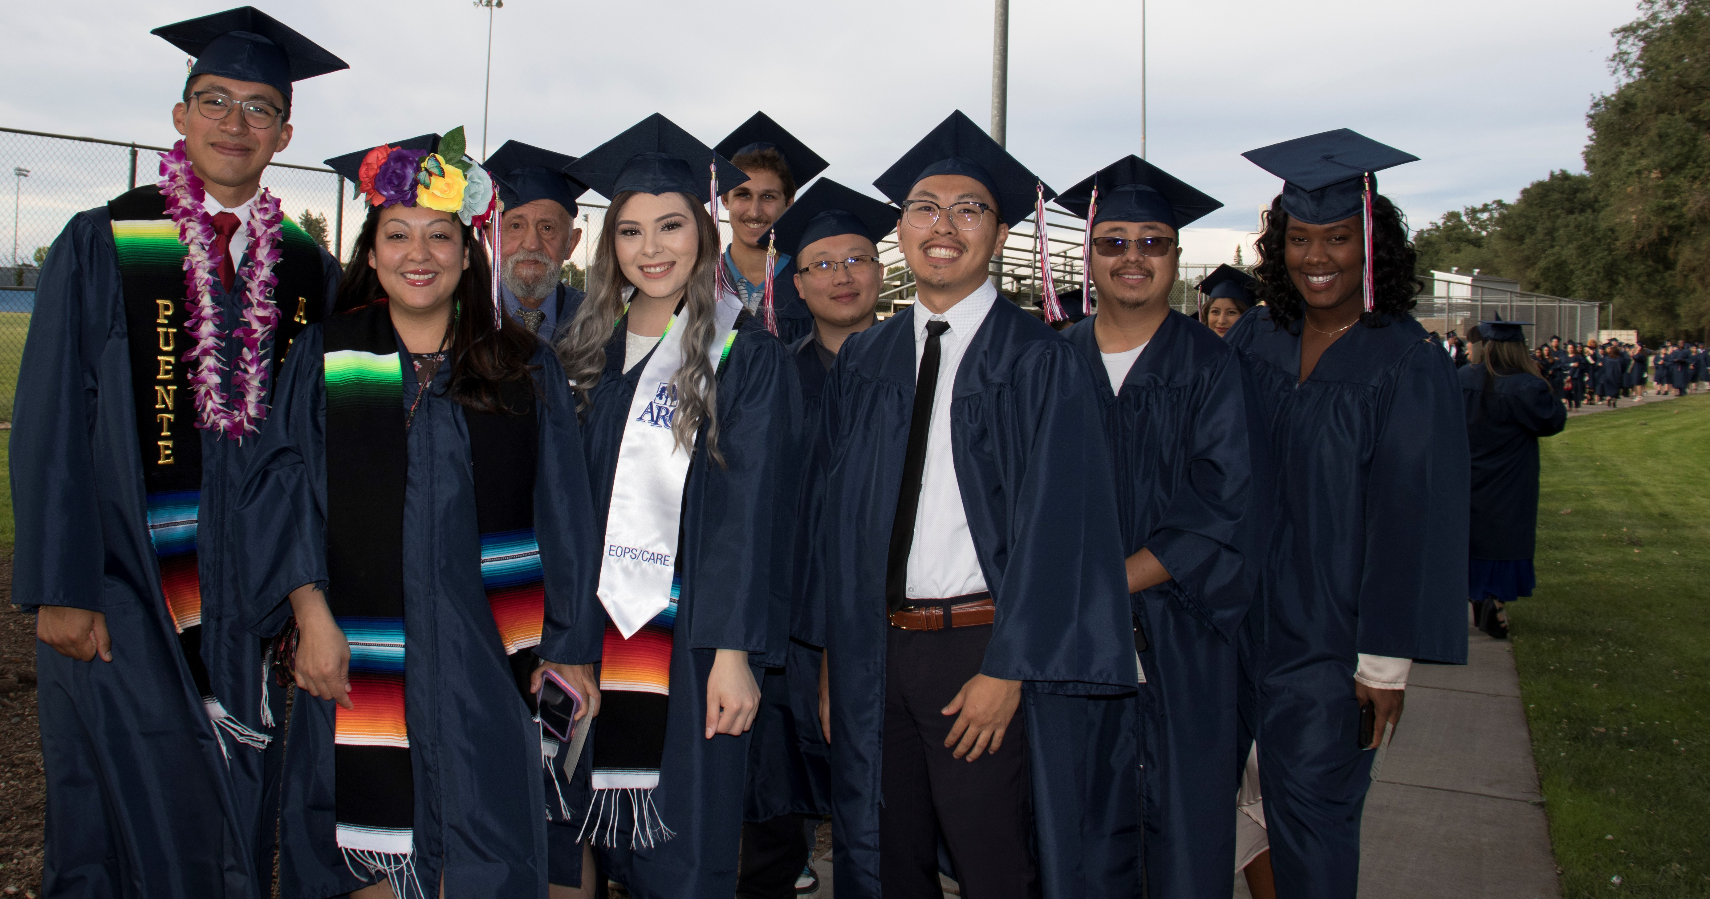
Native American: Executive Summary
Recommendation
There is one large recommendation to come from this study: ARC should shift to a sovereignty frame when addressing American Indian education and pivot away from the consideration of American Indians as part of a racial frame. American Indians are legally unique.
The sovereignty frame takes into account first the body of Federal and State laws that establish AI students as members of self-governing tribes.

“Indian Nations had always been considered as distinct, independent political communities, retaining their original natural rights, as the undisputed possessors of the soil… The very term “nation” so generally applied to them means ‘a people distinct from others.’”
- Chief Justice Marshall, United States Supreme Court (“Tribal Governance” 2020)

From this, then, the school must also take into account that its relationship is not just with the AI student; it is a reciprocal relationship that extends to the tribe as well.
The sovereignty frame also realizes that the relationship between the school and the AI student can only be navigated through the body of Federal and State Indian law.
Finally, the sovereignty frame acknowledges the relationship of the AI student to his/her traditional homeland and land base (reserve/reservation/traditional homeland).
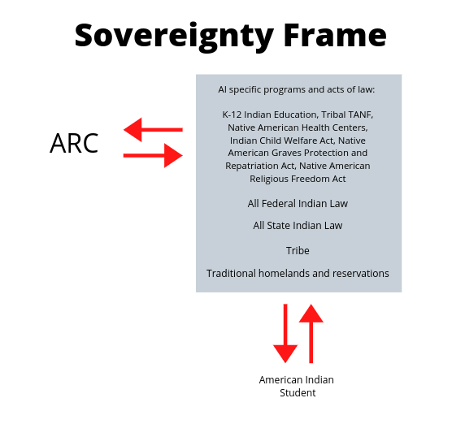
Implications of the Shift to a Sovereignty Frame:
- That a college must acknowledge its historical relationship to the land that it occupies.
- That a college should form executive-level MOU’s with local tribes to establish reciprocal relationships and unique services for citizens of those nations.
- That a college should create the administrative capacity to establish and maintain relationships with the tribes represented by its American Indian students.
- That a college should build-out support systems for citizens of tribal nations that take into account Federal and State Indian law; historic discrimination against citizens of tribal nations based on tribal status; K-12 Indian Education, Tribal TANF, Native American Health Centers, the Indian Child Welfare Act, the Native American Graves Protection and Repatriation Act, and the Native American Religious Freedom Act.
- That a college should systematically and in broad strokes employ a sovereignty frame, and that this may inform and enrich instruction, operations, construction, planning, and hiring.

Implementation Items
- Establish an Office of Tribal Relations to create, maintain, and support the above so as to create an environment where American Indian students can thrive.

Models:
Chico State University https://www.csuchico.edu/tribalrelations/
University of Idaho https://www.uidaho.edu/president/direct-reports/tribal-relations
University of Arizona https://universitysecretary.arizona.edu/tribal-relations
The University of Oklahoma http://www.ou.edu/diversityandinclusion/tribal-liaison
San Diego State University https://diversity.sdsu.edu/regional-transborder-affairs/about-tribal-liaison
https://diversity.sdsu.edu/regional-transborder-affairs/strategic-plan

- Continue and expand direct American Indian and Native American student support in the following ways and areas:

The Campus
- A continued dedicated physical space
- Permanent coordination and permanent staffing for the Native student support program
- An operating budget
- Aid navigating through first-in-college informational barriers
- Pathways support
- Tribal scholarship facilitation
- Dedicated counseling
- Direct aid: textbook library, Chromebooks for checkout, food resources, housing partnerships
- Campus and community role models and mentors
- Peer group support through Native Peer Advisors Corps
- Motivational events anchored in American Indian cultural practices
- The continuation of the land statement practice
- Creation of a roster of validated, community-approved consultants to provide individual and small group training to ARC employees in the areas of American Indian cultural awareness

The Classroom
- ARC teachers and counselors trained in cultural awareness regarding Native Americans as well as microaggression avoidance
- ARC teachers and counselors trained in "warm demanding" and "proximal development" (Hammond)
- Practitioner development in trauma awareness and trauma-informed approaches to interactions

The Self
- Mental and physical health services provided by partnership with the Sacramento Native American Health Center
- Healthy families workshops
- Sobriety and addiction support

The Community
- Outreach and collaboration with local Indian Education K-12 programs
- Collaboration with Native student support programs at CSU and UC
- Meaningful, formal partnerships with regional California tribal nations
- Participation in the Sacramento Native American Higher Education Collaborative
- Communication on a case-by-case basis with the specific tribes
- Statewide visibility and articulation with other American Indian associations

Sources: www.browsermedia.com, B. M.-. (n.d.). Tribal Governance. Retrieved from http://www.ncai.org/policy-issues/tribal-governance
Mapping of Recommendations
Shown below are the recommendations that overarch each group. They have been mapped to the Guided Pathway pillars (Clarify the Path, Enter the Path, Stay on the Path, and Ensure Learning). They have also been mapped to the appropriate ARC Strategic goals and Equity Plan recommendations to show how they are in alignment with the direction and goals of the institution.
Governance and Guidance
Recommendations | Guided Pathway Pillar | ARC  Strategic Goal | ARC Equity Plan  Recommendation
Add a component to faculty performance reviews that focuses on minimizing achievement gaps. | Ensure Learning | S3
Utilize systems like orientations and syllabi to publicize process for students to report abusive, incompetent, etc. administration, faculty, and staff |  | S1 | E4
Utilize systems like orientations and syllabi to ensure that students are aware and informed of their rights, particularly LatinX students |  |  | E4
Utilize systems like orientations and syllabi to publicize the role of the Office of Equity and Inclusion |  | S1 | E4
Establish and utilize community or campus peer mentoring to support the DI groups. Could be part of the Home Base program with training related to the above recommendations | Stay on the Path | S1 | E1
Support faculty inquiry groups to support success in the DI communities (create a spirit of innovation). | Stay on the Path | S4 | E5, E13
Establish campus African American, Latinx, Native American Advisory Councils which provide advisement on issues regarding DI success and student needs. |  |  | E5

Teaching and Learning
Recommendations | Guided Pathway Pillar | ARC  Strategic Goal | ARC Equity Plan  Recomm.
Increase the capacity of (HCD 310 College Success course(s)) with DI Emphasis with financial literacy, career planning, job skills and Racial Identity development as part of the SLOs. | Enter the Path | S2 | E1, E15
Embed tutors of color in classes, mentors, and technology assistants in the context of their courses/majors/areas of interest. | Stay on the Path | S2 | E15
Require accurate culturally reflective and relevant curriculum | Ensure Learning | S3 | E13, E14
Create a transformative syllabi (use transformative curriculum training) | Ensure Learning | S3 | E13, E14, E15
Create academic communities. | Clarify the Path; Stay on the Path; Ensure Learning | S1 | E15
Increase validation and a sense of belonging | All | S3 | E1, E14, E22

Community
Recommendations | Guided Pathway Pillar | ARC  Strategic Goal | ARC Equity Plan  Recomm.
Provide space for individual DI affinity students to study, get counseling, get career advice, do extracurricular activities, receive tutoring, and relax (what would make study, counseling, career advice, etc., places we want to go?) | Enter the Path; Stay on the Path | S2 | E1, E16
Focus on early outreach/recruitment and financial aid information | Clarify the Path | S1 | E1
Deploy financial aid specialist(s) when our DI students need help (just before semester starts and two weeks into semester) | Clarify the Path | S1 | E1, E21, E22
Create African American, LatinX and Native American staff/faculty support network. | Enter the Path | S2 | E1, E8

Campus Resources
Recommendations | Guided Pathway Pillar | ARC  Strategic Goal | ARC Equity Plan  Recomm.
Provide appropriate staffing and budgeting for individual DI centers |  | S3 | E23
Create technology loan programs. | Stay on the Path | S2 | E21
Administer financial needs assessment and provide financial aid and other workshops to prospective students and family members. Provide outreach early and often. | Clarify the Path | S1 | E1, E21
Initiate warm hand-offs to other faculty/staff/students in Financial Aid, Library, Tutoring. Connect students to people, not to departments. | Enter the Path | S2 | E1, E5, E22
Create dedicated textbook book funds, and other college funds separate from the college emergency fund for students in need. The funds will be administered by an advisory committee. | Stay on the Path | S2 | E15, E21
Create Integrated Success Teams that include instructional faculty, counseling faculty, Student Personnel Assistants, a Librarian, peer mentors, peer tutors, Financial Aid Specialist, Work experience/Internship staff, to provide case management support to students. | Enter the Path | S1, S2 | E1

Professional Development and Hiring
Recommendations | Guided Pathway Pillar | ARC  Strategic Goal | ARC Equity Plan  Recomm.
Provide Culturally Responsive Teaching, Culturally Sensitive andragogy/pedagogy (ACUE, CORA trainings) | Stay on the Path | S3 | E7, E13, E15, E17
Create mandatory training around anti-bias, cultural awareness and unintentional/intentional micro-aggression avoidance |  | S1 | E3, E5, E7, E8, E17
Cultivate leadership, paid internship and employment opportunities by hiring/training tutors, peer mentors, and student technology assistants from the DI groups, as well as Instructional Assistants, Student Personnel Assistants to embed them in classes and offer follow-up assistance to students. | Stay on the Path | S2 | E1, E8
Hire mental health providers for Native American, African American and bicultural, bilingual Spanish-speaking for Latinx populations. | Enter the Path; Stay on the Path; Ensure Learning | S2 | E8, E20
Hire Outreach Officer and Financial Aid Specialists for Native American, African American and bicultural, bilingual Spanish-speaking Latinx populations to provide information on career options, and college programs to prospective high school seniors and their families. | All | S1 & S2 | E8, E21, E22

Mapping Key

ARC Strategic Goals
# | Goal
S1 | Students First - The College engages and connects students early and often to people, programs, and services as an integrated educational experience. By providing personalized, proactive support, the College fosters relationships that ensure all students, particularly the historically underserved and marginalized, persist, learn, and succeed.
S2 | Clear and Effective Paths - The College provides easily recognizable pathways to, through, and beyond ARC. Offering well defined and supported pathways provides a foundation for success as students enter the College, make timely progress toward achieving their informed educational goals, and seamlessly transfer to other colleges and universities or find employment in their chosen career.
S3 | Exemplary Teaching, Learning & Working Environment - The College ensures an equitable, safe, and inclusive teaching, learning, and working environment. Culturally relevant curriculum, innovative, high- quality instructional methods and technologies, exemplary academic and student support services, and comprehensive and integrated professional development create the best conditions for teaching and learning. The College promotes liberation and honors the dignity, humanity, and contributions of all members of our community.
S4 | Vibrancy and Resiliency - The College promotes a culture of innovation, entrepreneurship, sustainability, and transparent communication. Proactive, effective, and efficient operational systems and governance and data-informed approaches to planning, decision-making, and resource allocation provide a high level of service to our students, community, and to one another.

Relevant Institutional Equity Plan Recommendations
# | Recommendations | Equity Plan Category
E1 | Focus on welcoming disproportionately impacted communities at ARC | Campus Climate
E2 | Conduct a climate study and a corresponding climate audit that utilizes an equity lens | Campus Climate
E3 | Build institutional capacity in cultural awareness and equity consciousness | Campus Climate
E4 | Cultivate a clear sense of accountability for making institutional equity a priority | Org. Structure
E5 | Foster greater collaboration related to equity issues and interests | Org. Structure
E6 | Extend transparency | Org. Structure
E7 | Offer training and professional development to all employees specific to equity and social justice | Human Resources
E8 | Nurture the essential conditions to hire and retain people of color | Human Resources
E9 | Operationalize the shared definitions, framework, and lens | Communication
E10 | Develop and execute a communication plan focused on equity | Communication
E11 | Assess and collaboratively revise college guidelines and procedures | Communication
E12 | Infuse equity communication by leaders throughout the organization | Communication
E13 | Provide faculty with resources to help prioritize curriculum that is inclusive of students from marginalized communities | Instruction and Curriculum
E14 | Ensure faculty have access to information (data) necessary for promoting the success of students from marginalized communities | Instruction and Curriculum
E15 | Sustain and support instructional approaches for supporting students of color | Instruction and Curriculum
E16 | Dedicate more space to supporting marginalized students | Physical Spaces
E17 | Increase planning and training related to hate and bias incidents | Student Support
E18 | Promote collaborative planning at the department/unit-level | Student Support
E20 | Expand mental health services focused on marginalized students | Student Support
E21 | Plan to strategically and comprehensively meet basic needs for students | Student Support
E22 | Enhance and increase onboarding efforts for marginalized students | Student Support
E23 | Allocate regular staffing in physical spaces designed for marginalized communities | Student Support

Four Pillars of Guided Pathways
Title | Pillar
Clarify the Path | Create clear curricular pathways to employment and further education.
Enter the Path | Help students choose and enter their pathway.
Stay on the Path | Help students stay on their path.
Ensure Learning | Ensure that learning is happening with intentional outcomes.

