Our Scheduling Vision:
Students are the reason we are here, and their education is our primary responsibility. The primary purpose driving the development of our Academic Schedule is to provide students access and opportunities to:
- develop their abilities;
- engage in critical and creative thinking;
- succeed in a competitive global work environment;
- exhibit responsible citizenship benefit society as well as themselves.
- participate in lifelong learning;

ARC’s schedule development process requires:
- fiscally sound, efficient, transparent, and accountable practices;
- effective communication within the college and with the communities served by the college;
- civil and honest communication that promote mutual respect and trust.

Guiding principle for selecting classes:
Courses should be selected to maximize the potential for student success. Courses scheduled should lead to the following:
- College readiness
- Two-year transfer preparation
- Associate degrees, particularly TMCs
- Degrees and certificates that prepare students for professional licensure and certification
- Certificates which have a demonstrated record of employment
- Support for visual and performing arts, cultural awareness, wellness, and intercollegiate sports

Guiding principle for scheduling:
Scheduling for student success means creating paths to transfer or employment while maintaining maximum effectiveness and efficiency in the use of faculty, finances, and facilities. A program map or a pathway is a promise that we are making to students that they will be able to complete a program in a set amount of time. Our goal is to provide a schedule which allows students to successfully meet their educational goals. Within this goal is an interest to move towards a model where we as accurately as possible schedule our courses so that we are not cutting sections at the beginning of the semester, rather we are adding in additional sections throughout registration to relieve bottlenecks.

Courses should be prioritized and scheduled based on the following considerations:
- Schedule courses to meet demand/required number of sections in order for students to efficiently navigate program pathways based on data.
- Schedule courses to meet the demand of opt-out-schedules and program pathways based on data.
- Schedule courses to meet the target WSCH/Productivity which has been determined for each program or discipline. FTEF will be apportioned based on historical data and balance of student needs.
- Schedule sections into blocks of time which allow for efficient use of classrooms. Students should be allowed at least ten minutes to get from one class to another. They should not be precluded from taking a class because it overlaps the timeframe of another.
- Schedule sequential courses which lead to college readiness, degrees, certificates, or licensure such that students will make successful progress from one course to another. Strategies include offering sections at a time which has proven successful and offering enough sections to accommodate the numbers of students completing the prerequisite course or move to college level writing and math skills.
- Offer low-enrollment courses needed for transfer, certification, or licensure at adequate intervals to allow students to move ahead with their goals. (Fill-rate alone should not be used as the basis for offering a course. While fill-rate is important for determining numbers of multi-section offerings, students’ ability to move toward transfer and employment must be actively ensured. In addition, low class size may be mandated by external regulations.)
- Balance choices of times, locations, and delivery methods based on data. Online and partially online courses offer students important options. Offer sufficient sections to meet student demand in all modalities.
- Other factors being equal, prefer courses with higher success rates and lower withdrawal rates. Departments need to address reasons for lower success and higher withdrawal rates paying particular attention to disproportionately-impacted students.
- Consider courses that provide student support and pathways to success, including learning communities, and supplemental instruction.

Other Considerations impacting how to prioritize sections to schedule:
- Schedule courses which have up-to-date outlines of record. Courses which are out of compliance may not be offered.
- Sections should be prioritized when added into the schedule
  - Priority should be given to courses that are a required part of degrees and certificates.
  - Courses that assist students to meet their Math and English requirements.
  - Courses that are a part of a narrow restricted list of electives within a degree or certificate should be added in based upon historical and predictive data evaluating demand for these sections.
  - Scheduling decisions regarding courses that meet GE/unrestricted electives that are specifically delineated in program pathways or maps should be driven by historical and predictive data evaluating demand for these sections.
  - All efforts should be made to schedule courses where departments have identified a rotation of the offerings (every Fall Term, every other Spring Term, etc.)
  - Courses that are required to support publications, performances, athletics, and equity and inclusion college efforts should be supported in the schedule. There should be a recursive conversation regarding enrollment and these programs.
  - Courses which have a demonstrated demand—in spite of a lack of predictive demand
  - Valuable courses which provide opportunities that promote lifelong learning however are not part of required portions of degrees or certificates, are parts of long lists of unrestricted electives or General Education options, or do not meet any specific requirements should be added last into the schedule.
- Courses intended to be scheduled into non-specialty classrooms that are scheduled within the Block Schedule Guidelines should be scheduled into rooms before courses which are scheduled “off-block.”

Full Time Equivalent Faculty (FTEF) Allocation:

District Allocation:
The Los Rios District produces a draft budget each year. The budget is crafted after the “May Revise” comes out from the Governor’s office. This draft is generally presented to the Board of Trustees at their June board meeting. After the State Budget is finalized, the final budget is brought to the board for approval (generally in the September Board meeting). Within the tentative and approved budgets, the District Office provides both the FTEF allocations for the year as well as the projected WSCH goals and Productivity goals for the district:
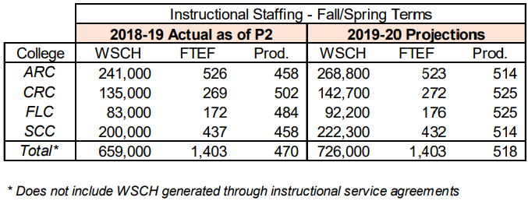
From 2019-20 Adopted Budget presented to the Board of Trustees September 11, 2019, Pg 124
The Instructional Staffing charts in the Adopted Budget documents provides the FTEF allocated by the district (annualized: multiply by 2 for the total authorized amount for Fall and Spring) and the District’s projected WSCH and productivity goals.
A few observations about the allocations coming from district:
- The FTEF allocations and WSCH/Productivity goals are first released to the college as a part of the tentative budget presented to the board in June. Schedule preparation for the Fall semester begins the previous October, is finalized in March, and enrollment began in April. The allocation is not finalized until almost a month into the Fall semester when the final budget is presented.
- ARC begins the Fall scheduling process by basing it off of the prior-year allocation and then adjusting the schedule as the Tentative budget is released in June.
Tentative allocations are prepared at the campus level based upon the prior year’s allocation as the process for creating the Fall schedule begins in October, seven to nine months before the district provides the actual allocation.

ARC Allocation Process:
FTEF is allocated from the Office of Instruction at the division level and the Area Deans then allocate FTEF down to the department level. The allocation process starts with an evaluation of what was scheduled in the prior Fall Term. Historically this began with a “Roll-over” of the previous production term into a development term for departments to adjust the schedule. Historically, the Instruction Office has worked with the District Office create a copy of the previous like term’s schedule with the room assignments and staffing removed. This copy would become the development schedule for the new term. For example the development schedule for Fall 2020 is a copy of the FAll 2019 schedule taken on or around the census date and stripped of instructor names and the rooms that classes had been scheduled into. The development schedule was then distributed to divisions as the first round of schedule development.
A few observations regarding the “Roll-Over” process of schedule development:
- Basing the development schedule for the next term off of the schedule which was in place at census the previous like term does capture what was scheduled, but is not nuanced enough of a process to account for:
  - Last minute sections which were added into the schedule to accommodate FTEF added just before the semester.
  - Under-enrolled sections that were not cut from the schedule, but are now rolled forward.
  - Accounting for course rotations for electives, capstones, or options within programs which call for courses to be rotated every other term.
- The timing of the roll-over and the release of the first round to divisions to work on the next term’s schedule does not leave a lot of time for analysis of student needs or FTEF allocations.

The Core Schedule
As schedules are rolled over there are incremental changes made. The table below shows the percentage of courses which have been scheduled over the past four, three, and two like terms where the course, beginning time, ending time, and day pattern remained the same. (Note this is a comparison of Crystal “Class Size No Grouping by LOC” (RCINS0019) reports for sections which had FTEF attached and was scheduled for a unit value--this eliminated cross-listed sections and the lab portions of Lecture/Lab courses which would have skewed the number of sections).
 |  | Main Campus
 |  | Past 4 Terms |  |  |  | Past 3 Terms |  |  |  | Past 2 Terms |  |  |  | Total Sections 2019
 |  | Count |  | % |  | Count |  | % |  | Count |  | % |  | Count
Fall |  | 807 |  | 36.3% |  | 1114 |  | 50.1% |  | 1471 |  | 66.2% |  | 2223
Spring |  | 786 |  | 35.9% |  | 1094 |  | 49.9% |  | 1454 |  | 66.4% |  | 2191
Summer* |  | - |  | - |  | 241 |  | 36.0% |  | 293 |  | 43.8% |  | 669
*Data missing for Summer 2016 comparison
 | Natomas
 | Past 4 Terms |  |  |  | Past 3 Terms |  |  |  | Past 2 Terms |  |  |  | Total Sections 2019
 | Count |  | % |  | Count |  | % |  | Count |  | % |  | Count
Fall | 58 |  | 30.5% |  | 90 |  | 47.4% |  | 131 |  | 68.9% |  | 190
Spring | 37 |  | 19.4% |  | 73 |  | 38.2% |  | 103 |  | 53.9% |  | 191
Summer* | - |  | - |  | 17 |  | 45.9% |  | 20 |  | 54.1% |  | 37
*Data missing for Summer 2016 comparison
Moving forward, allocations will begin with the approximately 66% of sections which are core to the schedule (i.e. they do not typically change like term to like term). This “core schedule” will provide the foundation for division allocations. Added to this will be the FTEF that has been identified by departments as being necessary for the rotational offerings, those courses which may be offered every other term or on some other pattern to allow for students to complete pathways, degrees, and or certificates. Additional FTEF will be allocated to divisions (beyond the amount needed to support core and rotational offerings) based upon the following FTEF Allocation Guidelines:
Schedules for each semester shall be planned to accommodate the needs of students, to ensure the quality of education, and to utilize facilities efficiently. The Strategic Enrollment Management Team will utilize the following criteria to determine FTEF allocations for divisions.

The semester FTEF allocations must:
- Provide enough FTEF to meet the contractual obligation to provide load for all full-time faculty.
- Afford the Natomas center the ability to enroll at least 1,000 FTES and maintain its Center Status per title 5, § 58771(i) (5).
- Take into account legislative, regulation, or other policy changes which may require resources to be adjusted.
- Be based upon data which indicates a historical five-year, like term-over-term student demand for courses. (Note that the historical demand must be tempered with an analysis of the current status of a program. For example, in 2019 a 5-year like term analysis of English and Math department enrollments would not provide much insight due to the changes wrought by AB 705.)
- Be based on predictive data which provides an analysis of what students will need to take in order to complete work on degrees, certificates, and college pathways. In particular, FTEF Allocation should be based upon meeting the following institutional interests:
  - College readiness;
  - Two-year transfer preparation;
  - Associate degrees, particularly TMCs;
  - Degrees and certificates that prepare students for professional licensure and certification;
  - Certificates which have a demonstrated record of employment;
  - Support for visual and performing arts, cultural awareness, wellness, and intercollegiate sports.

Rolling over the Schedule
Currently, after the census date (third week of a full-term semester) the scheduled is “rolled over” into a development schedule where the rooms, buildings, and instructors are stripped out. This becomes the “Round One” draft which is distributed to divisions to be used for schedule development on the next like term.
Working with District IT, ARC will create six Core developmental schedules in addition to the current production development schedules that we now have:
- Fall (odd year) & Fall (even year)
- Spring (odd year) & Spring (even year)
- Summer (odd year) & Summer (even year)
These development schedules would then have sandboxes in Platinum and Schedule where we would develop the schedules that would be rolled over into the draft schedules for departments and divisions to work on.
Rather than rolling over the prior term, ARC will roll-over the appropriate development schedule. It would look something like:
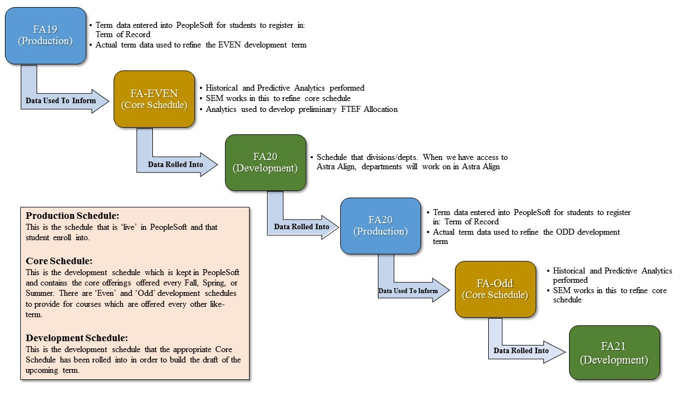
This process will allow ARC to:
- Develop a two-year pattern of course offerings representing both student needs and minimum scheduling levels to assure that we are meeting full-time contractual obligations
- Provide capacity and space for vetting schedules before they are rolled over and presented to department for review/scheduling work.
- Provide the capacity to hold post-mortem scheduling meetings in the summer to review what is working or not working with the core schedules.
- Capture course rotations beyond the whole-terms recorded by PeopleSoft: PeopleSoft only tracks course rotation for whole terms: every fall, every spring, etc. We have many courses which may need to be on an every-other fall, every-other spring, etc. type of rotation.
- Moving towards a model where we have time to discuss the core schedules and then departments propose additions to that schedule based upon data or programmatic changes.
- Develop schedules in a two-year rotation of sections where individual term schedules becomes more refined as the college gets closer to registration and the core schedule is continually being refined with multiple points of data.

Two-Year Scheduling Rotation
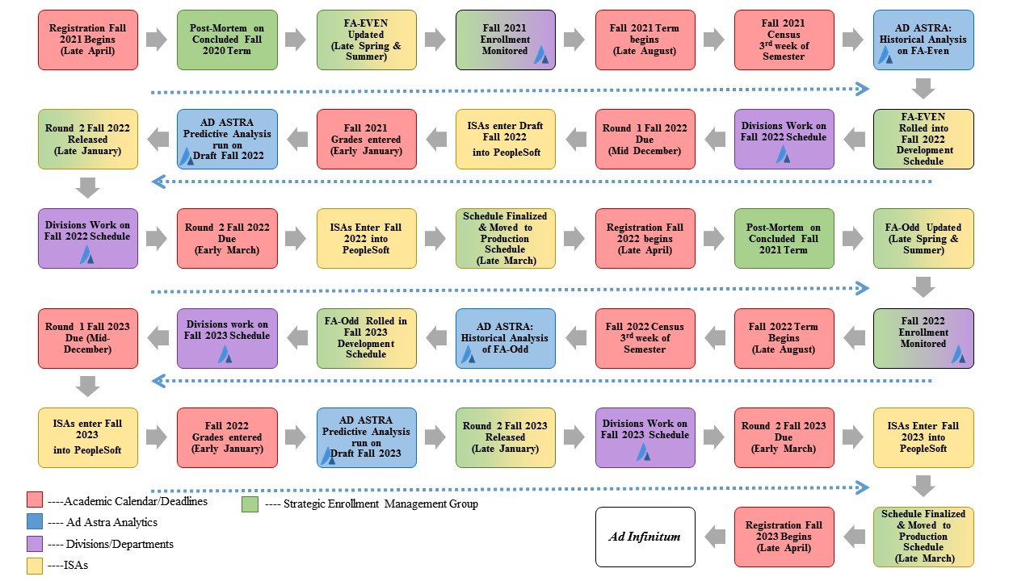
The graphic above represents the two-year cycle of scheduling and how the Core Schedules are informed with analytics, rolled into draft schedules, and moved into being a production schedule that students register into.

Identifying FTEF scheduled in the Previous Like-Fall Term
FTEF totals for Los Rios academic schedules are dynamically calculated by district in order to populate the quarterly CCFS-320 reports to the California Community College Chancellor’s Office (CCCCO) and Crystal reports. The CCFS-320 reports are what the CCCCO uses to determine the enrollment funding for the district. The baseline report used to begin the allocation process is the District Crystal report Summary FTE & WSCH by Location (RCSM 0294). When run after census, this report provides an accounting of the baseline of what was scheduled in each division:
 | Report ID:  RC SM 0294 V8 | Los Rios Community College District
 | Report ID:  RC SM 0294 V8 | SUMMARY FTE & WSCH BY LOCATION
 |  |  |  | # of Sections |  | FTE |  | Sem. WSCH |  | Productivity |  | Census Enrollments |  | Avg. Class Size, Census |  |  | Current Enrollments |  |  |  | Avg. Class Size, Current |  |  |  | Wait List Counts |  |  |  | Avg. Wait List Size
 | ARC MAIN
APPR Total |  |  | 328 |  | 82.797 |  | 22,855.94 |  | 276.05 |  | 8,485 |  | 19.89 |  |  | 8483 |  |  |  | 19.88 |  |  |  | 0 |  |  |  | 0.00
ART Total |  |  | 313 |  | 48.562 |  | 22,060.86 |  | 454.28 |  | 5,646 |  | 16.85 |  |  | 4986 |  |  |  | 14.78 |  |  |  | 208 |  |  |  | 0.66
BSS Total |  |  | 312 |  | 56.427 |  | 32,211.31 |  | 570.85 |  | 10,350 |  | 33.17 |  |  | 8741 |  |  |  | 28.02 |  |  |  | 293 |  |  |  | 0.94
COU Total |  |  | 19 |  | 2.934 |  | 1,642.23 |  | 559.82 |  | 648 |  | 34.11 |  |  | 583 |  |  |  | 30.68 |  |  |  | 39 |  |  |  | 2.05
ENG Total |  |  | 601 |  | 52.661 |  | 17,859.41 |  | 339.14 |  | 8,040 |  | 13.32 |  |  | 6777 |  |  |  | 11.24 |  |  |  | 123 |  |  |  | 0.20
HEDU Total |  |  | 107 |  | 38.614 |  | 13,665.34 |  | 353.90 |  | 2,587 |  | 20.55 |  |  | 2224 |  |  |  | 17.71 |  |  |  | 110 |  |  |  | 1.03
HUM Total |  |  | 319 |  | 61.049 |  | 29,440.85 |  | 482.25 |  | 7,535 |  | 22.13 |  |  | 6632 |  |  |  | 19.48 |  |  |  | 320 |  |  |  | 1.00
LRC Total |  |  | 8 |  | 0.667 |  | 288.24 |  | 432.20 |  | 158 |  | 16.20 |  |  | 135 |  |  |  | 13.80 |  |  |  | 0 |  |  |  | 0.00
MATH Total |  |  | 399 |  | 48.267 |  | 24,767.29 |  | 513.13 |  | 6,122 |  | 15.34 |  |  | 4671 |  |  |  | 11.71 |  |  |  | 62 |  |  |  | 0.16
PE Total |  |  | 150 |  | 21.523 |  | 11,040.60 |  | 512.96 |  | 2,673 |  | 17.80 |  |  | 2325 |  |  |  | 15.51 |  |  |  | 33 |  |  |  | 0.22
SCI Total |  |  | 228 |  | 69.499 |  | 36,579.24 |  | 526.33 |  | 6,225 |  | 26.72 |  |  | 5095 |  |  |  | 21.71 |  |  |  | 341 |  |  |  | 1.50
TECH Total |  |  | 258 |  | 40.794 |  | 20,042.10 |  | 491.30 |  | 6,366 |  | 24.07 |  |  | 5250 |  |  |  | 19.82 |  |  |  | 265 |  |  |  | 1.03
TVC Total |  |  | 107 |  | 27.737 |  | 10,999.28 |  | 396.56 |  | 2,097 |  | 20.04 |  |  | 1889 |  |  |  | 18.10 |  |  |  | 60 |  |  |  | 0.56
WEXP Total |  |  | 12 |  | 0.400 |  | 52.00 |  | 130.00 |  | 31 |  | 2.58 |  |  | 21 |  |  |  | 1.75 |  |  |  | 0 |  |  |  | 0.00
ARC MAIN Total |  |  | 3,161 |  | 551.929 |  | 243,504.69 |  | 441.19 |  | 66,963 |  | 20.25 |  |  | 57,812 |  |  |  | 20.34 |  |  |  | 1,854 |  |  |  | 0.59
Mather (TVC Totals Added into Main Campus TVC)
APPR Total |  |  | 3 |  | 0.925 |  | 390.02 |  | 421.69 |  | 74 |  | 24.67 |  |  | 60 |  |  |  | 20.00 |  |  |  | 6 |  |  |  | 2.00
TVC Total |  |  | 18 |  | 5.333 |  | 1,578.97 |  | 296.10 |  | 265 |  | 15.09 |  |  | 253 |  |  |  | 14.39 |  |  |  | 0 |  |  |  | 0.00
Mather Total |  |  | 21 |  | 6.258 |  | 1968.99 |  | 314.66 |  | 339 |  | 16.5641 |  |  | 313 |  |  |  | 16.564 |  |  |  | 6 |  |  |  | 0.285714
McClellan (Allocation based upon Total offered at McClellan, not set by divisions)
BSS Total |  |  | 1 |  | 0.200 |  | 101.91 |  | 509.56 |  | 33 |  | 33.00 |  |  | 30 |  |  |  | 30.00 |  |  |  | 4 |  |  |  | 4.00
CJ Total |  |  | 20 |  | 4.000 |  | 2,099.40 |  | 524.85 |  | 663 |  | 33.15 |  |  | 569 |  |  |  | 28.45 |  |  |  | 32 |  |  |  | 1.60
ENG Total |  |  | 1 |  | 0.200 |  | 69.00 |  | 345.00 |  | 23 |  | 23.00 |  |  | 14 |  |  |  | 14.00 |  |  |  | 0 |  |  |  | 0.00
HUM Total |  |  | 1 |  | 0.200 |  | 129.00 |  | 645.00 |  | 43 |  | 43.00 |  |  | 34 |  |  |  | 34.00 |  |  |  | 1 |  |  |  | 1.00
MATH Total |  |  | 1 |  | 0.333 |  | 187.20 |  | 561.66 |  | 36 |  | 36.00 |  |  | 31 |  |  |  | 31.00 |  |  |  | 0 |  |  |  | 0.00
SCI Total |  |  | 1 |  | 0.200 |  | 96.00 |  | 480.00 |  | 32 |  | 32.00 |  |  | 24 |  |  |  | 24.00 |  |  |  | 2 |  |  |  | 2.00
McClellan Total |  |  | 25 |  | 5.133 |  | 2682.51 |  | 522.57 |  | 830 |  | 33.2 |  |  | 702 |  |  |  | 33.4 |  |  |  | 39 |  |  |  | 1.56
Natomas (Allocation based upon Total offered at Natomas, not set by divisions)
ART Total |  |  | 10 |  | 2.192 |  | 1,052.04 |  | 480.03 |  | 293 |  | 28.00 |  |  | 263 |  |  |  | 25.21 |  |  |  | 5 |  |  |  | 0.50
BSS Total |  |  | 32 |  | 5.800 |  | 3,414.76 |  | 588.75 |  | 1,075 |  | 33.59 |  |  | 926 |  |  |  | 28.94 |  |  |  | 33 |  |  |  | 1.03
COU Total |  |  | 2 |  | 0.400 |  | 226.33 |  | 565.82 |  | 74 |  | 37.00 |  |  | 60 |  |  |  | 30.00 |  |  |  | 0 |  |  |  | 0.00
ENG Total |  |  | 79 |  | 6.199 |  | 2,111.62 |  | 340.67 |  | 1,054 |  | 13.34 |  |  | 916 |  |  |  | 11.59 |  |  |  | 28 |  |  |  | 0.35
HEDU Total |  |  | 3 |  | 0.600 |  | 310.10 |  | 516.83 |  | 96 |  | 32.00 |  |  | 89 |  |  |  | 29.67 |  |  |  | 4 |  |  |  | 1.33
HUM Total |  |  | 36 |  | 8.534 |  | 3,330.55 |  | 390.28 |  | 918 |  | 22.43 |  |  | 798 |  |  |  | 19.50 |  |  |  | 26 |  |  |  | 0.72
MATH Total |  |  | 82 |  | 6.600 |  | 2,850.93 |  | 431.96 |  | 699 |  | 8.52 |  |  | 501 |  |  |  | 6.11 |  |  |  | 6 |  |  |  | 0.07
PE Total |  |  | 4 |  | 0.600 |  | 319.34 |  | 532.23 |  | 100 |  | 25.00 |  |  | 80 |  |  |  | 20.00 |  |  |  | 1 |  |  |  | 0.25
SCI Total |  |  | 7 |  | 2.100 |  | 1,172.80 |  | 558.48 |  | 204 |  | 28.80 |  |  | 171 |  |  |  | 23.80 |  |  |  | 8 |  |  |  | 1.14
TECH Total |  |  | 12 |  | 2.634 |  | 1,039.79 |  | 394.83 |  | 293 |  | 23.00 |  |  | 249 |  |  |  | 19.50 |  |  |  | 9 |  |  |  | 0.75
Natomas Total |  |  | 267 |  | 35.657 |  | 15828.26 |  | 443.90 |  | 4806 |  | 17.92 |  |  | 4053 |  |  |  | 17.93 |  |  |  | 120 |  |  |  | 0.45
Modesto APPR |  |  | 1 |  | 0.834 |  | 63.00 |  | 75.58 |  | 21 |  | 21.00 |  |  | 21 |  |  |  | 21.00 |  |  |  | 0 |  |  |  | 0.00
PST Center Total |  |  | 54 |  | 11.478 |  | 5,212.06 |  | 454.11 |  | 1,156 |  | 21.56 |  |  | 1,158 |  |  |  | 21.70 |  |  |  | 0 |  |  |  | 0.00
SCSD Total |  |  | 1 |  | 2.839 |  | 3,036.71 |  | 1,069.71 |  | 62 |  | 62.00 |  |  | 50 |  |  |  | 54.00 |  |  |  | 0 |  |  |  | 0.00
SFD Total |  |  | 1 |  | 1.683 |  | 854.94 |  | 508.08 |  | 26 |  | 26.00 |  |  | 26 |  |  |  | 26.00 |  |  |  | 0 |  |  |  | 0.00
SPD Total |  |  | 33 |  | 2.014 |  | 4,115.82 |  | 2,043.91 |  | 194 |  | 6.55 |  |  | 191 |  |  |  | 6.43 |  |  |  | 0 |  |  |  | 0.00
UCD - Fire Total |  |  | 2 |  | 0.450 |  | 562.24 |  | 1,249.41 |  | 87 |  | 44.00 |  |  | 86 |  |  |  | 44.00 |  |  |  | 0 |  |  |  | 0.00
ARC Total |  |  | 3566 |  | 618.274 |  | 277829.22 |  | 449.36 |  | 74484 |  | 20.89 |  |  | 64412 |  |  |  | 18.06 |  |  |  | 2019 |  |  |  | 0.57
This report provides the total numbers of sections and FTEF scheduled by location. At ARC, division allocations are all of the sections which are taught on (or in the case of online sections: scheduled through) the Main campus. The exception to this are the TVC sections taught at Mather which are a part of TVC’s Main Campus allocation. The allocations for McClellan and Natomas are based upon the total amounts of FTEF to be scheduled at the center and are not split up into division allocations (the center deans allocate to the different departments/divisions within the center’s offerings).
From the totals of FTEF scheduled provided by the Summary FTE & WSCH by Location report, the following types of FTEF needs to be removed from the totals in order to get an accurate accounting of what was scheduled by divisions with their prior allocations:
- Any grant funded FTEF (sections that are paid for through external funding sources). Grand funded FTEF is scheduled on top of the FTEF allocation provided by district. A list of these sections is maintained by the _________ office.
For the FA19, the following grant funded FTEF was scheduled:
Div | # of Sections | FTEF
ART
BSS
COU
ENG
HEDU
HUM
LRC
MATH
PE
SCI
TECH
TVC
WEXP
- Apprenticeship, public safety, and other categorically funded FTE. This FTEF is removed and receives a separate ‘estimated’ allocation from district.
To determine the PSTC, FIRE, EMT, PMED, and Apprenticeship FTEF scheduled:
- Download the Crystal Report Class Size No Grouping by LOC (RCIN S0019).
- Add in a new sheet to the workbook.
- To identify the PSTC FTEF to be removed, in cell A1 of ‘Sheet2’ paste the following code:
=SUMIFS(Sheet1!R:R,Sheet1!A:A, "ARC",Sheet1!G:G, "PSTC",Sheet1!K:K, "P")
- To identify the FIRE FTEF to be removed, in cell A2 of ‘Sheet2’ paste the following code:
=SUMIFS(Sheet1!R:R,Sheet1!A:A, "ARC",Sheet1!G:G, "FIRE",Sheet1!K:K, "P")
- To identify the EMT FTEF to be removed, in cell A3 of ‘Sheet2’ paste the following code:
=SUMIFS(Sheet1!R:R,Sheet1!A:A, "ARC",Sheet1!G:G, "EMT",Sheet1!K:K, "P")
- To identify the PMED FTEF to be removed, in cell A4 of ‘Sheet2’ paste the following code:
=SUMIFS(Sheet1!R:R,Sheet1!A:A, "ARC",Sheet1!G:G, "PMED",Sheet1!K:K, "P")
- To identify the Apprenticeship FTEF to be remove, in cell A5 of ‘Sheet2’ paste the following code:
=SUMIFS(Sheet1!R:R,Sheet1!A:A, "ARC",Sheet1!C:C, "APPR")
For the FA19 schedule being used as an example for this document, the following results are returned:
PSTC | 12.760
FIRE | 1.683
EMT | 2.025
PMED | 3.300
APPR | 89.950
- Advanced Education FTEF used to schedule online courses taught for local high School Students. This FTEF comes out of ARC’s District FTEF allocation, but is not a part of the division’s allocation (rather the Advanced Ed program receives its own allocation). The list of these sections is maintained by the _________ office.
For the FA19, the following Advance Education funded FTEF was scheduled:
Div | # of Sections | FTEF
ART | 1 | 0.200
BSS | 5 | 1.000
COU | - | -
ENG | 6 | 1.200
HEDU | - | -
HUM | - | -
LRC | - | -
MATH | - | -
PE | - | -
SCI | - | -
TECH | - | -
TVC | - | -
WEXP | - | -

- The Study Abroad FTEF needs to be removed from the semester’s schedule as this 0.800 of FTEF is provided as a separate allocation from district. This allocation is maintained by the Study Abroad director’s office.
For the FA19 schedule being used as an example for this document, the BSS division scheduled an additional 0.800 FTEF to support the Study Abroad program.

The Division Baseline FTEF
The baseline FTEF is the minimum amount of FTEF a division needs to meet the obligation to schedule to meet the full-time faculty obligation. The amount is exclusive of any reassigned time or coordinator time assigned to fulltime faculty (this means that it may not be a 1:1 relationship between the number of fulltime faculty and the amount of FTEF needed to meet scheduling obligations). This number is provided by the Instruction office and is generated through the Regular Position Control FTE requests sent out to divisions.

Baseline FTEF Delta
Fall marks the beginning of the hiring process for American River College. As a part of this process, divisions must identify how resignations, retirements, or potential new hires may impact the FTEF needs in the following fall schedule. For example a division may be intending to hire a new faculty and convert currently taught courses (taught by adjuncts or a retiring/resigning faculty member) into the load of the new faculty member, this would represent a 0.000 change in the allocation need. Alternately, a division may be adding in a growth position to expand offerings within a program that would represent a need for additional FTEF to be added into the division FTEF Allocation.

 | FTEF Scheduled | PSTC Scheduled | PSTC Estimate | Grant Funded FTEF | Advanced Education FTEF | Study Abroad FTEF | FA19 Actual | FA19 Allocation | FTEF ∆ | BASELINE FTEF¹ | Projected Baseline ∆²
ARC MAIN
APPR Tota3 | 82.797
ART Total | 48.562 | 0.000 | 0.000 | 0.000 | -0.200 | 0.000 | 48.362 | 46.870 | 1.492 | 31.000 | 0.000
BSS Total | 56.427 | 0.000 | 0.000 | 0.000 | -1.000 | -0.800 | 54.627 | 50.000 | 4.627 | 35.200
COU Total | 2.934 | 0.000 | 0.000 | 0.000 | 0.000 | 0.000 | 2.934 | 2.730 | 0.204 | N/A
ENG Total | 52.661 | 0.000 | 0.000 | 0.000 | -1.200 | 0.000 | 51.461 | 52.000 | -0.539 | 29.400
HEDU Total | 38.614 | 0.000 | 0.000 | 0.000 | 0.000 | 0.000 | 38.614 | 34.800 | 3.814 | 27.100
HUM Total | 61.049 | 0.000 | 0.000 | 0.000 | 0.000 | 0.000 | 61.049 | 59.400 | 1.649 | 28.399
LRC Total | 0.667 | 0.000 | 0.000 | 0.000 | 0.000 | 0.000 | 0.667 | 0.600 | 0.067 | N/A
MATH Total | 48.267 | 0.000 | 0.000 | 0.000 | 0.000 | 0.000 | 48.267 | 46.060 | 2.207 | 33.800
PE Total | 21.523 | 0.000 | 0.000 | 0.000 | 0.000 | 0.000 | 21.523 | 23.500 | -1.977 | 17.030
SCI Total | 69.499 | 0.000 | 0.000 | 0.000 | 0.000 | 0.000 | 69.499 | 69.300 | 0.199 | 46.177
TECH Total | 40.794 | 0.000 | 0.000 | 0.000 | 0.000 | 0.000 | 40.794 | 41.130 | -0.336 | 23.200
TVC Total⁴ | 33.070 | 0.000 | 0.000 | 0.000 | 0.000 | 0.000 | 33.070 | 34.500 | -1.430 | 12.150
WEXP Total | 0.400 | 0.000 | 0.000 | 0.000 | 0.000 | 0.000 | 0.400 | 0.670 | -0.270 | N/A
ARC MAIN Total | 474.465 | 0.000 | 0.000 | 0.000 | -2.400 | -0.800 | 471.265 | 461.560 | 9.705 | 283.456
Mather
APPR Total³ | 0.925
TVC Total | 5.333
Mather Total | 6.258
McClellan
McClellan Total | 5.133 | 0.000 | 0.000 | 0.000 | 0.000 | 0.000 | 5.133 | 7.200 | -2.067 | N/A
Natomas
Natomas Total | 35.657 | 0.000 | 0.000 | 0.000 | 0.000 | 0.000 | 35.657 | 36.800 | -1.143 | N/A
PST Center⁵ | 19.296 | -19.296 | 17.755 | 0.000 | 0.000 | 0.000 | 17.755 | 17.555 | 0.200 | N/A
Advanced Ed
AE Total | 2.400 | 0.000 | 0.000 | 0.000 | 0.000 | 0.000 | 2.400 | 2.400 | 0.000 | N/A
ARC TOTALS | 536.9522 | -19.2962 | 17.755 | 0 | -2.4 | -0.8 | 532.211 | 525.515 | 6.696
¹Baseline FTEF represents the minimum amount of FTEF which has to be scheduled to maintain full-time faculty as reported on Position Control Reports.
²Projected Baseline Delta represents the projected change in FTEF due to resignations, retirements, or new hires. Identified as a part of the new faculty request process.
³Apprenticeship totals removed, they're allocated separately.
⁴TVC Main Campus total includes TVC courses scheduled at Mather.
⁵District produces an estimated PSTC FTEF amount using complicated math, alchemy, and, we can only assume, an abacus manufactured from unicorn horn and sprinkled with faery dust. (It's an enigma wrapped in a conundrum…)

Legislative, Policy, or other mandated changes requiring FTEF Allocation adjustment
AB705, what hath thou wrought?
- What is our process to evaluate potential changes wrought by external factors and how the FTEF will need to be shifted within the district?

Opt-Out Schedules requiring FTEF Allocation adjustment
- How do we ensure that the sections promised in the opt-out scheduling process (which will begin months after the schedule is initially discussed) are available for students?

Analytics requiring FTEF Allocation adjustment
- What are the criteria by which allocations should be adjusted due to analytics?
- What do those analytics need to evaluate?
- What’s the human factor in the analytics that provides context?

Pathways requiring FTEF Allocation adjustment
- How do we ensure that the sections promised in our pathways are available for students?
- How do we balance the developed pathways with the number of students in a pathway (i.e. how do we account for pathways where there are very low number of students identified as being in the pathway?)

(5) Educational centers: $1,000,000 for each center described in subdivision (b)(1) of section 55180 and reporting 1,000 or more FTES. A district is not eligible for the basic allocation revenue provided by this subdivision associated with an educational center that is approved by the Board of Governors on or after May 1, 2008, unless and until the Chancellor determines that the center reported at least 1,000 FTES on the district's most recent final attendance report.
No predictive model is absolutely accurate. Deference should be paid to the on-the-ground experience of discipline faculty serving their program’s students. However, if a decision is made to ignore predictive data the allocated FTEF should be monitored and evaluated. If the predictive data was correct about demand, it should be followed moving forward. If the intuition of discipline faculty/deans are correct about demand this should be brought to the SEM for an evaluation of the predictive model which was used.
“Dynamically calculated” refers to the fact that FTEF is not stored in PeopleSoft as a set value, rather is calculated from a variety of values store in PeopleSoft when queried.
The difficulty of pulling out this FTEF is one of the reasons that ARC is advocating for a new location code to be created within PeopleSoft to allow for a cleaner scheduling of these types of courses.

