Freedom of Expression Response & Support Team (FERST)

PURPOSE
The purpose of Folsom Lake College’s Freedom of Expression Response & Support Team is to support the free speech rights of the college’s diverse constituencies and public, through proactive planning, response, and support and to ensure that events, demonstrations, and tabling on campus are both respectful, positive, non-threatening and non-violent. The goals of the campus response team include:

- Providing proactive response & support
- Educating the campus community (students, staff, and faculty) about 1st amendment right of free speech and appropriate responses and strategies
- Fostering a campus dialogue about freedom of expression and strategies to understand differences of opinion
- Providing student support when controversial and potential harmful topics are addressed on campus

FRAMEWORK

Team Composition & Organization | - Designated Staff, faculty, administrators, LRCCD Police, and students interested and trained to volunteer already established before event(s)  - Response Team Member requirements:  - Must attend required de-escalation and response team training  - Opt in for Response Team Group Text  - Individuals interested in using a positive, solution and conflict resolution approach  - Participate in annual training pre-semester or first 2 weeks of fall semester
Logistics | - Initial assessment of whether event, demonstration, or tabling is controversial or inflammatory that may impact students negatively  - Sign-up sheet (online) for team members to sign up for shifts  - Group text for Response Team Members  - Team members to wear FLC Apparel and/or wear name tags to clearly identify staff/faculty monitors  - Response team members required to be trained through Equity Center on de-escalation techniques, etc.  - Checklist for use in advance of or as soon as an event, demonstration, or external organization tables on campus—page 5  - Email to campus/community if a potentially controversial or sensitive topic expected on campus (PIO)—see draft message on page 4  - Large A-Frame signage—see draft message on page 5  - Workshops/Activities ready to go day of event(s) Example: Hot Cocoa/ coffee in Equity Center  - Info table: wellspace Resources, Health Center, Title IX, Equity Center, Mental Health resources, Weave, Freedom of Expression Fact Sheet (with link to webpage), LRCCD Police resources (in box, have name tags and FLC shirts/vests ready to go)
Communications | - Sample Classroom statement for faculty to use on freedom of expression  - A-frame Signage ready to go  - Website content on freedom of expression at FLC  - include information about freedom of expression at new student orientations?  - Boiler plate language for faculty to send out Canvas message  - Website email /social media – link to Free Speech page in the email  - Large signage, simple text  - Supportive messaging/signage on campus for marginalized student populations (“we care,” “You’re Not Alone”…)  - Educate on Social Media: have ASFLC educate students  - Present information about freedom of expression and response team approach at Academic Senate, Classified Senate, Student Senate meetings  - “ready to go” email message for campus community
Student Support | Day of event:  - Promote Safe space for students in Equity Center with food  - Physical presence of Response Team Members to support students—help students find alternate routes to get to class if needed  - Promote availability of mental health supports  - Culturally /LGBTQ competent mental health support  - On-site counseling when upsetting/controversial interest groups are present on campus  Throughout semester:  - Connect/engage students in Clubs, Ad-Hoc Committee (Student Senate) about 1st amendment free speech rights and what that means, appropriate responses and strategies  - Educate on what types of groups to anticipate: anti-immigrant, anti-black, anti-undocumented, etc.  - Decompression activities pre-planned
Capacity Building | - Freedom of Expression day  - Training on de-escalation strategies  - Statement or Resolutions by Senates?  - Additional Mental Health services  - Institutionalize efforts with Equity lens  - Cultural competent student support  - Intergroup Dialogue training to facilitate group conversations and discussions
After Action Assessment | - Post-event assessment to continuously improve response in future

PARAMETERS
- We are here to support students, but we cannot interfere with an individual’s First Amendment right of free speech.
- Short of incitement of violence or actual physical violence/confrontation (violation of the law), staff cannot impede or shut down public events.
- Individuals on campus cannot block student walk-ways (they cannot create a material and substantial disruption for students to get to class)

SAMPLE EMAIL MESSAGE TO CAMPUS COMMUNITY

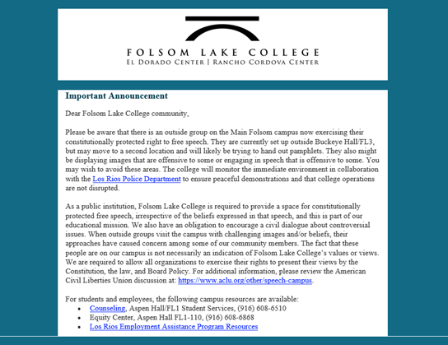

SAMPLE A-FRAME SIGNAGE MESSAGE

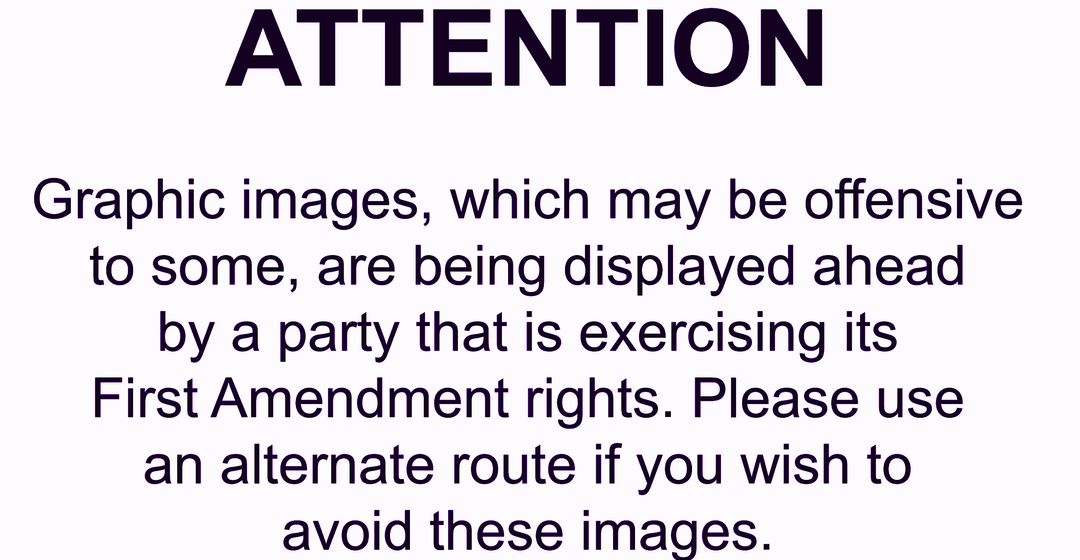

CAMPUS RESPONSE TEAM CHECK-LIST

- Initial assessment of whether event, demonstration, or tabling is controversial or inflammatory that may impact students negatively
- Sign-up sheet (online) for team members to sign up for shifts (Google Docs)
- Group text for Response Team Members
- Team members to wear FLC Apparel and/or wear name tags to clearly identify staff/faculty monitors
- Email to campus/community if a potentially controversial or sensitive topic expected on campus (PIO)—see draft message on page 3
- Large A-Frame signage—see draft message on page 4
- Workshops/Activities ready to go day of event(s) Example: Hot Cocoa/ coffee in Equity Center
- Info table: wellspace Resources, Health Center, Title IX, Equity Center, Mental Health resources, Weave, Freedom of Expression Fact Sheet (with link to webpage), LRCCD Police resources (in box, have name tags and FLC shirts/vests ready to go)
- Website email /social media – link to Free Speech page in the email
- Promote Safe space for students in Equity Center with food
- Physical presence of Response Team Members to support students—help students find alternate routes to get to class if needed
- Promote availability of mental health supports
- On-site counseling when upsetting/controversial interest groups are present on campus

