Guiding Principals
Classroom spaces are a limited resource and it is the role of the administration and department faculty to ensure that they are scheduled efficiently to promote student success and the mission of the college. Classrooms are owned by the college and ultimately by the citizens of the State of California and not by any department or individual. While classrooms may be allocated to individual departments, the assignments are not considered permanent.
Classroom scheduling is a dynamic process requiring reevaluation of class size, equipment specifications, and pedagogical changes each semester. The assignment of a specific room at a specific time in a given semester will not automatically guarantee a continuing assignment of that space, even if the room was used efficiently. Faculty members should not expect to use the same space on a continuing basis.
To carry out the mission of American River College, the classroom facilities are primarily for use by students, faculty and staff for activities and programs that are directly related to supporting students in strengthening basic skills, earning associate degrees and certificates, transferring to other colleges and universities, and achieving career as well as other academic and personal goals. Every effort is made to ensure that classrooms are assigned fairly, used appropriately, and accommodate the College’s academic and instructional needs.
All departments are strongly encouraged to plan and distribute classes across all the days of the week (Mon – Fri) and all hours of the day as much as possible to maximize use of campus classrooms and minimize class conflicts for students. These protocols are designed to ensure that semester course offerings are scheduled in a manner that permits access to available offerings by the greatest number of students and that allows the best match between the specific instructional needs of the faculty and courses being offered and the existing facilities.
Teaching facilities are a finite resource, and the goal of these policies is to maximize room and seat utilization as well as apply scheduling policies in a consistent and equitable manner. These objectives and classroom utilization expectations apply to all academic departments and classroom space.

Block Scheduling/Uniform Meeting Patterns
In the Fall of 2016, Dean Roger Davidson produced a draft of a Block Scheduling procedure for ARC. This portion of the paper will utilize that proposal as a basis with commentary injected with suggestions from the other Policy papers.

Overarching Guidelines
- There are more 3-unit lecture classes at ARC than any other format, and since these courses fit contiguously with a 10-minute passing time every 90 minutes, these “blocks” starting at 7:30AM form the basis for scheduling other class formats.
- Try to keep other class formats from crossing more than 2 “blocks” in general, and try to avoid more than one crossing during peak hours (assumed to be 9AM-1PM).
- Start evening classes at 6PM (no earlier than 5:30PM) to allow working students to travel from work to campus for class.

Proposed Start Times (by class units and days per week):
3-unit classes
- Meeting twice per week (MW or TR) – 80 minutes per day
  - 7:30AM, 9AM, 10:30AM, Noon, 1:30PM, 3PM, 4:30PM, 6PM, 7:30PM
  - These are the basic “blocks” of the block schedule.
- Meeting once per week – 185 minutes per day
  - Noon, 6PM
- 3-Unit Lecture/Lab sections need to start at a block time or end before a block time (schedule to minimize crossing blocks).
4-unit classes
- Meeting four times per week (MTWR) – 50 minutes per day
  - 8AM, 9AM, 11AM, Noon, 2PM, 3PM, 5PM, 6PM
- Meeting thrice per week (MWF {or TRSa?}) – 70 or 75 minutes per day
  - 7:30AM, 9AM, 10:30AM, Noon, 1:30PM, 3PM, 4:30PM, 6PM, 7:30PM
  - Same as the 3-unit, 2-day blocks
- Meeting twice per week (MW or TR) – 125 minutes per day
  - 8AM, 10:30AM, 12:45PM, 3PM, 6PM
- Meeting once per week (F, Sa or Su) – 245 minutes per day
  - 8AM, 1PM
5-unit classes
- Meeting four times per week (MTWR) – 65 minutes per day
  - 7:45AM, 9AM, 10:45AM, Noon, 1:45PM⁴, 3PM, 4:30PM, 6PM, 7:30PM
- Meeting thrice per week (MWF {or TRSa?}) – 90 minutes per day
  - 7:20AM, 9:15AM, 11AM, 12:45PM, 2:25PM, 6PM
  - Same as the 3-unit, 2-day blocks
- Meeting twice per week (MW or TR) – 140 minutes per day
  - 8AM, 10:30AM, 1:30PM, 6PM

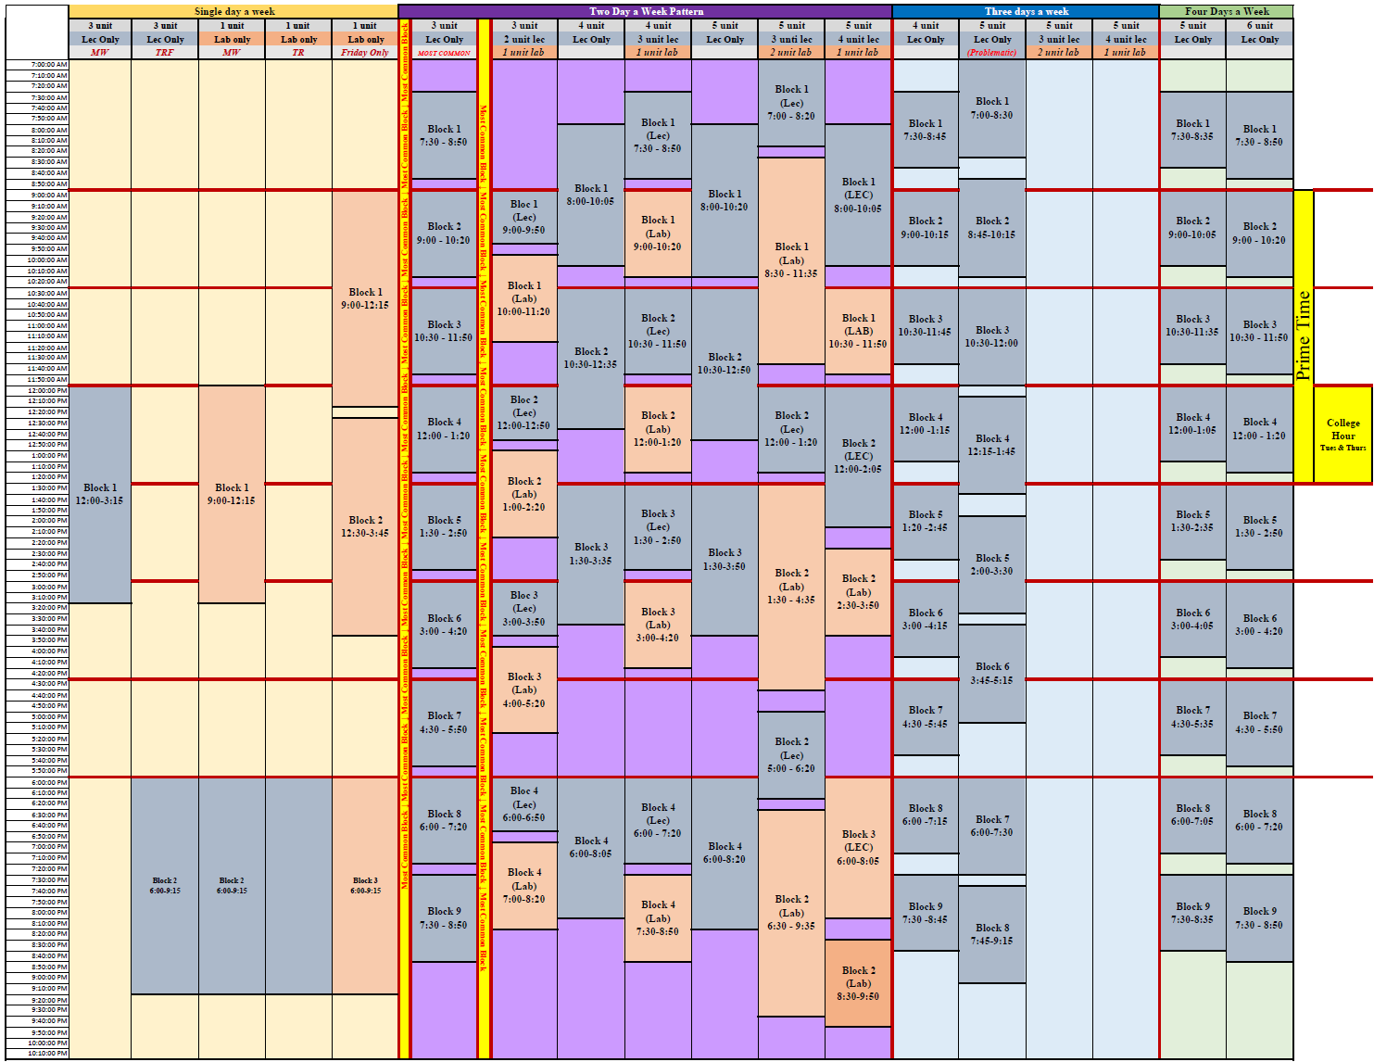

From an analysis of the scheduling policies, ARC will need to have further discussions on this block schedule proposal including:
- How to accommodate lab sections—how do we block 3, 4, and 5 unit lecture/lab courses to best utilize our spaces and provide the ability for students to take additional courses.
- Are there departments/programs exempted from the blocks:
  - Syracuse exempts “studio” classes in performing arts and studio arts.
  - Specialty rooms/labs
- Unusual day patterns

Distributional Constraints (Scheduling throughout the day/week)
Several of the Scheduling Policies have procedures imbedded to incentivize scheduling courses throughout the day. The University of Oregon divides the day into 5 zones and requires departments to proportionally schedule within the zones:
 | Zone 1 | Zone 2 | Zone 3 | Zone 4 | Zone 5
 | 8:00 - 9:50 | 10:00-11:50 & 12-1:50 | 2:00-3:50 | 4:00-5:50 | 6:00 or later
Max to schedule: | 20% | 40% | 25% | 15% | optional
Michigan provides a Scheduling Distribution Goal which also sets percentage goals for time periods:
Goal | Time of Day | Target Goal for Each School or College
1 | 10 -11 a.m. 11 a.m. – noon 1 – 2 p.m. | Up to 35% of classes and events can be scheduled at these times
2 | Noon – 1 p.m.  2 – 3 p.m. 3 – 4 p.m. | Up to 35% of classes and events can be scheduled at these times
3 | Before 10 a.m. After 4 p.m. | At least 30% of classes and events should be scheduled at these times

Goal | Day of Week | Target Goal for Each School or College
4 | Friday | At least 15% of classes and events should be scheduled on this day

Miami University adds in a third two-day pattern, Wednesday-Friday, in order to utilize facilities throughout the week—their standard day patterns are: MWF, TTH, MW, WF. Within their policy:
- A minimum of 90% of the full-term onsite or hybrid sections must occur within the schedule blocks.
- A distribution across MWF and TR must be achieved.
- A minimum of 50% of class section offerings must be on the MWF time block model; 4 and 5 day a week classes are included in this 50% minimum.
- A maximum of 50% of class sections can be on the TR time block model.
- An even distribution of class sections across all six daytime time blocks in both MWF and TR models must be achieved.
- To provide equal distribution throughout the day, time block #’s 1 through 5 must contain the same number of Monday and Friday meetings (e.g.: 10 MWF, 2 MW, 2 MF and 2 WF = 14 M and 14 F).
Several policies limit single day a week courses to Fridays or in the evening to limit disruption of a room’s schedule. For odd day patterns the recommendation is to try and “bundle” odd days to maximize the room usage: For example, a Mon-Tues class could be bundled with a Wed-Thurs section.

Room Control
Much of this will involve the room inventory and designating which room types may be exempted from shared usage (e.g. science labs and kitchens). The additional parts of this is in regards to what can be scheduled when. Generally, this involves establishing the following priorities:
- Regular Academic Credit Courses
- Support Activities (non-credit, tutoring, etc)
- Contracted use
- Ad Hoc reservations
Part of the discussion for ARC will be where we place departmental usage unattached to specific credit courses (for example rehearsals or club usage).

Who the Policy Applies To
Many of the policies have a minimum compliance percentage (i.e. “90 of all of the sections must occur within the schedule blocks”). Several have procedural steps that have to be followed for exceptions: often approval by the Provost. Several presenters at the Ad Astra conference noted that they didn’t process “off-block” or odd scheduled section in their first round of room assignments—so they would optimize for all of the courses which conformed to a “normal” schedule and then they would attempt to place the odd sections. It is important to note that one off-block section can substantially hinder true optimization of a room if it is hitting across time blocks.

Exception Process to the Block Schedule
Need to Flesh this out.

