This charter defines the guiding principles, roles, expectations, and practices applicable to all governance councils and project teams. It is intended to “serve as a complementary framework for how the groups will work together to achieve specified results with meaningful consensus. While Action Charters are designed specifically for each council or team, the Participation Charter provides a standardized approach applicable to all ARC governance groups.” (ARC Governance Framework, p. 7)

Charter Adoption: August 31, 2018 by the Executive Leadership Team (ELT)

EQUITY AND SOCIAL JUSTICE: GUIDING PRINCIPLES

To American River College, equity is defined as providing educational opportunities and support that meet the needs of the community, especially those who are historically underserved, marginalized, or disproportionately impacted. The ARC equity statement affirms that the college is committed to equity and social justice through equity-minded education, transformative leadership, and community engagement. Further, the institution strives to uphold the dignity and humanity of every student and employee since that is essential to achieving its mission and enhancing its community. (Institutional Equity Plan, p. 8)

The ARC Equity Framework provides three foundational principles that governance groups can actively pursue:

- College policies, practices, processes, and structures actualize success for disproportionately impacted and marginalized populations
- In professional roles, individuals utilize equity-based practices to effectively support and actualize success for disproportionately impacted and marginalized populations
- On a personal level, individuals practice self-awareness and equity; claim responsibility as a person and commit to equitable education; learn to recognize and address personal biases (Institutional Equity Plan, p. 9)

ROLE OF THE CHAIR(S) AND LEAD(S)
“The facilitative chair aspires to literally “make easy” the process of considering issues, engaging the participation of members, and arriving at meaningful consensus through an orderly and efficient process.” (ARC Governance Framework, p. 20)

The chair(s) of a chartered council are accountable to the Executive Leadership Team (ELT). Lead(s) of a chartered project are accountable to the sponsoring council. Individuals in these roles are expected to ensure communication and continuity of dialogue between governance tiers. Each sponsoring council’s chair and co-chair should discuss how this communication will be cultivated and coordinate with the lead(s) of sponsored projects. Chair(s) and lead(s) are responsible for preparing the agenda and facilitating meetings of the designated council or project team based on best practices to achieve “Great Governance” and guidelines for effective facilitation provided during training and described in the ARC Governance Framework.

Within each chartered council, the chair and co-chair should discuss and agree upon how the leadership role will be shared including how expected responsibilities will be divided. Once determined, the council members should be apprised of the role differentiation. Division of responsibilities may be revisited as often as needed to ensure effective council operations and facilitation.

Similarly, the lead and co-lead(s) of each project should discuss and agree upon how project leadership and project management responsibilities will be shared and/or delegated to a steward as soon as possible after being designated in leadership roles. The project team members should be informed of the role differentiation when expectations are set at the project kickoff.
ROLE OF THE MEMBER(S)
“Participants should be consensus-seeking rather than position taking which is only possible when the dialogue process is transparent and enables all members to both listen and understand one another clearly.” (ARC Governance Framework, p. 21)

Members are recognized as stakeholders with important expertise and perspectives relevant to the strategic charge of the designated council or team that can help to achieve the scope/deliverables described in the action charter. Members are expected to come prepared to actively attend and participate in all meetings, deliberations, and decision-making processes. While representing informed perspectives or those of a constituency group to which they belong, members are expected to engage in effective dialogue with their council or team peers with the intention of finding consensus on all issues that come before the designated council or team.

ROLE OF THE NOTE TAKER(S)
“Record keeping should be limited to capturing action items agreed upon by the group with contextual notes that frame the purpose of these actions. In this way the college community can “track” the work of each group with a clear understanding of the progress being made to address ARC Strategic Goals and component initiatives.” (ARC Governance Framework, p. 19)
The role of the note taker is to serve as an objective, but well informed, recorder of the activity and actions of the group. The note taker attends meetings and is expected to develop sufficient understanding of the topics to allow accurate recording. While the note taker serves as recordkeeper and drafts documentation, the chair(s) or lead(s) are responsible for the published content of meeting notes.

MEETING PROCEDURES AND EXPECTATIONS
“Effective meetings require well-designed agendas, active participation by members, and a record of results.” (ARC Governance Framework, p. 19)

Participants in councils and project teams are expected to adhere to the following participatory governance best practices.

Chairs and leads endeavor to:
- issue meeting agendas and supporting documentation in advance of meeting times
- organize meeting agendas to achieve milestones established in the charter and prioritize actions pending, actions required, and problem solving to move the work of the group forward
- arrange for notes to be captured during the meeting by an official designee (i.e., note taker) or record the meeting electronically so that notes can be produced after the meeting has finished
- conduct meetings efficiently including starting and ending meetings on time
- lead meetings in a manner that seeks participation, facilitates group understanding, and guides the dialogue towards consensus
- review and approve draft meeting notes prior to publication
- publish notes within a reasonable time frame, preferably within one business day

Members endeavor to:
- appropriately prepare for meetings based on the meeting agenda
- arrive promptly and stay for the duration of entire meetings
- participate in a problem-solving approach where the interests of all participants are considered in developing proposals and recommendations and, where appropriate, distinguish between constituency versus college-wide perspectives
- welcome all ideas, interests and objectives that are within the scope of the charter
- actively listen to engage in respectful and constructive dialogue
- speak with the intention of informing decision-making by offering relevant insights that have not already been shared
- focus on the perspective for which their expertise was originally sought (i.e., chartered perspective)
- work with a spirit of cooperation and compromise leading to authentic collaboration
- move forward once a consensus-based decision has been made
- continue to progress with the members who are present at each meeting
- follow through on tasks that are committed to outside of scheduled meetings

Note takers endeavor to:
- capture key discussion points, action items, and other information as directed by the chair(s) and/or lead(s)
- assist as needed with meeting scheduling, distributing materials, and other clerical support tasks

CONSENSUS AGREEMENT PROCESS AND DOCUMENTATION
“Achieving meaningful consensus is essential to great governance and leads to the formation of decisions that advance the college community in the direction of preferred future outcomes.” (ARC Governance Framework, p. 19)

Clear agreements and public indications of understanding and support are critical to maintain forward progress for the work of the group. On occasion, and after extensive dialogue, members will be asked to indicate their agreement to pursue a specific direction or to conclude discussion of a specific topic or action. This agreement will seek to be based on “consensus” which is a general state of agreement rather than a “majority opinion”.

Consensus-based decision-making processes attempt to resolve each member’s concerns before asking for agreement and closing discussion regarding a recommendation. The consensus-taking process will proceed according to the following steps:

- Any member, chair/co-chair, or lead/co-lead may ask for an indication of agreement.
- Members will indicate their degree of support for the selected recommendation as follows:
  - agreement with the recommendation,
  - support for the good of the whole without necessarily completely embracing the recommendation,
  - disagreement with the recommendation.
A simple method for indicating degrees of support can be used such as “Thumb’s Up” to signify agreement, “Thumb’s to the Side” to indicate support for the good of the whole, and “Thumb’s Down” to indicate disagreement.
 | Agree/support
 | Agree/support for the good of the council or project, but have some reservations
 | Disagree/do not support
- If there is no opposition indicated, the agreement will be recorded within the meeting notes and discussion will conclude.
- The chair/co-chair or lead/co-lead are responsible for determining if/when consensus has been reached. In circumstances where opposition is indicated, they may decide to continue discussion, table the item temporarily, or move forward.
- To sustain the forward progress of the work of the group it may be necessary to record participant agreement related to a specific item without full member consensus. If certain participants have persistent concerns that prevent them from agreeing to the item, then a majority opinion is recorded, and the minority opinion is also captured in the meeting notes. A minority opinion is defined as any level of dissent by less than 50% of those present who are listed on the official roster of the council or project. However, the level of detail at which the majority and minority opinions are recorded is left to the discretion of the chair/co-chair or lead/co-lead. It may be appropriate in certain situations to simply record that an item was not unanimously supported, but was moved forward by the majority despite concerns previously recorded in the notes.

AUTHORIZATION TO SEEK ADDITIONAL EXPERTISE/PERSPECTIVES
“Governance groups may consult with individual faculty, classified staff, and/or management to acquire specific information, resources, or other means of support needed to address action items, solve problems, or get technical assistance that supports the group’s chartered deliverables.” (ARC Governance Framework, p. 17)
Any council or project team may seek additional expertise and/or invite guest perspectives to a meeting when considered beneficial to inform decision-making. Invited guests may participate by speaking at the meeting as authorized by the chair/co-chair or lead/co-lead. The names of invited guests will be published in the appropriate section of the meeting agenda. Information offered by those contacted should be considered and appropriately limited by any boundaries previously specified within the council or project charter.

COMMUNICATION AND DISTRIBUTION OF MATERIALS

Each council and project team will strive to provide timely and accessible communication and documentation of its activity and outputs that reflect key discussion points and action items. Collaboration and communication will be enabled through the use of the following systems provided and supported by the college:

System | Audience | Documents/Information
Basecamp | Individual councils or project teams – intended to facilitate collaboration within a governance entity | - Meeting packets  - Relevant resources and research  - Communication via message boards  - Project work plans, task lists, and drafts of deliverables
Institutional Governance Online Repository (IGOR) | - All governance tiers (councils, projects, Senates, management groups)  - Campus community | - Project charters  - Meeting agendas  - Meeting notes  - Council/project team rosters  - Project status updates  - Completed deliverables and archived project information
ARC Web Site | - Campus community  - Public | - General governance information  - ARC Governance Framework  - List of current projects and accomplishments of past projects  - Forward Motion governance highlights  - Links to additional information residing in IGOR (e.g., project charters)

APPENDIX: GREAT GOVERNANCE
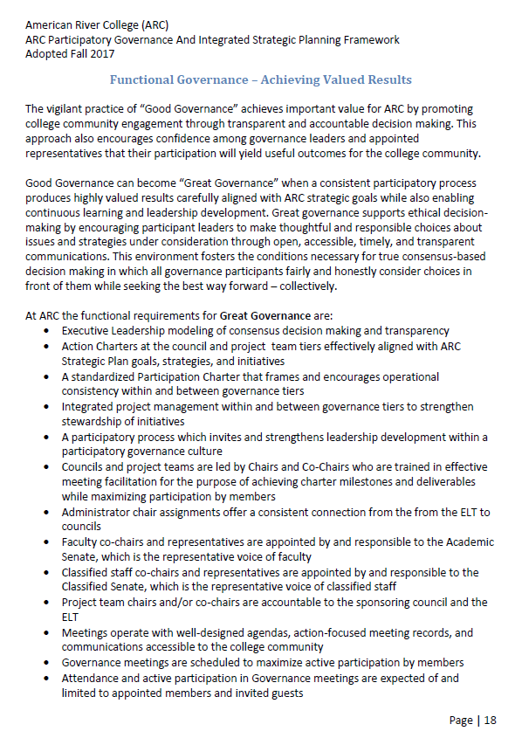
Note: In practice, ARC refers to council leadership as chair/co-chair and project leadership as lead/co-lead. Any reference to chair/co-chair in the ARC Governance Framework also applies to lead/co-lead.

