

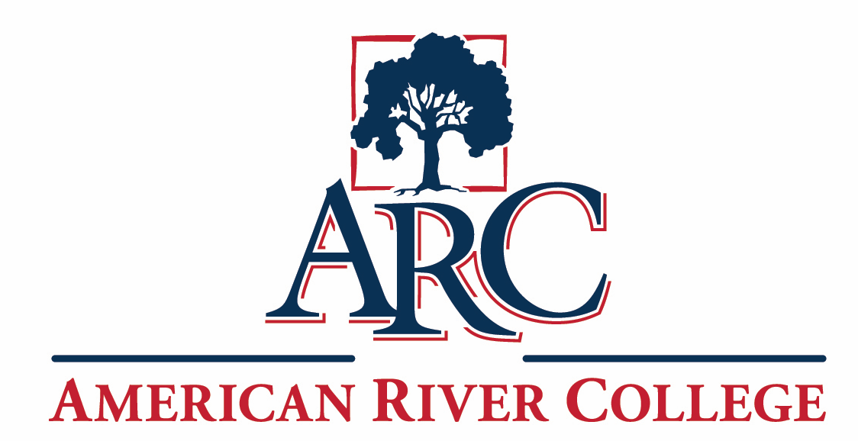
Technology Master Plan 2026–2033

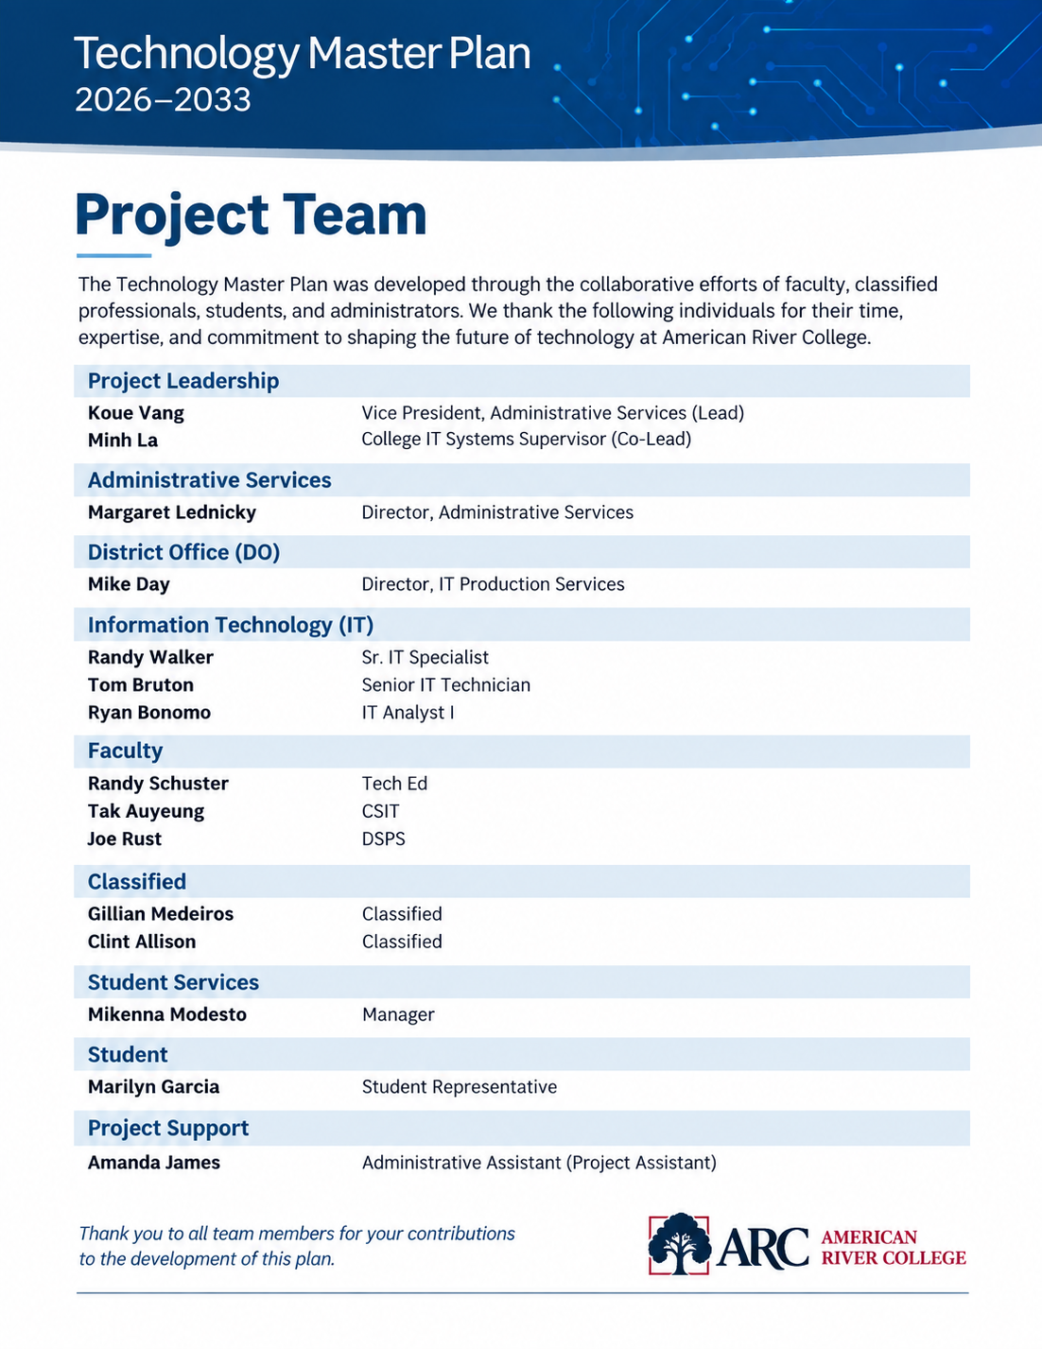

Table of Contents
1. Executive Summary 0
2. Planning Process & Institutional Context 0
Background and Need for the Plan 0
Planning Approach 0
Planning Phases 0
Guiding Principles 0
Alignment with Institutional Planning 0
3. Technology Environment Overview 0
District-Managed Systems 0
College-Managed Systems 0
Technology Scale and Complexity 0
Identity, Integration, and Hosting 0
Implications for Planning and Operations 0
4. Current State Summary 0
Infrastructure & Systems 0
Data & Systems 0
Teaching & Learning 0
User Experience 0
Operations 0
Cross-Cutting Themes & Strategic Implications 0
5. Vision Statement 0
6. Technology Goal Areas 0
Infrastructure & Systems 0
Teaching & Learning 0
User Experience 0
Data & Decision-Making 0
Equity & Access 0
Governance & Innovation 0
Operations 0
7. Prioritization Framework 0
Evaluation Criteria 0
Key Constraints 0
8. Technology Roadmap 0
Near-Term (0–18 Months) 0
Mid-Term (18 Months – 3 Years) 0
Long-Term (3–5+ Years) 0
9. Governance & Decision-Making 0
Governance Structure 0
Decision-Making Approach 0
Technology Implementation & Governance Workgroup 0
Initiative Ownership & Accountability 0
Future Direction 0
10. Technology Funding Strategy 0
Current Funding Environment 0
Key Challenges 0
Future Funding Approach 0
Strategic Direction 0
11. Training, Support & Adoption 0
Current State 0
Strategic Focus 0
Future Direction 0
12. Continuous Improvement & Assessment 0
Assessment Approach 0
Integration with Institutional Planning 0
Continuous Improvement 0
13. Metrics & Key Performance Indicators (KPIs) 0
14. Appendix A: Technology Initiative Summary 0

American River College
Technology Master Plan (TMP) 2026–2033 (Draft)

1. Executive Summary

The American River College (ARC) Technology Master Plan (TMP) establishes a strategic, multi-year framework to guide technology investments, modernization, and governance across instruction, student services, and administrative operations.

This plan reflects a comprehensive, participatory planning process involving faculty, classified professionals, administrators, Information Technology (IT) staff, and student representative. Through this process, ARC identified critical gaps in infrastructure, systems integration, data access, user experience, and operational efficiency.

The TMP is designed to:
- Improve student success and access
- Support modern teaching and learning environments
- Strengthen data-informed decision-making
- Enhance operational efficiency
- Ensure equity, accessibility, and security

The plan outlines a phased roadmap (near-, mid-, and long-term) that balances high-impact initiatives with institutional capacity, resource requirements, and key dependencies—particularly those at the district level. It provides a foundation for consistent decision-making, sustainable investment, and continuous improvement across ARC’s technology environment.

2. Planning Process & Institutional Context

Background and Need for the Plan
The prior Technology Master Plan became outdated due to evolving district-level technology discussions and the rapid transformation of instructional and operational needs, particularly following the COVID-19 pandemic. The expansion of distance learning, increased reliance on digital systems, and growing expectations for seamless technology experiences highlighted the need for a renewed, forward-looking plan.

Additionally, ongoing challenges—including aging infrastructure, fragmented systems, limited data access, and increasing accessibility requirements—underscore the importance of a coordinated and strategic approach to technology planning.

Planning Approach
The TMP was developed through a structured, collaborative, and iterative process aligned with ARC’s Integrated Planning Model.

Participants included:
- Faculty (instructional and student services)
- Classified professionals
- Administrators
- Information Technology staff
- Student representative

Planning Phases
- Meeting 1 – Orientation & Scope
Defined purpose, scope, and shared understanding of technology
- Meeting 2 – Current State Assessment
Identified infrastructure, systems, and operational gaps
- Meeting 3 – Needs Identification
Identified capability-based needs across the college
- Meeting 4 – Strategic Alignment
Aligned needs with institutional priorities
- Meeting 5 – Vision & Goal Areas
Established future-state vision and strategic goals
- Meeting 6 – Prioritization Framework
Developed criteria and constraints for decision-making
- Meeting 7 – Draft Roadmap Development
Consolidated initiatives into a multi-year roadmap

Guiding Principles
- Student-centered and equity-focused
- Standardization and integration
- Sustainable lifecycle planning
- Data-informed decision-making
- Flexibility and innovation
- Clear governance and accountability

Alignment with Institutional Planning
This plan aligns with:
- ARC Integrated Planning Model
- Institutional strategic priorities
- ACCJC Standard III.C (Technology Resources)

3. Technology Environment Overview

American River College operates within a hybrid technology environment that includes both district-managed and college-managed systems. This model provides opportunities for standardization and shared services while also requiring strong coordination, integration, and governance across organizational levels.

District-Managed Systems
Core enterprise systems—including the student information system, human resources, financial systems, email and productivity tools, learning management systems, cybersecurity platforms, and network infrastructure—are centrally managed at the district level. This centralized approach ensures consistency, enhances security, and achieves economies of scale across the Los Rios district.

These systems provide consistency, security, and economies of scale across the Los Rios Community College District, while also establishing standards that guide local implementation. Shared data environments between district and college systems are primarily batch-oriented with scheduled refresh cycles, which shape what is achievable for local analytics and operational decision-making.

College-Managed Systems
At the college level, ARC supports a range of local applications, instructional technologies, classroom systems, and operational tools that address campus-specific needs. These systems often require integration with district platforms and ongoing coordination with district IT to ensure compatibility, security, and effective support. ARC maintains a substantial portfolio of local web applications supporting instruction, student services, and administrative operations, sustained by a small programming team.

Technology Scale and Complexity
ARC supports a large and diverse technology environment, including:
- Hundreds of classrooms with varying levels of technology integration
- Multiple computer labs and specialized instructional spaces
- Thousands of students, faculty, and staff users
- Students access systems and instructional content across a wide range of devices, including smartphones, Chromebooks, laptops (Mac and Windows), and desktop workstations, increasing the complexity of supporting a consistent technology environment.
- A mix of legacy and modern systems

Identity, Integration, and Hosting
Identity and access management is in transition toward a unified single sign-on and multi-factor authentication model, with adoption currently limited across local systems. A district-level integration platform is under development and will shape future system-integration approaches. Local applications are primarily hosted in the college's cloud environment, with remaining workloads supporting on-premises infrastructure.

Implications for Planning and Operations
This hybrid environment creates both opportunities and operational challenges. While district-managed systems provide consistency and shared infrastructure, college-managed systems offer flexibility to meet local needs. At the same time, fragmentation, integration challenges, and varying system lifecycles impact user experience, operational efficiency, and the ability to scale technology solutions. Limited engagement between district-level technology planning and college practitioners and end-users can also result in solutions that do not fully reflect campus operational realities or user needs.

Effective technology planning at ARC requires:
- Strong coordination between college and district systems
- Standardization, where appropriate, to reduce complexity
- Strategic integration across platforms and services
- Clear governance to support decision-making and prioritization
- Sustained engagement between district-level technology planning and college practitioners and end-users to ensure solutions reflect operational realities and user needs

4. Current State Summary

Infrastructure & Systems
ARC’s infrastructure and systems environment reflects a mix of modern investments and aging components, resulting in inconsistent performance and reliability across campus. While core network and cloud capabilities provide a stable foundation, gaps in lifecycle planning, standardization, and proactive monitoring create challenges in scalability, security, and user experience.

- Aging infrastructure and inconsistent classroom technology
- Limited lifecycle planning and proactive monitoring
- Inconsistent standards across classrooms, labs, and support spaces, resulting in variable reliability and user experience
- Growing technical debt across legacy systems, hardware, and unsupported technologies
- Continued reliance on legacy application frameworks that are no longer vendor-supported increases both security and maintenance burden
- Gaps in proactive monitoring and maintenance, leading to reactive support models and downtime
- Limited centralized observability (e.g., log aggregation, performance monitoring) constrains proactive detection and response
- Infrastructure constraints (power, network capacity, facility limitations) are impacting scalability and modernization efforts
- Increasing cybersecurity risks due to outdated systems and uneven implementation of security controls (e.g., MFA, endpoint protection)
- Disaster recovery, backup, and business continuity practices for critical local systems are not consistently defined or regularly validated.

Data & Systems
ARC’s data and systems environment is heavily influenced by district-managed platforms, creating both consistency and constraints. While core systems provide essential functionality, limitations in data access, integration, and governance result in delays, inefficiencies, and reliance on manual processes. These challenges impact the college’s ability to make timely, data-informed decisions and highlight the need for a more streamlined and accessible data ecosystem.

- Dependence on district-managed systems
- Delayed and fragmented data access
- Primary district-to-college data interfaces operate on scheduled batch refresh cycles rather than real-time access, resulting in reporting and operational data that reflects source systems on a delayed basis, impacting timely decision-making
- Lack of direct control over data pipelines, integrations, and reporting tools
- Limited availability of programmatic (API-based) access to district data, requiring local workarounds and batch reporting to meet operational and reporting needs
- Disconnected systems requiring duplicate data entry and manual reconciliation
- Staff in student services programs serving equity-impacted populations (e.g., DSPS, EOPS, CalWORKs) rely on manual data reconciliation — calculating student eligibility from multiple systems by hand — due to the absence of integrated, real-time student data
- Inconsistent data definitions and governance practices across systems
- Limited self-service reporting capabilities for departments, increasing reliance on IT and workarounds
- Emerging need for institutional data governance, integration strategy, and analytics capability

Teaching & Learning
Technology plays a critical role in supporting teaching and learning at ARC; however, the current environment is inconsistent and not fully aligned with evolving instructional needs. Variability in classroom technology, limited support for hybrid modalities, and gaps in training and support for both students and faculty create barriers to effective teaching and learning, negatively impacting the student experience. As demand for integration of AI tools as well as flexible and accessible learning continues to grow, a more standardized, flexible, and well supported instructional technology environment is needed.

- Differences in how students and faculty experience and interact with instructional technologies, leading to misalignment, confusion, and inefficiencies in teaching and learning
- Limited hybrid instructional technology support and training for both students and faculty
- Significant variability in classroom AV technology, interfaces, 3rd party log-in requirements, and reliability, impacting instructional time
- Growing demand for hybrid, flexible, and “sync-flex” instructional modalities without consistent infrastructure or scheduling support
- Insufficient faculty and student training and support for instructional technologies and emerging tools
- Accessibility gaps in instructional materials and platforms, increasing compliance risk, and faculty workload
- Technology limitations (bandwidth, audio quality, software access) are affecting student engagement and learning outcomes
- Licensing and platform constraints are creating barriers to instructional delivery and innovation

User Experience
The digital experience at ARC is fragmented across multiple systems, platforms, and communication channels, creating challenges for students, faculty, and staff. Users often navigate disconnected tools with inconsistent interfaces and communication practices, leading to confusion, missed information, and inefficiencies. A more integrated, user-centered approach is needed to simplify access, improve communication, and enhance the overall experience across the institution.

- Fragmented communication platforms
- Lack of unified digital experience
- Disconnected systems for students, faculty, and staff requiring multiple logins and navigation across platforms
- Inconsistent communication practices across email, LMS, messaging tools, and other systems
- Limited centralized access to information, services, and status tracking (e.g., forms, requests, student services)
- Website and portal usability challenges, including accessibility and navigation issues
- Inconsistent mobile-responsive design across local applications, limiting access for students, faculty, and staff who rely on mobile devices
- Lack of standardized communication strategy for reaching students effectively (e.g., limited SMS/text integration)
- Need for a cohesive, user-centered digital ecosystem that supports all user groups (students, faculty, staff, administrators)

Operations
Operational processes across ARC rely heavily on manual workflows and disconnected systems, limiting efficiency, transparency, and scalability. The lack of automation and integration results in redundant efforts, delays, and limited visibility into processes and approvals. Addressing these challenges will require modernizing workflows, improving system integration, and aligning technology with operational needs and resources.

- Manual processes and limited automation
- Lack of transparency in workflows
- Heavy reliance on paper forms, PDFs, spreadsheets, and email-based processes
- Operational burden of maintaining local applications built on unsupported legacy frameworks
- Limited visibility into status of requests, approvals, and workflows (especially across departments and with district processes)
- Variable approval turnaround on district-managed system changes, with no accelerated path for low-risk changes
- Redundant and duplicative processes across departments, reinforced by limited programmatic data access and the absence of a mature integration platform between district and college systems
- Inefficiencies in scheduling, event management, and resource coordination systems
- Fragmented tracking of facilities work orders, IT assets, and classroom equipment
- Staffing constraints limiting the ability to modernize processes and support new initiatives
- Limited use of automation, system integration, and workflow tools to improve efficiency and reduce risk
- Lack of standardized processes and governance for technology adoption and operational systems

Cross-Cutting Themes & Strategic Implications
Across all areas, several common themes emerged that highlight systemic challenges and opportunities for improvement. These themes reflect institution-wide patterns and systemic challenges rather than isolated issues and will guide the development of strategic priorities, investments, and the overall technology roadmap.

- Fragmentation: Systems, data, and user experiences are disconnected and inconsistent across the institution
- Security Posture: Vulnerability remediation, identity modernization, and cyber risk management cut across all technology areas and require coordinated, institution-wide attention
- Application and Technical Debt: A meaningful share of the local application portfolio operates on legacy, unsupported frameworks, creating security, maintenance, and modernization obligations that span multiple goal areas
- Dependency on District Systems: Limited local control over key systems, timelines, and integrations; the absence of formal service agreements and shared governance frameworks between college and district IT adds uncertainty to planning and delivery
- Resource Constraints: Staffing, funding, and infrastructure capacity limit the pace of modernization
- Reactive vs. Proactive Operations: Many services rely on reactive support rather than planned lifecycle management
- Equity & Accessibility Gaps: Disproportionate impact on students requiring accessible and flexible learning environments
- Growing Demand vs. Capacity: Increasing expectations for digital services, hybrid learning, and data access exceed current capabilities
- Need for Governance: Lack of clear ownership, standards, and decision-making frameworks for technology

5. Vision Statement

Reliable, secure, and accessible technology that supports teaching and learning, enables integrated student services, and drives efficient, data-informed operations for all students, faculty, and staff.

6. Technology Goal Areas
The following goal areas define ARC’s strategic priorities for technology and provide the foundation for the initiatives and roadmap outlined in this plan. Implementation of these goals will be phased based on institutional priorities, available resources, staffing capacity, and district dependencies.

Infrastructure & Systems
ARC will establish a reliable, secure, and sustainable technology foundation that supports all college operations and instructional environments. This includes modernizing infrastructure, standardizing systems, and implementing proactive lifecycle management to ensure consistent performance, scalability, and security across campus.

- Reliable and sustainable infrastructure
- Secure and modern applications
- Sustained application modernization program to retire unsupported frameworks and bring local applications onto current, secure platforms
- System integration and interoperability
- Standardized classroom and campus technology environments to ensure consistent reliability and user experience
- Defined lifecycle replacement and modernization strategy spanning infrastructure, endpoints, classroom technology, and applications
- Proactive monitoring and maintenance to reduce downtime and service disruptions
- Strengthened cybersecurity posture, including unified single sign-on with multi-factor authentication, endpoint protection, defined service levels for vulnerability remediation, and maturing security operations capabilities

Teaching & Learning
ARC will enhance teaching and learning by providing modern, flexible, and accessible instructional technologies that support diverse modalities and instructional practices. The college will focus on creating consistent classroom environments, expanding hybrid capabilities, and strengthening training and support for faculty.

- Modern teaching and learning technology
- Flexible and hybrid learning environments
- Instructional technology support and training for students and faculty
- Consistent and adaptable classroom technology design to reduce instructional barriers, support diverse instructional needs, and minimize lost teaching time
- Expanded support for hybrid, online, and “sync-flex” modalities
- Ongoing faculty and student training aligned with evolving instructional technologies and tools
- Improved access to instructional software and platforms across disciplines

User Experience
ARC will create a cohesive, user-centered digital experience that simplifies access to systems, services, and information for students, faculty, and staff. By improving integration, communication, and usability, the college will reduce complexity and enhance engagement across all user groups.

- Integrated digital experience for students, faculty, and staff
- Simplified and consistent communication
- Unified access to systems, services, and information through streamlined platforms and single sign-on
- Clear and consistent communication tools and practices across the institution
- Improved website, portal, and mobile experience to support consistent access and navigation across devices for all user groups
- Centralized visibility into requests, services, and processes (e.g., forms, status tracking)

Data & Decision-Making
ARC will strengthen its data environment to support timely, accurate, and data-informed decision-making across the institution. This includes improving data access, establishing governance structures, and expanding analytics capabilities to reduce reliance on manual processes and fragmented reporting.

- Data governance and institutional intelligence
- Timely and accurate data access
- Improved access to real-time or near real-time data to support decision-making
- Reduced reliance on manual reporting and data workarounds
- Clear data governance structure, including ownership, definitions, and standards
- Formal partnership with Institutional Research on data definitions, metadata, and analytics governance to ensure institutional consistency
- Expanded self-service reporting and analytics capabilities for departments
- Integration of data across systems through programmatic and event-driven approaches to support a more complete institutional view and reduce manual reconciliation
- A clean, well-documented, and accessible data foundation that supports emerging analytical and AI capabilities

Equity & Access
ARC will ensure that all technology solutions are designed with accessibility and equity at the forefront by eliminating barriers to access, supporting diverse student needs, and ensuring compliance with accessibility standards across all systems and services.

- Accessibility and equity by design
- Technology solutions that meet accessibility standards and compliance requirements
- Ongoing accessibility audit cadence and defined remediation timelines for systems and instructional materials
- Proactive integration of accessibility into all systems, tools, and instructional materials
- Consistent captioning and transcription support for instructional and institutional video and audio content
- Expanded access to technology resources for all students, including those with limited connectivity or devices
- Reduction of equity gaps in digital access, navigation, and support services
- Elimination of manual data entry that disproportionately burden student services programs supporting equity-impacted populations (e.g., DSPS, EOPS, CalWORKs)

Governance & Innovation
ARC will establish clear governance structures and decision-making processes to guide technology planning, prioritization, and implementation. At the same time, the college will thoughtfully explore and adopt emerging technologies, ensuring innovation aligns with institutional priorities, risk management, and long-term sustainability.

- Responsible AI and emerging technology governance
- Structured decision-making
- Clear governance framework for evaluating, prioritizing, and implementing technology initiatives
- Structured evaluation and onboarding process for third-party software and services, covering security, accessibility, data handling, and total cost of ownership
- Defined roles, responsibilities, and decision pathways across the institution
- Exploration and adoption of emerging technologies (e.g., AI/LLMs) aligned with institutional priorities and safeguards
- Clear acceptable use, data-handling, and review processes for artificial intelligence and machine learning tools
- Balance between innovation and standardization to support both flexibility and sustainability

Operations
ARC will modernize operational processes through the strategic use of technology, automation, and system integration. By improving transparency, reducing manual work, and aligning investments with long-term funding strategies, the college will enhance efficiency, accountability, and service delivery.

- Operational efficiency and modernization
- Workflow automation and transparency
- Sustainable lifecycle funding strategies
- Expansion of eForms, automation, and system integrations to reduce manual processes
- Improved coordination and integration with district operational systems and processes to reduce duplicated effort and disconnected workflows
- Improved visibility into workflows, approvals, and service requests
- Reduction of high-cost manual data entry through integrated access to student and operational data
- Standardization of systems used for scheduling, events, and operational functions
- Alignment of technology investments with long-term funding strategies and lifecycle planning
- Consolidation of redundant operational systems and processes to simplify the institutional operational landscape

7. Prioritization Framework

To ensure that technology investments align with institutional priorities and available resources, ARC established a structured prioritization framework. This framework was used to evaluate and sequence initiatives based on impact, feasibility, alignment with the college’s mission and strategic goals, and risk.

Evaluation Criteria
Initiatives were evaluated using the following criteria:
- Student Impact – The extent to which the initiative improves student success, access, and experience
- Institutional Alignment – Alignment with ARC’s strategic priorities, accreditation standards, and integrated planning processes
- Risk & Compliance – Ability to address security, regulatory, accessibility, and operational risks
- Operational Efficiency – Potential to improve processes, reduce manual work, and increase effectiveness
- Feasibility & Readiness – Level of effort, technical complexity, and organizational readiness for implementation

Key Constraints
In addition to evaluation criteria, the following constraints were considered in prioritizing and sequencing initiatives:
- Staffing Capacity – Availability of IT and operational resources to support implementation and ongoing maintenance
- Budget – Availability of funding, including one-time and ongoing costs
- District Dependencies – Reliance on district-managed systems, timelines, and approvals
- Implementation Complexity – Technical, operational, and organizational complexity, including system integration and change management

8. Technology Roadmap
The following roadmap outlines a phased approach to implementing ARC’s technology priorities. Initiatives are sequenced based on impact, feasibility, institutional capacity, and dependencies, while also accounting for dependencies on district systems, available resources, and organizational readiness.

Near-Term (0–18 Months)
Focus: Stabilize, standardize, and address critical gaps
- Modernize and standardize classroom technology to improve reliability and consistency
- Address accessibility and compliance gaps across systems and instructional materials
- Expand eForms and workflow automation to reduce manual processes
- Improve system monitoring, maintenance, and overall reliability
- Enhance instructional technology training and user support

Mid-Term (18 Months – 3 Years)
Focus: Integrate systems, improve experience, and expand capabilities
- Develop a unified digital experience for students and employees
- Improve data access, integration, and reporting capabilities
- Advance system integration and modernization efforts
- Expand hybrid and flexible learning capabilities
- Implement the Technology Implementation & Governance Workgroup and initiative ownership model
- Implement a coordinated communication strategy and engagement tools
- Improve process transparency, tracking, and operational visibility
- Develop and implement an AI and emerging technology strategy

Long-Term (3–5+ Years)
Focus: Transform, optimize, and sustain
- Complete infrastructure modernization and lifecycle alignment
- Establish a fully integrated and unified digital ecosystem
- Advance cybersecurity maturity and risk management capabilities
- Enable adaptive, technology-rich learning environments

This roadmap will be refined over time as initiatives progress, resources evolve, and institutional priorities and technologies continue to change. Placement of an initiative within the roadmap reflects anticipated sequencing and does not represent a funding commitment. Implementation will depend on available resources, institutional priorities, staffing capacity, and applicable district dependencies.

9. Governance & Decision-Making

Effective technology planning and implementation require clear governance structures and decision-making processes that align with institutional priorities, support transparency, and ensure accountability.

Technology governance at ARC is guided by the following principles:
- Transparency – Clear and open communication regarding decisions, priorities, and processes
- Shared Responsibility – Inclusive participation across faculty, staff, administrators, and IT
- Alignment with Institutional Goals – Consistent connection to ARC’s mission, strategic priorities, and student success

Governance Structure
Technology-related decisions are informed through:
- Participatory governance processes
- Input from faculty, staff, administrators, and IT
- Alignment with college leadership and coordination with district partners

The Operations Council serves as a key body for reviewing and aligning operational and technology priorities with institutional needs, ensuring integration with broader college planning and resource allocation processes.

Decision-Making Approach
Technology decisions are guided by:
- The prioritization framework established in this plan
- Consideration of impact, feasibility, risk, and dependencies
- Alignment with student success, operational effectiveness, and equity

This approach supports consistent, data-informed, and transparent decision-making across all technology initiatives.

Technology Implementation & Governance Workgroup
To support the successful execution of the Technology Master Plan, ARC will establish a cross-functional Technology Implementation & Governance Workgroup.

The workgroup will include representation from faculty, classified professionals, Information Technology (college and district), and administration, with appropriate engagement of established participatory governance and constituent groups.

Responsibilities will include:
- Monitoring progress of TMP initiatives and roadmap implementation
- Identifying risks, dependencies, and resource constraints
- Coordinating across divisions and with District IT
- Ensuring alignment with the TMP prioritization framework and institutional goals

Governance Alignment:
The workgroup will report regularly to the Operations Council, which will provide oversight, ensure alignment with institutional priorities, and support decision-making related to resource allocation, sequencing, and policy direction.

This structure ensures that implementation remains coordinated, transparent, and responsive to evolving institutional and technology needs.

Initiative Ownership & Accountability
As initiatives advance to implementation, each major initiative will be assigned an appropriate lead based on scope, organizational responsibility, and available capacity.

Initiative leads may be assigned from Information Technology, instructional areas, student services, or administrative units, depending on the nature of the initiative.

Responsibilities of initiative leads include:
- Driving implementation planning and execution
- Coordinating with cross-functional partners
- Identifying risks, dependencies, and resource needs
- Reporting progress to the Technology Implementation & Governance Workgroup

This structure ensures clear accountability for outcomes while enabling the workgroup to focus on coordination, alignment, and institutional oversight.

Future Direction
ARC will continue to strengthen its technology governance model by:
- Formalizing a comprehensive technology governance framework
- Clearly defining roles, responsibilities, and decision-making pathways
- Establishing standardized processes for evaluating, prioritizing, and implementing technology initiatives
- Enhancing coordination with district IT and governance structures
- Incorporating emerging areas such as artificial intelligence (AI) and digital innovation into governance processes
- Ensuring ongoing review and adaptation of governance practices to meet evolving institutional needs

10. Technology Funding Strategy

Sustainable technology planning at ARC requires a coordinated, long-term funding strategy that supports ongoing operations, lifecycle replacement, and strategic innovation. As technology becomes increasingly central to instruction, student services, and operations, aligning funding with institutional priorities is critical to maintaining a reliable and modern technology environment.

Current Funding Environment
Technology at ARC is supported through a combination of funding sources, including:
- State funding sources
- District allocations
- College general funds
- Grants and categorical funding
- One-time funding opportunities

Key funding sources include the State Instructional Equipment Fund (SIEF), Scheduled Maintenance (SMSR), district allocations, and grant funding. ARC has also established a technology replacement fund to support ongoing equipment lifecycle needs. However, available funding sources are often limited in scope, unpredictable, or temporary, creating challenges for sustaining long-term technology investments.

Key Challenges
- Reliance on one-time or variable funding sources that limit long-term planning
- Limited sustainable funding for long-term lifecycle replacement of infrastructure, systems, and equipment
- Competing institutional priorities that impact available technology funding
- Increasing costs associated with infrastructure, cybersecurity, licensing, and cloud services

Future Funding Approach
To support a sustainable and strategic technology environment, ARC will:
- Move toward lifecycle-based funding approaches to support regular replacement and modernization of technology assets
- Align technology investments with institutional planning and budgeting cycles
- Prioritize funding decisions based on impact, risk, and institutional alignment
- Strengthen coordination between college and district funding strategies
- Explore and pursue external funding opportunities, including grants and partnerships
- Continue to support the technology replacement fund and evaluate opportunities to strengthen lifecycle funding as resources are available.

Strategic Direction
ARC’s long-term approach to technology funding will focus on balancing operational stability with strategic innovation. This includes supporting sustainable funding for core infrastructure and systems while also building capacity to invest in emerging technologies, improved user experiences, and data-driven capabilities that support student success and institutional effectiveness.

11. Training, Support & Adoption
The successful implementation of technology at ARC depends on the ability of faculty, staff, and students to effectively understand, adopt, and utilize available tools. Providing consistent training, accessible support, and user-centered systems is essential to maximizing the value of technology investments and ensuring equitable access to digital resources and consistent adoption across the institution.

Current State
- Inconsistent training across systems and departments
- Limited time and resources for professional development
- Variability in adoption, usage, and comfort with technology tools
- Gaps in awareness of available tools, features, and support resources
- Inconsistent user experience due to differences in training and system design

Strategic Focus
- Expand instructional technology training for faculty and staff
- Improve access to professional development opportunities, including flexible and on-demand options
- Strengthen user support models to provide timely and effective assistance
- Improve system usability and design to reduce reliance on training alone
- Promote awareness and communication of available tools and resources
- Ongoing technical training for IT and programming staff to support modernization, integration, and emerging technology initiatives

Future Direction
ARC will strengthen its approach to training, support, and adoption by:
- Integrating training and support into all major technology initiatives
- Aligning training with system rollouts, upgrades, and process changes
- Promoting consistent adoption of standard tools and practices across the institution
- Expanding flexible training delivery methods (e.g., workshops, online modules, self-paced resources)
- Enhancing support services to improve responsiveness and user satisfaction
- Incorporating user feedback to continuously improve training and system usability
- Proactive change management for major system transitions, including stakeholder communication and adoption planning, beyond training delivery alone

12. Continuous Improvement & Assessment
The Technology Master Plan is a living document that will be continuously evaluated and refined to ensure alignment with institutional priorities, emerging technologies, and the evolving needs of the ARC community.

Assessment Approach
ARC will evaluate the effectiveness of technology initiatives through:
- Key Performance Indicators (KPIs) aligned with strategic goals
- Program Review processes and outcomes
- Stakeholder feedback from faculty, staff, and students
- Operational and system performance data

Integration with Institutional Planning
Technology planning is integrated with ARC’s broader institutional planning processes, including:
- Educational Master Planning
- Program Review
- Resource allocation and budget development

This integration ensures that technology priorities are aligned with instructional, operational, and student success goals across the institution.

Continuous Improvement
ARC will support continuous improvement by:
- Regularly reviewing and updating the Technology Master Plan
- Adjusting priorities based on emerging needs, data, and feedback
- Using data and performance metrics to inform decision-making
- Monitoring progress on key initiatives and outcomes

These efforts align with existing institutional processes, including Program Review, Student Learning Outcomes (SLO) assessment, and the Educational Master Plan, ensuring that technology planning remains responsive, data-informed, and sustainable.

13. Metrics & Key Performance Indicators (KPIs)
The following Key Performance Indicators (KPIs) provide a framework for measuring progress toward ARC’s technology goals. These indicators will be refined over time to ensure alignment with institutional priorities, available data, and evolving needs.

Infrastructure & Systems
- Percentage of classrooms meeting established AV and technology standards
- System uptime and reliability
- Percentage of technology assets within defined lifecycle standards

Teaching & Learning
- Percentage of classrooms equipped to support hybrid or flexible instruction
- Faculty satisfaction with instructional technology
- Participation rates in instructional technology training and professional development

User Experience
- Student satisfaction with digital tools, systems, and services
- Reduction in reported access, navigation, and usability issues
- Usage and adoption rates of unified platforms and communication tools

Data & Decision-Making
- Reduction in data latency and reporting turnaround time
- Growth in self-service reporting and analytics usage
- Number of integrated systems supporting data access and decision-making

Equity & Access
- Accessibility compliance rates across systems and instructional materials
- Participation in accessibility and equity-focused training
- Reduction in identified equity gaps related to technology access and usability

Governance & Innovation
- Adoption and implementation of the technology governance framework
- Time required for technology decision-making and approvals
- Number of initiatives evaluated through the prioritization framework

Operations
- Percentage of processes automated or digitized
- Reduction in turnaround time for key workflows and approvals
- Improvement in service request tracking and completion rates

14. Appendix A: Technology Initiative Summary
The following table summarizes key technology initiatives aligned with ARC’s goal areas. These initiatives were identified through the planning process and represent a high-level view of priorities, impact, and implementation considerations.

Initiative | Goal Area | Impact | Complexity | Timing
Classroom AV Modernization | Teaching & Learning | High | Medium | Near
Adaptive Learning Environments | Teaching & Learning | High | High | Multi-Phase
UPS & Generator Refresh | Infrastructure & Systems | High | High | Long
Outdoor WiFi | Infrastructure & Systems | High | Medium | Mid
Infrastructure Monitoring Improvements | Infrastructure & Systems | High | Medium | Mid
Cybersecurity Enhancements | Infrastructure & Systems | High | High | Long
Data Access Improvements | Data & Decision-Making | High | High | Long
Digital Ecosystem Modernization | Data & Decision-Making | High | High | Multi-Phase
Accessibility Improvements | Equity & Access | High | Medium | Near
eForms Expansion | Operations | High | Medium | Near
Workflow & Process Tracking Improvements | Operations | High | Medium | Mid
Process Tracking – Integrated Work Order & Asset Lifecycle System | Operations | High | Medium | Mid
Digital Twin of Campus Spaces (Events, Predictive Maintenance) | Operations | High | Medium | Mid
Robotics in Custodial | Operations | High | Medium | Mid
Governance Framework | Governance & Innovation | High | Medium | Mid
AI & Emerging Technology Strategy | Governance & Innovation | High | Medium | Mid
Student Services Case Management System/Database | Infrastructure & Systems | High | Medium | Near

