American River College

Midterm Report

DRAFT

Submitted by:

American River College
4700 College Oak Drive
Sacramento, CA 95841

Submitted to:

Accrediting Commission for Community and Junior Colleges,
Western Association of Schools and Colleges

March XX, 2019

Midterm Report Certification

To: Accrediting Commission for Community and Junior Colleges,
Western Association of Schools and Colleges

From: Thomas Greene, President
American River College
4700 College Oak Drive
Sacramento, CA 95841

I certify there was broad participation/review by the campus community and believe
this Report accurately reflects the nature and substance of this institution.

Signatures:
________________________________________________________________
Thomas Greene, College President (Date)

________________________________________________________________
Pamela Haynes, Board of Trustees President (Date)

________________________________________________________________
Brian King, Los Rios Community College District Chancellor (Date)

________________________________________________________________
Gary Aguilar, Academic Senate President (Date)

________________________________________________________________
Olga Prizhbilov, Classified Senate President (Date)

________________________________________________________________
Rebeca Rico-Chavez, Associated Student Body President (Date)

________________________________________________________________
Adam Karp, Accreditation Liaison Officer (Date)

________________________________________________________________
William Simpson, Faculty Accreditation Chair (Date)

Table of Contents
Report Preparation 4
Plans Arising out of the Self-Evaluation Process 5
Actionable Improvement Plans Summary 5
Outcome of Actionable Improvement Plans 6
Institutional Reporting on Quality Improvements 11
Response to Team Recommendations for Improvement 11
Data Trend Analysis 13
Annual Report Data Analysis 13
Annual Fiscal Report Data Analysis 26
Appendix: Evidence 27

Report Preparation

In response to the recommendations resulting from the October 2015 team visit, American River College submitted a Follow-Up Report to ACCJC as required, and the College was notified in June 2017 that the Commission acted to reaffirm its accreditation for the remainder of the accreditation cycle. Since that time, the College continued its work to address its self-identified actionable improvement plans as well as the visiting team’s recommendations for improvement.

The process used to prepare the Midterm Report was discussed in fall 2017 with the President’s Executive Staff (PES). PES reviewed a timeline for the Report and discussed the process for disseminating the Report through the college’s governance process to gather constituency input. As part of the implementation of the College’s new governance structure, the Institutional Effectiveness Council met for the first time in January 2018. At its inaugural meeting the members of the Council reviewed its charter, which describes the Council’s role as it pertains to accreditation. Chaired by the accreditation liaison officer and co-chaired by the faculty accreditation co-chair, the Institutional Effectiveness Council is charged with considering the state of the College’s progress in regional accreditation. The Council also coordinates accountability and performance reporting associated with regional accreditation. Additionally, the Council provides leadership and coordination and monitors regional accreditation processes and requirements.

At its February meeting, the Institutional Effectiveness Council reviewed the timeline and the process for preparing the Midterm Report. The faculty, staff, and administrators serving on the Council maintained general oversight of the work on the Report. In addition, the Accreditation Liaison Officer was identified to oversee the writing of the Report for the College. A discussion of the Midterm Report process was led by Institutional Effectiveness Council representatives at the Executive Leadership Team meeting in March 2018. Following discussion of the Report with the Institutional Effectiveness Council in September and October, a draft of the Report was presented to the Executive Leadership Team for review at its meeting on November 5, 2018.

[Pending action: Constituency feedback was gathered, and the Institutional Effectiveness Council discussed feedback on the draft Report at its meeting on November 26, 2018. The Executive Leadership Team voted by consensus to approve the Report at its meeting on December 3, 2018.]

Plans Arising out of the Self-Evaluation Process

Actionable Improvement Plans Summary

- Develop integrated planning and governance guide. The College will develop a Guide to ARC’s Integrated Planning & Governance Processes (I.A.4, I.B.4)

- Develop capacity for focus groups. The College will develop the capacity to regularly conduct focus groups. (I.B.3)

- Improve SLO assessment process. The Student Learning Outcomes Assessment Committee (SLOAC) will continue to assess and improve the broad direct assessment, known as the AARR process (II.A.1.a)

- Develop SLO assessment handbook. The SLOAC will develop a handbook to augment the existing set of web pages to assist in training of new faculty and to provide a reference for faculty as they participate in the formal SLO assessment process. In conjunction with the handbook, the SLOAC will also review the faculty ease if interface for the new AARR process. (II.A.1.c)

- Validate assessment instruments. The College will submit necessary validation results to the CCCCO in order to regain approved status for the use its ESL writing sample and the CCDT tests. In addition, it will complete the validation of the updated Compass Math tests. (II.B.3.e)

- Provide governance training. In the spirit of continuous improvement of the College participatory governance processes, the College will establish a work group to organize and deliver training for all standing committee chairs. Chairs will subsequently provide training and orientation on the functions/responsibilities of their respective committees to their members no later than the second scheduled meeting of the academic year. (IV.A.2.a)

Outcome of Actionable Improvement Plans

Self-Identified Improvement Plan |  | Outcome | Timeline / Responsible Parties | Standards
1. | Develop integrated planning and governance guide | Following dialogue and discussion with Academic Senate leadership and the President’s Executive Staff in December 2015, the College convened a Governance Task Force, comprised of faculty, staff, administrators, and student representatives, to examine the current governance structure and to recommend a redesign of the College’s governance process that would better serve the needs of the College. (IP1.1, 1.2) The Governance Task Force presented the culmination of its work to the Planning Coordination Council in fall 2017, and the new governance structure was approved for implementation by the College president and published on the College website. (IP1.3) The adopted ARC Participatory Governance and Integrated Strategic Planning Framework has guided the mechanism by which the College is implementing its strategic plan. (IP1.4)  Under its new governance framework, the Institutional Effectiveness Council sponsored the chartering of an Integrated Planning Improvement project team charged with development an Integrated Planning Guide. (IP1.5) The team has presented a draft comprehensive Integrated Planning Guide for review by the Council, and its work is on track to be completed by December 2018. (IP1.6) | Completed by December 2018 /  Institutional Effectiveness Council;  Integrated Planning Improvement Project Team | I.A.4, I.B.4
2. | Develop capacity for focus groups | In 2017 a full-time research analyst was hired to improve the college’s capacity to conduct qualitative research.  As a means to inform the institutional focus on redesigning the student experience, during fall 2017 and spring 2018 a number of focus groups were conducted to hear directly from students about their earliest experiences at the College. Facilitated by the newly hired qualitative research analyst, focus groups were conducted to investigate how students picked majors, how they felt about the amount and types of support and connections that they made, their feelings of belonging at ARC, along with classroom experience and how the students felt about their overall ARC experience. (IP2.1) From this, we discovered that students were most critical of the counseling at ARC. Students felt disconnected from counselors, they were dissatisfied with the fact that they rarely saw the same counselor twice, and they disliked how difficult it was to get appointments with counselors. Among other things, students described the hurdles that they faces at school, how they explored majors, the services they utilized and how they felt ARC could improve (IP2.2) (See attached summary for additional analysis.) These results were considered in the design of the College’s case-management approach for counseling. (IP2.3)  Additionally, the College conducted focus groups that investigated the relevance of institutional student learning outcomes (ISLOs) for students that had recently petitioned to graduate. (IP2.4) As the College worked to update the ISLOs, it became apparent that student voices were needed to fully understand which ISLOs made sense to students and which did not. The SLOAC utilized the findings from these focus groups at its ISLO retreat to inform revision of the College’s ISLOs. (IP2.5) Armed with this qualitative data, the SLOAC is working to finish the design of a quantitative instrument that will be administered and aims to understand whether and how well the College is ensuring students graduate having gained the skills outlined in the ISLOs.  Focus groups were also conducted with foster youth students. The data collected from these groups were used to understand how services could be better directed toward and more beneficial for foster youth students. The students shared their perspectives on such things as their financial hurdles and the unique circumstances of their lives which have required them to spend countless hours tracking down court papers and legal documents to be able to prove their foster youth status. This gave insight into how their home-lives and family-lives are often different from those of non-foster youth students and the impacts and pressures on their education that result. (IP2.6)  Following the implementation of Achieve@ARC, the College will conduct a number of focus groups to investigate and work to better understand how the elements of the Achieve program impacted those students who participated in the program. We will be investigating what the students found most helpful during their onboarding and orientation, what they liked about the case management model that has been adopted by counseling and, importantly, we will be asking students for critical feedback so that we can further work to optimize the program, use data to drive our decisions, and, ultimately, to put students first and work toward ensuring their success. | Completed | I.B.3
3. | Improve SLO assessment process | The Authentic Assessment Review Record (AARR) has been fully implemented and all instructional SLO assessment cohorts have participated in the broad-based assessment. Faculty have been asked to document their assessment of up to three randomly assigned SLOs during the assessment cycle.  As shown in the chart below, the AARR process has resulted in broad faculty participation.  The AARR has strengthened the alignment of individual course SLOs and ISLOs. It includes documentation of assessment of all locations, modes of delivery, and faculty status. After the first year of implementation, the SLOAC made changes to the AARR to allow faculty to report individual actions to improve student learning in addition to required actions.  - In 2015-2016: 23 actions reported (before the AARR modification asking for actions even though the faculty are satisfied with the level of student learning)  - In 2016-2017: 78 actions reported (67 additional due to modification asking for actions even though the faculty are satisfied with the level of student learning)  - In 2017-2018: 114 actions reported (92 additional due to modification asking for actions even though the faculty are satisfied with the level of student learning)  Upon completion of the three-year cycle and additional review, further improvement is planned. In spring 2019, the sample rate will change from every three years to annually and faculty will be asked to document their review of one randomly assigned SLO instead of up to three. As an additional outcome of this review, the SLOAC has eliminated the Focused Assessment Plan and incorporated each part into curriculum, annual planning or program review which is aligned with our goal of respecting faculty workload. (IP3.1, 3.2, 3.3) | Completed | II.A.1.a
  Number of Completed AARRs | Number of Requested AARRs | Response Rate
  1050 | 1524 | 69.0%
4. | Develop SLO assessment handbook | The SLO assessment handbook is complete. It is annually reviewed and revised to reflect current processes. (IP4.1) | Completed | II.A.1.c
5. | Validate assessment instruments | The college submitted validation data in 2015 and was awarded probationary approval for continued use of the ESL writing sample. (IP5.1) Additional validation research necessary to be granted full approval was conducted and planned for future semesters. (IP5.2) However, this work was put on hold due to statewide changes relating to assessment placement, including the Common Assessment Initiative, its dissolution, MMAP, and sunsetting of assessment instruments in spring 2019. Therefore, this item is no longer relevant and no further action will be taken. | Completed | II.B.3.e
6. | Provide governance training | The College established a workgroup to design and deliver training for all members of governance groups. In order to effectively address the needs of participants in the governance entities, according to their roles in the governance process, three training activities were provided in fall 2018. The first training session provided note takers an introduction to the new Institutional Governance Online Repository (IGOR), created by the College’s IT department in collaboration with the governance workgroup, and Basecamp, the platform adopted by the College to support the collaborative work of project teams and councils. (IP6.1) The second training session provided council chairs/co-chairs and project team leads/co-leads with training on facilitative leadership as well as on IGOR and Basecamp. (IP6.2) The third training session provided a comprehensive overview of the governance process for all governance members of councils and project teams. (IP6.3)  Governance training will occur each semester, as new project teams are established, council membership changes, and as members who are new to serving on governance groups need support. Also, on an ongoing basis, each subsequent training will be informed by lessons learned, with continuous quality improvement of the governance process overall being central to the work. | Completed | IV.A.2.a

Institutional Reporting on Quality Improvements

Response to Team Recommendations for Improvement

College Recommendation 1 was a recommendation to meet the Standards. The College address this recommendation in its Follow-Up Report, and it was approved by the Commission in June 2017. College Recommendations 2, 3, and 4 were recommendations to improve institutional effectiveness and are addressed in this section.

College Recommendation 2: In order to improve institutional effectiveness, the evaluation team recommends that the College develop and implement a regularly scheduled and systematic evaluation of their governance and decision-making structures to assure their integrity and effectiveness. (I.B.6-7, IV.A.5)

In fall 2015, conversations began based on a growing concern that despite the resources devoted to governance in terms of time and commitment of participants, the current committee structure at ARC had become unwieldy, siloed and was appearing inadequate when it came to responding in a timely and transparent way to new initiatives. Feedback from the classified staff, faculty, and management constituency groups suggested that the dissemination of information between committees and constituent groups could be improved, and that some committee activities were duplicative, inefficient, or not well communicated to other committees or workgroups at the College. The proliferation of workgroups and task forces indicated that our present governance structure was not reflecting the most effective and efficient governance model for what is a rapidly evolving landscape. Feedback from the constituency groups also suggested that the functions for standing committees may no longer be aligned with the needs of the College to the same degree as they have in the past. Concern was expressed that our present governance structure may not be meeting our current needs and that increased institutional effectiveness and capacity is necessary in order to support our strategic plan and maintain the integrity of our institution. (R2.1)

Upon the recommendation of the Planning and Coordinating Council (PCC), in fall 2016 a group of faculty, classified staff, management, and student representatives were appointed to a Governance Task Force. This task force was charged with affirming those aspects of our institutional processes and governance structures that are working effectively while creating an efficient structure that allows the College to work smarter and adapt to a continually and rapidly changing environment. The task force was also committed to building on the strong institutional history of trust-based relationships to preserve and further enhance a participatory leadership culture. (R2.2, 2.3)

The task force established specific institutional redesign priorities intended to ensure the system of governance would be strategic, streamlined, agile, inclusive, value- and results-based. Additionally, the task force was charged with recommending a governance structure as a means to implement the College’s strategic priorities. Guided by these priorities and informed by the College strategic plan, the Governance Task Force proposed the ARC Participatory Governance and Integrated Strategic Planning Framework which was adopted by the Planning Coordination Council on October 2, 2017. (R2.4, 2.5)

The transition to the new governance structure began in spring 2018, and the College fully implemented the new governance model in fall 2018. The work of each of the College’s three governance councils, as well as the work of the project teams sponsored by the councils, is guided by a specific charter which describes the group’s purpose and scope, duties and outcomes, deliverables, and membership. At the start of the term, the charters are systematically reviewed and modified to reflect the necessary work of the council or team. (R2.6, 2.7, 2.8) The College will conduct regularly scheduled and systematic evaluation of its governance and decision-making process each semester.

College Recommendation 3: In order to improve institutional effectiveness, the evaluation team recommends that the College firmly establish a culture of evidence in all facets of institutional processes. The evaluation team further recommends that this include a systematic, integrated, and longitudinal analysis of quantitative data. (I.B.1, I.B.3, I.B.4, I.B.7, II.A.1.a, II.A.2.d-e, and IV.A.1)

Longitudinal data was published and examined by the College as a key component of making the case for engaging in institutional redesign to improve outcomes for all students. (R3.1)

In its commitment to providing systematic, integrated, and longitudinal analyses of quantitative data, the College is integrating its new, longitudinal data-on-demand system with existing planning and other processes. The college’s Integrated Planning System includes a longitudinal reporting component for a standard set of metrics, and the program review and annual unit planning process support teams (quality enhancement support team - QuEST) each include a research office staff member. (R3.2)

The institution has established metrics for its strategic plan and is in the process of building a data dashboard to be deployed in spring 2018. The data dashboard will present visualizations of the College’s progress towards achieving its strategic goals, as well a variety of other on-demand visualizations for institutional data. (R3.3)

Additionally, utilizing disaggregated longitudinal data has been critical for examining equity gaps and to inform strategies for improving the opportunity gaps that exist for disproportionately impacted groups of students. The College established the Equity Action Institute, which provides faculty opportunities to engage in inquiry and examination of course-level, disaggregated longitudinal data and exploration of instructional practices to better serve marginalized student populations. Participants were guided through analysis of their own disaggregated course-level data. (R3.4)

College Recommendation 4: In order to improve institutional effectiveness, the evaluation team recommends that the College formalize its course substitution policy for discontinued or modified programs and publishes this policy appropriately. (II.A.6.b)

The College has formalized its policy for discontinued or modified programs. A shared database for discontinued programs and courses is maintained on the computer of each counselor in the counseling department. Counselors are encouraged to review the database and make appropriate course substitution determinations.

It is the intent of the College to guide students into the right courses so they will have the greatest chance for program completion. Students following programs that were discontinued or modified are urged to see an academic counselor. Counselors advise students and provide guidance on the process for making appropriate course substitutions.

A student may submit a request for course substitution if a required course is no longer offered due to curricular changes. The student works in conjunction with the counselor to complete a petition for course substitution. Successful requests for course substitution should meet the following criteria: (1) The student must be actively enrolled at American River College; (2) The course to be substituted should meet the content and outcomes of the discontinued course; (3) The course substitution request is submitted after the student has matriculated and the course being used for substitution has been approved. The petition for course substitution must be signed and approved by the department chair and the dean of the program requiring the course substitution, as well as by an academic counselor and the dean of admissions and transition services.

This course substitution policy is utilized by the counseling department and is communicated to students. The policy will be published in the 2019-2020 Catalog and in the curriculum handbook.

Data Trend Analysis

Annual Report Data Analysis

STUDENT COURSE COMPLETION
(Definition: The course completion rate is calculated based on the number of student completions with a grade of C or better divided by the number of student enrollments.)

 | 2014-15 |  | 2015-16 |  | 2016-17
Institution Set Standard | 66.1% |  | 69.9% |  | 68.6%
Stretch Goal | N/A |  | N/A |  | 72.5%
Actual Performance | 70% |  | 71.5% |  | 74.2%
Difference between Performance & Set Standard | +3.9% |  | +1.6% |  | +5.6%
Difference between Performance & Stretch Goal | N/A |  | N/A |  | +1.7%
Analysis of the data:

Student course completion has increased by 4.2 percentage points over the past 3 years from 70% to 74.2%, exceeding the institution set standard each year. Stretch goals were first instituted in the most recent reporting year (2016-2017). For that year, student course completion (shown in green font) exceeded the stretch goal (see Figure below).

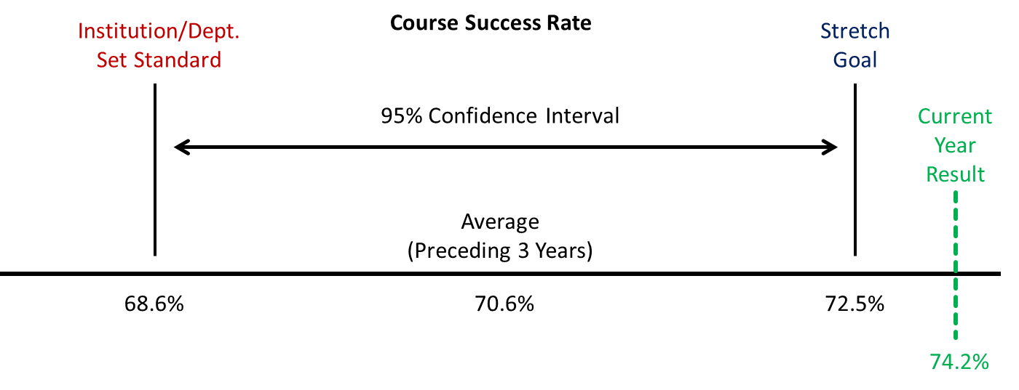

The increases were due in part to increased enrollment (from 1.6% share of total enrollment in 2014-15 to 11% share of total enrollment in 2016-17) and increased student course completion (from 94.8% in 2014-2015 to 97.3% in 2016-2017) in the Apprenticeship program. In addition, increased student course completion was observed in twelve additional programs, with all twelve not only exceeding the institution set standard, but also exceeding their department level stretch goals.

Going forward, student course completion is expected to increase as ARC implements its newly adopted strategic plan, which includes three major student success strategies (Start Right, IPaSS (Integrated Planning and Support for Students), and Clarify Program Paths) designed to help more students achieve their educational goals.

Methodology:

The methodology for setting institution set standards and stretch goals utilizes a 95% Confidence Interval centered on the rolling average of the preceding 3 years of student course completion data (excluding summers). The lower limit of the confidence interval serves as the institution set standard, and the upper limit of the confidence interval serves as the stretch goal. The confidence interval assumes a t distribution with 2 degrees of freedom (average +/- (standard error * 4.303). This methodology ensures that falling below the standard or above the stretch goal is unlikely to occur due simply to random year to year variation but instead is likely to reflect an actual change (increase or decrease) in student course completion for the target year. The institution set standard and stretch goal will be recalculated annually to reflect the preceding 3 years of student course completion outcomes.

DEGREE COMPLETION
(Students who received one or more degrees may only be counted once.)

 | 2014-15 |  | 2015-16 |  | 2016-17
Institution Set Standard | 1407 |  | 1579 |  | 1517
Stretch Goal | N/A |  | N/A |  | 2111
Actual Performance | 1731 |  | 1951 |  | 2050
Difference between Performance & Set Standard | +324 |  | +372 |  | +533
Difference between Performance & Stretch Goal | N/A |  | N/A |  | -61
Analysis of the data:

Degree completion has increased by about 18% over the past 3 years, from 1731 degrees to 2050 degrees, exceeding the institution set standard each year. Stretch goals were first instituted in the most recent reporting year (2016-2017). For that year, degree completion (shown in green font) fell short of the stretch goal by only 61 degrees (see Figure below).

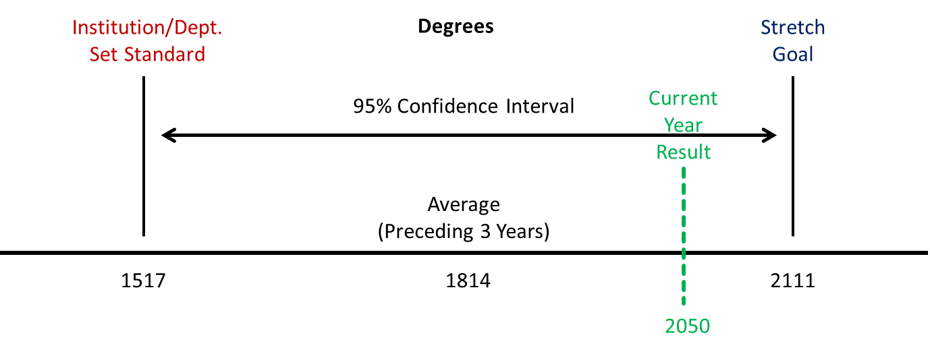

Going forward, degree completion is expected to increase as more ADT degrees are created and awarded, and as ARC implements its newly adopted strategic plan, which includes three major student success strategies (Start Right, IPaSS (Integrated Planning and Support for Students), and Clarify Program Paths) designed to help more students achieve their educational goals.

Methodology:

The methodology for setting institution set standards and stretch goals utilizes a 95% Confidence Interval centered on the rolling average of the preceding 3 years of degree completion data. The lower limit of the confidence interval serves as the institution set standard, and the upper limit of the confidence interval serves as the stretch goal. The confidence interval assumes a t distribution with 2 degrees of freedom (average +/- (standard error * 4.303). This methodology ensures that falling below the standard or above the stretch goal is unlikely to occur due simply to random year to year variation but instead is likely to reflect an actual change (increase or decrease) in degree completion for the target year. The institution set standard and stretch goal will be recalculated annually to reflect the preceding 3 years of degree completion outcomes.

CERTIFICATE COMPLETION
(Students who received one or more certificate may only be counted once.)

 | 2014-15 |  | 2015-16 |  | 2016-17
Institution Set Standard | 277 |  | 201 |  | 389
Stretch Goal | N/A |  | N/A |  | 577
Actual Performance | 441 |  | 514 |  | 434
Difference between Performance & Set Standard | +164 |  | +313 |  | +45
Difference between Performance & Stretch Goal | N/A |  | N/A |  | -143
Analysis of the data:

Certificate completion has remained stable over the past 3 years, exceeding the institution set standard each year. Stretch goals were first instituted in the most recent reporting year (2016-2017). For that year, certificate completion (shown in green font) fell short of the stretch goal by 143 certificates (see Figure below).

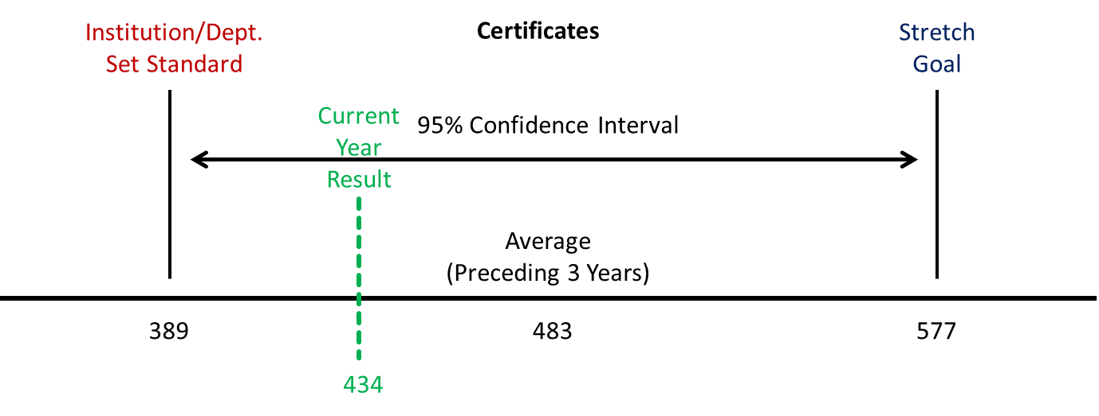

Going forward, certificate completion is expected to increase as ARC implements its newly adopted strategic plan, which includes three major student success strategies (Start Right, IPaSS (Integrated Planning and Support for Students), & Clarify Program Paths) designed to help more students achieve their educational goals.

Methodology:

The methodology for setting institution set standards and stretch goals utilizes a 95% Confidence Interval centered on the rolling average of the preceding 3 years of certificate completion data. The lower limit of the confidence interval serves as the institution set standard, and the upper limit of the confidence interval serves as the stretch goal. The confidence interval assumes a t distribution with 2 degrees of freedom (average +/- (standard error * 4.303). This methodology ensures that falling below the standard or above the stretch goal is unlikely to occur due simply to random year to year variation but instead is likely to reflect an actual change (increase or decrease) in certificate completion for the target year. The institution set standard and stretch goal will be recalculated annually to reflect the preceding 3 years of certificate completion outcomes.

TRANSFER

 | 2014-15 |  | 2015-16 |  | 2016-17
Institution Set Standard | 625 |  | 635 |  | 1032
Stretch Goal | N/A |  | N/A |  | 1418
Actual Performance | 1135 |  | 1187 |  | 1259
Difference between Performance & Set Standard | +510 |  | +552 |  | +227
Difference between Performance & Stretch Goal | N/A |  | N/A |  | -159
Analysis of the data:

Transfers have increased by about 10% over the past 3 years, from 1135 transfers to 1259 transfers, exceeding the institution set standard each year. Stretch goals were first instituted in the most recent reporting year (2016-2017). For that year, transfers (shown in green font) fell short of the stretch goal by 159 transfers (see Figure below).

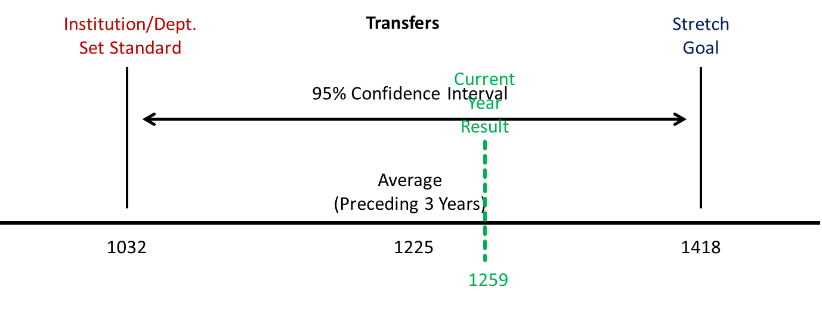

Going forward, the number of transfers is expected to increase as more ADT degrees are created and awarded, and as ARC implements its newly adopted strategic plan, which includes three major student success strategies (Start Right, IPaSS (Integrated Planning and Support for Students), and Clarify Program Paths) designed to help more students achieve their educational goals.

Methodology:

The methodology for setting institution set standards and stretch goals utilizes a 95% Confidence Interval centered on the rolling average of the preceding 3 years of transfers. The lower limit of the confidence interval serves as the institution set standard, and the upper limit of the confidence interval serves as the stretch goal. The confidence interval assumes a t distribution with 2 degrees of freedom (average +/- (standard error * 4.303). This methodology ensures that falling below the standard or above the stretch goal is unlikely to occur due simply to random year to year variation but instead is likely to reflect an actual change (increase or decrease) in transfers for the target year. The institution set standard and stretch goal will be recalculated annually to reflect the preceding 3 years of transfer outcomes.

STUDENT LEARNING OUTCOMES ASSESSMENT

 | 2014-15 |  | 2015-16 |  | 2016-17
Number of Courses | 2009 |  | 2074 |  | 2113
Number of Courses Assessed | 2009 |  | 2074 |  | 2113
Number of Programs | 400 |  | 410 |  | 421
Number of Programs Assessed | 399 |  | 410 |  | 421
Number of Institutional Outcomes | 7 |  | 7 |  | 7
Number of Outcomes Assessed | 7 |  | 7 |  | 7
Analysis of the data:

The number of courses and programs offered has increased over the past 3 years. All course, program, and institutional SLOs are assessed regularly.

The documentation of SLO assessment is accomplished through a combination of oversight of appropriate SLO assessment tools and SLO language integrated into the curriculum review process, SLO mapping from courses to programs, the regular reporting of SLO assessment results through the Authentic Assessment Review Record (AARR), and the collection of student voices through focus groups and survey instruments.

LICENSURE PASS RATE
(Definition: The rate is determined by the number of students who passed the licensure examination divided by the number of students who took the examination.)

Program Name | Institution Set Standard | Actual Performance |  |  | Difference (Performance – Set Standard) |  |  | Stretch Goal | Difference (Performance – Stretch Goal)
 |  | 14-15 | 15-16 | 16-17 | 14-15 | 15-16 | 16-17 |  | 14-15 | 15-16 | 16-17
Funeral Services | 60% | 94% | 92% | 81% | +34% | +32% | +21% | N/A | N/A | N/A | N/A
Paramedic | 70% | 100% | 100% | 100% | +30% | +30% | +30% | N/A | N/A | N/A | N/A
Respiratory Care | 70% | 100% | 92% | 100% | +30% | +22% | +30% | N/A | N/A | N/A | N/A
Nursing | 75% | 86% | 94% | 94% | +11% | +19% | +19% | N/A | N/A | N/A | N/A
Analysis of the data:

All programs have consistently exceeded their institution set standards. Stretch goals for licensure pass rates will be developed in spring 2019.

JOB PLACEMENT RATE
(Definition: The placement rate is determined by the number of students employed in the year following graduation divided by the number of students who completed the program.)

Program Name | Institution Set Standard | Actual Performance |  |  | Difference (Performance – Set Standard) |  |  | Stretch Goal | Difference (Performance – Stretch Goal)
 |  | 14-15 | 15-16 | 16-17 | 14-15 | 15-16 | 16-17 |  | 14-15 | 15-16 | 16-17
Accounting | 47% | 76% | 79% | 83% | +29% | +32% | +36% | N/A | N/A | N/A | N/A
Administration of Justice | 78% | 95% | 96% | 96% | +17% | +18% | +18% | N/A | N/A | N/A | N/A
Art New Media | 53% | 71% | 75% | 69% | +18% | +22% | +16% | N/A | N/A | N/A | N/A
Automotive Collision Technology | 45% | 70% | 61% | 73% | +25% | +16% | +28% | N/A | N/A | N/A | N/A
Automotive Technology | 56% | 64% | 66% | 74% | +8% | +10% | +18% | N/A | N/A | N/A | N/A
Business Technology | 51% | 62% | 69% | 55% | +11% | +18% | +4% | N/A | N/A | N/A | N/A
Carpenter Apprenticeship | 75% | 100% | 100% | 100% | +25% | +25% | +25% | N/A | N/A | N/A | N/A
CIS: Computer Networking Management | 44% | 74% | 86% | 95% | +30% | +42% | +51% | N/A | N/A | N/A | N/A
CIS: Microcomputer Applications | 32% | 62% | 79% | 83% | +30% | +47% | +51% | N/A | N/A | N/A | N/A
CIS: PC Support | 31% | 50% | 75% | 61% | +19% | +44% | +30% | N/A | N/A | N/A | N/A
CIS: Programming | 3% | 60% | 68% | 54% | +57% | +65% | +51% | N/A | N/A | N/A | N/A
CIS: Web Developer | 46% | 67% | 73% | 59% | +21% | +27% | +13% | N/A | N/A | N/A | N/A
Commercial Music | 45% | 75% | 67% | 73% | +30% | +22% | +28% | N/A | N/A | N/A | N/A
Design Technology | 51% | 63% | 75% | 71% | +12% | +24% | +20% | N/A | N/A | N/A | N/A
Diesel Technology | 59% | 71% | 65% | 76% | +12% | +6% | +17% | N/A | N/A | N/A | N/A
Drywall/Lathing Apprenticeship | 75% | 100% | 100% | 100% | +25% | +25% | +25% | N/A | N/A | N/A | N/A
Early Childhood Education | 47% | 66% | 75% | 74% | +19% | +28% | +27% | N/A | N/A | N/A | N/A
Electronic | 36% | 58% | 73% | 72% | +22% | +37% | +36% | N/A | N/A | N/A | N/A
Environmental Conservation | 46% | 71% | 58% | 80% | +25% | +12% | +34% | N/A | N/A | N/A | N/A
Fashion | 59% | 62% | 65% | 55% | +3% | +6% | -4% | N/A | N/A | N/A | N/A
Fire Technology | 78% | 95% | 88% | 79% | +17% | +10% | +1% | N/A | N/A | N/A | N/A
Funeral Service Education | 56% | 79% | 94% | 89% | +23% | +38% | +33% | N/A | N/A | N/A | N/A
General Business | 45% | 63% | 70% | 75% | +18% | +25% | +30% | N/A | N/A | N/A | N/A
Geographic Information Systems (GIS) | 60% | 76% | 75% | 91% | +16% | +15% | +31% | N/A | N/A | N/A | N/A
Gerontology | 17% | 65% | 77% | 56% | +48% | +60% | +39% | N/A | N/A | N/A | N/A
Hospitality Management: Baking | 52% | 63% | 63% | 74% | +11% | +11% | +22% | N/A | N/A | N/A | N/A
Hospitality Management: Culinary Arts/Restaurant | 31% | 80% | 86% | 68% | +49% | +55% | +37% | N/A | N/A | N/A | N/A
Human Services | 39% | 48% | 60% | 62% | +9% | +21% | +23% | N/A | N/A | N/A | N/A
Interior Design | 35% | 58% | 69% | 68% | +23% | +34% | +33% | N/A | N/A | N/A | N/A
Legal Assisting | 47% | 71% | 78% | 67% | +24% | +31% | +20% | N/A | N/A | N/A | N/A
Management | 27% | 50% | 74% | 65% | +23% | +47% | +38% | N/A | N/A | N/A | N/A
Nursing | 44% | 82% | 92% | 90% | +38% | +48% | +46% | N/A | N/A | N/A | N/A
Real Estate | 46% | 53% | 50% | 61% | +7% | +4% | +15% | N/A | N/A | N/A | N/A
Respiratory Care | 74% | 85% | 100% | 77% | +11% | +26% | +3% | N/A | N/A | N/A | N/A
Sign Language Studies:  Interpreter  Training | 73% | 84% | 100% | 100% | +11% | +27% | +27% | N/A | N/A | N/A | N/A
Speech Language  Pathology Assistant  Training | 55% | 73% | 95% | 88% | +18% | +40% | +33% | N/A | N/A | N/A | N/A
Welding Technology | 50% | 67% | 87% | 83% | +17% | +37% | +33% | N/A | N/A | N/A | N/A
Analysis of the data:

Nearly all programs exceeded their institution set standards for job placement rates. These rates were sourced from the California Community College’s Chancellor’s Office Perkins IV Core Indicator Report website.

Methodology:

The methodology for setting institution set standards utilizes a 95% Confidence Interval centered on the rolling average of the preceding 3 years of job placement rates. The lower limit of the confidence interval serves as the institution set standard. The confidence interval assumes a t distribution with 2 degrees of freedom (average +/- (standard error * 4.303). This methodology ensures that falling below the standard is unlikely to occur due simply to random year to year variation but instead is likely to reflect an actual decrease in job placement rates for the target year. An exception is made for programs with zero variability (e.g., 100% job placement in each year). For those programs, the institution set standard was set at the average of actual performance minus 25%). The institution set standard will be recalculated annually to reflect the preceding 3 years of job placement rates.

Stretch goals are expected to be instituted for the first time in spring 2019. The upper limit of the 95% Confidence Interval is expected to serve as the Stretch Goal.

Annual Fiscal Report Data Analysis
- See Excel spreadsheet

Appendix: Evidence

Response to Self-Identified Improvement Plans

IP1.1 PCC-Examining ARC Governance Structure
IP1.2 PCC Agenda
IP1.3 Governance website
IP1.4 ARC Participatory Governance and Integrated Strategic Planning Framework
IP1.5 Integrated Planning Improvement project team charter
IP1.6 Draft Integrated Planning Guide

IP2.1 Focus groups – Students’ earliest experiences at the college
IP2.2 Student focus groups summary
IP2.3 Achieve@ARC case-management design
IP2.4 1/25/18 SLOAC Meeting Minutes – ISLO focus group data collection
IP2.5 3/21/18 SLOAC Meeting Minutes – ISLO focus group
IP2.6 Foster youth student focus group

IP3.1 5/2 SLOAC Update – ISLO Retreat
IP3.2 9/26/18 SLOAC Meeting Minutes – New AARR process
IP3.3 10/11/18 Academic Senate Minutes

IP4.1 SLOAC Handbook

IP5.1 ESL assessment validation probationary approval
IP5.2 ESL validation research

IP6.1 Governance training for note takers
IP6.2 Governance training for leaders
IP6.3 Governance training for all members

Response to Team Recommendations for Improvement

R2.1 PCC-Examining ARC Governance Structure
R2.2 PCC Agenda -- Governance Task Force
R2.3 Governance Task Force Agenda
R2.4 ARC Participatory Governance and Integrated Strategic Planning Framework
R2.5 PCC Agenda 10-02-17
R2.6 Revised Student Success Council Charter
R2.7 Revised Institutional Effectiveness Council Charter
R2.8 Revised Operations Council Charter

R3.1 Redesign website
R3.2 Quality Enhancement Support Team
R3.3 Data visualizations
R3.4 Equity Action Institute data

R4.1 Course substitution database
R4.2 Draft course substitution policy update

