Math Department thoughts on the Executive Summary - February 21. 2023

1) We need to be careful how we interpret things like data-on-demand. For example, here’s data-on-demand that seems to indicate the one-year retention rates for those below poverty consistently are higher than one-year retention rates for those at or above middle class. It makes one wonder sometimes if there's more to the story than some of the data suggests. Overly simplistic conclusions can lead to policies/strategies that do more harm than good because they are not rooted in a more robust understanding of the issues involved.

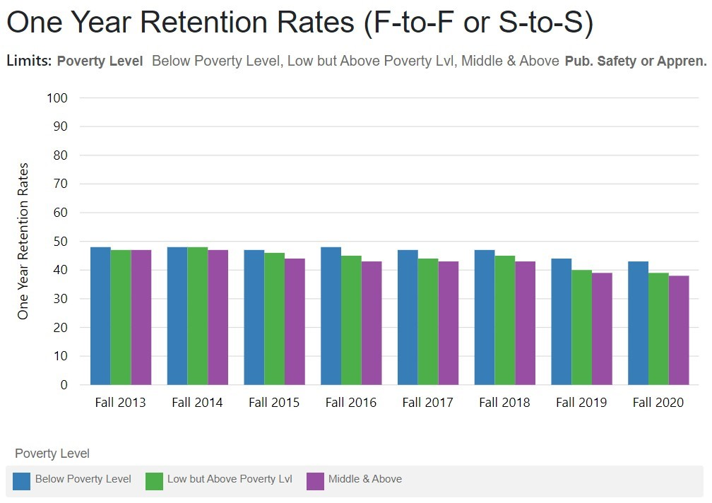

When we look at the data presented in the Performance Metric Executive Summary, it focuses on ethnicity, which can provide valuable information, but not in isolation from other significant factors. We need to also consider underlying identifiers; from a MESA perspective, financial aid eligibility and first-generation status were primary identifiers used to measure financial and educational disadvantages, but they weren't the only identifiers.

A quote from a math colleague: “The snapshots are not really showing how inequitable our department or college is as much as it's showing how inequitable the world is.” Well, perhaps it’s showing both. We as a department and college are a microcosm of the larger systemic inequities.

2) In the first tables (F-to-S and F-to-F Retention):
  - Do these numbers include Advanced Ed and other students with non-degree-oriented enrollment? In years past, those numbers might have been insignificant, but my understanding is that we’ve increased those significantly in the last couple of years.
  - Does goal completion (certificate, degree, transfer, etc.) count towards lack of retention? Response from a member of the Student Success Council: “Yes, the lack of overall retention includes those who left successfully. So, it is known that point needs to be considered as future research is conducted.”
  - There seems to be a significant gap between first time students and all students for both tables in all years, with retention of first-time students being higher; this means that the “all students” actually overrepresents (likely inadvertently) the fact that non-first-time students have an even lower retention rate when broken out from “all.” It would be interesting to see if there was a consistent trend (e.g. the longer a student has been enrolled, the less likely they are to be retained).

3) Regarding racial disaggregation:
  - Retention rates for black students are consistently lower than that of white and Asian students. We could hypothesize about why, but… This is one of my primary gripes with our “data-driven decision-making” around here. We don’t ever get data from the students who aren’t here anymore. We never know why they stopped coming. Per the on-demand data we know that retention of low-income students is consistently higher than those of middle- and upper-income class students, so there must be more at play than just income as a lurking variable.
  - Retention rate decreases for black students were significantly lower than those of white students; no doubt this will be celebrated as a shrinking of an equity gap, but one group seeing slightly less negative results doesn’t exactly inspire elation in me. In general, it seems that the lower the base retention rates were, the lower the decrease was (even when adjusted as percentage of the base)

4) Covid was such a unique situation. It’s unclear how much insight we can gain on what happened from 2020-2022. Data gathered in Fall 2022 is likely to be the best place to start assessing our current situation.

